**Comic Corner**

**A PROJECT REPORT**

***Submitted by***

**JAYDEEP HITESHBHAI MITHANI**

**200540107512**

***In partial fulfillment for the award of the degree of***

**BACHELOR OF ENGINEERING**

***in***

**COMPUTER ENGINEERING**

**DARSHAN INSTITUTE OF ENGINEERING AND TECHNOLOGY, RAJKOT**

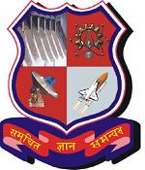

**Gujarat Technological University, Ahmedabad April - 2023**