1. **INTRODUCTION**: Meta-cognitive sequential learning algorithm for a neuro-fuzzy inference system for classification tasks, refered as ‘Meta-cognitive Neuro-fuzzy Inference System (McFIS)’.The McFIS learning algorithm is developed based on the principles of the best human learning strategy: viz., a self-regulatory learning strategy in a meta-cognitive framework. McFIS has two component, namely, a cognitive component and a meta-cognitive component. A neuro-fuzzy inference system forms the cognitive component of McFIS and a self-regulatory learning mechanism forms its meta-cognitive component. The learning ability of the cognitive component is monitored and controlled by the self-regulatory learning mechanism. For each sample in the training data set, the meta-cognitive component uses its self-adaptive thresholds to choose one of the following learning strategies based on criteria that depends on class-specific knowledge: a) Sample deletion b) sample learning c) sample reserve. Thus, the meta-cognitive component decides what-to-learn, when-to-learn, how-to-learn the training samples. When new rule is added, the parameters of the new rule are assigned such that the rule has minimum overlapping with the adjacent rules and also such that the localization property of the Gaussian rules are efficiently exploited. Meta-cognitive neuro fuzzy inference system (McFIS) imposes self-regulatory or self-monitored behavior through which the system is able to decide what-to-learn, how-to-learn, when-to-learn by using three learning strategies 1) sample delete 2) sample learn 3) sample reserve. The proposed system aims at improving the learning ability of neuro-fuzzy inference system and by implementing the system on Graphic Processing Unit (GPU) it improves the throughput of the system. The GPU implementation of FNN uses Meta-cognitive learning algorithm as it imposes self-regulated or self-monitored learning in the neuro-fuzzy system. To train Neuro-fuzzy inference system for high –dimension data is computationally intense task. Single threaded CPU will process the dataset in series instead of in parallel. Neuro-Fuzzy network are suitable for implementing on parallel processing units because they can be expressed as data-parallel computations due to the parallel processing property of fuzzy rules and input variables. The GPU-McFIS is proposed to make the system computationally less intense. CUDA is used to implement GPU-McFIS. In GPU-FNN, blocks of threads are partitioned based on fuzzy rules so the number of blocks is equal to the number of fuzzy rules, and the number of threads are equal to the number of input variables. Following figure shows the partition of membership function calculation into blocks of threads. For dataset parallelism, dataset can be divided into smaller chunks that are stored in the shared memory, and each chunk is visible to all threads of the same block. Each thread computes the same function with the only difference of input data, and the computed output is saved on the shared memory.

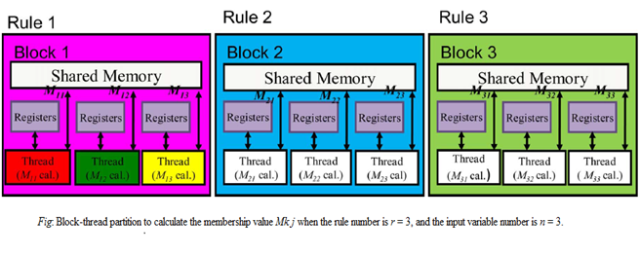

1. **OBJECTIVE:** To improve the learning ability of neuro-fuzzy system by using pseudo-samples as knowledge measures in order to address the classification problem in neural networks.
2. **PROPOSED METHODOLOGY:** The schematic diagram for the proposed McFIS network is as shown in the fig. 1. The cognitive component of McFIS has four layer : input layer, Gaussian layer, normalization layer and output layer. The meta-cognitive component contains knowledge measures and learning strategies. As compared to the existing Meta-cognitive Neuro-fuzzy Inference system the proposed system has two more learning strategies added in order to help the system address how-to-learn aspect of learning, along with that a addition of knowledge measures we are using for measuring the knowledge in the sample.
3. *The cognitive component of McFIS has four layers:*
4. **Input Layer:** The number of nodes *m* in this layer represents the input feature. The output of the input layer is directly transmitted to the Gaussian layer.
5. **Gaussian Layer:** It conatins the rule background information of each of the K rule of the McFIS system, and it performs rule inference to compute the overall contribution of the rule to the input features.
6. **Normalization Layer:** The number of nodes int this layer is same as Gaussian layer.
7. **Output Layer:** The number of nodes in this layer is equal to the number of distinct classes (n).

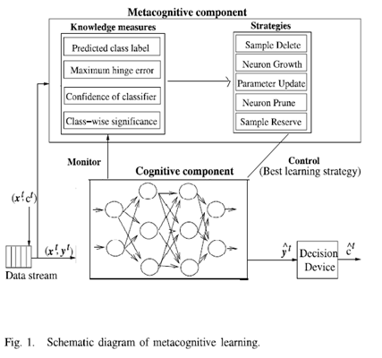

1. *The Meta-cognitive component of McFIS :*The meta-cognitive component contains the knowledge measures, and self-regulated thresholds. When a new training sample is presented to McFIS the metacognitve component estimates the knowledge present in the new training sample with respect to the cognitive component using its knowledge measures. The meta-cognitve component uses predicted class label, maximum hinge loss error, posterior probability, and classwise significance as the measures of knowledge in the new training sample. The self-regulated thresholds are adapted to capture the knowledge present in the new training sample. Based on the knowledge measures and self-regulated thresholds, the metacognitive component chooses one of the two sample-based learning strategies or three neuron-based learning strategies to learn the current sample accurately.

**FLOWCHART:**

Train all the samples

CPU: First incoming data?

Calculate the width and center of corresponding membership function

YES

NO

GPU: Calculate the membership value by using Gaussian membership function

GPU: Calculate the sample error, predicted posterior probability and significance .

If ac = = pc ?

Delete the sample

**YES**

**NO**

Else if

Se > Ta & Ac ≠ Pc ?

**YES**

Add new node

**NO**

Else if

Se > Tsa & Ac==Pc ?

**YES**

Update the parameters of the network.

**NO**

Reserve the sample to be learnt later

If contribution of a rule for the same class < Tp for N samples?

**NO**

**YES**

Prune the rule

**END**

Pc=Predicted class label , Ac= Actual class label, Se=Sample error , Ta=Add Threshold, Tsa= Self adaptive add threshold

1. **ORGANISATION OF REPORT:** Section I gives the introduction of the system, section II we discuss the objective, section III is about the proposed methodology followed by conclusion and references.
2. **CONCLUSION:** The proposed system will reduce the computational cost and will help improve the throughput of the system by employing parallel computing.

**REFERENCES**

1. K. Subramanian, S. Suresh and N. Sundarajan , “Meta-Cognitive Neuro-Fuzzy Inference Syatem (McFIS) for Sequential Classification Problems,” *IEEE* *Trans* *on Fuzzy systems (TFS)*, Vol, PP, Issue:99, 2013.
2. P. Anglov, Senior Member, IEEE and Xiaowei Zhou, Student Member, IEEE “Evolving Fuzzy-Rule based classifiers from data streams,”  *IEEE Trans on Fuzzy systems*, Vol. 16, NO. 6, December 2008.
3. Guang-Bin Huang, Senior Member, IEEE, Hongming Zhou, “Extreme Learning Machine for Regression and Multiclass Classification,” *IEEE Trans on Systems, Man and Cybernetice- Part B: CYBERNETICE,* VOL, 42 ,NO. 2, April 2012.
4. Chun-Fu Lin and Sheng-De Wang, “Fuzzy Support Vector Machines,”  *IEEE Trans on Neural Networks,* Vol, 13, No. 2 March 2002.
5. Guang-Bin Huang, Senior Member, IEEE, N. Sundarajan, “Online Sequential Fuzzy Extreme Learning Machines for Function Approximation and Classification Problems,” *IEEE Trans on Systems, Man and Cybernetice- Part B: CYBERNETICE,* VOL, 39 ,NO. 4, August 2009.
6. Hai-Jun, N. Sundarajan, Guang-Bin, P. Saratchandran, “Sequential Adaptive Fuzzy Inference system (SAFIS) for nonlinear system identification and prediction,”  *Fuzzy sets and systems* vol.157, no.9,pp. 1260-1275, 2006.
7. K. Subramanian, R. Savitha, S.Suresh, “A Meta-Cognitive Interval Type-2 Fuzzy Inference System Classifier and its Projection Based Learning,” *IEEE Conference* Publication 2013.
8. Classification and Feature Selection Techniques in Data Mining. By Sunita Beniwal, Jitendra Arora. Department of Information Technology, Maharishi Markandeshwar University, Mullana, Ambala-133203, India , International Journal of Engineering Research & Technology (IJERT) Vol. 1 Issue 6, August 2012.
9. A Sequential Learning algorithm for Meta- cognitive Neuro-Fuzzy Inference System for Classification Problem. By S. Suresh and K. Subramanian. Proceedings of International Joint Conference on Neural Networks, San Jose, California, USA, July 31- August 5, 2011.
10. “Neural Networks for Classification: A Survey,” *IEEE Ttrans on Systems, Man and Cybernetice*- Part C: CYBERNETICE, VOL, 30 ,NO. 4, November 2000
11. T-O. Nelson and L. Narens, “Metamemory A theoretical framework and new findings,” Psychology of learning and Motivation, Vol. 26, no. C, pp. 125-173,1990.
12. Jyh-Shing Roger Jang, “ANFIS: Adaptive –Network-Based Fuzzy Inference System,”  *IEEE Trans on Systems, Man, and Cybernetics,* Vol. 23, No. 3, May/June 1993
13. S. Kajan, J. Salka, “Computing of Neural networks on Graphics card”, Institute of control and industrial informatics, Faculty of electrical engineering and information technology, Slovak University of Technology, Bratislava.
14. Sundaram Suresh, “Sequential Projection based algorithm Meta-Cognitive Learning in Radial Basis Function network for classification problem,” *IEEE Trans on Neural networks and learning system* Vol. 24, No. 2, Feb 2013.