

**International Institute of Information Technology, Bangalore**

**CS/DS 901 Project Elective [ Term II ]**

**Using Hyperledger Construct An Application For Supply Chain Integrity**

**Name:**  **Roll Number:**

Jaydeep Godhani MT2018044

Yogesh Motwani MT2018136

Ankit Pathania MT2018015

**Goal Statement**

In this project we will be developing a **web-app** which helps pharmaceutical industry by prevention of counterfeit drugs and maintaining transparency from end to end (manufacturer to consumer) which uses Hyperledger blockchain underneath. We will also ensure that transportation of drugs happens under prescribed standard (Temperature, Humidity). For storing and transporting drugs we must maintain certain prescribed standards which can be recorded using IoT technology but IoT technology is not the main goal of the project. Instead we will provide these parameters manually.

**Repository Using**

<https://github.com/jaydeepgodhani/Project/tree/master/Hyperledger>

**Online journal for weekly updates**

<https://sites.google.com/view/bruteforce/projects/hyperledger>

**System Architecture**

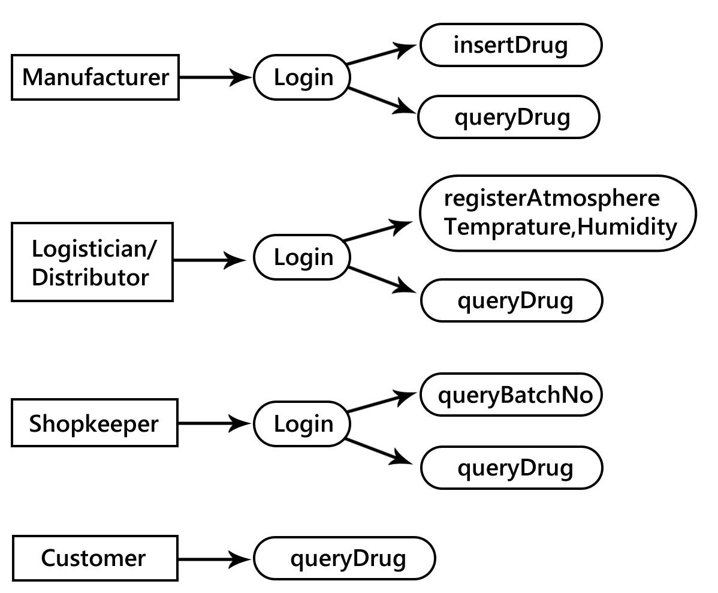

Manufacturer will have to login with credentials to gain access into the system. After login Manufacturer can do two operations namely InsertDrug and queryDrug. In InsertDrug function Manufacturer has to store SerialNo, BatchNo, DrugName, ExpiryDate, Message and ManufacturerName.

Logistician (Distributor) also has to login with credentials. After login he/she can do two operations namely registerAtmosphere (attributes temperature and humidity) and queryDrug . If temperature/humidity is higher than specified, appropriate message is added on the batchNo that the drug has been through extreme conditions.

Shopkeeper also has to login with credentials. After login he/she can do two operations namely queryBatchNumber and queryDrug.

Customer doesn’t need to login. He/She can see details of drugs like serialNo, batchNo, drugName, manufacturer, expiryDate, message from the specific URL.

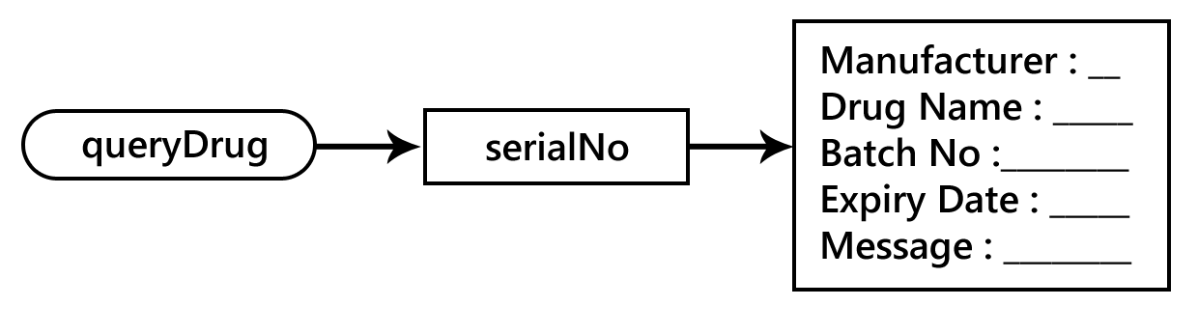

Here multiple manufacturers can produce different drugs. These drugs are transported by different logisticians(distributors) and purchased by different shopkeepers. Customers purchase these product through shopkeepers. All the entities are part of the BlockChain network.

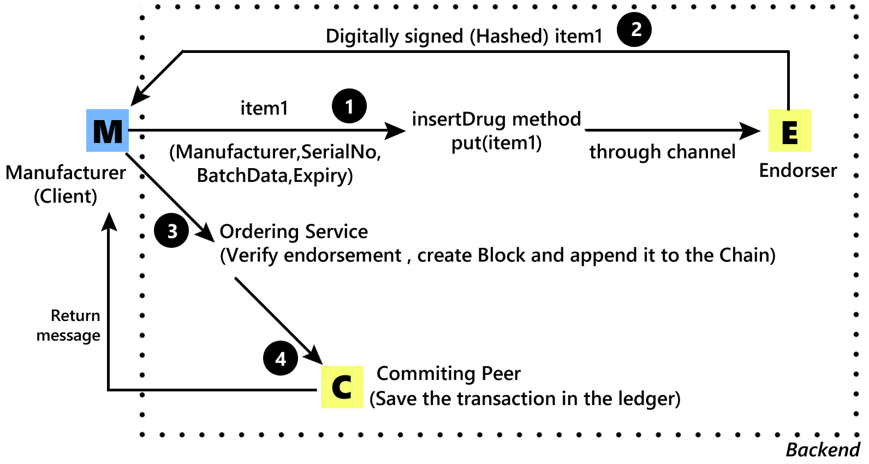

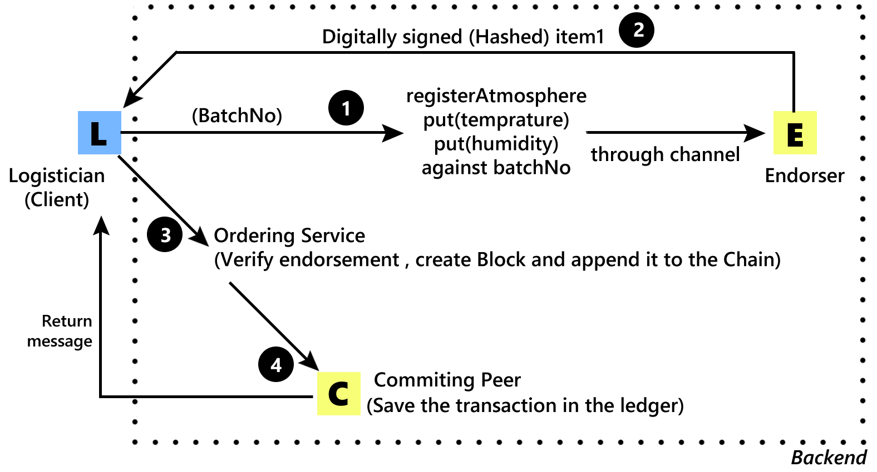

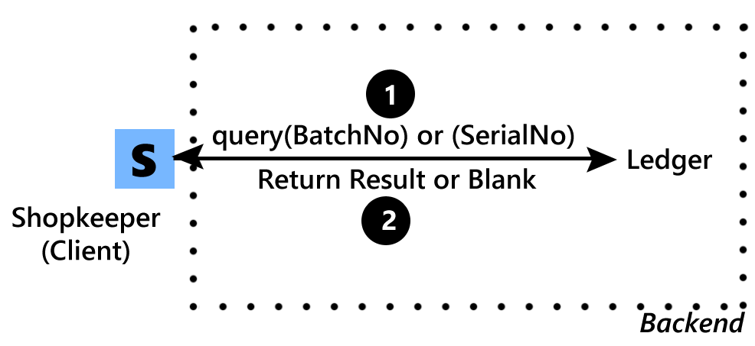

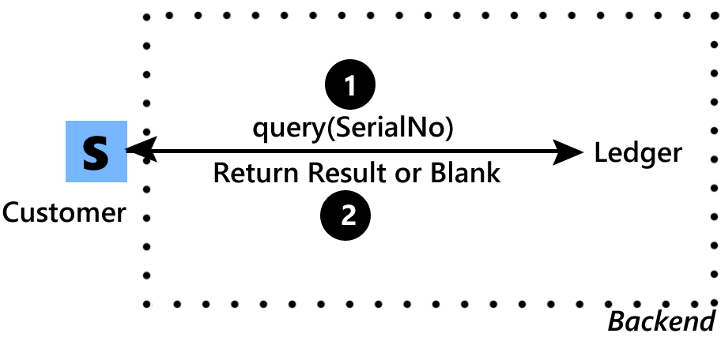

Above diagram represent what each actors can do and what will actually happen behind the scene.

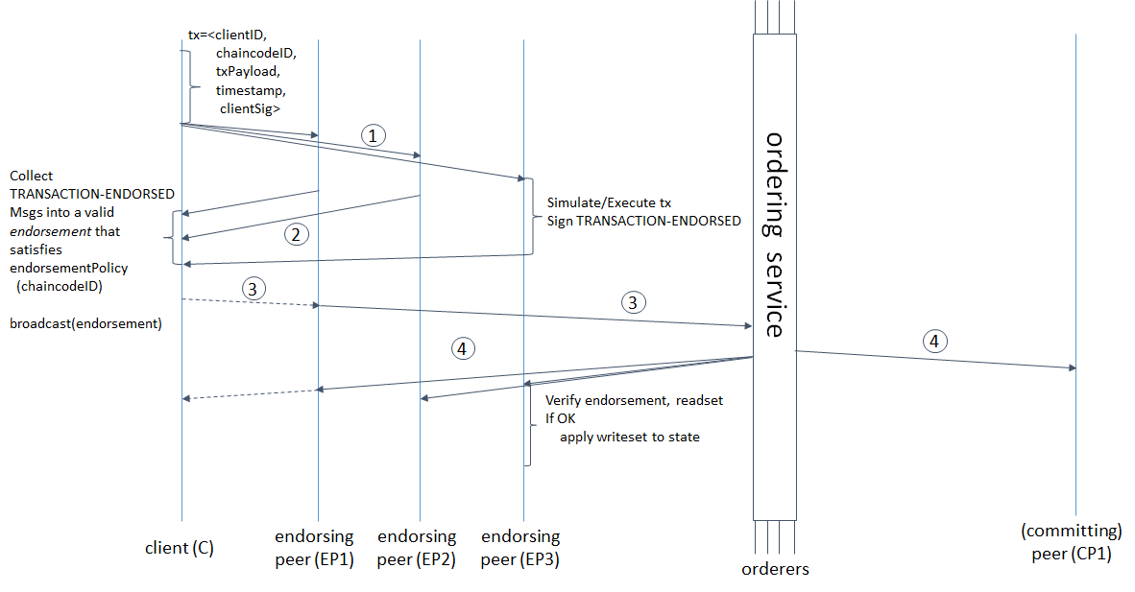

Internal Workflow of BlockChain (How blockchain actually works)

**Tools and Technology**

* **cURL** - It is a tool to transfer data from or to a server, using one of the supported protocols.
* **Docker** - It is a tool designed to make it easier to create, deploy and run applications by using containers.
* **Node.js and npm** - Node.js is an open source server environment which uses JavaScript on the server and npm is a package manager from Node.js packages and modules.
* **Go** - Go is an open-source programming language that is widely used in blockchain technology. we will be writing chaincode programs in Go.
* **LevelDB** - LevelDB is the default state database embedded in the peer node and stores chaincode data as simple key-value pairs and supports key, key range, and composite key queries only.
* **MySQL –** It is an open source relational database system, we’re using it for a login functionality.

**Hyperledger Framework:**

There are five frameworks available in Hyperledger which are Iroha, Sawtooth, Fabric, Indy and Burrow and three modules namely Cello, Explorer and Composer.

In this project we are using Fabric framework because it provides us with transparency and integrity and in extra if we want to share data with only certain parties, we can create a private channel with just those participants.

We are using Composer module which provides easy-to-use set of components that developers can quickly learn and implement and it is widely used with Fabric framework.

**Gap Analysis**

There isn’t any hyperledger technology related application available for enterprise and public as this cutting-edge technology is just introduced in December 2015. There is a project on pharmaceutical supply chain by IBM but it is still under development phase. In our project we are also emphasizing on whether transportation of drugs is taking place under controlled environment. Because of immutability of ledgers, manufacturer, logistician and shopkeeper can verify whether the drug is original and also get information regarding quality, expiry date extra.

**Milestones**

|  |  |
| --- | --- |
| 30/01/2019 | Choose openly available web template and Implement Ordering Service (Heart of the blockchain) |
| 13/02/2019 | Create ChainCode (smart-contract) and test it on any actor’s functionality |
| 27/02/2019 | Implement Manufacturer’s and Logistician’s functionality i.e insertDrugs, registerAtmosphere, queryBatchno etc. |
| 13/03/2019 | Finishing up all other functionalities (wrapping up all actor’s methods) |
| 27/03/2019 | Implement login functionality for appropriate actors |
| 13/04/2019 | Deploy and test web-app for end to end system. |
| 27/04/2019 | fine tune UI |