Woxsen University
School of Technology
A
PROJECT REPORT
on
FRAMEFLOW: AI/ML OPTICAL-FLOW BASED TEMPORAL INTERPOLATION
OF GEOSTATIONARY SATELLITE IMAGERY USING RIFE HDv3
Problem Statement 12 - "Fill in the Frames Seamlessly"
Submitted in partial fulfillment of the requirements for the degree of
B. Tech. in Artificial Intelligence and Machine Learning
Submitted by:
Atharva Kanojia and Team
[Roll Number]
Under the guidance of:
[Faculty Name]
Academic Year 2026 | Batch 2025 - 2029

CERTIFICATE
This is to certify that the project report entitled "FrameFlow: AI/ML Optical-Flow Based Temporal Interpolation of Geostationary Satellite Imagery using RIFE HDv3" submitted by Atharva Kanojia and Team ([Roll Number]) in partial fulfillment of the requirements for the award of the degree of B.Tech. in Artificial Intelligence and Machine Learning from Woxsen University is a bonafide record of work carried out by the student(s) under my supervision and guidance.
The work embodied in this project report has been carried out by the candidate(s) and has not been submitted elsewhere for a degree.

Signature of Mentor
Name: [Mentor Name]
Designation: [Designation]
Date:

DECLARATION of the candidate
I hereby declare that the project work entitled "FrameFlow: AI/ML Optical-Flow Based Temporal Interpolation of Geostationary Satellite Imagery using RIFE HDv3" submitted to the School of Technology, Woxsen University, in partial fulfillment of the requirements for the award of the degree of B.Tech. in Artificial Intelligence and Machine Learning is my original work and has been carried out under the guidance of [Guide Name].
I further declare that the work reported in this project has not been submitted and will not be submitted, either in part or in full, for the award of any other degree or diploma in this institute or any other institute or university.

Signature of Student
Name: [Your Name]
Roll Number: [Your Roll Number]

Signature of Student
Name: [Your Name]
Roll Number: [Your Roll Number]
Date:
Note: Please add more signature blocks if applicable.

ACKNOWLEDGMENT
I would like to express my sincere gratitude to all those who have contributed to the successful completion of this project on temporal interpolation of geostationary satellite imagery using the FrameFlow system.
First and foremost, I extend my heartfelt thanks to my project guide, [Guide Name], [Designation], for their invaluable guidance, continuous support, and constructive feedback throughout the duration of this project. Their expertise in machine learning and computer vision has been instrumental in shaping this work.
I am grateful to [Head of Department Name], Head of the Department of [Department Name], for providing the necessary facilities and resources required for this project.
I would also like to thank the Indian Space Research Organisation (ISRO) for framing Problem Statement 12 of the Bharatiya Antariksh Hackathon 2026, the NOAA GOES-R programme for making GOES-16 data publicly available, and the authors of RIFE (Huang et al.) for releasing their frame interpolation model, which formed the foundation of this work.
My sincere thanks to my peers and colleagues who provided valuable insights and suggestions during various phases of this project.
Finally, I am deeply grateful to my family for their unwavering support and encouragement throughout my academic journey.
Atharva Kanojia and Team

ABSTRACT
Temporal resolution is a recurring limitation in satellite-based weather monitoring. When a geostationary platform produces an image every fixed interval, fast cloud and storm evolution can occur between observations. This project, FrameFlow, studies whether a learned frame interpolation model can reconstruct useful intermediate satellite imagery without requiring another satellite observation. It was developed against ISRO Bharatiya Antariksh Hackathon 2026 Problem Statement 12.
The primary objective of this work is to develop and evaluate an optical-flow based pipeline that takes two consecutive satellite frames and generates the missing intermediate frame. The project uses the pretrained RIFE HDv3 (IFNet) model as the interpolation engine, adapts the input path for satellite imagery including single-channel thermal brightness temperature, and evaluates the generated frame against a withheld ground-truth frame using MAE, RMSE, PSNR and SSIM, compared against a linear interpolation baseline.
The methodology encompasses image preprocessing and normalization, RIFE inference, a confidence proxy derived from forward/backward warping residuals, quantitative evaluation, a FastAPI backend and a React/Vite dashboard with browser-level end-to-end verification.
Experimental results on GOES-16 Hurricane Ian data show that, across ten non-overlapping RGB temporal samples, RIFE obtained a mean MAE of 8.598 compared with 17.747 for linear interpolation, a mean PSNR of 24.839 dB versus 19.533 dB, and a mean SSIM of 0.8109 versus 0.6809. In the ABI Band 13 thermal experiment, the reconstructed brightness-temperature frame achieved 0.358 K MAE, 0.766 K RMSE, 45.836 dB PSNR and 0.9925 SSIM, all better than the linear baseline. These values demonstrate prototype-level feasibility and not operational meteorological accuracy.
This research contributes a complete, reproducible workflow from frame input to interpolation, quality measurement and visual inspection, and identifies the next steps required for real INSAT deployment, broader cross-event validation and satellite-specific fine-tuning.
Keywords: Satellite Imagery, Video Frame Interpolation, Optical Flow, RIFE, GOES-16, Brightness Temperature, Confidence Estimation, FastAPI, React

TABLE OF CONTENTS
Right-click and choose "Update Field" to generate the table of contents.

LIST OF TABLES
Table 1.1: Dataset Statistics
Table 3.1: Functional Requirements
Table 3.2: Inputs and Outputs of the Interpolation Model
Table 3.3: Repository Modules and Their Purpose
Table 3.4: Backend API Endpoints
Table 3.5: Verified Development Environment
Table 3.6: Evaluation Metrics and Interpretation
Table 4.1: Synthetic Demo Comparison of Interpolation Methods
Table 4.2: GOES-16 RGB Ten-Sequence Validation Results
Table 4.3: GOES-16 ABI Band 13 Thermal Evaluation Results
Table 4.4: Inference and Browser Performance
Table 4.5: Limitations and Risk Areas
Table 6.1: API Summary
Table 7.1: General Formatting Guidelines

LIST OF FIGURES
Figure 1.1: Basic Temporal Interpolation Problem Addressed by FrameFlow
Figure 3.1: High-Level Processing Path Implemented by FrameFlow
Figure 3.2: Thermal Band 13 Processing Path Used in the Prototype Experiment
Figure 3.3: Main Validation Stages Recorded in the Project Documentation
Figure 4.1: Dashboard in Its Initial State
Figure 4.2: Uploaded Bracketing Frames
Figure 4.3: Full Interpolation Result View
Figure 4.4: Metrics Section of the Dashboard
Figure 4.5: Handling of Invalid Input

1. INTRODUCTION
The temporal gaps between consecutive geostationary satellite observations represent a significant limitation in weather monitoring. With the increasing availability of high-cadence satellite datasets and advances in deep learning-based video frame interpolation, estimating the missing observation computationally has become increasingly feasible. This project focuses on developing a robust interpolation pipeline, FrameFlow, that generates an intermediate frame between two observed satellite frames and verifies it quantitatively.

1.1 Background
Satellite images are often used as a time series rather than as isolated pictures. The value of the sequence comes from observing how clouds, storm systems, and other surface or atmospheric structures change. The project problem statement highlights a simple difficulty: if a geostationary satellite observes an area every 30 minutes, any change that occurs inside the interval is not directly observed [1].
The problem becomes important during rapidly changing events. A storm cell can intensify, shear, expand, or lose structure between two observations. A fixed observation cadence therefore creates a temporal gap in the very period where the scene may be changing most quickly. FrameFlow asks whether that gap can be reduced computationally by estimating an intermediate frame from the two surrounding observations.
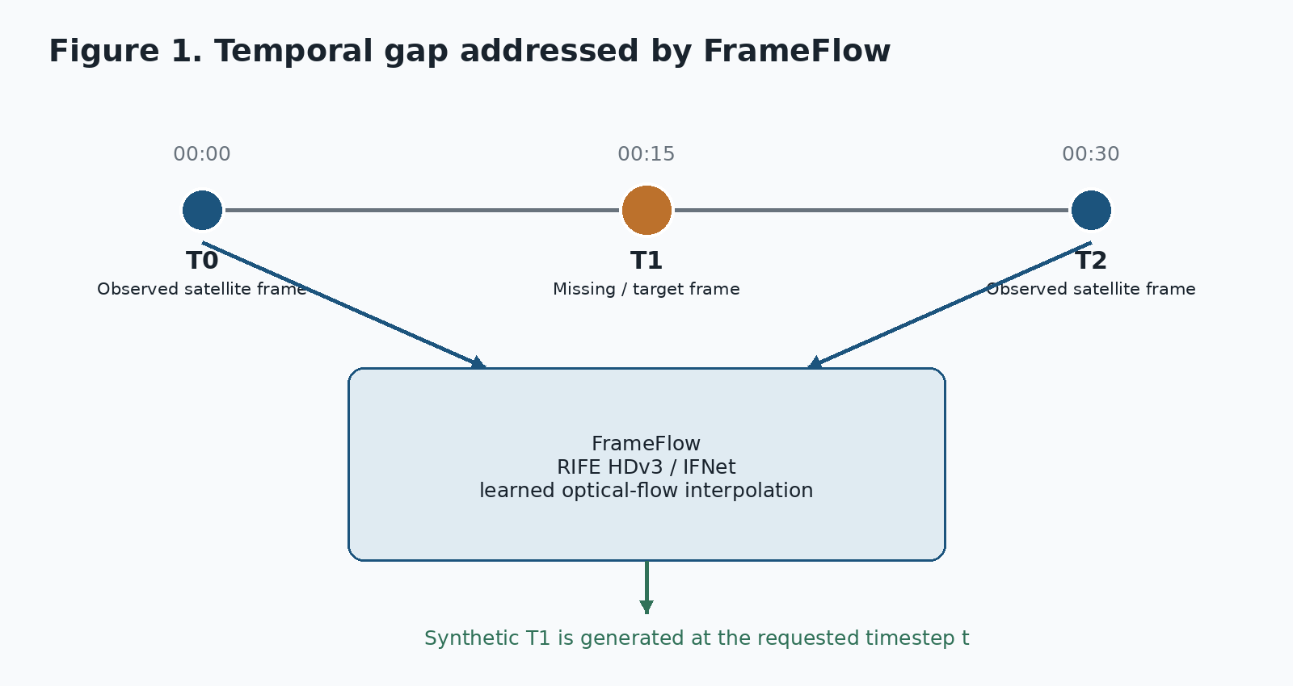
Figure 1.1: Basic Temporal Interpolation Problem Addressed by FrameFlow
The central assumption is not that the missing image contains completely new information. Instead, the two surrounding images contain evidence about how visible structures are moving or changing. Optical flow provides a way to represent that change as a field of motion vectors, and a learned interpolation network can use the estimated motion to produce an intermediate image. This is similar in spirit to video frame interpolation, but the satellite setting introduces different data characteristics: the input may be a single thermal band, image values have physical meaning, and weather structures do not always behave like rigid objects [2][4].

1.2 Motivation
The motivation for this project stems from several practical and research-oriented considerations:
- Improve the temporal continuity of geostationary satellite imagery without additional satellite hardware.
- Explore whether a pretrained flow-based interpolation model can be useful on satellite data before investing in a satellite-specific training pipeline.
- Provide a visual way to inspect both the generated frame and the regions where the interpolation is less consistent.
- Build a measurable evaluation workflow instead of relying only on visual judgment.
- Create a working software pipeline that can later be connected to high-cadence GOES/Himawari training data and the INSAT target workflow described in the architecture.

1.3 Problem Statement
The official problem statement asks for an AI/ML optical-flow based technique that takes two consecutive satellite images and generates intermediate frames. It specifically calls for improved temporal resolution, validation against higher-frequency datasets such as Himawari or GOES-19, metrics such as SSIM, MSE and PSNR, and a web dashboard showing observed and interpolated animations [1].
Let T0 and T2 denote two observed satellite frames and let T1 denote the real intermediate frame that is withheld during evaluation. The model receives T0, T2 and an interpolation fraction t, where t=0.5 corresponds to the midpoint. It produces a prediction T_hat1. The evaluation then compares T_hat1 directly with T1. During actual use, T1 is unknown and the generated frame is treated as an interpolated estimate rather than a measured observation [3][4].

1.4 Objectives
The specific objectives of this project are:
- Implement optical-flow based temporal interpolation using a pretrained RIFE/IFNet model.
- Build the preprocessing path needed for satellite imagery, including input formatting and normalization.
- Provide quantitative comparison against a simple linear interpolation baseline.
- Experiment with GOES-16 RGB and ABI Band 13 thermal imagery.
- Add a confidence proxy based on forward/backward warping consistency.
- Expose inference through an API and make the workflow usable from a browser-based dashboard.
- Keep the implementation reproducible and document the limitations that remain before operational deployment.

1.5 Dataset Overview
The project evaluates the system on two real data experiments drawn from GOES-16 observations of Hurricane Ian (27 September 2022), in addition to a synthetic end-to-end demo with the following characteristics:
Attribute | RGB Validation | Band 13 Thermal Experiment
Satellite | GOES-16 (GOES-East) | GOES-16 ABI Level-2 CMIP
Product | GEOCOLOR sequence | Band 13 (10.3 micrometer clean IR)
Event | Hurricane Ian, 27 Sep 2022 | Hurricane Ian, 27 Sep 2022
Samples | 10 non-overlapping triplets | 1 triplet (T0, T1, T2)
Region / size | Full-frame sequence | 512 x 512 crop
Units | RGB pixel values (0-255) | Brightness temperature (K)

Table 1.1: Dataset Statistics

1.6 Scope and Limitations
The scope of the current project is interpolation between known bracketing frames. It does not attempt to forecast beyond the last observed frame, infer unseen convective events that occur entirely between observations, or turn the interpolated pixels into an independent quantitative weather retrieval. The model card explicitly places these uses outside the intended scope [4].
Limitations of the present scope include:
- Real-data validation is centered on a single weather event (Hurricane Ian)
- The pretrained RIFE model has not been fine-tuned on a large multi-event satellite corpus
- Operational INSAT-3DS/3DR performance has not been established
- The confidence map is a consistency proxy rather than a calibrated uncertainty estimate

1.7 Organization of the Report
The remainder of this report is organized as follows: Chapter 2 presents a review of related work in optical flow, frame interpolation and satellite-specific interpolation. Chapter 3 details the methodology, including system requirements, architecture, data preprocessing, the RIFE model, confidence estimation, software implementation and evaluation design. Chapter 4 presents the experimental results and discussion. Chapter 5 concludes the report with a summary of contributions, limitations and directions for future work.

2. LITERATURE REVIEW / TECHNOLOGY REVIEW
This chapter reviews existing research and technology in the domains of optical flow, video frame interpolation and satellite image temporal interpolation, with particular emphasis on the RIFE family of models used in this project.

2.1 Optical Flow and Frame Interpolation
Traditional frame interpolation methods estimate motion between consecutive frames and then warp image content to the desired time. The problem statement notes that classical approaches often produce blur and artifacts in fast or non-linear cloud motion [1]. Learned VFI methods try to estimate a more useful intermediate representation from examples rather than applying a purely mechanical blend.

2.2 RIFE / IFNet
FrameFlow uses the RIFE family as its primary interpolation engine. The project model card identifies an IFNet-based RIFE backbone with coarse-to-fine intermediate-flow estimation, residual refinement, and support for arbitrary interpolation time t in the open interval (0,1) [4]. The integration keeps the upstream network architecture intact and wraps the required inference path locally [8].

2.3 Why RIFE Was Selected
The architecture document gives three practical reasons for choosing RIFE: it is flow-based, it supports arbitrary-time interpolation, and it is relatively small compared with many other video interpolation networks. The project repository also contains comparator paths for EMA-VFI, IFRNet, Super-SloMo, FILM, classical flow baselines, and persistence-style baselines as part of the wider evaluation plan [2].

2.4 Prior Satellite-Specific Work
The project architecture identifies the work by Vandal and Nemani on temporal interpolation of geostationary satellite imagery as a particularly relevant reference. Their reported Band 13 results are used in the project documentation as a quality bar for the production training phase [2]. This is useful because it keeps the target grounded in a satellite-specific result rather than comparing only against generic video benchmarks.

2.5 Evaluation Metrics in Interpolation Studies
Standard full-reference metrics for image reconstruction include mean absolute error (MAE), root mean squared error (RMSE), peak signal-to-noise ratio (PSNR) and the structural similarity index (SSIM). For thermal satellite products, errors are additionally reported in physical units (Kelvin) so that the result retains meteorological meaning rather than only display-domain similarity.

2.6 Research Gap
While significant progress has been made in generic video frame interpolation, several areas warrant further investigation for satellite data: handling single-channel physical fields, providing a visible confidence indicator for generated pixels, and packaging the whole workflow with a measurable evaluation loop and a usable interface. This project addresses these gaps by integrating a pretrained RIFE model with satellite-aware preprocessing, a flow-consistency confidence proxy, and an API and dashboard.

3. METHODOLOGY
This chapter details the methodology employed in developing FrameFlow. It covers the system requirements, architecture, data preparation, model integration, confidence estimation, software implementation and the evaluation strategy.

3.1 System Overview
The implementation is organized as a pipeline rather than as a single script. At a high level, the system moves through input handling, preprocessing, model inference, confidence estimation, evaluation and visualization. The broader architecture separates the expensive offline path from the web delivery path, with the model output converted into web-ready artifacts for larger deployments [2].
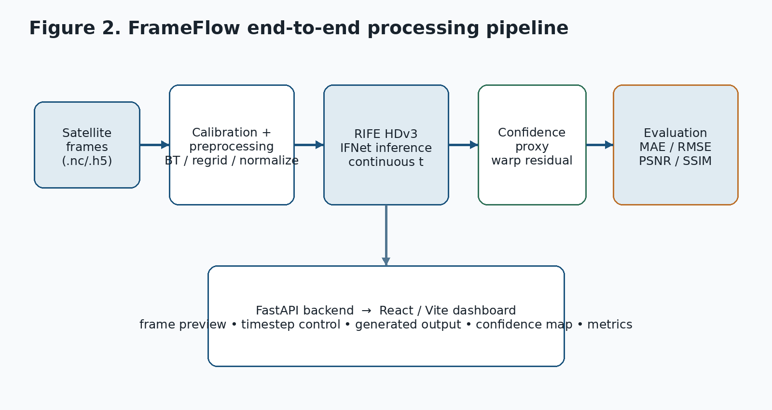
Figure 3.1: High-Level Processing Path Implemented by FrameFlow

3.2 System Requirements and Design Goals

3.2.1 Functional Requirements
ID | Requirement
FR-01 | Accept two input frames and a requested timestep.
FR-02 | Preprocess satellite or image inputs into the tensor shape expected by RIFE.
FR-03 | Generate an intermediate frame using RIFE HDv3.
FR-04 | Return the generated image and a confidence map.
FR-05 | Compute evaluation metrics when a ground-truth middle frame is available.
FR-06 | Provide model/device health information through the API.
FR-07 | Display inputs, outputs, confidence and metrics in a web interface.
FR-08 | Handle invalid input files without crashing the browser workflow.

Table 3.1: Functional Requirements

3.2.2 Non-Functional Requirements
- Reproducibility: documented environment, fixed data conventions and explicit contracts.
- Compatibility: CPU fallback for testing and CUDA acceleration when available.
- Measurability: every evaluation should expose numerical metrics rather than relying only on screenshots.
- Maintainability: isolate the RIFE implementation behind a wrapper instead of distributing upstream model details across the project.
- Clarity: keep observed frames, generated frames and quality indicators visually distinguishable in the dashboard.

3.3 Proposed System Architecture

3.3.1 Data Layer
The architecture defines a common analysis grid and a canonical three-dimensional cube layout with dimensions time, y and x. The data contract stores brightness temperature as float32 Kelvin and keeps timestamps and geographic coordinates alongside the data [3]. This design is intended to prevent each module from inventing its own assumptions about shape, units, or coordinate order.

3.3.2 Preprocessing Layer
Satellite inputs pass through calibration, normalization, spatial alignment and masking steps before inference. The long-term architecture proposes reading common satellite file types such as NetCDF and HDF5, converting values to brightness temperature, regridding to a shared geographic grid, and normalizing the thermal field [2][4].

3.3.3 Model Layer
The model layer contains the RIFE integration. The local wrapper handles image conversion and post-processing, while the upstream RIFE network remains isolated inside the project [8]. The implementation supports both CPU and GPU inference, and the environment documentation verifies CUDA on an NVIDIA GeForce RTX 4070 Laptop GPU [4][5].

3.3.4 Service Layer
A FastAPI backend provides the application boundary. The current API exposes health information, model information, interpolation and evaluation endpoints. This keeps the browser independent from the Python model internals and also makes inference easy to test separately from the UI [9].

3.3.5 Presentation Layer
The frontend is built using React and Vite. Users select two frames, choose a timestep, trigger interpolation, and inspect the returned image, confidence map and runtime information. The dashboard is deliberately focused on the scientific task rather than on generic application features [10].

3.4 Data Sources and Preprocessing

3.4.1 Intended Data Strategy
The architecture proposes a train-on-dense, deploy-on-sparse workflow. GOES-19 ABI and Himawari-9 AHI provide approximately 10-minute observations and therefore offer natural ground truth for a hold-out-the-middle training or evaluation design. INSAT-3DS/3DR TIR1 is the intended operational target because its approximately 30-minute cadence leaves larger gaps to fill [2][4].
Current experimental status The implemented validation artifacts available in the project repository are primarily based on GOES-16 Hurricane Ian data. The broader GOES-19/Himawari-to-INSAT workflow is the project architecture and roadmap, not a claim that the present prototype has already completed full INSAT operational validation.:

3.4.2 GOES-16 RGB Validation Dataset
The documented RGB experiment uses GOES-East / GOES-16 data associated with Hurricane Ian on 27 September 2022. Ten non-overlapping temporal triplets were selected so that each prediction could be checked against a distinct withheld middle frame. The dataset record describes the data as a public-domain GOES-16 GEOCOLOR sequence extracted from a historical weather animation, with the frames converted into arrays for RIFE processing [6][11].

3.4.3 ABI Band 13 Thermal Dataset
The Band 13 experiment uses GOES-16 ABI Level-2 CMIP data from the same Hurricane Ian period. Band 13 is a 10.3 micrometer clean infrared channel expressed as brightness temperature in Kelvin. A 512 x 512 crop was used for the reported test, and the experiment follows a strict T0 / ground-truth T1 / T2 temporal triplet [7].
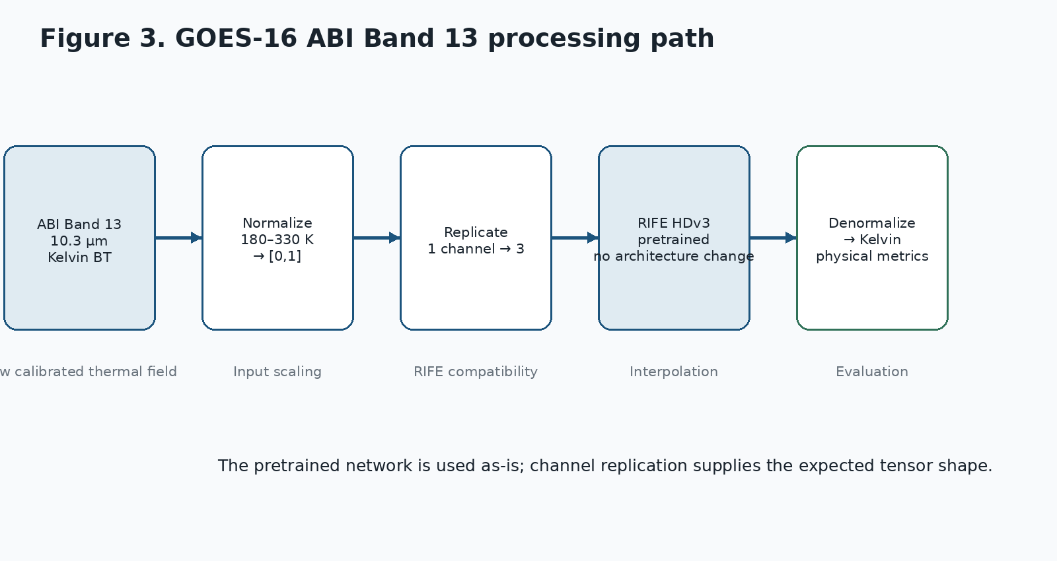
Figure 3.2: Thermal Band 13 Processing Path Used in the Prototype Experiment

3.4.4 Normalization and Physical Units
For the Band 13 model input, the prototype normalizes values spanning 180 K to 330 K into the [0,1] range. Because RIFE is a pretrained RGB video model, the single thermal channel is replicated to three channels before inference and one output channel is converted back to the physical domain [7][12]. This is a compatibility step; it does not add information or modify the RIFE network.
The project contracts separately define a fixed physical metric range of 180 K to 320 K, equivalent to a 140 K evaluation span, for full-reference metrics. This distinction is intentional: the normalization range is an input scaling convention, while the metric range is a comparison convention used to keep results comparable across frames and methods [3].

3.4.5 Registration and Masking
The project documentation treats spatial alignment as a prerequisite rather than as something to be repaired after interpolation. In the broader architecture, regridding uses a cached KD-tree so that the spatial mapping can be reused instead of rebuilt for every frame [2]. In the Band 13 experiment, invalid or off-disk values are masked before evaluation so that space-view pixels do not distort the reported thermodynamic error [7].

3.5 RIFE Model and Interpolation Method

3.5.1 RIFE HDv3 / IFNet
RIFE is the core inference model in the prototype. The model card describes the production configuration as an approximately 9.8 million parameter IFNet-based system that estimates intermediate motion and refines the generated image. Its ability to accept arbitrary t is important because the same network can be used for midpoint interpolation and, by recursion, for finer temporal densification [4].

3.5.2 Inputs and Outputs
Element | Role
Observed frame T0 | Earlier bracketing frame
Observed frame T2 | Later bracketing frame
t | Interpolation fraction, normally 0.5 for midpoint evaluation
Predicted T1 | Generated intermediate frame
Confidence map | Per-pixel consistency estimate
Metrics | When ground truth exists: MAE, RMSE, PSNR, SSIM and related values

Table 3.2: Inputs and Outputs of the Interpolation Model

3.5.3 Linear Baseline
A simple linear average is used as the primary baseline: T_hat1 = (T0 + T2) / 2. It is intentionally basic. A baseline of this kind answers a useful question: is the learned model doing more than averaging the two observed images? The evaluation documents show that RIFE consistently improves over this baseline on the reported RGB and Band 13 experiments [5][6][7].

3.5.4 Why the RIFE Architecture Was Not Modified
The prototype keeps the RIFE network unchanged and adapts the input representation around it. This decision reduces implementation risk and makes the experiment easier to interpret: any improvement can be attributed to using the pretrained interpolation model rather than to a newly designed satellite-specific network. The integration layer is responsible for shaping inputs and restoring outputs [8].

3.6 Confidence Estimation and Error Visualization

3.6.1 Motivation
A generated frame should not be presented as equally reliable everywhere. Regions with newly exposed structure, large displacement, or inconsistent flow can be harder to reconstruct. FrameFlow therefore adds a confidence proxy that uses the model's own dense optical flow instead of assigning a generic score to the whole image [8].

3.6.2 Computation
- RIFE estimates the bidirectional flow fields from the two input frames toward the requested time.
- The first and second input frames are warped toward the target time.
- The two warped estimates are compared pixel by pixel.
- The absolute difference between the two reconstructions is used as a residual.
- The residual is converted into a confidence value through an exponential decay function.
In the project documentation, the confidence map is defined as C = exp(-Delta / sigma). A larger residual therefore produces a lower confidence value. The implementation also reports aggregate values such as mean confidence and low-confidence fraction so that the dashboard can expose a simple summary in addition to the map itself [8][9].
Interpretation This is a structural consistency indicator, not a calibrated probability of correctness. It is useful for highlighting difficult regions, but it should not be described as a statistical uncertainty model.:

3.7 Software Implementation

3.7.1 Repository Organization
The project follows a modular monorepo structure. The Python side contains data, model, training, inference, validation, serving and visualization components. The web application is maintained separately from the Python package, while shared contracts define the format expected between stages [2][3].
Module | Purpose
frameflow/data | Satellite access, ingest and preprocessing
frameflow/models | RIFE and related model implementations
frameflow/train | Training and loss configuration
frameflow/infer | Inference and recursive temporal generation
frameflow/validate | Metrics and cross-validation
frameflow/serve | API-facing serving components
frameflow/viz | Image, tile and video generation
web / frontend | React/Vite dashboard
tests | Unit and integration verification

Table 3.3: Repository Modules and Their Purpose

3.7.2 Backend API
Endpoint | Purpose
GET /health | Server, CUDA and model-load status
GET /model/info | Model name, variant, device and supported timestep
POST /interpolate | Generate intermediate image and confidence output
POST /evaluate | Calculate comparison metrics against a provided ground truth

Table 3.4: Backend API Endpoints
The current health response records the active device and whether CUDA and the model are available. The interpolation response includes the generated image path, confidence-map path, timestep, device, inference time and confidence summary. The evaluation endpoint accepts the earlier frame, ground truth middle frame and later frame and returns the documented metric set [9].

3.7.3 Frontend Workflow
- Start the API service on port 8000.
- Launch the React/Vite development server.
- Upload the two bracketing frames.
- Select or keep the midpoint timestep.
- Trigger interpolation.
- Inspect the generated image, confidence map and reported runtime information.

3.7.4 Development Environment
Component | Verified environment
Python | 3.12.10
PyTorch | 2.5.1 + CUDA 12.1 wheels
GPU | NVIDIA GeForce RTX 4070 Laptop GPU
Web | React + Vite
Backend | FastAPI + Uvicorn
Testing | pytest + Playwright browser E2E

Table 3.5: Verified Development Environment

3.8 Evaluation Methodology

3.8.1 Evaluation Setup
The central evaluation design is a leave-the-middle-out test. The earlier and later observations are supplied to the model, while the real intermediate frame is held back as ground truth. The model output is then compared with that known frame. This arrangement is more meaningful than showing the model two frames and evaluating the output without a real reference [4][5].
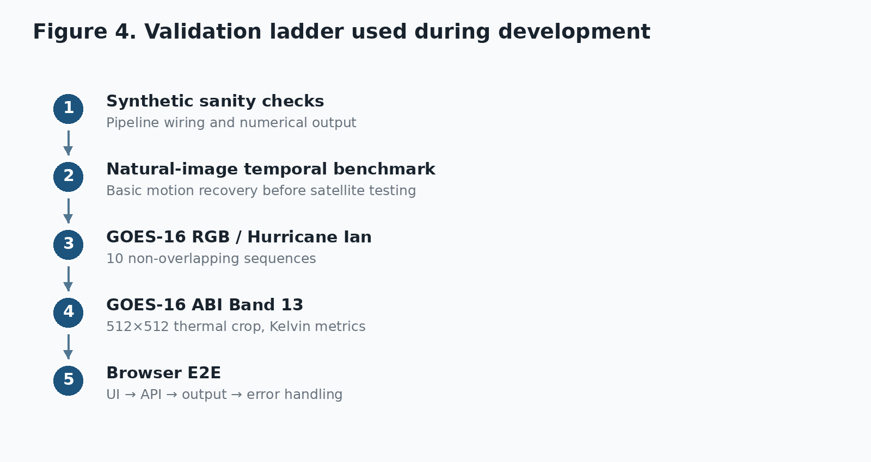
Figure 3.3: Main Validation Stages Recorded in the Project Documentation

3.8.2 Metrics
Metric | Interpretation
MAE | Mean absolute pixel error. Lower is better.
RMSE | Square-root mean squared error. Lower is better.
PSNR | Signal quality relative to reconstruction error. Higher is better.
SSIM | Structural similarity. Higher is better.
MS-SSIM / FSIM | Additional structural or perceptual checks used in the wider evaluation framework.
BT-RMSE | Brightness-temperature error in Kelvin for the thermal experiment.

Table 3.6: Evaluation Metrics and Interpretation

3.8.3 Baselines
The implemented comparison uses linear interpolation as the main reference and, in the reproducible synthetic demo, also includes TV-L1 based warping. The idea is not to claim that every classical method has been exhausted, but to establish a minimum baseline before attributing value to the learned model [5].

3.8.4 Test Coverage
The current repository includes unit tests, a browser E2E test and a reproducible synthetic pipeline. The project README records 173 tests passed with one skipped in the documented test run, while the separate browser report confirms that the upload, API invocation, result rendering and invalid-input error path were exercised in Chromium [10][13].

4. RESULTS AND DISCUSSION
This chapter presents the experimental results obtained from evaluating the FrameFlow pipeline. The results are analyzed in terms of reconstruction accuracy against the linear baseline, physical-unit error for thermal imagery, and inference and application performance.

4.1 Synthetic End-to-End Demo
The reproducible demo is deliberately small. It creates synthetic moving-cloud data, trains a tiny IFNet briefly on CPU, generates an intermediate frame, compares it with the withheld truth, and then precomputes web artifacts. The project documentation explicitly calls these numbers integration or sanity results rather than production-quality satellite results [5].
Method | PSNR | SSIM | MS-SSIM | FSIM | BT-RMSE K
Trained IFNet | 26.3637 | 0.9286 | 0.9109 | 0.9604 | 6.8158
Linear blend | 26.1937 | 0.8893 | 0.8724 | 0.9540 | 6.9671
TV-L1 | 25.5260 | 0.8886 | 0.8722 | 0.9509 | 7.5023

Table 4.1: Synthetic Demo Comparison of Interpolation Methods
The synthetic result is useful mainly because it proves that the complete pipeline can produce real numerical output and web artifacts without internet access or a large satellite dataset. It should not be used as evidence that the model has learned real atmospheric dynamics.

4.2 GOES-16 RGB Multi-Sequence Validation
The ten-sequence experiment uses non-overlapping temporal samples from the Hurricane Ian sequence. RIFE was compared with the linear baseline using MAE, PSNR and SSIM. According to the project validation report, RIFE was better on all three measures in every one of the ten samples [6].
Metric | RIFE | Linear | Observed difference
Mean MAE | 8.598 | 17.747 | 51.5% lower error
Median MAE | 8.567 | 17.751 | Lower
Mean PSNR | 24.839 dB | 19.533 dB | +5.306 dB
Median PSNR | 24.847 dB | 19.524 dB | Higher
Mean SSIM | 0.8109 | 0.6809 | +19.0% relative gain
Median SSIM | 0.8128 | 0.6808 | Higher

Table 4.2: GOES-16 RGB Ten-Sequence Validation Results
What this result tells us Within this evaluated Hurricane Ian sequence, the learned model reproduced the middle frame more accurately than a simple temporal average. Because all ten samples come from one event, the result is strong evidence of local feasibility but not proof of cross-event generalization.:

4.3 GOES-16 ABI Band 13 Thermal Evaluation
The Band 13 test is the most physically meaningful experiment in the current set because the output is evaluated in Kelvin rather than only in display-oriented RGB space. The model received a single thermal band, used replicated three-channel input for RIFE compatibility, and was evaluated after conversion back into brightness temperature [7].
Metric | RIFE HDv3 | Linear | Difference
MAE | 0.358 K | 1.688 K | 78.8% lower
RMSE | 0.766 K | 4.544 K | 83.1% lower
PSNR | 45.836 dB | 30.373 dB | +15.463 dB
SSIM | 0.9925 | 0.8734 | Higher

Table 4.3: GOES-16 ABI Band 13 Thermal Evaluation Results
The experiment demonstrates that a pretrained RIFE model can be driven by a scalar brightness-temperature field without changing the internal network architecture. At the same time, the test covers a 512 x 512 crop from one Hurricane Ian sequence, so the result should not be generalized to all atmospheric conditions or used as a claim of near-surface temperature accuracy [7][12].

4.4 Inference and Browser Performance
Measurement | Documented value
RIFE server-side execution | 12.19 ms
Browser/API round-trip | ~1600 ms
E2E outcome | Complete; zero uncaught exceptions
Outputs verified | Generated image, confidence map, inference time

Table 4.4: Inference and Browser Performance
The difference between the 12.19 ms model kernel and the approximately 1.6 second browser round-trip is expected because the latter includes request handling, file transfer and browser-side work. It is important to keep the two numbers separate rather than describing the complete application request as a 12 ms operation [10].

4.5 Dashboard Output and Visual Evidence
The React/Vite dashboard was exercised end to end in a Chromium browser. The following screenshots, captured from the working application, show the empty dashboard, the uploaded bracketing frames, the full result view, the metrics section and the invalid-input error path.
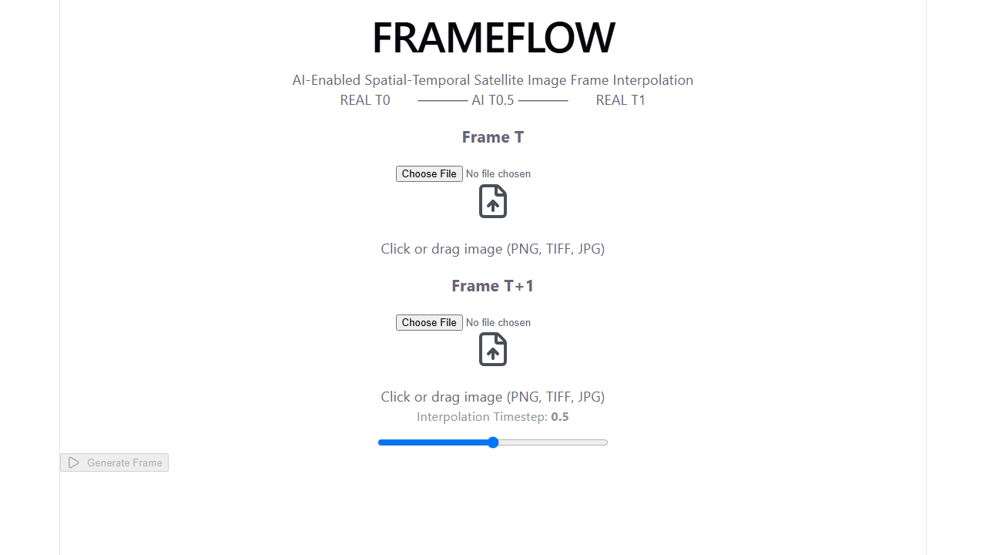
Figure 4.1: Dashboard in Its Initial State
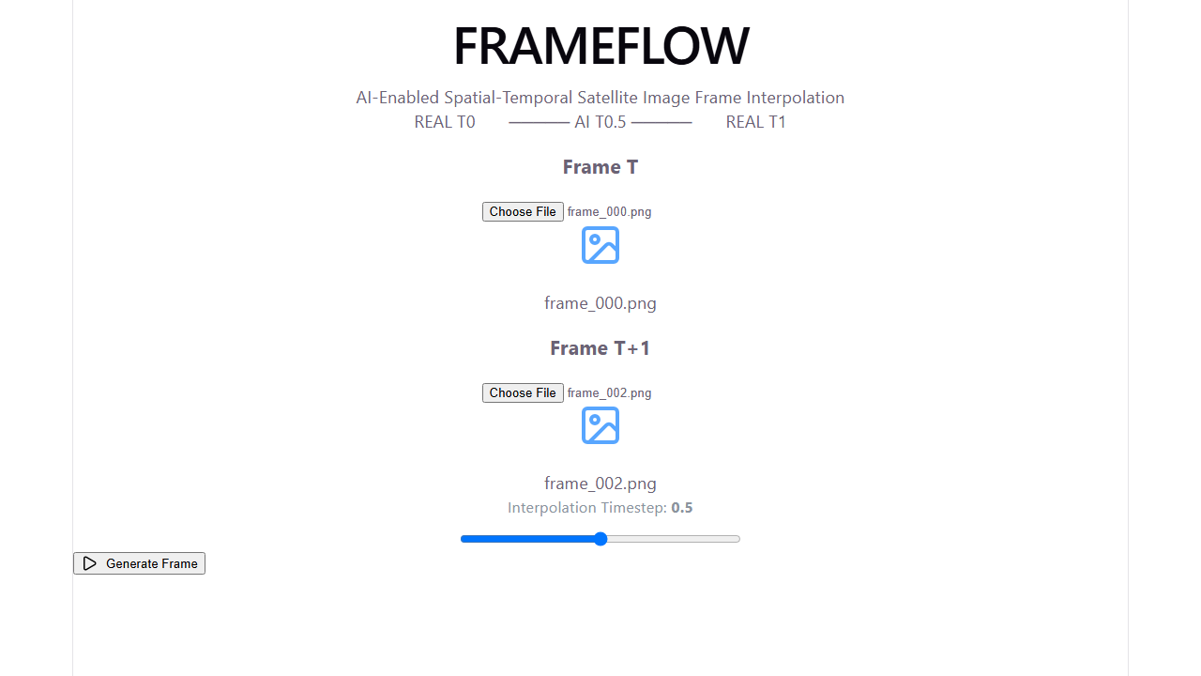
Figure 4.2: Uploaded Bracketing Frames
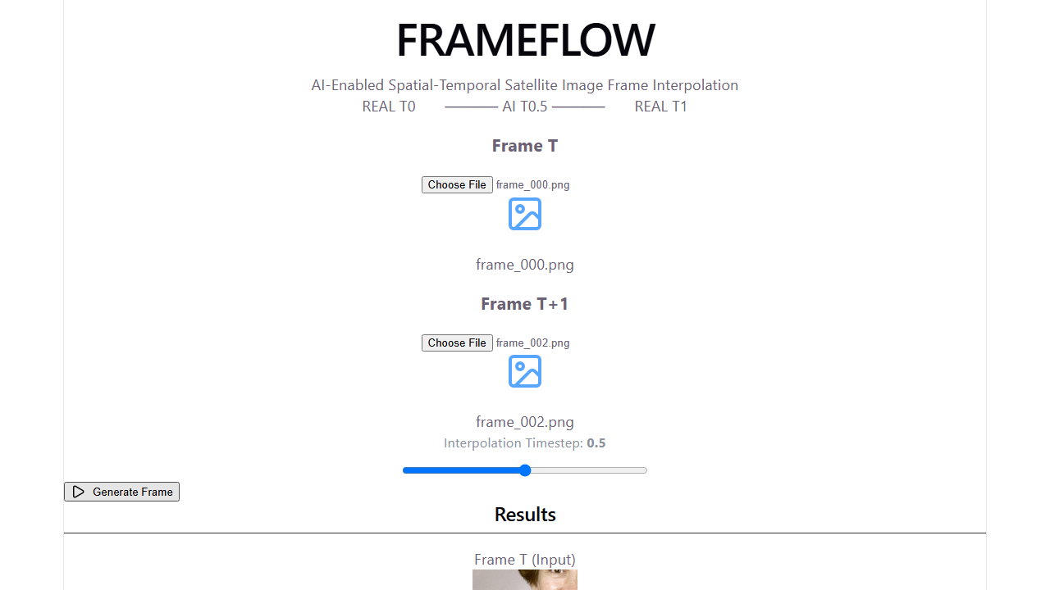
Figure 4.3: Full Interpolation Result View

Figure 4.4: Metrics Section of the Dashboard
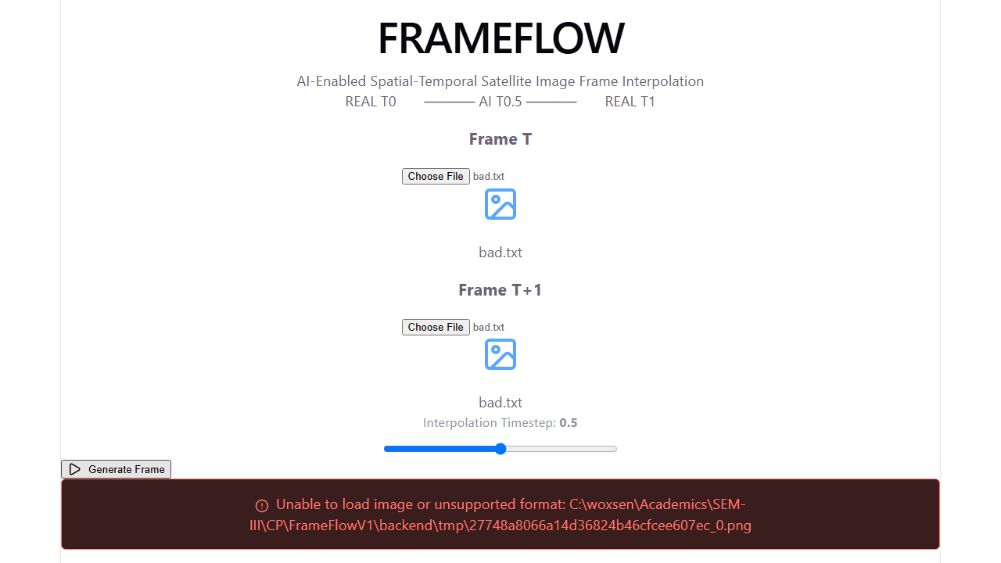
Figure 4.5: Handling of Invalid Input

4.6 Discussion

4.6.1 What Worked Well
The strongest part of the project is that the interpolation experiment was not left at the model-call stage. The work connects model inference to a testable service, a visual interface and a measurable validation loop. That makes it possible to ask not only "can RIFE produce an image?" but also "does the image agree with a real middle frame, how fast was it produced, and where does the model appear less consistent?"
The Band 13 experiment is another important step. Using a physical thermal variable forces the project to handle units, normalization and invalid values more carefully than a simple RGB demo. The sub-Kelvin MAE reported in the tested crop is promising, while the project documentation is appropriately cautious about what that number means.

4.6.2 Why the Baseline Still Matters
Linear interpolation is easy to implement and difficult to beat when the motion is slow and nearly linear. A learned model therefore has to justify its extra complexity by recovering structure that a simple blend cannot. The reported experiments show this advantage in the tested sequences, particularly in structural similarity and, for Band 13, in physical-unit error.

4.6.3 Where the Model Is Likely to Struggle
The failure analysis identifies four recurring issues. First, cloud structures can appear, grow and dissipate rather than simply translate, which violates the assumptions behind rigid optical-flow warping. Second, radiometric conditions can drift because of illumination and atmospheric effects. Third, strong shear can lead to crossing or inconsistent flow vectors. Finally, even small registration errors can be amplified by the flow calculation [12].
These limitations suggest that the next improvement should not be another visual polishing pass on the dashboard. The bigger gain is likely to come from satellite-specific training, better alignment, richer evaluation and a confidence mechanism that is calibrated against real interpolation error.

4.7 Limitations and Risk Areas
Risk / limitation | Practical implication
Limited event diversity | The strongest real-data validation is centered on Hurricane Ian.
Pretrained backbone | The current RIFE model was not fully fine-tuned on a large multi-event satellite corpus in the documented prototype.
Band 13 crop size | The dedicated thermal experiment is based on a 512 x 512 region.
Confidence calibration | The confidence map is a consistency proxy, not a probabilistic uncertainty estimate.
Cross-sensor comparability | RGB and thermal metrics are not directly comparable across domains.
INSAT operational validation | The architecture targets INSAT-3DS/3DR, but the documented results do not establish operational INSAT performance.
Weather event generalization | Results from one storm sequence should not be assumed to represent all seasons, cloud regimes or motion patterns.

Table 4.5: Limitations and Risk Areas

4.7.1 Research Integrity of the Current Claims
A useful feature of the current documentation is that it separates prototype evidence from intended future capability. The project does not describe the interpolated image as a newly observed physical measurement, and it explicitly states that operational forecasting performance has not been established. Maintaining that distinction will be important in the final presentation and report [4][13].

5. CONCLUSION AND FUTURE WORK

5.1 Summary of Contributions
This project successfully developed and evaluated an optical-flow based temporal interpolation system for geostationary satellite imagery. The key contributions of this work include:
- Integration of the pretrained RIFE HDv3 model with a satellite-aware preprocessing path for RGB and single-channel thermal imagery.
- Quantitative validation showing RIFE outperforming linear interpolation in all ten GOES-16 RGB samples (mean PSNR 24.839 dB vs 19.533 dB, mean SSIM 0.8109 vs 0.6809).
- A GOES-16 ABI Band 13 experiment reporting 0.358 K MAE and 0.9925 SSIM on the tested crop, evaluated in physical brightness-temperature units.
- A flow-consistency confidence proxy that exposes regions where the generated frame is less reliable.
- A complete software stack: FastAPI service, React/Vite dashboard, unit tests and a browser end-to-end test.
FrameFlow demonstrates a complete and technically coherent approach to the problem of temporal interpolation in geostationary satellite imagery. The project starts from a clear observation gap, applies an established optical-flow based VFI model, adapts the data path for both display-oriented RGB and physical thermal imagery, and closes the loop with quantitative evaluation and a browser-accessible interface.
The reported GOES-16 experiments provide a useful proof of concept. RIFE outperformed the linear baseline across all ten documented RGB samples, and the dedicated Band 13 experiment produced a substantial reduction in the reported physical-domain reconstruction error for the tested Hurricane Ian crop [6][7]. The software side is also more complete than a standalone model prototype: the API, dashboard and E2E workflow have been exercised, and the project includes structured contracts and reproducible demo artifacts [3][9][10].

5.2 Limitations
While the project achieved its objectives, several limitations should be acknowledged:
- Real-data validation is centered on one storm sequence (Hurricane Ian), which limits claims of cross-event generalization.
- The Band 13 experiment is based on a single 512 x 512 crop.
- The confidence map is a structural consistency indicator, not a calibrated probability of correctness.
- The documented results do not establish operational INSAT-3DS/3DR performance.

5.3 Future Work

5.3.1 Satellite-Specific Fine-Tuning
The first priority is to train or fine-tune IFNet on real high-cadence thermal satellite sequences. The architecture proposes GOES-19 and Himawari-9 as dense training sources, with temporal hold-out used to create true intermediate supervision [2].

5.3.2 Cross-Event and Cross-Satellite Validation
The current results should be extended beyond a single storm. A stronger evaluation would include multiple weather systems, seasons, geographic regions and, where possible, independent satellite overlap. The architecture also proposes additional cross-validation through polar-orbiting observations and cross-sensor consistency checks [2].

5.3.3 INSAT-3DS/3DR Domain Adaptation
The intended application is INSAT-3DS/3DR TIR1. Before making that transition operationally useful, the model must be adapted to the sensor characteristics, spatial grid, radiometric conventions and available validation opportunities of INSAT data. The project roadmap treats this as a separate deployment phase rather than assuming that a GOES-trained network will transfer perfectly [2][4].

5.3.4 Better Uncertainty Estimation
The current confidence map is useful as a warning layer, but it does not answer the question "what is the expected numerical error?" A future version should compare confidence values with actual per-pixel interpolation error on withheld real frames and calibrate the score accordingly.

5.3.5 Deployment Optimization
The broader architecture proposes precomputing interpolated frames and serving them as web-ready raster and video artifacts, avoiding model execution during normal dashboard playback. For true on-demand interpolation, the architecture also considers ONNX and TensorRT FP16. These optimizations make sense only after the model quality and validation pipeline are stable [2].

5.4 Concluding Remarks
At the same time, the project should be presented for what it is: a research prototype with promising results and a clear route toward stronger validation. The next stage is not to make larger claims; it is to make the evidence broader - more events, more sensors, more real training data, and a proper INSAT evaluation. That is the step that would turn FrameFlow from a convincing prototype into a more complete satellite-technology study.

REFERENCES
[1] ISRO Bharatiya Antariksh Hackathon 2026, Problem Statement 12, "Fill in the Frames Seamlessly - Enhancing Temporal Resolution of Satellite Imagery using AI/ML based on Optical Flow."
[2] FrameFlow Team, "FrameFlow - System Architecture," Architecture v1.0, 20 June 2026.
[3] FrameFlow Team, "FrameFlow - Interface Contracts (AUTHORITATIVE)."
[4] FrameFlow Team, "Model Card - FrameFlow VFI (satellite Thermal-IR frame interpolation)."
[5] FrameFlow Team, "FrameFlow - end-to-end demo results," generated by make demo.
[6] FrameFlow Team, "Phase 14B: Multi-Sequence Satellite Validation (10 non-overlapping temporal samples from the Hurricane Ian sequence)."
[7] FrameFlow Team, "Phase 15A: GOES-16 ABI Band 13 Prototype."
[8] FrameFlow Team, "RIFE Integration" and "Interpolation Confidence Proxy."
[9] FrameFlow Team, "FrameFlow API Documentation."
[10] FrameFlow Team, "FrameFlow E2E Browser Test Report" and "FrameFlow Dashboard."
[11] FrameFlow Team, "Satellite Dataset Documentation."
[12] FrameFlow Team, "Satellite Imagery Failure Analysis on Pretrained RIFE."
[13] FrameFlow Team, "FrameFlow README / Setup Guide / Implementation Status."
[14] Z. Huang, T. Zhang, W. Heng, B. Shi, and S. Zhou, "Real-Time Intermediate Flow Estimation for Video Frame Interpolation," European Conference on Computer Vision (ECCV), 2022.
[15] Vandal and Nemani, "Temporal Interpolation of Geostationary Satellite Imagery with Task-Specific Optical Flow," IEEE Transactions on Neural Networks and Learning Systems, 2021, cited in the FrameFlow architecture as the principal satellite-specific quality reference.

APPENDIX - I
Screen shots of work done.
Screen shots of deployment tools of:
- FrameFlow dashboard (React/Vite)
- FastAPI backend (interactive API documentation)
- GitHub repository
Dashboard screenshots are included in Section 4.5 (Figures 4.1 - 4.5). Additional repository and deployment screenshots may be inserted below.
Appendix I-A: API Summary
Method | Path | Description
GET | /health | Returns server status, CUDA availability and model-loaded status.
GET | /model/info | Returns model name/variant, device, weight availability and timestep support.
POST | /interpolate | Accepts frame0, frame1 and timestep; returns generated image, confidence map and runtime information.
POST | /evaluate | Accepts frame0, ground truth and frame2; returns MAE, PSNR, SSIM and runtime.

Table 6.1: API Summary
Appendix I-B: Documentation Status Note
The project folder contains phase-wise implementation records written at different stages of development. One earlier status file records satellite validation as pending, while later phase documents report the GOES-16 multi-sequence validation and the Band 13 experiment as completed. This report treats the later, more specific Phase 14B and Phase 15A validation documents as the current experimental status and retains the earlier note as a historical progress record rather than mixing the two states [6][7][13].

APPENDIX - II

FORMATTING GUIDELINES
This appendix summarizes the formatting guidelines followed in the preparation of this report, as per the Woxsen University project report template.
Element | Specification
Paper Size | A4
Margins | 1 inch (2.54 cm) on all sides
Font Family | Times New Roman
Body Text Font Size | 12 pt
Line Spacing | 1.5
Text Alignment | Justified
Paragraph Spacing | 6 pt after paragraphs

Table 7.1: General Formatting Guidelines
Heading Styles
- Heading 1 (Chapter Titles): 16 pt, bold, black, 18 pt before, 12 pt after
- Heading 2 (Section Titles): 14 pt, bold, black, 12 pt before, 6 pt after
- Heading 3 (Subsection Titles): 13 pt, bold, black, 10 pt before, 6 pt after
Document Structure
- Title Page
- Certificate
- Declaration
- Acknowledgment
- Abstract
- Table of Contents
- List of Tables
- List of Figures
- Main Chapters (numbered)
- References
- Appendices

