Capstone Project

Empowering Hidden Creators - Predicting YouTube Video Popularity from Metadata

By
Jayden Doan
Date: 01/08/2025
Table of Contents
Problem statement 3
Industry/ domain 3
Stakeholders 3
Business question 4
Data question 4
Data 4
Data science process 5
Data analysis 5
Modelling 7
Outcomes 8
Implementation 9
Data answer 9
Business answer 9
Response to stakeholders 10
End-to-end solution 10
References 10

Problem statement
In today’s creator economy, millions of people aspire to share their ideas and creativity on platforms like YouTube. However, many hesitate to start or continue creating due to the fear that their videos won’t be seen or appreciated, especially those in niche categories. Meanwhile, established creators often face uncertainty about which content ideas will perform best.
This project aims to address both challenges by using machine learning to predict the popularity of a YouTube video before it is published using its metadata. The goal is to give creators early insight into the potential reach of their content, helping them build confidence, validate ideas, and optimise their creative strategy.

Industry/ domain
This project sits within the digital content creation and online video industry, specifically focusing on YouTube. The industry has grown rapidly in recent years. A major challenge for newer or niche creators is discoverability. Without an established audience or viral momentum, it’s difficult to gauge whether an idea will succeed. On the other end, established creators face pressure to maintain engagement and produce consistently high-performing content. The content creation value chain includes ideation, production, publishing, distribution, and performance analytics. Key concepts in the industry include engagement metrics (views, likes, watch time), audience targeting, algorithmic discoverability, and metadata optimisation. While this project focuses on YouTube, its approach is highly relevant to other industries such as digital marketing, influencer strategy, online education, and podcasting.

Stakeholders
The primary stakeholders are YouTube content creators, both aspiring/niche creators and established influencers or channels. Niche creators care about this problem because they often lack visibility, confidence, and access to data-driven tools that could help them forecast success. Being able to predict potential popularity could give them the confidence to publish more consistently or test riskier creative ideas. For popular creators, they seek to maintain engagement and revenue, and would benefit from a system that helps validate or prioritise their content roadmap. These stakeholders expect the model to provide reliable predictions that can inform creative or strategic decisions without requiring deep technical expertise.

Business question
The core business question is: Can we predict how popular a YouTube video will be based solely on its metadata before it is published? Accurately answering this allows content creators, especially those in niche categories or starting out, to make data-informed decisions on video planning and publishing. By estimating the potential view count in advance, creators can optimise their content strategy, saving time and increasing engagement. For example, if a video that might normally get 10,000 views can be adjusted based on feedback from the model to reach 100,000 views, the improvement could directly translate into higher ad revenue, brand sponsorships, and channel growth. Assuming a CPM (cost per thousand views) of $5, a 90,000-view increase would mean an additional $450 in revenue. False positives (overpredicting popularity) might lead to misplaced effort or inflated expectations, while false negatives (underpredicting high-potential videos) could cause creators to abandon valuable ideas. Both errors matter, but the psychological and financial cost of false negatives may be especially relevant for small creators trying to break through.

Data question

The data question is: Which features of a YouTube video and its associated channel are predictive of the video's future popularity, as measured by view count? To answer this, we need structured metadata that is available at or before the time of upload. This includes attributes such as the video title, tags, category, duration, thumbnail type, description length, and whether the video is HD or SD, as well as channel-level metadata like subscriber count, total video uploads, and whether subscribers are hidden.

Data

The dataset was sourced from https://www.kaggle.com/datasets/canerkonuk/youtube-trending-videos-global. It includes both video-level and channel-level features. The dataset contains more than 4 million rows, with attributes such as video_id, title, tags, duration, category_id, view_count, like_count, comment_count, channel_subscriber_count, channel_country, and many more. The data appears to be scraped or collected via the YouTube Data API, and while the structure is well-organised, it is important to note that it only includes videos that trended, so it may be biased toward high-performing content. Furthermore, features like views and likes are snapshots from a specific trending date, meaning time-sensitive context is important.
In terms of reliability, the dataset is reasonably trustworthy for exploratory and modeling purposes, but likely contains missing values (e.g., for subscriber counts or tags), duplicate entries (from multiple trend snapshots), and imbalances (e.g., between countries or categories). The data is not real-time or streaming, but could theoretically be refreshed on an ongoing basis using the YouTube API. For this project, the dataset is sufficient to train and test a model that generalises insights about popularity, particularly across video metadata and creator scale.

Data science process

Data analysis

The data pipeline began with cleaning and preprocessing over 4 million records from the YouTube Trending dataset. Key steps included removing duplicates based on video_id, converting ISO 8601 duration formats into seconds, filtering out rows with missing view or subscriber counts, and engineering new features such as title length, number of tags, and binary resolution flags. After cleaning, there were 119,039 rows left in the dataset. Text-based metadata (tags and titles) were vectorised using TF-IDF and then compressed into a smaller number of semantic features using Truncated SVD. During Exploratory Data Analysis (EDA), we discovered that channel-level metrics (e.g., total view count, number of uploads) strongly correlate with video popularity, while video-level metadata such as duration and title length had a weaker but still notable influence. Figure 1 shows the distribution of the cleaned dataset with ‘log_view_count’. The pipeline is designed to be fully reusable, allowing new or future datasets to pass through the same preprocessing and transformation steps with minimal adjustment. Intermediary data structures include TF-IDF matrices and SVD topic feature sets, which integrate seamlessly with the rest of the dataset for modeling.

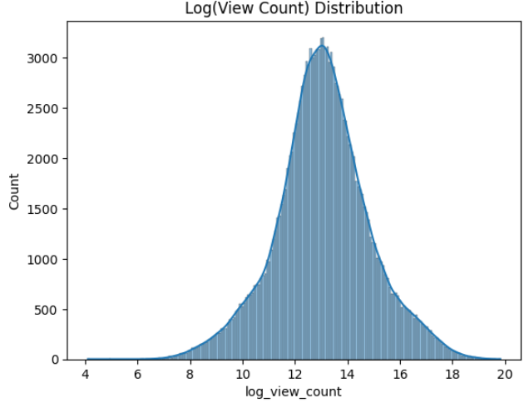
Figure 1: Log(View Count) Distribution of the cleaned dataset
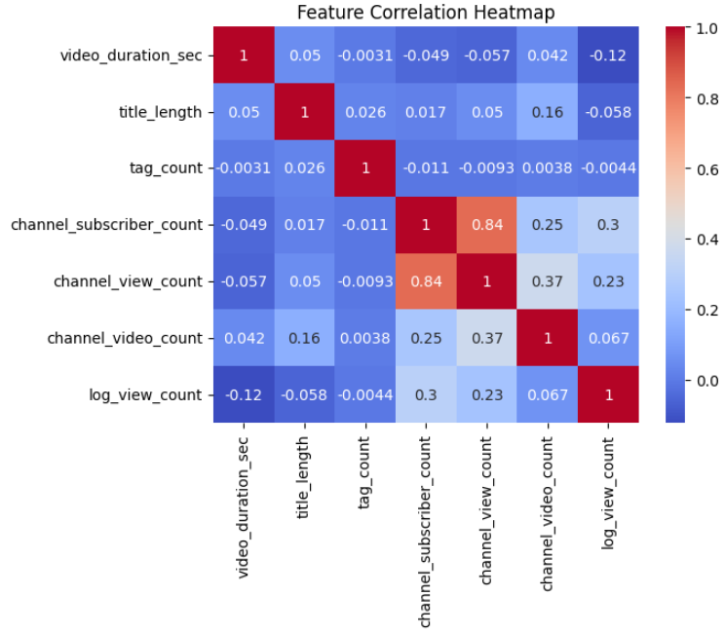
Figure 2: Feature Correlation Heatmap. The last row shows the correlations of the dataset columns with ‘log_view_count’.

Modelling

The model leveraged a combination of numerical, categorical, and semantic features to predict video popularity, specifically using the log-transformed view count as the target variable. The main features included video_duration_sec, title_length, channel_subscriber_count, channel_view_count, channel_video_count, and is_hd, alongside compressed topic vectors derived from video tags and titles using TF-IDF followed by Truncated SVD. These SVD-based features captured underlying semantic themes in the content without exploding dimensionality, making them ideal for generalising across unseen niches.
During analysis, we found that channel-level metrics (especially channel_view_count) had a strong positive correlation with video popularity, while shorter durations and higher topic relevance (from TF-IDF components) also contributed positively in many cases. Interestingly, some TF-IDF-derived topics captured niche concepts that helped predict success in unconventional or less saturated categories. A SHAP value analysis confirmed that a small subset of high-impact features—primarily channel_view_count, channel_video_count, and the first few tag_topic_* and title_topic_* components—contributed significantly to the final predictions, suggesting that even a streamlined model using 20–30 features could retain most of the performance.

Feature selection was done through a combination of domain knowledge and empirical performance testing. Initial feature importance rankings from Random Forest, along with SHAP interpretations, guided the decision to retain and engineer relevant variables. Feature engineering involved text vectorisation (TF-IDF), dimensionality reduction (Truncated SVD), and log-transforming skewed distributions like view counts to stabilize model training.

Several models were trained and evaluated, including Linear Regression, Gradient Boosting, Random Forest, XGBoost, and LightGBM. Training time varied across models, with Random Forest and LightGBM taking the longest (up to 30 minutes), while Linear Regression was nearly instantaneous. All work was conducted on Google Colab, making use of cloud-based GPUs and parallel CPU threads for performance optimisation.

In terms of performance, the Random Forest model achieved the best results with an RMSE of ~1.05, MAE of ~0.78, and an R² score of ~0.66 (see figure 3 for a comparison). These metrics indicate a strong level of predictive power for a real-world application. Given its balance of accuracy, interpretability, and robustness, the Random Forest Regressor was selected as the final model for deployment and evaluation.
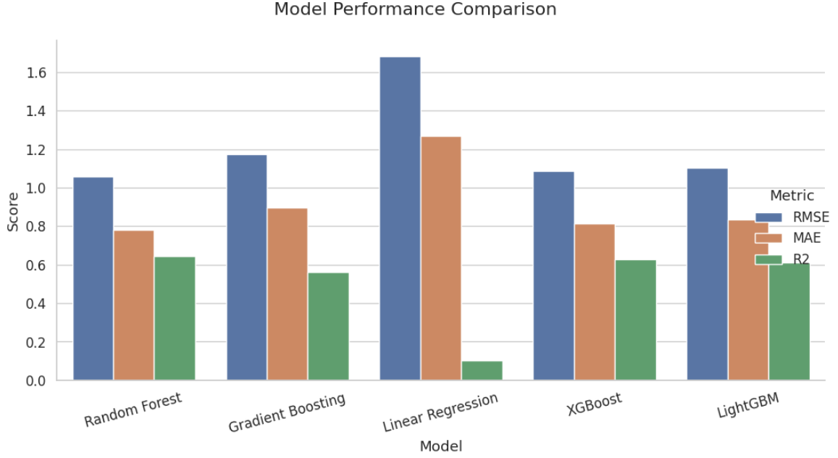
Figure 3: A comparison between the 5 different models used for the cleaned dataset.

Outcomes
The project successfully demonstrated that YouTube video popularity can be reasonably predicted using metadata alone, even before a video is published. Through feature engineering and modeling, we found that channel-level attributes such as total view count and number of uploaded videos are the most powerful predictors, suggesting that existing reputation plays a large role in future success. However, semantic features derived from video tags and titles (via TF-IDF and SVD) also provided valuable signals, enabling the model to capture the influence of niche content themes. The final Random Forest model achieved strong performance (R² ≈ 0.66, MAE ≈ 0.78), showing that the model can reliably guide creators on whether an idea is likely to perform well. These findings support the potential of data-driven tools to empower smaller or less-established creators by providing early feedback on their content strategy and giving them confidence to pursue unconventional but high-potential video ideas.

Implementation
To implement the model in production, several key considerations must be addressed. First, the input metadata for new videos such as title, tags, duration, and channel statistics must be collected in a consistent format and passed through the same preprocessing pipeline used during training. This includes applying TF-IDF vectorisation and SVD transformations to the text features, which requires saving the fitted vectoriser and dimensionality reduction models. The system must also handle missing data gracefully, particularly for newer channels with limited historical metrics. Performance efficiency is another factor, as the model should return predictions quickly to provide real-time or near-real-time feedback to users. Finally, a user-facing interface should clearly present the predicted popularity along with explanations (e.g., SHAP visualizations) to help creators understand and act on the insights, thereby turning predictions into actionable recommendations.

Data answer
Yes, the data question of whether YouTube video popularity can be predicted using metadata was answered satisfactorily. The final model demonstrated a strong ability to estimate log-transformed view counts based solely on pre-publication features such as channel metrics, video duration, and semantic content from titles and tags. With an R² score of approximately 0.65 and a mean absolute error around 0.78, the model provides a confident directional prediction of video performance. Confidence in the data answer is high due to the dataset’s large size, diverse representation of trending videos across countries and genres, and thorough preprocessing. However, limitations exist in generalising to entirely novel content types or brand-new channels, as these were underrepresented in the dataset. Overall, the model offers a reliable and valuable tool for guiding content strategy, particularly for emerging creators.

Business answer
The business question was answered satisfactorily. The model successfully translates metadata into a viewership estimate, giving content creators a data-driven tool to assess whether their video idea is likely to succeed. This addresses a core business need: reducing uncertainty in content planning and encouraging creativity, especially among lesser-known or niche creators who may lack prior audience traction. The predictive performance (R² ≈ 0.65) provides a solid level of confidence in the business utility of the model. While it does not eliminate all risk, it offers valuable foresight that can inform title refinement, tag optimisation, and content strategy before investing time and resources. Given its robustness, interpretability through SHAP, and alignment with real-world creator needs, confidence in the business value of this solution is high.

Response to stakeholders
To stakeholders, the key message is that video performance on YouTube can be meaningfully predicted using metadata alone, even before the video is published. Our model enables early assessment of content potential by analysing features like title, tags, video duration, and channel metrics, offering creators a strategic advantage in planning and optimizing their uploads. We recommend using this tool to test and refine ideas, especially for creators exploring new or niche topics to maximize reach and engagement. Ultimately, this predictive system empowers creators to take creative risks with greater confidence and reduces guesswork in the highly competitive digital content space.

End-to-end solution
The end-to-end solution developed in this project enables users to predict YouTube video popularity from metadata through a streamlined, reproducible pipeline. It begins with data ingestion, where new video ideas are input with fields such as title, tags, duration, and channel metrics. These inputs are then processed through a data pipeline that includes cleaning, feature engineering (e.g., extracting title length, tag count, TF-IDF vectorization), and dimensionality reduction (using Truncated SVD). The processed features are passed to the trained Random Forest model, which outputs a predicted log-transformed view count. This is then converted into an interpretable view estimate for users. SHAP-based interpretability is also integrated to show which features most influenced the prediction, offering transparency and insight. The solution is deployable via a simple web interface or API, allowing creators to test video ideas in real-time.

References

The data used in this project was sourced from https://www.kaggle.com/datasets/canerkonuk/youtube-trending-videos-global
, which includes metadata on trending videos across various countries. All code and experiments were developed and executed within Google Colab notebooks, allowing for easy experimentation, reproducibility, and cloud-based computation.

The key assets used throughout the project include:
- Main Notebook: Contains the complete workflow—data cleaning, feature engineering, modeling, evaluation, and prediction interface.
- Dataset: YouTube Trending Video Metadata (4M+ rows)
- Exported Models: Trained Random Forest model, TF-IDF vectorizer, and SVD transformers were serialized for reuse.
- EDA and Visualisations: Embedded within the notebook for trend analysis and model interpretability (e.g., SHAP plots).

The core resources and libraries used include:
- pandas, numpy, matplotlib, seaborn – for data manipulation and visualization
- scikit-learn – for ML modeling, metrics, TF-IDF, SVD, and preprocessing
- SHAP – for interpreting model decisions
- XGBoost & LightGBM – for comparative modeling
- Google Colab – cloud-based development and training environment
Together, these tools enabled a full end-to-end machine learning pipeline from raw metadata to predictive insights and user-facing outputs.

