1. Boolean value is either true or false. This is the basis of all modern computer logic.

Example: 5 <= 6 (true) 1> 2 (false) 3==4 (false)

1. Flowchart is the type of diagram that represent an algorithm, workflow or process, showing the steps as boxes of various kind, and connecting them with arrow.

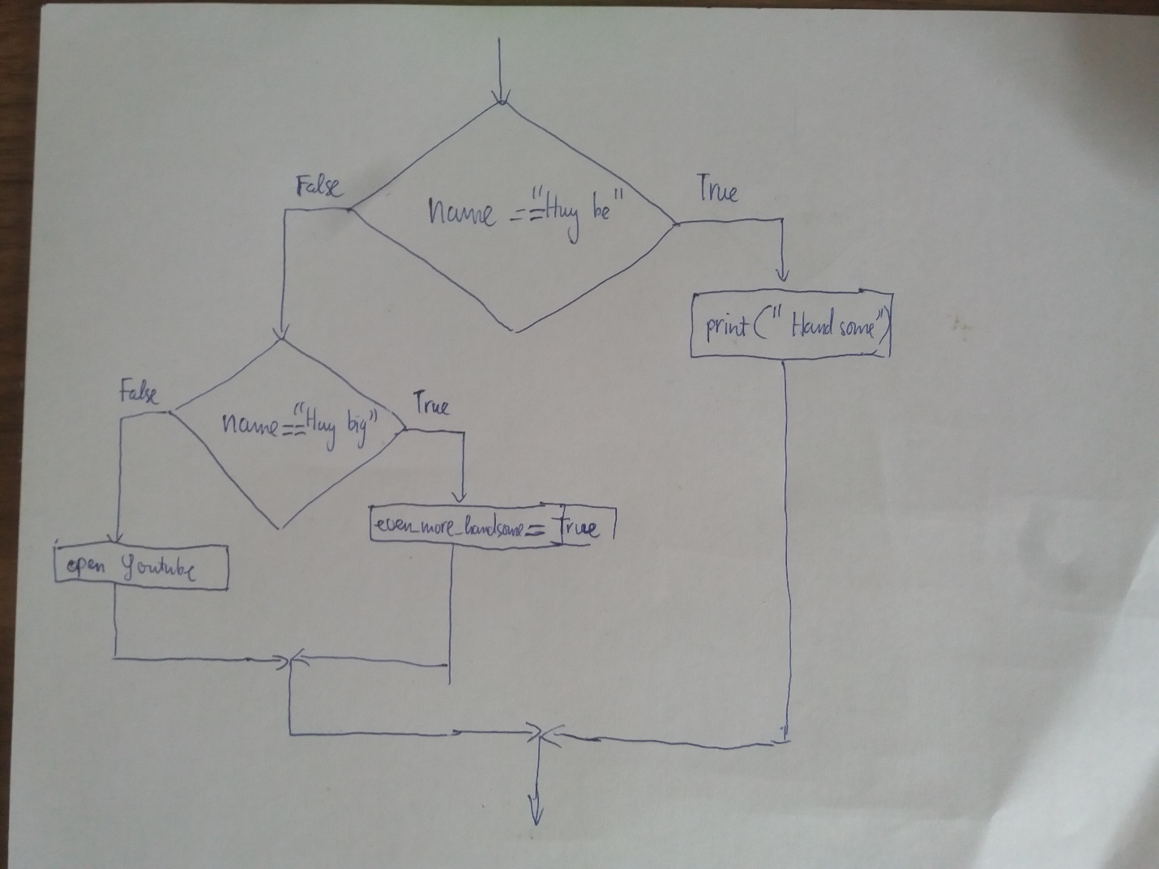

1. Nested conditional is the one that one conditional can be nested within another.

Example:

if x > 0 :

if x > 10 :

print(“great”)