5.11

5.12

5.13

7.1

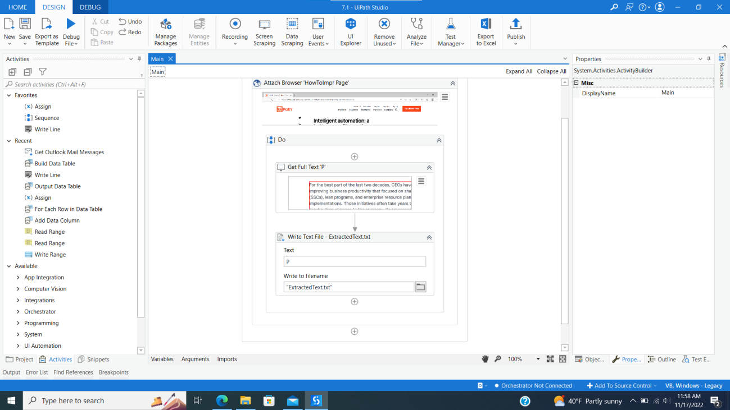

7.2

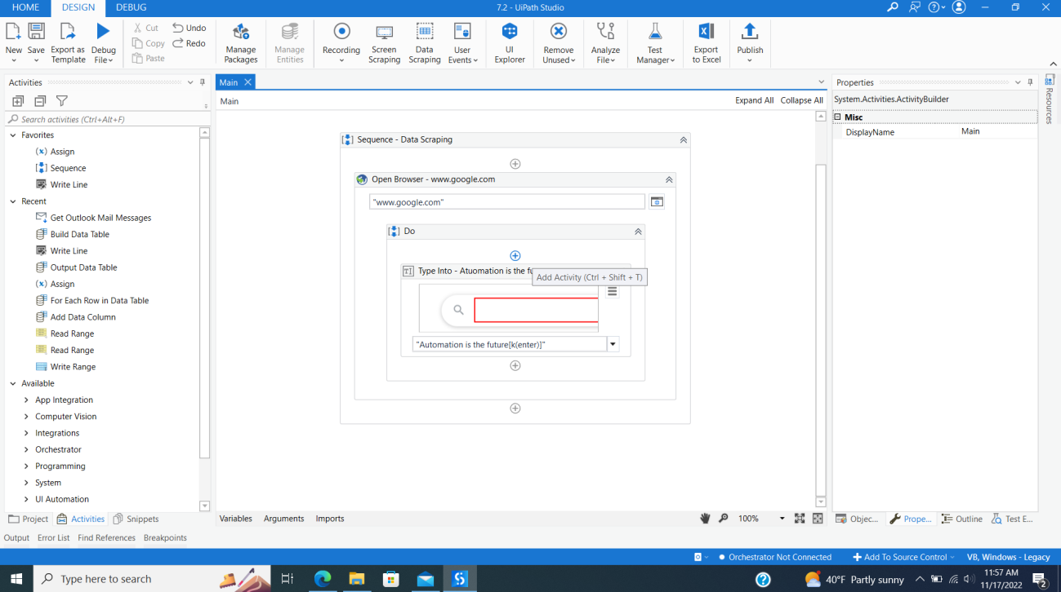

7.3

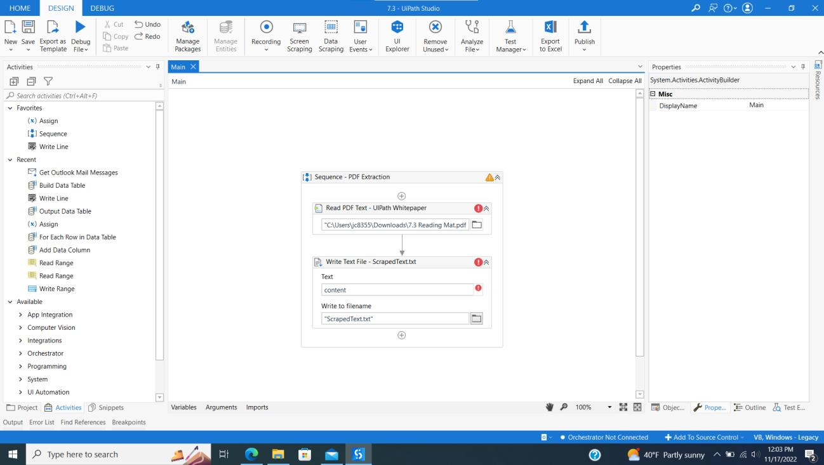

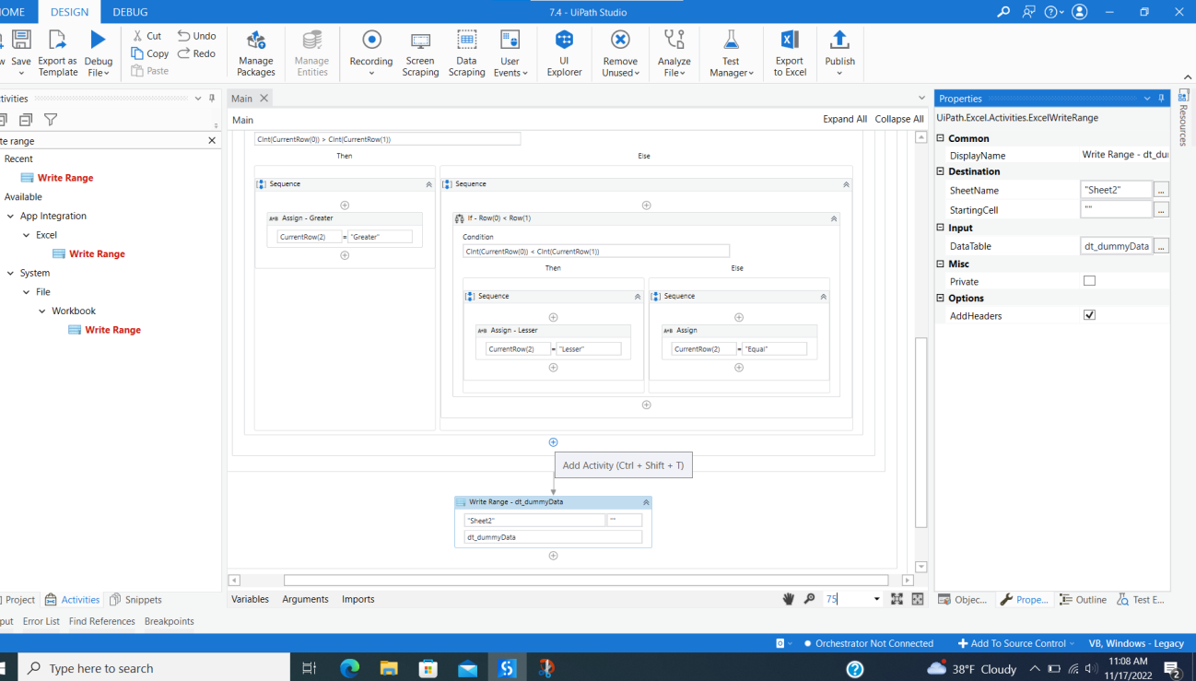7.4

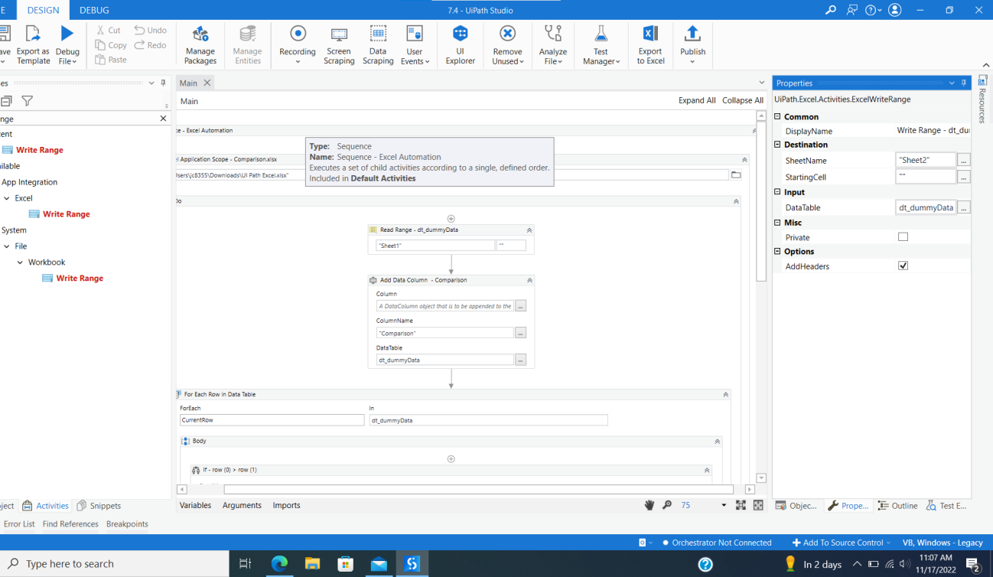

7.5

**\*There are no outputs / results of running due to PiP Preventing me**

