Attendance

|  |  |
| --- | --- |
| Alex Loke | Present |
| Henry Lei | Present |
| Jayden Xian | Present |
| Jimmy Wang | Present |
| Oliver Xu | Present |

Agenda

1. set up teams
   * navigate the posts, files and minutes
   * get everyone on the team familiar with this
2. start the assignment
   * plan how to approach the assignment
   * delegate roles to each members
3. assign tasks to be done
   * plan stand-up??
4. plan next meeting
   * everyone should agree to selected time

Notes

* Discord call starting at 8pm
* Minutes taken by alex on microsoft teams
* might need to change our approach and work on the functions together instead of separately
* jimmy screen-sharing code
* working on one function at a time together
* Call ended at 11pm

​​​​​​​​​​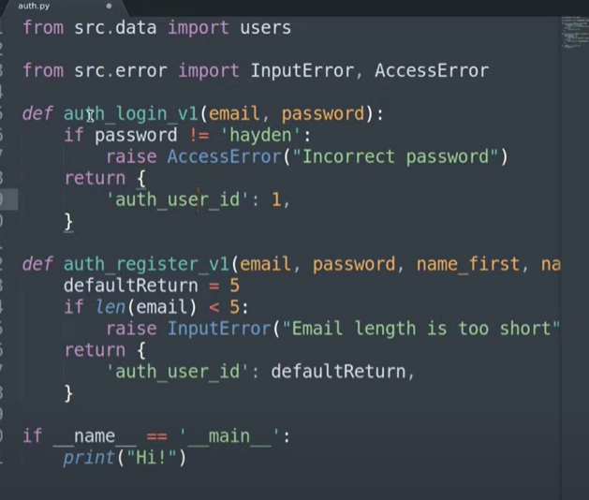

Action items

We felt that since we didn’t have a good understanding of the project yet, action items were not appropriate. Nonetheless, this is how we plan to format it in the future:

|  |  |  |
| --- | --- | --- |
| **Task** | **Responsible** | **Deadline** |
|  |  |  |
|  |  |  |
|  |  |  |
|  |  |  |