Attendance

|  |  |
| --- | --- |
| Alex Loke | Present |
| Henry Lei | Present |
| Jayden Xian | Present |
| Jimmy Wang | Present |
| Oliver Xu | Present |

Agenda

1. Fix iteration 2

Notes

* Had an error with get in the frontend
* 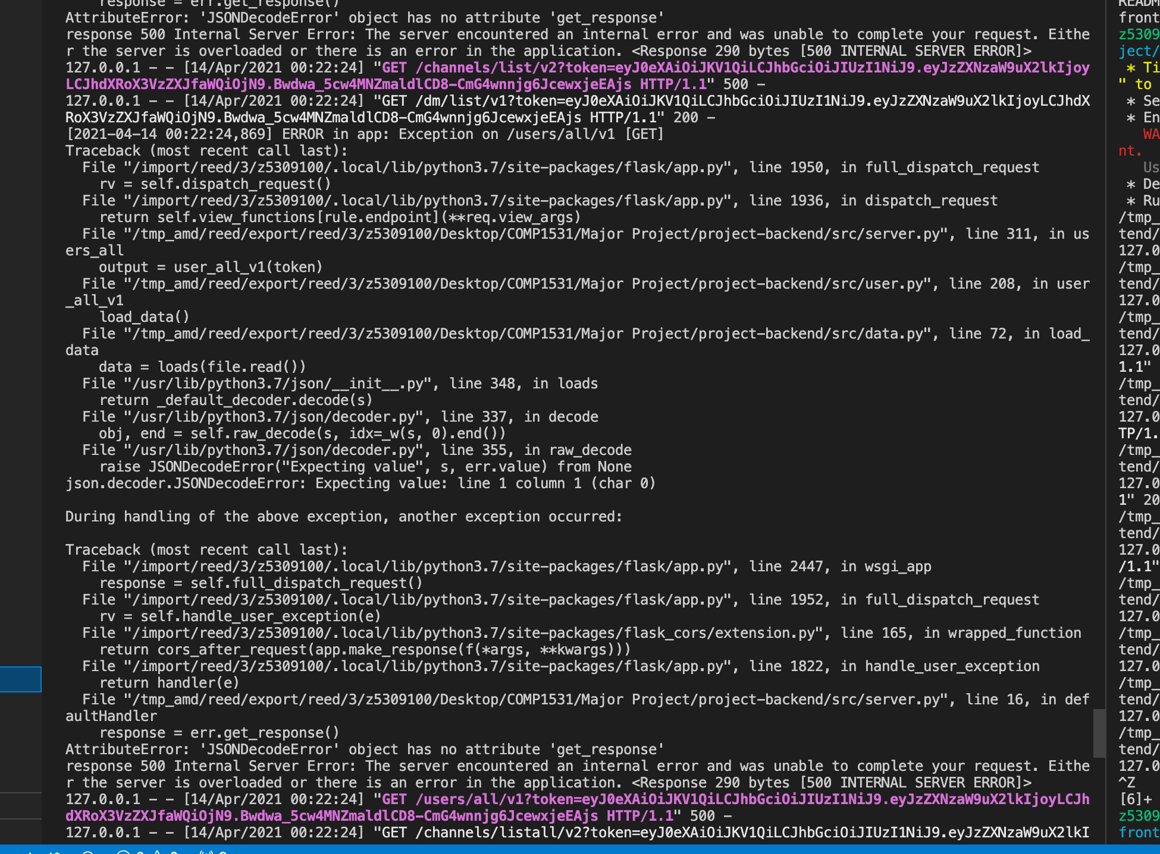
* Changed get test input to params instead of json
* Changed server.py get functions to take args from get instead of json

Standup:

* We plan to have a standup every 2 days 10pm