Jayden McKenna
CS380P
Lab5: MPI Barnes-Hut
Intro
This lab explores the performance of the N-body problem. It is a direct simulation of mutual gravitational attraction. Comparing each body results in a naïve O(N²) algorithm. This implementation quickly becomes unfeasible. The Barnes-Hut algorithm provides an improvement to O(N log N) by organizing the bodies into a heirarchical spatial tree. Approximating the force from aggregated clusters in the tree from the center of mass makes a great improvement.
In this lab we implement the Barnes-Hut algorithm with MPI parallelization. We use MPI because the computation of forces can be distributed across processes. This greatly reduces the overal work from a basic sequential version. By using MPI, studying massive entities such as galaxies can be done in a real feasible way.
Implementation
The Barnes-Hut algorithm uses a tree of nodes A node can be visualized as a region of space. Each node corresponds to a square region of space and may recursively subdivide into four child regions: NW, NE, SW, and SE. Each node has its own metadata that contain its COM, the region of space it covers, and the body located inside it. As a rule, only one body can contain a node. This acts as the rule on how and when to divide nodes into subnodes. If more than one node is in a region of space, divide the node into 4 subregions and place the bodies into the respective subregions. From there, every body has its own COM and coordinates.
The key performance benefit in the Barnes-Hut algorithm gives comes from the force calculation. The algorithm checks whether a distant region is “far enough” using the threshold parameter θ. If the ratio (L / d) is less than θ (where L is the size of the region and d is the distance to the region’s COM) then the entire subtree can be approximated as a single body located at its COM. This drastically reduces the number of force computations from O(N²) to approximately O(N log N), while maintaining good accuracy
After building the basic algorithm, I parallelized it using MPI. Each process is then assigned a contiguous subset of the bodies for which it computes forces using the shared global tree. Every rank produces partial force results for its assigned bodies, and these are reduced to rank 0 using MPI_Reduce. Rank 0 updates the positions and velocities of all bodies and broadcasts the updated array back to all ranks for the next timestep. This approach distributes the most expensive part of the computation: the force calculations.
Theoretical Performance
For a reasonably uniform particle distribution, the tree height grows as O(log N) and each body interacts with only a small number of nodes rather than all other bodies. As a result, the expected computational complexity becomes O(N log N) per timestep.
If work is divided evenly among processes, the expected comptutational cost becomes
$$T_{ll}=O(\frac{N Log N}{P})$$
However, additional overhead arises from broadcasting values and updating each individual force across processes.
With this in mind, we would expect that for larger N the number of processes greatly reduces the total time as the work outweighs the communication costs. However, as P also grows there will be some eventual slow down as the repeated sequential tree builds at the end of each timestep limits the scalability. This means for small N and large P we should see actually a less than 1 speedup because of both of these factors.
Results
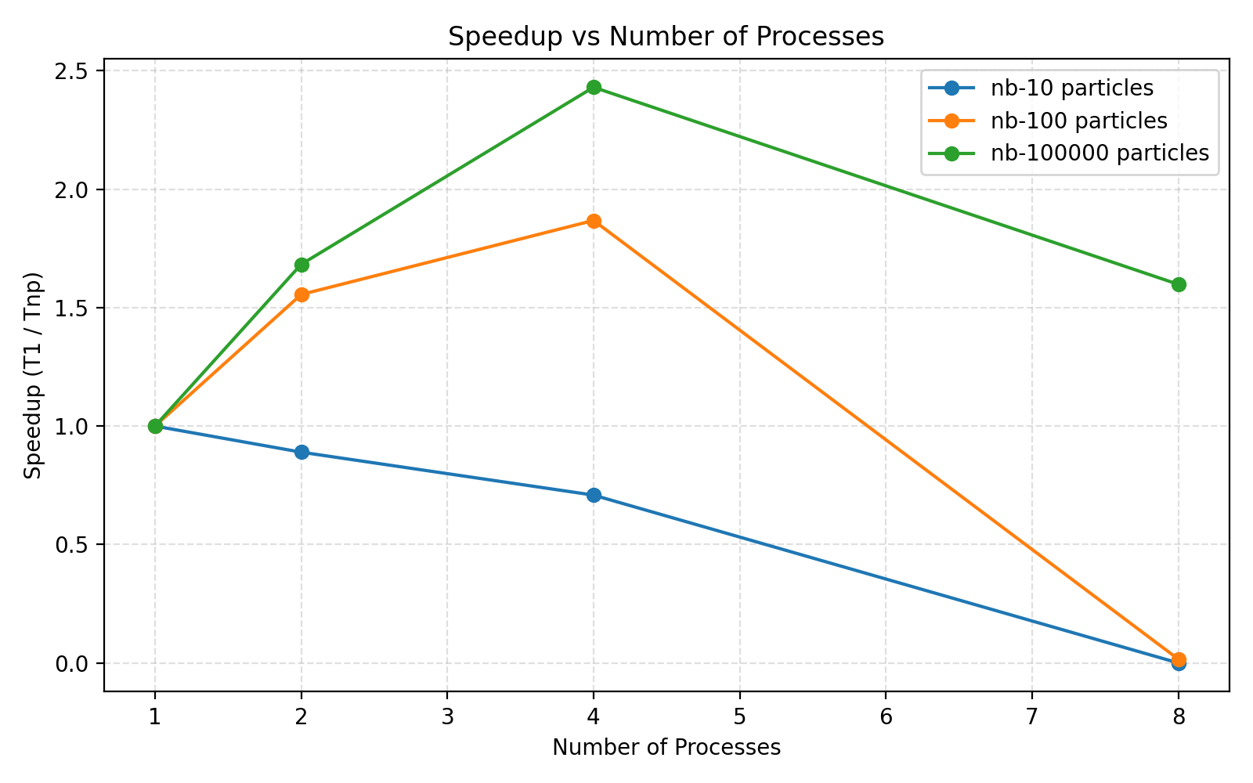
To evaluate the performance of the MPI Barnes-Hut implementation, I measured execution time on the three provided datasets (nb-10, nb-100, and nb-100000) using a fixed timestep count of 100 and varying the number of MPI processes from 1 to 8. All measurements were taken on the Codio environment. Because of this, the scaling results reflect the overhead characteristics of Codio’s virtualized execution model rather than the ideal multi-core performance.

The results obtained highlight 3 distinct behaviors.
- Nb-10 (small N): The runtime is dominated almost entirely by communication and redundant work. Building the entire tree on each process costs far more than the force calculations for just 10 bodies. As a result, MPI introduces pure overhead, causing performance to degrade as the number of processes increases. This is expected and matches my theoretical inference.
- Nb-100 (medium [but still small] N): While there are more bodies than the nb-10 test this is still a relatively small sample size. There is a small initial speedup between 1 and 4 processes, but this gain disappears beyond that point. The cost of MPI_Allreduce and the repeated full tree builds outweigh any compute savings beyond P =4, and even within this threshold the speedup gained is pretty minimal. Here the problem size is too small to pay off communication costs.
- Nb-10000 (large N): The largest dataset experiences the best and most meaningful speedups. Speedup is improved among all processes but does taper off as P grows. Speedup peaks at around 2.4x with P =4. I assume it starts to taper off after this due to the same reasons mentioned in the medium test case.
I am curious to know if the speedup is a lot more drastic on a mutli processor machine rather than on Codio. Unfortunately, I do not have access to a machine like this. However, I expect the speedup would be significantly more pronounced. A multi-core system would provide much higher bandwidth and lower latency than a VM. This would help with both the communication costs and the tree builds that were slowing down the speedups on Codio.
Another optimization that crossed my mind was also parallelizing the tree builds. This would distribute workloads even further rather than each process conducting the whole N sized serial builds. I would hypothesize that this would increase speedup drastically, but the potential for broadcasting updates and sharing metadata across processes sounds challenging and potentially not worth the speedup if it turns out to be minimal.
MPI parallelism is different than what we learned in the rest of the class. Previously we touched on thread parallelism, goroutines, and Rust’s ownership based concurrency. These all rely on shared memory, where threads within a proess access the same address space. These models excel when finer grained workloads are used. From this lab, I learned that MPI parallelism relies on distributed memory parallelism where each process has its own isolated address space. This makes MPI far more suitable for large-scale scientific workloads like Barnes-Hut simulations, where data sets are huge and the computation can be partitioned cleanly across processes. While MPI introduces communication overhead and requires more deliberate data movement than threads or goroutines, it can scale to multiple machines cleanly, something shared-memory models struggle to do.
I spent 50 hours on the lab, including project setup, reading, coding, debugging, simulating, and the write up.

