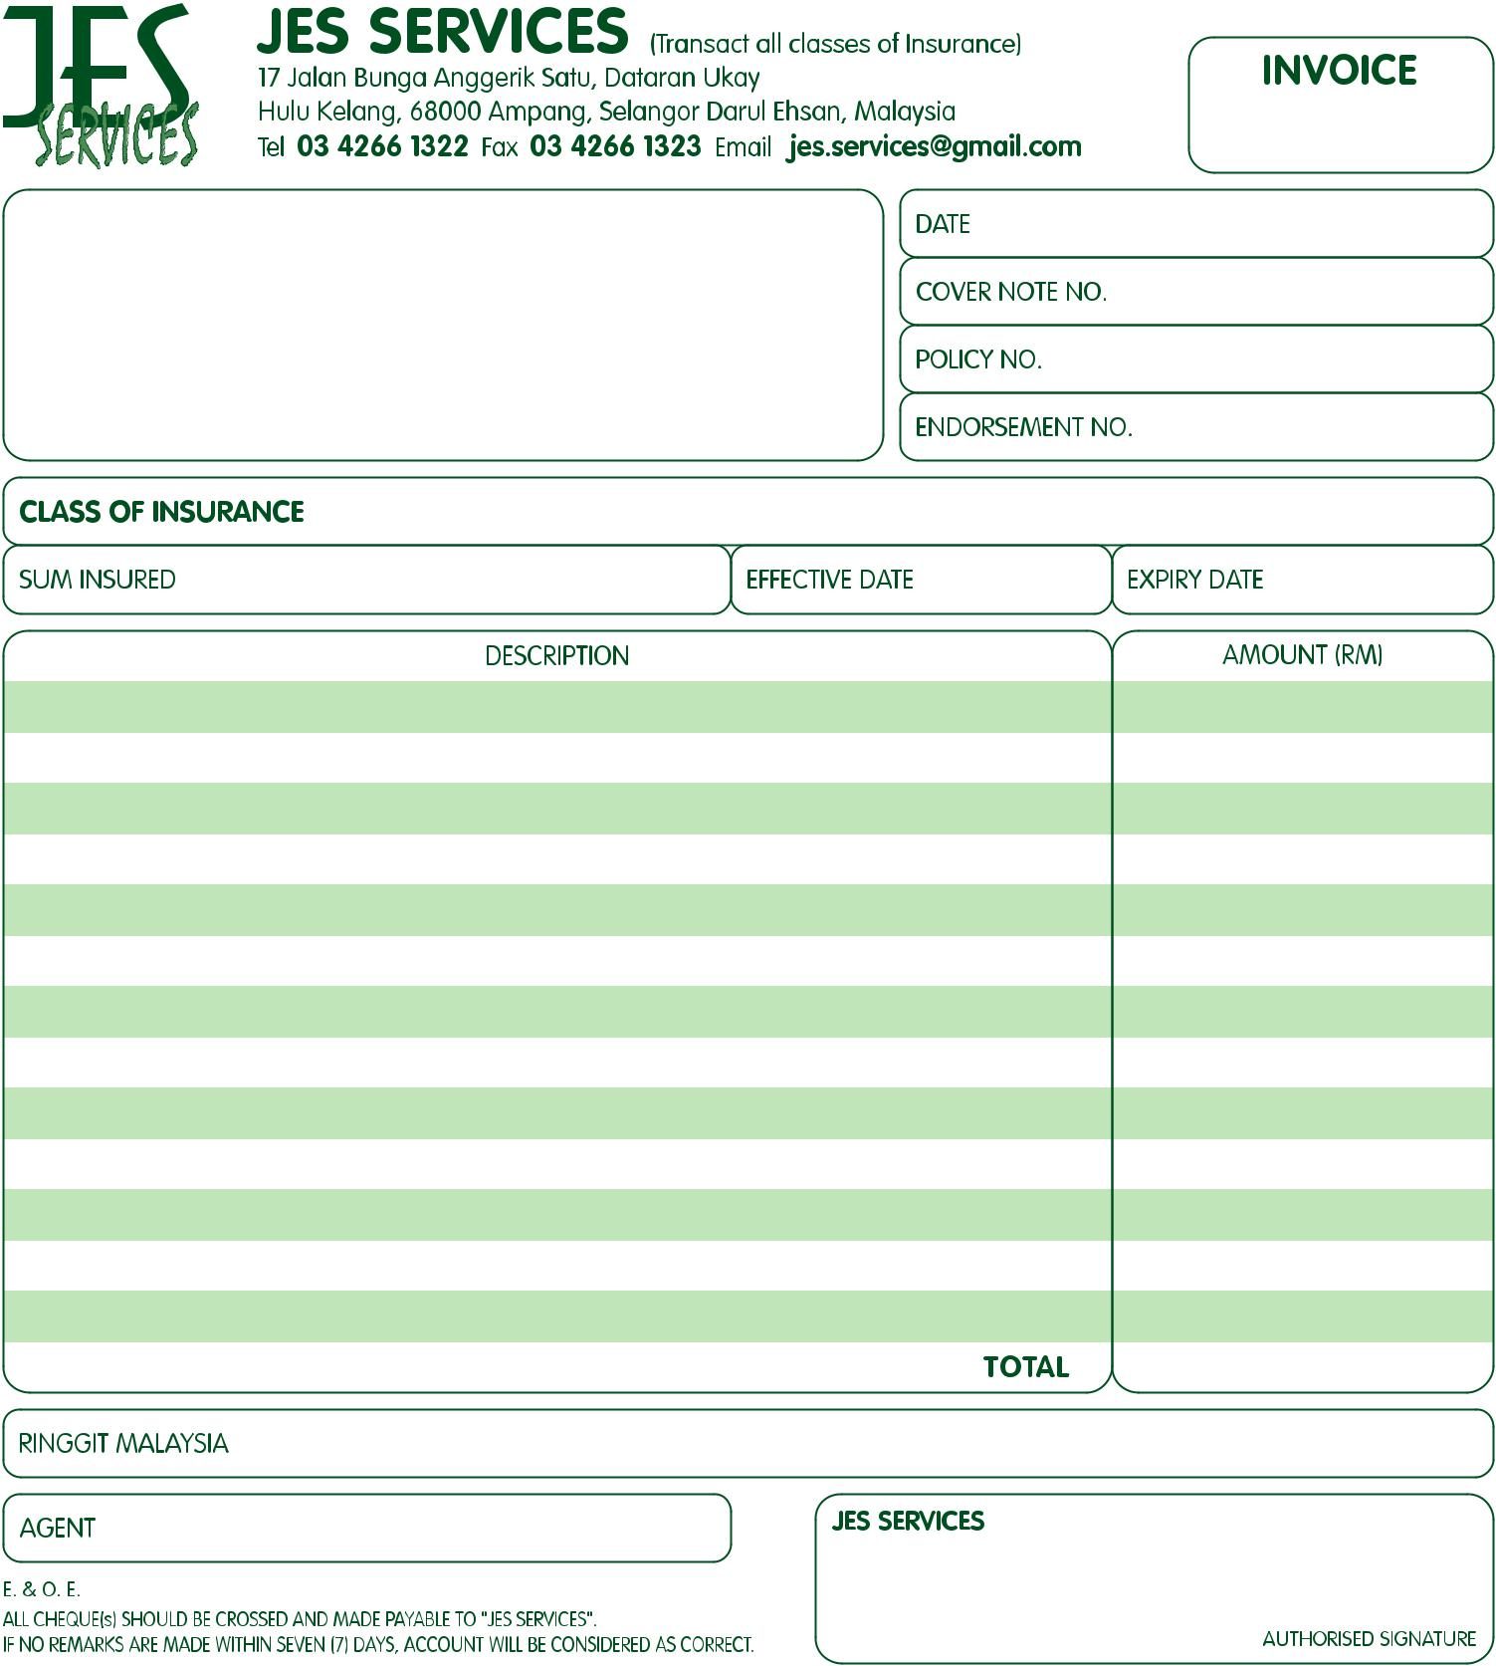

#HiddenInvoiceNo#10

#HiddenEffDate#13-07-2017

#HiddenExpDate#12-07-2018

Jes Services

#HiddenSumInsured#RM 2.00

#HiddenInsuranceClass#44

#HiddenDescription1#PREMIUM

#HiddenNameAddress#Atos Origin Services (M) Sdn. Bhd.

Suite 19.02, Level 19,Lingkaran Syed Putra,

Mid Valley City, 59200,

Kuala Lumpur, Wilayah Persekutuan,

59200,Malaysia

Maybank

A/C No: 5144 0430 4301

#HiddenAgent#Kurnia

#HiddenRinggitMalaysia#Forty-Two Ringgit and Twenty-Six Cents Only

#HiddenTotal#RM 42.26

#HiddenAmount5#

#HiddenAmount4#

#HiddenAmount3#RM 20.00

#HiddenAmount2#RM 1.26

#HiddenAmount1#RM 21.00

#HiddenDescription2#6% GST

#HiddenDescription3#Stamp Duty

#HiddenDescription4#

#HiddenDescription5#

#HiddenDate#13-07-2017

#HiddenEndorsementNo#333

#HiddenPolicyNo#22

#HiddenCoverNoteNo#111