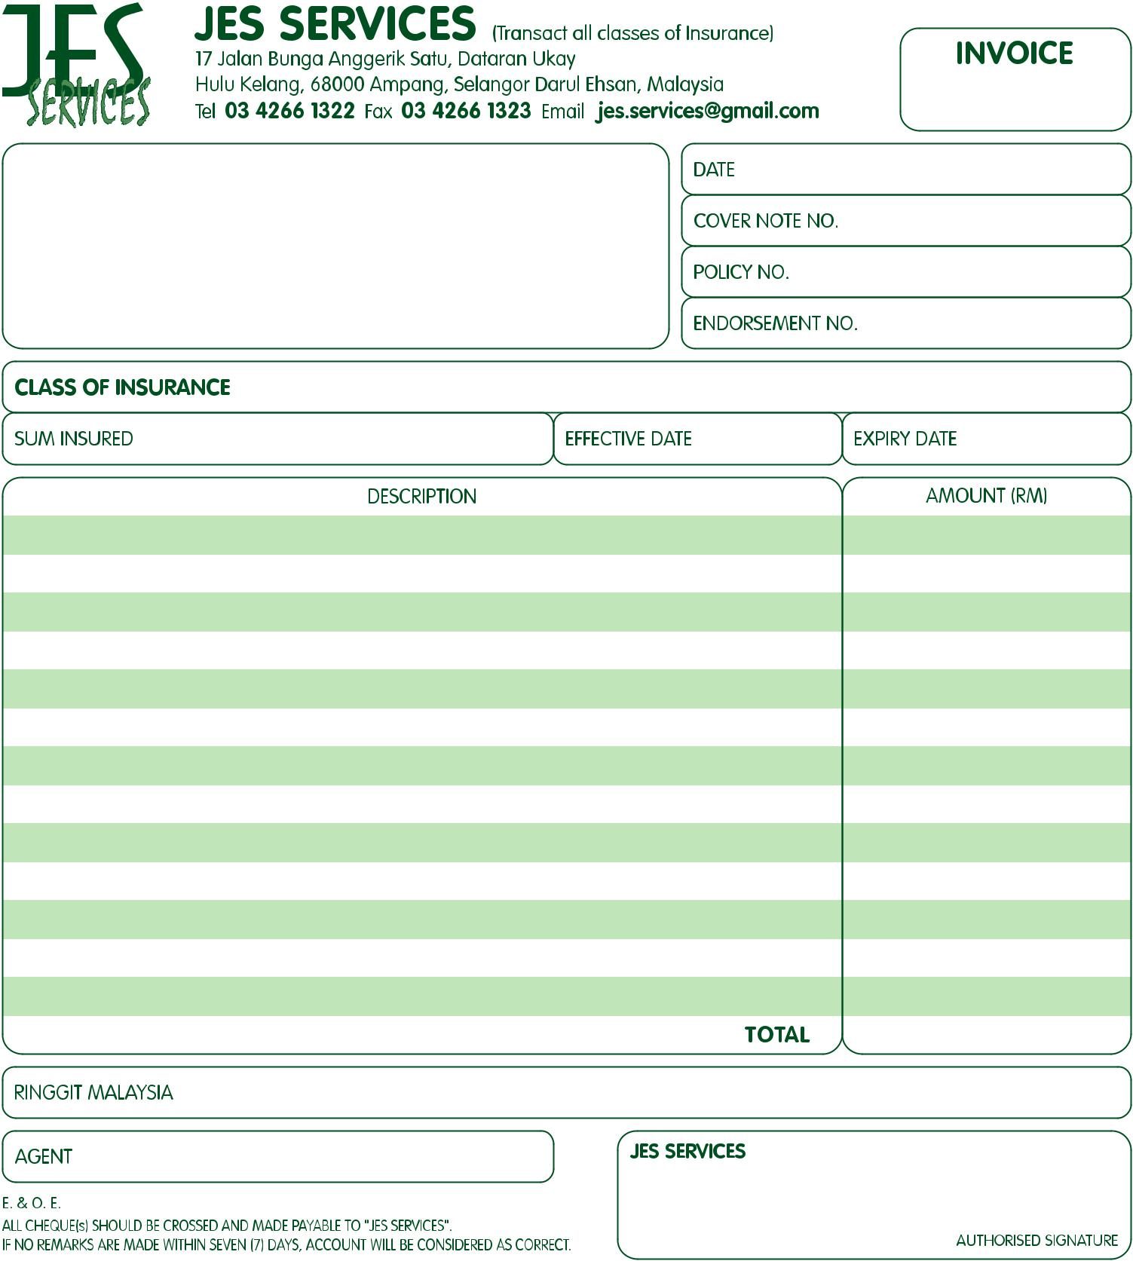

#HiddenInvoiceNo#2

#HiddenEffDate#13-07-2017

#HiddenExpDate#12-07-2018

Jes Services

#HiddenSumInsured#

#HiddenInsuranceClass#

#HiddenDescription1#

#HiddenNameAddress#

Maybank

A/C No: 5144 0430 4301

#HiddenAgent#Kurnia

#HiddenRinggitMalaysia#Zero Ringgit and Zero Cents Only.

#HiddenTotal#RM 0.00

#HiddenAmount5#

#HiddenAmount4#

#HiddenAmount3#

#HiddenAmount2#

#HiddenAmount1#

#HiddenDescription2#

#HiddenDescription3#

#HiddenDescription4#

#HiddenDescription5#

#HiddenDate#13-07-2017

#HiddenEndorsementNo#

#HiddenPolicyNo#

#HiddenCoverNoteNo#