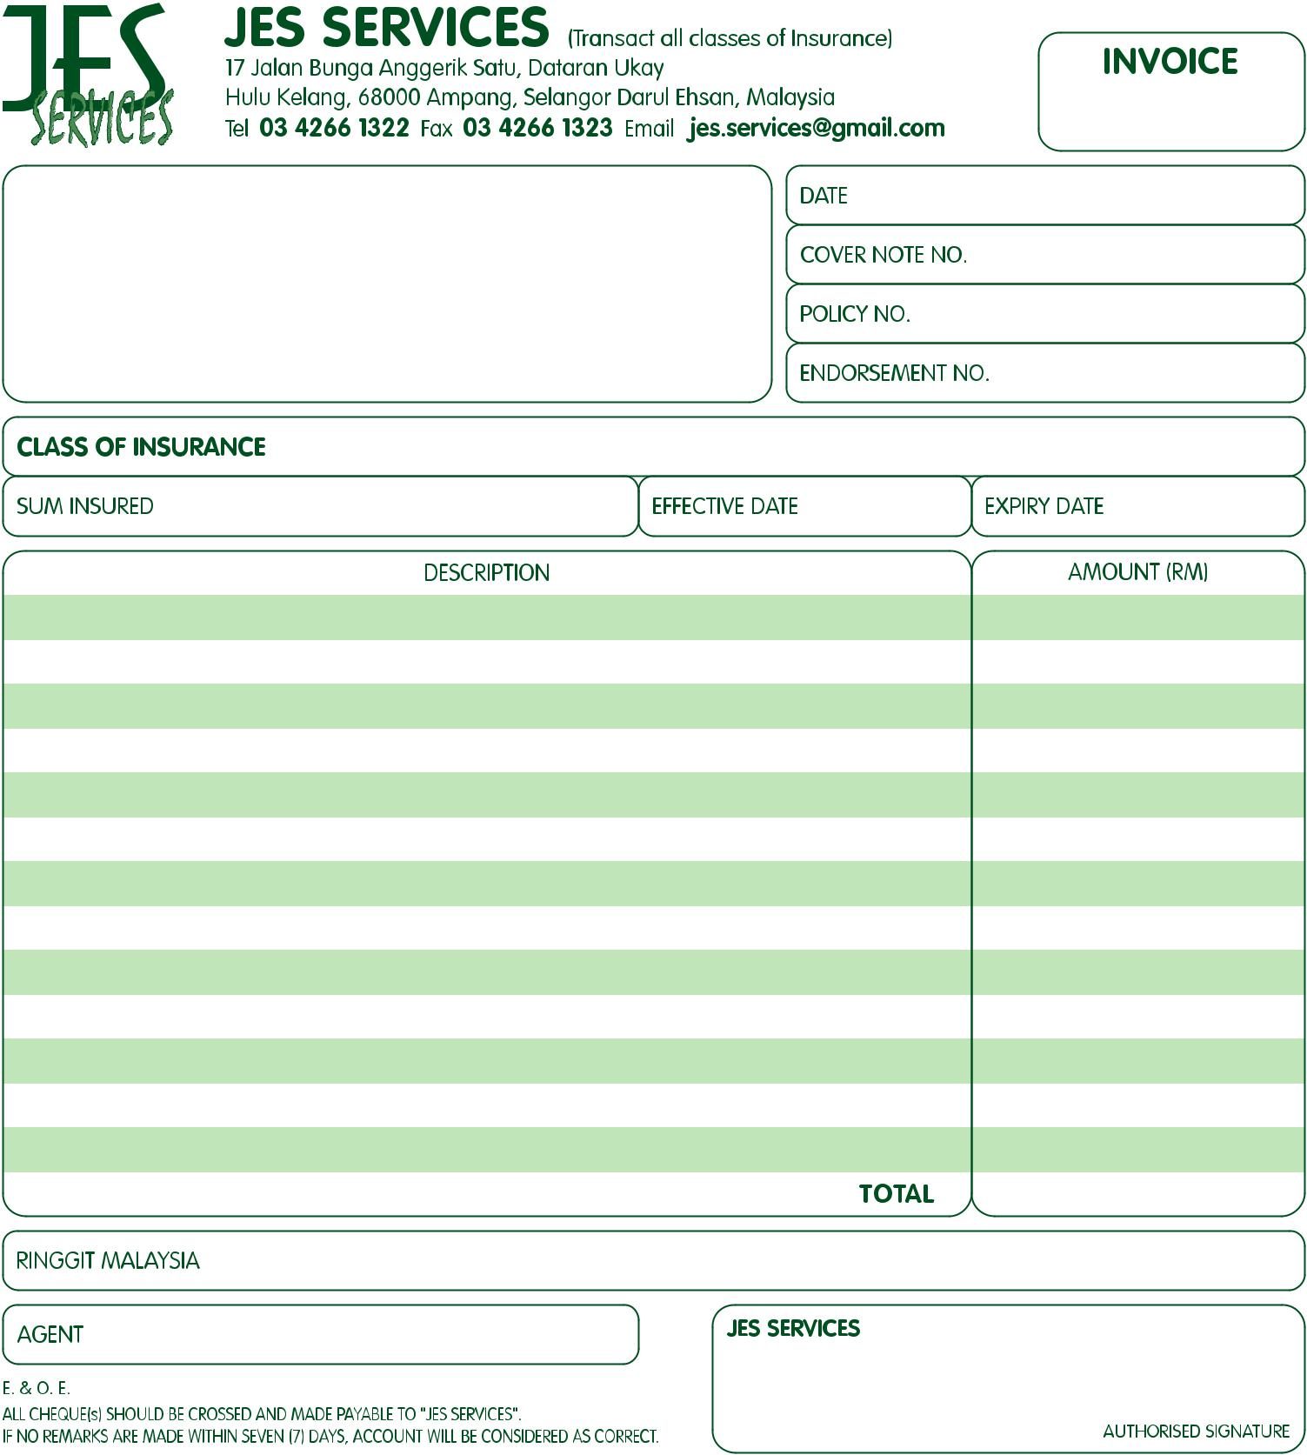

12-07-2017

11-07-2018

Jes Services

RM

Maybank

A/C No: 5144 0430 4301

Kurnia

Zero Ringgit and Zero Cents Only

RM 0.00

12-07-2017