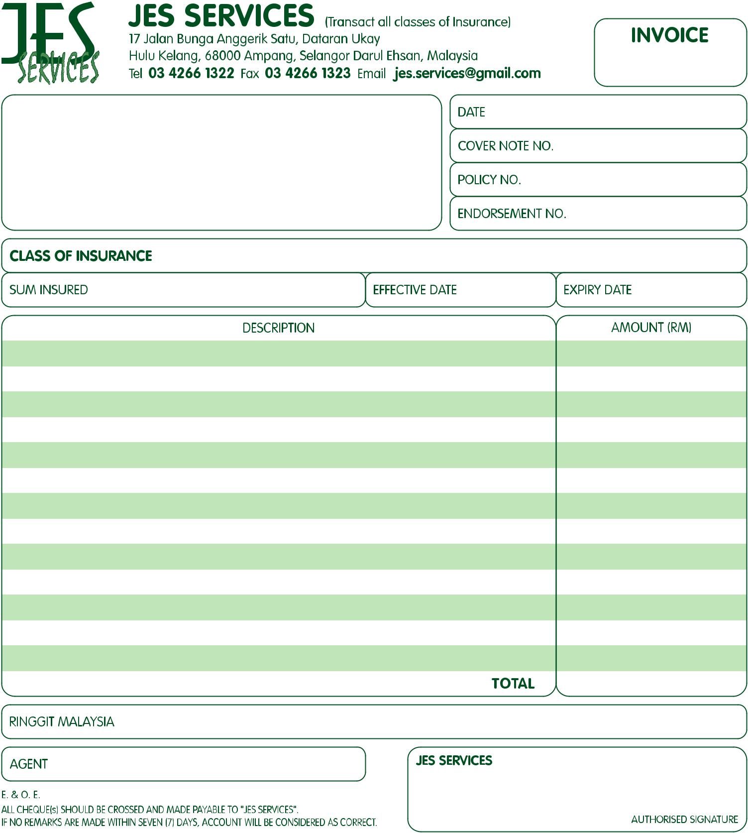

#InvoiceNo#

#EffDate#

#ExpDate#

Jes Services

#SumInsured#

#InsuranceClass#

#Description1#

#NameAddress#

#BankName#

A/C No: #BankAccountNo#

#Agent#

#RinggitMalaysia#

#Total#

#Amount5#

#Amount4#

#Amount3#

#Amount2#

#Amount1#

#Description2#

#Description3#

#Description4#

#Description5#

#Date#

#EndorsementNo#

#PolicyNo#

#CoverNoteNo#