****C:\Program Files\Microsoft Office\MEDIA\CAGCAT10\j0240695.wmf****



**Karmaveer Kakasaheb Wagh Education Society’s**

**K. K. Wagh Arts Commerce, Science, & Computer Science Colleg­e**

**Saraswati Nagar Nashik-422003**

**CERTIFICATE**

This is to certify that,

**Miss. Snehal Anil Jamkar & Suyasha Vilas Pujari**

Has satisfactory completed their project **Online Handy Man Care System** as fulfillment in **B.Sc. (Comp Sci)** Department for the academic year **2017-2018**.

Prof . Pavan Malani. Prof . Bendale A.H.

(Project Guide) (H.O.D)

Internal Examiner External Examiner

**ACKNOWLEDGEMENT**

We own our sincere gratitude to all those people who have given us their constant support and encouragement without which our project report would not have reached this stage.

We would like to express our thanks to **Prof. Pavan Malani**. Sir For her advice and encouragement. She has been pillar of strength right through the project till the preparation of this report and helped by boosting moral, so we could surmount the difficulties that came across during completion of this project.

We would like to express our gratitude to **Dr.V.M.Sewlikar**, Principal, K.K.Wagh Arts, commerce, science and Computer Science College. And **Prof.Bendale A.H**. Head of Computer department for the support and the infrastructure they have provide, so that we could successfully complete the project on time.

Last but not the least we would like to express our sincere thanks to all staff members and our friends for their help and cooperation in all phases of the project.

.

Suyasha Pujari.

Snehal Jamkar.

.

**Index**

|  |  |  |
| --- | --- | --- |
| **Sr.No** | **Title** | **Page NO.** |
|  | Problem Definition. | **5** |
|  | Existing System. | **6** |
|  | Proposed System. | **7** |
|  | Feasibility study. | **8** |
|  | Requirement analysis. | **12** |
|  | ER-Diagram. | **13** |
|  | UML Diagrams. | **14** |
|  | Data Dictionary. | **19** |
|  | Sample I/O Screen. | **22** |
|  | Conclusion. | **29** |
|  | Limitations. | **29** |
|  | Bibliography. | **31** |

**Problem Definition**

* This system provide guideline for the implementation of all basic handyman services at a single place.
* With the help of the services which are needed in day to day life with a single source code.
* In time to get some information of contact details of handyman for a particular problem or rather getting a particular services, the system provide everything at one place & that too with trusted assurance.

**Existing System**

* The existing system was semi-automated as user use either manual information or online apps for the services.
* In the old system or manual process it either provide the services or provide job for handyman for jobs.
* Many times unavailability of some services and it is very painful task to gather contact details of handyman.

**Proposed system**

* This will reduce the time consumption and make task easier.
* Give information quickly and provide services as per the user’s need and provide systematic view of all services.
* It is user friendly and easy to handle and use.
* Require no maintenance from user side.
* Provide handyman services and job for handyman at one place.
* Minor and major handyman jobs services are available.

**Feasibility Study**

*TECHNICAL FEASIBILITY

* It is concerned with specific equipment and software that satisfy the user need.
* The technical or hardware which may be required to get the best performance may include.
* In this system less hardware needs are required from user side and the response time is very less as compared to manual functioning.
* The speed of allotting best services and fulfilling customer ‘s need in less time.

*ECONOMICAL FEASIBILITY

* Economical feasibility means cost or benefits analysis that require to design & implement the system.
* While making this system as per the employee and customers needs and requirements are taken into consideration.
* As the system only requires a system to operate and a web browser to serve and use.

*OPERATIONAL FEASIBILITY

* It refers to an evaluation which analysis the system how to operate in ideal condition.
* It include how worker respond to the system and whether it is easy to operate and work on it.
* In this system it is taken into consideration that if new changes occur or additional plans are added then it can accommodate in the existing system as per the requirements.
* It is a user friendly system ,anyone can enjoy its fruitful services with few simple clicks and the system provide the facilities of job registration on the same platform.

**GATHERING DATA REQUIREMENTS AND FUNCTIONAL REQUIREMENT**

* Functional Requirements

1] Data to be entered in to system

* In the system the data that can be entered are depended on 2 different things i.e. whether it’s a customer or tread person.
* There are separate form for customer and tread person where they can enter details about them and the required services.User name and password should be entered to login into the system services.
* Needed services specification should be entered so that services can be provided.

2] Who can enter the data in the system

* The person who wants services from the system can enter the details about the requirements.
* Tread person can enter their details and job specifications and specialization.

3] Operation and work flow performed by the system

* In the system every page is connected or related to other pages.
* Clicking on a page will redirect the user to the page where they meet the requirements.
* Firstly user have to login into the system or register themselves with a identity.
* After login customer can choose the services as per the requirements.

**REQUIREMENT ANALYSIS**

->Hardware specification

Processor: Intel core i3

RAM : 4GB

->Operating System

Platform : Windows 10

->Software Requirements

front end tool: Wamp server2.2

back end tool: MySQL

programming language: PHP

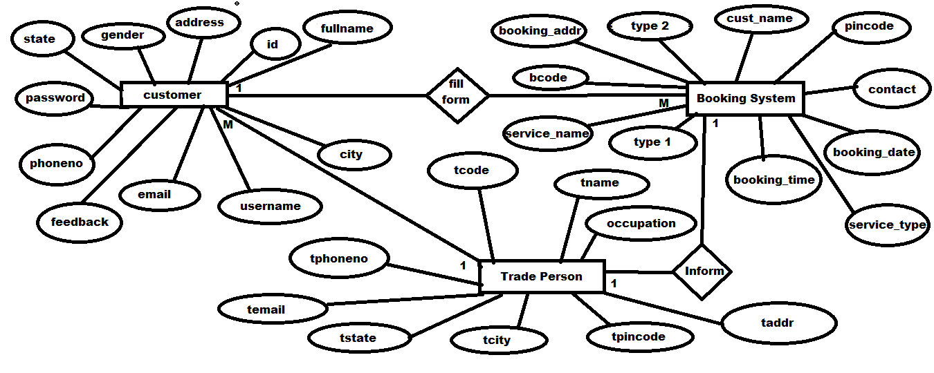 **ER-Diagram**

**USE CASE DIAGRAM**

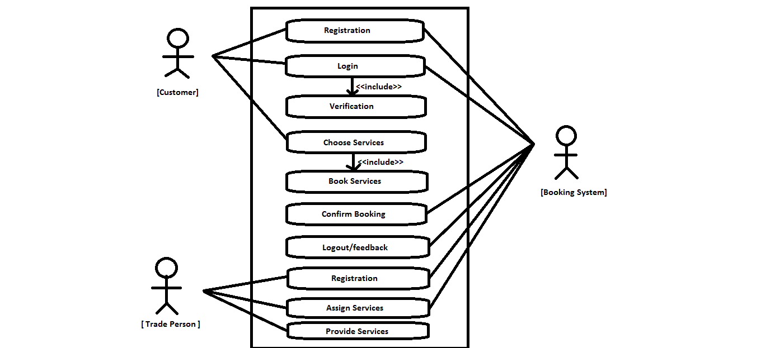

**SEQUENCE DIAGRAM**

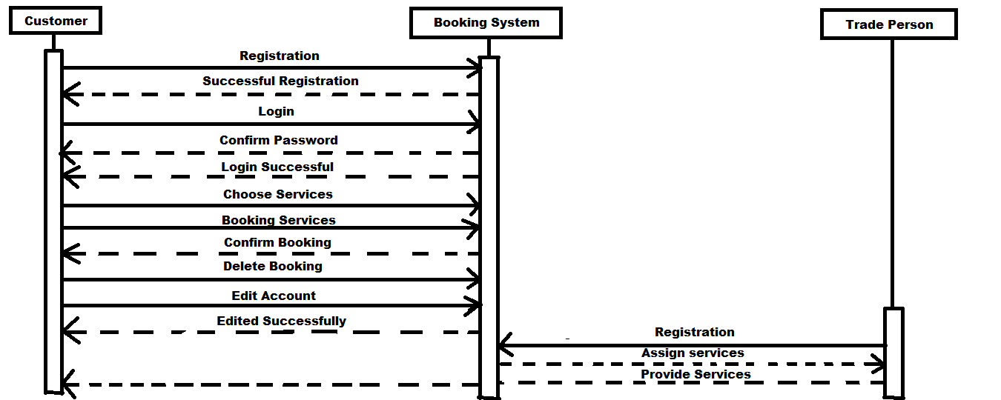

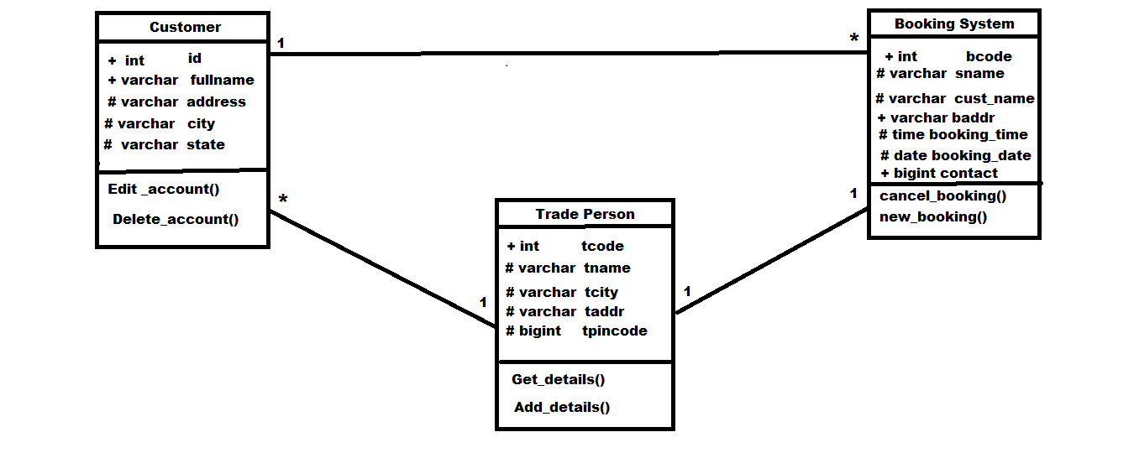**Class Diagram**

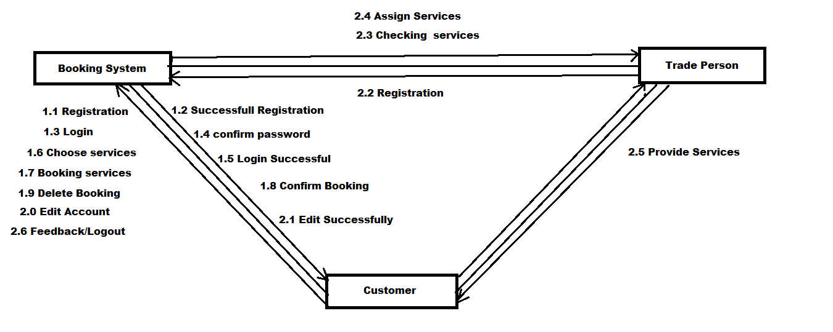**Collaboration Diagram**

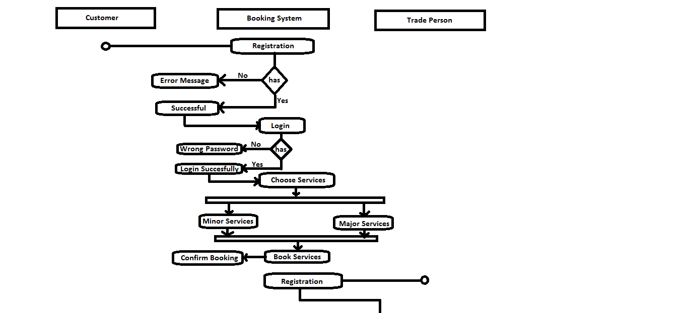**ACTIVITY DIAGRAM**

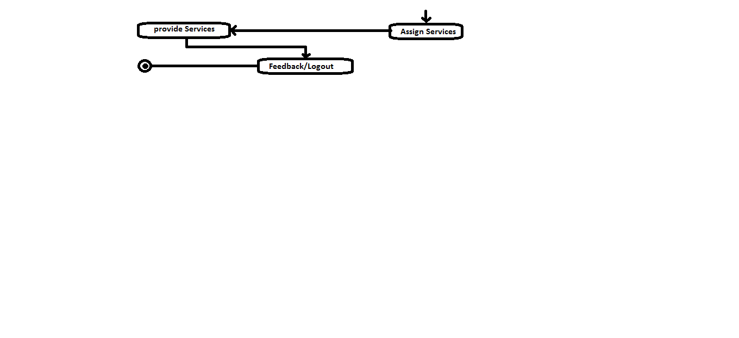

**Data Dictionary**

A data dictionary is a catalogue repository of the elements in a system. These dictionary mainly talks about data and the way they are structured to meet user requirements and organizational needs.

1. **Trade Person**

|  |  |  |  |
| --- | --- | --- | --- |
| **Data Type** | **Data Field** | **Description** | **Length** |
| **Int** | **tcode** | **Primary key,notnull,unique,Autoincreament=100** | **40** |
| **Varchar** | **tname** | **Not Null** | **60** |
| **Varchar** | **taddr** |  | **60** |
| **Bigint** | **tpincode** | **Not Null** |  |
| **Varchar** | **tcity** |  | **15** |
| **Varchar** | **tstate** |  | **15** |
| **Varchar** | **temail** |  | **20** |
| **Bigint** | **tphoneno** |  |  |
| **Varchar** | **occupation** |  | **20** |

**2)Customer**

|  |  |  |  |
| --- | --- | --- | --- |
| **Data Type** | **Data Field** | **Description** | **Length** |
| **Int** | **id** | **Not Null,primarykey,Auto_Increment=1000** |  |
| **Varchar** | **fullname** | **Not Null** | **20** |
| **Varchar** | **address** |  | **60** |
| **Varchar** | **gender** |  | **10** |
| **Varchar** | **city** |  | **20** |
| **Varchar** | **state** |  | **20** |
| **Varchar** | **email** |  | **40** |
| **Bigint** | **Phoneno** |  |  |
| **Varchar** | **username** | **Not Null** | **15** |
| **Varchar** | **password** | **Not Null** | **15** |
| **Varchar** | **feedback** |  | **60** |

**3) Booking System**

|  |  |  |  |
| --- | --- | --- | --- |
| **Data Type** | **Data Field** | **Description** | **Length** |
| Int | Bcode | Not Null,primarykey,Auto-Increrament |  |
| varchar | Service_name | Not Null | 15 |
| varchar | Cust_name |  | 15 |
| Varchar | Booking_addr |  | 60 |
| Bigint | pincode | Not Null |  |
| bigint | contact |  |  |
| date | booking_date |  |  |
| time | Booking_time |  |  |
| varchar | Service_type |  | 20 |
| varchar | Type1 |  | 20 |
| varchar | type2 |  | 20 |
| Int | id | Fk_reference Customer |  |
| Int | tcode | Fk_referencceTradePerson |  |

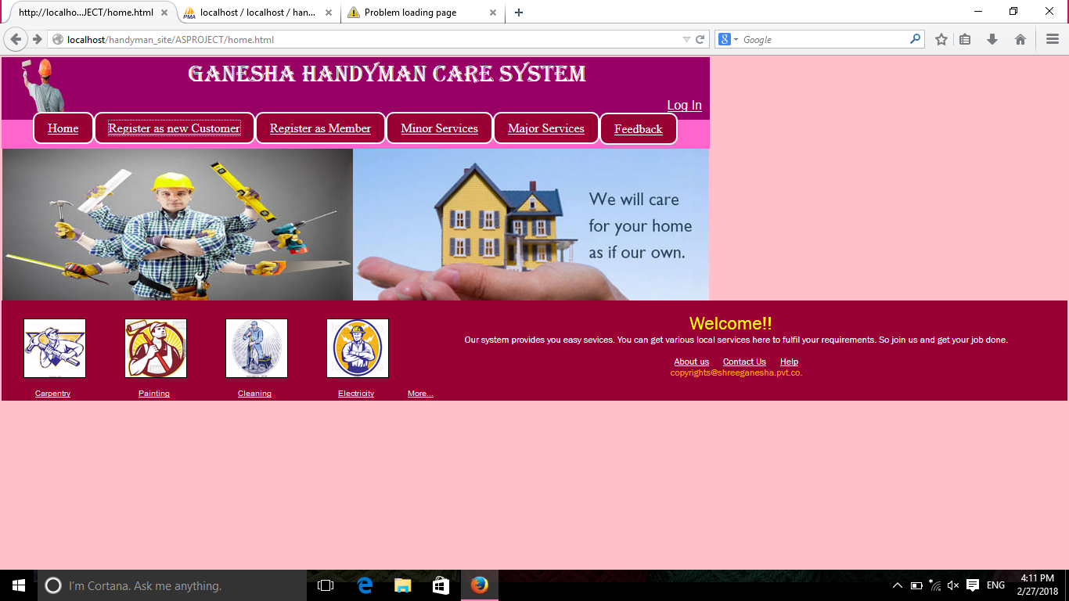**A)Home Page**

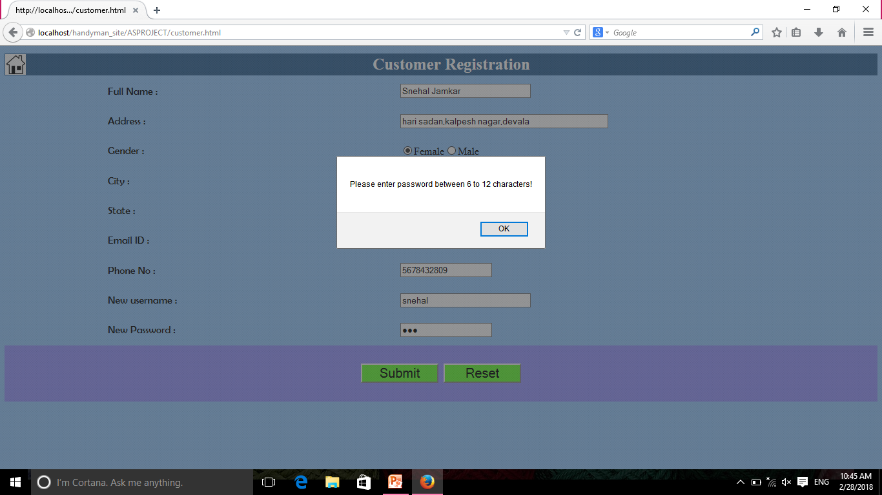**B)Customer Registration with validation**

**C)TradePerson Registration**

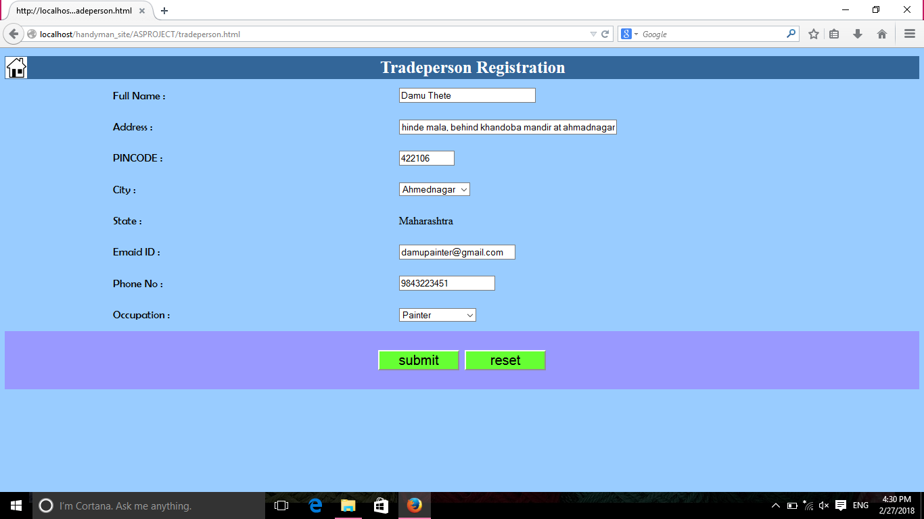

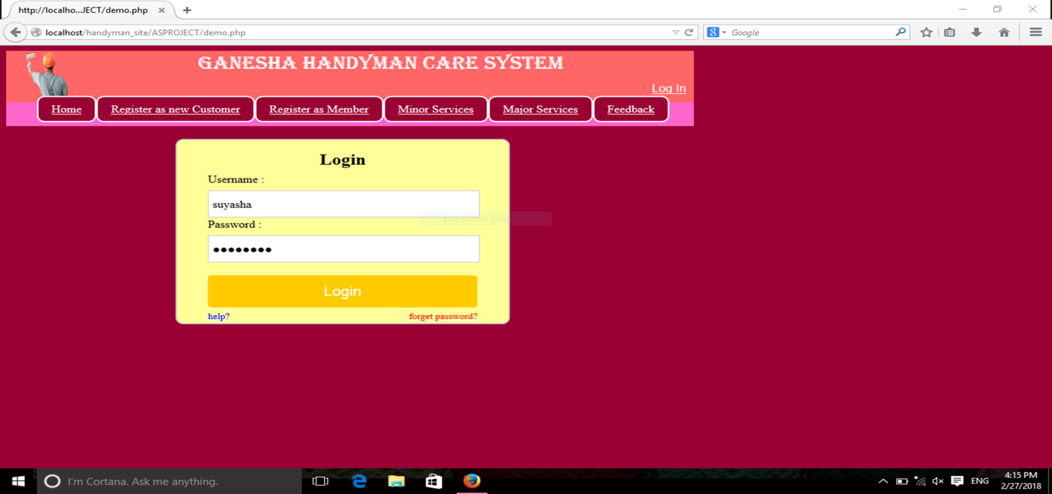**D) Login Screen**

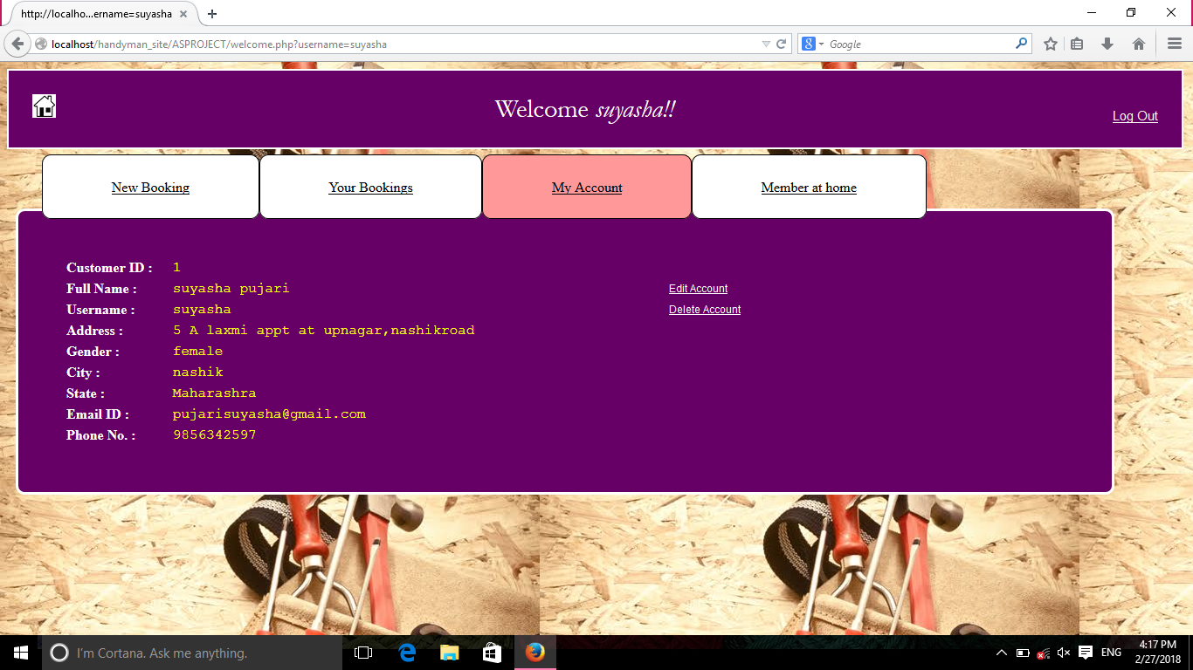**E)MyAccount Screen**

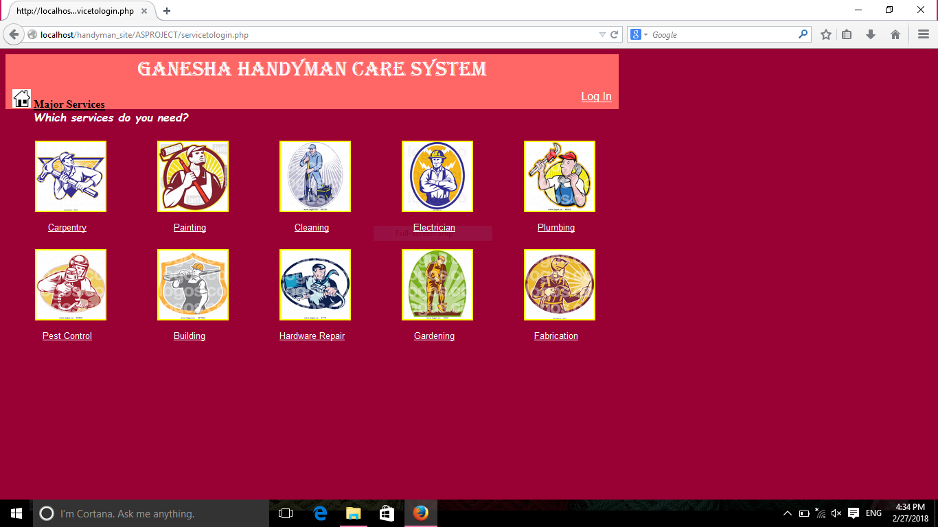**F) Major Services**

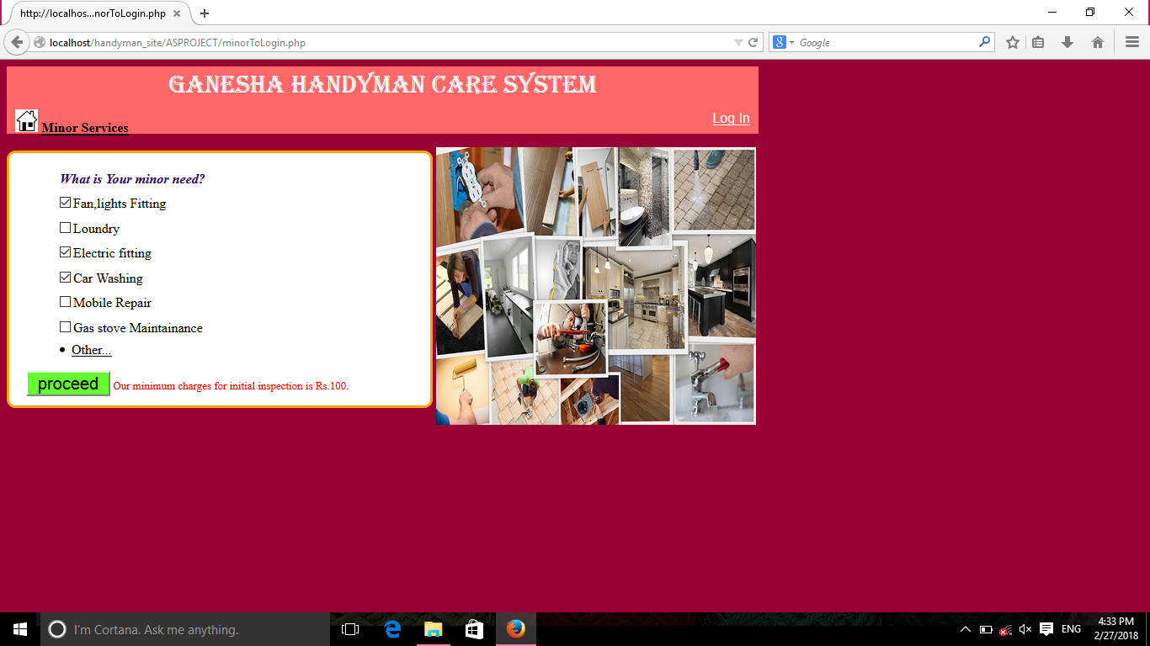**G) Minor Services**

**CONCLUSION**

* The speed of allotting best services and fulfilling customer ‘s need in less time.
* It is a user friendly system.
* Anyone can enjoy its fruitful services with few simple clicks and the system provide the facilities of job registration on the same platform.

**LIMITATION**

* Limited cities are there for providing the handy man services.
* Customer is unaware of the handy man tracking details.
* Limited fields of the services.

**FUTURE ENHANCEMENT**

* Trade person are informed online about the services they have to give.
* Easy to track the path of trade person while delivery of services.

**BIBLOGRAPHY**

* Beginners of PHP(book)
* Masters in HTML(book)
* Beginners of Java Scripts
* Other references are taken from Google.