**Aim:** To configure default and static routes to a connection of routers.

**Topology:**

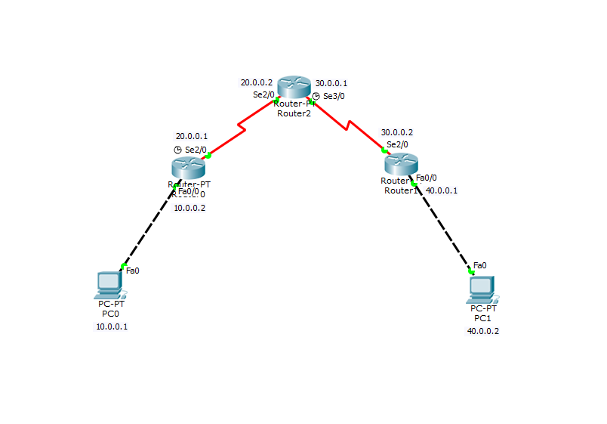

**Configuration and Routing:**

1. **Router 0:**

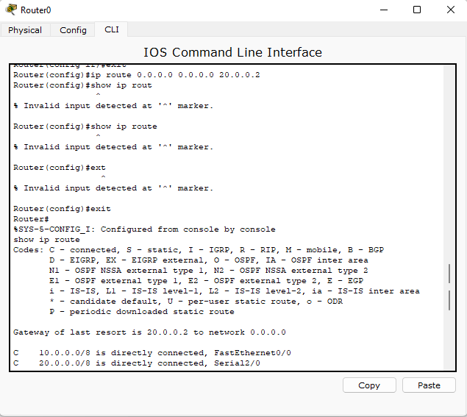

1. **Router 1:**

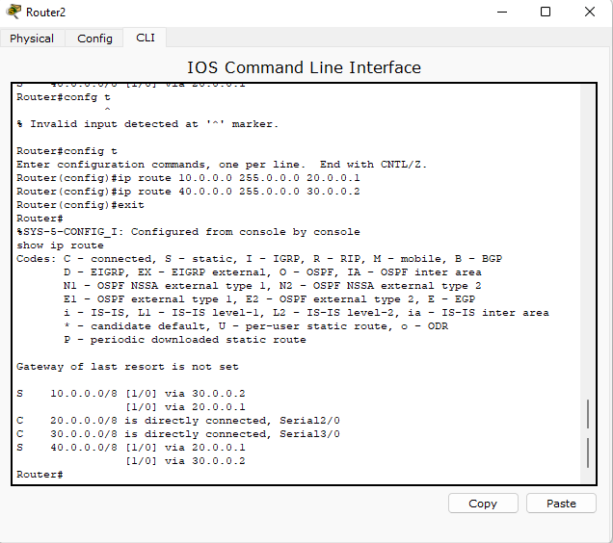

1. **Router 2:**

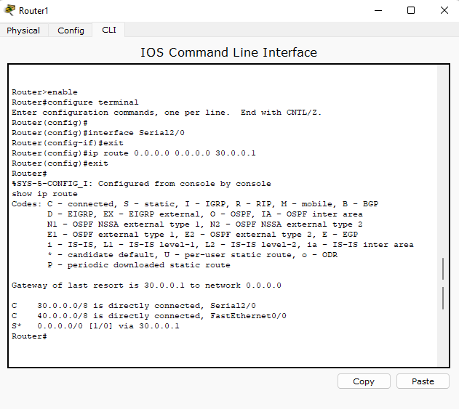

**Output:**

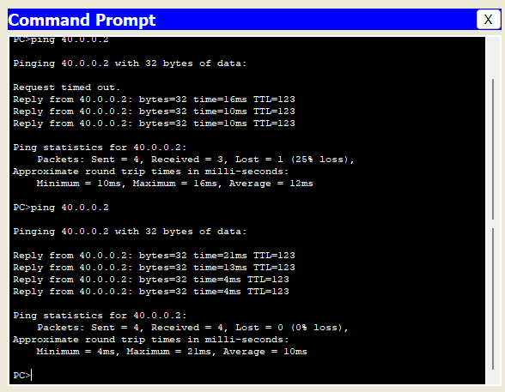

**Simulation:**

