lOMoARcPSD|35174359

A project on

**ONLINE FOOD ORDERING SYSTEM**

**MANAGED TO:**

**SHREE ADARSH BCA COLLEGE RADHANPUR**



**EXAM NO:**  **YEAR:2023-24**

**GROUP NO: 4**

**SUBMITTED BY:** **GUIDED BY:**

GAUSWAMI JAYDIP M.T.CHAUDHARI

CHAUHAN MOTISINH

PREFACE

➤ It gives us great pleasure in placing this individual report, in the hands of our esteemed faculties; we believe that, it will go through the documentation of the project work done by me. The objective of this report is to provide both a conceptual understanding of the system as well as working guide.

As the students of B.C.A when we acquire all the theoretical knowledge, it is both necessary and advisable to acquaint the students with the real situation through, well-planned project in relevant fields. Using all the theoretical knowledge and applying into the real application the student learns to develop efficient real world application at the time of project training. So, the project training is very important for the student for self-development and self-confident. Also student learns organizational structure, rules and regulations and management in a real sense, which helps student to get discipline in life.

➤ We did a project on "Online Food order System Website". An effort has been made to exhaustively deal with every part of the systems developed and at the appropriate position.

ACKNOWLEDGEMENT

➤ With immense pleasure we would like to present this report on the project assignment of "Adarsh BCA College Website".

We are thankful to all that have helped us for the project and for providing valuable guidance throughout our project work.

We are thankful to Principal of B.C.A College Mr.P. B.Chaudhary who granted permission to carry out the project work in the college.

Having nurtured the project with our hard labor for whole academic session, it is indeed great pleasure and matter of immense satisfaction for me to express our sense of gratitude and indebt towards my project guide, Mr.maheshbhai chaudhari for their valuable guidance and untiring inspiration. His enthusiasm and ever ready attitude to encounter with seemingly insurmountable obstacles helped this task successfully.

We would like to thank our friends and family members and all those persons who have directly or indirectly helped us during this project.

Contents

## Table of Contents

Chapter I: Introduction

* 1. Introduction 5
  2. Objective 5
  3. Needs of Online Food Order 6
  4. Methodology Development Model 6
  5. Tools and Technique 7

1.6.1 External Interfaces 7

Figure: Schema Diagram 15

Chapter II: Task and Activities Performed

* 1. Profile of Problems 21
  2. Structure of the project 21
  3. Scope and Feasibility 22
  4. System Analysis 22
  5. System Design 22
  6. Implementation 23
  7. Test Generation 23

Screen Shot 24 to 30

## Chapter I: Introduction

# Introduction

## **Online food ordering** is the process of ordering food from a website .The product can be either ready-to-eat food (e.g., direct from a certified home-kitchen, restaurant) or food that has not been specially prepared for direction consumption (e.g., vegetables direct from a farm/garden, frozen meats. etc).The aim of developing Online Food Ordering system project is to replace the traditional way of taking orders with computerized system. Another important reason for developing this project is to prepare order summary reports quickly and in correct format at any point of time when required.

Online Food Ordering System has a very lot of scope. This PHP project can be used by any restaurants or fast foods for customers for keeping their order records. This project is easy, fast and accurate. It requires less disk space. Online Food Ordering System uses MYSQL Server as backend so there is not any chance of data loss or data security. A customer can choose to have the food delivered or for pick-up. The process consists of a customer choosing the restaurant of their choice, scanning the menu items, choosing an item, and finally choosing for pick-up or delivery. Payment is then administered by paying with a credit card or debit card through the app or website or in cash at the restaurant when going to pickup. The website and app inform the customer of the food quality, duration of food preparation, and when the food is ready for pick- up or the amount of time it will take for delivery

# Objective

The main objective of this system is to manage the details of item category, food, delivery address, order, and shopping cart. It manages all the information about item category, customer, shopping cart, item category. The project is totally built at administrative end and thus only the administrator is guaranteed the access. The purpose is to build and application program to reduce the managing the item category, food customers. It tracks all he delivery address ordered.

# Needs of Online Food Order

Helps customer to order their food at any time. The customers will be able to order their favorite dishes at any point of time, and as we have pointed out earlier, that time is a minimal option, and restaurants must have a specified system through which they can serve a huge number of customers while making their work smoother. Ordering.co is one of the best platforms which provides all of these platforms along with numerous innovative features which has turned countless small and large businesses into an inspiring leader in the online marketplace.

# Methodology Development Model

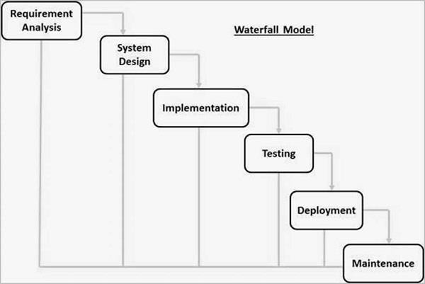

The sequential phases in Waterfall model are −

**Requirement Gathering and analysis** − All possible requirements of the system to be developed are captured in this phase and documented in a requirement specification document.

* + - **System Design** − The requirement specifications from first phase are studied in this phase and the system design is prepared. This system design helps in specifying hardware and system requirements and helps in defining the overall system architecture.
    - **Implementation** − With inputs from the system design, the system is first developed in small programs called units, which are integrated in the next phase. Each unit is developed and tested for its functionality, which is referred to as Unit Testing.
    - **Integration and Testing** − All the units developed in the implementation phase are integrated into a system after testing of each unit. Post integration the entire system is tested for any faults and failures.
    - **Deployment of system** − Once the functional and non-functional testing is done; the product is deployed in the customer environment or released into the market.
    - **Maintenance** − There are some issues which come up in the client environment. To fix those issues, patches are released. Also to enhance the product some better versions are released. Maintenance is done to deliver these changes in the customer environment.

# Tools and Technique

1. Php
2. Xampp
3. Mysql yog
4. HTML
5. Bootstrap
6. Sublime text
7. Git hub
8. Java Script
9. Css

Php

**Hypertext Preprocessor** (or simply **PHP**) is a [server-side scripting](https://en.wikipedia.org/wiki/Server-side_scripting) language designed for [Web](https://en.wikipedia.org/wiki/Web_development) [development,](https://en.wikipedia.org/wiki/Web_development) but also used as a [general-purpose programming language.](https://en.wikipedia.org/wiki/General-purpose_programming_language) It was originally created

by [Rasmus Lerdorf](https://en.wikipedia.org/wiki/Rasmus_Lerdorf) in 1994[,]](https://en.wikipedia.org/wiki/PHP#cite_note-History_of_PHP-5) the PHP [reference implementation](https://en.wikipedia.org/wiki/Reference_implementation) is now produced *by* The PHP Group. PHP originally stood for Personal *Home Page*[,]](https://en.wikipedia.org/wiki/PHP#cite_note-History_of_PHP-5) but it now stands for the [recursive acronym](https://en.wikipedia.org/wiki/Recursive_acronym) *PHP: Hypertext Preprocessor*.

PHP code may be embedded into [HTML](https://en.wikipedia.org/wiki/HTML) code, or it can be used in combination with various [web](https://en.wikipedia.org/wiki/Web_template_system) [template systems,](https://en.wikipedia.org/wiki/Web_template_system) web content management systems, and [web frameworks](https://en.wikipedia.org/wiki/Web_framework). PHP code is usually processed by a PHP [interpreter](https://en.wikipedia.org/wiki/Interpreter_(computing)) implemented as a [module](https://en.wikipedia.org/wiki/Plugin_(computing)) in the web server or as a [Common Gateway](https://en.wikipedia.org/wiki/Common_Gateway_Interface) [Interface](https://en.wikipedia.org/wiki/Common_Gateway_Interface) (CGI) executable. The web server combines the results of the interpreted and executed PHP code, which may be any type of data, including images, with the generated web page. PHP code may also be executed with a [command-line interface](https://en.wikipedia.org/wiki/Command-line_interface) (CLI) and can be used to

implement [standalone](https://en.wikipedia.org/wiki/Computer_software) [graphical applications](https://en.wikipedia.org/wiki/Graphical_user_interface).

Xampp

XAMPP is a [free and open source](https://en.wikipedia.org/wiki/Free_software) [cross-platform](https://en.wikipedia.org/wiki/Cross-platform) [web server](https://en.wikipedia.org/wiki/Web_server) [solution stack](https://en.wikipedia.org/wiki/Solution_stack) package developed by Apache Friends, consisting mainly of the [Apache HTTP Server,](https://en.wikipedia.org/wiki/Apache_HTTP_Server) [MariaDB](https://en.wikipedia.org/wiki/MariaDB) [database](https://en.wikipedia.org/wiki/Database), and [interpreters](https://en.wikipedia.org/wiki/Interpreter_(computing)) for scripts written in the [PHP](https://en.wikipedia.org/wiki/PHP) and [Perl](https://en.wikipedia.org/wiki/Perl) [programming languages](https://en.wikipedia.org/wiki/Programming_language). XAMPP stands for Cross-Platform (X), Apache (A), MariaDB (M), PHP (P) and Perl (P). It is a simple, lightweight Apache distribution that makes it extremely easy for developers to create a local web server for testing and deployment purposes. Everything needed to set up a web server – server application (Apache), database (MariaDB), and

scripting language (PHP) – is included in an extractable file. XAMPP is also cross-platform, which means it works equally well on

Linux, Mac and Windows. Since most actual web server deployments use the same components as XAMPP, it makes transitioning from a local test server to a live server extremely easy as well.

Mysql yog

MySQL Workbench is a unified visual tool for database architects, developers, and DBAs. MySQL Workbench provides data modeling, SQL development, and comprehensive administration tools for server configuration, user administration, backup, and much more. MySQL Workbench is available on Windows, Linux and Mac OS X.

HTML

Hypertext Markup Language (HTML) is the standard [markup language](https://en.wikipedia.org/wiki/Markup_language) for creating [web pages](https://en.wikipedia.org/wiki/Web_page) and [web](https://en.wikipedia.org/wiki/Web_application) [applications.](https://en.wikipedia.org/wiki/Web_application) With [Cascading Style Sheets](https://en.wikipedia.org/wiki/Cascading_Style_Sheets) (CSS) and [JavaScript](https://en.wikipedia.org/wiki/JavaScript), it forms a triad of cornerstone technologies for the [World Wide Web](https://en.wikipedia.org/wiki/World_Wide_Web)[.[4]](https://en.wikipedia.org/wiki/HTML#cite_note-4)

[Web browsers](https://en.wikipedia.org/wiki/Web_browser) receive HTML documents from a [web server](https://en.wikipedia.org/wiki/Web_server) or from local storage and [render](https://en.wikipedia.org/wiki/Browser_engine) the documents into multimedia web pages. HTML describes the structure of a web page [semantically](https://en.wikipedia.org/wiki/Semantic_Web) and originally included cues for the appearance of the document.

[HTML elements](https://en.wikipedia.org/wiki/HTML_element) are the building blocks of HTML pages. With HTML constructs, [images](https://en.wikipedia.org/wiki/HTML_element#Images_and_objects) and other objects such as [interactive forms](https://en.wikipedia.org/wiki/Fieldset) may be embedded into the rendered page. HTML provides a means to

create [structured documents](https://en.wikipedia.org/wiki/Structured_document) by denoting structural [semantics](https://en.wikipedia.org/wiki/Semantics) for text such as headings, paragraphs, lists, [links,](https://en.wikipedia.org/wiki/Hyperlink) quotes and other items.

Bootstrap

Bootstrap is a [free and open-source](https://en.wikipedia.org/wiki/Free_and_open-source_software) front-end framework for designing [websites](https://en.wikipedia.org/wiki/Website) and [web applications](https://en.wikipedia.org/wiki/Web_application). It contains [HTML](https://en.wikipedia.org/wiki/HTML)- and [CSS](https://en.wikipedia.org/wiki/CSS)-based design templates for [typography](https://en.wikipedia.org/wiki/Typography), forms, buttons, navigation and other interface components, as well as optional [JavaScript](https://en.wikipedia.org/wiki/JavaScript) extensions. Unlike many web frameworks, it concerns itself with [front-end development](https://en.wikipedia.org/wiki/Front-end_web_development) only.

Java Script

JavaScript often abbreviated as JS, is a [high-level,](https://en.wikipedia.org/wiki/High-level_programming_language) [interpreted](https://en.wikipedia.org/wiki/Interpreted_language) [programming language](https://en.wikipedia.org/wiki/Programming_language). It is a language which is also characterized as [dynamic,](https://en.wikipedia.org/wiki/Dynamic_programming_language) [weakly typed,](https://en.wikipedia.org/wiki/Weak_typing) [prototype-based](https://en.wikipedia.org/wiki/Prototype-based_programming) and [multi-paradigm](https://en.wikipedia.org/wiki/Multi-paradigm_programming_language).

Alongside [HTML](https://en.wikipedia.org/wiki/HTML) and [CSS,](https://en.wikipedia.org/wiki/CSS) JavaScript is one of the three core technologies of the [World Wide](https://en.wikipedia.org/wiki/World_Wide_Web)

[Web.](https://en.wikipedia.org/wiki/World_Wide_Web) JavaScript enables interactive [web pages](https://en.wikipedia.org/wiki/Web_page) and thus is an essential part of [web applications](https://en.wikipedia.org/wiki/Web_application). The vast majority of [websites](https://en.wikipedia.org/wiki/Website) use it, and all major [web browsers](https://en.wikipedia.org/wiki/Web_browser) have a dedicated [JavaScript engine](https://en.wikipedia.org/wiki/JavaScript_engine) to execute it.

Sublime Text

Sublime Text is a [proprietary](https://en.wikipedia.org/wiki/Proprietary_software) [cross-platform](https://en.wikipedia.org/wiki/Cross-platform) [source code editor](https://en.wikipedia.org/wiki/Source_code_editor) with a [Python](https://en.wikipedia.org/wiki/Python_(programming_language)) [application programming](https://en.wikipedia.org/wiki/Application_programming_interface) [interface](https://en.wikipedia.org/wiki/Application_programming_interface) (API). It natively supports many [programming languages](https://en.wikipedia.org/wiki/Programming_languages) and [markup languages,](https://en.wikipedia.org/wiki/Markup_languages) and functions can be added by users with [plugins,](https://en.wikipedia.org/wiki/Plugins) typically community-built and maintained under [free-software](https://en.wikipedia.org/wiki/Free_software_licenses) [licenses.](https://en.wikipedia.org/wiki/Free_software_licenses)

Github

GitHub is a web-based [hosting service](https://en.wikipedia.org/wiki/Internet_hosting_service) for [version control](https://en.wikipedia.org/wiki/Version_control) using [Git.](https://en.wikipedia.org/wiki/Git) It is mostly used for [computer code.](https://en.wikipedia.org/wiki/Source_code) It offers all of the [distributed version control](https://en.wikipedia.org/wiki/Distributed_version_control) and [source code management](https://en.wikipedia.org/wiki/Source_code_management) (SCM) functionality of Git as well as adding its own features. It provides [access control](https://en.wikipedia.org/wiki/Access_control) and several collaboration features such as [bug](https://en.wikipedia.org/wiki/Bug_tracking_system)

[tracking,](https://en.wikipedia.org/wiki/Bug_tracking_system) [feature requests,](https://en.wikipedia.org/wiki/Software_feature) [task management,](https://en.wikipedia.org/wiki/Task_management) and [wikis](https://en.wikipedia.org/wiki/Wiki) for every project.

GitHub offers plans for both private repositories and free accounts which are commonly used to host [open-](https://en.wikipedia.org/wiki/Open-source) [source](https://en.wikipedia.org/wiki/Open-source) software projects.

Css

Cascading Style Sheets (CSS) is a [style sheet language](https://en.wikipedia.org/wiki/Style_sheet_language) used for describing the [presentation](https://en.wikipedia.org/wiki/Presentation_semantics) of a document written in a [markup language](https://en.wikipedia.org/wiki/Markup_language) like [HTML.](https://en.wikipedia.org/wiki/HTML) CSS is a cornerstone technology of the [World Wide](https://en.wikipedia.org/wiki/World_Wide_Web) [Web,](https://en.wikipedia.org/wiki/World_Wide_Web) alongside HTML and [JavaScript.](https://en.wikipedia.org/wiki/JavaScript)

CSS is designed to enable the separation of presentation and content, including [layout](https://en.wikipedia.org/wiki/Page_layout), [colors](https://en.wikipedia.org/wiki/Color),

and [fonts.](https://en.wikipedia.org/wiki/Typeface) This separation can improve content [accessibility,](https://en.wikipedia.org/wiki/Accessibility) provide more flexibility and control in the specification of presentation characteristics, enable multiple [web pages](https://en.wikipedia.org/wiki/Web_page) to share formatting by specifying the relevant CSS in a separate css file, and reduce complexity and repetition in the structural content.

# Specification Requirement

## External Interfaces

- This interface will be actual interface through which the user will communication with the application and perform the desired tasks.

Admin login

### D:

**Role**: Admin wishes to login to the system

**Precondition**: Username and Password

**Success end Condition**: Main option of screen display

**Failed end Condition**: User has entered incorrect Username and

Password or both

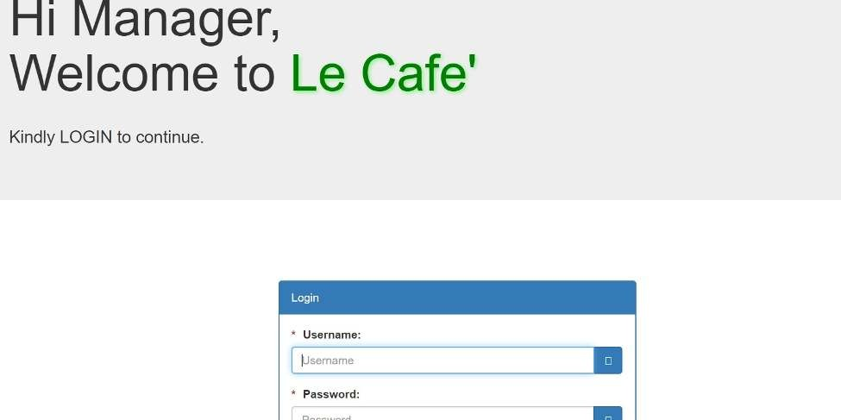

Edit

### ID:

**Precondition:** User has successfully navigated to the search result

**Success end Condition:** User has successfully made the changes

1. To edit user records in the data base, first search the record you want to edit then click on ‘edit’ button.
2. Edit the particulars user that you want to change and click on’ Save’ button.

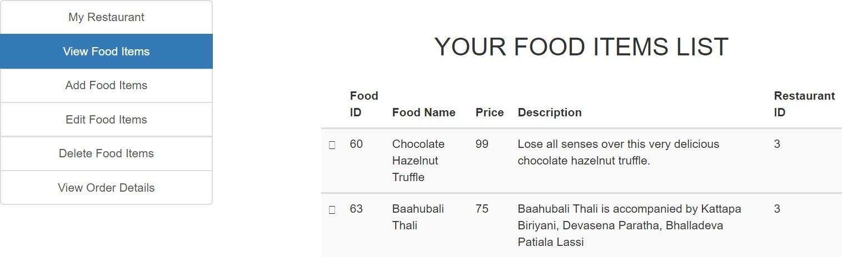

* + 1. Software Product Features

Online Food Order

Login Information System

* Description

-The system will maintain the login information of its user to enter in to the software

* Validating Checks

-Administrator need to login the unique id and password.

-Contact number should have maximum 10 digits.

-All the details must be fill up.

-Email address should be in the proper format.

* Sequencing information

-Login information should be filled before the user allowed.

* Error Handling

-If user doesn’t filled up validate information then the system display error message for user and request to enter the validate information.

Performance required

* Security

-System should be Protected from unauthorized access Where the validate Username and Password are required so no other can access.

* Maintainability

-System should be design in a maintain order. So it can be easily modified.

Logical Database

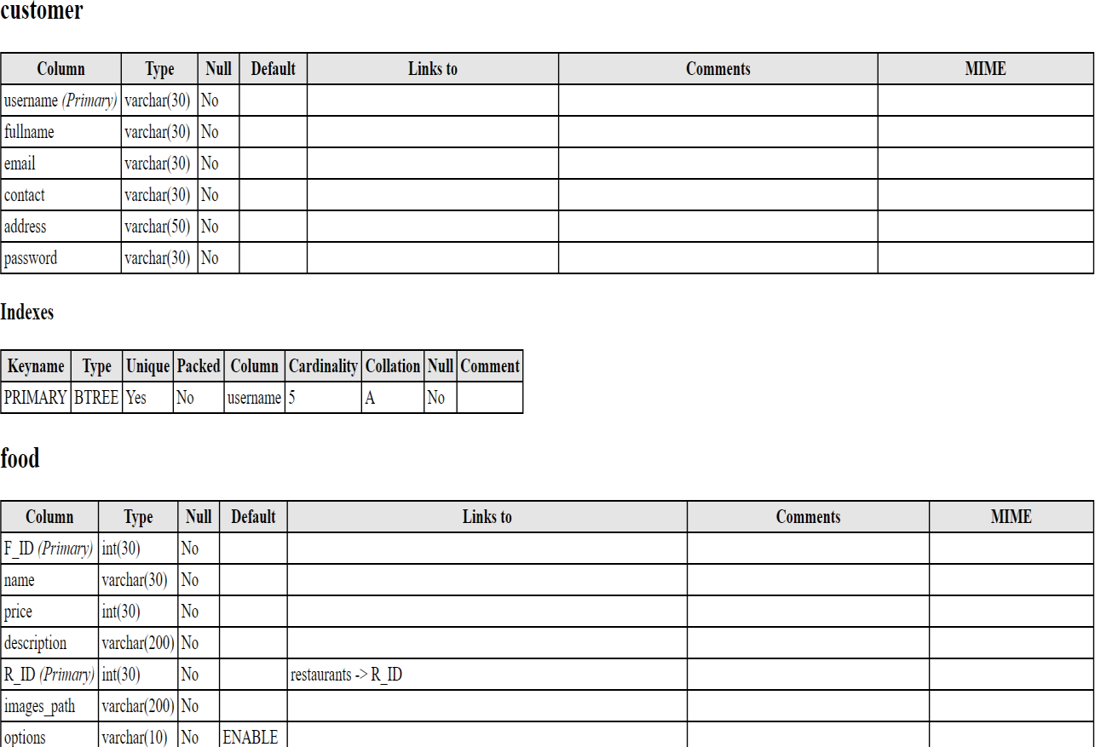

Data Design

Data Model: A database model is a type of data model that determines the logical structure of a database and fundamentally determines in which manner data can be stored, organized and manipulated.

Level 0

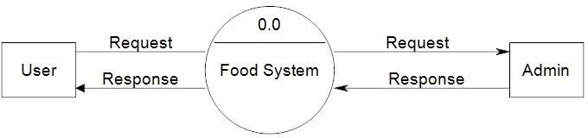

Figure: Data flow

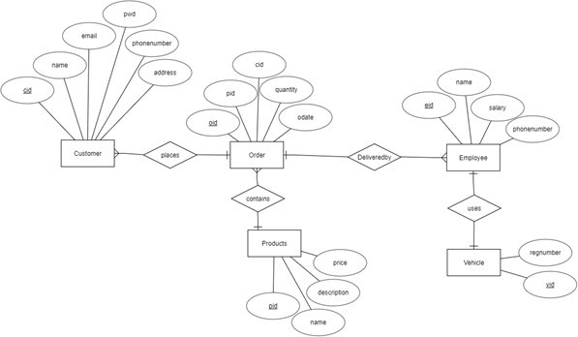

Figure:ER diagram

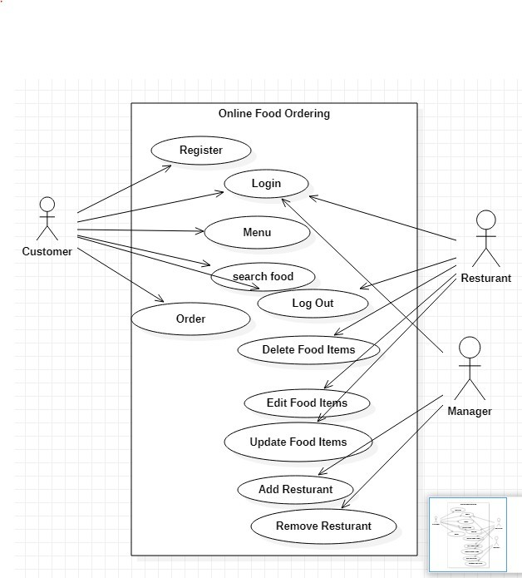

Figure: Use case Diagram of Ecommerce

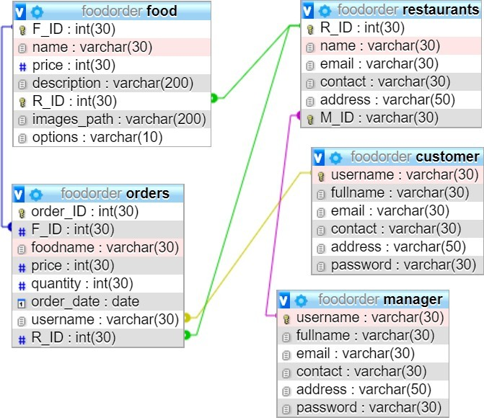

**Figure: Schema Diagram**

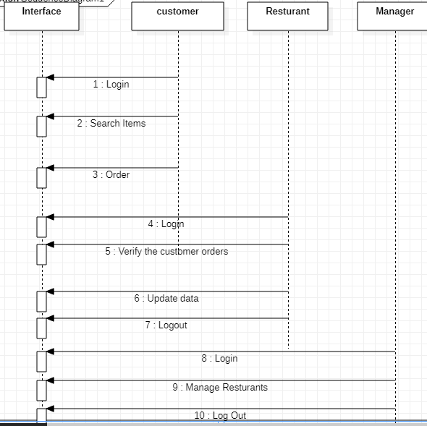

Figure: Sequence Diagram

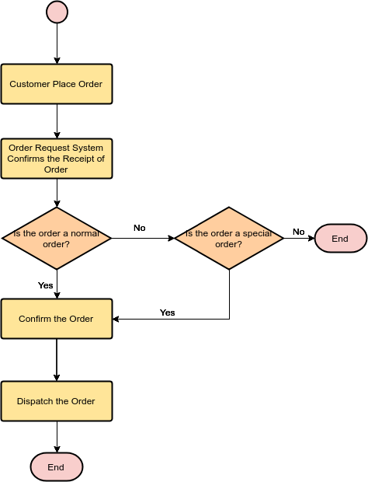

Figure: Flowchart of Ecommerce

## Chapter II: Task and Activities Performed

# Profile of Problems

In the present system all work is done on paper. The order report, food category and food are stored in register and at the end of the session the reports are generated. We are not interested in generating report in the middle of the session or as per the requirement because it takes more time in calculation. The existing system is not user friendly because the retrieval of data is very slow and data is not maintained efficiently. We require more calculations to generate the report so it is generated at the end of the session. All calculations to generate report is done manually so there is greater chance of errors.

# Structure of the project

## Before Login

* + Login

## Register

* + Administrator Login

## About Us

* + Contact Us

## After Administrator Login

* + Edit Website Details

## Add Food Items

* + Remove food Items

## Add Restaurants

* + Delete Restaurant

## Logout

* After User Login

## My Profile

* + Menu

## Search Food Items

* + My Cart

## Order

* + Logout

# Scope and Feasibility

## This activity is also known as the feasibility study. It begins with a request from the user for a new system. It involves the following:

* + - Identify the responsible user for a new system

## Clarify the user request

* + - Identify deficiencies in the current system

## Establish goals and objectives for the new system

* + - Determine the feasibility for the new system
    - Prepare a project charter that will be used to guide the remainder of the Project

# System Analysis

## It is a process of collecting and interpreting facts, identifying the problems, and decomposition of a system into its components.

System analysis is conducted for the purpose of studying a system or its parts in order to identify its objectives. It is a problem solving technique that improves the system and ensures that all the components of the system work efficiently to accomplish their purpose.

## The objective of the system analysis activity is to develop structured system specification for the proposed system. The structured system specification should describe what the proposed system

would do; independent of the technology, which will be used to implement these requirements. The structured system specification will be used to implement these requirements.

## The essential model may itself consist of multiple models, modeling different aspect of the system. The data flow diagrams may model the data and there relationships and the state transition diagram may model time dependent behavior of the system. The essential model thus consists of the following.

* + - Context diagram

## Leveled data flow diagrams

* + - Process specification for elementary bubbles
    - Data dictionary for the flow and stores on the DFDs.

# System Design

## System design involves transformation of the user implementation model into software design. The design specification of the proposed system consists of the following:

* + - Database scheme

## Structure charts

* + - Pseudo codes for the modules in structure charts

# Implementation

This activity includes programming, testing and integration of modules into a progressively more complete system. Implementation is the process of collect all the required parts and assembles them into a major product.

# Test Generation

This activity generates a set of test data, which can be used to test the new system before accepting it. In the test generation phase all the parts are come which are to be tested to ensure that system does not produce any error. If there are some errors then we remove them and further it goes for accepting.

# Screen Shot

Home Page

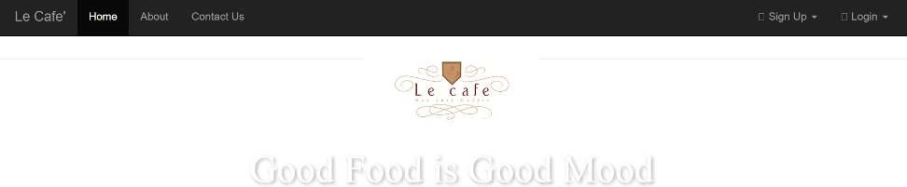

Contact Page

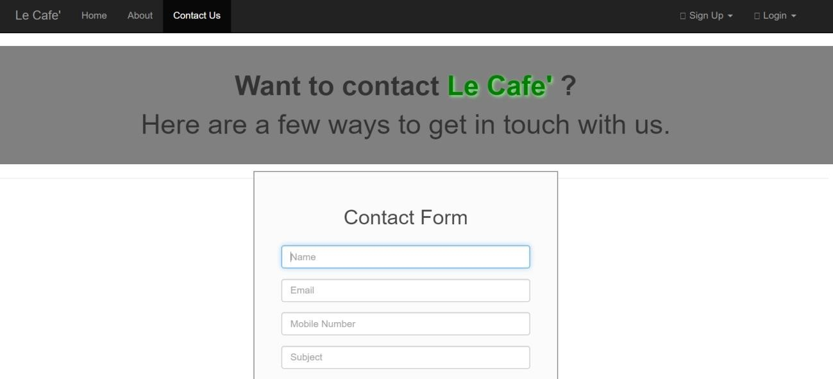

User Signup page

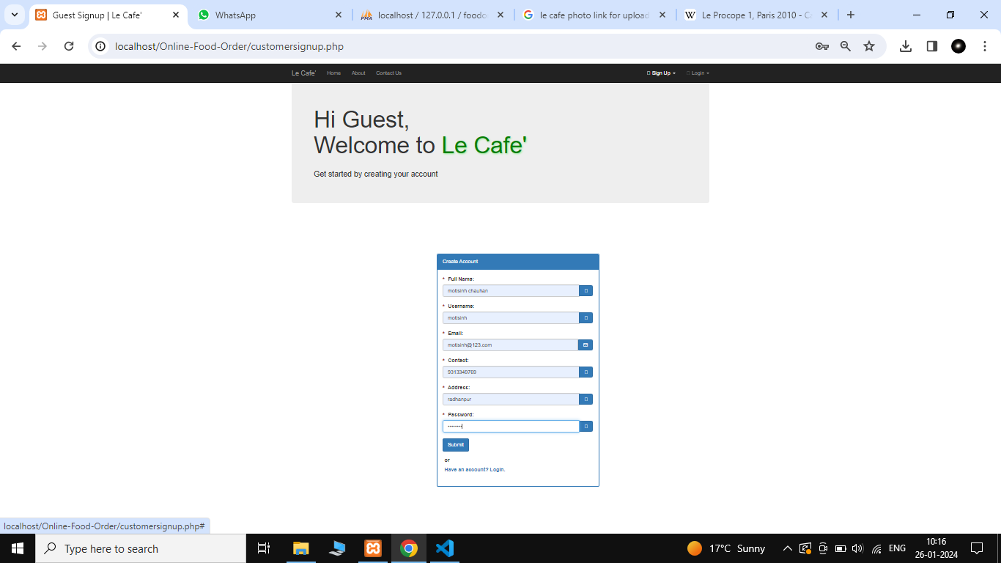

User login page

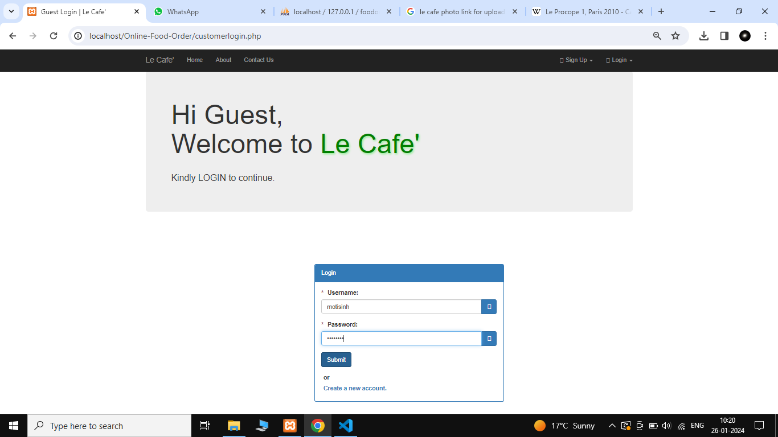after user login

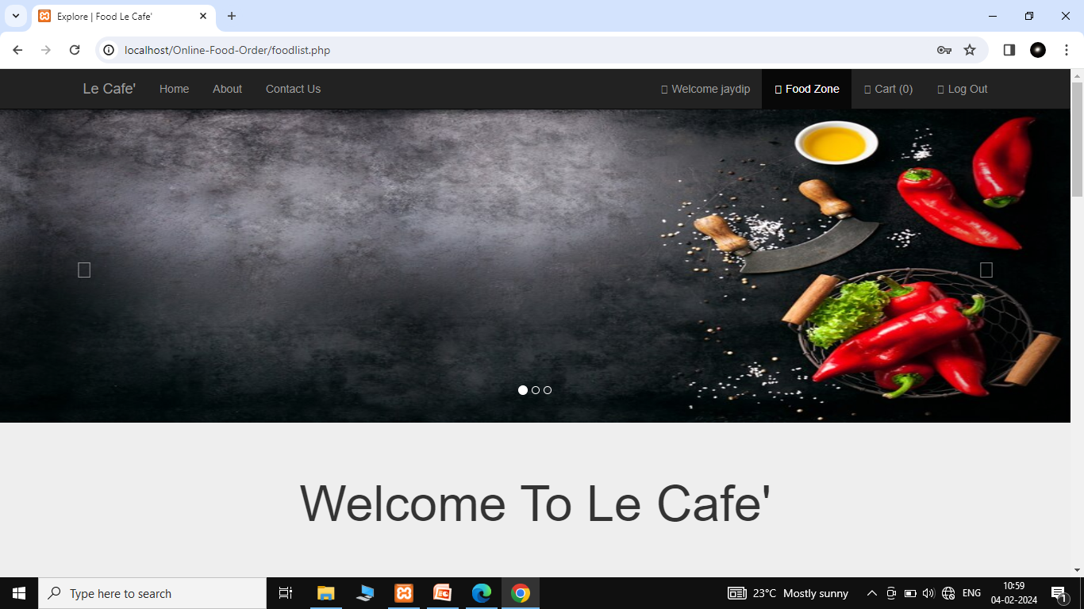

Food list show

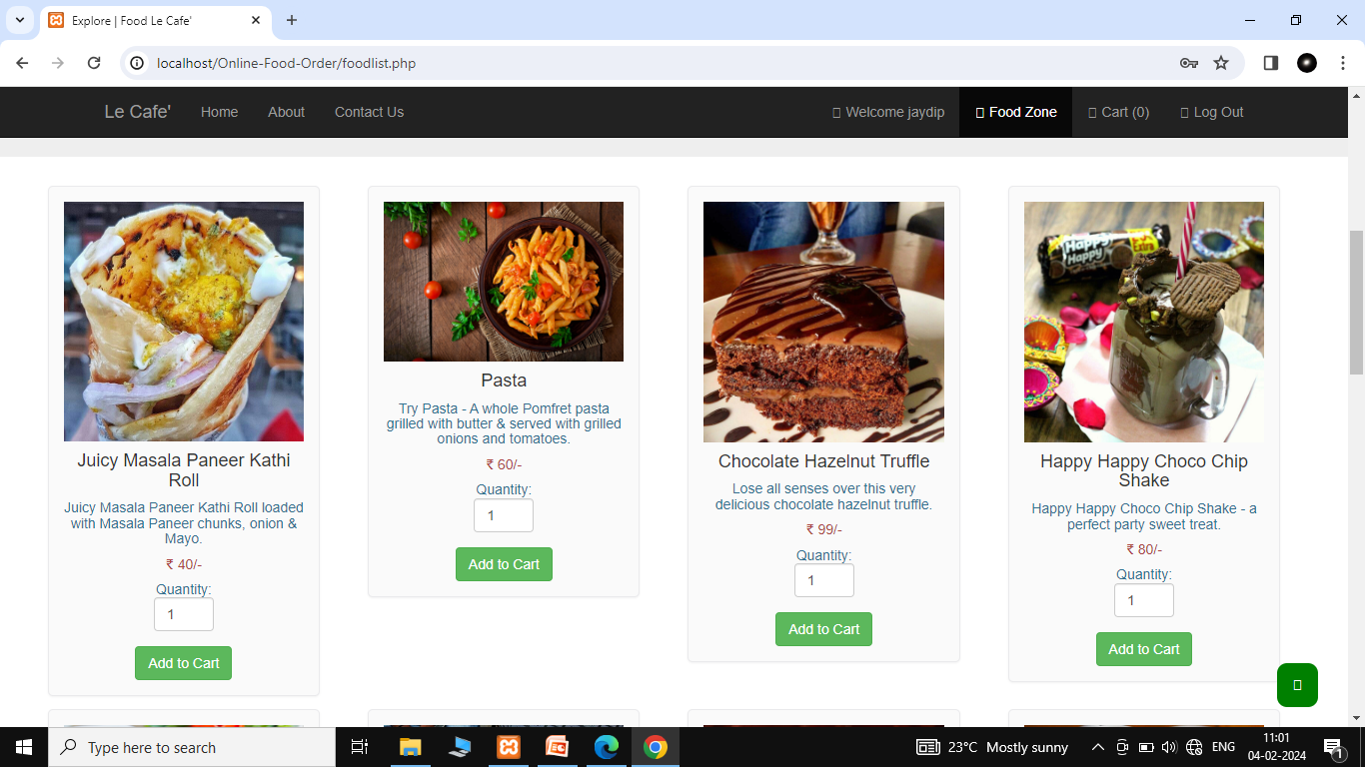

Cart

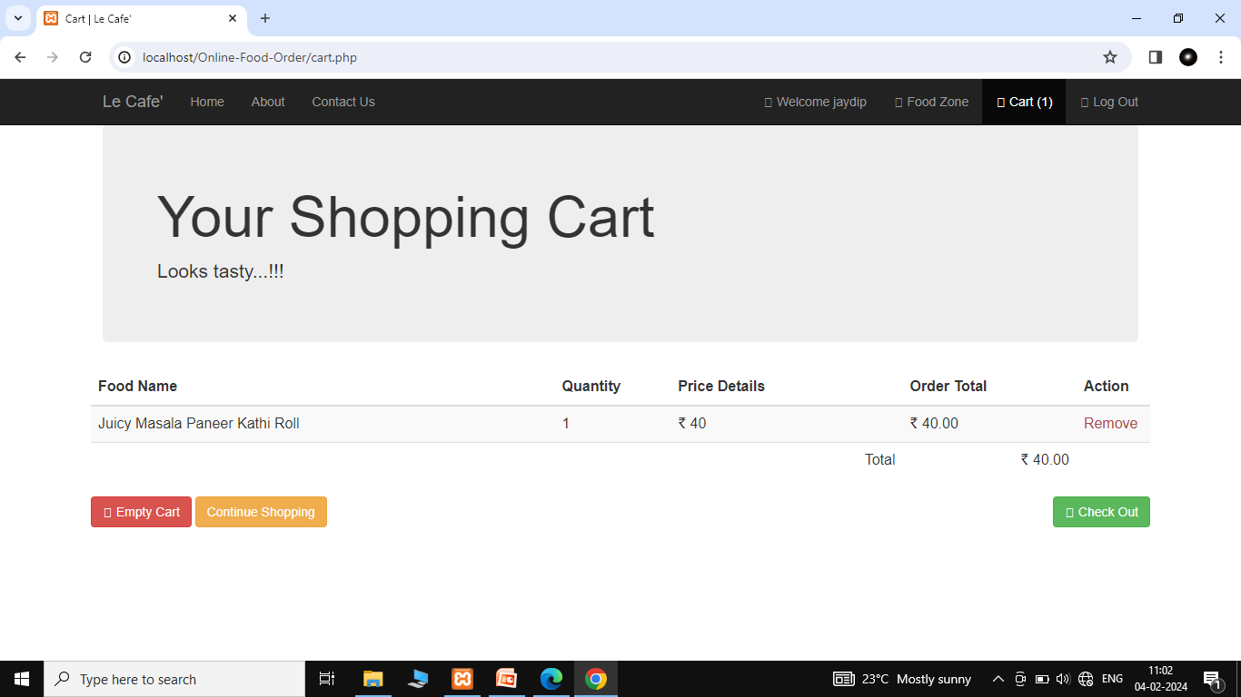

Paymentoption

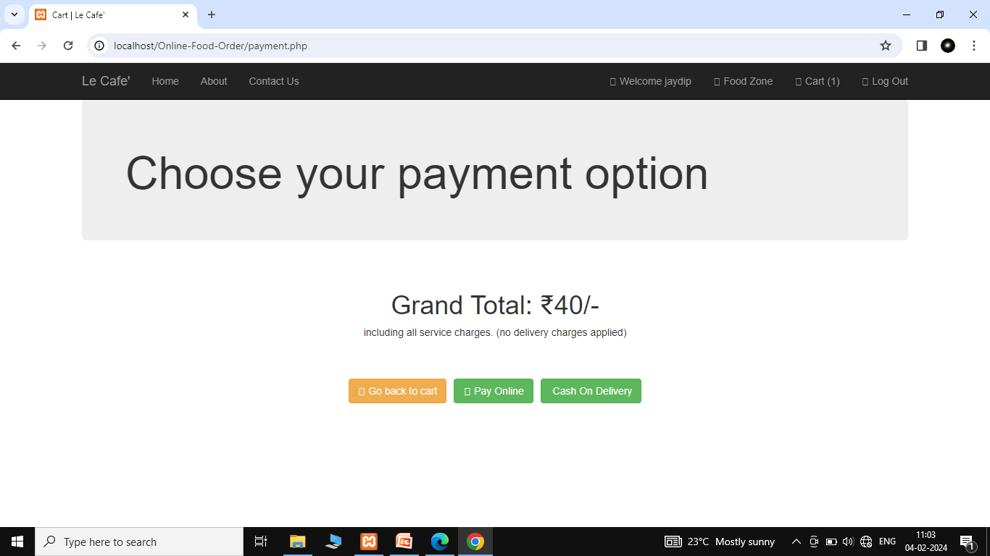

Order placed successfully

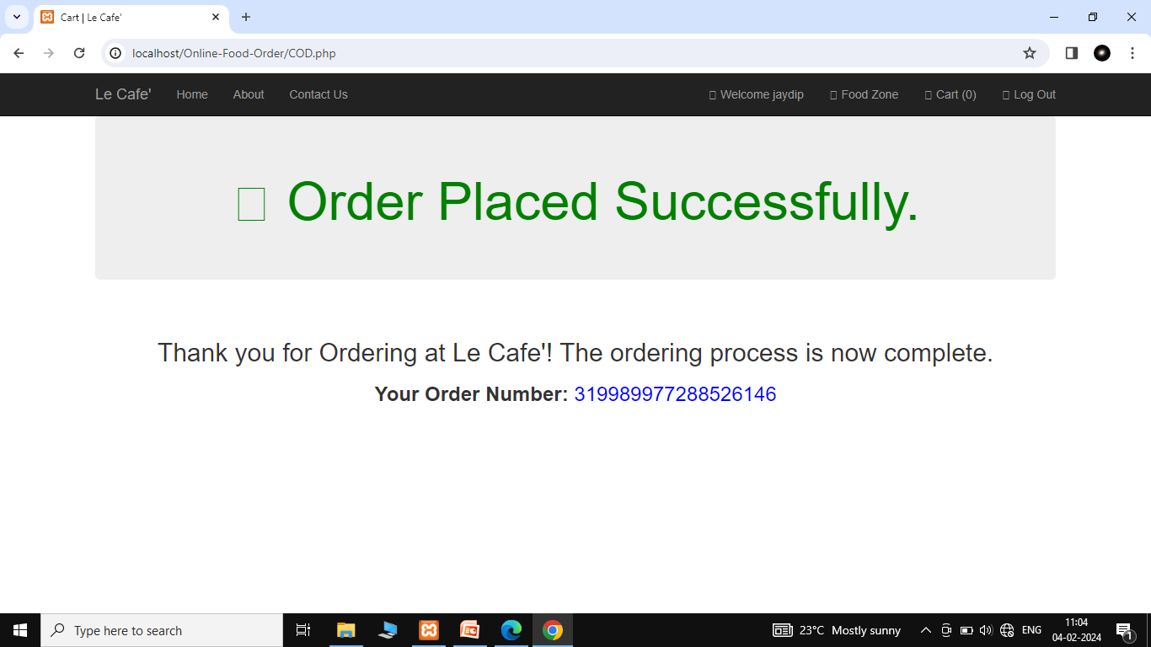

Manager control panel

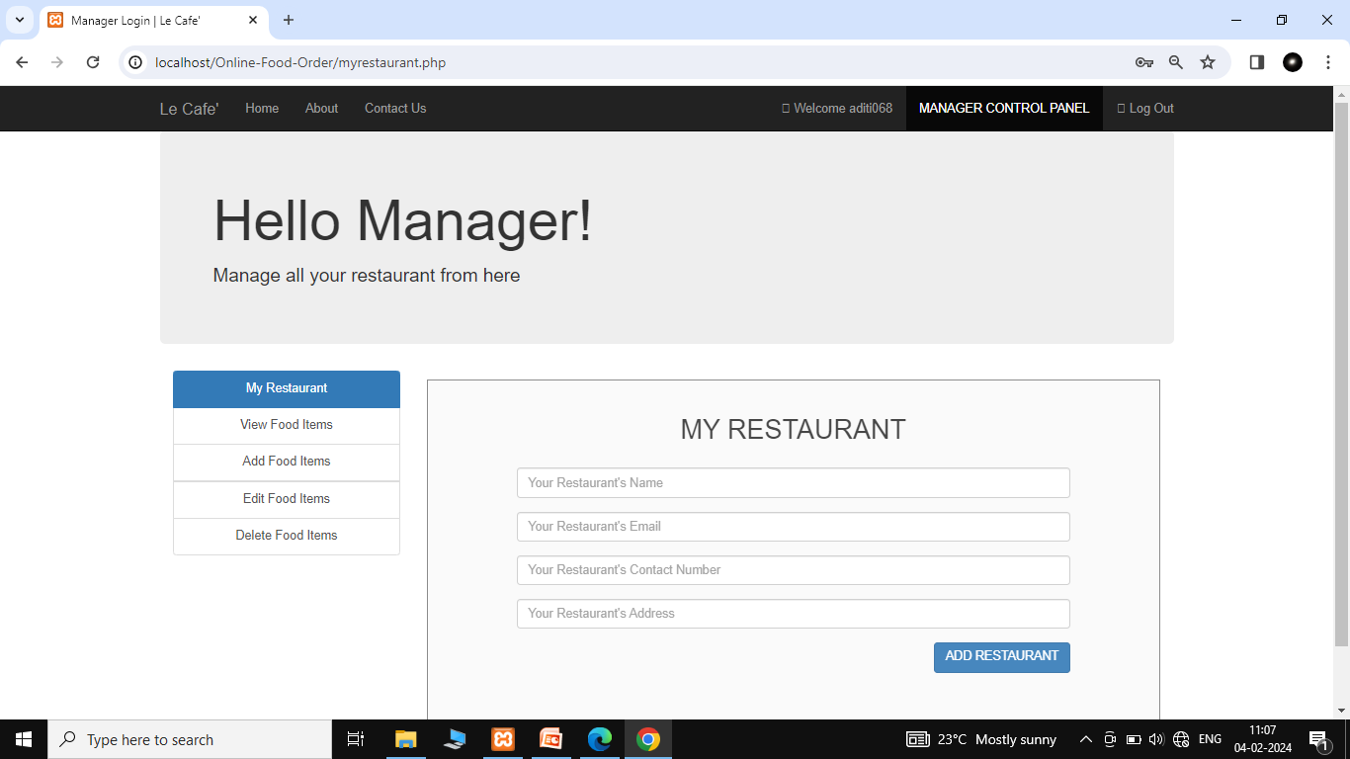

View food order detail

