A Project Report On

# Zoo Management system

Post-Graduation

Master of Computer Application Silver Oak College of Computer Application



Submitted to Department of Computer Application

Master of Computer Application Silver Oak College of Computer Application

Silver Oak University

Submitted By:

Manav Dhorajiya (2404070100236)

Ronak Vadodariya

(2404070100253)

Jaydip Poriya

(2404070100284)

Under the Guidance of Mr. AKASH KUMAR

Department of Computer Application Master of Computer Application Silver Oak College of Computer Application



## Silver Oak College of Computer Application Department of Computer Application Masters of Computer Application

**Certificate**

**Date**: /12/2024

This is to certify that the project report submitted along with the project entitled **Zoo Management** has been carried out by **Dhorajiya Manav (2404070100236)** under guidance of Mr. Akash Kumar in fulfilment of the MCA (Sem-1), Degree of Master of Computer Application at Silver Oak College of Computer Application, Silver Oak University, Ahmedabad during the academic year 2024-25.

Mr. Akash Kumar

Project Guide HOD



## Silver Oak College of Computer Application Department of Computer Application Masters of Computer Application

**Certificate**

**Date**: /12/2024

This is to certify that the project report submitted along with the project entitled **Zoo Management System** has been carried out by **Ronak vadodariya (2404070100253)** under guidance of Mr. Akash Kumar in fulfilment of the MCA (Sem-1), Degree of Master of Computer Application at Silver Oak College of Computer Application, Silver Oak University, Ahmedabad during the academic year 2024-25.

Mr. Akash Kumar

Project Guide HOD



## Silver Oak College of Computer Application Department of Computer Application Masters of Computer Application

**Certificate**

**Date**: /12/2024

This is to certify that the project report submitted along with the project entitled **Zoo Management System** has been carried out by **Jaydip Poriya (2404070100284)** under guidance of Mr. Akash Kumar in fulfilment of the MCA (Sem-1), Degree of Master of Computer Application at Silver Oak College of Computer Application, Silver Oak University, Ahmedabad during the academic year 2024-25.

Mr. Akash Kumar

Project Guide HOD



# Acknowledgement

We would like to extend our sincere gratitude to all those who supported and guided us throughout the development of the "Spicy Village" project. First and foremost, we express our deep appreciation to our project mentor/advisor for their continuous guidance, valuable insights, and encouragement. Their expertise and suggestions helped shape the direction of this project and ensured that we remained focused and motivated.

Our heartfelt thanks go to the entire development and design team who worked diligently to bring this project to fruition. Their technical expertise in web development and design played a crucial role in creating an engaging, user-friendly, and visually appealing website. Special mention goes to the content creators and media team for providing captivating images, copy, and visual elements that enhanced the overall user experience and effectively communicated the brand message.

Lastly, we would like to thank the Spicy Village team for their collaboration and input, as well as the testing and QA team for ensuring the website's functionality, security, and performance. We also appreciate the various tools and technologies that were used, from web development frameworks to third-party services, which helped us build a seamless experience for our users. To everyone who contributed, your support and effort were invaluable to the success of this project.

# 

# Preface

The Math Patterns App is designed as a cutting-edge, interactive educational tool that brings mathematical concepts to life through visual representations. The core goal of the app is to simplify and enhance the understanding of complex mathematical operations by providing users with dynamic and interactive visual aids. This app focuses on presenting visual mathematical calculations, particularly in the areas of set theory and its related operations, with the intention of making abstract mathematical ideas more tangible and comprehensible.

In the modern educational landscape, the ability to interact with and visualize mathematical processes is invaluable. Traditional methods of teaching and learning mathematics often rely heavily on theoretical explanations and written formulas, which can sometimes be challenging for learners to grasp, especially when dealing with concepts like set operations, algebraic structures, and mathematical theorems. The Math Patterns App addresses this challenge by offering a hands-on approach, where users can explore, experiment, and learn through visual demonstrations of mathematical functions.

The purpose of this project is to create a dynamic, user-friendly website for "Spicy Village," a restaurant specializing in a variety of flavourful dishes. This website aims to provide a platform where customers can easily access information about the restaurant's menu, place orders, and learn about the restaurant's history and unique offerings. The primary goal of this project is to enhance customer engagement, streamline the ordering process, and improve the overall online presence of Spicy Village.

|  |  |  |  |  |  |
| --- | --- | --- | --- | --- | --- |
| **INDEX** | | | | | |
| SR. NO | TITLE | | | | PAGE NUMBER |
| 1 | PROJECT TITLE | | | | 5 |
| 2 | PROBLEM DEFINITION | | | | 5 |
| 3 | NEED OF PROJECT | | | | 6 |
| 3.1 | CURRENT SYSTEM AND ITS DRAWBACK | | | 7 |
| 3.2 | PROPOSED SYSTEM AND ITS FEATURE | | | 7 |
| 4 | REQUIREMENT | | | | 9 |
| 4.1 | SOFTWARE (CLIENT SIDE AND SERVER SIDE) | | | 9 |
| 4.2 | HARDWARE (CLIENT SIDE AND SERVER SIDE) | | | 10 |
| 5 | TIME DURATION | | | | 10 |
| 6 | TECHNOLOGY USED | | | | 10 |
| 7 | FUNCTIONAL AND NON- FUNCTIONAL DEPENDENCY | | | | 11 |
| 8 | DESIGN | | | | 11 |
| 8.1 | | SYSTEM FLOW DIAGRAM | | 11 |
| 8.2 | | UML DIAGRAMS OR DATA FLOW DIAGRAM | | 12 |
| 8.2.1 | USE CASE OR CONTEXT LEVEL / 0 LEVEL | 12 |
| 8.2.2 | ACTIVITY OR FIRST LEVEL | 12 |
| 8.3 | | ER DIAGRAM | | 13 |
| 8.4 | | SCREENSHOTS OF MODULE | | 14 |
| 9 | FUTURE SCOPE | | | | 28 |
| 10 | REFERENCES | | | | 29 |

**1) Project Title:**

### **Zoo Management System**

**2) Problem Definition**:

* Before the introduction of the Safari Zoo Management System, purchasing tickets for the zoo was an arduous and time-consuming process, characterized by long queues and limited accessibility. Visitors often faced the following challenges:
* **Inconvenient Queues:** Visitors had to endure long queues at the zoo's ticket counters, resulting in extended waiting times and frustration.
* **Limited Ticketing Options:** The absence of an online ticketing system meant that visitors had only one way to obtain tickets, making it difficult for those unable to visit the zoo in person.
* **Lack of Information:** Visitors had limited access to real-time information about zoo timings and exhibits, making it challenging to plan their visits effectively.
* **Manual Ticket Issuance:** Ticket issuance was a manual process, prone to errors and inefficiencies, often leading to incorrect ticket information.
* **Visitor Discomfort:** The lengthy ticketing process often resulted in visitor discomfort, impacting their overall zoo experience and discouraging repeat visi

**3) Need of Project:**

* SAFARI Aims to provide a comprehensive and unified platform that simplifies zoo management tasks, including efficient animal care and an engaging visitor experience
* A **Zoo Management System (ZMS)** is crucial for improving the operational efficiency of zoos, ensuring the welfare of animals, enhancing visitor experiences, and streamlining staff management. Given the increasing complexity of managing zoos, especially with the integration of modern technologies, the need for an automated, user-friendly, and comprehensive zoo management system has never been greater. Below are some key reasons highlighting the **need** for such a system:
* A **Zoo Management System** project definition is necessary to clearly identify and address the specific challenges that zoos face in managing their operations. Defining the project provides clarity, structure, and a focused objective
* that guides the development of an efficient management solution
* **Current Project:**
* The current zoo management system typically involves integrated software that streamlines various aspects of zoo operations.
* A Zoo Management System (ZMS) is a software application used to streamline and automate the processes involved in managing a zoo. This typically includes handling animal records, managing staff, maintaining visitor data, and overseeing operations like ticketing, inventory, and animal care. The "current system" you’re referring to could relate to an existing implementation or a project you're developing.
* To give you a comprehensive answer, I’ll explain the key components of a typical Zoo Management System in its current form, including the strengths and weaknesses of such systems. This could be relevant if you’re analyzing an existing system for a project or looking to understand what a functional zoo management system includes.

**3.1) Drawbacks of the Current Project:**

* + **Integration Issues:** Multiple software tools often don’t work seamlessly together, causing data silos.
  + **High Costs:** Implementation and maintenance are expensive, especially for smaller zoos.
  + **Data Privacy Risks**: Sensitive animal and visitor data may be vulnerable to security breaches.
  + **Limited Real-Time Monitoring:** Tracking animal behavior or environmental conditions in real-time is often inadequate.
  + **Customization Limits**: Many systems lack flexibility to meet the specific needs of diverse zoos.
  + **Resistance to Technology:** Staff may resist adopting new systems due to lack of training or familiarity.
  + systems or personalized recommendations based on eating habits.

**3.2 Features of the Proposed Solution:**

* **Expansion of Service Area**:
  + **Nationwide Coverage**: Expand the platform to additional cities and regions to cater to a larger audience. The goal is to reach all major metropolitan areas and expand to smaller cities over time.
  + **International Expansion**: As the platform matures, potential international expansion could be explored.
* **Flexible Subscription & On-Demand Models**:
  + **Multiple Delivery Models**: Provide not only subscription-based services but also an **on-demand** option, where users can order meals without subscribing to a plan.
  + **Customizable Subscription Plans**: Allow users to choose their subscription plan based on their dietary preferences, number of meals per week, and meal types (e.g., vegetarian, non-vegetarian, vegan, gluten-free).
  + **Pay-per-Meal Options**: In addition to the existing subscription plans, offer a pay-per-meal system where users can order meals
* **Broader Meal Selection & Customization**:
  + **Meal Personalization**: Allow users to customize their meals based on preferences, dietary restrictions, allergies, or special needs (e.g., low-carb, keto, paleo).
  + **Expanded Menu Options**: Offer a more diverse and dynamic menu with seasonal dishes, regional Flavors, and special promotions (e.g., healthy snacks, smoothies, and desserts).
  + **Build-Your-Meal Option**: Users can create their own meals by selecting ingredients or types of proteins, carbs, and vegetables.
* **Advanced Delivery and Tracking System**:
  + **Real-Time Tracking**: Implement real-time GPS tracking for deliveries so customers can monitor their food’s journey in real-time.
  + **Faster Delivery**: Optimize delivery logistics by partnering with more local delivery providers or improving fleet management, aiming for more accurate and reliable delivery windows.
  + **Dynamic Delivery Windows**: Instead of a strict 20-minute delivery guarantee, implement a more realistic window (e.g., 30–40 minutes) based on real-time traffic and distance calculations.
* **Customer Feedback and Engagement**:
  + **Rating and Review System**: Allow customers to rate meals, delivery, and service quality, and provide suggestions for improvement.
  + **Loyalty Program**: Implement a rewards program that incentivizes repeat customers, offering discounts, freebies, or special deals based on order frequency and loyalty.
  + **Personalized Recommendations**: Use data analytics to recommend meals based on previous orders, preferences, and dietary habits.
* **Better User Interface (UI) & User Experience (UX)**:
  + **Intuitive Interface**: Simplify the app and website interface for easy navigation and an enjoyable ordering experience.
  + **Multilingual Support**: Include language options to make the platform accessible to a larger audience.
  + **Customized Dashboard**: Users can access personalized dashboards where they can track their subscriptions, meal history, and upcoming orders, along with dietary progress or goals.

**4) Requirement**

**4.1) Software**

* Client side:
* Operating Systems:

Windows 10/11, macOS, iOS, Android

* Web Browsers:

Latest versions of Chrome, Firefox, Safari, Edge

* Development Tools:

HTML, CSS, JavaScript, jQuery

* **Server side:**

PHP , MYSQL

* 1. **Hardware Requirements:**
* Devices:

Desktop/Laptop: Intel i5 or higher, 8GB RAM, 256GB SSD

* Peripherals:

High-resolution monitors for design and development Testing devices for different screen sizes and resolutions.

## 5) Time During:

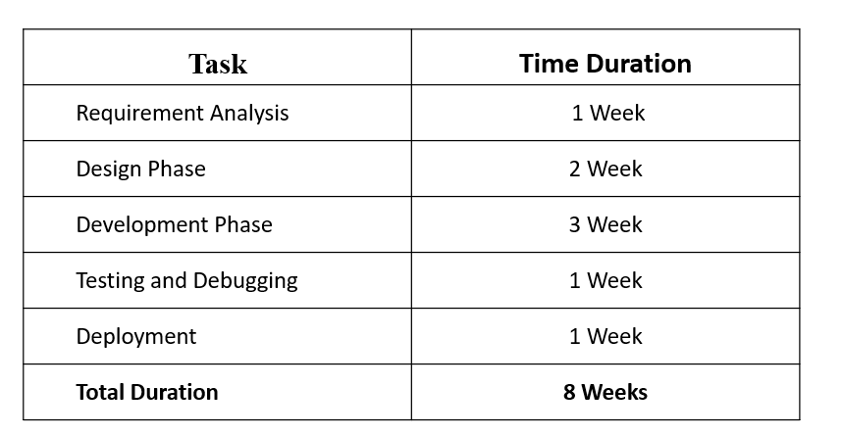

### **6)Technologies Used :**

 **Frontend**: HTML, CSS, jQuery

 **Responsive Design:** Bootstrap

 **Backend:** PHP

**Database:** MySQL



7) **Function and Non Function Dependency :**

* **Functional dependency** refers to the relationship between attributes (fields) in a database where one attribute uniquely determines the value of another. In simple terms, if knowing one attribute allows you to determine the value of another attribute, then the second attribute is functionally dependent on the **first one.**
* **Non-functional dependency** refers to aspects of the system that are not directly related to the functional tasks of the system (i.e., it’s not about how the system should work, but about how well it performs or behaves under certain conditions). These dependencies focus on the quality attributes of the system.

**8) Design :**

**8.1) System Flow Diagram :**

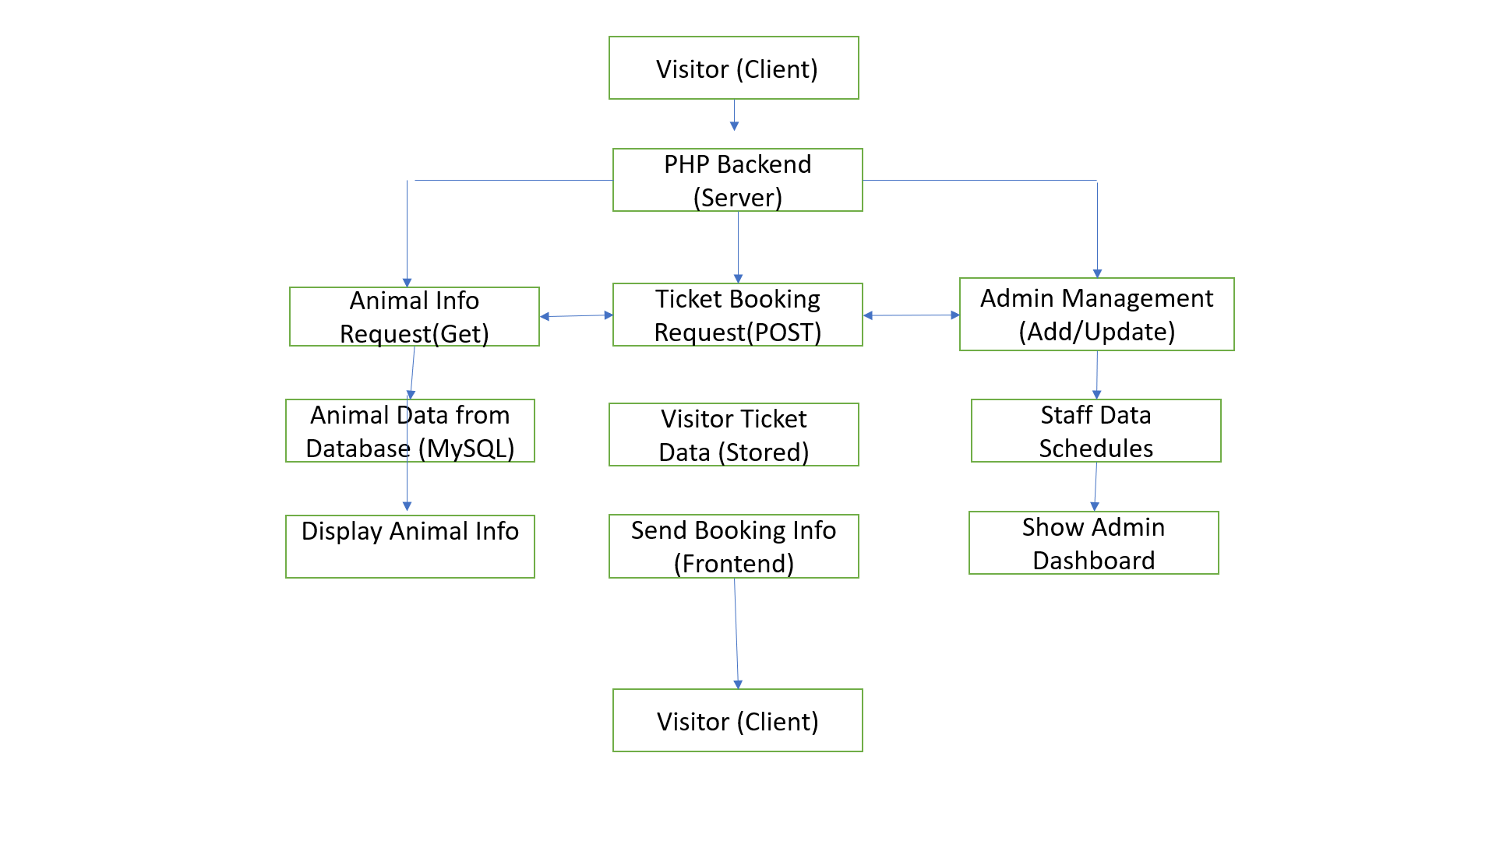

**8.2) Data Flow Diagram :**

**8.2.1) UML Use case diagram**

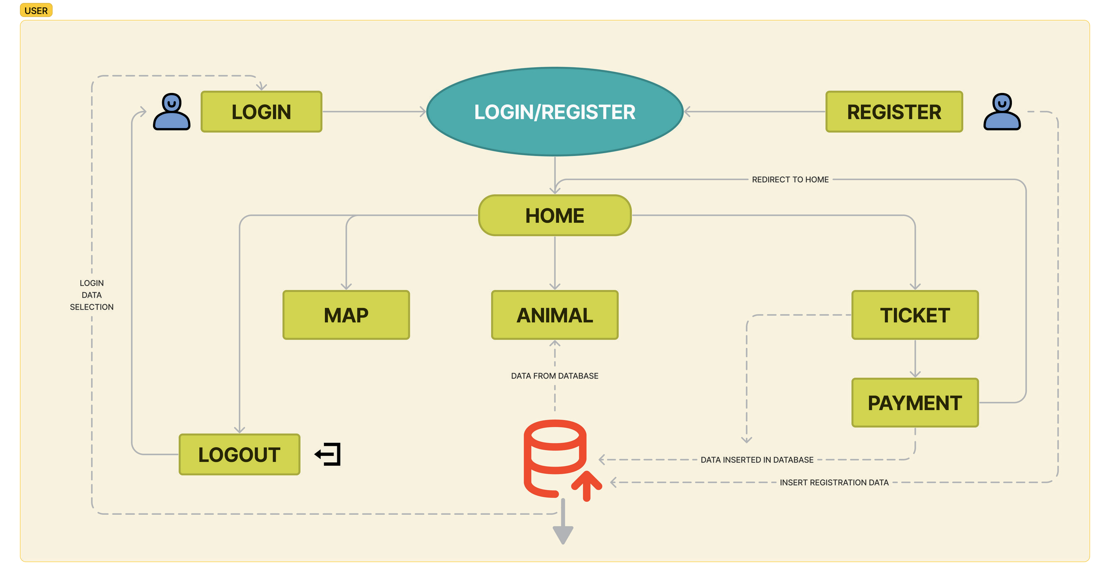

**8.2.2) Activity diagram**

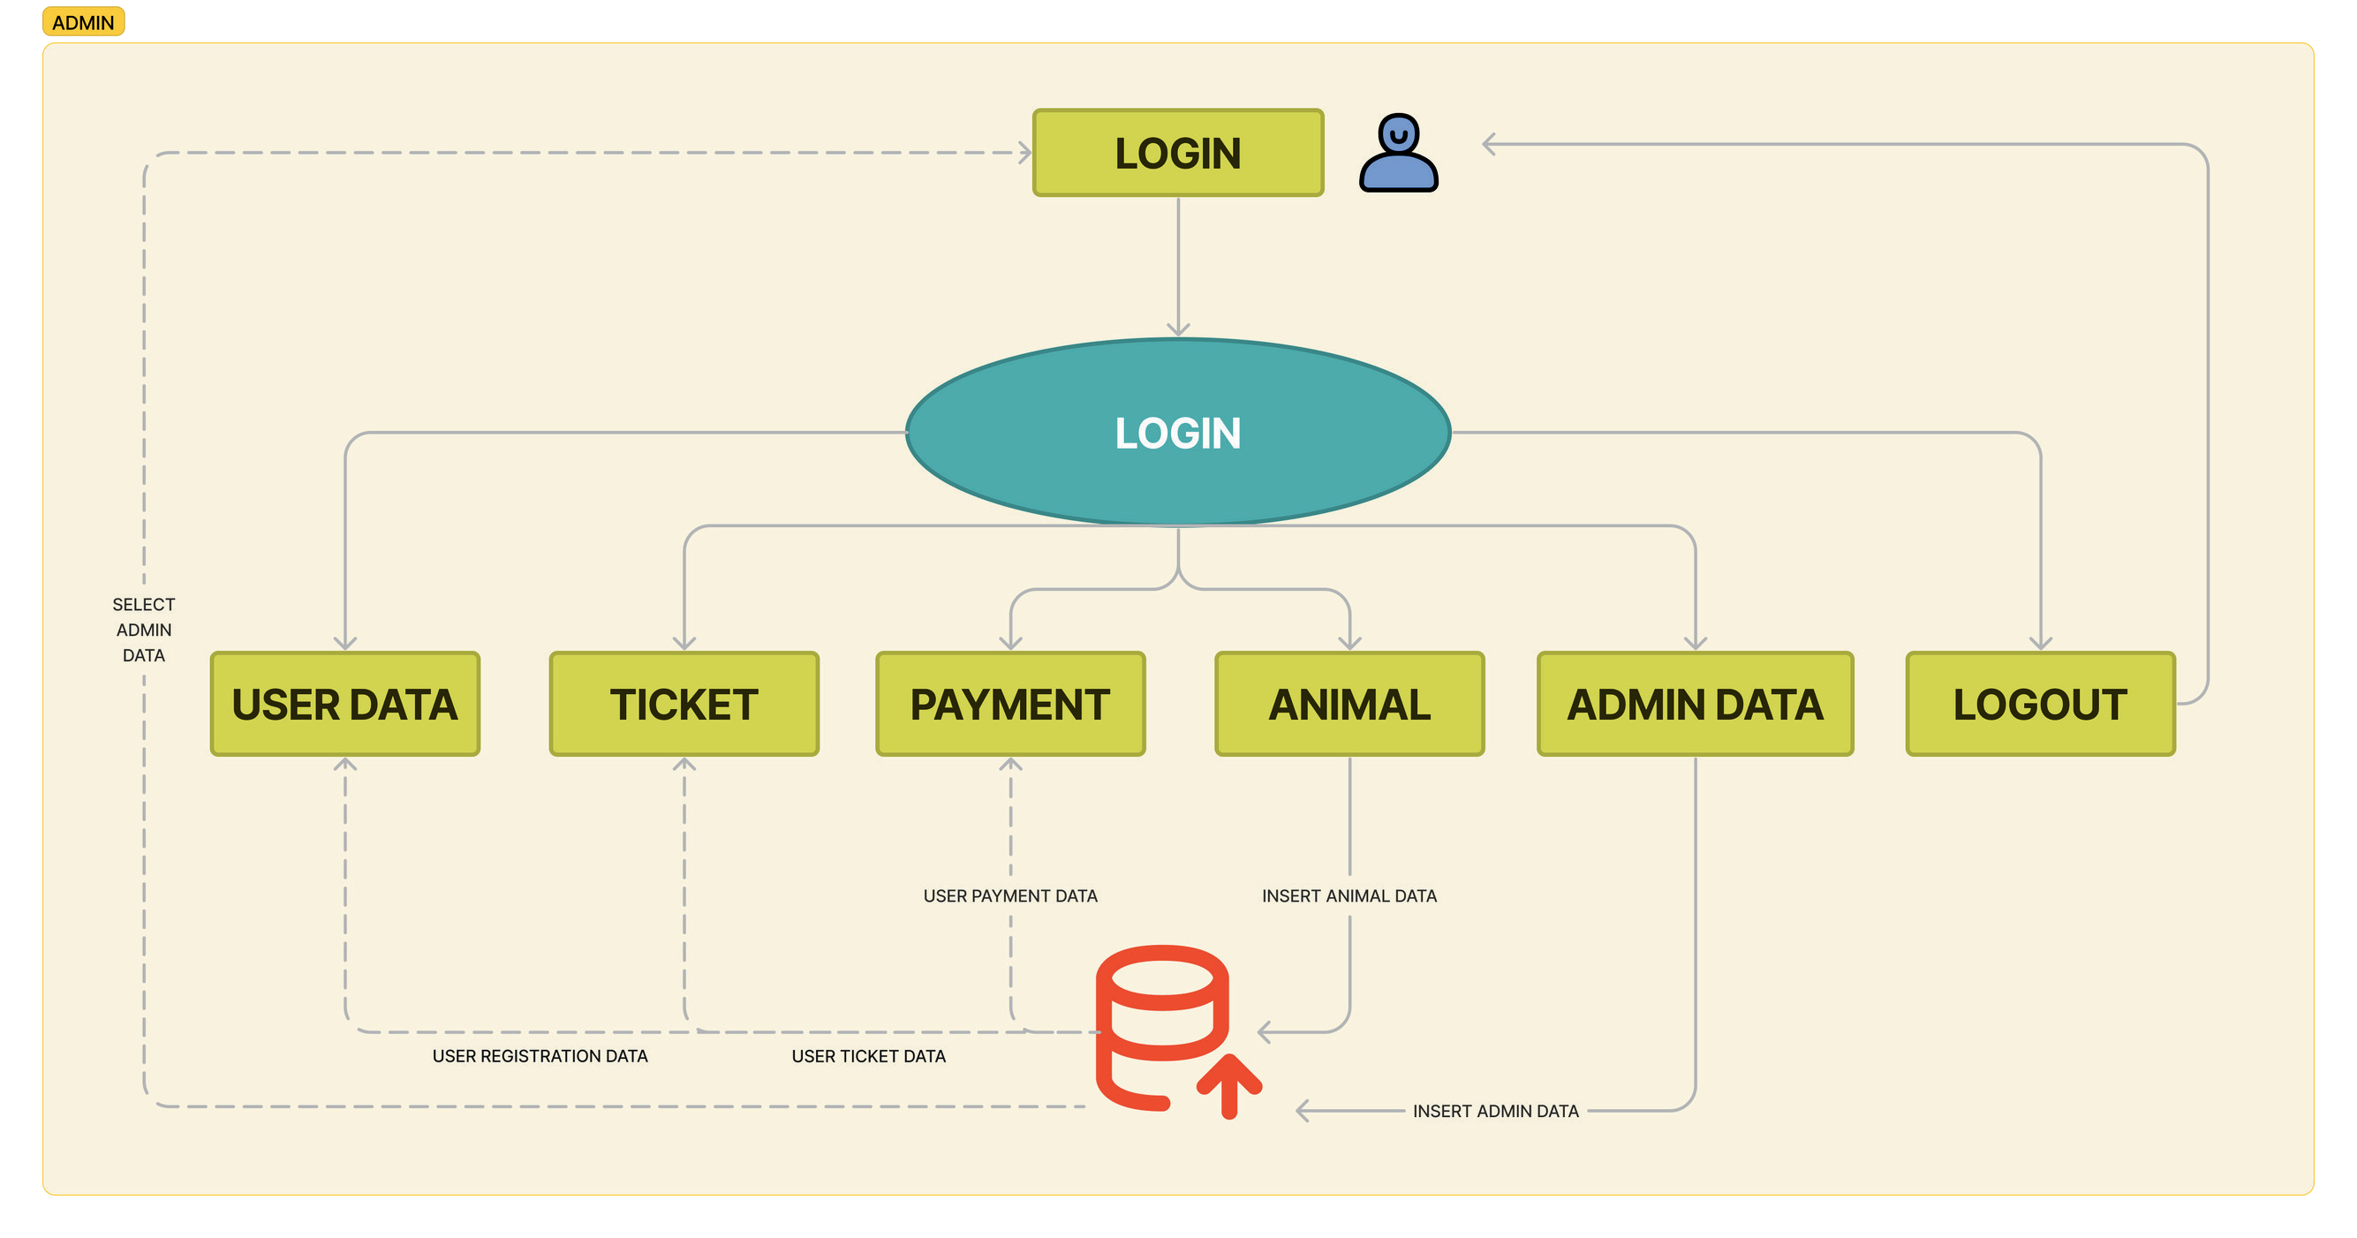**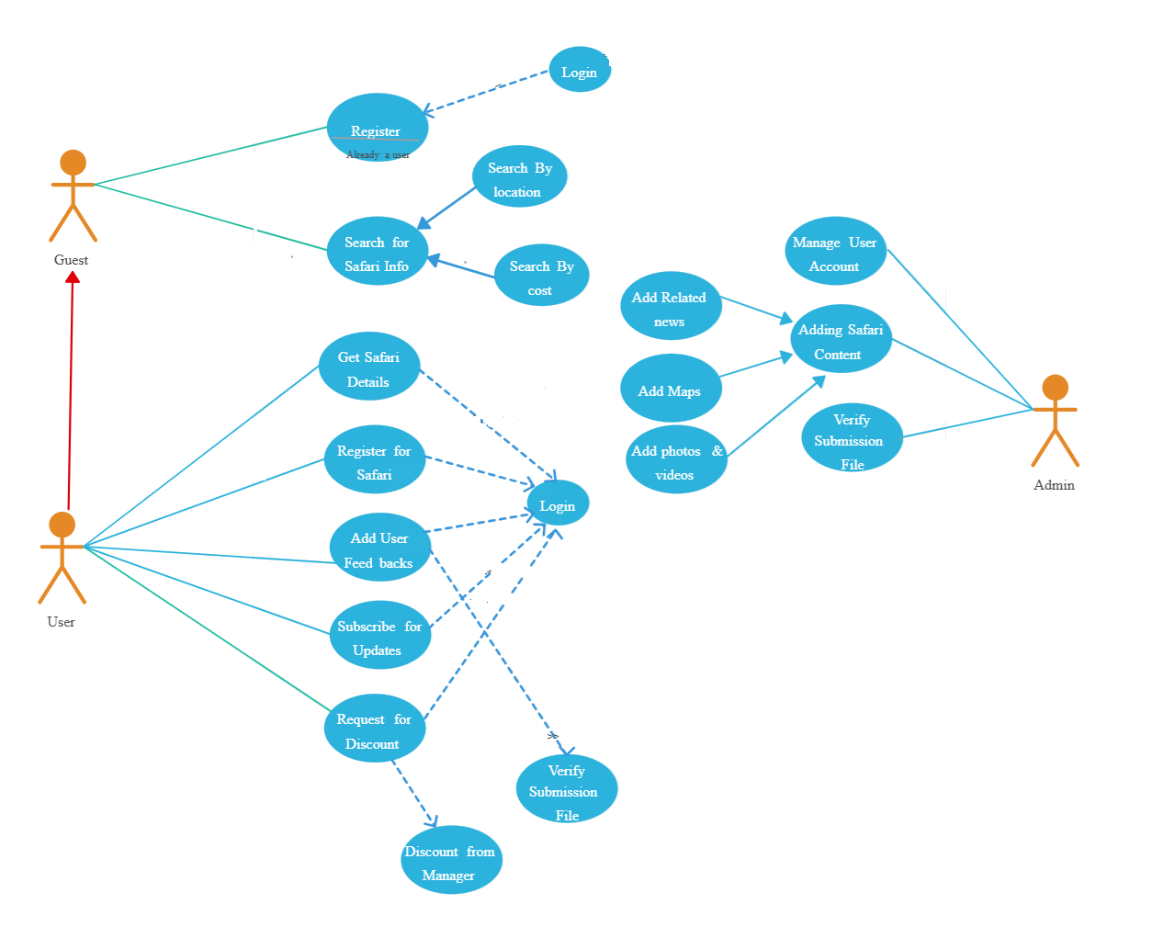8.3) E-R Diagram :**

**8.4 Data Dictionary:**

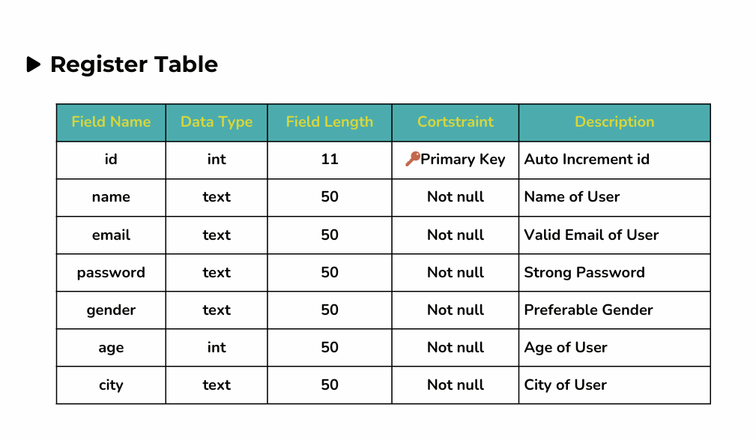

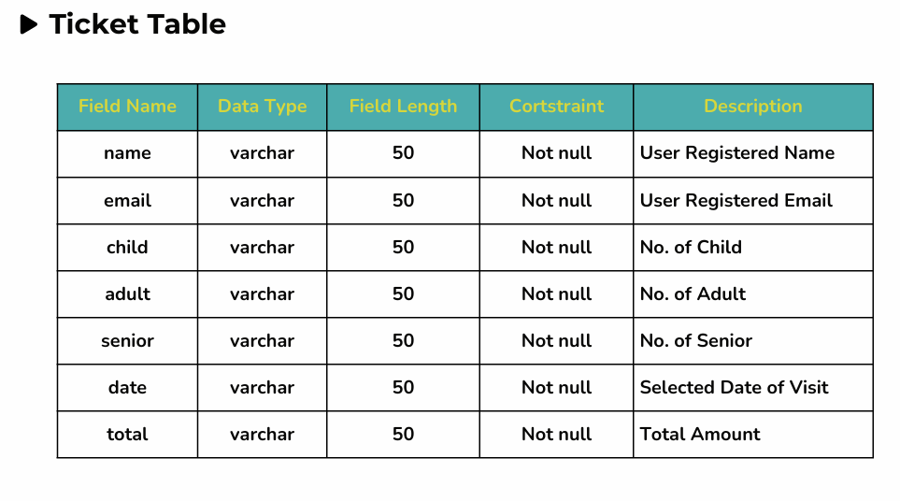

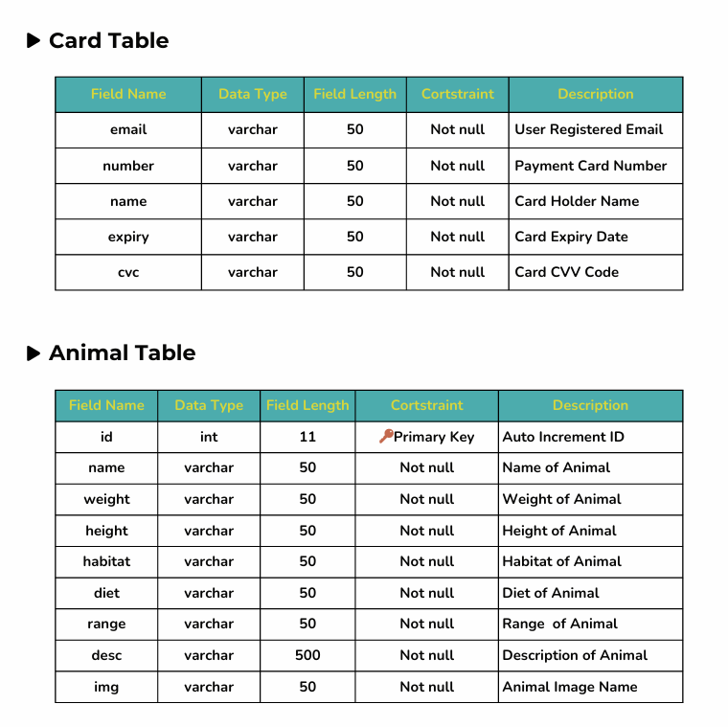

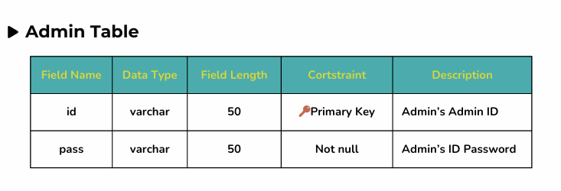

**8.5 Screenshots of Module :**

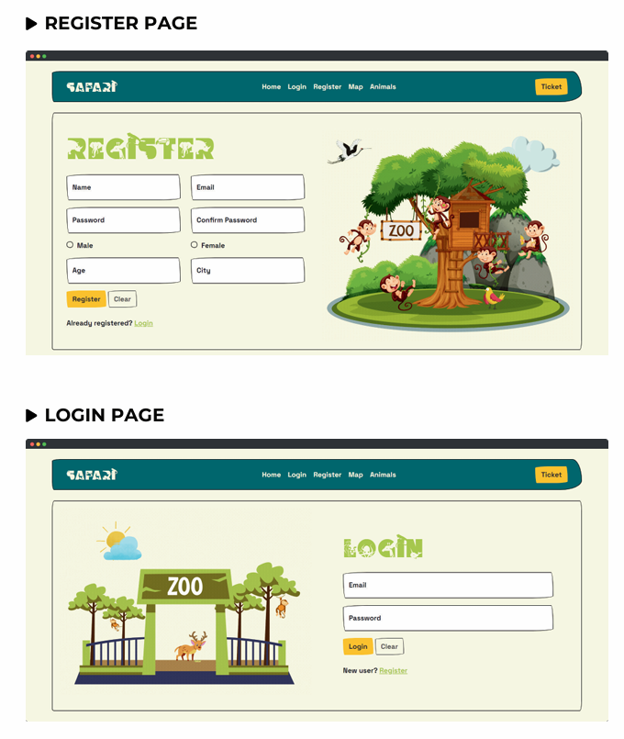

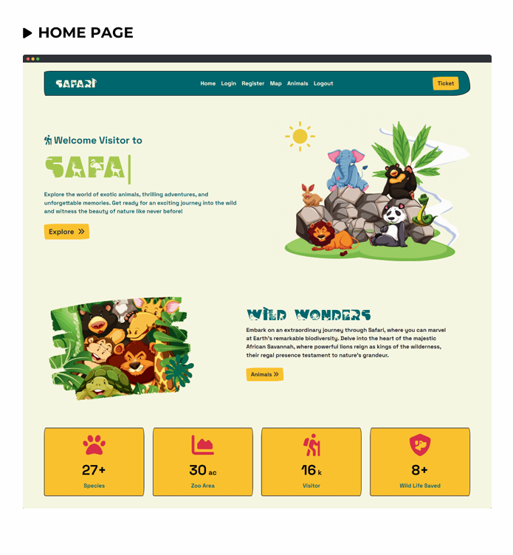

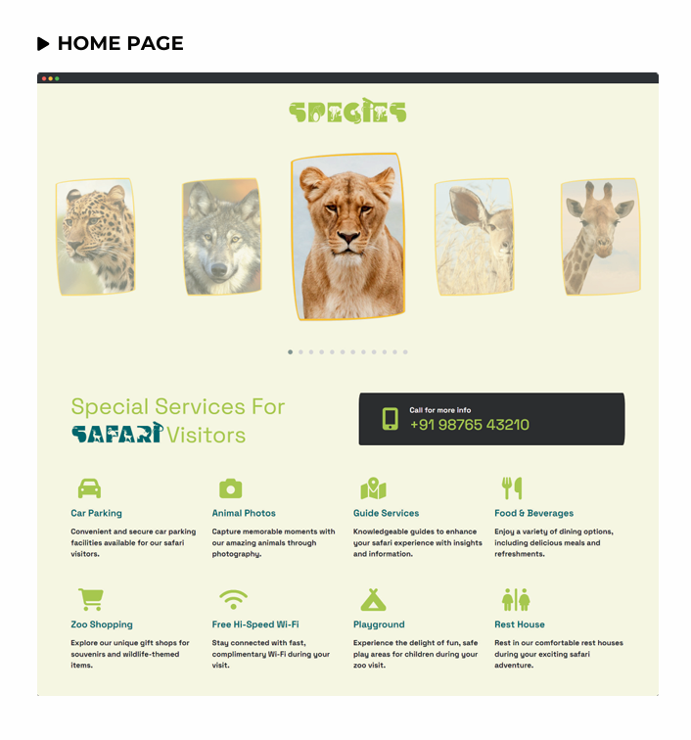

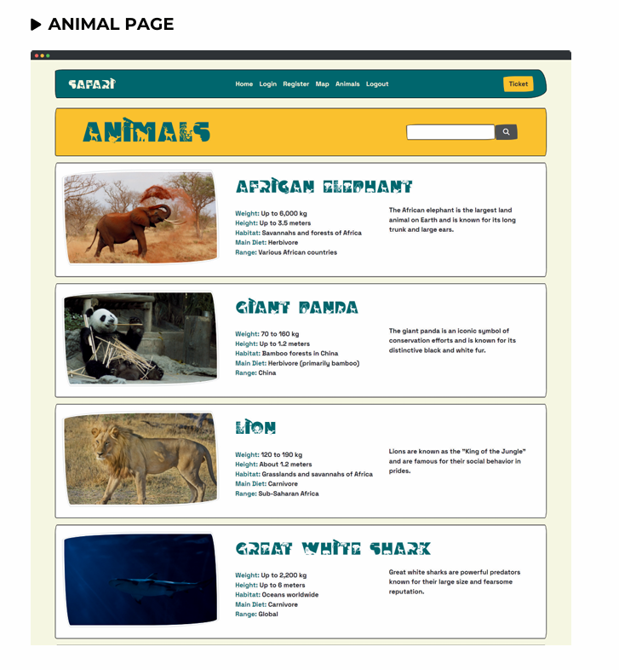

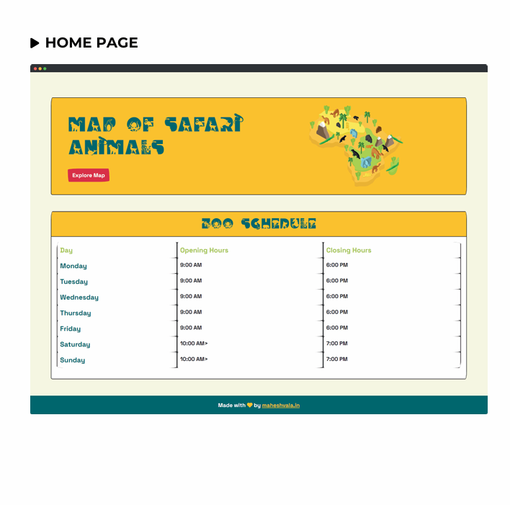

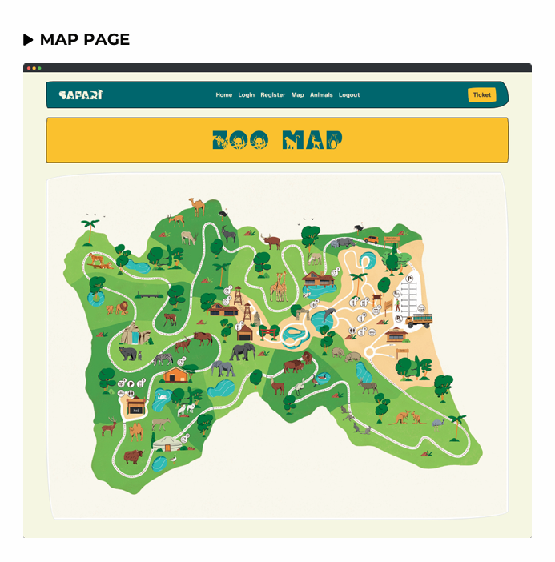

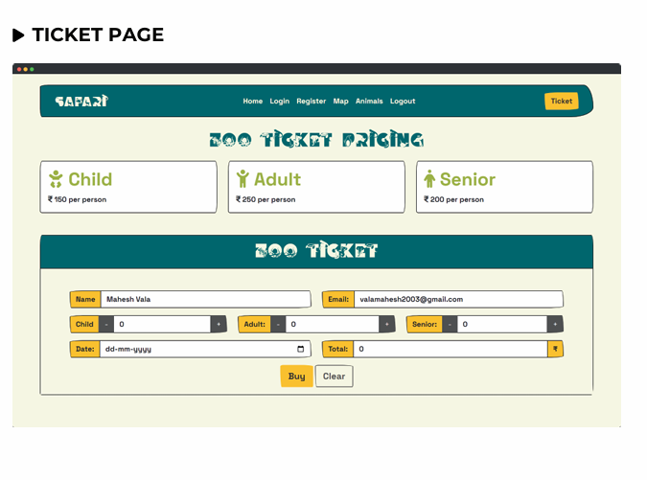

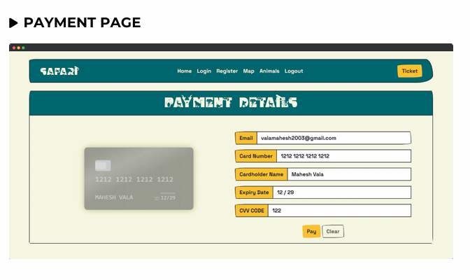

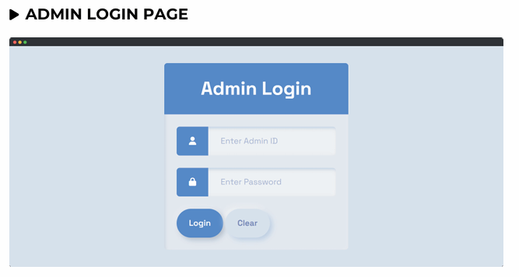

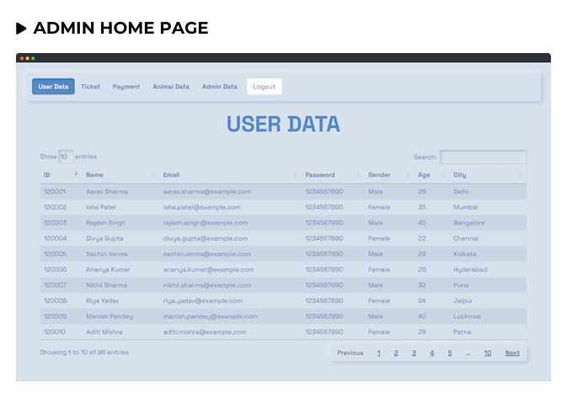

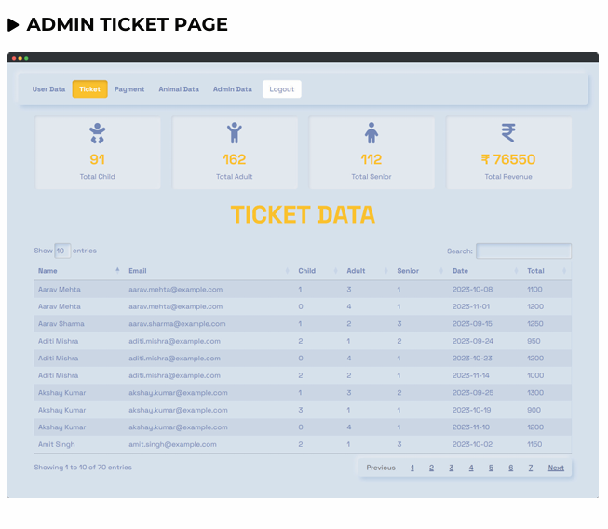

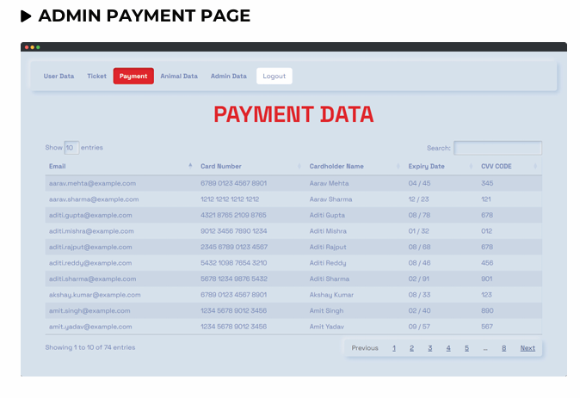

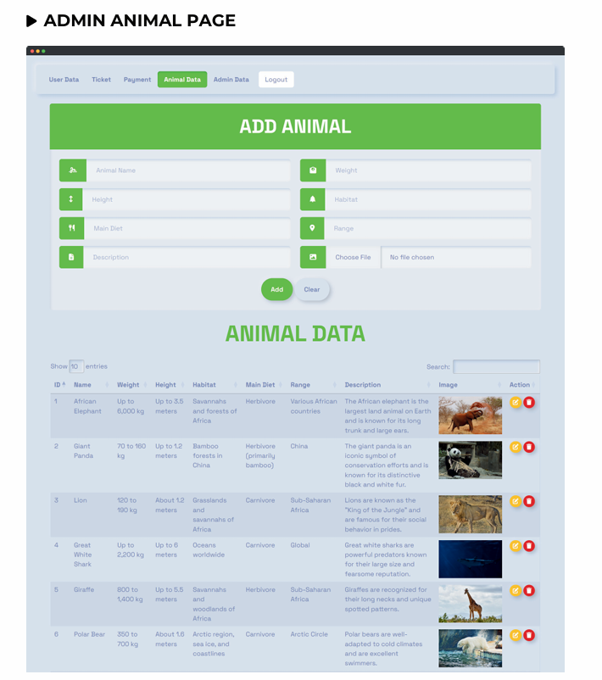

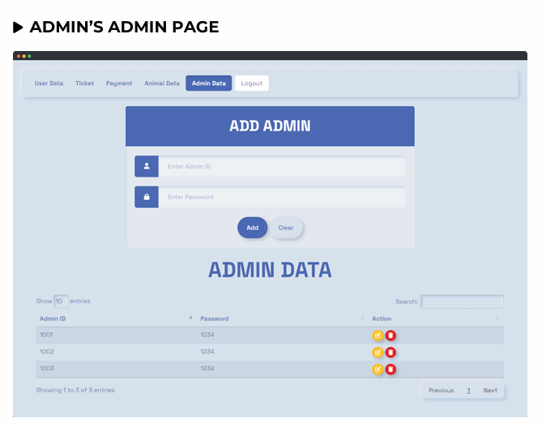

**9) Future Scope :**

### **Form Validation Refinement:**

Improve and refine form validation mechanisms to ensure data accuracy and user- friendly error messages.

Implement real-time validation for fields such as email addresses, ensuring that users receive immediate feedback on their input.

Enhance security by validating and sanitizing user inputs to prevent potential vulnerabilities.

### **Ticket PDF Generation Enhancement**

Enhance the ticket generation module to provide more customizable and visually appealing PDF tickets.

Include additional details on the PDF tickets, such as QR codes for easy scanning and access control.

Allow users to personalize their tickets with optional customizations, such as background themes or personalized messages.

### **Email Notification**

Enhance email notification functionality to provide visitors with timely updates, such as event notifications or special offers.

Enable users to choose their email notification preferences, ensuring they receive relevant information.

Implement email tracking and analytics to measure the effectiveness of email campaigns.

**10) References :**

* **GreeksforGreeks**: https://[www.greekf4greek.com/](http://www.greekf4greek.com/)
* **W3scholl**: https://[www.w3scholl.com/Algebra](http://www.w3scholl.com/Algebra)