Network Commands
The Windows operating system provides its user with a powerful tool, i.e., Command Prompt, which allows us to access and configure system settings and data.
In this article on ‘Networking Commands’, we will look into some of the most popular network commands.
These network commands prove helpful when there is a need to configure or troubleshoot the network settings of our system
Every system is connected to numerous different networks and systems through internal or external network channels.
These network settings often run into issues and affect the system’s working.
Such network problems can be resolved using ‘networking commands.’
These commands are specifically designed to troubleshoot network problems with minimum complexity using the windows command prompt tool.

Networking Commands
The below mentioned commands are some of the most useful commands required to troubleshoot network problems and configure network settings.

IPCONFIG
The IPCONFIG network command provides a comprehensive view of information regarding the IP address configuration of the device we are currently working on.
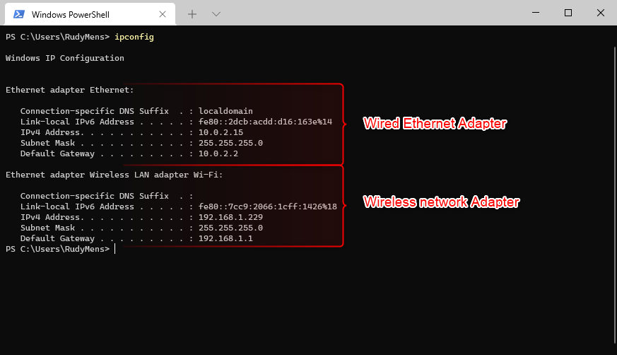
The command will return information about each network adapter on your computer. In this case, we have an ethernet adapter (for our wired network connection) and a wireless network adapter.

Ipconfig/all
This will return the following information for each network adapter in your device:
Physical Address | This is the MAC address of your network adapter.
DHCP Enabled | Indicates if the network connection is using DHCP or Static IP Address
IPv4 Address | The IP Address of your computer
Default Gateway | The router to which your computer is connected
DHCP Server | Router/server that hands out IP Addresses in your network
DNS Servers | Servers used to translate domain names to IP Addresses
Link-Local IPv6 Address | IPv6 address of your computer (often not used)
Lease Obtained | Date-time when your computer received the IP Address

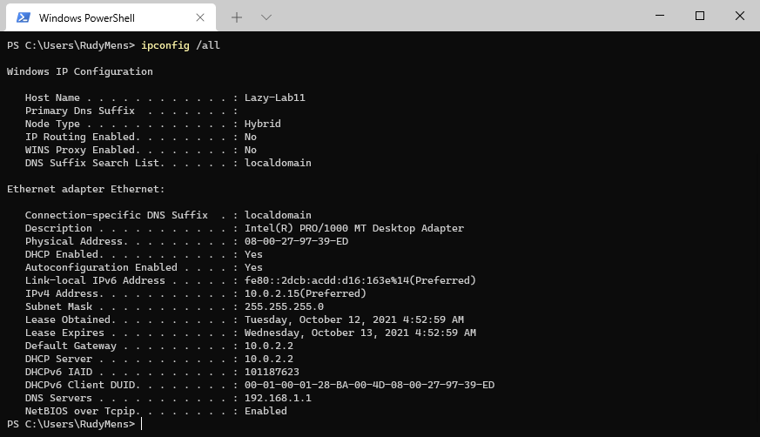

The ipconfig /all command is often used to troubleshoot network connection problems.
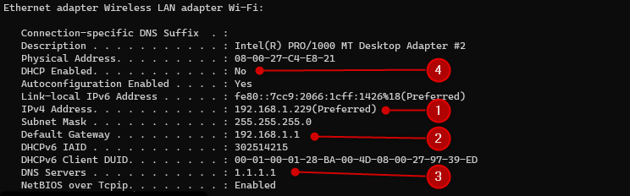
- IPv4 Address – This is your IP Address
- Default Gateway – The router or modem to which you network package are sent
- DNS servers – Used to translate domain names to IP Addresses
- DHCP Enabled – Needs to be Yes in most cases. No means that you have manually enter an IP Addres

Subnet mask –
Since the internet must accommodate networks of all sizes, an addressing scheme for a range of networks exists based on how the octets in an IP address are broken down. You can determine based on the three high-order or left-most bits in any given IP address which of the five different classes of networks, A to E, the address falls within.
A Class A subnet mask reflects the network portion in the first octet and leaves octets 2, 3, and 4 for the network manager to divide into hosts and subnets as needed. Class A is for networks with more than 65,536 hosts.
A Class B subnet mask claims the first two octets for the network, leaving the remaining part of the address, the 16 bits of octets 3 and 4, for the subnet and host part. Class B is for networks with 256 to 65,534 hosts.
In a Class C subnet mask, the network portion is the first three octets with the hosts and subnets in just the remaining 8 bits of octet 4. Class C is for smaller networks with fewer than 254 hosts.
Class A, B, and C networks have natural masks, or default subnet masks:
- Class A: 255.0.0.0
- Class B: 255.255.0.0
- Class C: 255.255.255.0
You can determine the number and type of IP addresses any given local network requires based on its default subnet mask.
An example of Class A IP address and subnet mask would be the Class A default submask of 255.0.0.0 and an IP address of 10.20.12.2.

The IPConfig command also provides us with some variation in the primary command that targets specific system settings or data, which are:
- IPConfig/renew - Used to renew the system’s IP address.
- IPConfig/release - Removes the system’s current IP address.
- Hostname
The Hostname command displays the hostname of the system. The hostname command is much easier to use than going into the system settings to search for it.

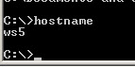

- Getmac
- The getmac is a Windows command-line utility used typically when troubleshooting network issues to retrieve the MAC address, also known as the physical address, of network adapters in a computer.
- The getmac will only able to retrieve MAC addresses (the 6-byte 'burned-in' physical/hardware address) of connected adapters.
- If an adapter is disabled (in Windows Device Manager for example), or is not connected to the network, getmac will not be able to retrieve its MAC address.
- The getmac is not the only way command-line tool to identify the MAC address of a network adapter.
- The ipconfig utility can also be used for this purpose, along with other functions.
- In screenshot example, it shows the MAC address (physical address) of two network adapters.
- MAC Address #1: 30-5A-3A-7F-17-A1
- MAC Address #2: 00-FF-49-B8-4F-89
- The response "Hardware not present" for the other three adapters indicated that they are currrently disabled - this command can not show MAC addresses for adapters that are disabled..

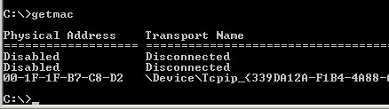

- Systeminfo
Displays detailed configuration information about a computer and its operating system, including operating system configuration, security information, product ID, and hardware properties (such as RAM, disk space, and network cards).

- Tracert
The TRACERT command is used to trace the route during the transmission of the data packet over to the destination host and also provides us with the “hop” count during transmission.
Using the number of hops and the hop IP address, we can troubleshoot network issues and identify the point of the problem during the transmission of the data packet.
Command to enter in Prompt-
tracert IP-address OR tracert www.destination_host_name.com

The following table lists some important options of the tracert command.
Option | Description
-d | Do not resolve the IP addresses of intermediate routers to their names.
-h | Specifies the maximum number of hops (routers) to search on the path. The default is 30 hops.
-w | Specifies the amount of time in milliseconds to wait for a reply message from the router. If not received within the time-out, an asterisk (*) is displayed. The default time-out is 4000 (4 seconds).

- ARP
To send IP packets, a computer needs two addresses. These addresses are the MAC address and the IP address. A MAC address is the physical or hardware address of the NIC. An IP address is the logical or software address of NIC. If a computer knows the IP address of the destination computer but it does not know the MAC address of the destination computer, it uses the ARP protocol to know the MAC address of the destination computer.
The ARP protocol broadcasts a given IP address over a local network. The corresponding host responds to the broadcast with its MAC address. To avoid repetition, ARP stores the answer in a table known as ARP table. ARP maintains a separate ARP table for each NIC.
To view the ARP table, you can use the following command.
arp

By default, this command displays the ARP table of the active NIC. If multiple NICs are installed on the computer, you can use the -a option with this command. If the -a option is used, the ARP command displays all ARP tables.
The following image shows the output of the arp command when used with the -a option.
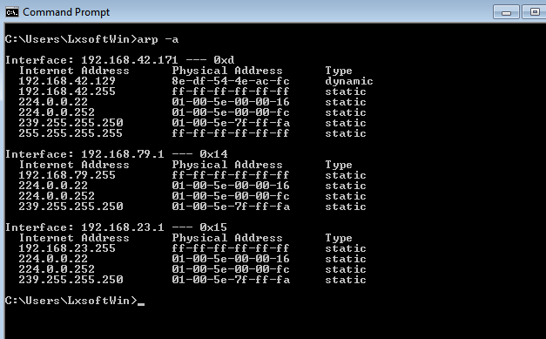
To display the ARP cache entry for a specific IP address, specify the IP address with the -N option. For example, the following command displays the ARP cache table for the interface that is assigned the IP address 192.168.42.171.
Arp -a -N 192.168.42.171
The following image shows the output of the above command.
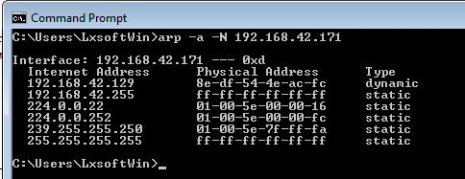

- Netstat
This command displays active connections, ports on which the computer is listening, Ethernet statistics, the IP routing table, and IP statistics.
The output of this command is organized in rows and columns. Each row represents a new connection or an entry in the output. It contains four columns. These columns provide the following information about the row.
Proto: - This column displays the name of the protocol (TCP or UDP).
Local Address: - This column displays the IP address of the local computer and the port number being used. If the port is not yet established, the port number is shown as an asterisk (*).
Foreign Address: - This column displays the IP address and port number of the remote computer to which the port is connected.
State: - This column displays the status of the connection.
The following image shows the sample output of this command.
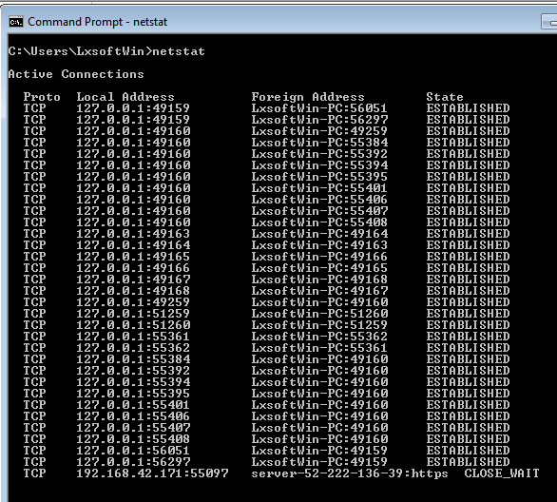

Options and parameters
The following table lists some common options of the netstat command.
Option | Description
-a | Displays all active TCP connections and the TCP and UDP ports on which the computer is listening.
-e | Displays Ethernet statistics, such as the number of bytes and packets sent and received.
-n | Displays active TCP connections, however, addresses and port numbers are expressed numerically and no attempt is made to determine names.
-o | Displays active TCP connections and includes the process ID (PID) for each connection.
-p | Shows connections for the protocol specified by Protocol. In this case, the Protocol can be TCP, UDP, tcpv6, or udpv6.
-s | Displays statistics by protocol. By default, statistics are shown for the TCP, UDP, ICMP, and IP protocols.
-r | Displays the contents of the IP routing table.

- Ping
The ping command is used to ensure that a computer can communicate with a specified device over the network. The pings command sends Internet Control Message Protocol (ICMP) Echo Request messages in the form of packets to the destination computer and waits in order to get the response back. Once the packets are received by the destined computer, it starts sending the packets back. This command keeps executing until it is interrupted.
ping command provides details such as
- the number of packets transmitted.
- the number of packets received.
- time is taken by the packet to return.
ping command is generally used for the following purposes:
- measuring the time taken by the packets to return to determine the speed of the connection.
- to make sure that the network connection between the host and the destined computer can be established.
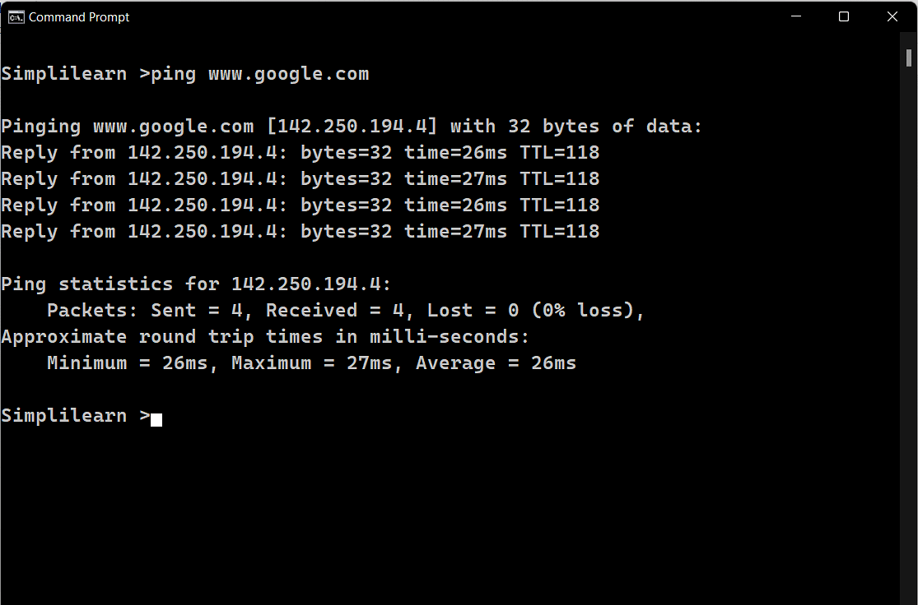
- nslookup
The name of the nslookup command is an abbreviated version of “name server lookup”. nslookup sends a request to the local domain name system server asking for information from its DNS records. In response, the DNS server returns the IP address or relevant domain information for a specific website or server. However, it can also return the domain associated with a particular IP address.
Here are some of the main purposes of the nslookup command:
- nslookup quickly returns the IP address for any domain. It is considered one of the best tools for troubleshooting DNS problems. It is especially handy for situations where the IP address of a domain has recently changed, but requests for the domain are not resolving.
- It is used to investigate suspicious domains. A good example is a web address designed to closely mimic an existing domain, for instance, examp1e.com in place of example.com.
- It can defend against cache poisoning in which invalid domain information is sent to secondary DNS servers, known as resolvers.
Route
The function and syntax of the Windows ROUTE command is similar to the UNIX or Linux route command. Use the command to manually configure the routes in the routing tabl
Route print
nbtstat: Displays NetBIOS over TCP/IP information, such as NetBIOS name tables and MAC addresses. Usage: nbtstat -n.
Network Basic Input/Output System) is a network service that enables applications on different computers to communicate with each other
Pathping
Provides information about network latency and network loss at intermediate hops between a source and destination. pathping sends multiple Echo Request messages to each router between a source and destination over a period of time and then computes results based on the packets returned from each router
-g host-list Loose source route along host-list.
-h maximum_hops Maximum number of hops to search for target.
-n Do not resolve addresses to hostnames.
-p period Wait period milliseconds between pings.
.
-w timeout Wait timeout milliseconds for each reply.
-4 Force using IPv4.
-6 Force using IPv6.

