NOTE:

All The Green Colour requirement developed my side. DONE

All The DARK Green Colour requirement Detail Explain Done with screen shot

Requirements:

* There should be three “actions” a user can take:
  + Main page (/) – contains a form where long URLs can be input and submitted. Form redirects to the info page on success. Must have validation.
    1. Add Long Url with basic reference url title

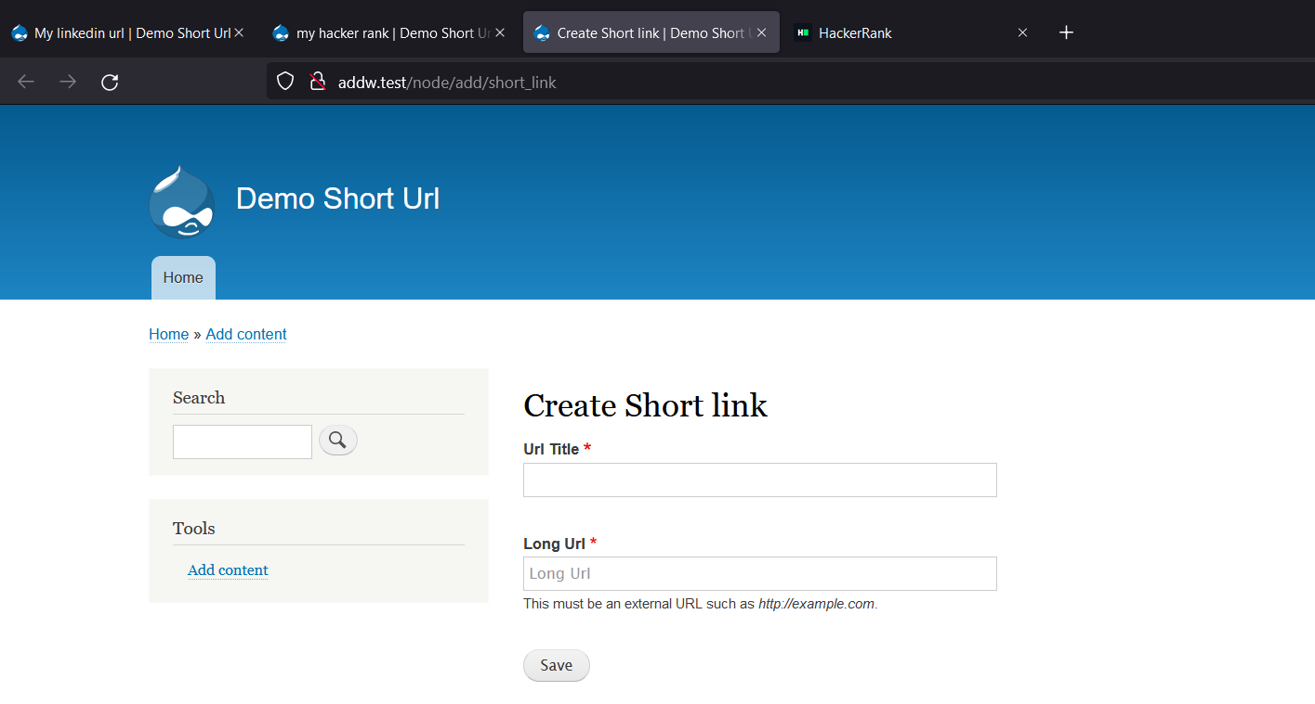

* + 1. Developer Comment : Validation

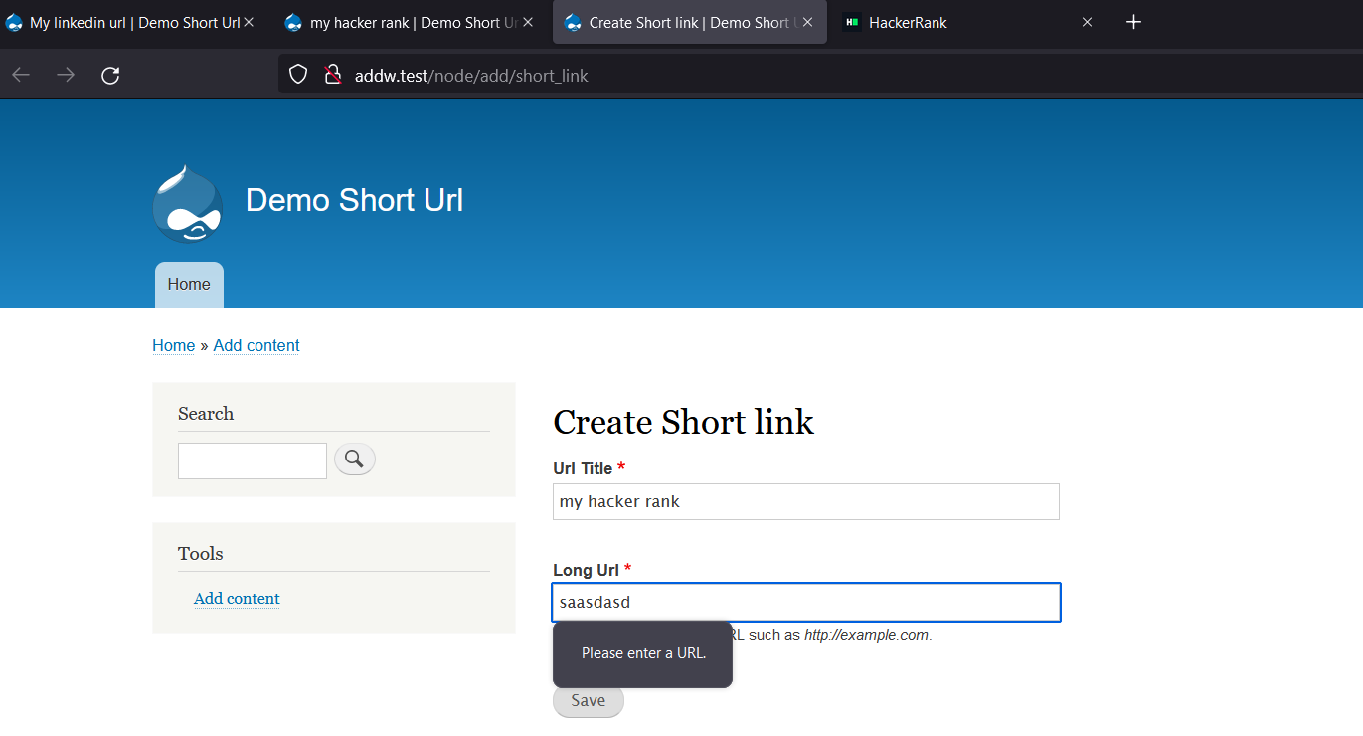

* + 1. Redirect to Info Page
  + 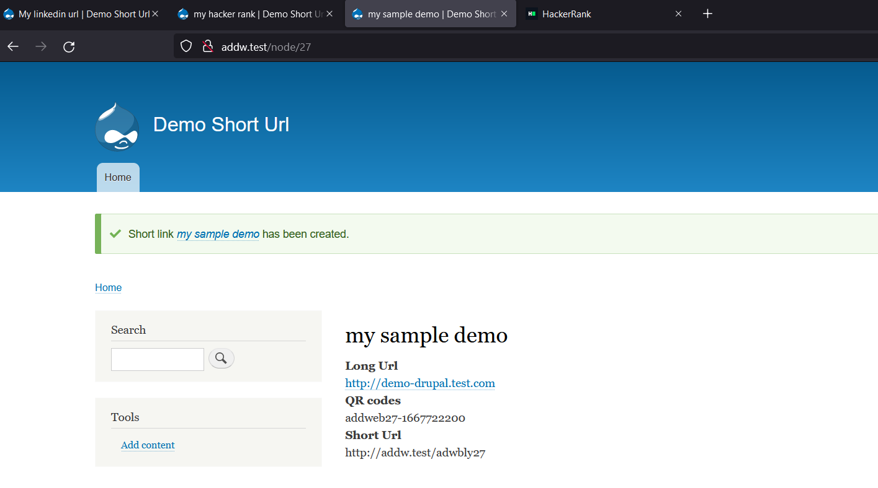
  + Short link info page (/view/abcd123) – shows information about the shortened URL.

I have created multiple view page

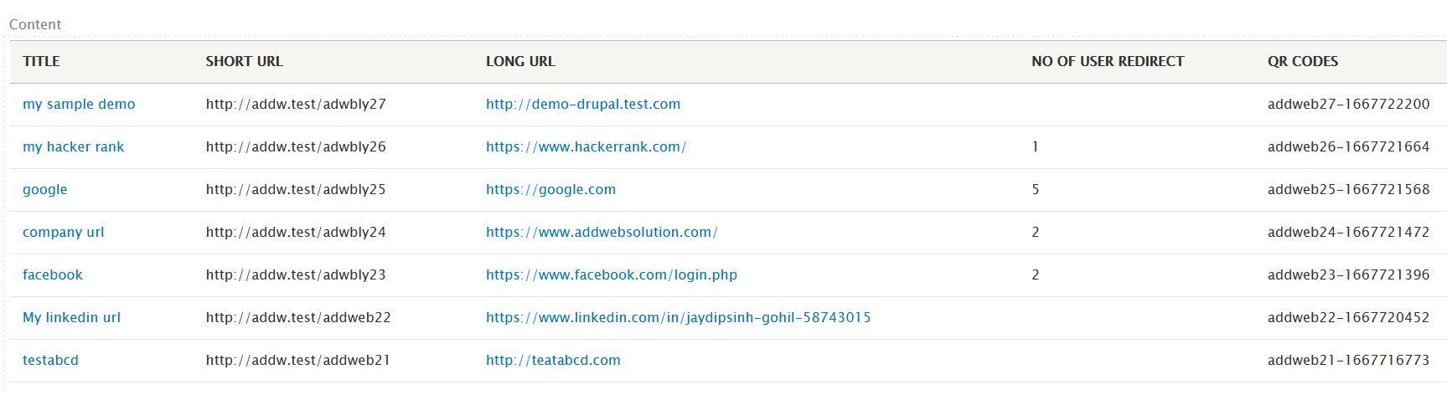

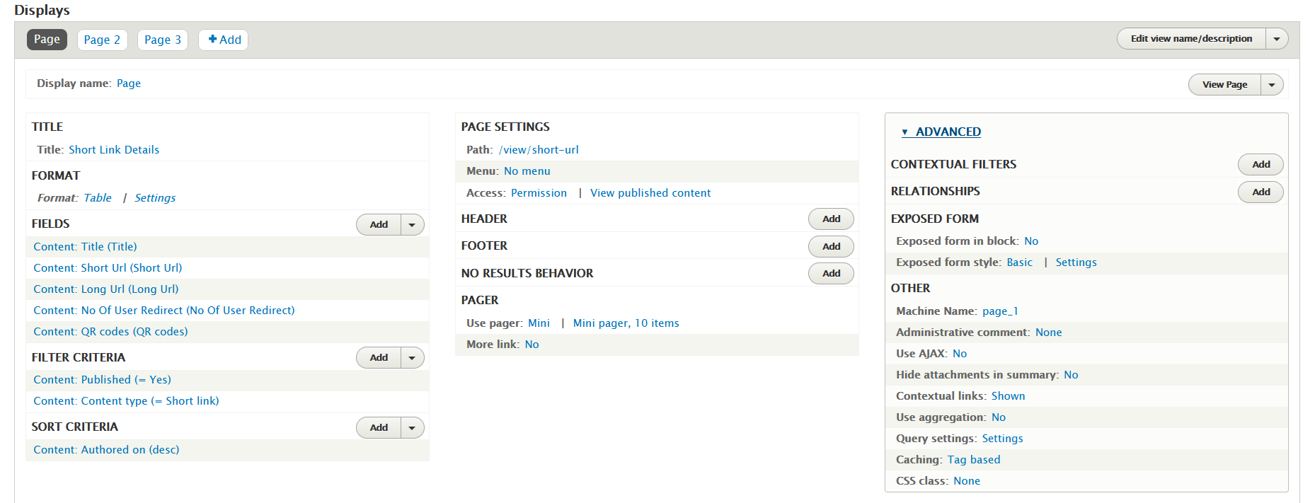

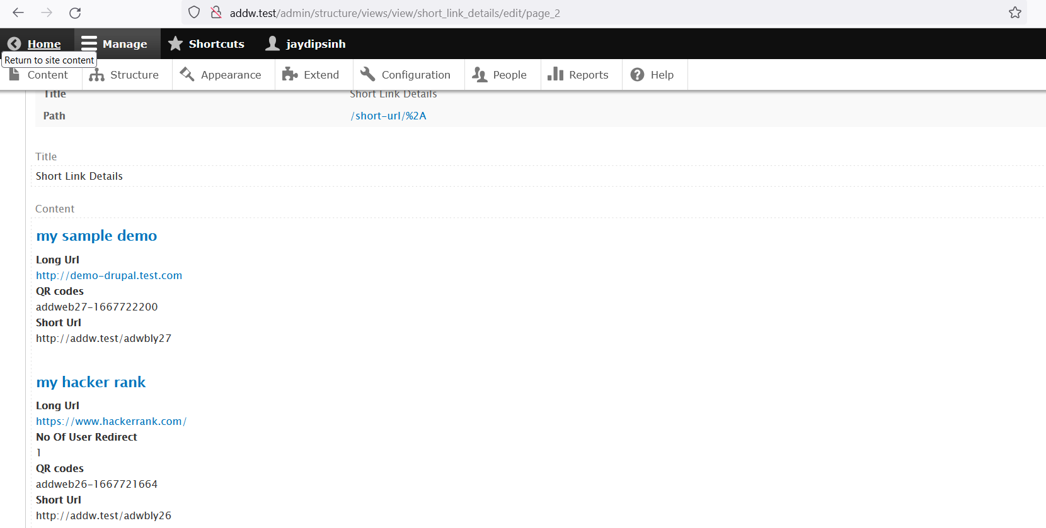

* + Redirect link (/abcd123) – looks up the full URL and redirects to it

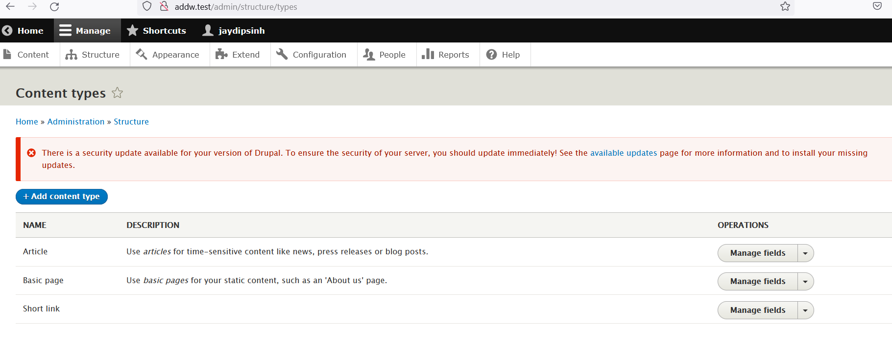

Create content type and add all the required field – Long Url , Short Url , no of user redirect & qr code string

* One additional feature of your choosing. Some possible ideas:
  + Analytics (number of users redirected)
  + QR codes

I have add these field and we can use for analytic or report purpose

* Links must be stored in a database (of your choosing)
  + Provide the schema with your project

Data store in database and schema is shown in below screen shot

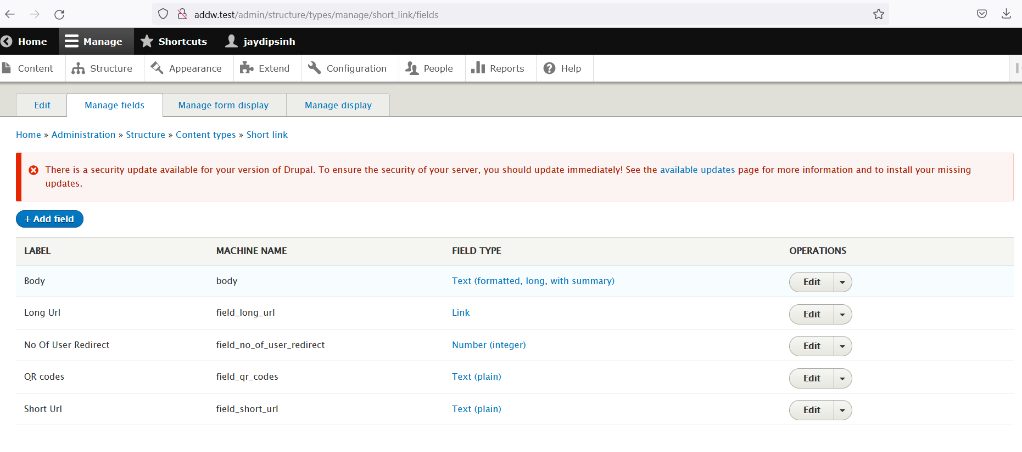

Proof of data store in database

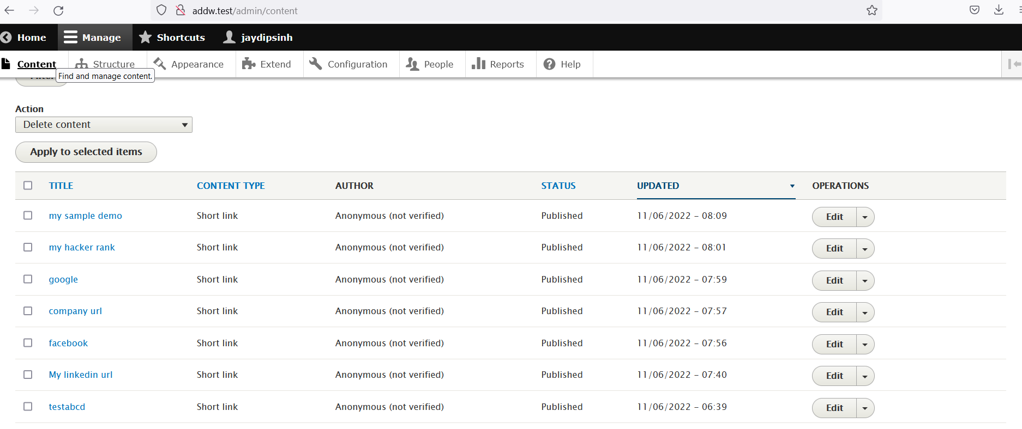

* Shortened link identifiers must be unique strings of 5-9 alphanumeric characters

I create string with pattern of six character and 2 number with always unique

My initial string I set ‘adwbly’ and other number is node unique number

So example short url like – adwbly21, adwbly50, adwbly10,…

I create virtual host - addw.test for these project so url will be.

We can do any type of link

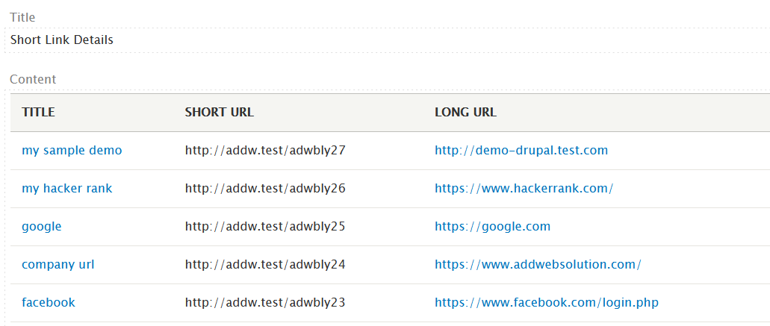

* Code should be written in an object-oriented fashion using appropriate design patterns

Yes Drupal follow object-oriented and I am also used same and code in standard contribute module with drupal hook.

You can verify in contribute – general_sction module

And database screenshot

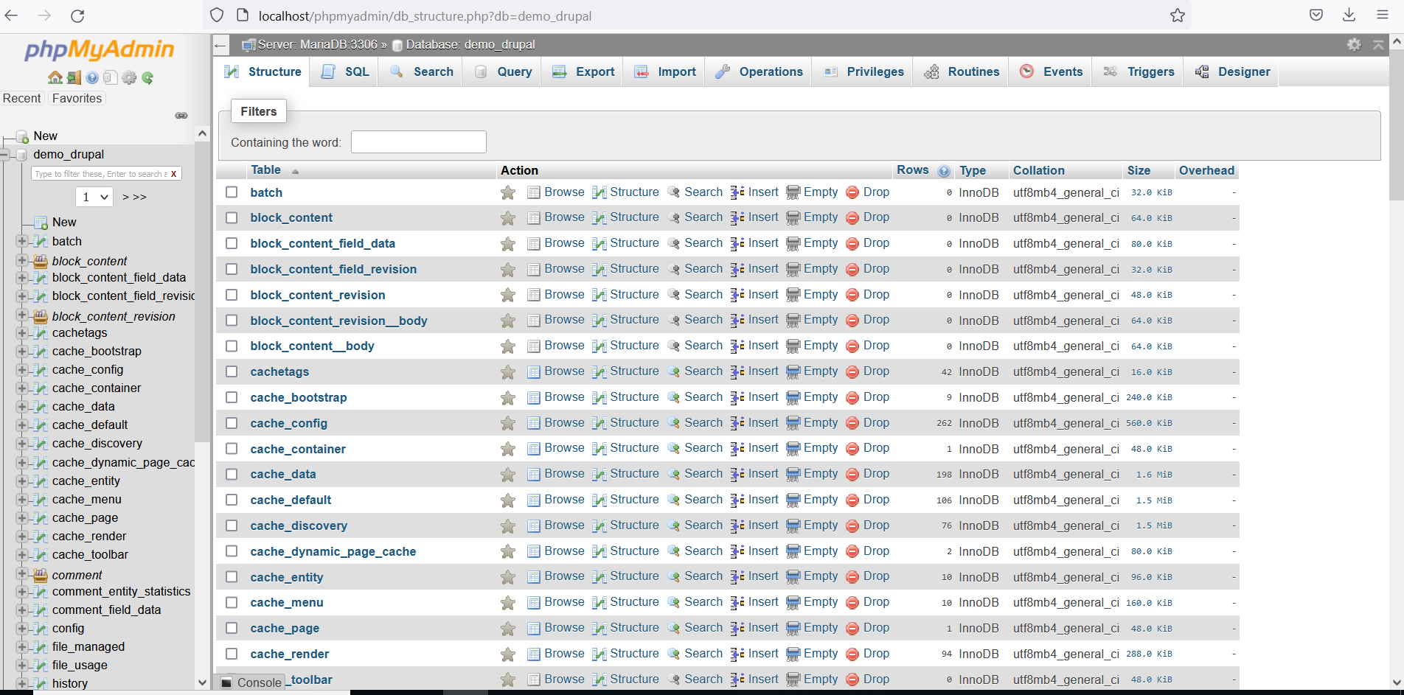

* Project should be committed to Git and pushed up to GitHub or BitBucket

https://github.com/jaydipsinh/demo_drupal

Thanks and if any query then contact me