1. Design a simple college website using html5 and css3 having following characteristics:

Header ,Nav bar ,body ,footer ,admission/registration form

2. Design a facebook like webpage using html5 and css3 perform client side validation using js

3. Create a simple arithmetic calculator using html,css,js

4. Create a webpage which takes distance as input in km / weight in kg and converts it to miles/ pounds (Unit conversion)

5. Create a webpage which takes height in metres and weight in kg and calculates BMI for given height and weight.

6.Create a website using Html and Css as a simulation of popular hacking mini game from Fallout. It creates a 4 digit code using random digits from 0 to 5 (each digit used only once) It allows user 5 attempts to try and guess the code. The result is a combination of characters O, X and V O - correct digit in correct place, X - wrong digit, V - correct digit in wrong place, e.g. (Assume the code = 3251),

"5 ATTEMPTS LEFT...",

"CODE : 1234",

"SYS : VOVX",

"4 ATTEMPTS LEFT...",

"CODE : 3215",

"SYS : OOVV",

"3 ATTEMPTS LEFT...",

"CODE : 3251",

"SYS : OOOO",

"SUCCESS !"

7. Create an xml page for cd collection and use Ajax to retrieve its contents and display it as HTML Table.

8. Prime number generation between the two numbers prompted from users

9. Create an xml page for storing information about groceries (item,quantity,price,brand,etc) and translate it to html page using dtd and xsl

10. Create an xml page for cd collection and translate it to html using dtd xsl

11. Using jQuery, Find all <p> elements that are children of a <div> element and apply a background to them. Sample data as given below:

<h1>abc</h1>

<div> <p>para-1</p> <p>para-2</p> </div>

<h1>xyz</h1>

<p> para-3</p>

12 Create a form using HTML CSS(name, surname, gender, address, phone no., email). Perform client side Validation using jQuery. On clicking the submit button,Access HTML form data using jQuery and show data using alert()

13 .Design a form that accepts student details as fname, lname, email, contact no and marks of 3 subjects and displays percentage (use onclick event )

14. Write a program to display form having Toy library. List toy names with drop down list and accept quantity and rent and generate a bill of requested toys on click of Generate button.

15 Write a program to design login form and change the color of textbox as mouseover happens over text box. And also validate the password for valid alphanumeric and length >=12.

16 Design a form having two drop down list as background color(3 colors) and text color(5 colors) and one change color button. Document background color and text should change to selected color on a click of change color button.

17 . Design a Signup Form using HTML. The signup for should have the following HTML elements and validate according to the stated criteria using Javascript

Name (Should not be null , should contain only characters)

Age (Should not be null , should contain only numbers)

Address (Should not be null)

City (ComboBox listing the major cities)

Mobile No (Should not be null , should contain only 10 digits)

Username (Should not be null, can contain characters, special characters and numbers, but should not start with anything other than character)

Password((Should not be null , should contain minimum 8 in length, One uppercase and one number and one special character)

Email : a valid email Id

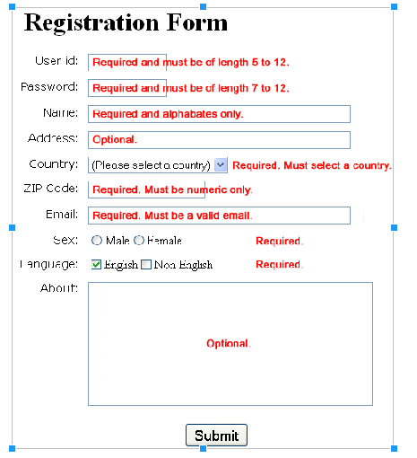18 Design the following registration form using HTML and satisfy the following validations shown in the diagram using Javascript.

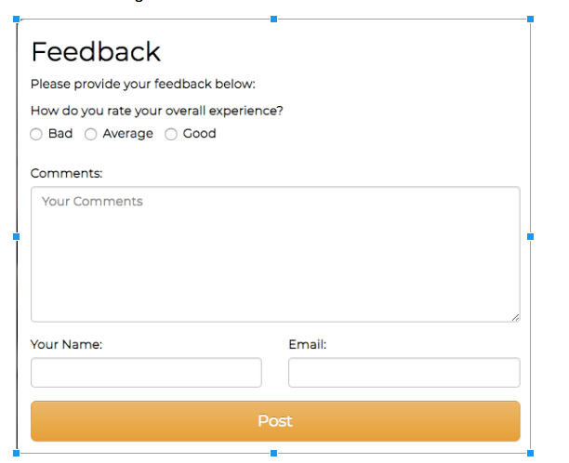

19 Design the Following form using HTML and insert the data of the form in a Mysql database. Display all the feedback received from the database in a table on an HTML web Page

20. Create a database in mysql using php myadmin and perform various crud operations

21. Write a php code to find whether an entered number is Armstrong or not. Design the page using html and css.

22. AJAX program with a simple HTTP Request. Create a webpage in which JavaScript will request an HTML document, test.html, which contains the text "I'm a test." and then alert() the contents of the test.html file.

23 Display all the CUSTOMER details from the database in a table on an HTML web Page .(Use php)

24. Design a form to display products , calculate the price based on cost and quantity of selected items and display the total.(Use session)

25 Design a web page that starts a session and register a variable called **counter** that is incremented each time the page is visited during the session

26.Create a database of GUESTS in mysql using php myadmin and perform update operations on guest details

27 Demonstrate the following CSS properties for controlling layout of elements display,float, in-line ,overflow properties