**Cloud Computing: Assignment 1 Tweet Map**

**Group Members**

| **Net ID** | **Name** |
| --- | --- |
| jds797 | Jay Dharmendra Solanki |
| akb501 | Aniket Krishna Bhandarkar |

This Assignment is in Python. There are 3 modules in the project:

1. Web Application which is scaled by deploying it to AWS ElasticBeanstalk in Django Framework
2. AWS Elastic Search for finding text quickly
3. Python code to add tweets in the AWS Elastic Search in Real Time

Following are the dependencies for Web Application

1. Django Framework
   * Install using pip install django
2. wheel
   * Install using pip install wheel
3. certifi
   * Install using pip install certifi
4. elastic search
   * Download the Elasticsearch executable to run locally. To run on AWS ElasticBeanstalk or EC2, start an AWS Elastic Search Cluster on AWS
   * Install using pip install elasticsearch
5. Google Maps Javascript API
   * Get from https://developers.google.com/maps/documentation/javascript/
6. Bootstrap
   * Get from http://getbootstrap.com/
7. jQuery v1.x
   * Get from https://code.jquery.com/ by selection jQuery 1.x

To get started with the application there are some steps to be followed

1. Download/Clone the project
2. Run
   * python manage.py migrate
3. Make sure you have stated ElasticSearch service at localhost or at AWS. If you run on AWS make sure to get the url for accessing the elastic search. Then run
   * python populate_index.py <index_name> <host for elasticsearch>   
     where replace <index_name> with the name of the index you want to create and replace <host for elasticsearch> with the Elastic Search Host url (pass an empty string ("") for localhost)   
       
     This may take a while and after that your Elasticsearch index will be created and populated   
     Schema used for Elasticsearch:   
     location: geo_point  
     tweet: string
4. Open Assignment1/settings.py and change the variables INDEX_NAME and HOST_NAME as per your configuration
5. To run it locally, run
   * python manage.py runserver   
     The web appication will be accesible from localhost:8000   
     To run on ElasticBeanstalk make sure you have installed EB cli. Follow the steps from http://docs.aws.amazon.com/elasticbeanstalk/latest/dg/create-deploy-python-django.html#python-django-deploy.
   * eb init -p python2.7 cloud-assignment
   * eb init
   * eb create django-env
   * eb open   
     After the above steps the website will open at

**http://django-env.m3txbp3s2c.us-west-2.elasticbeanstalk.com/**

**VERY IMPORTATNT NOTE:**While doing eb deploy or eb create django-env it is **VERY IMPORTANT**to commit the changes made, otherwise new changes won't be deployed. Also dont forget to do python manage.py collectstatic if you add any new static files before commiting.

1. For live tweets make sure you have your own Twitter
   * consumer_key
   * consumer_secret
   * access_token
   * access_token_secret  
     You can get it from from https://apps.twitter.com/.  Then install

pip install certify tweepy elasticsearch

Once you have the credentials. Start an EC2 server and make a cronjob for

python live_elastic_search.py <index_name> <host of elastic search>

to run it with the index name and host of elastic search, it will populate the index in real time and the web application will use the indexed data.

**Features**

This project gives 2 search functionalities

1. Search tweets for speicific keywords and visualize on a World Map
2. Click on Map to get a location and search tweets within 'N' KMs from that selected point using geo_spatialsearch

**Output**

**Home Page**

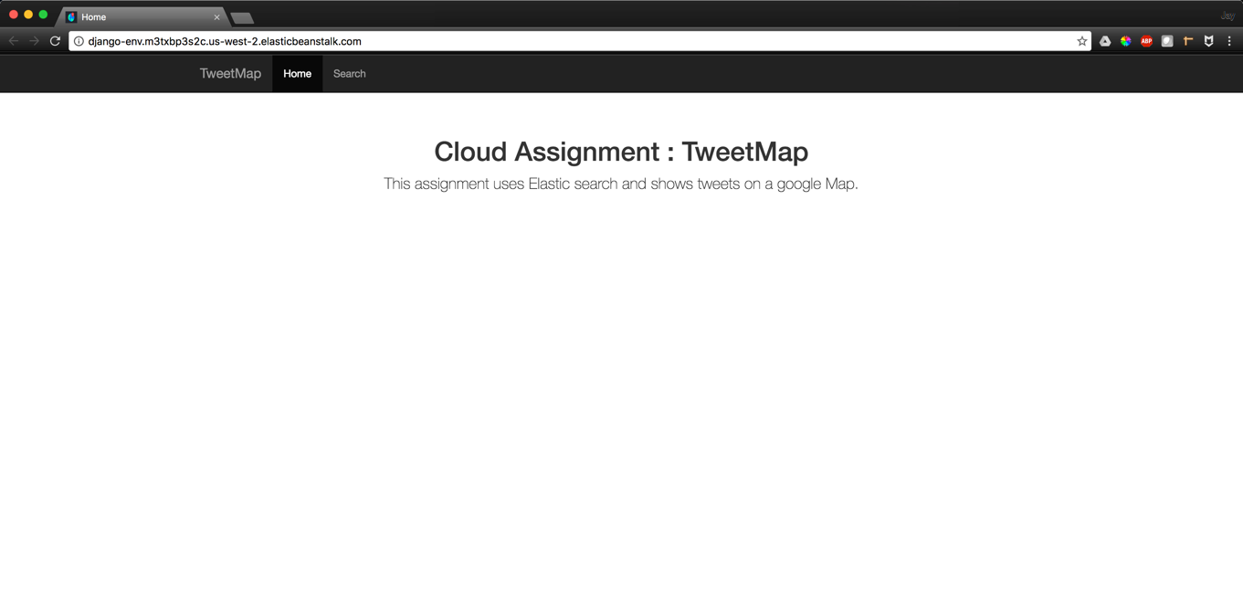

**AWS Elastic Search**

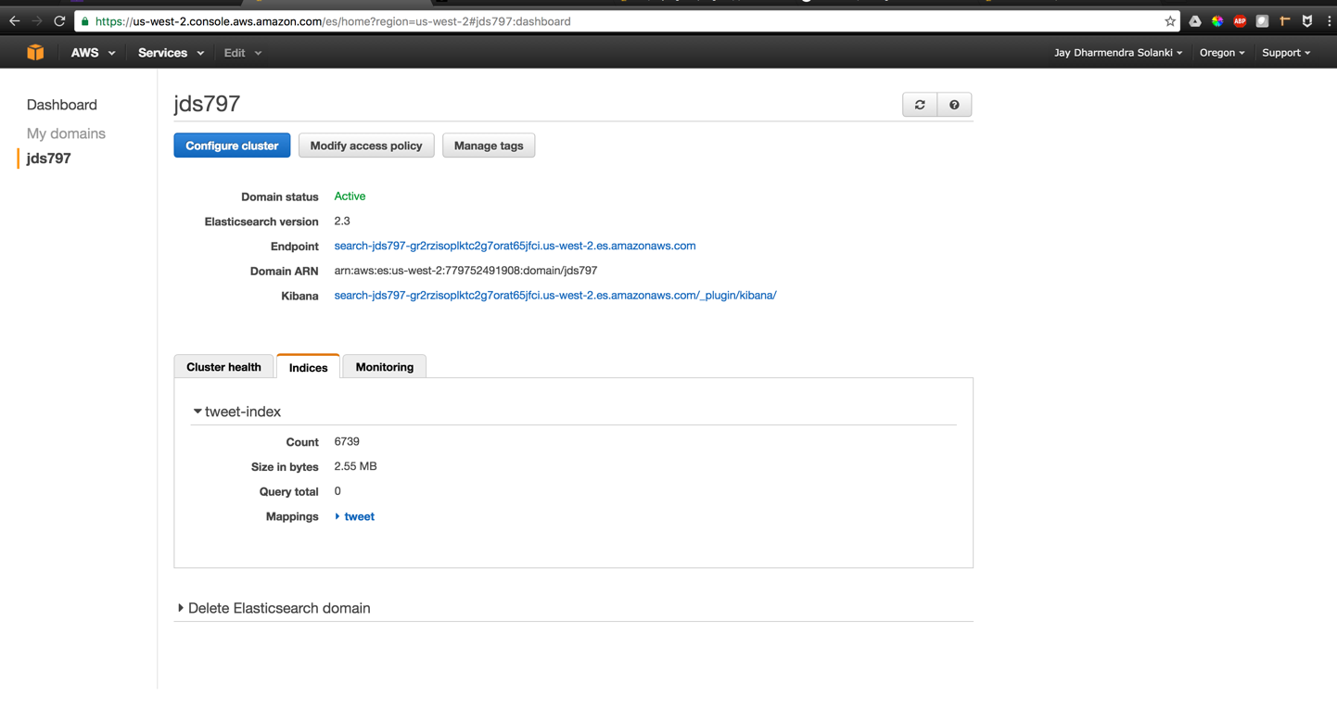

**Keyword Search Output**

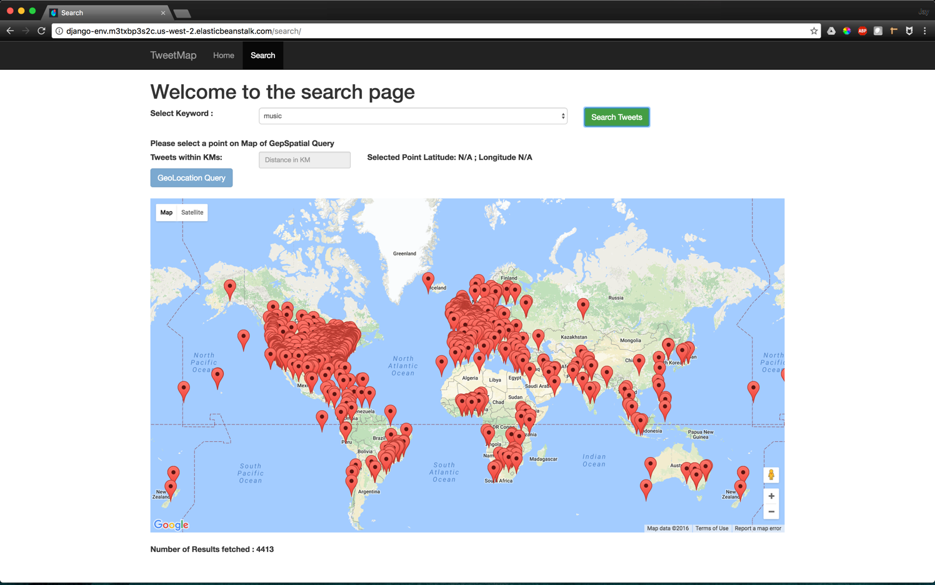

**GeoSearch Query**

The green marker is what User Selects and the distance will be calculated from the green marker

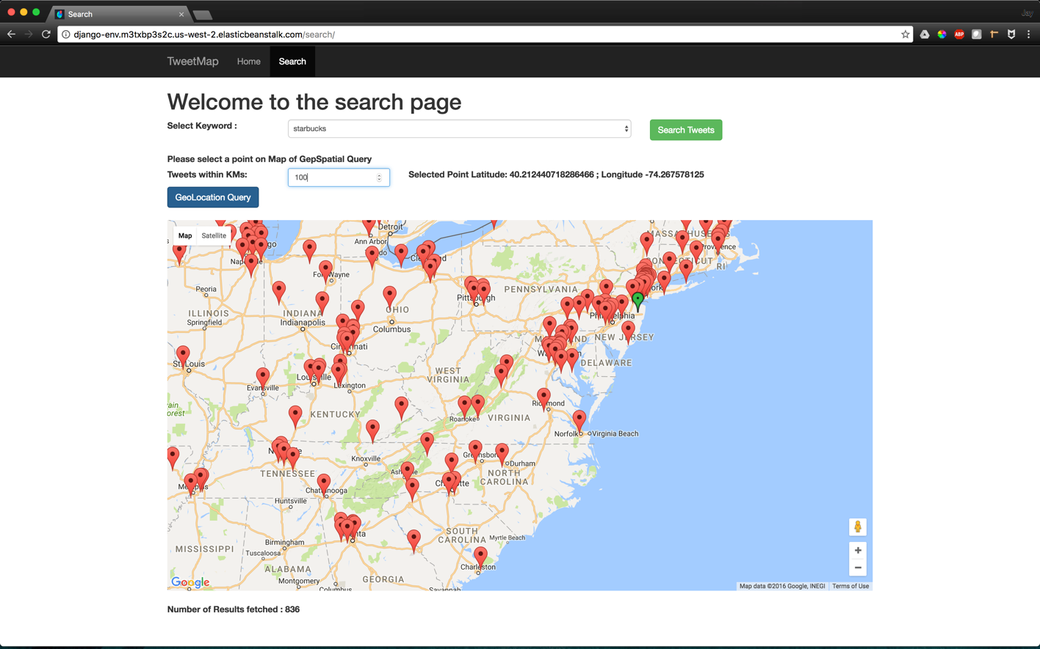

**GeoSearch Query Output**

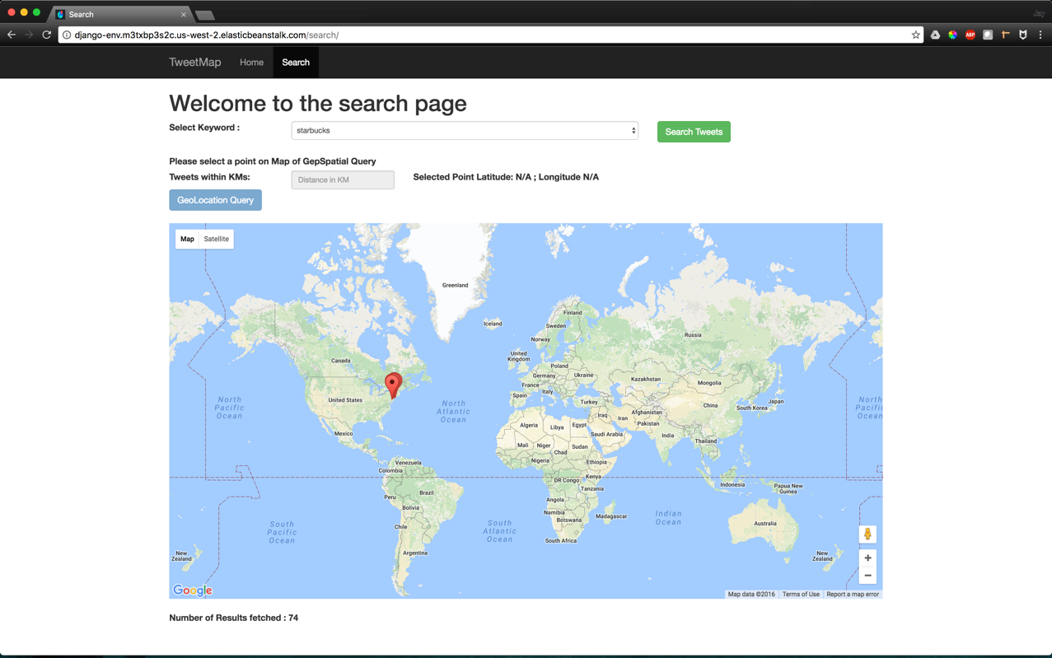

**EC2 instance for running Live Tweet input**

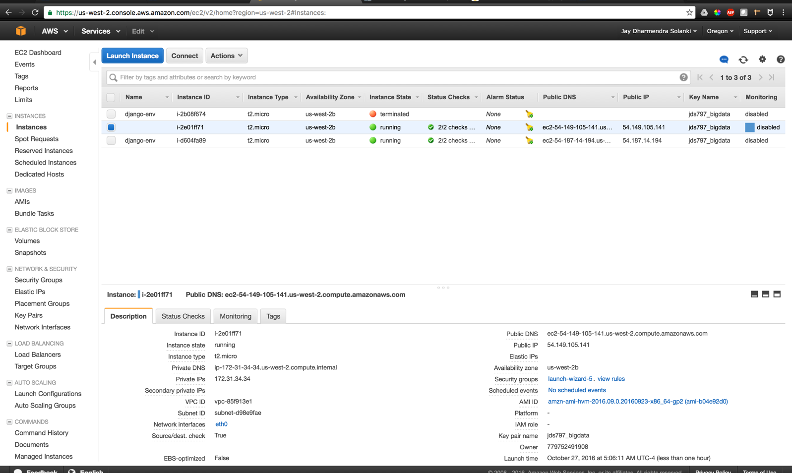

**Elastic Beanstalk used**

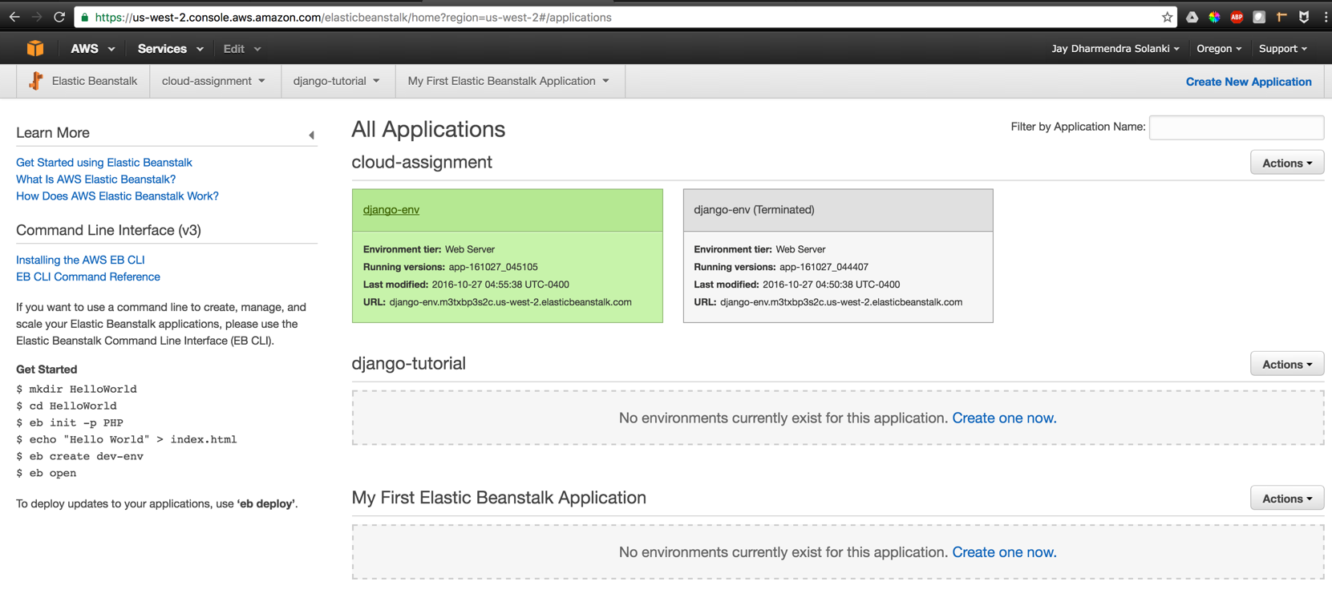

**Url for the Project on Beanstalk: http://django-env.m3txbp3s2c.us-west-2.elasticbeanstalk.com/**

References

1. Tweepy Example http://adilmoujahid.com/posts/2014/07/twitter-analytics/
2. Bootstrap Started Tempalte http://getbootstrap.com/examples/starter-template/