

## Project Name: BEAUTY PARLOUR MANAGEMENT SYSTEM

## Course Name: INTRODUCTION TO DATABASE

## Section: [I]

## Group members:

|  |  |
| --- | --- |
| **NAME** | ID |
| Dipty Moni Kha | 19-39335-1 |
| Sadia Islam | 19-39338-1 |
| Jayed Bin Islam | 19-39523-1 |
| Fardin Ahsan | 19-39798-1 |

***Scenario:***

In a beauty parlor management system, customers can have many treatments from the parlor. A customer is identified by a unique customer id, customer name, payments and phone number. Treatment is identified by unique service no, fees, manicure, pedicure, waxing, threading, massage. Customers can make payment in many ways. Payment is identified by a unique payment id, record, cash, Credit. Payments can be ready and paid in many ways into beauty parlors. On the other hand, many treatments can be done in the beauty parlors. Beauty parlor is identified by a unique code no, appointments, employees’ availability and payment records. Treatments can be performed by many employees. Employees can be recognized by a unique id, Phone-number, name, salary, work-time, profession, address. One property can deal with many beauty parlors and one property may have many owners. Owner who owns the property, is identified by his/her name, address, a unique id, phone number. Property has a unique id, address city and country. And that is how a beauty parlor management system run.

ER Diagram:

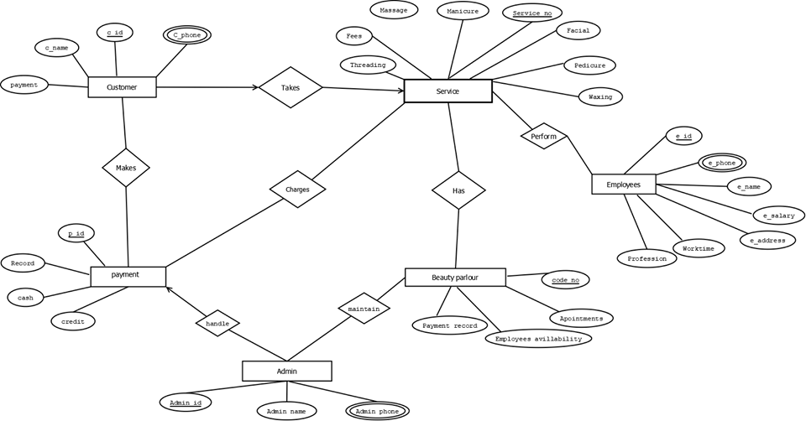

**Normalization:**

**Makes:**(c_id, c_phone,c_name,payment,p_id,record,cash,credit)

**1NF:** c_phone is a multivalued attribute

**2NF:** c_id, c_name, c_phone, payment

p_id, record, cash, credit

**3NF:**c_id, c_name, c_phone

P_id, payment

P_id, record

C_id, cash, credit

Table list for makes-

1.c_id, c_name, *p_id*

2.c_id, c_phone

3.p_id, payment

4.p_id, record, *c_id*

5.c_id, cash, credit

**Takes:** (c-id, c_phone, c_name, payment, service_no, facial manicure, massage, fees, threading, pedicure, waxing)

**1NF:** c_phone is a multivalued attributed

**2NF:** c_id, c_phone, c_name, payment

Service_no, facial manicure, massage, fees, threading, pedicure, waxing

**3NF:** c_id, c_name, c_phone

P_id, payment

Service_no, manicure, facial, pedicure, waxing, massage, threading

F_id, fees

**Table list for takes:**

1.c_id, c_name, *service _no, f_id*

2.c_id, c_phone,

3.service_no, manicure, facial, pedicure, waxing, massage, threading, *F_id*

4.f_id, fees

Charges: (p_id, record, cash, credit, service_no, facial manicure, massage, fees, threading, pedicure, waxing)

**1NF:** There is no multivalued attribute

**2NF:** p_id, record, cash, credit

service_no, facial manicure, massage, fees, threading, pedicure, waxing

**3NF:** p_id, record

C_id, cash, credit

service_no, facial manicure, massage, threading, pedicure, waxing

F_id, fees

**Table list for changes:**

1.p_id, record, *service_no, c_id, f_id*

2. C_id, cash, credit

3. service_no, facial manicure, massage, threading, pedicure, waxing, *F_id*

4. F_id, fees

**Handle:** (p_id, record, cash, credit, admin_id, admin_name, admin_phone)

**1NF:** admin_phone is a multivalued attribute

**2NF:** p_id,record, cash, credit

admin_id, admin_name, admin_phone

**3NF:** p_id, record

C_id, cash, credit

admin_id, admin_name

admin_id, admin_phone

**Table list for handle:**

1. p_id, record*, C_id, admin_id*

2. C_id, cash, credit

3. admin_id, admin_name

4. admin_id, admin_phone

**Maintain:** (admin_id, admin_name, admin_phone, code_no, payment_record, employees_availability, appointments)

**1NF:** admin_phone is a multivalued attribute

**2NF:** admin_id, admin_name, admin_phone

code_no, payment_record, employees_availability, appointments

**3NF:** admin_id, admin_name

admin_id, admin_phone

code_no, appointments, employees_availability

p_id, payment record

**Table list for Maintain:**

1. admin_id, admin_name, *code_no, p_id*

2. admin_id, admin_phone

3. code_no, appointments, employees_availability, *p_id*

4. p_id, payment record

**Has:** (service_no, facial manicure, massage, fees, threading, pedicure, waxing, code_no, payment_record, employees_availability, appointments)

**1NF:** There is no multivalued attribude

**2NF:** service_no, facial manicure, massage, fees, threading, pedicure, waxing

code_no, payment_record, employees_availability, appointments

**3NF:** service_no, facial manicure, massage, threading, pedicure, waxing

F_id, fees

code_no, appointments, employees_availability

p_id, payment record

**Table for Has:**

1.service_no, facial manicure, massage, threading, pedicure, waxing, *F_id*, *code_no*, *p_id*

2. F_id, fees

3. code_no, appointments, employees_availability, *p_id*

4. p_id, payment record

**Perform:** (service_no, facial manicure, massage, fees, threading, pedicure, waxing, e_id, p_phone,e_name, e_salary, e_address, worktime, profession)

**1NF:** e_phone is a multivalued attribuide

**2NF:** service_no, facial manicure, massage, fees, threading, pedicure, waxing

e_id, e_phone,e_name, e_salary, e_address, worktime, profession

**3NF:** service_no, facial manicure, massage, threading, pedicure, waxing

F_id, fees

e_id, e_phone, e_name, profession

e_id, e_salary, e_address

w_id, worktime

**Table list for perform:**

1. service_no, facial manicure, massage, threading, pedicure, waxing, *F_id*, *e_id*

2. F_id, fees

3. e_id, e_name, profession, e_salary, *w_id, a_id*

4. e_id, e_phone

4. a_id, e_address

5. w_id, worktime

**Table list:**

1.c_id, c_name, c_id

2.c_id, c_phone

3.p_id, payment

4.p_id, record, c_id

5.c_id, cash, credit

6.c_id, c_name,c_id

7.c_id, c_phone

8.service_no, manicure, facial, pedicure, waxing, massage, threading

9.F_id, fees

10.p_id, record, c_id

11.c_id,cash, credit

12.service_no, manicure, facial, waxing, massage, threading

13.F_id, fees

14.p_id, record, c_id

15.c_id, cash, credit

16.Admin_id, Admin_name, A_id

17.A_id, Admin_phone

18.Admin_id, Admin_name, A_id

19.A_id,Admin_phone

20.code_no, appoinments, employees, availability, p_id

21.p_id,payment record

22.service_no, manicure, massage, threading, facial, pedicure, waxing

23.F_id, fees

24.code_no, apoinments, employees, availability, p_id

25.p_id, payment record

26.service_no, manicure, massage, threading, facial, pedicure, waxing

27.F_id, fees

28.e_id, e_phone, e_name, profession, e_id

29.e_id, e_salary, e_address

30.w_id, worktime

## Final Table List:

1.c_id, c_name, c_id

2.c_id, c_phone

3.p_id, payment

4.p_id, record, c_id

5.c_id, cash, credit

6. service_no, manicure, facial, pedicure, waxing, massage, threading

7. F_id, fees

8..Admin_id, Admin_name, A_id

9.A_id, Admin_phone

10.code_no, appoinments, employees, availability, p_id

11.p_id,payment record

12.e_id, e_phone, e_name, profession, e_id

13.e_id, e_salary, e_address

14.w_id, worktime

15.c_id

16.A_id

17.p_id

18.e_id