

## Project Name: BEAUTY PARLOUR MANAGEMENT SYSTEM

## Course Name: INTRODUCTION TO DATABASE

## Section: [I]

## Group members:

|  |  |
| --- | --- |
| **NAME** | ID |
| Dipty Moni Kha | 19-39335-1 |
| Sadia Islam | 19-39338-1 |
| Jayed Bin Islam | 19-39523-1 |
| Fardin Ahsan | 19-39798-1 |

***Scenario:***

In a beauty parlor management system, customers can have many treatments from the parlor. A customer is identified by a unique customer id, customer name, payments and phone number. Services is identified by unique service no, fees, manicure, pedicure, waxing, threading, massage. Customers can make payment in many ways. Payment is identified by a unique payment id, record, cash, Credit. Payments can be ready and paid in many ways into beauty parlors. On the other hand, many treatments can be done in the beauty parlors. Beauty parlor is identified by a unique code no, appointments, employees’ availability and payment records. Treatments can be performed by many employees. Employees can be recognized by a unique id, Phone-number, name, salary, work-time, profession, address. In a beauty parlor there is an admin who maintains the beauty parlor and takes payment from the customer after the service. An admin can be identified by name, phone and their ID.

ER Diagram:

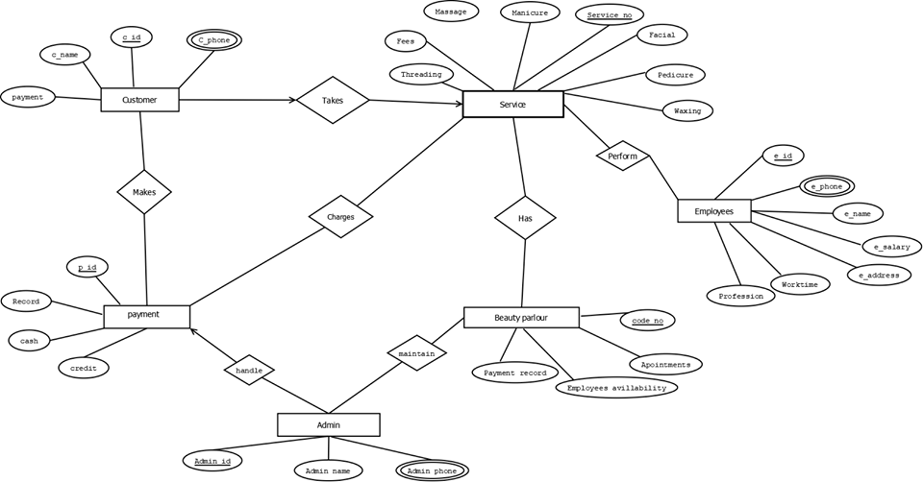

**Normalization:**

**Makes:**(c_id, c_phone,c_name,payment,p_id,record,cash,credit)

**1NF:** c_phone is a multivalued attribute

**2NF:** c_id, c_name, c_phone, payment

p_id, record, cash, credit

**3NF:**c_id, c_name, c_phone

P_id, payment

P_id, record

C_id, cash, credit

Table list for makes-

1.c_id, c_name, *p_id*

2.c_id, c_phone

3.p_id, payment

4.p_id, record, *c_id*

5.c_id, cash, credit

**Takes:** (c-id, c_phone, c_name, payment, service_no, facial manicure, massage, fees, threading, pedicure, waxing)

**1NF:** c_phone is a multivalued attributed

**2NF:** c_id, c_phone, c_name, payment

Service_no, facial manicure, massage, fees, threading, pedicure, waxing

**3NF:** c_id, c_name, c_phone

P_id, payment

Service_no, manicure, facial, pedicure, waxing, massage, threading

F_id, fees

**Table list for takes:**

1.c_id, c_name, *service _no, f_id*

2.c_id, c_phone,

3.service_no, manicure, facial, pedicure, waxing, massage, threading, *F_id*

4.f_id, fees

Charges: (p_id, record, cash, credit, service_no, facial manicure, massage, fees, threading, pedicure, waxing)

**1NF:** There is no multivalued attribute

**2NF:** p_id, record, cash, credit

service_no, facial manicure, massage, fees, threading, pedicure, waxing

**3NF:** p_id, record

C_id, cash, credit

service_no, facial manicure, massage, threading, pedicure, waxing

F_id, fees

**Table list for changes:**

1.p_id, record, *service_no, c_id, f_id*

2. C_id, cash, credit

3. service_no, facial manicure, massage, threading, pedicure, waxing, *F_id*

4. F_id, fees

**Handle:** (p_id, record, cash, credit, admin_id, admin_name, admin_phone)

**1NF:** admin_phone is a multivalued attribute

**2NF:** p_id,record, cash, credit

admin_id, admin_name, admin_phone

**3NF:** p_id, record

C_id, cash, credit

admin_id, admin_name

admin_id, admin_phone

**Table list for handle:**

1. p_id, record*, C_id, admin_id*

2. C_id, cash, credit

3. admin_id, admin_name

4. admin_id, admin_phone

**Maintain:** (admin_id, admin_name, admin_phone, code_no, payment_record, employees_availability, appointments)

**1NF:** admin_phone is a multivalued attribute

**2NF:** admin_id, admin_name, admin_phone

code_no, payment_record, employees_availability, appointments

**3NF:** admin_id, admin_name

admin_id, admin_phone

code_no, appointments, employees_availability

p_id, payment record

**Table list for Maintain:**

1. admin_id, admin_name, *code_no, p_id*

2. admin_id, admin_phone

3. code_no, appointments, employees_availability, *p_id*

4. p_id, payment record

**Has:** (service_no, facial manicure, massage, fees, threading, pedicure, waxing, code_no, payment_record, employees_availability, appointments)

**1NF:** There is no multivalued attribude

**2NF:** service_no, facial manicure, massage, fees, threading, pedicure, waxing

code_no, payment_record, employees_availability, appointments

**3NF:** service_no, facial manicure, massage, threading, pedicure, waxing

F_id, fees

code_no, appointments, employees_availability

p_id, payment record

**Table for Has:**

1.service_no, facial manicure, massage, threading, pedicure, waxing, *F_id*, *code_no*, *p_id*

2. F_id, fees

3. code_no, appointments, employees_availability, *p_id*

4. p_id, payment record

**Perform:** (service_no, facial manicure, massage, fees, threading, pedicure, waxing, e_id, p_phone,e_name, e_salary, e_address, worktime, profession)

**1NF:** e_phone is a multivalued attribuide

**2NF:** service_no, facial manicure, massage, fees, threading, pedicure, waxing

e_id, e_phone,e_name, e_salary, e_address, worktime, profession

**3NF:** service_no, facial manicure, massage, threading, pedicure, waxing

F_id, fees

e_id, e_phone, e_name, profession

e_id, e_salary, e_address

w_id, worktime

**Table list for perform:**

1. service_no, facial manicure, massage, threading, pedicure, waxing, *F_id*, *e_id*

2. F_id, fees

3. e_id, e_name, profession, e_salary, *w_id, a_id*

4. e_id, e_phone

4. a_id, e_address

5. w_id, worktime

**Table list:**

1.c_id, c_name, c_id

2.c_id, c_phone

3.p_id, payment

4.p_id, record, c_id

5.c_id, cash, credit

6.c_id, c_name, c_id

7.c_id, c_phone

8.service_no, manicure, facial, pedicure, waxing, massage, threading

9.F_id, fees

10.p_id, record, c_id

11.c_id, cash, credit

12.service_no, manicure, facial, waxing, massage, threading

13.F_id, fees

14.p_id, record, c_id

15.c_id, cash, credit

16.Admin_id, Admin_name, A_id

17.A_id, Admin_phone

18.Admin_id, Admin_name, A_id

19.A_id, Admin_phone

20.code_no, appoinments, employees, availability, p_id

21.p_id, payment record

22.service_no, manicure, massage, threading, facial, pedicure, waxing

23.F_id, fees

24.code_no, apoinments, employees, availability, p_id

25.p_id, payment record

26.service_no, manicure, massage, threading, facial, pedicure, waxing

27.F_id, fees

28.e_id, e_phone, e_name, profession, e_id

29.e_id, e_salary, e_address

30.w_id, worktime

## Final Table List:

1.c_id, c_name, c_id

2.c_id, c_phone

3.p_id, payment

4.p_id, record, c_id

5.c_id, cash, credit

6. service_no, manicure, facial, pedicure, waxing, massage, threading

7. F_id, fees

8.Admin_id, Admin_name, A_id

9.A_id, Admin_phone

10.code_no, appoinments, employees, availability, p_id

11.p_id, payment record

12.e_id, e_phone, e_name, profession, e_id

13.e_id, e_salary, e_address

14.w_id, worktime

15.c_id

16.A_id

17.p_id

18.e_id

***Table Creation:***

**Admin Table:**

create table Admin (Admin_id number (10) , Admin_name varchar2(20), Admin_phone number(10));

alter table Admin add constraint aw primary key (Admin_id)

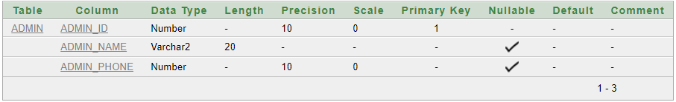

**Customer Table:**

create table customer (c_id number (10), c_name varchar2(20), payment number(10), c_phone number(10));

alter table customer add constraint bw primary key (c_id)

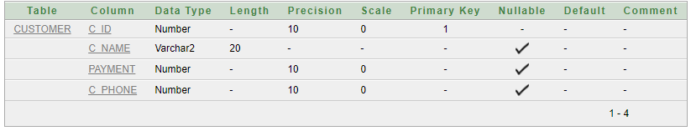

**Payment Table:**

create table payment (p_id number(10), record varchar2(20), cash varchar2(20), credit varchar2(20));

alter table payment add constraint cw primary key (p_id)

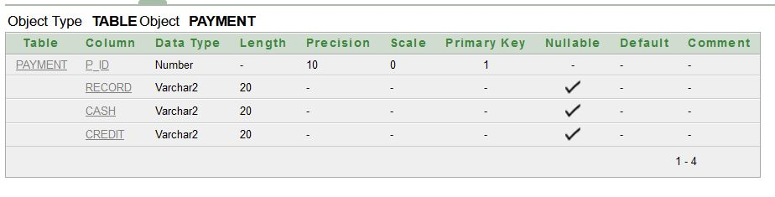

**Service Table:**

create table service (Service_no number(10), Pedicure varchar2(20), Manicure varchar2(20), Facial varchar2(20), Massage varchar2(20), Fees varchar2(20), Threading varchar2(20), Waxing varchar2(20));

alter table service add constraint dw primary key(service_no)

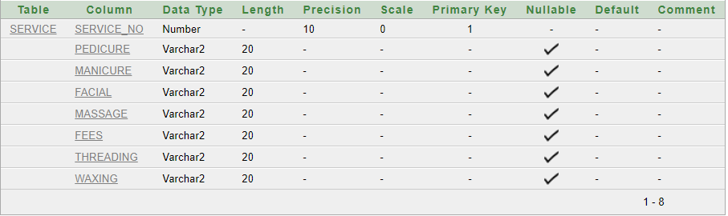

**Beauty Parlor Table:**

create table beautyparlor(code_no number(10), Appointments varchar2(20), payment_records number(10), Employees_availability varchar2(20));

alter table beautyparlor add constraint ew primary key (code_no)

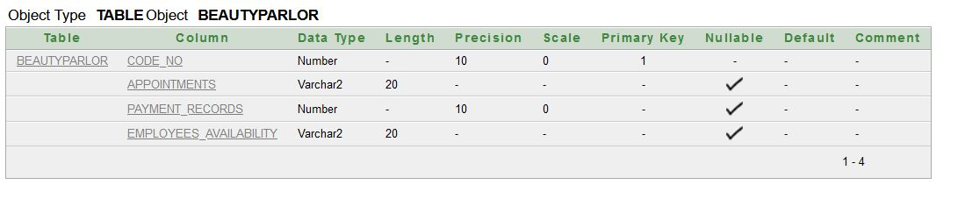

**Employees Table:**

create table employees(e_id number(10), e_name varchar2(20), worktime number(10), E_address varchar2(20), salary number(10), E_phone number(10), profession varchar2(20));

alter table employees add constraint fw primary key (e_id)

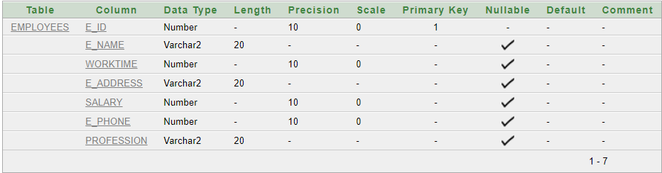

***Value Insertion:***

**Admin Table:**

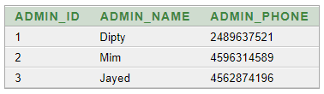

**Customer Table:**

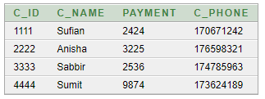

**Payment Table:**

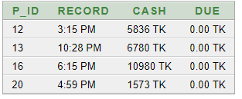

**Service Table:**

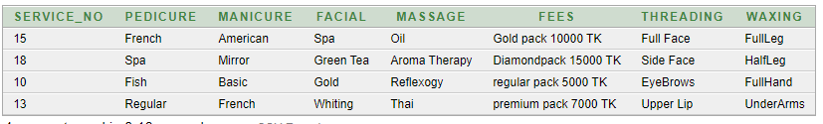

**Beauty parlor Table:**

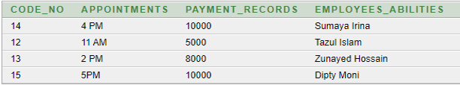

**Employees Table:**

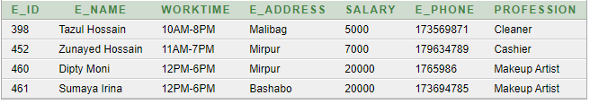

**Questions:**

**1.**Print the employee_id and salary of all employee whose salary is less than Dipty Moni’s salary.

**Answer:** select E_ID, SALARY from Employees where salary<(select salary from Employees where E_NAME = Dipty Moni

**2.**Create a view named “My_Appointment”to find the payment records of where code no starts with 15.

**Answer:** create view My_Appointment as select PAYMENT_ RECORDS from Beauty parlor where CODE_NO like 15

**3.**Create a view named “My_Payment”to find the Due of where payment id starts with 13.

**Answer:** create view My_Payment as select DUE from Payment where P_ID like 13

**4.**Display the payment that has customer id less than that of customer name Sabbir- which would be the inner query?

**Answer:** select C_ID from Customer where C_NAME=’Sabbir’

**5.** Display the payment that has customer id less than that of customer name Sabbir- which type of query is this?

**Answer:** Single row Querry

**6.**Display all the Employee Name along with their Profession and Work time-which type of join we can use to solve the quarry?

**Answer:** Equi Join

**7.** Display the Service no and Fees for all Waxing who have a Fin their name?

**Answer:** select SERVICE_NO,FEES from Service where WAXING like’F%’

**8.** Create a query to display the Employees that earn a salary that is higher than the salary of all makeup artists. Sort the results on salary from highest to lowest.

**Answer**: select E_NAME,SALARY

from Employee

where SALARY>all

(select SALARY from Employee where PROFESSION='Makeup Artists')

order by SALARY

**9.** Write a query to display the Employee name and Email Address for all employees in the same Profession as Dipty Moni. Exclude Sumaya Irina.

**Answer**: select E_NAME,E_ADDRESS

from Employees where Profession=(select Profession from Employees where E_NAME='Dipty Moni') and E_NAME<>'Sumaya Irina'

**10.** Write a query to display the employee name, work time and email address of all employees whose profession is cashier.

**Answer:** select E_NAME,WORK_TIME,E_ADDRESS from Employees where profession =’Cashier’