**Normalization Practice**

**Delivery_company**

|  |  |  |  |  |  |  |
| --- | --- | --- | --- | --- | --- | --- |
| **DID** | **D_name** | **Company** | **Phone** | **Customer1** | **Customer2** | **Customer3** |
| **101** | **A** | **S.A** | **987654** | **Q** | **W** | **R** |
| **102** | **B** | **Pathao** | **79998877** | **T** | **-** | **Y** |
| **103** | **C** | **-** | **-** | **-** | **-** | **-** |
| **104** | **D** | **Pathao** | **87654** | **H** | **G** |  |

**1NF-normalization form- multivalued attribute**

**2NF- all non-key should be depends on pk- sid,sname,age,gpa,cgpa**

**3NF-transitive dependency**

**gpa,cgpa**

**sid,sname,age**

|  |  |  |  |
| --- | --- | --- | --- |
| **name** | **age** | **Phone** | **adrs** |
| **Smith** | **18** | **555** |  |
| **Smith** | **18** | **666** |  |
| **Smith** | **18** | **777** |  |
| **smith** | **18** | **888** |  |

**Green one is the primary key,**

**red one is the foreign key.**

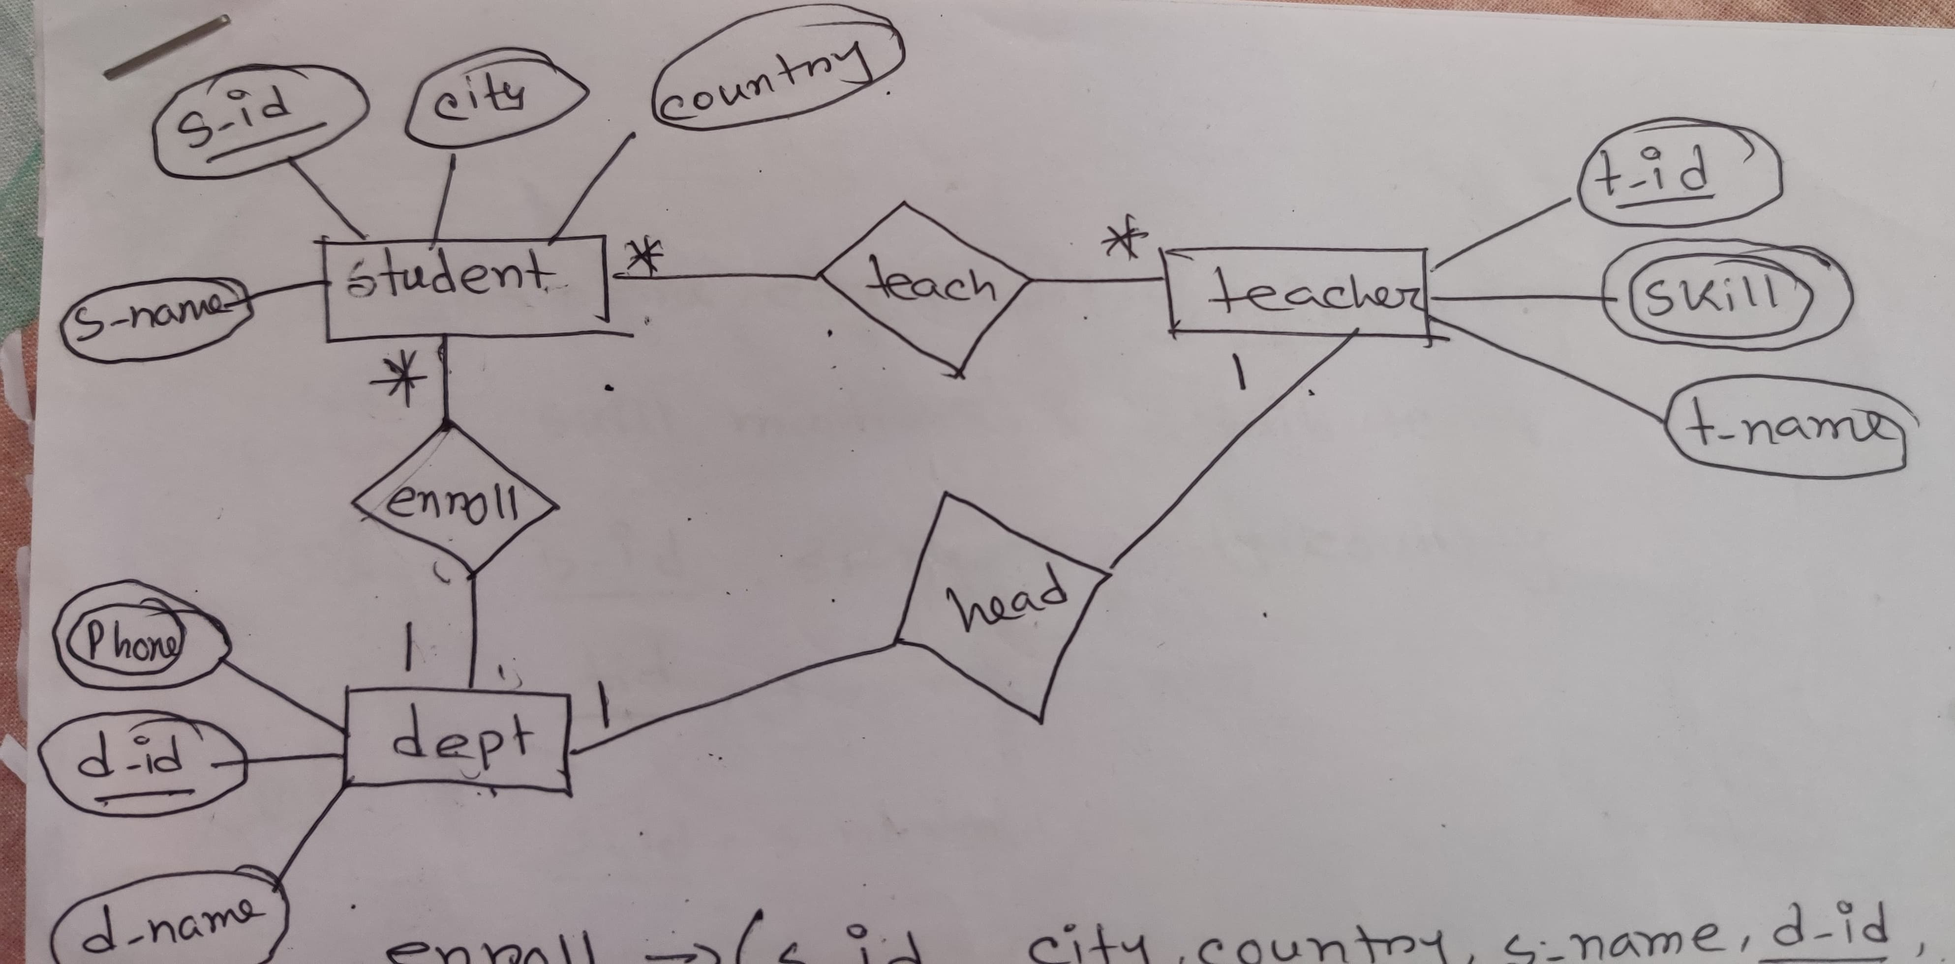

**Head- (d_id,d_name,phone,t_id,t_name,skill)**

**1NF-phone & skill are multivalued attribute**

**2NF- d_id, d_name,phone**

**T_id,t_name,skill,**

**3NF- no transitive dependency**

**d_id, d_name,phone**

**T_id,t_name,skill**

**Table for Head-**

1. **d_id, d_name,t_id**
2. **t_id,t_name**
3. **d_id, phone**
4. **t_id, skill**

**Teach-(s_id,s_name,city,country, t_id, t_name,skill)**

**1NF- skill is a multivalued attribute**

**2NF- s_id, s_name,country,city**

**T_id, t_name,skill**

**3NF- s_id, s_name**

**c_id,country,city**

**T_id, t_name,skill**

**Table for teach-**

1. **s_id, s_name,c_id**
2. **c_id,country,city**
3. **T_id, t_name**
4. **N_id, s_id, t_id**
5. **T_id, skill- composite pk**

**Enroll- (s_id , s_name, country , city , d_id , d_name, phone)**

**1NF- phone is a multivalued attribute**

**2NF- S_id, s_name,country,city**

**D_id, d_name, phone**

**3NF- S_id, s_name**

**C_id, country,city**

**D_id, d_name, phone**

**Table for Enroll-**

1. **S_id, s_name, d_id, c_id**
2. **C_id, country,city**
3. **D_id, d_name**
4. **D_id, phone- composite pk**

**Final table list-**

1. **S_id, s_name, d_id, c_id - student**
2. **C_id, country,city- cont_ct**
3. **D_id, phone- dept1**
4. **T_id, t_name - teacher**
5. **N_id, s_id, t_id- newtbl**
6. **T_id, skill- teacher2**
7. **d_id, d_name,t_id- dept**