Gold as a Hedge in Pandemic: A Case Study in West Bengal from June,2020 to June,2021

Abstract

*Gold is one of the oldest ways to store wealth. Any major crisis across the world resulted in a sharp spike in prices of gold. The biggest rise has been due to Covid-19, known to be a hedge against economic and geopolitical crises; gold prices have rallied whenever a crisis had taken place. The gold prices in domestic market have galloped 38% northward since the corona virus outbreak began spreading outside china. The connection between Gold price rate and present covid 19 pandemic situation economic condition can be considered as an important indicator for the economic condition of any country or state. This study analyses whether gold rate is significantly affected by this present pandemic through a regression study of weekly change in gold rate on weekly new covid cases as well as weekly deaths due to covid. Granger’s causality test is also used to capture the temporal cause-and-effect relation among those variables.*

1. Introduction

Gold is one of the most malleable, ductile, dense, conductive, non-destructive, brilliant, and beautiful of metals. This unique set of qualities has made it a coveted object for most of the human history in almost every civilization, and there have been active gold markets for over 6,000 years Green (2007). As money, as an investment, as a store and source of value, hundreds of papers have been written on Gold. This review provides a state of the art overview of this voluminous research, and acts as an introduction to this special issue of the International Review of Financial Analysis, while also assisting as a source of reference for future research.

The long and intertwined history of gold, financial markets and money has resulted in gold’s regular prominence in investment and monetary discussions.

*Figure 1- Gold Related Articles in the Financial Times*



Using quantitative time series analysis, this study attempts to determine the nature of causal relationships between Gold price rate and economic condition of a state. One empirical result is that there is mutual causality between research and economic growth in our State. Gold has always been the most secure form of investment. Following the global trend, Kolkata’s gold price has experienced a huge increase in the recent years. But the world economy is avoiding risk and still turning to the reliable asset. Although prices are high, current gold rates remain flat due to Covid-19. Use references here

In the next section we provide a brief overview of the relationship between gold price rate changes and covid-19 impacts on it in West Bengal. In section 3 we discuss about the data and methodology to find this relationship and in section 4, a conclusion is provided.

1. **What is the impact of Covid 19 pandemic on gold prices in West Bengal?**

Gold prices have remained steady since the last week of March in West Bengal. Investors are now shifting to cash by selling off their assets due to the pandemic and due to this; the price of the gold had dipped considerably in the last month.

After the corona virus or COVID-19 became a global pandemic, investors are turning to gold globally considering it the safest option to curb the economic distress. The investors in the state are investing in the bullion market for its safe-haven demand due to global economic distress. The price of gold in the state opened at Rs. 4253 per gram for the month of April and remained steady until the end of the first week of the month at Rs. 4253 per gram.

Gold in West Bengal is a solid instrument for investments even before the pandemic arrived. Traders in West Bengal invest in gold bullion as it is considered a safe option. Gold prices have reached an all-time high in West Bengal due to the pandemic, but a large part of this has been driven by depreciating rupee and increased import duty. It must be noted that gold prices in West Bengal include 12.5% import duty and 3% GST. On the other hand, international gold prices are much lower than the all-time high price.

**Plot of gold prices over time**

**How will gold price impact borrowers?**

A correction in gold price means that the borrower will get a lesser loan amount. As the corona virus pandemic continues to spread across the world, a large number of people have been hit hard by financial setbacks. Many have lost their jobs or their businesses have been shut down.

In West Bengal, a large number of people have opted for gold loans to fulfill their urgent fund requirements as it is convenient to get a gold loan due to less paperwork. Generally, these are short-term loans with a tenure extending up to one year.

However, the price of gold has corrected by more than 20% from its peak and is currently hovering around ₹46,000 per 10 gm.

So, let’s understand what this correction in the price of the precious commodity means for new and existing gold loan borrowers.

**About Gold price rate in Kolkata**

The gold price in Kolkata will help discerning investors to make the right choices, when it comes to buying the precious metal for investment or merely for consumption. Please do check todays gold rates in Kolkata, before you choose to buy gold and other precious ornaments in India.Have you ever wondered why gold prices of 22 carat today in Kolkata differs from other cities. We cannot say with certainty whether the rates would be high or low on a given day. What we know is that they are never different on any given day. Now, many individuals ask why this differs. There are plenty of reasons for the same and there is no one reason. For example, Kolkata being a port city gold can be imported much easier. However, that is not the case. For example, take the case of tariffs. If the tariffs in the city differ than the gold rates today of Kolkata would be much higher than that of other cities. Again transportation costs play an important role in determining the price of gold. The buyer of course ends up paying so much more in India, as compared to the international rates, because of so many costs involved. So, the best thing and the only thing that will help you make money is to look at prices. If gold rates in Kolkata today are low, you can make money or else you cannot. If you buy the metal as a compulsion,just buy and hold. So, if the rupee falls gold prices would change accordingly in Kolkata.

Generally speaking gold prices change twice a day in the city of Kolkata. However, it is extremely difficult to say when prices change. Now, let us cite an example. By the time the prices are disseminated to the jewelers it would take time to reflect and some would have changed the gold rates, while others would have not.

What if there is a customer who has just been checking the gold at a certain price, only to suddenly realize that the prices of gold have changed. Would he renegotiate the prices all over again. This is highly possible though the jeweler might give him the original price at which he saw and decided to buy the gold. In any case, as we mentioned earlier, gold prices in the city of Kolkata do not change at a particular time. In fact, sometimes there is no movement in the precious metal and hence the prices are almost flat or little changed. So, buy when you are comfortable with prices.

1. The Dataset

We collect a data over 22 carat gold rate and 24 carat gold rate from June 16,2020 to June 16,2021 and also collect the data of daily Covid new cases and daily Covid deaths from June 16,2020 to June 16,2021.Then we set a combined data with four columns and three hundred sixty five rows. But there are many troubles to compute these data because of the big row size. So we shorten this big dataset by taking the weekly average of each column like weekly average of 22 carat gold, weekly average of 24 carat gold, weekly average of Covid new cases and weekly average of Covid deaths to avoid the errors due to this big dataset in analysing the relationship between gold economy and daily Covid new cases and Covid deaths.

|  |  |  |  |  |  |  |  |  |
| --- | --- | --- | --- | --- | --- | --- | --- | --- |
|  | Weekly Average of Gold Price | | | |  | | Weekly Average of daily | Weekly Average of |
| Week No |  | 22 Carat | | 24 Carat |  | | New Covid Cases | Covid Deaths |
|  |  |  | |  |  |  | |  |
| Jun 18-Jun 24 |  | 47,324.29 | | 48,614.29 |  | 387 | | 12 |
| Jun 25-Jul 1 |  | 47,658.57 | | 48,948.57 |  | 571 | | 13 |
| Jul2-Jul 8 |  | 47,434.29 | | 48,732.86 |  | 808 | | 21 |
| Jul9-Jul 15 |  | 48,171.43 | | 49,747.14 |  | 1372 | | 25 |
| Jul16-Jul 22 |  | 48,515.71 | | 50,042.86 |  | 2128 | | 32 |
| Jul23-Jul 29 |  | 50,475.71 | | 51,875.71 |  | 2277 | | 38 |
| Jul30-Aug 5 |  | 52,418.57 | | 53,804.29 |  | 2649 | | 51 |
| Aug 6-Aug 12 |  | 54,134.29 | | 55,720.00 |  | 2929 | | 51 |
| Aug 13-Aug 19 |  | 52,082.86 | | 54,784.29 |  | 3085 | | 54 |
| Aug 20-Aug 26 |  | 51,398.57 | | 54,108.57 |  | 3122 | | 55 |
| Aug 27-Sep 2 |  | 50,307.14 | | 53,011.43 |  | 2987 | | 54 |
| Sep 3-Sep 9 |  | 50,214.29 | | 53,342.86 |  | 3052 | | 56 |
| Sep 10-Sep 16 |  | 50,572.86 | | 53,272.86 |  | 2269 | | 56 |
|  |  |  | |  |  |  | |  |
| Sep 17-Sep 23 |  | 50,395.71 | | 53,094.29 |  | 3185 | | 60 |
| Sep 24-Sep 30 |  | 49,217.14 | | 51,977.14 |  | 3197 | | 59 |
| Oct1-Oct7 |  | 49,660.00 | | 52,570.00 |  | 3351 | | 60 |
| Oct8-Oct 14 |  | 50,018.57 | | 52,961.43 |  | 3599 | | 62 |
| Oct15-Oct 21 |  | 49,857.14 | | 51,805.71 |  | 3918 | | 62 |
| Oct22-Oct 28 |  | 49,927.14 | | 51,978.57 |  | 4082 | | |  |  |  |  | | --- | --- | --- | --- | | 60 |  |  |  | |
| Oct29-Nov 4 |  | 49,314.29 | | 52,675.71 |  | 3982 | | 58 |
| Nov 5-Nov 11 |  | 49,507.14 | | 52,650.00 |  | 3915 | | 55 |
| Nov 12-Nov 18 |  | 49,202.86 | | 53,738.57 |  | 3557 | | 53 |
| Nov 19-Nov 25 |  | 50,061.43 | | 52,461.43 |  | 3587 | | 50 |
| Nov 26-Dec 2 |  | 49,037.14 | | 51,522.86 |  | 3297 | | 51 |
| Dec 3-Dec 9 |  | 47,748.57 | | 50,791.43 |  | 2983 | | 49 |
|  |  |  | |  |  |  | |  |
| Dec 10-Dec 16 |  | 48,727.14 | | 51,427.14 |  | 2466 | | 46 |
| Dec 17-Dec 23 |  | 49,267.14 | | 51,967.14 |  | 1916 | | 40 |
| Dec 24-Dec 30 |  | 49,472.86 | | 52,130.00 |  | 1324 | | 30 |
| Dec 31-Jan6 |  | 49,935.71 | | 52,572.86 |  | 908 | | 26 |
| Jan7-Jan13 |  | 49,297.14 | | 51,997.14 |  | 792 | | 19 |
| Jan14-Jan20 |  | 48,395.71 | | 51,124.29 |  | 527 | | 12 |
| Jan21-Jan27 |  | 48,524.29 | | 51,224.29 |  | 343 | | 8 |
| Jan28-Feb 3 |  | 48,250.00 | | 50,904.29 |  | 242 | | 8 |
| Feb 4-Feb 10 |  | 47,010.00 | | 49,707.14 |  | 176 | | 4 |
| Feb 11-Feb 17 |  | 46,882.86 | | 49,577.14 |  | 171 | | 2 |
| Feb 18-Feb 24 |  | 45,831.43 | | 48,567.14 |  | 184 | | 3 |
| Feb 25-Mar 3 |  | 45,370.00 | | 48,138.57 |  | 202 | | 2 |
|  |  |  | |  |  |  | |  |
| Mar 4-Mar 10 |  | 44,080.00 | | 46,737.14 |  | 222 | | 2 |
| Mar 11-Mar 17 |  | 44,294.29 | | 46,934.29 |  | 270 | | 2 |
| Mar 18-Mar 24 |  | 44,448.57 | | 47,107.14 |  | 387 | | 2 |
| Mar 25-Mar 31 |  | 44,104.29 | | 46,822.71 |  | 721 | | 2 |
| Apr1-Apr 7 |  | 44,625.71 | | 47,317.14 |  | 1873 | | 5 |
| Apr8-Apr 14 |  | 45,810.00 | | 48,510.00 |  | 4299 | | 14 |
| Apr15-Apr 21 |  | 46,512.86 | | 49,215.71 |  | 8406 | | 36 |
| Apr22-Apr 28 |  | 47,254.29 | | 49,647.14 |  | 14942 | | 64 |
| Apr29-May 5 |  | 46,260.00 | | 48,998.57 |  | 17583 | | 98 |
| May 6-May 12 |  | 46,138.57 | | 49,577.14 |  | 19497 | | 126 |
|  |  |  | |  |  |  | |  |
| May 13-May 19 |  | 46,242.86 | | 49,982.86 |  | 19679 | | 144 |
|  | | |
|  | | | | |  | | | |

|  |  |  |  |  |
| --- | --- | --- | --- | --- |
| Week No | Weekly Average of Gold Price | | Weekly Average of New Covid Cases | Weekly Average of Covid Deaths |
| 22 Carat | 24Carat |
| May 20-May 26 | 47,650.00 | 50,662.86 | 18191 | 156 |
| May 27-Jun 2 | 48,092.86 | 50,911.43 | 10932 | 141 |
| Jun 3-Jun 9 | 47,875.71 | 50,840.00 | 6872 | 105 |
| Jun 10-Jun 16 | 48,161.43 | 50,828.57 | 4057 | 80 |
|  |  |  |  |  |
|  |  |  |  |  |

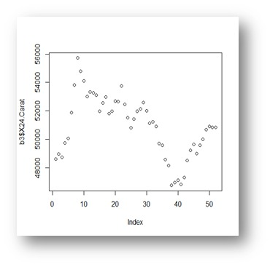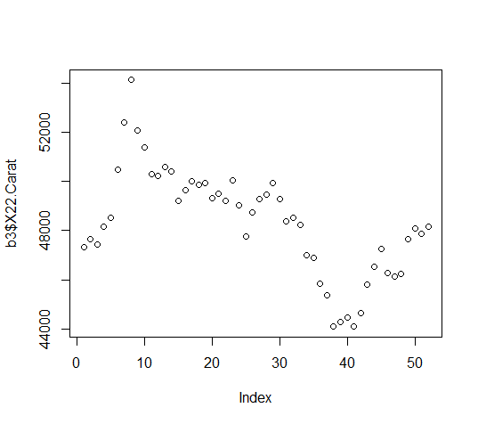

1. **Statistical Aanalysis**

**Write what methods you have used for analysis and show the results**

1. **Correlation**
2. **Regression**
3. **Ganger test**

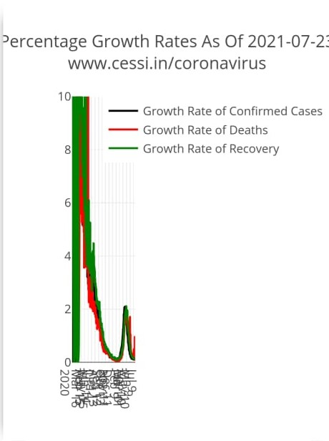

The plot above shows the growth rate of deaths and confirmed cases from March 1st, 2020. Growth rate of confirmed cases has been calculated as the ratio of the number of new cases on a day to the total number of cases on that day. Growth rate of deaths has been calculated as the ratio of the number of new deaths on a day to the total number of deaths on that day. It can be seen that all three growth rates are stabilizing after the lockdown.

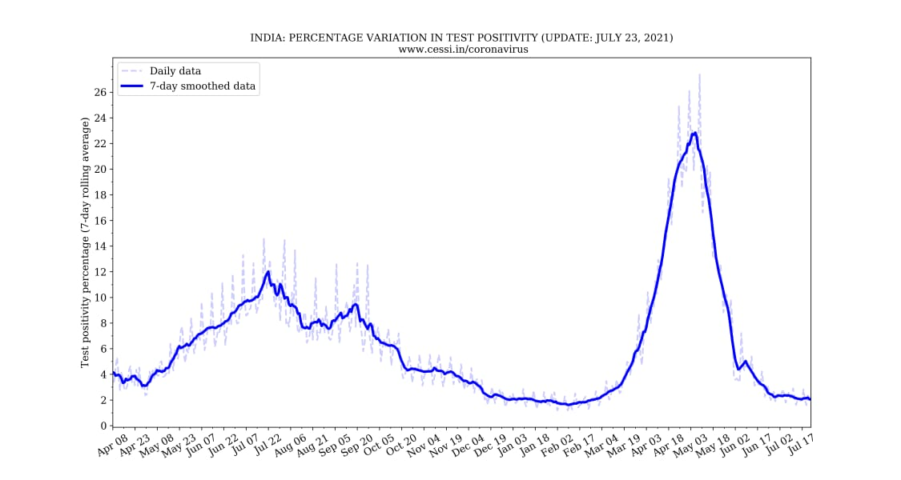

How the test positivity percentage is calculated: 100*daily confirmed/daily tested.

The assumption in this plot is that the results become immediately available on a daily basis following tests, which may not be true. However, the long term trends would not be affected by the validity of this assumption.

Covid-19 death is compatible illness in a probable or confirmed COVID-19 case, unless there is a clear alternative cause of death that cannot be related to COVID-19 disease (e.g. trauma). There should be no period of complete recovery between the illness and death.

WHO (World Health Organization) periodically updates the Global Surveillance for human infection with corona virus disease (COVID-19) document which includes surveillance definitions.

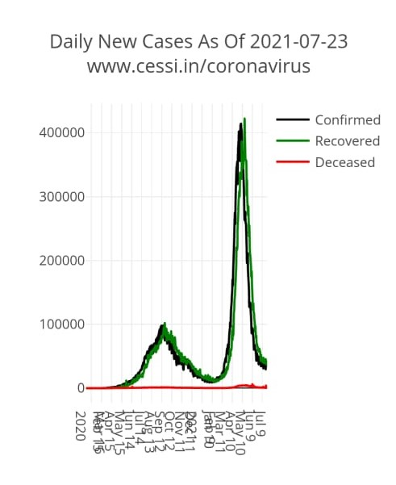

The above chart shows the the number of new cases being confirmed, new deaths and new recoveries all over India, each day.

**#Test for Stationarity in R**

Stationarity is an important concept in time series analysis. Stationarity means that the statistical properties of a time series (or rather the process generating it) do not change over time. Stationarity is important because many useful analytical tools and statistical tests and models rely on it. A common assumption in many time series techniques is that the data are stationary. A stationary process has the property that the mean, variance and autocorrelation structure do not change over time. So testing for stationarity is very important because the whole results of the regression might be fabricated. In formal way the series is called stationary if it satisfies three conditions, otherwise it will be a non-stationary series. So, here we test **Ljung-Box** test for independence to check stationarity of each data which are weekly average of gold price (22 carat and 24 carat each), weekly average of daily new covid cases and covid deaths. Quantitatively, we can also use built-in test for testing stationariy. First, the **Ljung-Box** test examines whether there is significant evidence for non-zero correlations at given lags (1-25 shown below), with the null hypothesis of independence in a given time series (a non-stationary signal will have a low p-value).

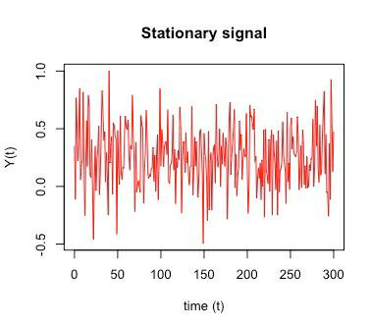

Here, we will look at a couple methods for checking stationarity. If the time series is provided with seasonality, a trend, or a change point in the mean or variance, then the influences need to be removed or accounted for.

The first thing that I will want to do to analyze our time series data will be to read it into R, and to plot the time series. I can read data into R using the scan () function, which assumes that our data for successive time points is in a simple text file with one column.

But, we find weekly average of 22 carat gold price, weekly average of 24 carat gold price, weekly average of new covid cases and covid deaths are not stationary data. So, to make these data stationary, we take first different of each column of dataset. Then we see the data of weekly average of 22 carat and 24 carat gold price are become stationary after taking the first difference of each row. But, we find the data of weekly average of daily covid new cases and weekly average of covid deaths are not become stationary after taking the first difference also. Then we take second difference of each row of these two different column of the dataset and delete the first row from the first difference of weekly average of 22 carat gold price and 24 carat gold price to make the column length of each dataset same. Then we check stationarity of each column of the dataset by Ljung-Box test and find all the data stationary.

Remove this highlighted part

No need of describing how to do in R. only describe what you hv done and what is ur findings

**C. Granger Causality Test:**

Granger causality is a way to investigate causality between two variables in a time series. The method is a probabilistic account of causality; it uses empirical data sets to find patterns of correlation. A variable X is causal to variable Y if X is the cause of Y or Y is the cause of X. A Granger-causality analysis has been carried out in order to assess whether there is any potential predictability power of one indicator for the other. The conclusion that can be drawn is that stock market prices can be used in order to predict growth, but the opposite it is not true. If this assumption is not satisfied then Granger-causality is actually Granger-usefulness-for-forecasting. For example, if there is a variable Z that causally influences both X and Y, then the conclusion that Y Granger-causes X can be explained as the influence of Z being felt in Y before it's felt in X.

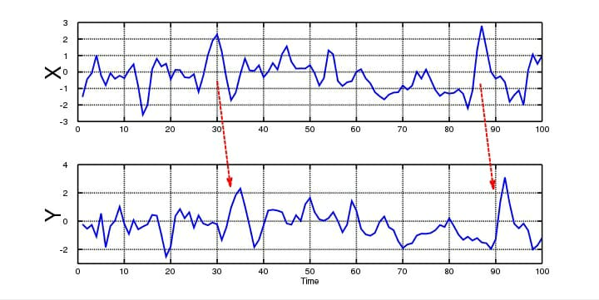 When time series X Granger-causes time series Y, the patterns in X are approximately repeated in Y after some time lag (two examples are indicated with arrows). Thus, past values of X can be used for the prediction of future values of Y.

The basic steps for running the test are:

i) State the null hypothesis and alternate hypothesis. For example, y(t) does not Granger-cause x(t).

ii) Choose the lags. This mostly depends on how much data you have available. One way to choose lags i and j is to run a model order test (i.e. use a model order selection method). It might be easier just to pick several values and run the Granger test several times to see if the results are the same for different lag levels. The results should not be sensitive to lags.

iii) Find the f-value. Two equations can be used to find if βj = 0 for all lags j:

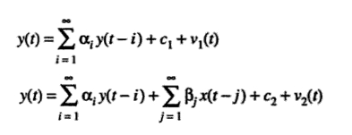

Two equations for Granger causality: Restricted (top) and unrestricted (bottom).

Similarly, these equations test to see if y(t) Granger-causes x(t):

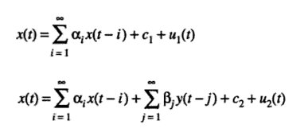

iv) Calculate the f-statistic using the following equation:

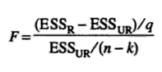

v) Reject the null if the F statistic (Step 4) is greater than the f-value (Step 3).

The Granger causality test is used to demonstrate casual relationships between time series. Granger (1980) defines Granger causality as: ‘‘A time series variable X Granger causes Y, if the probability of Y conditional on its own past history and the past history of X does not equal the probability of Y conditional on its own past history alone.’’ Using this concept, it is possible to assess whether GDP causes publications or vice versa.

There are thus two hypotheses: null hypothesis and alternative hypothesis.

**Null hypothesis:** no causal relationship between gold economy and covid-19 daily new cases and covid-19 deaths.

This hypothesis imagines a situation in which research has a direct impact on gold economy that is covid situation does not affect gold price rate(22 carat and 24 carat both) or gold prices does not increases or decreases due to covid-19 virus (daily total no. new cases and daily total no. of deaths)implicitly or explicitly.

**Alternative hypothesis:** causal relationship between gold economy and covid-19 daily new cases and covid-19 deaths holds.

This hypothesis imagines a situation in which research has not a direct impact on gold economy. Covid situation affects gold price rate(22 carat and 24 carat both) or gold prices of 22 carat and 24 carat both (from June,2020 to June,2021) increases or decreases due to this covid-19 virus directly.

Vector auto regression (VAR) is a popular model used in econometrics to capture the evolution and the interdependencies between multiple time series. Combined with vector auto regression, the Granger causality test can provide further evidence for causality relationship between gold price rate and covid-19 virus affected cases and deaths.

**make it brief. Remove high lighted part**

**write conclusion**

**add reference**