**University of Makati**





JP Rizal Extension, West Rembo, Makati City

ADEPT

**Learning Module for AY 2023 – 2024**

Lesson 1:

Self-Awareness for Job Readiness

**Name**  **Section Date**

|  |  |  |
| --- | --- | --- |
|  |  |  |



**Let’s Accomplish…**

Read the ***Learning Outcomes*** of this Lesson.

At the end of the learning engagement, you should be able to:

1. show awareness of own strengths and areas for development,

2. assess yourself accurately on personal hygiene and dress, attitude, and career personality,

3. evaluate your own transferable skills,

4. participate in activities in discussing the lesson, and

5. appreciate the significance of knowing yourself for job readiness.



**Get the Ball Rolling…**

***A. Being Aware of Me.*** Finish writing each of these sentences.

|  |
| --- |
| 1. My best quality is |
| 2. I am strong in the areas of |
| 3. I am weak in the areas of |
| 4. In my spare time I like to |
| 5. My happiest memory is |
| 6. I get scared when |
| 7. I usually pick friends who are |
| 8. I tend to stay away from people who are |
| 9. The people I believe may be able to help me the most are |
| 10. When I am worried, I usually |
| 11. To decrease stress in my life |
| 12. I ask for help when |
| 13. I get angry when |
| 14. I usually lose interest |
| 15. I am willing to improve myself in the areas of |

***B. Image Checklist.*** Assess yourself accurately on personal hygiene and dress by completing the following Image Checklist. Shade the box corresponding to your choice.

|  |  |
| --- | --- |
| **IMAGE CHECKLIST for MEN** | **IMAGE CHECKLIST for WOMEN** |
| **I. Personal Appearance**  *Hair Cleanliness:*   A. Healthy-looking, squeaky clean   B. Dull, lifeless   C. Greasy   D. Dandruff   E. Accumulation of hair gel  *Hair Style:*   A. Freshly, trimmed and styled   B. Shaggy, needs trim and style   C. Very long or extreme style   D. Uncombed, unkempt  *Face and Complexion:*   A. Freshly shaven, glow of cleanliness   B. Five o’clock shadow   C. Didn’t shave at all today   D. Scraggly or unkempt beard or mustache  *Personal Hygiene:*   A. Clean smelling, used deodorant, fragrance is subtle, breath is clean   B. Showered, but did not use deodorant   C. Cologne that is too strong  *Hands and Nails:*   A. Neat and tidy and trimmed   B. Nails too long or chewed   C. Jagged, broken, dirty nails   D. Nicotine-stained fingers | **I. Personal Appearance**  *Hair Cleanliness:*   A. Healthy-looking, squeaky clean   B. Dull, lifeless   C. Greasy   D. Dandruff   E. Accumulation of hair spray  *Hair Style:*   A. Freshly, trimmed and styled   B. Extreme style or color   C. Dyed or bleached hair with roots needing retouching   D. Uncombed and/or messy looking  *Face and Complexion:*   A. Fresh, natural-looking makeup matching skin color   B. Smudged makeup, worn off lipstick   C. Very heavy, theatrical makeup   D. No makeup  *Personal Hygiene:*   A. Clean smelling, breath is fresh   B. Showered but did not use deodorant and mouthwash   C. Strong perfume  *Hands and Nails:*   A. Neat and clean, well kept   B. Very long or chewed nails   C. Jagged, broken, dirty nails   D. Nicotine-stained fingers |
| **II. Attire**  *Jewelry:*   A. Tastefully simple   B. Big, gaudy jewelry   C. Visible tattoos, body piercing  *Footwear:*   A. Simple, clean, polished, and appropriate   B. Unpolished   C. Heels worn down   D. White socks or socks that do not match slacks   E. Socks so short that part of the leg shows    *Clothing:*   A. Clean and pressed, appropriate for work   B. Pants bunched up with a belt   C. Belt buckle worn to side of slacks   D. Stains on tie   E. Perspiration-stained clothes   F. Loose buttons   G. Clothing in need of repair   H. Wild-looking tie or no tie   I. Thick wallet in back pocket | **II. Attire**  *Jewelry:*   A. Simple and attractive   B. Jewelry which is noisy   C. Pierced ears without earrings   D. Visible tattoos, body piercing    *Footwear:*   A. Clean, polished, appropriate   B. Unpolished or worn   C. Very high heels   D. Torn stockings   E. Toe-reinforced stockings with sandals   F. Dirty toenails with sandals  *Clothing:*   A. Clean, pressed, appropriate for the job   B. Too tight or short pants or skirt   C. Underwear showing or visible   D. Perspiration-stained clothes   E. Loose buttons   F. Clothing in need of repair |
| **III. Language**   A. Proper communication skills   B. Profanity   C. Slang   D. Dialect/Vernacular with regional accent | **III. Language**   A. Proper communication skills   B. Profanity   C. Slang   D. Dialect/Vernacular with regional accent |

***My Reflection*** (How do you see yourself now after accomplishing the Image Checklist? What aspects do you think you need to change or improve on?)

***C. Self-Assessment – My Attitude Quiz.*** Put a check mark inside the box (True or False) that appropriately corresponds to your answer to each question in the list.

**My Attitude Quiz**

|  |  |  |  |
| --- | --- | --- | --- |
|  | **Question** | **True** | **False** |
| 1. | People would describe me as unhappy. |  |  |
| 2. | I complain right away if there is something I don’t like. |  |  |
| 3. | Being positive most of the time is far too unrealistic. |  |  |
| 4. | If I have a bad morning, the rest of my day is sure to be ruined. |  |  |
| 5. | I tend to think more about my weak points than my strong points. |  |  |
| 6. | I don’t give out compliments because I don’t want someone to get a big ego. |  |  |
| 7. | In the past two weeks, I have called myself depressed. |  |  |
| 8. | I worry too much about things I can’t control. |  |  |
| 9. | It takes a lot to make me happy. |  |  |
| 10. | When I experience a failure, I usually just stop trying. |  |  |

(Self-Assessment Quiz from saylordotorg)

Now, count the number of true and false answers. The *more false answers* you have, the *better attitude* you tend to have.

If you have many true answers, what are some ways to help you change to a more positive attitude?

Based on your answers, what are three things you’ve done in the last week that demonstrate you have a positive attitude?

1.

2.

3.

Now, think about the opposite. What happened this week that a family member, friend or co-worker might consider to be negative attitude?

1.

2.

3.

***D. Skills Checklist.*** You not only have Job Related Skills. You also have “Transferable Skills”. **Transferrable skills** are abilities that a job seeker has learned in earlier community, school or work environments that can be used in other positions or industries, even if they aren't directly related.

In this list of transferable skills, **check off as many as you have**… and remember, don’t be shy or modest!

**MY TRANSFERABLE SKILLS**

|  |  |
| --- | --- |
| **Key Skills: *I can…***  □ Meet deadlines  □ Supervise others  □ Solve problems  □ Teach others and give clear instructions  □ Manage people  □ Organize and manage projects  □ Speak in public  □ Accept responsibility  □ Plan daily work, or special events | **Hands-on Skills: *I can…***  □ Assemble kits  □ Build or repair things  □ Work well with my hands  □ Operate tools, machinery  □ Use complex equipment  □ Drive or operate vehicles  □ Inspect and maintain equipment or  vehicles |
| **Data/information Skills: *I can…***  □ Make a budget, manage money  □ Record facts, classify information by  date  □ Analyze data, audit and maintain  records  □ Check information for accuracy  □ Pay attention to details  □ Investigate and clarify results  □ Locate answers, gather information  □ Calculate or compute  □ Evaluate  □ Take inventory  □ Keep financial records  □ Research and write reports | **People Skills: *I can…***  □ Help and care for others  □ Manage conflicts, resolve issues  □ Counsel people  □ Be tactful and diplomatic  □ Interview people  □ Be kind and understanding  □ Be a good listener  □ Negotiate  □ Be outgoing  □ Show patience  □ Be pleasant and sociable  □ Supervise, teach  □ Be tough when necessary  □ Trust people, my instincts |
| **Verbal/Communication Skills: *I can…***  □ Clearly express myself  □ Talk easily with others  □ Create and talk about new ideas  □ Design presentations  □ Be inventive  □ Conduct research in a library or on the  Internet  □ Set up my own network of experts, or  helpers  □ Be logical  □ Speak in public  □ Write clear and concise reports  □ Work well with others | **Creative/Artistic Skills: *I can…***  □ Be artistic  □ Write short stories or articles  □ Draw or create other art  □ Express myself through music, poetry  or art  □ Design posters, draw cartoons and  illustrations  □ Perform and act  □ Present artistic ideas  □ Dance, create body movement  □ Use computers to create presentations  □ Design and layout web pages  □ Achieve high scores in video games |
| **Leadership Skills: *I can…***  □ Arrange meetings or social functions  □ Be competitive when necessary  □ Make decisions  □ Direct the work of others  □ Help set goals for my team  □ Explain things to others  □ Solve problems  □ Motivate people  □ Settle disagreements  □ Plan activities and put them into action  □ Take risks when necessary  □ Organize and chair a meeting  □ Show self-confidence | **Personal Skills: *I am…***  □ Accurate  □ Adaptable  □ Adventurous  □ Alert  □ Ambitious  □ Amiable  □ Analytical  □ Articulate  □ Assertive  □ Broad-minded  □ Calm  □ Capable  □ Careful |
| **Personal Skills (continued): *I am…***  □ Cautious  □ Charitable  □ Cheerful  □ Compassionate  □ Competent  □ Competitive  □ Confident  □ Conscientious  □ Considerate  □ Consistent  □ Constructive  □ Cool-headed  □ Cooperative/Courageous  □ Courteous  □ Creative  □ Curious  □ Decisive  □ Dedicated  □ Dependable  □ Determined  □ Disciplined  □ Discreet  □ Easy-going  □ Efficient  □ Energetic  □ Enterprising  □ Flexible  □ Forceful  □ Friendly  □ Generous  □ Hard-working  □ Helpful  □ Honest  □ Humorous  □ Imaginative  □ Independent  □ Industrious  □ Innovative  □ Introspective  □ Logical  □ Loyal | **Personal Skills (continued): *I am…***  □ Mature  □ Meticulous  □ Motivating  □ Objective  □ Obliging  □ Open-minded  □ Optimistic  □ Original  □ Organized  □ Outgoing  □ Patient  □ People-oriented  □ Persistent  □ Perceptive  □ Positive  □ Practical  □ Productive  □ Professional  □ Progressive  □ Prudent  □ Punctual  □ Quick  □ Realistic  □ Reliable  □ Resourceful  □ Responsible  □ Self-confident  □ Self-reliant  □ Sensitive  □ Sincere  □ Sociable  □ Spontaneous  □ Stable  □ Steady  □ Supportive  □ Systematic  □ Tactful  □ Thoughtful  □ Tolerant  □ Trustworthy  □ Versatile |

(*My Transferable Skills* has been grabbed from Job Search Workbook of The Canadian Career Development Foundationpublished in 2015)

Now it’s time to identify your most important Transferable Skills – the ones you want to continue to use in your next job. These will be the skills you want to highlight in your résumé and career pitch.

Look back over the transferable skills you chose in the preceding pages. Decide which ones you think are your strongest and which ones are your favorites (i.e., you enjoy using the most). Sometimes these will be the same, but not always. Give a short explanation for each chosen strongest and favorite transferable skill.

**My 5 Strongest Transferable Skills Explanation**

1.

2.

3.

4.

5.

**My 5 Favorite Transferable Skills Explanation**

1.

2.

3.

4.

5.



**Catch a Glimpse…**

Watch the following video titled “**What Career Personality Are You? The Six Career Personality Types (Holland Codes)**” by SupertutorTV with Brook Hanson at https://www.youtube.com/watch?v=3MT7ouxoS6M. Then, complete the activities that follow.

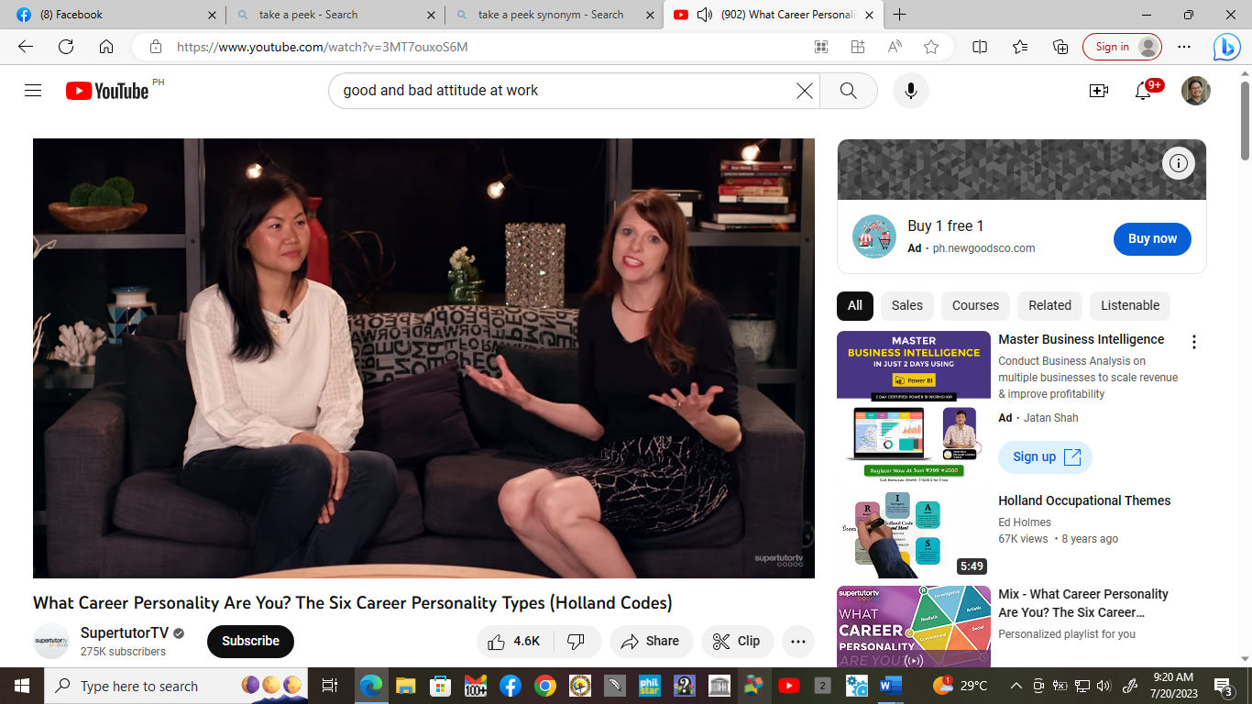

(Image grabbed from YouTube)

**Summary**

**Quick Response:** Based on the content of the video presentation, what career personality are you? Explain.