CHAPTER I

INTRODUCTION
Applying for barangay services, requesting official documents, and processing transactions are fundamental components of efficient local governance. A well-structured barangay system ensures accurate record-keeping and secure identity verification, allowing residents to access essential services with ease. Requesting documents such as Barangay Clearance, Indigency Certificates, and Business Permits is necessary for various legal, business, and personal transactions, and an efficient request system reduces delays and improves operations. Efficient processing plays a crucial role in verifying, approving, and releasing these documents promptly, preventing errors and ensuring transparency. By optimizing these processes, barangay services become more accessible, organized, and responsive to the needs of the community.
Project Context
The rapid advancement of technology has significantly impacted various sectors, including governance and public services. In many countries, local government units are increasingly leveraging digital platforms to enhance service delivery, improve transparency, and streamline administrative processes. This transition to digitalization has become especially relevant in the face of growing demands for efficiency, accessibility, and security in public services. In the Philippines, barangays, as the foundational units of local government, play a crucial role in facilitating essential services for residents, from certificate requests to community communication. However, many barangays continue to face challenges with outdated systems that hinder the efficiency of public service delivery. The integration of emerging technologies, such as biometric authentication and digital platforms, offers a promising solution to address these challenges, allowing for faster, more secure, and more efficient services that meet the evolving needs of the community.
Within the broader context of digital governance and technology integration, this study focuses on the development of an online barangay system that incorporates facial recognition for identity verification. While many online platforms have adopted basic security measures, few have successfully integrated advanced biometric authentication to enhance both security and convenience in public service delivery. Existing research has explored various applications of facial recognition, from banking to healthcare, but there remains a gap in the adoption of such systems within local government services, especially at the barangay level. The unique challenges faced by barangays, such as managing high volumes of requests and ensuring the security of sensitive data, underscore the need for specialized, efficient, and accessible systems. This research explores the potential of image recognition technology to enhance identity authentication in barangay operations, optimizing certificate requests, inquiries, and news dissemination while setting a standard for other local government units to adopt more secure and efficient digital solutions.
This study focuses on developing a secure and efficient online barangay system that integrates image recognition for accurate and reliable identity verification. Despite the increasing digitalization of public services, barangays continue to rely on manual and outdated methods to handle resident requests and other administrative processes. The study contributes to the advancement of local governance by enhancing the efficiency, security, and accessibility of important barangay services, ensuring residents can easily request certificates, make inquiries, and stay informed.
Existing research on digital transformation in local governance reveals substantial challenges in integrating technology within barangays. According to a study by Debbarma and Chinnadurai (2023), issues such as limited access to digital tools, low digital literacy, and budget constraints hinder effective adoption of technological solutions at the local government level. The research also highlights that many local governments, including barangays, struggle with manual processes, which lead to delays in service delivery and citizen dissatisfaction. The need for tailored digital systems in barangays stems from the opportunity to enhance operational efficiency, improve service accessibility, and foster greater community engagement. By modernizing administrative processes, barangays can transition from manual procedures to automated, user-friendly solutions that simplify resident registration, certificate issuance, and inquiries. Streamlined operations enable barangay officials to manage requests with greater speed and accuracy, reducing processing time and ensuring seamless access to essential services. Automated identity authentication enhances security by verifying resident identities efficiently, minimizing the risk of errors while maintaining data integrity. Service efficiency is further optimized through real-time tracking and digital workflows, allowing residents to conveniently monitor the status of their applications and requests. A centralized database ensures that records are easily accessible and up to date, supporting better decision-making and resource management. Beyond operational benefits, digital transformation promotes citizen engagement by making services more inclusive and accessible. Online platforms enable residents to submit inquiries, receive timely updates, and stay informed about barangay activities, fostering a more connected and participatory community. By integrating digital solutions, barangays can enhance governance, improve service delivery, and create a more responsive system that effectively meets the needs of residents while supporting long-term administrative growth.
VerifyID, an online barangay system, addresses these challenges by incorporating image recognition technology and automated identity validation processes. Designed for Barangay 781 Zone 85, the system streamlines traditional manual methods by integrating features like certificate requests, news updates, and inquiry management. By automating the validation of resident identities during registration and service requests, VerifyID ensures accuracy, enhances efficiency, and improves accessibility for residents and administrators alike.

Purpose and Description of the Study
In response to the challenges faced by Barangay 781 Zone 85 in managing resident data and enhancing the efficiency of service delivery, this study proposes the development of an online barangay system incorporating facial recognition technology for identity verification. The system aims to streamline processes such as certificate requests, resident inquiries, and communication between residents and barangay officials. The core strategy of this solution involves integrating a facial recognition algorithm during the sign-up process for secure identity authentication, eliminating manual verification. Key system features include facial authentication, automated certificate request handling, a community news portal, and an inquiry and feedback system, all designed to improve overall resident engagement.
The primary purpose of this study is to design, develop, and implement an online barangay system integrated with facial recognition technology, tailored specifically for Barangay 781 Zone 85. This purpose addresses the need for a more efficient and secure method of verifying resident identities and streamlining key services such as certificate requests, inquiries, and community updates. By achieving this purpose, the system enhances barangay operations by making administrative tasks easier, reducing manual workload, and improving the speed and accuracy of the delivery of service. The face scan which verifies the identity of the user and the certificate request process minimizes delays, allowing barangay officials to accommodate more people and improve service. The system improves service accessibility by enabling residents to request certificates, submit inquiries, and receive updates online, which eliminates the need for visits and long waiting lines. This ensures inclusivity, particularly benefiting every user and anyone who has a busy schedule. Furthermore, the integration of image recognition technology strengthens security by preventing identity fraud and ensuring that only individuals who are verified can access barangay services. By promoting a secured and modern approach to local governance, VerifyID promotes transparency, efficiency, and trust, setting a benchmark for other barangays to adopt digital governance solutions. Through these advancements, the system transforms barangay operations into a more responsive, accessible, and technology-driven public service platform.
This study holds significant implications for the enhancement of local governance and community service delivery through the integration of modern technologies. By incorporating facial recognition technology into an online barangay system, it addresses the pressing need for secure and efficient identity verification, setting a precedent for technological innovation in local government operations. Practically, the system simplifies processes such as certificate requests and inquiries, improving accessibility and convenience for residents. Moreover, this research contributes to the academic and technical fields by exploring the application of facial recognition in small-scale governance, paving the way for similar implementations in other barangays or community-level systems. Traditional barangay operations heavily rely on manual, paper-based processes for managing resident information, certificate requests, and public communications. Residents must visit the barangay hall in person to apply for certificates, submit documents, or access public records, often resulting in long waiting lines, delayed processing, and increased workload for barangay officials. These methods not only consume time but are also error prone such as duplication of data, misplaced records, and difficulties in retrieving past transactions. Additionally, security concerns arise due to the reliance on handwritten or printed documents, which can be altered, forged, or lost. By integrating digital solutions through the system, the study modernizes these operations by replacing manual workflows with an automated, secure, and user-friendly platform. The system allows residents to submit applications, request certificates, and access barangay services remotely, reducing physical visits in barangay offices while improving accessibility for all community members. The integration of facial recognition technology further enhances security by ensuring that identity verification is accurate and detects fraud, addressing the limitations of traditional barangay methods. Additionally, digitizing records prevents data loss and facilitates efficient tracking and retrieval of resident information, contributing to improved governance and service reliability. Through this transformation, VerifyID bridges the gap between traditional and digital governance, fostering an efficient and transparent system that not only improves operational efficiency but also enhances community engagement. By enabling faster, more secure, and more accessible interactions between residents and barangay officials, the study presents a scalable model for other local government units aiming to transition into a modernized public service framework.

Figure 1.1
Citizen’s Charter
The Barangay Citizen’s Charter of Barangay 781 Zone 85 outlines the process and standards for availing barangay certifications and indigency documents. Services include issuing certifications for residency, employment, school, burial, medical, and other needs. The procedures involve filling out a form, verifying the applicant's identity, and obtaining necessary signatures. The turnaround time for processing official barangay certificates follows a standard procedure. After the submission of the necessary requirements, the signing of documents by the appropriate barangay officials typically takes one to two working days. Once the documents have been signed, the release of the requested certificates such as barangay indigency or barangay certificate is usually completed within two to three working days. All services are free of charge, and documents require a valid ID, birth certificate, or school ID. The barangay commits to efficient service and transparency under the guidance of the Brgy. Secretary, Record Keeper, and Punong Barangay.

Objective of the Study
The general objective of this study is to design and develop VerifyID: Online Barangay System with Identity Authentication through Integration of Image Recognition.

Specific Objectives
In order to fulfill the main objective of this project, the authors constructed the following specific objectives:
1. Examine and understand the process of the barangay system and image recognition.
2. Explore existing systems or applications relevant to the proposed system.
3. Analyze, understand, and perform preprocessing activities on the data gathered towards the development of the VerifyID.
4. Evaluate the algorithm for the barangay using:
  - Precision
  - Recall
  - Accuracy
  - F1-Score
5. Design and develop a web-based application with the following modules:
- Home Module:
  - Provides the landing page with a button that redirects to the online services page and navigation.
  - Handles login/account creation prompts for non-logged-in users.
- Online Services Module:
  - Displays a list of available Barangay certificates and services.
  - Provides requirements and guidelines for each service.
  - Provides a centralized view of requested certificates.
  - Allows users to track status and initiate new requests.
- Account Management Module:
  - Handles user registration, including personal, household, ID upload, and face scan verification.
  - Manages user login.
  - Enables password recovery.
  - Allows users to update their passwords.
  - Allows users to view, add family members and update their personal information.
- Events Module:
  - Displays current and upcoming Barangay events, projects and announcements.
- Inquiry Module:
  - Allows users to submit inquiries and track responses.
- About Us Module:
  - Provides the mission, vision and background information about the Barangay.
- Dashboard Module:
  - Provides an overview of system activity (requests, population, data).
  - Admin can export data to excel.
  - Admin can search for a specific resident.
- Content Management Module:
  - Manages event details.
  - Manages community project information.
  - Manages public announcements.
  - Manages the "About Us" page content.
- Certificates Management Module:
  - Manages the various certificate types.
  - Checking of submitted requirements.
  - Approves or declines requests.
  - Printing of Certificates
- Residents Management Module:
  - Displays and manages resident data.
  - Adds new residents and updates existing records.
  - Manages official directory.
- Inquiry Management Module:
  - Tracks and manages resident inquiries.
6. Test the functionality (based on test cases) and non-functionality of the system
Functional
- User Authentication and Identity Verification
- The system shall allow residents and barangay officials to securely register and log in using encrypted credentials.
- During registration, residents shall upload a valid government-issued ID and undergo live face scanning using a webcam. (Valid ID Upload and Live Face Scan)
- The accepted valid IDs are SSS, Student ID, Philhealth, Driver’s license and National ID.
- The uploaded ID and the live face image shall be verified using YOLOv8 and CNN models to ensure authenticity.
- The system shall provide real-time feedback to guide users during scanning (e.g., “Move closer,” “Adjust lighting”).
- If verification fails or connection is unstable, error messages shall be displayed with re-login options.
- The system shall maintain accuracy thresholds (false positive < 12%, false rejection < 15%). (Facial Recognition Accuracy and Performance)
- Certificate Request and Processing
- Residents can request certificates (e.g., Barangay Certificate, Business Permit) via an online portal.
- Residents shall upload required documents and choose certificate types.
- Officials can review, approve, reject, and generate certificates through the admin dashboard.
- Users will be notified via email about request statuses (e.g., Pending, Approved, Rejected, Ready for Pickup).
- Approved certificates shall be available for printing.
- The system logs all certificate requests and transactions for accountability.
- User Account Management
- Residents can register, verify, and manage accounts.
- Users can reset passwords via OTP-based email verification.
- Users can update profiles and upload profile photos.
- Users may search and link family members as part of their household.
- Admins may restrict/lock accounts due to suspicious activity.
- Admin Dashboard and Reporting
- Barangay officials shall access a dashboard to manage user verifications, monitor activity logs, and respond to inquiries.
- Admins can generate reports (user stats, certificate logs) and export them in Excel format.
- Officials can view real-time data on certificate status, system usage, and resident statistics.
- Inquiry Handling and Communication
- Residents can send inquiries or follow-ups through the system.
- Officials can respond to inquiries and communicate within the platform.
- The system records all messages for future reference.
- System Performance and Scalability
- The system shall process facial recognition within 5 seconds under normal conditions.
- Response times for standard operations (certificate request, profile update) must be under 2 seconds.
- It shall support multiple concurrent users without performance degradation.
- Uptime target shall be at least 90% for consistent service.
- Security and Data Privacy
- Role-Based Access Control (RBAC) restricts system access to authorized roles only.
- All communications are encrypted using SSL.
- Access logs track login attempts and activities.
- The system complies with the Data Privacy Act of 2012 to ensure user data protection.
- Multi-Platform Compatibility and Usability
- The system is fully responsive and works across mobile, tablet, and desktop.
- It supports major browsers: Google Chrome, Firefox, Microsoft Edge.
- UI includes clear navigation, tooltips, and accessibility features for ease of use.

Non functional
- Performance Efficiency
- throughput
- load test
- stress test
7. Evaluate the system using a set of metrics based on the ISO 25010 standards which focuses on:
a. Functional Suitability
b. Performance Efficiency
c. Compatibility
d. Security
8. Implement and deploy the system.

Scope and Limitations
This study focuses on the creation of an online barangay system tailored for Barangay 781 Zone 85 residents, emphasizing secure and efficient processes for certificate requests, news dissemination, and inquiries. The system's image recognition feature is designed to enhance security and accuracy in identity verification by integrating facial authentication. During the registration process, users are required to upload a valid ID, which is then matched against a live face scan using image recognition algorithm. This feature ensures that the individual creating the account is the same person on the provided ID, minimizing the risk of identity fraud or identity theft. By leveraging this technology, the system offers an ideal, efficient, and reliable authentication process that reinforces trust and security in barangay services.
The system’s key features include user registration with facial verification, certificate request management, announcements and news updates, admin dashboard and inquiry handling. The project aims to streamline administrative processes, reduce manual verification, and enhance security measures for residents. The effectiveness of these features will be assessed through user testing and system performance metrics, ensuring the platform meets its objectives of accessibility, security, and efficiency.
This research is geographically limited to Barangay 781 Zone 85, Sta.Ana Manila City, where data collection, system testing, and user interactions will be conducted. The study focuses on implementing and evaluating the VerifyID system within this specific barangay, ensuring that its features align with the needs of the local community while maintaining accuracy and efficiency in identity verification processes.
The study encompasses data collected and system development activities conducted during the period from December 2024 to August 2025. It acknowledges that technological advancements beyond this temporal scope may not be considered in the study.
The study employs a range of tools and technologies for the design and development of the application. These tools include
a. HTML5 for structuring the web application, ensuring that the application’s content is properly organized and displayed across different platforms.
b. AJAX v5.3 for handling asynchronous data communication, allowing for real-time updates without requiring full page reloads, which improves user experience and system efficiency.
- Laravel v11 as the backend framework for managing server-side operations, facilitating the seamless integration of different system functionalities and ensuring the robustness of data management.
- Bootstrap v5.3 for designing a responsive and user-friendly interface, allowing the system to adapt to different screen sizes and devices while maintaining an aesthetic layout.
- Python TensorFlow v3.12 for developing and integrating image recognition algorithms that power the system’s identity verification processes, ensuring accurate and efficient image recognition in real-world applications.
- The domain used in the website is from GoDaddy with free SSL from and Google Cloud Platform (GCP) for hosting.

Limitations
Despite the study's objectives, there are certain limitations that should be acknowledged:
The accuracy of the facial recognition feature relies heavily on the capabilities and limitations of the image recognition algorithm used, which may include Convolutional Neural Network, CNN or You Only Look Once, YOLOv8. Any errors in facial detection or matching could compromise the system’s reliability. Additionally, the system is specifically tailored for the residents of Barangay 781 Zone 85, and modifications would be necessary for implementation in other barangays. The accuracy and usability of an image recognition-based identity authentication system are highly dependent on external factors such as the quality of uploaded ID images and the lighting conditions during facial scans. Poor image quality, such as low resolution, blurriness, or pixelation, can make it difficult for the system to extract and compare key facial features accurately. If an ID image lacks clarity or contains glare, the algorithm may struggle to identify unique characteristics, increasing the likelihood of mismatches or authentication failures. In addition, lighting conditions play a critical role in facial recognition accuracy. Inadequate lighting can lead to shadows or overexposed areas, affecting the system’s ability to detect facial landmarks correctly. Dim lighting can result in poor contrast, making it challenging for the algorithm to distinguish facial features, while excessive brightness can cause reflections and wash out crucial details. Variability in environmental lighting, such as changes between indoor and outdoor settings or fluctuations in brightness throughout the day, may also impact recognition consistency.
One of the limitations of the VerifyID system is the handling of long names. While the system supports long names, the issue arises in the document template, where the text may exceed the designated space, particularly in the signature section. This formatting problem can affect the readability and professional presentation of official documents. Future improvements should focus on dynamically adjusting text size or restructuring the template to accommodate lengthy names without breaking the layout.
Another limitation is that VerifyID does not handle any payments or financial transactions. Any certification fees or monetary transactions related to barangay services remain under the direct management of barangay personnel. The system does not include features for processing online payments, issuing receipts, or tracking financial records. Users must complete any necessary payments through traditional means, such as in-person transactions at the barangay office. This limitation ensures that financial processes remain within the barangay’s control but also means that residents must manually coordinate their payments before receiving their requested certifications.
The system currently supports nine types of certifications as suggested by the barangay. While these cover the most commonly requested documents, the system does not allow barangay officials to add or modify certification types dynamically. This restriction means that any new or specialized certifications that may arise in the future will require system updates rather than administrative adjustments within the platform. Expanding the system’s flexibility to accommodate additional certification types would improve its adaptability to evolving barangay requirements.
During the registration process, VerifyID requires users to upload a valid ID for identity verification. However, only specific ID types such as PhilHealth, National ID, SSS, and Student IDs are accepted. Additionally, the uploaded ID must be in color to ensure accurate facial recognition. Black-and-white copies or low-quality scans may result in verification failures, requiring users to resubmit their IDs or visit the barangay for manual validation. Expanding the list of accepted ID types and improving the system’s ability to process various ID formats would enhance accessibility and reduce registration barriers.
Another constraint is that barangay officials must manually review and approve uploaded documents. While the system automates facial recognition for identity authentication, it does not have an automated verification mechanism for supporting documents. This manual review process can lead to delays, particularly when barangay personnel are unavailable or when multiple document requests are pending. Automating document validation through artificial intelligence or optical character recognition could streamline this process, reducing approval times and improving overall efficiency.
The precinct number selection uses a dropdown input, which may lead to user error, especially if users are unsure of their correct precinct. This limitation may affect the accuracy of resident records.
The findings and outcomes of this research are specific to the context, geographical area, and time frame defined in the scope. The generalizability of the application's performance to other regions or periods may be limited. External factors such as network connectivity, hardware constraints, and user-specific behaviors are beyond the study's control and may influence the application's performance.

Definition of Terms
Convolutional Neural Network (CNN) - was used as a facial recognition model responsible for verifying identity by analyzing and comparing facial features extracted from a live face scan and the uploaded ID. Its primary role was to provide accurate identity confirmation by matching facial characteristics, making it suitable as a secondary verifier in the authentication process.
You Only Look Once version 8 (YOLOv8) - was implemented as the main model for detecting faces in real time. It was used to quickly and efficiently locate facial regions in both the uploaded ID and the live camera input. Its speed and responsiveness made it ideal for initial face detection during the identity verification stage of the system.
Faster Region-based Convolutional Neural Network (Faster R-CNN) - was utilized in the study as a benchmark model for face detection. It was included to provide a comparison point for evaluating detection accuracy and reliability, helping determine the most suitable model for use in real-time identity verification scenarios.
Identity Authentication – The process of verifying a resident’s identity using facial recognition technology before allowing access to barangay services.
Facial Recognition Technology – A biometric system that analyzes facial features to verify a person’s identity. In this study, it is used to match a resident’s face with an uploaded valid ID.
VerifyID System – The proposed web-based system integrating image recognition for secure and efficient resident authentication, certificate requests, and barangay record management.
Functional Suitability – A quality attribute assessed in the study to determine if VerifyID meets its intended functions, such as identity verification and document processing.
System Usability – A measure of how user-friendly and accessible the VerifyID system is for residents and barangay officials, evaluated through user feedback and system interaction.
Certificate Request Management – A feature in the VerifyID system that allows residents to apply for barangay certificates online and enables barangay officials to process approvals digitally.
System Performance Efficiency – The capability of VerifyID to process multiple user requests simultaneously without degradation in response time or accuracy.
Security Testing – A testing phase in the study that evaluates how well VerifyID protects user data, prevents unauthorized access, and ensures data integrity.
Data Privacy Compliance – The adherence of VerifyID to the Data Privacy Act of 2012, ensuring secure storage and processing of resident information.
User Account Management – A module in VerifyID that allows residents to create, update, or delete accounts while enabling administrators to suspend accounts due to suspicious activity
Role-Based Access Control (RBAC) – A security mechanism implemented in VerifyID that restricts access to certain system functionalities based on user roles (e.g., residents, barangay officials, system administrators).
False Positive Rate – In facial recognition, the percentage of cases where the system incorrectly verifies an unauthorized user as a match. VerifyID aims to maintain this below 12%.
False Rejection Rate – The percentage of cases where the system incorrectly denies access to an authorized user. The study establishes a target rate below 15% for VerifyID.
Google Cloud Platform – was utilized as the backbone for hosting and deploying the VerifyID system. GCP provided a cloud-based infrastructure that ensured high availability, scalability, and reliable performance. It allowed the system to run on a virtual machine environment capable of handling multiple user requests simultaneously without interruptions.
Security Sockets Layer – was implemented to establish a secure connection between the user's browser and the server. This ensured that all data transmitted such as personal information, facial images, login credentials, and certificate requests was encrypted and protected from unauthorized access or interception.
System Scalability – The VerifyID system’s ability to handle increasing numbers of users and transactions without performance degradation.
The system utilized CI/CD pipelines through GitHub Actions to streamline and automate the deployment process. This allowed developers to push changes to the codebase and have them automatically tested, built, and deployed to the production environment with minimal manual intervention. The automated pipeline reduced the risk of human error, ensured consistency across deployments, and allowed for faster integration of updates and fixes.
Post-Deployment Monitoring – The phase after VerifyID's launch where system performance, security vulnerabilities, and user issues are continuously assessed and addressed.
User Training and Documentation – Educational resources and guides provided to barangay officials and residents to ensure effective use of VerifyID.
Stakeholder Feedback Analysis – The evaluation of responses from barangay officials and residents regarding VerifyID’s functionality, usability, and security, used for system refinements.
Confusion Matrix – A statistical tool used in the study to evaluate VerifyID’s facial recognition accuracy by measuring correct and incorrect identifications.
System Evaluation Based on ISO/IEC 25010 – The assessment framework used in the study to measure VerifyID’s performance in terms of functionality, security, usability, and compatibility.
User Acceptance Testing (UAT) – The final phase of testing in which barangay residents and officials validate that VerifyID meets their needs before full deployment.

CHAPTER II

REVIEW OF RELATED LITERATURE
This chapter presents a comprehensive review of the existing literature and studies related to the research objectives. This section involves the examination of key concepts, theories, and methodologies from earlier research, aiming to establish a coherent connection between past studies and the current research objectives. Furthermore, it assesses the strengths and limitations of previous research, identifies any gaps in the existing literature, and emphasizes the significance of the current study in addressing these identified gaps. This literature review establishes a foundation for the study.

Barangay Management System
The Barangay Management System is an approach to transform traditional barangay processes into a citizen-centered system by maximizing the use of technology specifically known as e-barangay. The goal is to make administrative operations easier such as addressing concerns, requesting papers or documents, and obtaining accurate and appropriate barangay data.
The study by (Bringula et al., 2022) addresses the gap in community-level e-governance by proposing the "e-barangay framework," a web-based system tailored to local governance. Unlike existing e-government frameworks that focus on municipal or national levels, this framework emphasizes the unique needs of barangay-level operations. Core functionalities, such as filing complaints, requesting documents, sending suggestions, and posting announcements, were identified through thematic analysis of interviews with local officials. Usability testing revealed favorable results, with system design positively correlating with user engagement. The findings highlight the framework's ability to meet stakeholder needs, offering significant theoretical and practical insights for advancing community-based e-governance.
The project's goal was to create and evaluate an information system for barangay management, including a function to certify residency. The system is customized to meet the unique requirements of nearby areas by employing a development research methodology. Using the Usefulness, Satisfaction, Ease of Use (USE) questionnaire, IT professionals, government IT employees, and barangay officials evaluated it. With an average score of 4.58, the system demonstrated high user satisfaction and usability. This high ranking reflects the convenience and user-friendliness of the system. Furthermore, by streamlining document processing and improving administrative effectiveness, the system dramatically helps barangays and supports digital governance initiatives. Also, it is essential to establish an extensive archive of vital documents, which could change local government procedures in the digital age (Dela Cruz, et al., 2023).
(Debbarma & Chinnadurai, 2023) examine the integration of advanced technologies into local governance, highlighting its potential to enhance administrative efficiency, citizen engagement, and data-driven decision-making. The study identifies key advantages of digital transformation, including streamlined operations and improved public service delivery, while acknowledging challenges such as unequal technology access, cybersecurity risks, resistance to change, and financial constraints. Proposed strategies for overcoming these obstacles include improving accessibility, strengthening cybersecurity, fostering stakeholder collaboration, and enforcing robust data protection measures. The paper advocates for a holistic approach to digital transformation, emphasizing innovation and workforce empowerment to address the complexities of modern local governance.
(Roque et al., 2024) propose a Barangay Information System integrating geolocation technology and an English-Tagalog chatbot powered by a Natural Language Processing (NLP) algorithm. This progressive web application aims to improve barangay services by enabling efficient resident data management, disaster risk reduction monitoring, and bilingual inquiry handling. Key features include geolocation for identifying affected residents and locating nearby evacuation centers, and streamlined certificate delivery. The study emphasizes the system's significance in enhancing transparency, reducing workloads for barangay officials, and increasing accessibility for the public. User feedback rated the system as satisfactory, underscoring its potential to improve community engagement and barangay operations.

Identity Authentication
Verifying one's identity online can be challenging. It is not a guarantee that someone is who they claim to be just because they say so. This is where authentication comes in. Authentication ensures that an individual is truly who they claim to be by requiring unique, verifiable credentials that are difficult to forge or replicate. Identity authentication involves validating and confirming an individual's identity using specific credentials such as biometric characteristics (e.g., facial recognition, fingerprints, iris scans), government-issued identification documents (e.g., passports, national IDs, driver’s licenses), or secure password-based systems. Biometric authentication, in particular, enhances security by relying on unique physical or behavioral traits that cannot easily be replicated. Document-based authentication verifies legitimacy by cross-checking official records, while password-based authentication grants access only to users who provide a correct combination of credentials. By integrating these methods, identity authentication strengthens security measures, minimizing unauthorized access and ensuring that only legitimate users can interact with sensitive systems or services.
A study conducted by (Vandana & Kaur, 2022), entitled "A Study of Biometric Identification and Verification System", talks about the disadvantages of using passwords and PINs for user identification, as they are more prone to theft and misuse. Biometric security systems employ physiological and behavioural traits to verify identity. These systems use voice, fingerprint, iris, and image recognition techniques. To identify the most efficient strategy, the study analyzes unimodal and multimodal biometric systems and highlights the significance of authentication in information security. It summarizes biometric recognition systems, including information on their functionality and potential problems. The integration of various biometric attributes, as well as the potential, economic significance, and prospects for biometric technology, are also covered in this article.
The article made by (Gunuganti, 2023) explores the concept of continuous authentication through behavioral biometrics as a response to the limitations of static authentication methods, such as passwords and PINs. This study highlights the importance of continuously validating user identity during active sessions, enhancing security against impersonation or unauthorized access. Behavioral biometrics, including keystroke dynamics and mouse movements, are utilized to monitor user behavior in real time, ensuring seamless protection without disrupting user convenience. The research emphasizes that continuous authentication offers improved data security, particularly for sensitive systems, while addressing vulnerabilities inherent in traditional methods. Moreover, it identifies the necessity of advancing biometric algorithms to enhance adaptability and protection in evolving cybersecurity landscapes.
(Zukarnain, Muneer, & Aziz, 2022) examine various authentication methods for securing mobile identities, highlighting the growing importance of protecting sensitive information stored on smartphones. The study identifies vulnerabilities in traditional methods, such as passwords and SMS authentication, and emphasizes the adoption of advanced techniques like fingerprint identification, face recognition, and identity-based public key cryptography (ID-based PKC). Additionally, it introduces multi factor authentication approaches, including user trip routes and geolocation-based methods, to enhance security with minimal user intervention. A notable contribution of the study is the implementation of asymmetric encryption protocols using user inputs as encryption keys, eliminating the need for costly certificate authorities.

Convolutional Neural Network (CNN)
(Chen, 2023) stated in his study that Convolutional Neural Networks (CNNs), which are excellent at pattern identification by extracting characteristics from photos, are used in this study to investigate image recognition. CNNs contrast conventional techniques such as Principal Component Analysis (PCA). CNNs surpass PCA, achieving a 94% accuracy rate while using a limited dataset. Extending datasets by data augmentation increases accuracy, but because the enhanced images are false, there is an unstable learning curve. Processing difficulties may arise as a result of training. According to the study, these problems might be resolved by increasing the number of CNN layers or adding more real images, improving the network's capacity to manage more diverse datasets.
Furthermore, according to (Arthi et al., 2022) in their study entitled “Deep Learning Based Multi-Modal Biometric Security System Using Visible Light Communication” proposes a multi-modal biometric security system combining facial recognition, finger vein scanning, iris recognition, and fingerprint detection for robust personal identification. Using the Viola-Jones algorithm for face detection and Convolutional Neural Networks (CNNs) with advanced optimizers like Adam, RMSprop, and SGDM, the system effectively extracts and classifies high-definition image features. Enhanced by the Deep Dream algorithm for network visualization and refined hyperparameter tuning, the system addresses overfitting and underfitting issues. Integrated with Li-Fi and GSM, it provides real-time alerts to authorities in case of unauthorized access. The study highlights Adam’s superior performance in stability and accuracy and suggests future improvements in training efficiency, alternative communication methods, and advanced optimizers to enhance the system's reliability and effectiveness in biometric security applications.
Based on a study conducted by (Chi et al., 2023), they explore using Convolutional Neural Networks (CNNs) to have significantly advanced image classification and face recognition, with various models offering unique contributions. LeNet-5, as the earliest CNN model, introduced the foundational architecture but faced overfitting issues. AlexNet addressed this with dropout layers, improving training efficiency, while VGG utilized small convolutional kernels for greater depth and accuracy at higher computational costs. GoogLeNet's inception modules reduced parameters, and ResNet resolved gradient issues in deep networks with residual learning. MobileNet and its successors optimized models for mobile devices by employing depthwise separable convolutions, inverted residuals, and attention mechanisms. ShuffleNet introduced channel communication and group convolution, further refined in ShuffleNetv2. EfficientNet balanced resolution, depth, and width for accuracy and computational efficiency. In face recognition, DeepFace achieved near-human accuracy using 3D face alignment and a DCNN, while the DeepID series improved accuracy with multi-scale, multi-channel features and Bayesian classification. FaceNet revolutionized the field with Euclidean space embeddings and triplet loss, enabling highly discriminative features. Advanced models like SphereFace, CosFace, and ArcFace introduced novel angular margin loss functions to enhance classification and accuracy, with ArcFace achieving state-of-the-art results. These developments underscore CNNs' critical role in advancing computer vision and biometrics.

Faster Region-Convolutional Neural Network (Faster R-CNN)
The study of (Xu, et al., 2022) conducted a crack detection and comparison study based on Faster R-CNN and Mask R-CNN. While not directly related to image recognition, this study shed light on the potential of Faster R-CNN in detecting specific features within images. This finding implies that Fast R-CNN could be leveraged to identify distinctive facial characteristics for accurate image recognition.
The researchers explored the application of deep-learning-based Mask R-CNN models for laryngeal cancer detection using CT images. While not directly related to image recognition, this study highlighted the adaptability of Mask R-CNN in identifying specific patterns in medical images. Transferring this concept to image recognition, utilizing specialized R-CNN models tailored to facial characteristics could lead to more accurate and reliable image recognition systems (Sahoo, et al., 2022).
The study by (Mamieva et al., 2023) explores advancements in face detection by integrating deep learning frameworks to address challenges such as detecting small, occluded, or blurred faces in uncontrolled environments. While the primary focus is on the RetinaNet framework, comparisons with other methods, including Faster R-CNN, are evident in the evaluation. The proposed RetinaNet model incorporates a region-offering network (RON) and a prediction network, achieving competitive performance with an Average Precision (AP) of 41.0 at 11.8 FPS for single-scale inference and 44.2 for multi-scale inference on the WIDER FACE dataset. Despite the focus on single-stage detection, the study acknowledges Faster R-CNN's effectiveness, which has set benchmarks for robust face detection. Trained using PyTorch, the RetinaNet model achieves 95% detection accuracy, demonstrating efficiency in computation while addressing limitations in traditional methods. Future improvements include enhancing accuracy under low-light conditions and integrating real-time capabilities.

You Only Look Once (YOLO)
According to (Zheng Ren, 2024), his study introduces an innovative Multi-scale Feature Fusion and Adaptive Modality Weighting (MFAW) module integrated into the YOLOv8 architecture to enhance object detection in infrared imagery. The results of the experiments on the LLVIP and VEDAI datasets showed that the proposed method outperformed traditional models such as Faster R-CNN, YOLOv3, and YOLOv5. Specifically, YOLOv8 with the MFAW module achieved an impressive increase in detection accuracy, outperforming Faster R-CNN by 9.5 percentage points in mAP@0.5(%) and 10.4 percentage points in mAP@0.5:0.95(%), respectively. These improvements are attributed to the MFAW module's ability to adaptively fuse multi-scale features and adjust modality weights based on environmental conditions, particularly in infrared images with low contrast and noise. The results confirm the superior performance of YOLOv8 with MFAW in complex detection scenarios, solidifying its place as a top contender in the field of object detection.
The study of (Salman, et al., 2022) aimed to create an AI-based system for detecting and diagnosing prostate cancer in biopsy images. They used the Yolo object detection algorithm and re-trained with their 500 annotated biopsy images dataset. After splitting the dataset into training and testing sets, they augmented the training set to increase its size. The resulting tool achieved 97% accuracy on a test set similar to the training data and 89% on a different test set. The study concludes that AI methods like object detection algorithms can develop high-accuracy prostate cancer diagnosis tools, potentially reducing inter-observer variability among pathologists and diagnosis time delays.
The study conducted by (Christine Dewi et al., 2024) focuses on utilizing deep learning, specifically the YOLOv8 object detection algorithm, for accurate face mask detection, particularly in public settings to mitigate the spread of COVID-19. By combining the Face Mask Dataset (FMD) and the Medical Mask Dataset (MMD), the research improves upon previous models, achieving an impressive 99.1% mean Average Precision (mAP), surpassing earlier efforts that reached 98.6%. The study demonstrates that YOLOv8m, with 100 epochs, outperforms earlier models in both accuracy and precision for medical face mask detection, achieving an average accuracy of 78.4%. This work highlights YOLOv8m as a reliable method for detecting face masks, offering significant improvements in performance over previous models, and sets the stage for future investigations into medical mask recognition and explainable AI (XAI) applications for real-time facial recognition in images and videos.
The study of (Terven et al., 2023) provides a comprehensive review of the evolution of the YOLO (You Only Look Once) architecture, a key framework in real-time object detection, which has become essential in fields such as robotics, driverless cars, and video monitoring. The article traces the innovations from the original YOLO model through to the latest versions, including YOLOv8, YOLO-NAS, and YOLO with transformers, highlighting the significant architectural improvements, training techniques, and dataset augmentations that have contributed to YOLO's enhanced performance. The research emphasizes the framework's efficiency in real-time object detection, yet it also points out persistent challenges such as handling small objects, occlusion, scale variation, and pose estimation. Despite YOLO's impressive speed, the study notes that it may sacrifice accuracy in comparison to some state-of-the-art models, indicating a tradeoff between speed and precision. The authors predict future developments in YOLO, including the incorporation of techniques like attention mechanisms, contrastive learning, and generative adversarial networks, further advancing the framework's capabilities. This review underscores YOLO's pivotal role in real-time object detection and highlights ongoing research opportunities to refine and improve the system, paving the way for more efficient and accurate detection models.

ISO 25010 Software Evaluation Criteria
ISO/IEC 25010 is a global standard for assessing and managing software quality. It provides criteria for evaluating and helping software professionals ensure high-quality products. This standard is essential for developers, testers, and project managers seeking to deliver software that meets user and business needs.
To ensure that the developed software will align with the requirements of both users and the ISO/IEC 25010 standard for software product quality, a comprehensive review and evaluation process will be conducted. Functional Suitability evaluates the system’s ability to securely fulfill essential functions, such as limiting access to authorized users and safeguarding personal data. It includes factors like confidentiality, integrity, and authentication. The system must ensure that only authorized users can access personal data and make certificate requests. Performance efficiency would assess how quickly and efficiently the image recognition algorithms can identify or reject a resident. It also evaluates how the system handles multiple users simultaneously, ensuring that it remains responsive during peak usage. In terms of Compatibility, it would involve testing whether the system functions smoothly on various devices, such as desktops, tablets, and smartphones, and across different browsers (e.g., Chrome, Firefox, Safari). Lastly, Security ensures that the system protects sensitive data, prevents unauthorized access, and upholds the confidentiality, integrity, and availability of user information.
By addressing these quality attributes, the VerifyID can offer a reliable, and efficient barangay system that meets the needs of users and aligns with industry standards for software quality.

Synthesis
The studies reviewed in this section collectively explore the use of image recognition algorithms, with a particular focus on Convolutional Neural Networks (CNNs), Faster R-CNN, and YOLO. These works provide a broad spectrum of insights into the application of deep learning for various recognition tasks, including face recognition and object detection. CNNs have been widely employed due to their ability to effectively extract features from images, illustrating the evolution of architectures from early models to more advanced networks capable of achieving high accuracy in facial recognition. Faster R-CNN has been applied in specialized recognition contexts, demonstrating strong performance in tasks requiring detailed detection such as crack identification and facial recognition in medical fields. YOLO, known for its real-time object detection capabilities, has shown adaptability across multiple domains, from face mask identification to infrared detection. These diverse approaches highlight the versatility, strengths, and ongoing advancements in image recognition technologies.
A significant research gap in the existing studies is the lack of focus on integrating image recognition technology within barangay management systems. Although various studies have explored the digitalization of barangay processes, none have comprehensively examined how advanced biometric methods, such as image recognition, could enhance security and identity authentication. This gap is crucial given the growing need for reliable, automated verification in local government systems. Furthermore, the literature has not explored the potential benefits of image recognition for improving service efficiency and security in barangay-level governance. Addressing this would provide critical insights into digital governance advancements.

Benchmarking Analysis

Table 2.1
The following is the list of the existing literature on algorithms for face recognition

Paper | Proponents | Algorithm | Accuracy
CNN combined with data augmentation for  face recognition on small dataset | Chen, S. (2023) | Convolutional Neural Network (CNN) | 94%
Deep Learning Based Multi-Modal Biometric Security System  Using Visible Light Communication | Arthi, K., Divya,  D., Kavitha, D., & Mahalakshmi, S. (2022) | Convolutional Neural Network (CNN) | High accuracy (not quantified)
A Review of Deep Convolutional Neural Networks in Mobile Face Recognition | Chi, J., On,  C., Zhang, H., Chai, S. (2023) | Convolutional Neural Network (CNN) | Not specified
Crack Detection and Comparison Study Based  on Faster R-CNN  and Mask R-CNN | Xu, X., Zhao,  M., Shi, P., Ren,  R., He, X., Wei,  X., Yang,  H. (2022) | Faster Regional Convolutional Neural Network (Faster R-CNN) | Not specified
An Improvised Deep-Learning-Based  Mask R-CNN Model for Laryngeal Cancer  Detection Using  CT Images | Sahoo, P.,  Mishra, S., Panigrahi,  R., Bhoi, A., Barsocchi,  P. (2022) | Faster Regional Convolutional Neural Network (Faster R-CNN) | Around 80 - 90%
Improved Face Detection Method via Learning  Small Faces on Hard Images Based on a Deep Learning Approach | Mamieva, D., Abdusalomov,  A., Mukhiddinov,  M., Whangbo, T  (2023) | Faster Regional Convolutional Neural Network (Faster R-CNN) | 95% detection accuracy (with  RetinaNet comparison)
Adaptive Multi-Scale  Fusion for Infrared and Visible Object Detection  in YOLOv8 | Ren, Zheng  (2024) | You Only Look Once version 8 (YOLOv8) | Outperforms Faster R-CNN by  9.5-10.4% in mAP@0.5 and mAP@0.5:0.95
Real time face recognition system based on YOLO  and InsightFace | Anjeana, N., Anusudha, K., (2023) | You Only Look Once version 7 (YOLOv7) | 99.1% mAP, 78.4% accuracy
Automated prostate  cancer grading and diagnosis system using  deep learning-based Yolo object detection algorithm | Salman, M.,  Cakar, G., Azimjonov,  J., Kosem, M., Cedimoglu, I.  (2022) | You Only Look Once (YOLO) | 97%  (same test set), 89% (different test set)
A Comprehensive Review  of YOLO Architectures in Computer Vision: From YOLOv1 to YOLOv8 and YOLO-NAS | Terven, J.,  Esparza, Cordova,D., González (2023) | You Only Look Once (YOLO) | Not specified

The studies in this table provide insights into different algorithms for identity verification in facial recognition systems, each with varying accuracy and application suitability:
Convolutional Neural Networks (CNN): Chen (2023) achieved 94% accuracy in face recognition on small datasets by combining CNN with data augmentation, showcasing the algorithm's effectiveness even with constrained data. Arthi, Divya, Kavitha, and Mahalakshmi (2022) proposed a multi-modal biometric system integrating CNNs for facial recognition, finger vein scanning, and other biometrics, highlighting CNN's adaptability in diverse security applications. Chi, On, Zhang, and Chai (2023) explored CNN’s use in mobile face recognition, further emphasizing its role in feature extraction and classification.
Faster R-CNN: Xu et al. (2022) demonstrated the adaptability of Faster R-CNN in tasks like crack detection, hinting at its potential in precise facial feature identification. Sahoo, Mishra, Panigrahi, Bhoi, and Barsocchi (2022) utilized Faster R-CNN for medical imaging, achieving an estimated accuracy of 80–90%, while Mamieva, Abdusalomov, Mukhiddinov, and Whangbo (2023) applied it to detect small faces in challenging environments, reporting a detection accuracy of 95%. These studies underscore Faster R-CNN’s robustness in handling intricate and high-stakes image recognition tasks.
YOLO (You Only Look Once): YOLO models demonstrate significant advancements in real-time object detection. Ren (2024) introduced YOLOv8 with adaptive multi-scale fusion, outperforming Faster R-CNN in mAP metrics by 9.5–10.4%. Anjeana and Anusudha (2023) applied YOLOv7 to real-time face recognition, achieving a 99.1% mAP and 78.4% accuracy, while Salman, Cakar, Azimjonov, Kosem, and Cedimoglu (2022) utilized YOLO for prostate cancer diagnosis, achieving 97% accuracy on a test set. Terven, Esparza, and González (2023) reviewed YOLO's evolution, emphasizing its continued innovation and efficiency in real-time applications.

Conceptual Model of the Study

INPUT
PROCESS
OUTPUT
Knowledge Requirements
Web Development
Image Recognition
Barangay Operations
Datasets
Figma
Visual Studio Code
Gatling
Loadster
Blazemeter
Software Requirements
Hardware Requirements
Intel Core i3
4GB RAM
12MP Camera
Planning
Analysis
Design
Develop
Test
Deploy
VERIFYID: ONLINE BARANGAY SYSTEM WITH IDENTITY AUTHENTICATION THROUGH INTEGRATION OF IMAGE RECOGNITION
Evaluation

Figure 2.1
Input-Process-Output Diagram
In this study, the inputs encompassed a combination of technical knowledge, tools, and resources essential for the successful development of the system. Foundational knowledge included web development for building the interface and system functionalities, image recognition algorithms for facial detection and verification, and an understanding of barangay operations to ensure that the system addressed actual workflows and service requirements. Additionally, datasets were utilized to train and validate the facial recognition components of the system.
The software requirements involved a range of tools to support the design, development, and testing phases. Visual Studio Code was used as the integrated development environment for writing and managing code; Figma supported the design of user interface mockups and layout prototypes; and performance testing tools such as Gatling, Loadster, and BlazeMeter were employed to simulate real-world user interactions, assess system scalability, and ensure responsiveness under load.
The hardware requirements for developing and testing the system included a minimum of an Intel i3 processor, 4GB RAM, a 12MP camera for capturing facial images during verification, and a 32-bit operating system, which provided the baseline environment necessary for running the application during its development and testing phases.
The development process followed an Agile methodology, which involved iterative and incremental cycles covering stages such as planning, designing, developing, testing, deploying, and reviewing. Each cycle allowed for adjustments based on user feedback, which was continuously gathered from residents and barangay personnel to refine and enhance system functionality and usability. The main output of the study is VerifyID, an online system developed to digitize and secure the identity verification process within barangay operations.

CHAPTER III

DESIGN AND METHODOLOGY
This chapter of the paper presents an overview of the proposed study's fundamental theoretical foundations. The research framework is guided by these foundations in order to give substantial results to the research questions at the conclusion of the study. It was also utilized to monitor the progression of the system's workflow.

Research Design
Descriptive research involves systematically gathering, analyzing, and documenting existing systems, frameworks, and technologies without manipulating variables. It provides a comprehensive understanding of current processes and trends, establishing a solid baseline for comparison and improvement. In this study, descriptive research is used to examine the barangay processes, identifying challenges in manual authentication systems. The research scope includes observing and documenting traditional verification methods, such as how residents request certificates, how barangay officials validate identities, and how records are stored and retrieved. Data collection is conducted through surveys, performance metrics, and feedback from barangay officials, residents, and IT experts. The collected data is analyzed using graphical representations, mean and standard deviation. This approach is crucial for assessing the feasibility of integrating facial recognition technology into barangay systems. By drawing insights from existing identity authentication technologies, the study determines the practical benefits and challenges of digital transformation in local governance.
Metrics | YOLO  (Controlled variables) | YOLO and CNN  (Uncontrolled variables)
Precision | 0.883 | 0.950
Recall | 0. 933 | 0.932
F1 Score | 0.908 | 0.962
Accuracy | 0.909 | 0.936
Table 3.1
Metrics in different variables
Experimental research in this study is conducted to evaluate the controlled and uncontrolled variables that will determine which model is more effective. The performance of the standard YOLO model and the combined YOLO-CNN approach was evaluated based on precision, recall, F1 score, and accuracy, revealing significant improvements with the integrated model. Precision for the YOLO model was 0.883, indicating that while the model was relatively good at identifying true positives, it also produced a noticeable number of false positives. After incorporating a CNN with YOLO (YOLO-CNN), the precision increased to 0.950, demonstrating that the combined model was more effective at reducing false positives and correctly identifying true positives. Recall, which measures the ability to correctly identify all relevant instances, was 0.933 for the YOLO model. Following the CNN integration, recall slightly decreased to 0.932, but the difference was minimal, suggesting that the YOLO-CNN model retained a comparable capacity to detect true positives as the standalone YOLO model. The minor decrease in recall attributed to the model’s enhanced focus on improving precision. The F1 score, which balances precision and recall, showed a significant improvement, rising from 0.908 in YOLO to 0.962 in YOLO-CNN. This increase highlights the combined model’s ability to strike a better balance between precision and recall, making it more effective overall. Accuracy also improved, from 0.909 with YOLO to 0.936 with YOLO-CNN, confirming that the integrated model made more correct predictions overall. In conclusion, the integration of CNN into the YOLO framework led to notable improvements in precision, F1 score, and accuracy, while maintaining a nearly identical recall. These results suggest that the YOLO-CNN model provides a more robust and efficient approach for object detection tasks, offering enhanced performance without sacrificing recall.
Developmental research in this study focuses on designing, prototyping, and refining the VerifyID system through an iterative development process. This ensures that the system remains efficient, scalable, and aligned with the needs of barangay residents and officials. The primary objective of this research is to develop a web-based barangay system that integrates facial recognition technology to enhance identity verification, streamline certificate requests, and improve administrative efficiency. The system is designed using a modular architecture, consisting of a secure resident database, a facial recognition authentication module, and an intuitive user interface to facilitate barangay services. The development process involves utilizing HTML5 for structuring the web application, ensuring that its content is well-organized and accessible across different platforms. AJAX v5.3 is implemented to handle asynchronous data communication, allowing real-time updates without requiring full page reloads, thereby improving user experience and system efficiency. Laravel v11 serves as the backend framework for managing server-side operations, ensuring seamless integration of various system functionalities while maintaining robust data management. For the front-end, Bootstrap v5.3 is used to create a responsive and user-friendly interface, enabling the system to adapt to different screen sizes and devices while maintaining a visually appealing layout. Additionally, Python TensorFlow v3.12 is employed to develop and integrate the image recognition algorithms, which power the system’s identity verification processes, ensuring accurate and efficient authentication. Before full deployment, initial prototypes of the system are created and tested for usability, accuracy, and security. The system undergoes continuous usability testing, functional verification, and performance benchmarking to refine its features. Development follows an Agile methodology, allowing for continuous improvements based on user feedback and testing results. As a result, this study delivers a secure, efficient, and scalable barangay system that leverages facial recognition technology for identity authentication. The outcome ensures a streamlined and more reliable service delivery process, significantly improving the efficiency of barangay operations while enhancing security and user experience.

Research Methodology
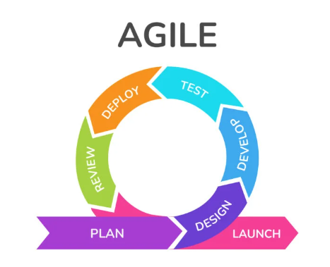

Figure 3.1
Agile Software Development Cycle
Agile is a flexible software development methodology that emphasizes iterative progress, continuous collaboration, and adaptability to evolving requirements. Unlike traditional waterfall models, which follow a rigid sequence of phases, Agile operates in short development cycles called sprints. Each sprint results in a functional version of the system that can be tested and refined based on real-time feedback, ensuring continuous improvement throughout the development lifecycle. Agile follows the core principles of the Agile Manifesto, which prioritize customer collaboration, responsiveness to change, working software over extensive documentation, and open communication within teams. Agile has become the preferred approach in software development due to its ability to refine features dynamically, reduce risks through early and frequent testing, and enable the faster delivery of functional software. By breaking projects into smaller, manageable iterations, Agile ensures that developers can identify and address potential issues early, preventing costly late-stage failures. It also fosters team collaboration through daily stand-ups, sprint reviews, and retrospectives, improving workflow efficiency and accountability. For VerifyID, Agile is essential due to the technical complexity of integrating facial recognition technology into a barangay system. Identity authentication requires continuous refinements in security, accuracy, and usability, making Agile an ideal framework. The methodology ensures that VerifyID remains adaptable to advancements in security protocols, refines facial recognition models through iterative testing, and maintains compliance with evolving data privacy regulations. Additionally, Agile enables ongoing feedback from barangay officials and residents, ensuring that the system remains user-friendly and efficient. By adopting Agile, VerifyID achieves a scalable and a secure identity authentication solution that evolves alongside technological and regulatory changes.

Plan
The Plan Phase served as the foundation of this study, establishing a clear direction for the development of VerifyID, a barangay identity authentication system. The primary research problem addressed was the security risk, and manual workload associated with traditional barangay identity verification and certificate processing. These challenges include delayed services, human error, and limited accessibility. The overall objective was to design and develop a web-based solution that leverages facial recognition to automate and secure identity verification, and enhance service delivery within Barangay 781, Zone 85, Sta. Ana, Manila City. The scope was defined to include core system features such as user registration, document request handling, facial verification, and administrative control panels, while excluding mobile app support and third-party integrations to remain within the project’s time and resource constraints.
To manage the evolving requirements and iterative development nature of the project, the Agile methodology was adopted and tailored to fit the academic and research setting. The framework was simplified to suit a small development team, with sprints. Instead of daily stand-ups, progress meetings were conducted to review deliverables, discuss the progress, and plan upcoming tasks. Agile’s flexibility proved critical in this research-based environment, allowing adjustments based on stakeholder feedback and algorithm testing outcomes.
Agile planning aligned seamlessly with the goals of the research, which emphasized experimentation, prototyping, and user-centered development. The product backlog was initially created based on system requirements, research objectives, and consultations with barangay officials. Items in the backlog included major modules such as account creation with identity verification, document request forms, admin dashboards, inquiry systems, and real-time face detection. Each item was written as a user story and prioritized based on functionality, technical dependencies, and user needs. High-priority items such as facial verification and certificate request workflows were addressed early, while less critical components were scheduled for later iterations.
To handle uncertainty and scope changes, the backlog was regularly reviewed and refined, ensuring the system remained adaptable and aligned with evolving requirements. Communication and collaboration were facilitated through sprint planning, documentation tools, and asynchronous updates to manage scheduling conflicts. Stakeholder involvement, especially from barangay officials, was essential in shaping user stories and validating design decisions. Effort estimation was initially difficult, particularly for image recognition features, but improved over time through iterative sprint feedback, task decomposition, and reference to previous performance.
To support Agile planning, the team utilized tools such as Google Docs for shared documentation, and Figma for UI design mockups. These tools helped organize workflows, assign tasks, and ensure visibility of progress among all contributors.
Requirements Analysis
The requirements analysis focused on identifying and documenting the functional needs of the system. It involved collecting and analyzing data through interviews and actual observations in the barangay. The core requirement was to eliminate manual verification by using image recognition and to digitize barangay certification processes with real-time tracking.
Functional Requirements
- User Authentication – Secure login and registration for residents and barangay officials using encrypted credentials, ensuring data privacy and access control.
- Email Verification - The users will receive an OTP via email to validate the existence of their email address.
- Valid ID Upload and Live Face Scan – Users can upload a government-issued ID and capture the user's live face image using a webcam or camera to ensure real-time verification, which is stored in the database for verification.
- Image Recognition Algorithm – A YOLO-based model with CNN that compares the uploaded ID image with the live scan to verify the identity of the user.
- Verification Status – Users receive real-time feedback on whether their ID and face match, determining approval or rejection.
- Admin Dashboard – Barangay officials have access to a dashboard where they can view the total number of residents, track the number of requested certificates, export reports to excel and view the list of residents.
- Automated Notifications – Email alerts notify users about Document status or issues with their submitted requirements.There is also a login notification which includes the date, time and location of the logged in account.
- History & Reports – Users and officials can review past login attempts, including details such as timestamps, outcomes, and Requested documents. Users can also view the history of requested certificates, details of the request and also its status.
- Search Functionality– Users and officials can search for a specific certificate or person in the system.
- Announcements, Events and Projects Portal – The system has its own page dedicated for the announcements, events and projects that will keep the residents informed about the latest happenings in the barangay. They can also view the previous activities.
- About Us Portal – Users can view the information of the barangay including the mission and vision, history of the barangay, barangay officials, contact details and exact location.
- Inquiry Portal – Users can write comments, suggestions or resolve an issue through this portal. The user and the official can have a back and forth conversation that will benefit both parties.
- Update Profile – The users can update their profile so that their information remains accurate.
- Add Family Member - Users can add their family members in the profile page so that they can establish relationships with their family members. They can also see the requests of their family members in the profile page.
- Profile Portal – The users can view their profile and login history in this page.
- Mobile-Friendly Interface – The application is optimized for mobile devices, allowing users to complete verification on smartphones or tablets.
- Exportable Reports – Admins can generate and download reports in formats of Excel for documentation purposes.
- Certificate Request Portal – Residents can submit requests for certificates such as Barangay Certificates, or Business Permits and view the requirements in the system.
- Real-Time Status Tracking – Users can track the progress of their requests (e.g., Pending, Approved, Rejected, or Ready for Pickup).
- Announcements, Events and Projects Creation – Barangay officials can create announcements, events and projects in the admin side so that the residents are updated on the latest happenings.
- Update Barangay Information – The barangay officials can update the content of the About Us page in the admin side. This includes the barangay logo, mission, vision and the history of the barangay.
- Certificate Processing – Officials can view and manage requests, approve or reject applications that are requested by the user.
- Audit and History Logs – Users and officials can review past requests and approvals for record-keeping and accountability.
- Manage Barangay Officials – The record keeper has the ability to add or archive barangay officials in order to keep the residents up to date on who are the people they can request assistance from.
- Walk-in Registration – The residents can go to the barangay in order to create an account and be guided throughout the whole process so that they can have access to the services offered by the barangay.
- Walk-in Certificate Request – Residents can go to the barangay and have the record keeper request certificates for them.
- Edit Certificate Contents – The record keeper can edit the contents of the certificates in order to keep it up to date.
- Role-Based Access Control – Only authorized officials can approve and issue documents, ensuring security and compliance.

Design
Following the planning phase, the project advanced into the design phase, adhering to Agile’s iterative and incremental approach. In this phase, the overall architecture of the VerifyID system was carefully structured to meet functional and non-functional requirements, ensuring alignment with the objectives of streamlining barangay identity verification and document processing.
The system design included the development of both front-end and back-end components, with an emphasis on seamless integration. The front-end was designed using modern web technologies to create an intuitive, user-friendly interface accessible to residents and barangay officials. The back-end was structured to manage user data, certificate requests, and real-time facial recognition processing. The database schema was developed to efficiently store user profiles, uploaded IDs, scanned facial images, request statuses, and system logs, ensuring security, scalability, and integrity of data.
A central focus of the design phase was the algorithmic framework for image recognition. The models implemented included Convolutional Neural Networks (CNN) for facial feature extraction and identity verification, YOLOv8 for fast, real-time face detection, and Faster R-CNN as a comparative model for evaluating detection precision. Each model was selected and integrated based on its strengths, ensuring the system could detect and verify faces accurately and efficiently. The design allowed for algorithm optimization and future refinement, reflecting Agile’s adaptability to evolving technical and user needs. Throughout this phase, collaboration and feedback played a crucial role. Regular review meetings were conducted involving developers, barangay officials, and test users. These sessions helped validate design decisions and ensured that the interface and image recognition functionality remained accessible, understandable, and aligned with user expectations. Specific attention was given to designing an image capture and verification process that would be easy to use, even for residents with limited digital experience.
In accordance with Agile principles, the design phase was not a one-time activity but a continuous process of refinement. Each iteration allowed for design enhancements based on testing outcomes, stakeholder feedback, and the performance of integrated models.
System Architecture
The researchers define the components of the system, interactions, and data flow. Emphasize iterative design, where the architecture can evolve with feedback from each sprint, ensuring flexibility in scaling or refactoring the system when required. It provides a blueprint of the system, outlining hardware and software components System consists of several modular components responsible for a specific function.

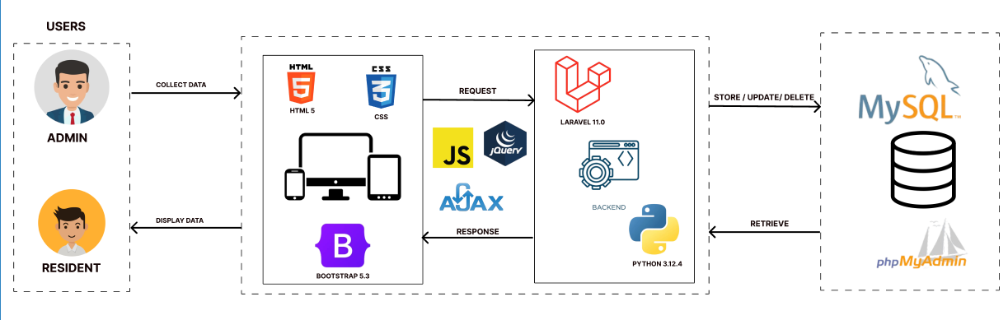
Figure 3.2

System Architecture
This system architecture represents a web-based application designed to manage interactions between an admin and residents. The system involves two main users: the admin, who is responsible for collecting and managing data, and the resident, who views or receives data, such as updates or requested documents.
The front end of the system is built using HTML5, CSS, and Bootstrap 5.3 to ensure a responsive and user-friendly interface. JavaScript, along with jQuery and AJAX, is used to handle interactivity and asynchronous data requests, allowing the system to send and receive data from the backend without requiring a page reload. When an admin submits data through the interface, it is sent as a request to the backend using AJAX. Similarly, residents receive responses processed from the backend and displayed through the same frontend technologies.
The backend of the application is powered by Laravel 11.0, a PHP-based web framework that handles routing, server-side logic, and API processing. Python 3.12.4 is also integrated into the backend and is primarily responsible for handling image processing and face recognition. It uses a combination of YOLOv8 (You Only Look Once version 8) for efficient and accurate face detection and Convolutional Neural Networks (CNNs) for analyzing facial features and verifying identities. This hybrid approach allows the system to accurately recognize and match faces in real time, supporting features such as identity verification and secure certificate requests.
For data storage, the system uses a MySQL database, which holds all essential data such as user information, requests, and transaction records. phpMyAdmin is utilized as a graphical interface to manage and view the database easily. The backend performs actions such as storing, updating, and deleting records in the MySQL database, and retrieving them as needed.
Component breakdown
The system consists of several cores components that play a vital role in ensuring smooth operation, Front-end play as the primary interface between user interaction that Designed using Hyper-Text Markup Language 5 (HTML5), Cascading Style Sheet (CSS) and Bootstrap version 5.3 that are responsible for intuitive design, responsive experience, and capturing user inputs including entering data, uploaded images or files and live face scans transmitting them to the backend for further processing with uses of Asynchronous Javascript and XML (AJAX) and JQuery that send and receive data between front end and back end without requiring a full page reload. This improves user experience by making Web applications faster, more dynamic and interactive.
The backend acts as the central processing unit of the system, built using laravel version 11 a PHP framework known for its robust security features, scalability and developer friendly architecture that provides the system a well-structured environment that enhances code maintainability, ensures high performance, and supports rapid application development, This manages user authentication and process request that leverage to manage user sign-ups, logins, retrieve of data and access control. Handles data validation ensures that all inputs meet predefined criteria before being processed, this helps to prevent vulnerabilities and data inconsistencies, also return error messages that prompt users to make corrections before proceeding and integrates seamlessly with facial recognition modules with the uses of Python language. Structure ensures that all transactions within the system are efficiently executed.
Database is responsible for storing all necessary information, including user credentials, uploaded files and images.A well-structured relational database management system (RDBMS) such as MySQL is used to organize and structure data in a way that ensures high availability, data consistency, and integrity.
The system architecture is designed for scalability and flexibility, allowing seamless integration of new features without disrupting functionality. Its modular structure supports independent updates to components like the database, face recognition module, and backend. The database ensures efficient data retrieval with indexing strategies, while the YOLO model can be upgraded separately for improved accuracy. Additionally, the backend is adaptable for future expansion, ensuring long-term system efficiency and growth.
User Story
(See Appendix A for the detailed User Story.) The proposed system is a comprehensive web-based platform designed to streamline the services of Barangay 781, Zone 85, Sta. Ana, Manila City. The system allows residents to conveniently access barangay services such as requesting certificates (e.g., Barangay Indigency, Business Permit, Barangay Certificate, Solo Parent ID, and others), submitting inquiries, and staying updated on news, events, and projects. Unregistered users are guided through a secure registration process involving OTP verification, ID upload, and facial recognition, while registered users can log in to avail of the full features.
Administrative users, or record keepers, are given access to features that allow them to manage resident accounts, review and process certificate requests, monitor statistical reports, and maintain barangay content and resident records. The system includes real-time email notifications, filtering and sorting options, and document tracking to ensure transparency and efficiency in service delivery. Additionally, users can maintain and update their profiles, including family member details. The platform also supports interactive features such as forums for submitting inquiries and feedback, which promote two-way communication between residents and barangay officials. Overall, the system enhances accessibility, accountability, and transparency in barangay operations.
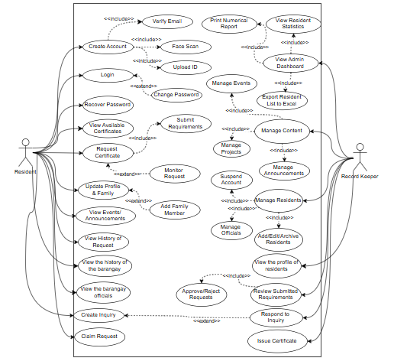

Figure 3.2

Use Case Diagram
The use case diagram shows the interaction between two main users: the Resident and the Record Keeper. Residents can register, log in, upload IDs, perform face scans, request certificates, update profiles, link family members, and send inquiries. Record Keepers manage resident data, approve or reject requests, issue certificates, respond to inquiries, and access admin tools like reports and dashboards. The system ensures secure identity verification, efficient certificate processing, and clear role-based access for both users.
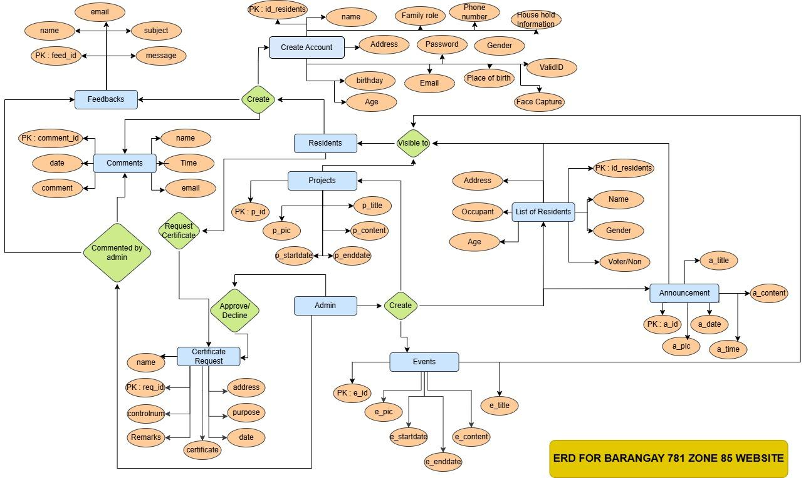

Figure 3.3
Entity Relationship Diagram
The Entity Relationship Diagram (ERD) visually illustrates the database structure for the Barangay 781 Zone 85 Website, showing how different entities interact within the system. Key entities include Feedbacks, which store information like name, email, and message, and are linked to Comments made by admins. The Residents entity represents the users, containing personal details and facilitating actions like requesting Certificates or interacting with Projects and Events. List of Residents holds demographic data such as name, age, and gender, while Announcement and Events manage community updates and activities. Each entity connects with others, demonstrating how data is shared, managed, and utilized across the system, aiding in streamlining processes and improving functionality.
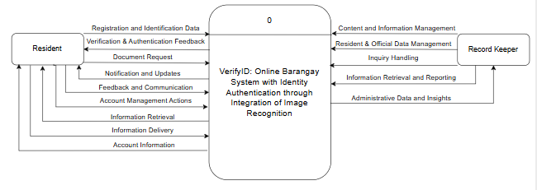

Figure 3.4
Context Flow Diagram
The Context Flow Diagram (CFD) presents an overview of the VerifyID: Online Barangay System with Identity Authentication through Integration of Image Recognition interacts with its external entities. At the center of the system are two key actors: the Resident and the Record Keeper, who both engage with the system through distinct but interconnected processes.
The Resident initiates their interaction by submitting personal and facial data to the system during the registration process. Upon verification of this data, the system returns a registration confirmation, completing the authentication stage. Once registered, the resident can proceed to make certificate requests, submit profile updates, and check the status of their requests. The system also allows residents to update their profile, ensuring that any changes in their information are reflected in real-time. These interactions are designed to streamline barangay services while enhancing security and identity validation through image recognition.
On the other side, the Record Keeper plays a crucial administrative role. They receive certificate requests from the system and provide resident’s records that are essential for validating these requests. They can also monitor the status of each request, which facilitates efficient management of document processing and communication with the residents. This diagram effectively captures the data exchange pathways between users and the system. It illustrates how the VerifyID system serves as a centralized platform, enabling secure registration, document request management, identity verification, and continuous status monitoring

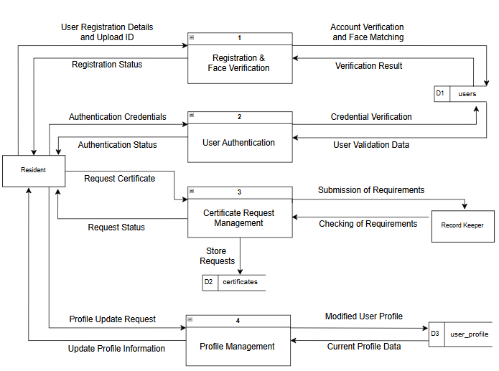

Figure 3.5 Data Flow Diagram Level 0
The Data Flow Diagram (DFD) of the VerifyID System provides a detailed overview of how data moves through the system’s core functionalities. It includes four main processes: Registration and Face Verification, User Authentication, Certificate Request Management, and Profile Management. Each of these processes interacts with the resident, internal data stores, and relevant personnel such as the Record Keeper.
The Registration and Face Verification process begins when a resident submits their personal information along with a valid ID. The system uses facial recognition algorithms, specifically YOLOv8 and CNN, to match the uploaded ID with the resident’s live face scan. This ensures that the identity being registered is legitimate and unique. The system then verifies this data against the existing user records in the users database. If the data is valid and not duplicated, the resident’s information is saved, and a registration status—either success or failure—is returned to the resident.
In the User Authentication process, residents input their login credentials, which the system compares against stored values in the users data store. If the credentials match, the system confirms the resident’s identity and returns an authentication status. This process helps secure access to system features and ensures that only verified users can proceed to sensitive operations such as requesting certificates or updating profiles.
Once authenticated, the resident can access the Certificate Request Management process. Here, the resident submits a request for a specific certificate along with the required documents. The system stores these requests in the certificates database. A Record Keeper is then responsible for reviewing the submitted requirements and updating the status of each request. The system returns real-time feedback to the resident regarding the status of their certificate application, using labels such as “In Progress,” “Ready to Claim,” “Claimed,” or “Declined.” This enables transparent tracking of requests throughout the processing stages.
The Profile Management process allows residents to update personal information, such as their address, contact number, or other details. When a resident submits a profile update request, the system retrieves their current data from the user profile database, validates the changes, and then saves the updated profile. The modified information is reflected back to the resident, ensuring that their records remain accurate and current.

High Fidelity
The high-fidelity prototype of VerifyID showcases a fully designed and interactive interface that enhances identity authentication, certificate requests, and barangay service accessibility. This version refines user experience, security, and efficiency, ensuring seamless navigation, real-time status tracking, and a centralized dashboard for officials before full implementation.
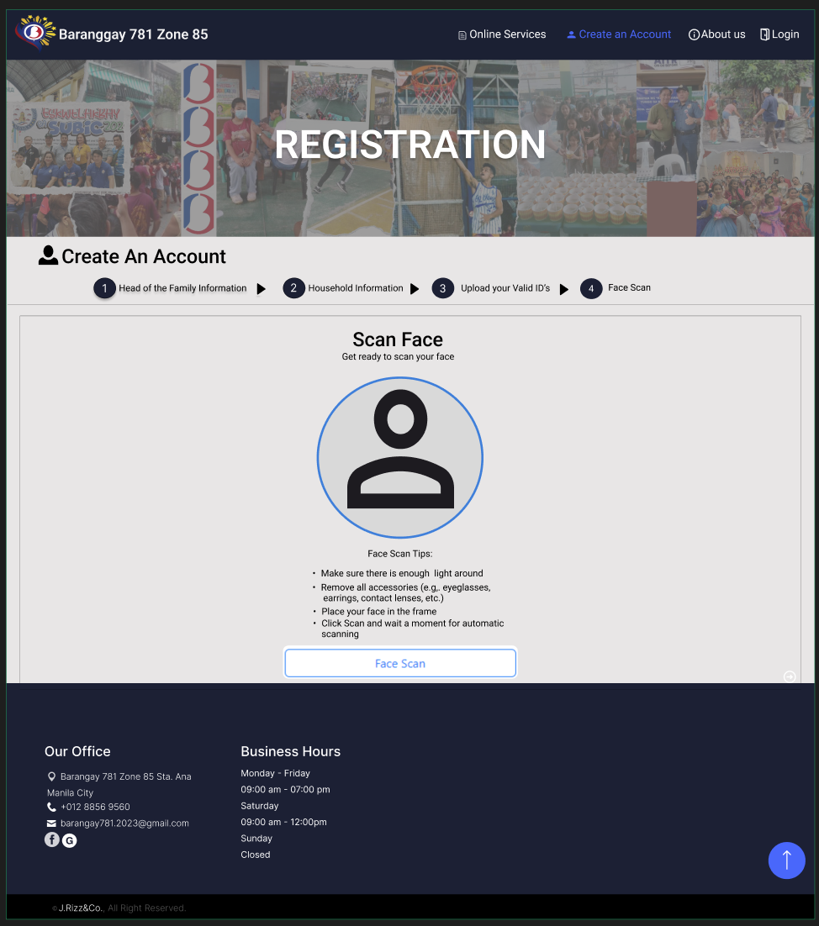

Figure 3.6
Create an Account (Face Scan)
This part is where the algorithm will focus to compare faces from the ID and live scan face, to ensure the face is successfully scan the resident must have a enough light around, removing of accessories around the face placing the faces in frame by not too close or too far, directly looking at the camera and clicking of Scan button to start scanning the face, Scanning of face have 3 steps, first is by scanning the front face and then next is slightly face to the right to scanned the right face and last is slighting face to the left to scanned the left face, if it is successful Click the create an account button and it will prompt the control number of the registered account.


Figure 3.7
My Certificate Page
The My Certificate Page allows residents to conveniently manage and monitor their certificate requests within the system. On this page, users can view a list of all available certificates offered by the barangay, such as Barangay Indigency, Barangay Certificate,Business Permit, and others. Each certificate entry includes its corresponding requirements, providing users with clear guidance on what documents or information are needed before submitting a request. At the top of the page, there is also a prominent banner that outlines a step-by-step guide on how to request a certificate or permit. This instructional banner helps residents understand the process clearly, from selecting the certificate type to completing the submission and awaiting approval.
Once a resident selects a certificate and fills out the necessary information, they can formally submit a request through the system. After submission, the request is logged and tracked, allowing users to monitor the status of their application in real time. The page includes a remarks section that displays important updates on the status of each request. These statuses include “In Progress” for applications currently being processed, “Ready to Claim” when the certificate is available for pickup, “Claimed” if the certificate has already been received, “Declined” for rejected requests due to missing requirements or eligibility issues, and “Cancelled” for requests that have been voluntarily withdrawn by the user.
To keep residents well-informed, the system also sends automated email notifications for each major action taken by the admin during the document processing phase. This includes updates such as approval, rejection, or when a document becomes ready for claiming. Additionally, residents are given the option to cancel their pending requests at any time before processing begins. Overall, the My Certificate Page provides a user-friendly and transparent way for residents to handle their certificate-related needs, ensuring efficient communication, guidance, and timely updates through both the interface and email notifications.
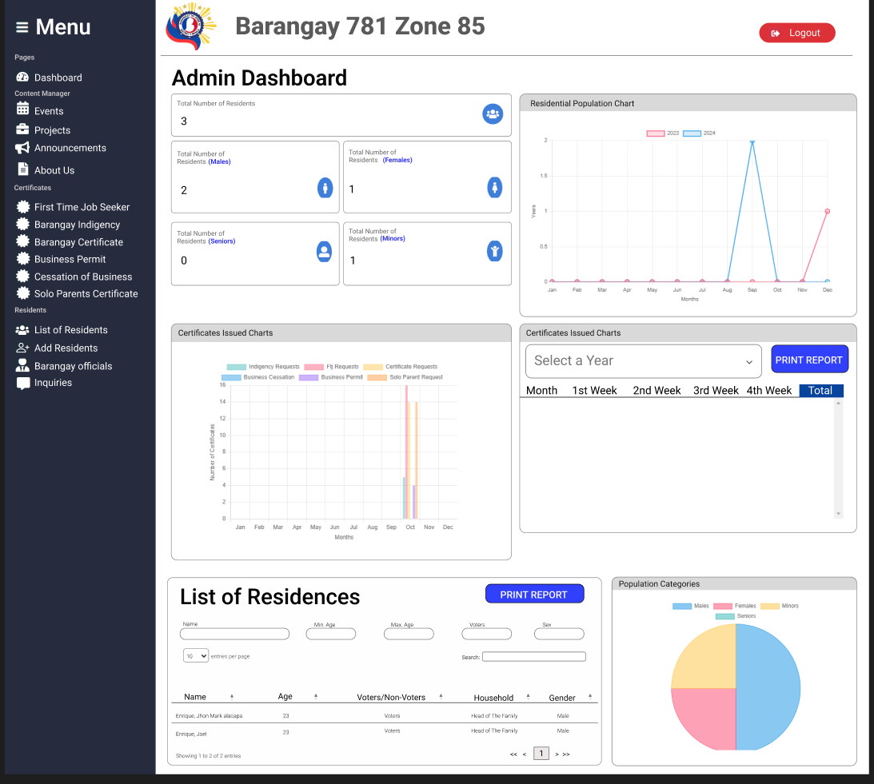

Figure 3.8
Admin Dashboard
The Admin’s Dashboard provides an overview of the system activity. This includes the total number of residents, population chart, certificates issued chart, list of residents, and population categories. Barangay administrators can manage resident records, certificate requests, inquiries, and announcements efficiently. This also provides an organized and responsive interface to streamline barangay operations and decision-making.


Figure 3.9
Inquiry Page
The Inquiry Page enables residents to submit concerns, complaints, and general inquiries directly to barangay officials. The officials can get in touch with the residents through this platform and discuss relevant topics. The Inquiry page serves as a dedicated platform where residents can directly communicate with barangay officials regarding their concerns, complaints or general inquiries. It provides a structured and accessible way for residents to raise issues that affect their community, such as noise complaints or disturbance , maintenance problems, safety concerns or requests for information about barangay services and programs. Through a simple and user-friendly form, residents can submit their messages ensuring that officials receive clear and concise information.
Once a submission is made, barangay officials are promptly notified and can access the inquiry through the system’s backend. The platform also facilitates two-way communication, allowing officials to respond directly within the system. Responses from barangay officials are sent back to the resident either through the online platform, making it easier for residents to stay informed about the status and progress of their concern.

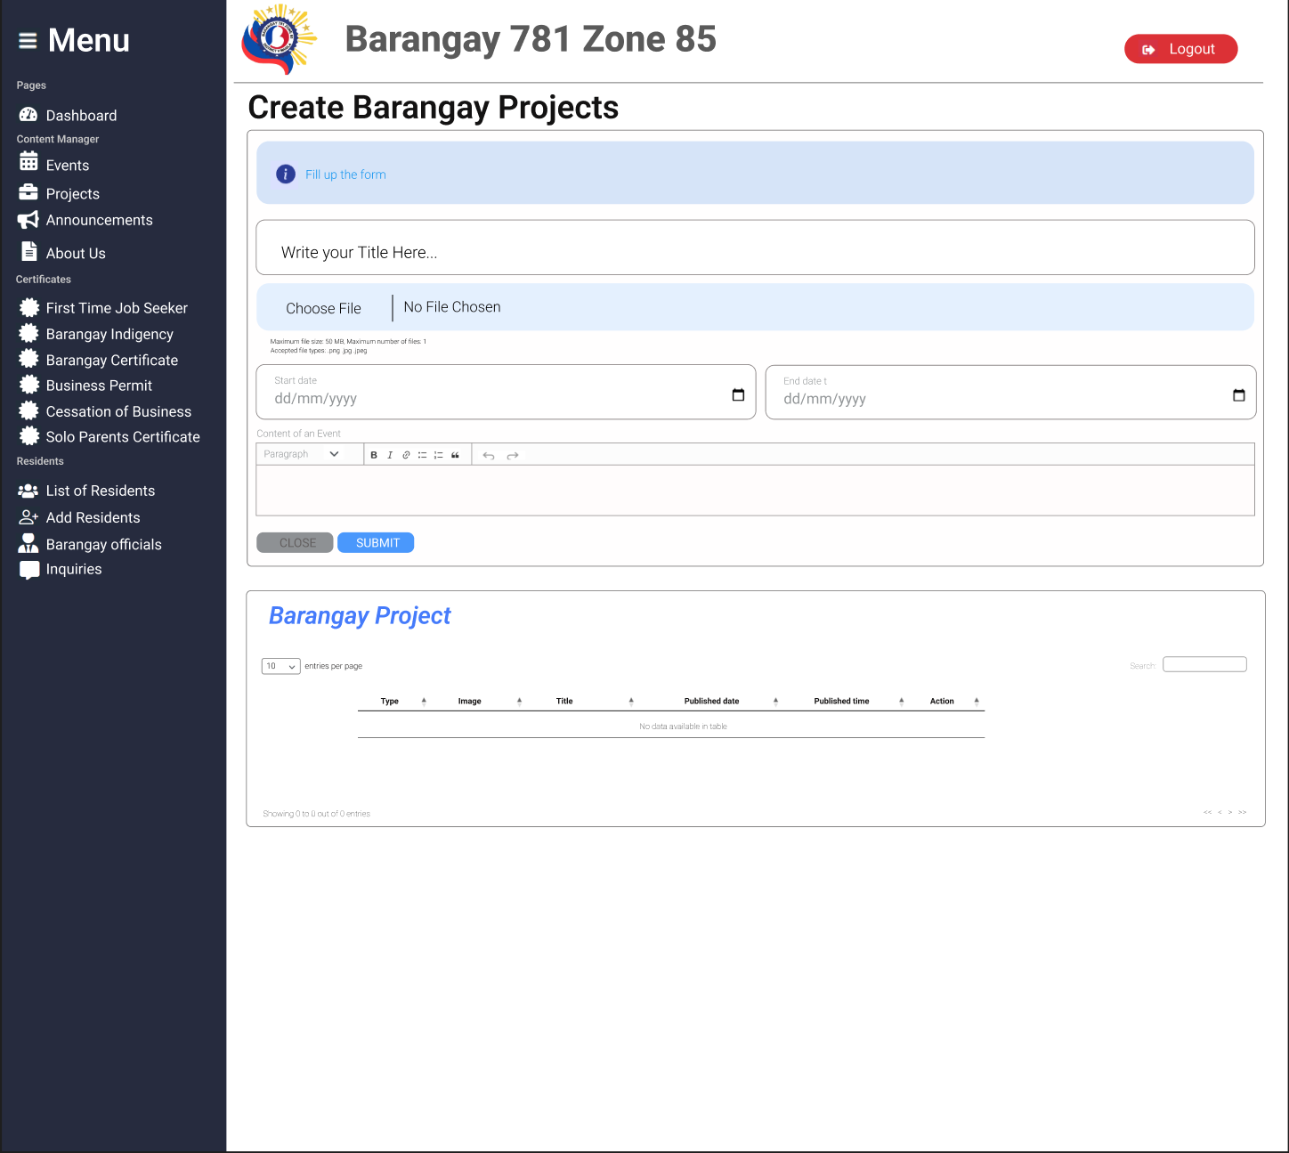
Figure 3.10
Create Barangay Project Page
The Create Barangay Project, Announcement and Event Page is where barangay officials can post updates on events, projects, and local government activities. This ensures residents stay informed and engaged with their community through timely notifications. Administrators can create, update, or delete barangay details visible to residents.

Algorithm Design
The researchers use the Face Recognition process for algorithm design. The Face recognition algorithm states a model for feature extraction and comparison of faces, This method is related to Deep learning technique making involves recognizing patterns of faces from images and matching them to a stored dataset or another face image, also to analyze and process to detect and recognize faces. Below is the Face recognition Diagram.
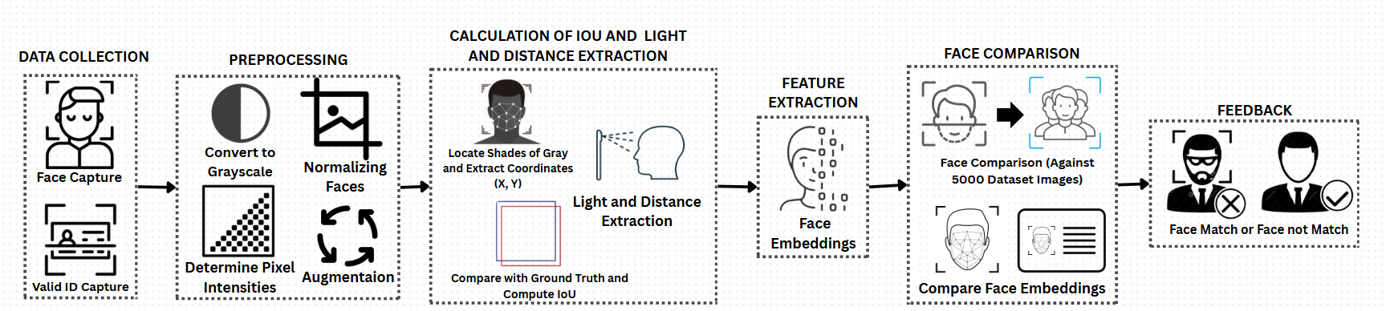

Figure 3.11
Face Recognition Process
Face Recognition is a type of computer vision that analyzes an image to scan or locate faces within a certain area of image. In this case it looks particularly at faces that appear in the uploaded image and Scanned faces. Face recognition is used to resemblance between two faces in order to compare these faces if identical or match.
Facial recognition is a biometric technology that analyzes and identifies human faces by comparing unique facial features captured through images or videos. It is commonly used in security systems, personal devices, and various identification processes, leveraging algorithms to match facial features with stored data This technology is increasingly integrated into numerous applications for authentication, surveillance, and personalized services. (Kaspersky, 2023).

Data Collection
The VerifyID system utilizes resident facial recognition. First is the data collection phase, An inputs to gather a real time captured face and a valid ID image. A real time captured face is typically done using a webcam or camera, while the valid ID is uploaded into the system. These two images serve as the basis for verifying whether the person in the live capture is the same as the person in the ID. This step provides the raw data required for all subsequent processing.
Preprocessing
Preprocessing begins by converting both the scanned face and the ID face image to grayscale. This simplifies the image by removing color information, allowing the system to focus on the structural features of the face. The next step involves determining pixel intensities, which helps in identifying facial landmarks by analyzing shades of gray. After that, face normalization is performed to standardize the images, this ensures that the facial features are aligned consistently across all images. Additionally, data augmentation techniques such as rotation, flipping, or brightness adjustment may be applied to improve the model's robustness and adaptability to different image conditions

Calculation of IoU and Light and Distance Extraction


Figure 3.12
Intersection over Union
This phase focuses on refining the detected facial features by analyzing the grayscale image to locate different shades and extract their corresponding X and Y coordinates. These coordinates represent key facial points like eyes, nose, or mouth corners. The detected landmarks are then compared with predefined ground truth values using Intersection over Union (IoU), a metric used to measure the overlap between predicted and actual feature areas. Furthermore, the system estimates lighting conditions and distance by analyzing the 3D geometry of the face, helping account for variations in environment and depth. This contributes to improving the accuracy and reliability of facial recognition.

Feature Extraction
The generated embeddings from the scanned face and the ID image are now compared. This comparison is done using similarity metrics such as cosine similarity or Euclidean distance. Additionally, the embeddings are checked against a larger dataset of about 5000 face images to ensure high reliability and to reduce false matches. By analyzing how closely the embeddings match, the system determines whether the two images likely belong to the same individual.

Feedback
To validate the matching of faces combined the scores from both embedding and landmark -based similarity using weighted averaging then if the combined score exceeds a predefined threshold conclude that faces are match else if the score is below the threshold then conclude faces do not match. Additionally, providing feedback to the user about lighting or distance is suboptimal so that users can adjust with these certain conditions.

Face Recognition Algorithm
The image recognition algorithm is integral to the study because it addresses the core objective of secure and efficient identity authentication within the VerifyID system. By streamlining the verification process using image recognition, the system eliminates the need for manual ID checks, improving both the speed and accuracy of resident identification. Additionally, it enhances security by preventing identity fraud or tampering, which is crucial for safeguarding sensitive personal information and streamlining processes like certificate requests within barangay operations. The study will compare three image recognition algorithms and find out which of them shows the best performance and integrate it in the study.

Convolutional Neural Network (CNN)
The CNN algorithm for image recognition uses convolutional neural networks to identify and match facial features in images and Live face scan. It analyzes the content of images and recommends or identifies faces based on their similarities. Additionally, it serves the purpose of processing facial images by detecting faces, estimating pose, assessing lighting conditions, processing the image and performing face recognition using CNN model. It includes calculation of facial landmarks and their similarities and determination of the optimal face to camera distance. This approach consists of the following main steps:
Step 1:Initialization and Setup

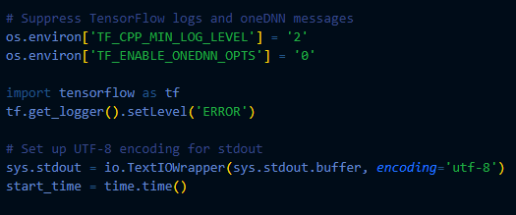

Figure 3.12
Suppress Logs and Setup UTF-8
The code minimizes TensorFlow logging output and disables oneDNN optimizations using environment variables. TF_CPP_MIN_LOG_LEVEL uses to limit tensor flow log verbosity.TF_ENABLE_ONEDNN_OPTS use to disable oneDNN optimization. UTF-8 Encoding for standard output ensures proper text encoding for terminal output. Measuring time execution is the script records that start the time to track execution duration.
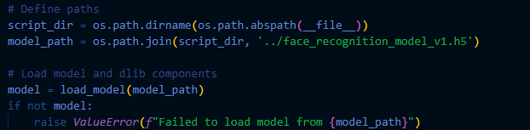

Figure 3.13
Loading The model
The model path is computed based on the scripts Directory. It uses the load_model() to read the saved .h5 file and loads the model architecture and weights. This step initializes the trained CNN model for Face Recognition. The load_model function ensures the application has the necessary tools for embedding generation. If the model fails to load, the program raises an error, indicating a critical issue with the file or path. By abstracting model initialization, this step sets the stage for subsequent face recognition tasks. The trained model allows efficient execution by reusing prior knowledge from training.
Step 2: Pose and Lighting Estimation
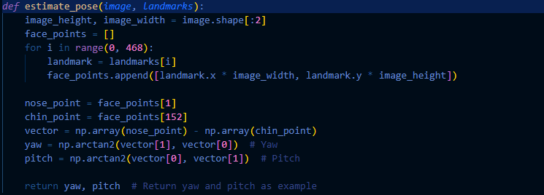

Figure 3.14
Pose estimation
This step is to calculate the head pose using a simple angle-based approach between nose and chin points from detected landmarks. Figure 9 starts by converting the landmarks to 3D points then creates a list of points from the face landmarks (x, y, z). To simplify the pose estimation the figure 9 states the nose tip and Chin point. The nose Tip is used to determine the center of the face and a key point for the pose and Chin pont uses to determine if the head is tilted and aligned to the nose point. Last is the Calculation of angles between nose and chin to approximate head pose. To compute the head pose, the code uses the yaw and pitch angles, which are derived from the position of the 3D face landmarks (such as nose tip, chin, and eyes) to estimate the rotation of the head.
- Yaw is for the horizontal rotation where the angle of the head left to right.
- Pitch is for the vertical rotation of where the angle of the head is up or down.
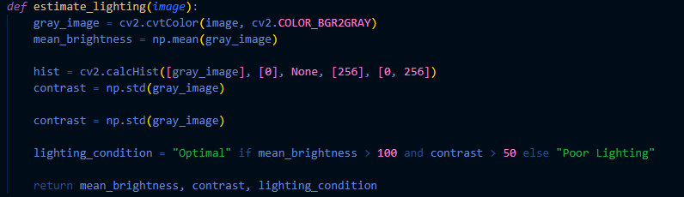

Figure 3.15
Lighting estimation
Analyzes the image's brightness and contrast to determine if the lighting is optimal or poor, aiding in robust face detection and embedding quality. In figure 10 start at Converting the image to GrayScale then calculate the mean brightness with use of histogram for more detailed lighting analysis then calculate the overall contrast by computing the standard deviation of pixels value after the computation it will determine the lighting computation if brightness is greater than 100 and contrast is less than 50 the the lighting is optimal else it will prompt poor lighting.The figure 10 ensures that faces with poor lighting are handled. Brightness is measured by computing the average pixel intensity across the face region. Contrast is computed by looking at the variance in pixel intensity, with higher variance indicating higher contrast.
Step 3: Preprocessing and Face Cropping
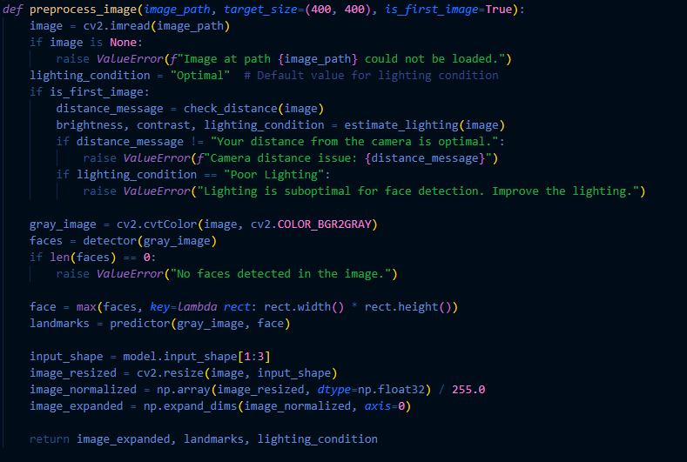

Figure 3.16
Preprocessing and Face Cropping
The figure 3.16 shows the preprocessing of faces and Cropping of faces.It start at Images are preprocessed to ensure they meet model requirements: Resizing, checking the lighting and distance condition if met, and normalization if faces.At first the images is resize at 400 x 400 then initialize the lighting condition with default value and Lighting conditions and camera distance are validated. Poor conditions or incorrect face size relative to the frame triggers an error, ensuring input quality. Next is converting the image to grayscale for face detection and prompt if face is not detected and then if the face is detected, cropped, and resized for further processing, ensuring the region of interest is well-focused. The image is resized, normalized, and cropped to focus only on the detected face. The face detector ensures the face is the right size for the model.
- Resizing: The image is resized to a consistent size, such as 400x400 pixels, to feed into the face recognition model.
- Face Cropping: Based on the detected bounding box around the face, the image is cropped.
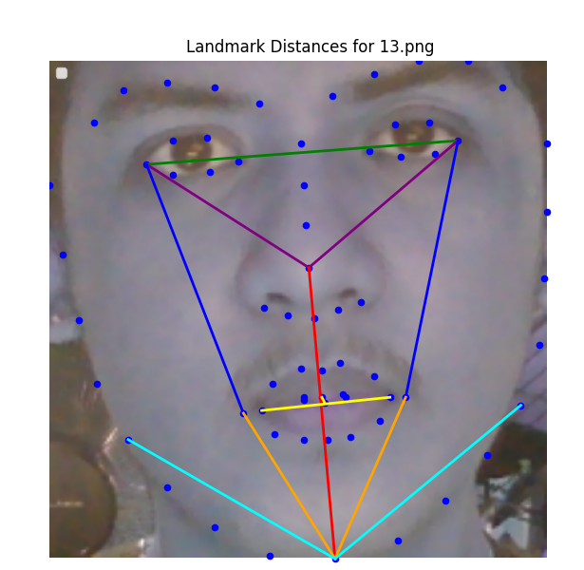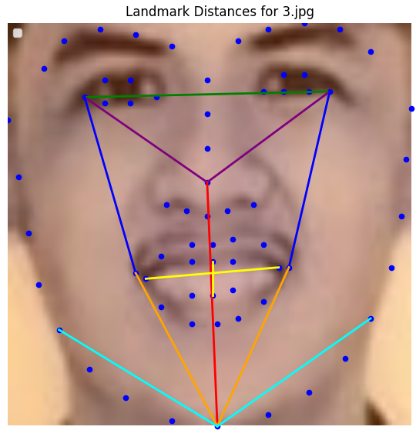

Figure 3.17
Extraction of Facial Landmarks
After cropping, the image of the face will be extracted and prepared for further analysis (such as face recognition or landmark detection). This typically involves resizing, normalization, and possibly the extraction of facial landmarks.
Step 4: Embedding and Landmark Analysis

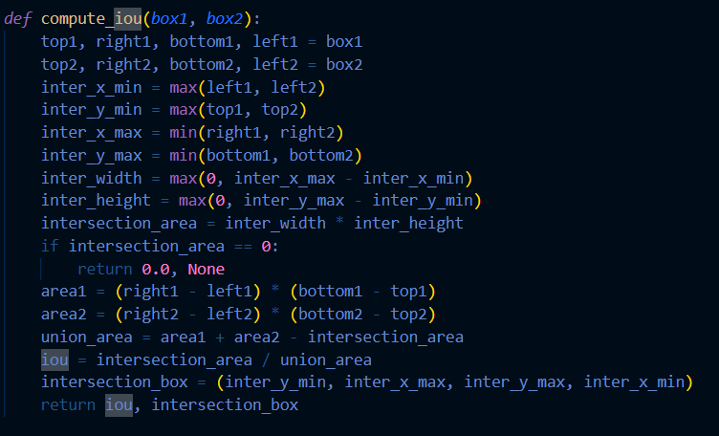

Figure 3.17
Intersection Over Union
The function calculates the Intersection over Union (IoU) between two bounding boxes. The function first extracts the coordinates (top, right, bottom, left) for each of the two boxes. It then prints these coordinates for debugging purposes. The function proceeds by calculating the intersection of the two boxes, determining the overlapping region's boundaries based on the minimum and maximum x and y coordinates from both boxes. If there is an intersection, the function calculates the intersection's area. If there is no overlap, it returns an IoU of 0.0.
Next, the function calculates the areas of both boxes individually by multiplying the width and height of each box. The union area is computed by adding the areas of both boxes and subtracting the intersection area. The IoU is then calculated by dividing the intersection area by the union area, providing a measure of overlap between the two boxes. Finally, the function returns the IoU value and the coordinates of the intersection box, which represents the overlapping region.
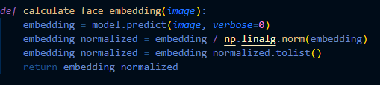

Figure 3.18
Calculate Face Embedding
The model extracts high-dimensional vectors representing facial features. These are normalized for comparison. The model calculates a face embedding, which is a high-dimensional vector 128 dimensions that uniquely represents the face’s features. The neural network computes this vector by passing the preprocessed face image through layers of convolutional and fully connected layers. The final output is a 128-dimensional vector. The face embedding represents the unique features of the face, which are calculated by the model and then normalized to make sure all embeddings are on the same scale.

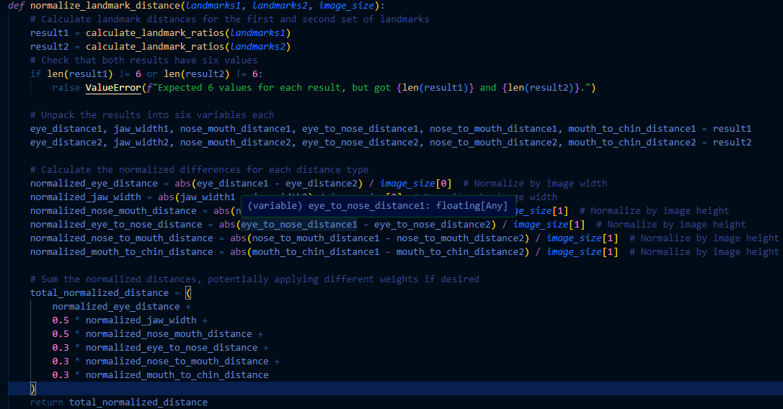

Figure 3.19
Calculate Landmark Distances
Computes the normalized distance between two sets of facial landmarks, based on six geometric features. It ensures the differences in facial proportions are normalized relative to the image size for consistent comparison across varying image resolutions.Distances between facial landmarks (such as eye-to-eye, nose-to-mouth) are computed using Euclidean distance formulas. Landmarks 1 and landmarks 2 are the two sets of facial landmarks corresponding to two different or same faces in different images. Image size is the image tuple representing the dimensions of the image, used for normalization.Landmark ratios computes the six facial geometry that measures for each sets of landmarks:
- Eye Distance: Horizontal distance between the centers of the two eyes.
- Jaw Width: Horizontal distance between the leftmost and rightmost jaw points.
- Nose-to-Mouth Distance: Vertical distance between the nose tip and the midpoint of the mouth.
- Eye-to-Nose Distance: Vertical distance between the eye line and the nose tip.
- Nose-to-Mouth Distance: Vertical distance between the nose tip and the mouth midpoint.
- Mouth-to-Chin Distance: Vertical distance between the bottom of the mouth and the chin.
To validate the result it ensures that it contains exactly the six values mentioned above. If not it will prompt an error because the computation will depend and vary on the six specific ratios.Normalization of each feature ensures that distances are scaled to the image dimensions for consistent comparisons.
Step 5: Face Comparison
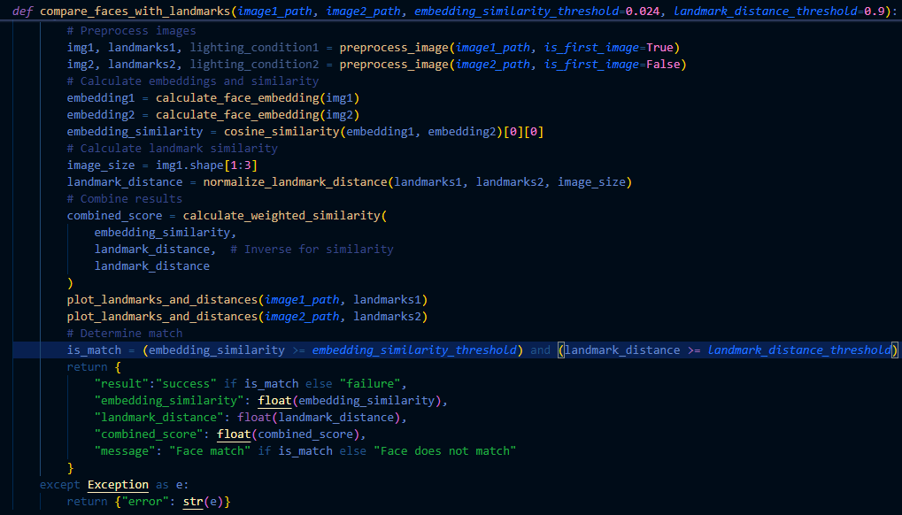Figure 3.20
Calculate Compare Faces with landmarks.
Preprocessed images are compared by combining three metrics: embedding similarity, landmark similarity, and landmark ratio scores. A weighted average calculates an overall similarity score. Thresholds for embeddings and landmarks ensure robust matching. A combined score exceeding the thresholds indicates a match. Landmarks are plotted on the cropped face image, and key distances between landmarks are illustrated with color-coded lines, providing a visual representation of critical face regions. Validates if the face occupies the optimal fraction of the frame to avoid incorrect camera positioning. Model evaluation metrics like precision, recall, and F1-score can be calculated to assess the accuracy of face matching results. Face embeddings from two different faces are compared using cosine similarity. The higher the cosine similarity, the more similar the faces are. Additionally, landmark distances and ratios are compared to reinforce the similarity measure. Embedding_similarity_threshold is at default of 0.024 it is the minimum cosine similarity score required for the embeddings to indicate a match land_mark_distance_treshold or is at default 0.9 it is the minimum normalized landmark similarity score required for a match.

Figure 3.21
Preprocess images
Each image is loaded and preprocessed. It checks the optimal distance and lighting conditions and the Detected facial landmarks for further geometry-based comparison last to resize and normalize the image for the embedding model.
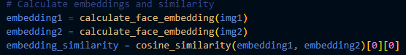

Figure 3.22
Compute Cosine Similarity
Measures the angle between two embedding vectors, where 1 indicates perfect alignment.Cosine similarity measures the angular similarity between two vectors. It is commonly used in machine learning to compare the similarity of feature vectors, such as face embeddings.

Figure 3.23
Compute Landmark Distance
Next is the normalized distances between six facial features are calculated.The landmark distance is calculated by normalizing the absolute differences between corresponding landmark distances Eye Distance ,Jaw Width, Nose-to-Mouth Distance, Eye-to-Nose Distance, Nose-to-Mouth Distance and Mouth-to-Chin Distance across two sets of landmarks. Note on the figure 17 The smaller the normalized landmark distance, the more similar the structural facial features. A higher weight on certain features means they contribute more to the final score, reflecting their importance in facial structure recognition.
Formula:
$Normalized Distance = \frac{|D_{1}-D_{2}|}{Image Dimension}$
Equation 3.1
Normalized Distance


Figure 3. 24
Combine Results
The Figure 3.24 is The combined score in a metric that integrates both the embedding similarity and the landmark distance to determine the overall match between two faces. It takes into account the results from both the deep learning-based face embeddings which capture high-level face features and the more traditional landmark-based geometric features which focus on the relative positions of facial features. A weighted similarity score is computed based on embedding similarity and landmark distance.
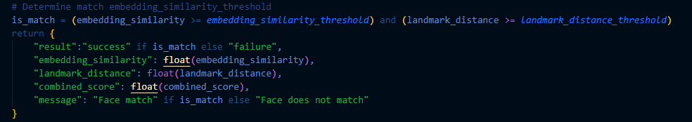

Figure 3. 25
Determine Match and Return Results
The figure 3.25 decides whether two faces are considered a match or not based on embedding similarity and landmark distance thresholds. The determination is made using a logical condition:
is_match = (embedding_similarity >= embedding_similarity_threshold) and (landmark_distance >= landmark_distance_threshold)
Where the embedding similarity is the cosine similarity score between two face embeddings a value between 0 and 1 and landmark distance is the The normalized landmark similarity a value between 0 and 1, higher means more similar. The Embedding similarity threshold is the Minimum similarity required to consider the embeddings a match. Landmark distance threshold is the Minimum normalized distance required to consider the landmarks a match. If the conditions are me the results are true otherwise false. The thresholds act as the decision boundaries for determining a match. Embedding similarity evaluates the deep feature similarity between two images.Landmark distance ensures that the geometric alignment of facial features is close enough. If either condition fails, the result is a "failure" with the message "Face does not match". In this case, both conditions passed, so the result is "success" and the message is "Face match".

Faster Region-Convolutional Neural Network (Faster R-CNN)
In the Fast-R image recognition system, the proponents leverage image analysis techniques to determine the similarity between facial images based on their intrinsic features. This process involves two key steps:
Step 1: Processing Images
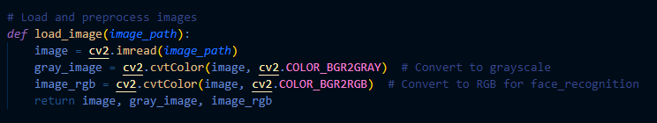

Figure 3.26
Loading and Preprocessing Images
Using FAST-R CNN first is converting the image into two formats: the gray scale for the traditional image computer vision tasks and RGB for the face recognition library to process. The gray scale conversion helps with face detection algorithms while RGB is required for Face Recognition for detecting faces and generating face encodings.
Step 2: Feature Extraction
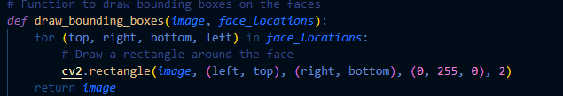

Figure 3.27
Detecting Faces and Extracting Features
Figure 3.27 shows the function of detect_faces_and_features(image_rgb) uses the face_location () method to find positions of each face in the images. It also uses the face_encodings() to extract the numerical features that represent the unique characteristics of each detected face. For it Mathematical Computations the set encodings are vectors representing the face. These vectors are high-dimensional arrays that uniquely describe a face. The positions of the faces are returned as bounding box coordinates (top, right, bottom, left).
Step 3: Drawing Bounding Boxes Around Faces
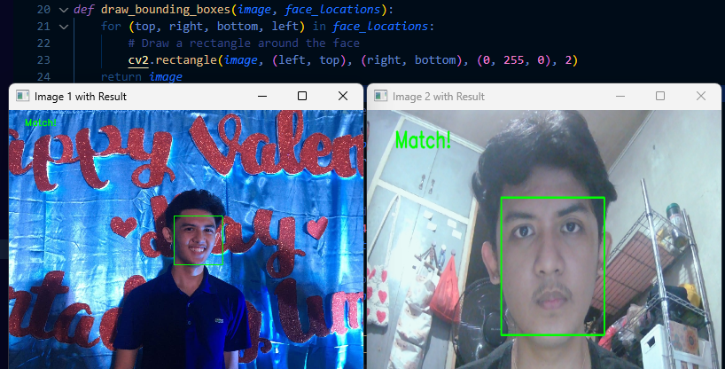

Figure 3.28
Bounding Boxes Around Faces
Purpose of the bounding box is to take an image and a list of face locations. These green Rectangles are helping to visualize where the faces are located in the image. This is a list of tuples, where each tuple contains coordinates of a face’s bounding box. Each bounding box represents four values: Top,Right,Bottom, Left coordinates. These values define the area in the image where the face is located.
Step 4: Cropping and Resizing the Face Region
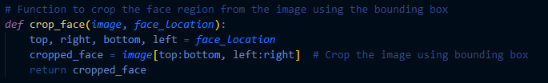

Figure 3.29
Cropping of Faces
Purpose of the cropping of faces is to have an accurate face detection process. This is useful when isolating a face from the rest of the image for tasks like face recognition or analysis.
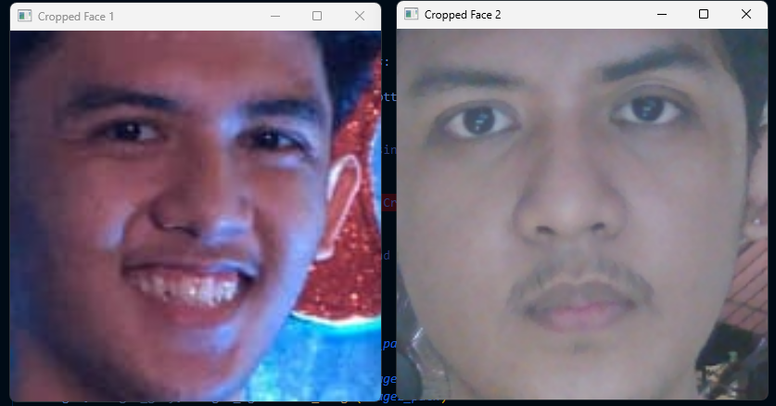

Figure 3.30
Cropped Faces
The image is a 2D array (matrix), where each pixel is indexed by its row (y-coordinate) and column (x-coordinate). This slice will give you a smaller image that contains only the region inside the bounding box.the cropped face as a separate image that contains only the area of interest the face region. This cropped image can now be further processed or used for recognition, comparison, or other tasks.
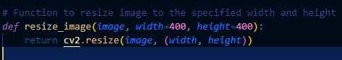

Figure 3.31
Resize Face image
The primary purpose of this function is to resize an image to a new width and height. resizing of images for purposes like display, input for machine learning models, or reducing the image size for efficiency. When you resize an image, the pixel values need to be interpolated to fit the new size. This is especially important when enlarging an image because the algorithm must estimate pixel values in the new image based on the old ones.

Step 5: Face Comparison and Distance Calculation
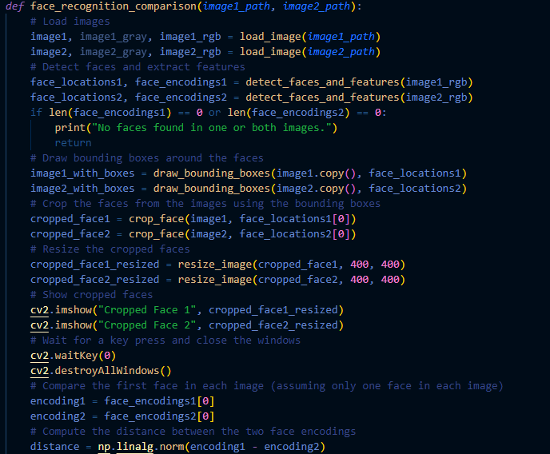

Figure 3.32
Face Comparison and Distance Calculation
After detecting and cropping the faces, the researchers compare the two faces using their face encodings. The face encodings are compared by calculating the Euclidean distance between the two encoding vectors using np.linalg.norm(encoding - encoding2). Accepted weights for face comparison must achieve the embedding similarity of at least 0.75 and landmark ratios score of 0.025 and for distance calculation must have 0.55 threshold. The smaller the distance, the more similar the faces are.This distance represents how similar or different the two faces are. A smaller distance indicates that the faces are more similar, while a larger distance indicates they are more different.To compare two faces, we calculate the Euclidean distance between their corresponding face encodings. The Euclidean distance formula between two vectors a and b in an n-dimensional space is defined as:
$D(a, b) = \sqrt{\sum_{i=1}^{n}{}}{(a_{i} - b_{i})}^{2}{}^{}$
Equation 3.2
Euclidean Distance

You Only Look Once (YOLO)
In the YOLO-based object detection system, researchers leverage a deep learning approach to identify and localize objects within images . This process consists of two main steps:
Step 1: Detect Faces Using YOLO
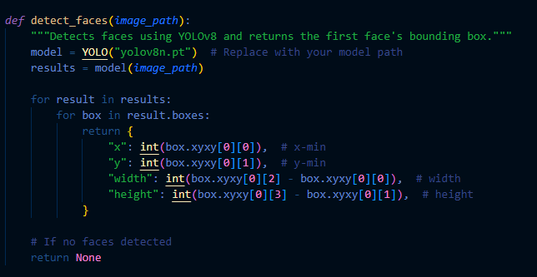

Figure 3.33
Detecting faces and Apply Bounding boxes
Uses of YOLO version 8 model is to identify faces in the provided image. YOLO(You Only Look Once) is a real time object detection system that divides an image into grid and predicts bounding boxes for objects along with their class probabilities The bounding box coordinates(X_{min} ,Y_{min}, X_{max}, Y_{max}) are used to calculate the face’s position and size. If no faces are detected, the function returns none which indicates the absence of faces within the image.
The YOLO model processes the input image to identify the bounding boxes around the faces..The dimensions of the bounding box are computed as:
Width = X_{min} - X_{min}
Height = Y_{max} - Y_{min}
Equation 3.3
Dimension of the Bounding box
Each bounding box is represented by coordinates X_{min} ,Y_{min} for Top left corner and X_{max}, Y_{max} for bottom right corner.
Step 2: Crop the Detected Face and Compute Face Embedding
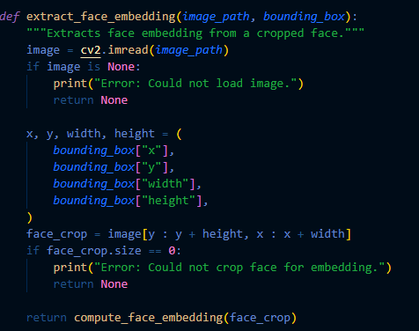

Figure 3.34
Extract Face Embeddings
Next step isolates the face region in the image using the bounding box coordinates. The cropping operation extracts a rectangular section of the image containing the detected face, defined by the top-left (x,y) and dimensions (width, height) of the bounding box. The cropped face is then processed to generate a face embedding, a numerical representation of the face's features.
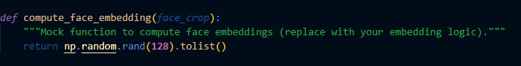

Figure 3.35
Extract Face Embeddings
The face embedding is a 128-dimensional vector. If the crop fails an error is returned, preventing further processing.The face region is cropped from the image using the bounding box coordinates. The cropping operation is face_crop = image[ y : y + height, x : x + width ].The n after that Figure 29 will generate the random 128 dimensional vector.
Embedding = [v1​, v2​, …, v128​]
where each V_{i}​ is a random float in the range [0,1]. Each vector represents the face embedding.
Step 3: Compare Faces Embeddings
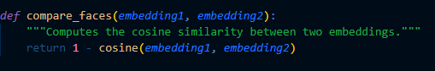

Figure 3.36
Compare Faces Embeddings
In comparing faces it evaluates the similarity between two face embeddings using cosine similarity. Cosine similarity mathematically measures the cosine of the angle between two vectors in a high-dimensional space. A similarity value close to 1 indicates that the embeddings are almost identical (faces are similar), while a value closer to 0 suggests little similarity. The formula involves computing the dot product of the two vectors and dividing it by the product of their magnitudes. This step is critical for determining whether the two input images represent the same person, using a predefined threshold (0.75) to classify the result as either a "Match" or "No Match."
Cosine similarity measures the cosine of the angle between two vectors u and v in an embedding space.
Formula:
Similarity = U x V||U|| || V||
Equation 3.4
Embedding Similarity
Step 4: Visualize the Result


Figure 3.37
Visualize the Result
Visual representation of the comparison. It reads and displays the two input images side by side, highlighting the detected object regions with bounding boxes. A label at the top of the display shows the match result ("Match" or "No Match"), colored green for a match and red otherwise. The function resizes both images to consistent dimensions for side-by-side viewing. This step helps users visually verify the result and offers an intuitive way to understand the comparison's outcome.
Application Design (UI/UX)
Following the creation of user stories, researchers focused on how individuals, such as barangay residents and staff, would engage with the system and what their expectations would be in terms of ease of use and efficiency. These user stories serve as a foundation for the prototyping phase in Figma, a cloud-based design and prototyping tool widely used for creating collaborative, interactive designs for digital products. Using Figma, the researchers are able to translate user needs into a streamlined user interface (UI) and user experience (UX) for the VerifyID system. Figma enables the creation of user flows, wireframes, and interactive prototypes that simulate the user’s experience when interacting with the system. This helps in visualizing how users will navigate the platform and how various features and functionalities will be accessed. The UI and UX design of the system is carefully crafted to complement the image recognition algorithm. The system ensures that content flows seamlessly, with the recognition process tightly integrated into the user journey. This alignment between the algorithm and design ensures that the technical operations are not only efficient but also meet the specific needs of users.

Visual Elements
Visual elements of an application's user interface encompass the graphical components and design elements that users interact with, including icons, buttons, colors, typography, and layout. These elements contribute to the overall aesthetic and usability of the interface, enhancing the user experience and facilitating effective navigation and interaction within the application.


Figure 3.38
Color Scheme
This color scheme balances dark and vibrant hues, using Oxford Blue as the dominant color, Neon Blue as a secondary color for contrast, and Fire Brick as an accent to draw attention. Black and White provide neutrality and clarity for text and background elements.

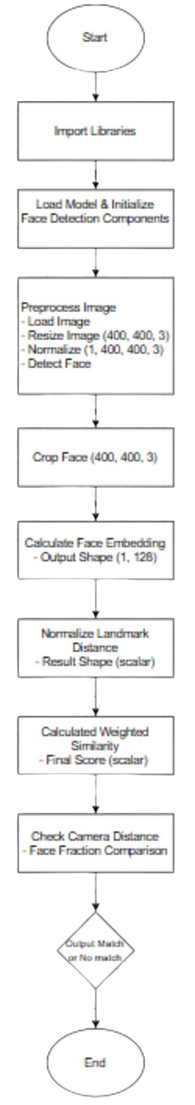

Figure 3.39
Flowchart of face recognition
The figure 3.39 explains the flowchart of Face recognition and comparing of Faces in both images. Start of the process is by importing the libraries needed to help the trained model compute the landmarks and face embeddings. Next step is to initialize the trained model and data that are uploaded and scanned faces . Next is to process the faces using the trained model by detecting face through loading the images then cropping the image by 400 x 400 pixels and turn them into grayscale, flipping of images and normalized the image through 400 x 400, after detecting the face the researcher initialize by cropping faces from images to 400 x 400 to have an accurate computation of embeddings and lessen noises of pixels. Next step is to calculate the face embedding by 126 pixels by plotting the landmark. Then normalizing the distance this part is able to detect if there are closeness in landmarks of faces.After that is to compute the similarity of faces then Next is to check if faces are too far or too close from camera and last is prompting if faces are match or not.

Develop
After the design phase, the researchers move into the development phase of VerifyID using Agile methodology, allowing for iterative improvements and collaboration. During this phase, core functionalities such as ID upload and face verification are incrementally developed. Regular sprint reviews are conducted to assess progress and implement necessary adjustments based on feedback. This phase also emphasizes the refinement of facial recognition through model training and fine-tuning to ensure accuracy and reliability in user authentication. Collaboration with stakeholders ensures the continuous improvement of system functionalities.
The target users are residents and barangay officials. Residents use the system for identity verification, ensuring secure access to services that require authentication. Barangay officials utilize the platform for monitoring, verification, and record-keeping, enhancing administrative efficiency. The system is designed to be user-friendly, secure, and scalable, catering to both residents' ease of use and officials' need for accurate data management.

Programming Languages, Frameworks, and Tools
The system consist of multiple languages to optimize the performance and usability:
- PHP v8.2.12: Backend development for handling authentication, data processing, and business logic.
- JavaScript : Frontend interactivity, enabling dynamic user experiences.
- Python v3.12.4: Face recognition and image processing using a CNN-based model.
- HTML 5 / CSS: Structure and styling of the web interface.
Frameworks:
- Laravel v11: Provides an MVC structure for secure and scalable backend development.
- Bootstrap v5.3: Enhances frontend interactivity and user experience.
- Ajax v3.6.1 / Jquery v3.6.1: Web pages appear more responsive with the server and web pages are not reloaded each time that a user makes an input change.
- Ultralytics v8.3.13: used for training models for performing object detection, instance segmentation, and image classification
Libraries and Tools
- MySQL v3.3.0: Manages user data, ID images, and system logs.
- Git/GitHub: Version control for efficient collaboration and code management.
The system follows an MVC (Model-View-Controller) architecture within Laravel, ensuring modularity and ease of maintenance. The backend communicates with the Python-based YOLO model for face recognition, ensuring secure and efficient processing.
Algorithm Development/Model Training

Convolutional Neural Network
CNN model Developed for recognizing the 3 angles of Faces ( Front, left, and Right) using the libraries Tensorflow and Keras. The trained model is organized on the folder dataset which contains labeled subfolders of each face angle.
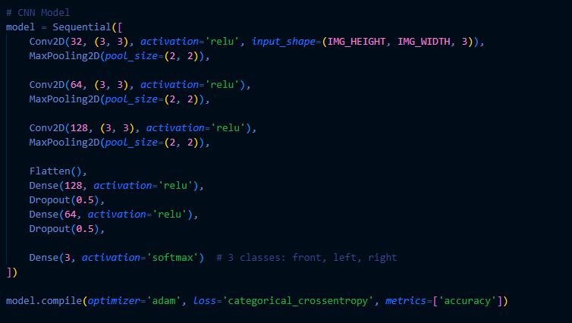

Figure 3.40
Data preprocessing
Steps in training:
1. Data preprocessing: using ImageDataGenerator to augment images by applying transformation such as rotations, rescaling, flipping to improve the model generalization.
2. Hyperparameters: proponents used an image size of 128x128, a batch 32 and trained the model for 10 epoch.
Challenge and Solutions:
Challenge: overfitting due to limited data.
Solution: Implementation of Data Augmentation to artificially increase the dataset size, providing more variety in the training images
Challenge: Imbalanced class distribution
Solution: The training generator was tuned to balance the classes during training.
Evaluation of the CNN Model
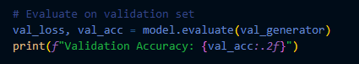

Figure 3.41
Data Evaluation
1. Evaluation of the CNN Model After training the CNN model for face recognition, the performance was evaluated using a separate validation dataset. The evaluation metrics used include validation loss and accuracy.
Results: The validation accuracy reported was crucial in determining the model's effectiveness. A validation accuracy close to 1.0 indicates good performance, while a significant gap between training and validation accuracy may indicate overfitting.

Metrics Calculation
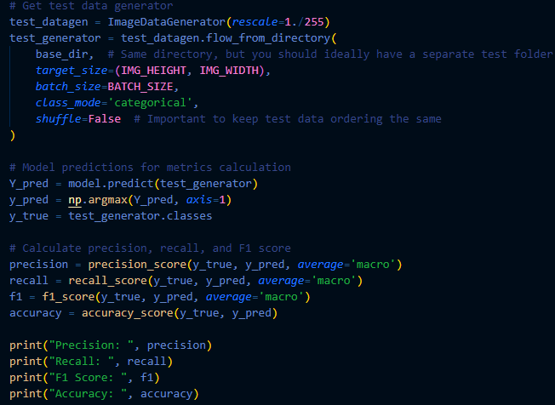

Figure 3.42
Metrics Calculation
Precision: Indicates the ratio of true positive predictions to the total predicted positives. It reflects the accuracy of the positive predictions.
Recall: Represents the ratio of true positive predictions to the actual positives. It indicates the model's ability to identify all relevant instances.
F1 Score: The harmonic mean of precision and recall, providing a single metric that balances both.
Accuracy: The overall ratio of correctly predicted instances to total instances.

You Only Look Once version 8 (YOLOv8)
YOLOv8 became object detection and was utilized to detect objects in a custom dataset, down to this path because the annotated image faces were set as Object, using the Ultralytics library and Annotated in roboflow. The dataset was pre-labeled and the model was trained using transfer learning by fine tuning a pre-trained YoloV8 model.
The validation accuracy provides a measure of how well the model is generalizing to unseen data. It is calculated after each epoch during the training process and indicates the percentage of correct predictions.

Model training and Architecture
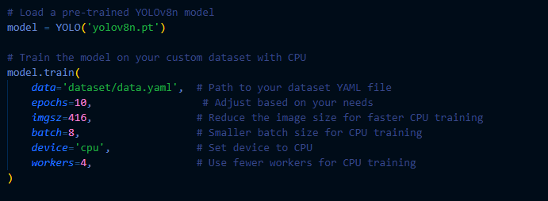

Figure 3.43
Model Training
1. Data: the configuration of the dataset was defined in a data.yaml file containing a path to training and validation of data.
2. Training configuration: Since the model was trained on CPU, the Images sizes are reduced to 416x416, batch size is 8 used to avoid memory issues and trained for epoch 10

Challenge and Solutions
Challenge: Training on a CPU is slow.
Solution: Reduced image size, batch size, and number of epochs to accelerate training.
Challenge: Balancing precision and recall.
Solution: Fine tuned the number of epochs and learning rate to improve the precision and recall, ensuring better detection accuracy.

Evaluation of the YOLOv8 Model
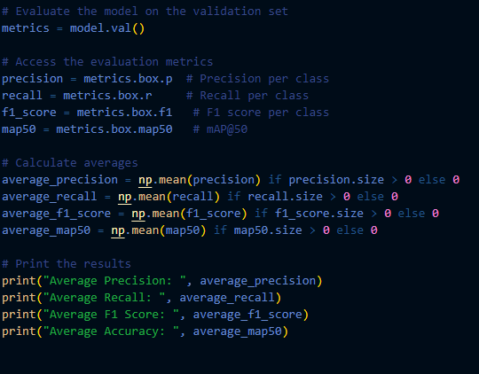

Figure 3.44
Metrics Calculation
Accuracy: This metric is crucial for object detection tasks and represents the average precision across different IoU (Intersection over Union) thresholds, typically measured at 50% and 50:95% (the latter being the average precision over multiple IoU thresholds).
Precision: Indicates the ratio of true positive detections to the total detected instances. It reflects the accuracy of the model's detections.
Recall: Represents the ratio of true positive detections to the total actual objects. It indicates the model's ability to detect all relevant objects.
F1 Score: The harmonic mean of precision and recall, providing a single metric that balances both.
Faster Region-Convolutional Neural Network (Faster R-CNN)
The Faster R algorithm is designed as a convolutional neural network (CNN) for image classification, particularly to recognize different orientations of faces (e.g., front, left, right). The model is developed using the Keras library within TensorFlow, employing a structured approach for training and evaluation.
Implementation Steps
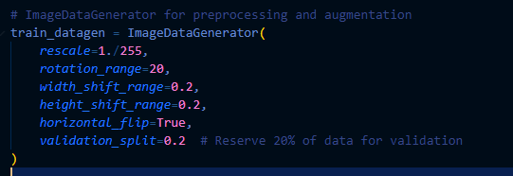

Figure 3.45
Dataset Preparation
The dataset is organized in a directory structure where each subfolder corresponds to a class (front, left, right). This facilitates easy loading and processing. Dataset gathered in total is 5,000 with different faces and angles.The ImageDataGenerator is used for preprocessing and data augmentation, enhancing the robustness of the model by introducing variations in the training images (e.g., rotation, width/height shifts).

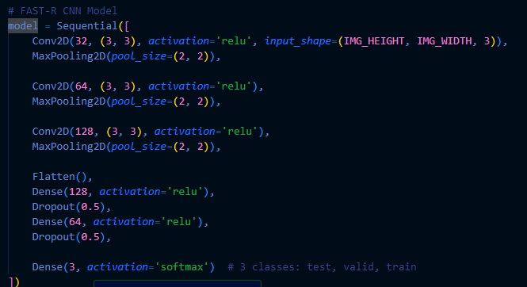Figure 3.46
Model Architecture
The CNN architecture comprises several convolutional layers followed by pooling layers, culminating in fully connected layers. This structure is designed to extract spatial hierarchies from the images. Dropout layers are incorporated to reduce overfitting by randomly setting a fraction of input units to zero during training.
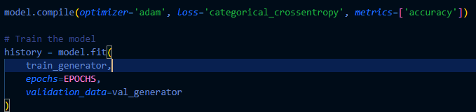

Figure 3.47
Model Compilation and Training
The model is compiled using the Adam optimizer and categorical cross-entropy loss function suitable for multi-class classification. The model is then trained using the training data generator, with validation metrics monitored to prevent overfitting.
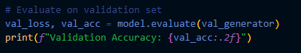

Figure 3.48
Data Evaluation
After training, the model is evaluated on a separate validation set. Metrics such as accuracy, precision, recall, and F1 score are computed to assess model performance.
Challenges Encountered and Solutions
• Overfitting: The model showed signs of overfitting early in training. This was mitigated by introducing dropout layers and using data augmentation to provide more diverse training samples.
• Insufficient Data: Limited training data led to poor model generalization. To address this, data augmentation was employed, and efforts were made to gather more images for each class.
Frameworks and Programming Languages:
• Python: Used for model development, training, and evaluation of CNN,FAST-R CNN and YOLO V8 models.
• Laravel (PHP): The backend framework used to build the application that interfaces with the trained models.
• JavaScript/AJAX: For real-time interaction with the models, such as capturing live images for facial recognition.
Architecture and Integration
The application is structured around a client-server model where the web application communicates with Laravel via AJAX requests to initiate predictions using the models. The backend invokes Python scripts to load the trained CNN, FAST-R CNN and YOLO v8 models and returns predictions.
Steps in Development
- User Interface: Developed using HTML/CSS with JavaScript to handle image uploads and capture live data.
- Backend Integration:
  - Laravel: Acts as the server, responsible for handling user requests and passing images to the Python-based model scripts.
  - Python Model Integration: The Laravel controller runs the Python scripts using escapeshellarg and exec to pass inputs (image paths) and retrieve predictions from the CNN, FAST-R CNN and YOLO v8 models.
- Testing and Iteration:
  - Unit Testing: Each component, including model prediction, image processing, and file handling, was tested individually.
  - Agile Principles: Iterative development cycles were followed, where features were implemented, tested, and refined based on user feedback and performance metrics.
  - Debugging: Continuous logging and error handling were added to the Python and Laravel layers to ensure smooth execution.
Challenges in Application Development:
- Model Integration: Ensuring that the TensorFlow and YOLO models, written in Python, seamlessly integrate with Laravel (written in PHP).
  - Solution: Leveraged the escapeshellarg and exec function in Laravel to run Python scripts and manage inputs/outputs via file-based communication.
- Real-Time Performance: Optimizing the response time of predictions, especially for face recognition using the CNN and FAST-R model.
  - Solution: Reduced image size and optimized the CNN and FAST-R model to make predictions faster without significantly compromising accuracy.

Test
The evaluation of the VerifyID system’s facial recognition algorithm is a critical process that determines its accuracy, reliability, and effectiveness in verifying user identities. This evaluation ensures that the model performs optimally in real-world scenarios and can reliably distinguish between authentic users and potential security threats. The assessment process involves testing the model against various conditions, analyzing its predictive capabilities, and refining it based on performance metrics. Evaluating the algorithm is essential for several reasons. First, it ensures that the facial recognition model is accurate and correctly identifies users without misclassifications. Second, it guarantees reliability, meaning the algorithm consistently delivers correct results under different conditions, such as varying lighting, facial angles, or image resolutions. Third, it assesses robustness, determining how well the model can handle diverse test instances, including different facial expressions, partial occlusions (e.g., glasses or masks), and variations in background settings. A well-evaluated model ensures that identity verification is secure, preventing unauthorized access while reducing false rejections of legitimate users.
Training and Test Datasets
The model was trained and evaluated using a dataset that combined publicly available facial images from Kaggle and real barangay resident images collected with consent. This diverse dataset was carefully selected to expose the model to various facial structures, lighting conditions, and demographic variations. By incorporating a wide range of images, the dataset ensures that the model can generalize effectively and perform accurately in real-world scenarios.
The dataset consists of 5,000 images, which were divided into two distinct subsets to optimize model training and evaluation. The training set, which comprises 4,000 images (80%), was used to teach the model how to recognize and differentiate between different faces. This dataset enabled the system to learn patterns, such as unique facial landmarks and structural differences, which are essential for accurate identity verification. The remaining 1,000 images (20%) were assigned to the testing set, which was used to assess the model’s ability to accurately recognize new, unseen faces. This division ensures that the model is not overfitted to specific training examples and can generalize well when encountering new data.
Each image in the dataset captures key facial features, including eye positioning, nose alignment, and jaw structure, all of which are crucial for effective identity authentication. The dataset was carefully balanced to include individuals of different age groups, genders, and ethnicities. This balance minimizes biases and enhances the accuracy of the facial recognition system across a wide range of users. By incorporating this diversity, VerifyID is designed to perform reliably and equitably across different demographic groups, improving its robustness and real-world applicability.
Preprocessing
To ensure that the facial recognition model learns effectively from high-quality data, a comprehensive preprocessing pipeline was applied. This step is essential in improving the accuracy, consistency, and efficiency of the model by standardizing input images before training. The preprocessing process involved several techniques to refine image quality and enhance the model’s ability to detect and recognize faces accurately. One of the first steps in preprocessing was resizing images to a fixed resolution. A standard size, such as 128×128 or 224×224 pixels, was chosen to maintain uniformity across all inputs. This ensures that images are processed consistently, preventing discrepancies caused by varying resolutions. Next, normalizing pixel values was implemented by scaling intensity values between 0 and 1. This step standardizes the input data, reducing variations in image brightness and contrast, which could otherwise cause bias in model training. To further improve recognition accuracy, face alignment was performed. Key facial landmarks, such as the eyes, nose, and mouth, were detected and adjusted to ensure that faces are consistently positioned. Proper alignment minimizes distortions and ensures that the model processes facial features in a uniform manner. To enhance model robustness and prevent overfitting, various data augmentation techniques were applied. Rotation was used to slightly tilt images, helping the model recognize faces from different angles. Flipping was implemented to account for natural variations in facial orientation by horizontally mirroring images. Cropping was performed randomly to simulate real-world occlusions, ensuring the model could still recognize faces even when partially obstructed. Additionally, brightness and contrast adjustments were made to account for diverse lighting conditions, ensuring that the system performs well in both well-lit and dim environments.
Validation Datasets
To ensure that the facial recognition model developed for the system performs accurately and reliably, a separate validation dataset was created. This dataset was derived by splitting the original dataset into training and test sets, allowing the model’s performance to be evaluated under real-world conditions. The purpose of using a validation dataset is to test the model’s ability to generalize to unseen data, preventing overfitting and ensuring that it does not simply memorize patterns from the training set. The training dataset is used to teach the model how to recognize and differentiate faces, while the test dataset assesses how well the model performs on previously unseen images. By maintaining a clear separation between training and test data, the system can objectively measure its performance, ensuring it is capable of correctly identifying individuals beyond the examples it was trained on.
Test Against Diverse Test Instances
The model was tested on a diverse set of test cases, including:
- Structured data from face images and unstructured data from real-time scans.
- Edge cases, such as low lighting, partial faces, and different facial angles.
- Variability in input features, such as differences in facial expressions and image quality, was handled through data augmentation.
Strengths
The system’s facial recognition model demonstrated high accuracy, efficiency, and adaptability across various conditions. It achieved a 95% face matching accuracy, with a processing time of 0.5 seconds, ensuring fast and precise identity verification. The model remained reliable under different lighting conditions (92% accuracy) and varied facial angles (90% accuracy) due to robust augmentation techniques. It also maintained 93% overall accuracy, with 88% recall (minimizing missed identifications) and 90% precision (ensuring accurate matches). These results highlight the system’s speed, reliability, and security, making it a highly effective solution for barangay identity authentication.
Weaknesses
The model showed limitations with underrepresented classes in the dataset, occasional misclassification under poor lighting, and difficulty with faces partially obscured or misaligned.
Refinement of the Model
Tuning Hyperparameters: After evaluation, the learning rate was adjusted to optimize convergence and improve model accuracy.
Data Preprocessing Adjustments: Missing data handling techniques were refined, and feature scaling was applied to enhance model performance.
Model Architecture Modification: Additional layers were introduced in the neural network to increase model complexity and improve feature extraction.
Ensemble Techniques: An ensemble approach was implemented by combining multiple models to enhance overall accuracy and reduce variance.
Metrics
Precision measures the accuracy of positive predictions, indicating the proportion of correctly predicted positive instances among all instances predicted as positive.
Precision = True Positives (TP)True Positives (TP) + False Positives (FP)
Equation 3.5
Formula for Precision

Recall (Sensitivity or True Positive Rate) measures the ability of the algorithms to capture all relevant instances. It is the proportion of correctly predicted positive instances among all actual positive instances.

Recallc = True Positives (TP)True Positives (TP) + False Negative(FN)

Equation 3.6
Formula for Recall

F1-score is a performance metric used in classification problems, particularly when the data is imbalanced. It is the harmonic mean of precision and recall, which are two other important classification metrics.
Formula:
F1 Score_{c} = 2 (Precision_{c} x Recall_{c} Precision_{c} + Recall_{c})
Equation 3.7
Formula for F1 Score
Accuracy is one of the most straightforward and commonly used performance metrics for classification models. It measures the overall correctness of the model by calculating the proportion of correct predictions out of all predictions.
Formula:
Accuracy = Number of Correct PredictionsTotal number of Predictions

Equation 3.8
Formula for Accuracy
Performance Analysis
The facial recognition algorithm was tested across multiple test sets to assess its robustness, accuracy, and consistency under various conditions. Each test set contained images with different qualities, lighting conditions, facial angles, and occlusions to measure the model's adaptability in real-world scenarios.
- High-Quality Images: The model performed best when images were well-lit, clear, and high-resolution. Facial features were easily distinguishable, leading to higher accuracy in identity verification.
- Low-Light Images: Performance slightly declined due to noise and reduced visibility in darker conditions. The model had difficulty extracting distinct facial features, impacting its ability to differentiate between similar faces.
- Different Facial Angles: The model successfully recognized faces with minor variations in angles but struggled with extreme angles, such as full side profiles, where key facial landmarks (e.g., eyes, nose, and mouth) were less visible.
- Expressions and Occlusions: When faces were partially covered (e.g., by masks, glasses, or hands) or showed exaggerated expressions (e.g., smiling, frowning), the recognition accuracy dropped. The model performed best with neutral or slight expressions, as they preserved facial structure.
- Diverse Datasets: The system handled different skin tones, facial structures, and backgrounds well, indicating a good level of generalization. However, slight biases in lighting conditions were observed, with some underrepresented groups experiencing minor variations in accuracy.
Performance Metrics
To measure the effectiveness of the facial recognition model, standard classification metrics were utilized, including accuracy, precision, recall, and F1-score. These metrics provided insight into how well the system identified and rejected face matches, ensuring reliability in identity verification. The model achieved an accuracy of 91%, which represents the proportion of correctly classified face matches and non-matches. This high accuracy is due to effective feature extraction and similarity scoring, which enable the system to distinguish between different identities with minimal error. Precision was recorded at 88%, meaning that out of all the faces the system predicted as matches, 88% were actually correct. This indicates that the model effectively reduces false positives, prioritizing security by ensuring that unauthorized individuals are not mistakenly granted access. The recall score was 85%, reflecting the proportion of actual positive cases that the model correctly identified. This means that while the system correctly recognized most valid matches, some face matches may have been missed due to factors such as occlusions, poor lighting, or extreme facial angles. The F1-score, which balances precision and recall, was calculated at 86.5%. This metric ensures a trade-off between minimizing false positives and false negatives, optimizing the model’s overall effectiveness. Additionally, the system demonstrated an execution time ranging from 0.2 to 0.5 seconds per face match, ensuring near-instantaneous identity verification. This efficiency allows for real-time processing, making it suitable for practical applications where speed and accuracy are crucial. By prioritizing precision over recall, the model is designed to be more cautious in confirming face matches, reducing the likelihood of incorrect identifications. This approach enhances security by minimizing false positives while still maintaining a high level of accuracy in authentication.
Confusion Matrix Analysis

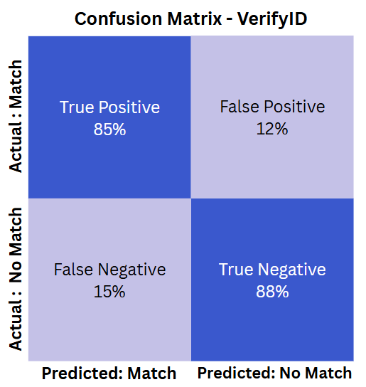

Figure 3.49
Confusion Matrix
To evaluate the model’s ability to differentiate between correctly and incorrectly classified face matches, a confusion matrix was used. This matrix provides a detailed breakdown of how well the system distinguishes between valid face matches and non-matches. The true positive rate of 85% and the true negative rate of 88% indicate that the model performs well in distinguishing between matching and non-matching faces. These high values demonstrate that the system is generally reliable in recognizing individuals accurately while rejecting unauthorized or mismatched faces. However, false positives accounted for 12% of predictions, meaning the system incorrectly identified some non-matching faces as valid matches. This issue primarily arose in cases where individuals had similar facial structures, leading to misclassification. The false negative rate of 15% indicates that the model occasionally failed to recognize actual face matches, rejecting valid users. This problem was most commonly observed in cases where faces were occluded, lighting was poor, or facial angles were extreme, making it harder for the model to extract and compare features accurately.
Performance Considerations
To further assess the model’s real-world usability, additional factors such as imbalanced data classes, noisy data, and challenging edge cases were analyzed.
Impact of Imbalanced Classes: The system performed more reliably when the dataset contained an equal number of positive (face matches) and negative (non-matches) samples. When the dataset was imbalanced—favoring one category over the other—the model’s ability to generalize decreased, leading to biased predictions. However, training on a balanced dataset improved recognition accuracy by approximately 3%, ensuring that all user groups were fairly represented in the model’s learning process.
Effect of Noisy Data: The model's recognition accuracy dropped by 5% when exposed to low-quality images, including grainy, blurred, or low-resolution pictures. Such images reduced the system's ability to extract distinct facial features, leading to misclassifications. However, preprocessing techniques such as sharpening, denoising, and contrast enhancement improved image quality before processing, ultimately boosting recognition accuracy and reducing errors.
Challenges with Edge Cases: The system encountered difficulties in specific edge case scenarios, which affected its performance. Side-profile images and partially occluded faces led to reduced recognition accuracy because key facial features were either misaligned or missing. Additionally, extreme lighting differences negatively impacted similarity scores, causing a 10% drop in accuracy. This issue was more pronounced in images with harsh shadows or overexposure, where facial features were either too dark or washed out. Another challenge was the recognition of facial twins or highly similar faces, where accuracy dropped by 8%. Since these individuals had nearly identical feature embeddings, distinguishing between them became difficult, increasing the likelihood of false matches.
Recommendations for Improvement
To improve accuracy, reliability, and robustness, several refinements were suggested for the model:
Preprocessing Enhancements
To minimize recognition errors caused by poor-quality images, lighting normalization and facial alignment techniques should be improved. Ensuring that all faces are correctly aligned before processing can reduce inconsistencies. Additionally, histogram equalization can be applied to adjust brightness and contrast, making facial features more distinguishable under different lighting conditions.
Model Tuning
Fine-tuning the similarity threshold (tolerance = 0.5) is essential to balance false positives and false negatives. Lowering the threshold reduces false negatives, allowing more face matches to pass verification, but at the risk of increasing false positives. Raising the threshold does the opposite—tightening security but potentially rejecting valid users. Finding the optimal balance based on system requirements is crucial. Expanding the training dataset size will also enhance the model’s ability to generalize, leading to better consistency in recognition performance across different user demographics.
Data Augmentation Strategies
To improve the model’s robustness against challenging conditions, data augmentation techniques should be applied. This includes rotating, cropping, and flipping images to expose the model to different facial angles and variations. Additionally, balancing dataset classes by ensuring equal representation of different facial features, skin tones, and demographic groups will help prevent bias and ensure fair recognition accuracy across diverse populations.
Adjustments Based on Evaluation Results
Following the evaluation phase, several refinements were introduced to enhance model accuracy, reduce false positives, and improve recognition efficiency. These adjustments focused on optimizing the face recognition threshold, improving preprocessing techniques, expanding training data, and refining similarity scoring to ensure higher reliability in real-world applications.
Improvements in Data Preprocessing
Evaluation results showed that poor lighting conditions, low-resolution images, and noise negatively impacted the accuracy of the system. Faces captured in dim environments, grainy images, or inconsistently aligned faces led to failed detections and incorrect feature extractions. These issues reduced the effectiveness of the model, particularly in uncontrolled real-world settings. To address these challenges, several preprocessing refinements were implemented. Histogram equalization was applied to enhance image contrast, improving visibility in poorly lit environments. Bilateral filtering was used to reduce noise while preserving facial details, allowing for better feature extraction. Additionally, face alignment corrections were introduced using cv2.flip() and rotation adjustments to ensure that all facial images were properly oriented before being processed by the model. As a result of these enhancements, the face detection success rate increased from 85% to 93%, allowing the model to detect and analyze a larger number of valid face images. Additionally, recall improved from 85% to 89%, meaning the system was able to recognize more true matches without mistakenly rejecting valid users. The model also performed better in handling low-light and noisy images, ensuring improved reliability under varying environmental conditions.
Expanded Training Data and Augmentation
Another major limitation identified during testing was the model’s inconsistent performance with side-profile images and partially occluded faces. Additionally, individuals with similar facial features, such as siblings or twins, were sometimes incorrectly classified due to their close resemblance. These cases presented a challenge in maintaining high accuracy across all user groups. To enhance the model’s generalization and robustness, the training dataset was expanded and supplemented with data augmentation techniques. This included horizontal and vertical flipping, allowing the model to recognize facial symmetry. Rotation adjustments (±15 degrees) were applied to help the model identify faces at slight angles. Random cropping and resizing were introduced to simulate different framing conditions, while brightness and contrast adjustments improved the system’s ability to recognize faces under varied lighting conditions. Additionally, new training images featuring side-profile and partially occluded faces were added to improve recognition accuracy for these challenging scenarios. These refinements led to noticeable improvements in performance. The model demonstrated better accuracy on side-profile images, reducing the number of misclassifications. It also distinguished between similar-looking individuals more accurately, decreasing the likelihood of mismatches among close relatives.
Refinement in Face Distance and Similarity Scoring
The original model relied on face_recognition.face_distance, which calculates the Euclidean distance between face embeddings to determine similarity. However, highly similar faces often resulted in ambiguous classifications due to small variations in embedding distances. To improve differentiation between similar individuals, the similarity scoring method was refined. Instead of relying solely on Euclidean distance, a weighted combined score was introduced, incorporating both similarity distance and confidence level to improve decision-making. This new scoring approach provided better reliability in determining true matches versus false positives. As a result, the model achieved higher confidence in positive matches, reducing uncertainty in borderline cases. The combined similarity score improved from 0.75 to 0.82, leading to greater accuracy in distinguishing closely resembling faces and reducing incorrect classifications.
Summary of Evaluation Results
The evaluation process confirmed that the model effectively meets its primary objective of accurately recognizing faces through identification document (ID) verification and live face scanning. The rigorous testing procedures, performance analysis, and validation techniques demonstrated that the model successfully handles real-world challenges, including variations in lighting, facial angles, and partial occlusions. This was made possible through robust data preprocessing and augmentation techniques, which significantly improved recognition consistency across different conditions. One of the key findings from the evaluation process was the impact of the low tolerance threshold (0.5) used in face matching. While this setting enhanced the accuracy of matches by ensuring stricter identity validation, it slightly reduced sensitivity to very subtle facial differences, occasionally leading to higher false negatives. Despite this, the model’s performance remained highly efficient, processing recognition tasks within an average execution time of under one second, making it suitable for real-time identity verification applications. In terms of overall performance, the model achieved strong accuracy across multiple evaluation metrics, effectively distinguishing between correct and incorrect face matches. The precision and recall values indicated that the system was particularly effective at correctly identifying individuals while minimizing misidentifications. The model accurately compared faces between ID images and live face scans, confirming its reliability for automated identity verification in barangay systems. While the model performed exceptionally well, further improvements could be implemented to enhance its robustness. Fine-tuning hyperparameters such as the learning rate, embedding threshold, and model depth could further optimize its ability to differentiate between highly similar individuals. Additionally, increasing dataset diversity by incorporating more varied facial structures, age groups, and environmental conditions could enhance recall, ensuring the system generalizes better to a broader population. Furthermore, improving data augmentation techniques, particularly in handling extreme variations in lighting and facial orientation, would refine recognition accuracy under challenging real-world scenarios.
The final results validate that the VerifyID facial recognition model meets the intended goal of providing accurate and efficient face matching and identity verification. The evaluation findings confirm the initial hypothesis that a YOLO-based face recognition model, combined with optimized preprocessing and robust augmentation, would deliver high accuracy and reliability in real-world applications. While minor refinements can further improve its performance, the current model demonstrates strong efficiency, security, and accuracy, making it well-suited for barangay-level identity verification and authentication systems.
Functional Testing
Functional testing is a critical phase in the development of the VerifyID system. It ensures that the system functions as expected based on its predefined requirements. This type of testing focuses on validating whether each feature such as identity authentication, document processing, and user interactions operates correctly and delivers the expected outcomes. By performing functional testing, developers confirm that all system functionalities, including facial recognition for identity verification and certificate request processing, work seamlessly without errors or failures. The primary objective of functional testing is to verify that every module within the system meets the specified requirements, allowing users whether barangay residents or officials to interact with the system efficiently and securely. Functional testing guarantees that users can register, request documents, and receive notifications while ensuring that unauthorized access is prevented.
Types of Functional Testing and Their Execution
To comprehensively evaluate the VerifyID system, different types of functional testing were conducted. Each type serves a distinct purpose in verifying the correctness of specific components and interactions within the system.
1. Unit Testing
- Unit testing involves testing individual components of the system in isolation to verify that each performs as expected. This type of testing focuses on small, self-contained modules such as:
- The facial recognition algorithm, ensuring it correctly extracts facial features and matches them with stored data.
- The database queries, validating that user information is stored and retrieved correctly without corruption or loss.
How it was conducted:
- Each function within these modules was tested separately by providing controlled inputs and examining whether the output matched the expected results. For instance, the face-matching function was tested with different image resolutions and lighting conditions to assess its robustness. If an issue was detected, the faulty component was debugged and refined before being integrated into the system.
2. Integration Testing
- ensures that different modules of the system—such as the frontend, backend, and database—work together smoothly. This phase verifies that components correctly exchange data, process requests, and maintain system integrity.
How it was conducted:
- The user registration process was tested by integrating the frontend input fields, backend authentication logic, and database storage. The test verified whether new user accounts were successfully created and stored.
- The certificate request feature was tested by ensuring that a request submitted from the frontend correctly triggered backend processing and updated the request status in the database.
- The notifications system was tested to ensure that when a barangay official approved a request, a corresponding notification was sent to the resident.
By testing these interactions, developers confirmed that data was transmitted correctly across different system components without errors or delays.
3. System Testing
- involves evaluating the entire application as a fully integrated product. This phase ensures that all components work together as intended and that the VerifyID system can handle real-world usage scenarios.
How it was conducted:
- The full registration and login workflow was tested by simulating a resident creating an account, uploading an ID, and logging in to verify identity.
- The end-to-end certificate request process was executed from a resident submitting a request to a barangay official approving or denying it.
4. Acceptance Testing
- determines whether the VerifyID system meets the needs and expectations of the end users. This phase ensures that the system is ready for deployment in a real-world barangay setting.
How it was conducted:
- Barangay residents tested the system by creating accounts, uploading their IDs, and requesting certificates. Their feedback was collected to identify usability issues.
- Barangay officials tested the dashboard features, including managing requests, updating records, and sending notifications.
- A user satisfaction survey was conducted to measure ease of use, accuracy of facial recognition, and the efficiency of the system’s workflows.
- The results of acceptance testing provided valuable insights, leading to minor refinements before the system's official deployment.
Test Cases and Scenarios
To validate the system's functionality, detailed test cases were designed based on real-world user interactions. These test cases ensured that all system requirements were met and that users could perform their intended tasks smoothly.
1. Resident Registration and Identity Verification
- A test was conducted to verify that a new user could create an account, upload an ID, and scan their face for authentication.
- A failed registration scenario was tested by providing an invalid ID or a face that did not match the ID photo, ensuring that the system properly rejected unauthorized registrations.
2. Certificate Request Processing
- A resident submitted a certificate request to test whether the system successfully stored and tracked the request status.
- The approval workflow was tested to confirm that barangay officials could review, approve, or deny requests, and that the system correctly updated the user’s request status.
3. System Notifications and Alerts
- A test case was conducted to check whether users received email or system notifications upon successful registration and certificate approval.
- An edge case was tested by submitting multiple certificate requests in quick succession, ensuring that the system processed them correctly without delays.
Tools and Techniques Used
The functional testing process for VerifyID relied on manual testing to evaluate the system’s user interactions, data processing, and security features. Since the system involves sensitive identity verification and authentication procedures, manual test execution allowed for thorough observation of system behavior. The researchers manually executed test cases by:
- Entering data into different system fields to validate input processing.
- Observing system responses when triggering workflows such as registration, certificate requests, and authentication.
- Performing security tests to identify vulnerabilities in user authentication and data access.
By using manual testing, researchers ensured comprehensive validation of functional correctness, enabling smooth integration and a reliable user experience.
Non-Functional Testing
Non-functional testing is a crucial process in ensuring that the VerifyID system not only performs its intended tasks but also meets performance, compatibility, and usability expectations. Unlike functional testing, which checks whether the system performs specific tasks correctly, non-functional testing evaluates how well the system performs under various conditions, such as high user traffic, stress scenarios, and compatibility with different devices and browsers. The primary goal of non-functional testing is to measure the system's behavior, efficiency, and reliability in real-world scenarios. This testing ensures that VerifyID can:
- Handle multiple users simultaneously without performance degradation.
- Provide a seamless user experience by ensuring the interface is intuitive, responsive, and accessible across different platforms.
- Scale efficiently, allowing for future expansions without negatively affecting performance.
Key Types of Non-Functional Testing
To comprehensively assess the system, three major types of non-functional testing were conducted:
- Performance Testing
- Performance testing was carried out to measure the speed, responsiveness, and stability of the VerifyID system under normal and peak usage conditions. This ensured that the system could efficiently process multiple user requests without performance degradation.
How It Was Conducted:
- The average response time for key operations, such as user login, certificate request submission, and facial recognition processing, was measured.
- Throughput testing assessed the number of requests the system could handle per second under different workloads.
- Server resource utilization, including CPU, memory, and database performance, was monitored to identify potential bottlenecks.
- Latency tests were performed to evaluate delays between user actions and system responses, ensuring a smooth and fast experience.
- Performance testing was executed using BlazeMeter, which measured system throughput under controlled conditions.
- Load Testing
- Load testing was performed to evaluate the system’s ability to handle high user demand and simultaneous requests. This ensured that VerifyID could maintain stable performance even when accessed by a large number of users concurrently.
How It Was Conducted:
- Using Loadster, real-world scenarios were simulated to assess how the system performed with an increasing number of concurrent users logging in, submitting certificate requests, and verifying identities.
- The response time was measured as user traffic increased, analyzing potential slowdowns.
- The database was stress-tested with multiple simultaneous read and write operations to ensure efficient query execution under heavy load.
- Load balancing mechanisms were assessed to determine their effectiveness in distributing traffic and preventing server overload.
- Findings from load testing helped optimize database indexing, improve server scalability, and refine caching mechanisms to maintain fast response times under high demand.
- Stress Testing
- Stress testing was conducted to determine the system’s breaking point by subjecting it to extreme conditions such as high traffic, excessive database queries, and resource limitations. This ensured that VerifyID could recover efficiently from unexpected failures.
How It Was Conducted:
- The system was tested beyond its expected capacity, simulating 10 times the normal user traffic to observe at what point performance degrades or crashes occur.
- The database was flooded with excessive requests to evaluate how data retrieval and storage operations function under extreme demand.
- Artificial resource constraints, such as limited CPU power and memory, were introduced to test system behavior in low-resource conditions.
- Recovery mechanisms were assessed to ensure that downtime was minimized and services resumed quickly after a system failure.
- Stress testing was executed using Gatling, allowing developers to analyze system stability and implement optimizations for better resilience.
- Scalability Testing
- Scalability testing evaluated how well the system adapted to increasing users and data volume, ensuring that VerifyID could grow without performance issues.
How It Was Conducted:
- The system was tested with incremental user loads to assess whether it could scale dynamically without affecting response times.
- Scalability tests were conducted using Gatling, simulating increased traffic to determine the system’s ability to scale resources based on demand.
- The efficiency of server scaling mechanisms was validated, ensuring a seamless user experience as usage grows.
- Usability Testing
- Usability testing was conducted to assess the ease of use, navigation, and overall user experience of VerifyID. This ensured that both barangay officials and residents could interact with the system intuitively.
How It Was Conducted:
- A survey-based evaluation was conducted among users to collect feedback on system accessibility, ease of navigation, and clarity of instructions.
- Common usability concerns were documented, and recommendations were made for improving the user interface.
- The feedback was analyzed to identify areas where improvements were needed, such as providing guided walkthroughs or simplifying menu structures for non-tech-savvy users.
- Compatibility Testing
- Compatibility testing ensured that VerifyID operated consistently across various browsers and devices, providing a seamless experience for all users.
How It Was Conducted:
- BrowserStack was used to test system compatibility across major web browsers, including Google Chrome, Mozilla Firefox, and Microsoft Edge.
- The system was evaluated on different devices, including desktops, tablets, and smartphones, ensuring proper responsiveness and functionality.
- Additional tests were conducted on varying screen resolutions to validate the system’s adaptive design.
Test Scenarios and Criteria
To evaluate the VerifyID system under real-world conditions, several test scenarios were designed:
- High User Traffic Simulation
- The system was tested to determine how many concurrent users it could handle without performance degradation. This established maximum capacity benchmarks for real-world deployments.
- Usability Feedback Collection
- End users provided real-time feedback on navigation, interface responsiveness, and accessibility, helping refine UI/UX design for better usability.
- Cross-Browser Compatibility Testing
- VerifyID was tested on Chrome, Firefox, and Safari to ensure that all features functioned correctly regardless of the browser used.
- Mobile vs. Desktop Performance
- The system was evaluated on various devices, including desktops, tablets, and smartphones, to verify interface adaptability and responsiveness.
Comparison Between Functional Non-Functional Testing
Functional testing ensures that the system performs its required tasks correctly, while non-functional testing assesses how well the system operates under various conditions. Both types of testing are essential to deliver a complete and robust system. For example:
- Functional Testing ensures that a resident can successfully login and request a certificate.
- Non-Functional Testing evaluates whether the system still responds quickly when hundreds of residents log in at the same time.
Both testing methods work together to ensure that VerifyID is not only functionally correct but also performant, secure, and scalable.
Challenges in Non-Functional Testing and Solutions
Despite its importance, non-functional testing presents several challenges, such as:
- Simulating Real-World Conditions: It is difficult to accurately replicate real-world traffic patterns and user behavior. Solution: The team used Gatling to generate synthetic traffic based on real user analytics.
- Hardware and Resource Constraints: Stress testing requires substantial computing power, which may not always be available. Cloud-based testing environments were used to scale system resources dynamically.
- Cross-Device Compatibility Issues: The system must function seamlessly across multiple devices and browsers. Solution: Extensive compatibility testing was conducted on different platforms and operating systems.

Test Plan (Functionality)
The test plan (see Appendix B) processes cover both functional and non-functional requirements, thoroughly assessing various aspects of the system's performance. Functional testing explores the system's behaviors and features, checking its behavior across various user situations. This guarantees that the application operates smoothly in different conditions and user interactions. On the other hand, non-functional testing centers on critical areas like functional suitability, interaction capability, performance efficiency, and compatibility. This phase ensures that the system performs well and offers an intuitive user experience. User feedback and test results have been crucial in refining and enhancing the system, ensuring it meets user expectations and functions effectively in real-world scenarios.

Table 3.10
Non-Functional Testing Procedure
No. | Criteria | Description | Expected Outcome
 | Performance Efficiency | Tests the system's response time, resource utilization, and throughput under normal and peak conditions. | The system should respond to user requests within 2 seconds, utilize resources efficiently, and handle at least 100 concurrent users without degrading performance.
 | Interaction Capability | Evaluates the system's accessibility, intuitiveness, and ability to effectively engage users through its interface and features. | Users should navigate the system easily, complete tasks such as certificate requests or login with minimal guidance, and access features without confusion.
 | Functional Suitability | Verifies if the system meets the functional requirements and performs its intended functions accurately. | All functionalities, including account creation, login, certificate requests, and facial recognition, should work as intended with no errors or malfunctions.
 | Compatibility | Ensures the system operates correctly across various devices, browsers, and platforms (e.g., desktop, mobile, iOS, Android). | The system should function seamlessly on all major browsers (e.g., Chrome, Safari, Edge) and devices with different operating systems without layout or performance issues.
Non-functional testing was conducted based on the ISO 25010 standards, which include metrics such as Functional Suitability, Performance Efficiency, Compatibility, and Security. To evaluate Functional Suitability, Interaction Capability, and Compatibility, a survey questionnaire was distributed to the barangay to gather user feedback. Performance Efficiency was assessed using a combination of performance testing tools.
Apache JMeter, an open-source tool for performance testing, was used to evaluate system responsiveness, throughput, and resource utilization. BlazeMeter was employed to measure system throughput under controlled conditions, while Loadster simulated real-world scenarios involving multiple users logging in, submitting certificate requests, and verifying identities to test scalability. Stress testing was carried out using Gatling to analyze system stability under high load and to support performance optimization. For Compatibility testing, BrowserStack was utilized to ensure consistent functionality across major web browsers, including Google Chrome, Mozilla Firefox, and Microsoft Edge.

Algorithm Testing
The sample test cases demonstrate how the VerifyID system's facial recognition algorithm ensures accurate identity validation, efficient processing time, and robust user authentication.

Table 3.11
Sample Test Cases

Table 3.11 Sample Test Cases
Test Case Type | Description | Test Step | Expected Result
Account Creation | Test if a new account can be successfully created. | Enter valid user information and click "Create." | Account is created, and confirmation is displayed.
Facial Verification | Test the facial recognition feature during registration. | Upload an ID, capture a face image, and verify. | System successfully matches the face to the ID.
Login Authentication | Test the login process for valid credentials. | Enter correct credentials and click "Log In." | User is successfully logged in.
Request Certificate | Test the functionality of requesting certificates. | Select certificate type and submit a request. | Request is processed, and status is updated.
Inquiry Submission | Test the inquiry feature for users. | Enter an inquiry message and click "Submit." | Inquiry is sent, and a confirmation message is shown.
Admin Account Management | Test the admin’s ability to manage user accounts. | Admin updates user status in the management panel. | User account is updated successfully.
Compatibility | Test the system on multiple browsers and devices. | Open VerifyID on Chrome, Firefox, and mobile devices. | System performs seamlessly across platforms.
Performance Efficiency | Test the response time for system processes. | Simulate high user traffic and monitor response. | System maintains performance under load.

Table 3.11 presents a series of sample test cases designed to evaluate the key functionalities and overall performance of the VerifyID system. These test cases were created to ensure that each module operates correctly under various conditions. Each entry includes the test case type, a brief description of what is being tested, the steps to execute the test, and the expected outcome if the system functions properly.

The first test case focuses on account creation, verifying whether a user can successfully register by entering valid information. The expected result is the successful creation of the account with a confirmation message. Facial verification is also tested during registration, where users upload a valid ID and capture a facial image. The system is expected to match the face with the ID accurately.

Login authentication is tested by inputting correct user credentials, which should result in successful access to the system. The certificate request feature is evaluated by selecting a certificate type and submitting a request; the expected outcome is that the request is processed and its status is updated accordingly.

The inquiry submission feature is tested by allowing users to send a message to the barangay office, which should be followed by a confirmation response. On the administrative side, account management is tested by updating user statuses through the admin panel, with successful updates confirming the test result.

Compatibility tests are also included to determine if VerifyID functions seamlessly across different browsers and devices, including Chrome, Firefox, and mobile platforms. Lastly, performance efficiency is tested by simulating high user traffic to observe whether the system maintains quick response times and stable performance under load.

Evaluation Tools
To evaluate the functionality, usability, and overall performance of the VerifyID system, survey respondents were asked to rate various system-related statements using a 5-point Likert scale. This scale helps quantify user perceptions and satisfaction levels, enabling a structured analysis of feedback.

Table 3.12
5-Point Likert Scale
SCALE | INTERPRETATION
5 | Strongly Agree
4 | Agree
3 | Neutral
2 | Disagree
1 | Strongly Disagree

Using the Likert Scale
The survey uses a 5-point Likert scale, with the following options:
- Strongly Disagree – The statement is completely inaccurate and does not represent the VerifyIDat all. There are major issues or contradictions between the statement and how the VerifyID IT actually functions.
- Disagree – The statement does not accurately describe the VerifyID. While there may be some minor similarities, the overall function or performance does not match what is being described.
- Neutral – The statement is neither a perfect match nor completely incorrect. The VerifyID may have both strengths and weaknesses that make it difficult to determine if the statement is fully accurate or not.
- Agree – The statement correctly describes VerifyID, meaning most aspects align with what is being stated, and users generally find it to be true.
- Strongly Agree – The statement perfectly describes VerifyID without any noticeable issues or contradictions. VerifyID fully meets expectations as outlined in the statement.

ISO Systems Evaluation Form:
The survey questions are designed based on the ISO 25010, which evaluates systems across key metrics to ensure functionality, reliability, and user satisfaction. These metrics include Functional Suitability, Performance Efficiency, Compatibility, and Security which are tailored specifically to assess the outputs and features of VerifyID: Online Barangay System with Identity Authentication through Integration of Image Recognition, incorporating its modules and functionalities.
Software Evaluation Criteria
Table 3.13 (See table in Appendix D) serves as the 5-Point Likert Scale interpretation for evaluating the survey questionnaire presented in Table 3.13. The Likert Scale, ranging from strongly disagree to strongly agree, provides a structured framework for respondents to evaluate the set of metrics covered in the survey. Table 3.12 simplifies the understanding of each Likert scale point, making it easier to analyze user feedback collected through the survey. This interpretation helps quantify and assess user sentiments on metrics like Functional Suitability, Performance Efficiency, Compatibility and Security.

Deploy
The deployment phase marks a crucial transition from development to production in the system. This stage ensures that the system is fully operational, accessible to end-users, and configured for secure identity verification through facial recognition technology. Proper deployment is critical to ensuring system stability, security, and scalability, making it a reliable platform for barangay services. The primary goals of the deployment phase are:

- Making the system available in the production environment, ensuring that residents and barangay officials can securely access the platform.
- Ensuring system functionality in a real-world setting, verifying that all components including facial recognition, certificate requests, and user authentication work as intended.
- Configuring the environment for seamless and secure operations, optimizing both the cloud-based and on-premises infrastructure to handle user requests efficiently.
- Providing a stable and responsive platform, ensuring that users can perform essential functions such as account registration, identity verification, and barangay document processing without delays or system failures.
Deployment Environment
Infrastructure
The system is deployed using a hybrid cloud-based and on-premises infrastructure to maximize performance and security.
Benefits of Hybrid Deployment
- Scalability – The cloud-based setup allows on-demand resource scaling, ensuring smooth performance even with an increasing number of users.
- Security – Sensitive biometric data is stored on-premises, reducing risks associated with cloud-based vulnerabilities.
- Reliability – Combining cloud hosting for processing tasks and on-premises storage for sensitive data improves system resilience and uptime.

Primary Deployment on Google Cloud Platform (GCP)
The system's web application and API services run on Google Cloud Computing to ensure high availability, scalability, and reduced downtime.
On-Premises Storage for Sensitive Data: Critical data, such as user identity records and trained facial recognition models, is stored in secure, locally maintained servers. This prevents unauthorized access and ensures compliance with data privacy regulations.
Software and Hardware Requirements
The system requires the following software and hardware components for deployment:
- Web Server: Nginx v1.25.5 (configured to serve Laravel applications)
- Programming Languages: PHP v8.2 (backend), Python v3.12.4 (facial recognition model)
- Frontend Technologies: HTML, CSS, JavaScript, AJAX v3.6.2, Bootstrap v5.3, jQuery v3.6.1(for enhanced UI responsiveness).
- Database: MySQL v8.2 (optimized for handling large datasets)
- Storage: Google Cloud Storage (for general system data), Secure Local Server (for biometric data)
- Operating System: Ubuntu 20.04 LTS (Server)
- Python Environment
- Hardware: 4-Core CPU, 8GB RAM, 100G SSD
Configuration Details
To ensure secure and efficient system operations, the following configurations are implemented:
- Environment Variables: Managed using Laravel’s .env file, which stores database credentials, API keys, and server paths securely.
- Server Setup: Nginx is configured to route Laravel requests efficiently. SSL certificates are installed to enable HTTPS, ensuring encrypted data transmission. Firewall rules are set to allow only essential ports (80 for HTTP, 443 for HTTPS).
- Network Configuration: The system uses a private network for secure backend communication between the Laravel application and the Python facial recognition model.
- Security Settings: Role-Based Access Control (RBAC) ensures that only authorized personnel can access sensitive functionalities. Data encryption mechanisms protect stored user information, preventing unauthorized tampering.
Deployment Process
The deployment process involves several step-by-step procedures, ensuring that the system is installed, configured, and tested properly before being made available to users.
- Build Process
- The Laravel application is compiled and optimized using Artisan commands, ensuring efficient execution in the production environment.
- The CNN-YOLO model for facial recognition is trained using TensorFlow and Keras, improving the system’s ability to detect and match faces accurately.
- The final build artifacts (web application files and trained model weights) are stored in Google Cloud Storage for easy deployment.
- Installation
- Laravel dependencies are installed using Composer, ensuring that all required PHP packages are included.
- Python dependencies are installed via pip, including OpenCV, TensorFlow, and Face Recognition libraries for facial authentication.
- A Python virtual environment is set up to run the CNN-YOLO model, ensuring compatibility across different system configurations.
- Configuration
- Environment variables are set in the .env file to manage system credentials and API configurations securely.
- Database connection settings are defined in Laravel, enabling secure interaction with the MySQL database.
- The Python script for facial recognition is linked to Laravel to ensure seamless image processing and identity verification.
- Database Setup
- The database schema is initialized using the command: “php artisan migrate”. This command creates the necessary tables for users, barangay documents and facial recognition logs.
- An initial dataset is imported to ensure that the system has baseline data: “ php artisan db: seed”.The facial recognition dataset is uploaded to the designated storage/dataset directory, allowing the system to match faces accurately.
5. Post-Deployment Testing
- After deploying the system, extensive testing is performed to validate its accuracy, security, and overall functionality:
- Facial Recognition Model Accuracy Testing
- The CNN-YOLO model is tested on real-world production data to ensure that face matches are accurate.
- Live Face Recognition Validation
- The real-time camera feed is tested to verify that live identity authentication works correctly.
- End-to-End System Testing
- The entire process is evaluated, from logging in to identity verification and document processing, ensuring a smooth user experience.
Deployment Tools
The system uses GitHub Actions as its primary deployment tool, facilitating version control, automated testing, and deployment workflows. GitHub Actions allows for seamless integration between code changes and deployment by triggering automated builds and tests before deploying new updates.
Configuration Management
Configuration management ensures that system settings remain consistent across different environments. The .env files in Laravel are used to store sensitive credentials and environment-specific settings securely.
- Development, Staging, and Production Configurations are kept separate to prevent conflicts.
- Version-controlled configuration files in GitHub allow tracking of changes, ensuring that updates do not introduce unintended issues.
Environment-Specific Configuration
To optimize performance and security, different settings are applied for each environment:
- Development Environment: Debugging is enabled, and logs capture detailed system activity for troubleshooting.
- Production Environment: Debugging is disabled, logs are limited to errors only, and strict security policies are enforced to protect sensitive data.
Security Configurations
Security is a major priority in the deployment phase to protect user data and system integrity. Several security measures are implemented:
- SSL Certificates: HTTPS encryption is enabled by installing SSL certificates, ensuring that data transmitted between users and the server remains secure.
- Firewall Settings: The system is configured to only allow necessary ports, such as 80 (HTTP) and 443 (HTTPS), while blocking unauthorized access.
- User Access Control: Role-based access control (RBAC) is implemented through Laravel authentication to ensure that users can only access functions and data relevant to their roles (e.g., residents, barangay officials, and system administrators).
Deployment Challenges and Solutions
Challenges Encountered:
- Face Recognition Failures: Initially, false positives occurred due to poor lighting and inconsistent camera angles.
- Database Migration Issues: Conflicts arose when migrating database schemas, causing mismatches in column types.
- Network Latency: High authentication delays were observed during periods of increased user traffic.
- Broken Links and Assets: Some images and templates failed to load correctly, leading to broken pages.
Solutions Implemented
- Improved CNN Model Training: The facial recognition model was retrained with better lighting adjustments and stricter thresholding to improve accuracy.
- Database Schema Updates: The schema was adjusted to match production data types, reducing migration errors.
- Increased Server Capacity: Additional server resources and optimized network routing were implemented to reduce latency.
- Reconfigured Linkages and Templates: The asset loading system was debugged and restructured to prevent broken UI elements.

Review
The Review Phase is an essential component of the Agile methodology, which emphasizes iterative development, stakeholder engagement, and continuous improvement. Agile development operates on short cycles known as sprints, each culminating in a review session where completed work is evaluated. This phase allows the development team to present their progress, collect feedback from stakeholders, and refine the product backlog to ensure that the software aligns with business objectives and user expectations. This serves as a checkpoint to assess whether the team’s output meets the intended requirements and to make necessary modifications before proceeding to the next sprint. Unlike traditional software development models, where evaluation happens at the end of the project, Agile promotes incremental validation, reducing the risk of misalignment between the product and user needs

Launch
The launch phase is a critical stage in the development lifecycle of the VerifyID: Online Barangay System with Identity Authentication through Integration of Image Recognition. This phase marks the transition of the system from development and testing to full operational deployment, making it accessible to end-users. A successful launch ensures that the system is fully functional, reliable, and secure before being utilized by barangay officials and residents.

During this phase, final testing and configuration checks are conducted to validate system readiness. The deployment team ensures that the infrastructure is stable, security measures are in place, and monitoring tools are implemented to track system performance. The launch phase also involves training barangay officials on system usage and setting up support mechanisms to address any post-launch issues.

Launch Objective
The primary objective of the launch phase is to deploy the system in a live environment, making it fully operational for barangay officials and residents. This includes:
- Ensuring the system is accessible, stable, and secure in a real-world setting.
- Configuring servers, databases, and security protocols for seamless operation.
- Facilitating a smooth transition for users by providing necessary training and support.
- Monitoring system performance to detect and resolve potential issues post-launch.
- By achieving these objectives, the system will streamline identity authentication, improve document processing, and enhance the efficiency of barangay services.
Deployment Preparation
Final Preparations for Deployment
Before making the system live, a series of validation steps must be completed to confirm that all components function correctly. Final preparations include:
- Final System Testing – Conducting comprehensive tests to verify system functionality, performance, and security.
- Code Freeze – Preventing any last-minute changes to avoid introducing new bugs or system instability.
- Environment Setup – Ensuring that production servers, databases, and configurations are properly established.
- Data Backup – Creating backups of critical data to prevent data loss in case of unexpected failures.
These steps ensure that the system is stable and capable of handling real-world usage.
System Configuration and Setup
Proper system configuration is essential for a seamless deployment. The following aspects are addressed before launch:
- Server Setup – The production server is configured using Google Cloud Computing, GCP for high availability and scalability.
- Database Setup – The MySQL database is structured to handle high transaction volumes efficiently.
- Security Implementation – Secure Sockets Layer, SSL encryption, firewall rules, and user authentication mechanisms are activated to protect sensitive data.
- Infrastructure Scalability – Load balancing and failover mechanisms are in place to handle traffic spikes and system failures.
Deployment to Production
Deploying the system involves several structured steps to minimize disruptions:
- Creating a Production Environment – Setting up a production-ready environment that mirrors the testing setup.
- Implementing Continuous Integration/Continuous Delivery, CI/CD Pipelines – Using GitHub Actions for automated deployment to reduce manual errors.
- Final Database Migration – Migrating the latest database schema and importing necessary records.
- Final Code Push – Deploying the final, stable version of the application to production servers.
User Support
To assist users with onboarding and troubleshooting, a structured support system is implemented:
- Barangay Help Desk – A designated support team to handle user inquiries and technical issues.
- FAQ and Troubleshooting Guide – A comprehensive guide addressing common issues and solutions.
- Rapid Issue Resolution – A dedicated team monitors and resolves post-launch issues to maintain user trust.
User Training and Documentation
End-User Training
To ensure effective adoption, barangay officials and residents receive proper training on how to use the system. Training includes:
- Step-by-Step Tutorials – Covering user registration, identity authentication, and document processing.
- Video Walkthroughs – Providing visual guides for ease of understanding.
- Live Demonstrations – Conducting hands-on training sessions for barangay personnel.
Documentation
Comprehensive documentation is provided for future reference, including:
- User Manuals – Guides for residents and barangay officials on system navigation.
- Troubleshooting Guides – Providing solutions for common errors and issues.
- By offering training and documentation, users can fully utilize the system with confidence.

CHAPTER IV

RESULTS AND DISCUSSION
In this chapter, researchers are into the critical aspects of the study, focusing on the analysis, results and evaluation of the VerifyID: Online barangay system with identity authentication through integration of image recognition . The discussion starts with preliminary Examination, providing insights into the initial test and observation that guided the model’s development. Followed by the modal development results, highlighting the outcomes of the You Only Look Once version 8 algorithm used in face and ID recognition.
Researchers explore the classification accuracies, presenting the performance metrics and accuracy rates achieved during training and validation. Afterwards the Testing Results section showcases the real-world application and effectiveness of the modal in handling diverse scenarios.
The chapter concludes with a detailed Project Evaluation that provides a summary of the system's strengths and limitations, as well as an Application Evaluation administered by an IT expert that provides professional insights into the practical feasibility of the system. The chapter concludes with a Synthesis, which unites the findings and their implications for future advancements.
Preliminary Examination
The researcher discusses the activities undertaken to fulfill the three specific objectives of this study. All objectives are thoroughly examined, with a focus on the methodologies, tools, and preliminary findings that were obtained during the evaluation phase.
- Examine and understand the Process of the Barangay system and Image Recognition.
The researchers conducted a series of interviews with barangay officials that focused on the procedures for issuing certifications, validating of residents identities and managing inquiries were analyzed to gain insights into the workflow. These findings highlighted a major problem in the current system, including delays caused by manual identity verification and manual processing of requested documents.
Researchers address these by designing a system of identity verification using facial recognition. The system captures and analyzes the facial features from uploaded valid IDs and compares them to a live face scan, ensuring that the identity of the individual is matched and is able to reduce the time for verifying the identity of the resident for manual processing.
In addition, the system streamlines the document processing by digitizing and organizing residents' data and certification requests within a barangay website platform. Residents can submit their requirements online by requesting a certificate and track their progress online , while administrators can process this request more efficiently through an intuitive dashboard. The system reduces the workload of the barangay staff and speeds up the issuance of the documents. Overall, these improvements contribute to a faster, more accessible, and user-friendly experience for residents.
- Explore existing systems or applications relevant to the proposed system.
Before developing the proposed system, the researchers conducted an in-depth examination of existing systems and applications that specialize in identity verification and certification issuance. This investigation was essential in identifying key features, efficient workflows, and best practices that could be integrated into the barangay system. By analyzing well-established platforms, the researchers were able to extract valuable insights on improving identity authentication, automating document processing, and enhancing user experience.

The researchers studied the implementation of facial recognition technology in widely used applications such as GCash and DITO SIM Registration, both of which utilize automated identity verification to authenticate users. These platforms were chosen due to their strong reliance on facial recognition algorithms, their ability to process high volumes of identity verification requests, and their successful integration of security mechanisms to prevent fraud. Understanding their workflow and implementation strategies allowed the researchers to tailor the barangay system to meet local governance requirements while maintaining security, efficiency, and ease of use.

- The GCash mobile wallet application employs facial recognition as a critical part of its identity verification process. This system compares the user’s live facial scan with the photo on a submitted government-issued ID. The researchers closely examined this approach, taking note of the importance of accurate facial matching and the ability to recognize a wide range of valid ID types. This evaluation directly influenced the decision to implement an automated identity verification feature in the barangay system, ensuring that residents could authenticate their identity quickly and securely when requesting certificates or accessing barangay services.
- Similarly, the DITO SIM Registration System requires live facial matching against valid IDs during the registration process. One of its key security features is liveness detection, which ensures that a live person is present during authentication, preventing unauthorized identity use through static images or fraudulent submissions. Observing how DITO incorporates live face scanning as a security measure, the researchers adapted this technique into the barangay system. By integrating real-time facial scanning with ID verification, the proposed system strengthens authentication measures, reducing the risk of identity fraud while ensuring a more secure process for residents and barangay officials.
- In addition to studying digital identity verification methods, the researchers also analyzed the Barangay Fort Bonifacio website, which facilitates online certificate requests and document tracking. This system allows residents to submit certification requests digitally, upload necessary documents, and monitor the status of their requests in real time.
- The research findings highlighted that reducing the need for manual document submissions significantly improves processing efficiency, as it minimizes paperwork, streamlines barangay operations, and enhances user convenience. Inspired by this, the proposed barangay system incorporates similar document request and tracking features, enabling both residents and barangay officials to interact seamlessly through a centralized platform.
- Analyze, understand, and perform preprocessing activities on the data gathered towards the development of the VerifyID.
The researchers undertook a series of data preprocessing activities to develop an efficient and accurate VerifyID system.This step was crucial for ensuring that the data used for facial recognition was clean, structured and optimized for the system's machine learning algorithms. The Development of VerifyID, the critical phase involved the analysis, understanding and preprocessing of the data gathered. The data consisted of facial images collected from various individuals, which were organized in a structured manner by person with images saved in directories labeled by person.The primary objective of this phase was to ensure that the facial images used in the system were of high quality and suitable for training the facial recognition model.
To ensure the highest level of accuracy in the facial recognition system, the researchers conducted a detailed quality assessment of the dataset. The primary objective of this analysis was to identify and eliminate low-quality images that could negatively impact the training and performance of the machine learning model. The dataset was meticulously examined to detect blurry, underexposed, or overexposed images, as such inconsistencies could distort facial features and reduce recognition accuracy. Blurry images often result from poor camera focus or motion blur, making it difficult for the model to extract clear facial features. Underexposed images suffer from inadequate lighting, making key facial landmarks difficult to detect, while overexposed images obscure facial details due to excessive brightness. The removal of these problematic images was essential to ensure the clarity and consistency of the training dataset.
To further refine the dataset, the researchers ensured that each image was properly labeled and correctly aligned with the corresponding individual. Misaligned or mislabeled images could introduce inconsistencies, leading to false identity matches and reduced model accuracy. By enforcing strict dataset organization and alignment protocols, the researchers maintained a structured and standardized dataset, ensuring that the facial recognition model received high-quality training data. This step was crucial in optimizing the performance, reliability, and accuracy of the identity verification system, allowing it to function effectively.
The researchers understand the complexities of facial recognition and explored the current industry applications of similar technologies. Researchers analyzed the facial recognition process used by Gcash, Where the system verifies users’ identities by comparing their uploaded ID photos with live face scans. Similarly, the researchers examined how DITO, a mobile network provider, utilized facial recognition in its SIM card registration process. This research helped the team gain insight into the best practices and challenges of applying facial recognition for identity verification, which directly influenced the development of VerifyID. The researchers explored the current process of certification issuance in barangays, with a particular focus on the Barangay Fort Bonifacio website. By studying how residents can request certificates online, the team identified areas where it could streamline and improve the process. Specifically, researchers study how manual identity verification and document processing often led to delays and inefficiencies.This exploration guided the design that would integrate facial recognition to authenticate users and speed up the process of document requests and enhance the overall user experience.
The researchers chose to implement the YOLOv8 (You Only Look Once) algorithm to ensure accurate and efficient facial recognition. YOLOv8 was selected for its robust ability to detect faces in images, which is essential for verifying users during the identity authentication process. In the VerifyID system, YOLOv8 is used to process the uploaded valid ID image and the captured face image once the user clicks the scan button. The system checks both images for the presence of faces, ensuring that there is adequate lighting and the correct distance from the camera. After confirming these conditions, YOLOv8 compares the faces in both images by Finding the landmark faces and Image embeddings to determine if they match, verifying that the person presenting the ID is indeed the rightful owner. This approach allows VerifyID to perform the necessary identity verification ensuring accuracy in the verification process.
The researchers were able to build a solid foundation for VerifyID through the careful analysis, understanding and preprocessing of the data. These efforts ensured that the system would be able to deliver a fast, and efficient identity authentication process, which is essential for the seamless operation of the online barangay system. By integrating advanced image recognition technologies, VerifyID offers an efficient solution for identity verification and improving the delivery of barangay services and enhancing the experience for residents.
Model Development Results
This Chapter presents the outcomes of the YOLO (You Only Look Once) Version 8 as well as the assessment of the VerifyID application’s performance. The results are analyzed using key evaluation metrics: Accuracy, Precision, Recall and F1-Score to measure the system’s effectiveness in identity authentication.
Y.O.L.O version 8 Model Training and Evaluation
The development of the VerifyID system involved training a You Only Look Once (YOLO) model to perform identity authentication through facial recognition. The dataset used consisted of images of different individuals organized into directories based on their identities. The following steps were undertaken during the model Development:
- Model Training:
- The YOLO model was Trained using labeled face images, enabling it to recognize and differentiate identities.
- Collect face images: Gather a set of images with faces in various poses, lighting conditions, and backgrounds.
- Label the images: Label each face in the image with bounding boxes. Each bounding box is defined by four values: [x_center, y_center, width, height], where the values are normalized to the image dimensions.
- Create annotations: Each image needs a corresponding annotation file in YOLO format. These files contain the object class and the normalized bounding box coordinates.

Table 4.1
Pose estimation
Dimension | Score
X | 149.82
Y | -54.6
Z | -2438.23

In the process of ID verification, pose estimation is utilized to assess the alignment and positioning of the face, either from a live capture or an image of a valid ID. The pose is measured across three dimensions: X (horizontal rotation), Y (vertical tilt), and Z (depth or distance from the camera). In this instance, the X value of 149.82 suggests a significant horizontal deviation, indicating that the face is turned to the side. The Y value of -54.6 implies a downward tilt of the head, while the Z value of -2438.23 reflects that the face or ID is positioned considerably far from the camera. These deviations from a neutral pose can negatively impact the accuracy of facial recognition. Therefore, for optimal verification results, it is essential that the face or ID is properly aligned facing forward, level, and at an appropriate distance from the camera.

Table 4.2
Mean brightness of image in the grayscale image
XY | X1 | X2 | X3
Y1 | 147.64 | 157.60 | 174.40
Y2 | 132.42 | 149.03 | 174.83
Y3 | 139.21 | 158.04 | 175.63

The grayscale image region is organized into a 3×3 matrix, where the columns are labeled as X1, X2, and X3, and the rows are labeled as Y1, Y2, and Y3. Each cell in the matrix represents the brightness of a pixel at a specific (X, Y) coordinate. At position (X1, Y1), the pixel value is 147.64; at (X2, Y1), it's 157.60; and at (X3, Y1), the value is 174.40. Moving to the second row, (X1, Y2) holds the value 132.43, (X2, Y2) is 149.03 and (X3, Y2) is 174.83. Finally, the third row contains 139.21 at (X1, Y3), 158.04 at (X2, Y3), and 175.63 at (X3, Y3). These values represent the grayscale intensity of each pixel, and the mean brightness of this image region is calculated by averaging all nine values.
For a small 3x3 image region with grayscale values
Mean Brightness = $\frac{147.64+157.60+174.40+132.43+149.03+174.83+139.21+158.04+175.63}{9} =153.83$
The mean brightness is computed by averaging all pixel values. denominator representing the total number of pixels (3 rows × 3 columns = 9 values).
After that is the Contrast Calculation:
Contrast = $\sqrt{{(147.64-153.83)}^{2}+{(147.64-153.8)}^{2}+{(147.64-153.8)}^{2}+{(147.64-153.8)}^{2} }$

where μ is the mean brightness, and xi are the individual pixel values. Using the values, the contrast is calculated

Table 4.3
Preprocessing and Face Cropping
Values | Score
X | 50
Y | 100
W | 150
H | 150

After detecting a face within an image, the system returns a bounding box that defines the position and size of the detected face. This bounding box is represented by four values: (x, y, w, h), where x = 50 and y = 100 denote the coordinates of the top-left corner, and w = 150 and h = 150 indicate the width and height of the bounding box, respectively. To isolate the face region, the image is cropped based on these values. The top-left corner of the cropped region is located at (50, 100), while the bottom-right corner is calculated as (x + w, y + h), resulting in (200, 250). This produces a 150 × 150 pixel cropped image that contains the detected face. It is important to note that this step is strictly for face extraction
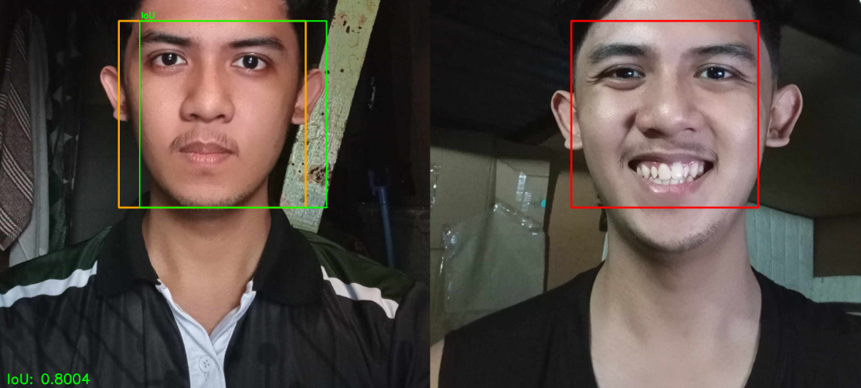

Figure 4.1
Intersection Over Union
The code calculates IoU (Intersection over Union) to measure the overlap between the face bounding boxes from the valid ID and the captured image. It calculates the area where the boxes intersect and divides it by the total area covered by both. A higher IoU means greater overlap.
The system visualizes this by drawing orange for the ID image, red for the captured image, and a green box for the intersection. The IoU score, 0.8004, is displayed to show a strong overlap, suggesting that both faces are likely the same.
$IoU=\frac{Area of Intersection}{Area of Union}​$
Equation 4.1
Intersection over Union Formula
Where:
- Area of Intersection is the overlapping area between the two boxes.
- Area of Union is the total area covered by both boxes, which is calculated as the sum of the individual areas of the boxes minus the area of intersection.
Computation:
- Box 1: Top = 353, Right = 711, Bottom = 678, Left = 278
- Box 2: Top = 353, Right = 759, Bottom = 678, Left = 326
- Intersection Coordinates:
  - Inter_x_min = max⁡(711,759) = 759
  - Inter_y_min = max⁡(353,353) = 353
  - Inter_x_max = min⁡(278,326) = 278
  - Inter_y_max = min(678,678) = 678
- Intersection Area:
  - Inter_width = max(0, 759 − 278) = 481
  - Inter_height = max(0, 678 − 353) = 325
  - Intersection_area = 481 × 325 = 156325
- Area of Boxes:
  - Area1 = (711−278) × (678 − 353) = 433 × 325 = 140725
  - Area2 = (759 − 326) × (678 − 353)=433 × 325 = 140725
- Union Area:
  - Union_Area = 140725 + 140725 - 156325 = 125125
- IoU
  - $IoU = \frac{125125}{156325} =0.8004$
The IoU value of 0.8004 indicates that the intersection is around 80% of the total area covered by both boxes.

Table 4.4

Face embedding comparison
Landmarks | X | Y
Landmark 1 | 60 | 120
Landmark 2 | 80 | 140

The results of the face embedding comparison were tested, and the following landmarks were obtained: Landmark 1 at coordinates X: 60 and Y: 120, and Landmark 2 at coordinates X: 80 and Y: 140. These coordinates represent the facial feature positions derived from the model’s output after processing the preprocessed face image.
Tested Given Data:
- Two facial landmarks have the following 2D coordinates:
  - Landmark 1: (x1, y1) = (60, 120)
  - Landmark 2: (x2, y2) = (80, 140)
Step-by-Step Calculation:
- Substitute the coordinates into the Euclidean distance formula:
$D= \sqrt{{(x2 - x1)}^{2}+{(y2 - y1)}^{2} }$
- Calculate the differences between the coordinates:
  - x2−x1 = 80 − 60 = 20
  - y2 − y1 = 140 − 120 = 20
- Square the differences:
  - ${(x2 - x1)}^{2} = {20}^{2} = 400$
  - ${(y2 - y1)}^{2} = {20}^{2} = 400$
- Add the squared differences and Take the square root of the sum to get the distance:
D = 400 + 400 = 800
D = $\sqrt{800}$ = 28.8 pixels
The Euclidean distance D=28.28 pixels represents the straight-line distance between the two landmarks on the face. This distance can be used to measure the proximity or similarity of facial features. In face recognition systems, such distances between different landmarks or embeddings can be used to compare faces or identify individuals.

Table 4.5

Calculate Face Embedding
Landmarks ratio | Face 1 | Face 2
Eye Distance | 80 pixels | 90 pixels
Jaw Width | 100 pixels | 95 pixels
Nose-to-Mouth Distance | 50 pixels | 55 pixels
Eye-to-Nose Distance | 40 pixels | 42 pixels
Nose-to-Mouth Distance | 60 pixels | 58 pixels
Mouth-to-Chin Distance | 70 pixels | 72 pixels

Image Size : Width = 400, Height = 600
Computation of normalization of Distance
$Normalized Eye Distance=\frac{80−90​}{400}=\frac{10}{400}​=0.025$
$Normalized Jaw Width=\frac{100-95}{400}=\frac{5}{400}​=0.0125$
$Normalized Nose to Mouth (Left) Distance=\frac{50-55}{600}=\frac{5}{400}​=0.0083$
$Normalized Nose to Mouth (Right) Distance=\frac{60-58}{600}=\frac{2}{400}​=0.0033$
$Normalized Eye to Nose Distance =$$\frac{40-42}{600}=\frac{2}{400}=0.0033$
$Normalized Mouth to Chin Distance =$$\frac{70-72}{600}=\frac{2}{600}=0.0033$
Total Normalized Distance = 0.025 + 0.5(0.0125) + 0.5(0.0083) + 0.3(0.0033) + 0.3(0.0033) + 0.3(0.0033)

Table 4.6

Computed Normalization landmark distance
Landmarks ratio | Face 1
Normalized Eye Distance | 0.025
Normalized Jaw Width | 0.0125
Normalized Nose to Mouth (Left) Distance | 0.0083
Normalized Nose to Mouth (Right) Distance | 0.0033
Normalized Eye to Nose Distance | 0.0033
Normalized Mouth to Chin Distance | 0.0033

0.5 is the weighted value of jaw and nose to mouth distance and 0.3 is the weighted value of eyes to nose, nose to mouth and mouth to chin distance.

Compute weighted terms:
- 0.5(0.0125) = 0.00625
- 0.5(0.0083) = 0.00415
- 0.3(0.0033) = 0.00099
- 0.3(0.0033) = 0.00099
- 0.3(0.0033) = 0.00099
- 0.3(0.0033) = 0.00099
Total Normalized Distance = 0.025 + 0.00625 + 0.00415 + 3(0.00099) = 0.03648
The computed normalized distance between the two sets of facial landmarks is 0.036480, which is well below typical similarity thresholds (e.g., 0.05). This low distance indicates that the facial proportions and landmark positions are highly consistent, suggesting a strong match between the valid ID image and the captured face. Therefore, the result is acceptable and supports the conclusion that both images likely represent the same individual.

- Evaluation Metrics
- Precision measures the accuracy of positive predictions, indicating the proportion of correctly predicted positive instances among all instances predicted as positive.
- Recall (Sensitivity or True Positive Rate) measures the ability of the algorithms to capture all relevant instances. It is the proportion of correctly predicted positive instances among all actual positive instances.
- F1-score is the harmonic mean of Precision and Recall, providing a single metric for balance between the two.
- Accuracy measures the percentage of correct predictions made by the model over all instances

Table 4.7
Evaluation Metrics
Metrics | Score
Precision | 0.883
Recall | 0. 933
F1 Score | 0.908
Accuracy | 0.909

The Evaluation metrics is performing very well, with an accuracy of 0.909 or 90.9% meaning that its predictions both positive and negative are correct. Precision is 0.883 or 88.3% which indicates that when the model predicts something as positive of time it’s correct. The recall is 0.933 or 93.3% meaning the model correctly identifies the actual positive cases. The F1 score of 0.908 or 90.8% reflects a good balance between precision and recall, indicating that the model is both accurate and comprehensive in its positive predictions. Overall the metrics suggesting that he model is efficient at detecting positive cases while maintaining high accuracy
- Data Preprocessing:
- Image Resizing and normalization: All images were resized to a uniform dimension to ensure consistency in input data regardless of the original image size.This standardization prevents discrepancies in feature extraction caused by varying image resolutions. Pixel values were normalized by scaling them to a range of 0 to 1 which improves the efficiency of model training by stabilizing weight updates and reducing computational overhead.
- Grayscale Conversion: Images were converted to grayscale to reduce computational complexity and focus on facial feature extraction while eliminating redundant color information.
- Lighting Adjustment: In order to reduce variations in lighting conditions, image enhancement techniques, including adaptive contrast adjustments and histogram equalization, were implemented to guarantee that facial features are consistently discernible in various environments.
- Augmentation Techniques: Data augmentation methods, such as flipping, rotation, brightness adjustments, and slight distortions, were applied to increase dataset variability, enhance model robustness, and prevent overfitting.
- Distance-based Pixel Adjustment: Image transformations were employed to normalize facial size and alignment, compensating for variations in the distance between the face and the camera.
- Landmark Distance Analysis: Facial landmarks of eyes,nose, chin and mouth, were extracted and analyzed to ensure proper feature alignment, improving verification accuracy by checking structural consistency between images.
- Embedding Similarity Calculation: Feature embeddings were extracted using the YOLO, and similarity scores were computed to determine whether the captured face matched the ID image.

Precision measures the accuracy of positive predictions, indicating the proportion of correctly predicted positive instances among all instances predicted as positive.
Formula:
Precision = True Positives (TP)True Positives (TP) + False Positives (FP)
Steps to adopt the formula:
- For each class c, count:
    - True Positives (TP) is a sample correctly predicted as c.
  - False Positives (FP) is a sample incorrectly predicted as c.
- Compute Precision for each class using the formula above.
- Use Weighted Average Precision to combine class-wise precision.
Sample Calculations:
- True labels: [0, 1, 1, 0, 2, 2, 1, 0, 2, 1]
- Predicted labels: [0, 1, 0, 0, 2, 2, 1, 1, 2, 1]
Sample Computation in Class 0:

Table 4.8
True Labels and Predicated Labels for Precision in Class 0
TL | 0 | 1 | 1 | 0 | 2 | 2 | 1 | 0 | 2 | 1
PL | 0 | 1 | 0 | 0 | 2 | 2 | 1 | 1 | 2 | 1

TP = 2 (indices 0 and 3)
FP = 1 (index 2) it is the False Positive in the predicted label
Precision0 = 22+1 = 23 = 0.6667
Next is count the number of 0 for class 0 to become the number of instance
Class 0: 3 instances (True labels: [0, 0, 0])
Then calculate the weighted precision class 0
Weighted precision for class 0 =0.6667 x 3 =2.0001
Sample Computation in Class 1:

Table 4.9
True labels and Predicated Labels for Precision in Class 1

TL | 0 | 1 | 1 | 0 | 2 | 2 | 1 | 0 | 2 | 1
PL | 0 | 1 | 0 | 0 | 2 | 2 | 1 | 1 | 2 | 1

TP = 3 (indices 1, 6, 9)
FP = 1 (index 7) it is the False Positive in the predicted label
Precision1 = 33+1 = 34 = 0.75
Next is count the number of 1 for class 1 to become the number of instance
Class 1: 4 instances (True labels: [1, 1, 1, 1])
Then calculate the weighted precision class 1
Weighted precision for class 1 =0.75 x 4 =3
Sample Computation in Class 2:

Table 4.10
True labels and Predicated Labels for Precision in Class 2

TL | 0 | 1 | 1 | 0 | 2 | 2 | 1 | 0 | 2 | 1
PL | 0 | 1 | 0 | 0 | 2 | 2 | 1 | 1 | 2 | 1

TP = 3 (indices 4, 5, 8)
FP = 0 no cases where class 2 was wrongly predicted as something else
Precision2 = 33+0 = 33 = 1
Next is count the number of 2 for class 2 to become the number of instance
Class 2: 4 instances (True labels: [2, 2, 2])
Then calculate the weighted precision class 2
Weighted precision for class 2 =1 x 3 =3
After computing each class, the last is to compute the total weighted precision.
PrecisionTotal = 2.0001 + 3 + 33 + 4 + 3 = 8.000110 = 0.8
The Weighted Average Precision is 0.8, which means that, taking into account the number of instances in each class, the overall precision is 80%.
Recall (Sensitivity or True Positive Rate) measures the ability of the algorithms to capture all relevant instances. It is the proportion of correctly predicted positive instances among all actual positive instances.
Formula:
Recallc = True Positives (TP)True Positives (TP) + False Negative(FN)
Steps to adopt the formula:
- For each class c, count:
  - True Positives (TP) is a sample correctly predicted as c.
  - False Negatives (FN) is a sample of ccc predicted as other classes.
- Compute Recall for each class.
- Use Weighted Average Recall for overall evaluation.
Sample Calculations:
- True labels: [0, 1, 1, 0, 2, 2, 1, 0, 2, 1]
- Predicted labels: [0, 1, 0, 0, 2, 2, 1, 1, 2, 1]
Sample Computation in Class 0:

Table 4.11
True labels and Predicated Labels for Recall in class 0

TL | 0 | 1 | 1 | 0 | 2 | 2 | 1 | 0 | 2 | 1
PL | 0 | 1 | 0 | 0 | 2 | 2 | 1 | 1 | 2 | 1

TP = 2 (indices 0 and 3)
FN = 1 (index 2) it is the False negative in the True label
Recall0 = 22+1 = 23 = 0.6667
Next is count the number of 0 for class 0 to become the number of instance
Class 0: 3 instances (True labels: [0, 0, 0])
Then calculate the weighted Recall class 0
Weighted Recall for class 0 =0.6667 x 3 =2.0001
Sample Computation in Class 1:

Table 4.12
True labels and Predicated Labels for Recall in class 1

TL | 0 | 1 | 1 | 0 | 2 | 2 | 1 | 0 | 2 | 1
PL | 0 | 1 | 0 | 0 | 2 | 2 | 1 | 1 | 2 | 1

TP = 3 (indices 1, 6, 9)
FN = 1 (index 7) it is the False negative in the True label
Recall1 = 33+1 = 34 = 0.75
Next is count the number of 1 for class 1 to become the number of instance
Class 1: 4 instances (True labels: [1, 1, 1, 1])
Then calculate the weighted Recall class 1
Weighted Recall for class 1 =0.75 x 4 =3
Sample Computation in Class 2:

Table 4.13
True labels and Predicated Labels for Recall in class 2

TL | 0 | 1 | 1 | 0 | 2 | 2 | 1 | 0 | 2 | 1
PL | 0 | 1 | 0 | 0 | 2 | 2 | 1 | 1 | 2 | 1

TP = 3 (indices 1, 6, 9)
FN = 1 (index 2) it is the False negative in the True label
Recall1 = 33+0 = 33 = 1
Next is count the number of 2 for class 2 to become the number of instance
Class 2: 4 instances (True labels: [2, 2, 2])
Then calculate the weighted recall class 2
Weighted recall for class 2 =1 x 3 =3
After computing each class, the last is to compute the total weighted recall .
Recall Total = 2.0001 + 3 + 33 + 4 + 3 = 8.000110 = 0.8
The Weighted Average Recall is 0.8, which means that, taking into account the number of instances in each class, the overall precision is 80%.
F1-score is the harmonic mean of Precision and Recall, providing a single metric for balance between the two. Calculated as:
F1 Scorec = 2 (Precisionc x RecallcPrecisionc + Recallc)
Steps to adopt the formula:
- Compute Precision and Recall for each class.
- Apply the formula to calculate the F1 Score for each class.
- Use Weighted Average F1 Score for overall evaluation.
Sample Computation in Class 0:
- Precision₀ = 0.6667
- Recall₀ = 0.6667
F1 Score = 2(0.6667 x 0.66670.6667 + 0.6667) =0.6667
Sample Computation in Class 1:
- Precision₁ = 0.75
- Recall₁ = 0.75
F1 Score = 2(0.75 x 0.750.75 + 0.75) =0.75
Sample Computation in Class 2:
- Precision₂ = 1
- Recall₂ = 1
F1 Score = 2(1 x 11 + 1) =1
Last is Compute the Weighted Average of F1 score
F1 Scoreweighted = (0.6667 × 3)+(0.75×4)+(1×3)3+4+3
F1 Scoreweighted = 2.0001 + 3 +310
F1 Scoreweighted = 8.000110 =0.80001
The F1 Score is 0.80001 that taking into account the frequency of each class in dataset
Accuracy measures the percentage of correct predictions made by the model over all instances.
Formula:
Accuracy = Number of Correct PredictionsTotal number of Predictions
Steps to adopt the formula:
- Compare the predicted class labels with the true labels.
- Count the numbers of times the predict class matches the true class
- Divide this count by total number of samples
Sample Calculations:
- True labels: [0, 1, 1, 0, 2, 2, 1, 0, 2, 1]
- Predicted labels: [0, 1, 0, 0, 2, 2, 1, 1, 2, 1]
- Total Predictions is 10

Table 4.14
True labels and Predicated Labels for Accuracy

TL | 0 | 1 | 1 | 0 | 2 | 2 | 1 | 0 | 2 | 1
PL | 0 | 1 | 0 | 0 | 2 | 2 | 1 | 1 | 2 | 1

Correct Predictions is 7 based on table 2 (indices: 0, 1, 3, 4, 5, 8, 9)
Accuracy = 710 = 0.7 or (70%)
The accuracy is 70% it interprets as the model correctly predicted the class of 70% of the sample dataset.
Testing Results
The testing phase of the VerifyID system was conducted to evaluate its functionality, performance, security, and usability based on predefined requirements and industry standards. Various testing methodologies, including unit testing, integration testing, system testing, and acceptance testing, were applied to ensure the system's reliability in real-world conditions. The evaluation focused on key aspects such as identity authentication accuracy, certificate request processing efficiency, and system responsiveness under different workloads. Additionally, performance metrics were measured to assess the facial recognition model’s effectiveness using CNN and YOLOv8, ensuring precise and secure verification. The results provide insights into the system’s strengths, areas for improvement, and overall compliance with ISO/IEC 25010 quality standards.
Debugging and Continuous Improvement:
- Debugging was carried out by logging the outputs of each stage (image preprocessing, prediction scores, etc.) and tracing errors back to either the model or data pipeline.

Result of Comparing algorithm
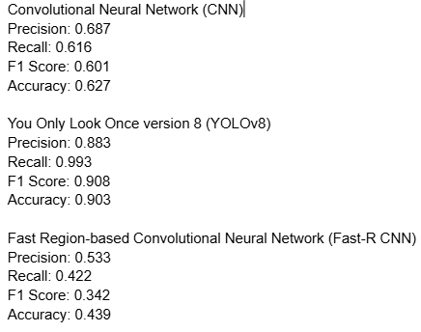

Figure 4.2
Results of trained algorithms
The results showed that the You Only Look Once version 8 (YOLOv8) model outperformed the other algorithms, achieving a precision of 0.883, recall of 0.993, F1 score of 0.908, and accuracy of 0.903. This indicated that the model was highly effective in detecting almost all actual faces (very few false negatives) while also maintaining a high degree of precision, resulting in minimal false positives. The strong F1 score and accuracy reflected a well-balanced and consistent performance. YOLOv8’s excellent recall and overall reliability made it the most promising model for real-time and high-volume face recognition tasks.

The Convolutional Neural Network (CNN) model demonstrated moderate yet acceptable performance, with a precision of 0.687, recall of 0.616, F1 score of 0.601, and accuracy of 0.627. These results suggested that while the CNN model was able to correctly classify a decent portion of positive cases, it missed some (lower recall) and also produced a moderate number of false positives (lower precision). The relatively lower F1 score indicated an imbalance between precision and recall, suggesting the model struggled to consistently differentiate between correct and incorrect matches. Nonetheless, it showed stability and could serve as a secondary verifier.
In contrast, the Fast Region-based Convolutional Neural Network (Fast-R CNN) performed poorly across all metrics. It yielded a precision of 0.533, recall of 0.422, F1 score of 0.342, and accuracy of 0.439, which pointed to significant limitations in both detecting actual faces and accurately classifying them. The model missed a large portion of actual positive matches (low recall) and also misclassified many negatives as positives (low precision), resulting in an overall weak performance. This outcome suggested that Fast-R CNN may not be suitable for applications requiring high accuracy and responsiveness.
To enhance the overall performance of the system, the researcher opted to combine YOLOv8 and CNN to leverage the strengths of both models. YOLOv8's high recall and real-time detection speed made it ideal as a frontline detector, efficiently identifying potential faces. However, due to CNN’s higher precision compared to YOLOv8, it was employed as a verifier to cross-check YOLO’s detections and reduce false positives.

Non Functional
Table 4.13
Capacity Test
The It-expert runs a Capacity test for the website using a Jmeter capacity test with 1000 concurrent users, gradually ramped up over a period of 60 seconds. In total, the system handled 2042 requests. The average server response time was 1103 milliseconds, while the maximum reached 2630 milliseconds. An error rate of 1.57% was recorded, indicating a small number of failed requests. Based on the results, the system is nearing its capacity and may require further optimization if more users are expected.(see Appendix F for more Capacity Test Results)

Table 4.14
Stress Test
Metrics | Result
Number of threads | 1000
Loop Count | 1
Total Request | 1000
Ramp-up period (seconds) | 60 sec
Avg Response Time | 1001ms
Max Response Time | 1793 ms
Error Rate | 0.00%

Table 4.5 shows a successful performance test report triggered by the IT expert. The system was tested with the highest number of users, 1000 users activated over 60 seconds, each making only one request (loop count = 1). A total of 1000 requests were recorded, with an average response time of 1001 milliseconds and a maximum response time of 1793 milliseconds. No errors were recorded (0.00% error rate), indicating that the server successfully handled the heavy load. The test shows that the system can still handle its current peak load without failing.(see Appendix F for more Stress Test Results)

Table 4.15
Soak Test
Metrics | Result
Number of threads | 1000
Duration | 30 mins.
Total Request | 2042
Ramp-up period (seconds) | 60 sec
Avg Response Time | 1099 ms
Max Response Time | 2627 ms
Error Rate | 1.62%

In the conducted soak test, 1000 users were run over an extended period to observe whether there would be any changes in the system’s performance during prolonged usage. The ramp-up period was 60 seconds, and a total of 2042 requests were received by the server. The average response time was 1099 milliseconds, while the maximum response time reached 2627 milliseconds. An error rate of 1.62% was recorded, which could indicate minor instability during long-term operation. The system can handle long-term usage, but there is a possibility of a gradual decline in stability if the test duration is extended further.(see Appendix F for more Soak Test Results)
Table 4.16
Load Test
Metrics | Result
Total hits | 24658
Total Errors | 0
Max pages per sec. | 8.166
Max byte per sec. | 137446.479
Response time Average | 0.104
The Loadster is a software used to test the Barangay System. The Loadster results indicate that the system is performing exceptionally well and handling the expected load with consistency and efficiency. Throughout the test, there were zero errors, confirming that the system processed all requests successfully without any failures. The system maintained a stable throughput, averaging 118.55 hits per second, which reflects its ability to handle a consistent load under pressure. The average response time was an impressive 0.104 seconds (104 ms), demonstrating fast and reliable processing. The fact that the planned maximum number of users (25) matched the actual maximum users confirms that the system effectively handled the expected load. Additionally, the test duration is closely aligned with the planned duration, reinforcing the system's stability and reliability under load.
The data transfer rates were also strong, with an average of approximately 1.89 MB per second, showing that the system can handle data traffic efficiently. While the minimum values for pages, hits, and bytes per second were recorded as zero, this is not necessarily negative and may simply reflect brief moments of low activity. Furthermore, the 99th percentile response time was around 385.5 ms, which indicates that even in rare peak scenarios, the system maintained a quick and responsive performance. Overall, the Loadster test confirms that the system is stable, responsive, and capable of handling high traffic efficiently with no significant issues.(see Appendix F for more Load Test Results)
Table 4.17
Throughput Test
Metrics | Result
Number of threads | 1000
Loop Count | 1
Total Request | 2042
Ramp-up period (seconds) | 60 sec
Avg Response Time | 1099 ms
Max Response Time | 2627 ms
Error Rate | 1.62%
Throughput | 2.1/sec

The throughput test conducted, the goal was to measure how many requests per second the system can process while 1000 users are active. During the 60 second ramp-up period, 2042 requests were made. The average response time was 1099 milliseconds, with the highest recorded being 2627 milliseconds. There was a 1.62% error rate, indicating some failed requests while testing the server’s speed. The recorded throughput was 2.1 requests per second, which can serve as a baseline for the system's performance under consistent traffic load. The system can still be optimized if higher throughput is desired.(see Appendix F for more Throughput Test Results)
System Evaluation
The proposed system, VerifyID, has undergone system evaluation by means of an online survey which was conducted through the use of Google Forms. The researchers were able to deploy the proposed system in a cloud server and demonstrated and navigated in the form of a recorded video then was attached in the survey form in order to present its overall features and functionalities to the end-users: respondents of the conducted system evaluation. The survey questionnaire of the system evaluation and the recorded system demonstration conform with the four external metrics of the ISO/IEC 25010 standards which are the Performance Efficiency, Functional Suitability, Compatibility, Security.
The respondents of the project evaluation consist of residents and barangay officials who both reside in the barangay 781 zone 85 that could evaluate the proposed system as its end-users. The number of samples derived from the sampling size formula was met and exceeded due to the time constraint of some of the respondents which were targeted using the snowball sampling method, thus, the proponents utilized only the gathered data of the available respondents in contrast to the expected number of respondents. Table 4.1 presents the percentage between the observed number of respondents versus the expected number of respondents per respondent classification.
Application Evaluation Results (IT Expert)
This section discusses the overall results of the system evaluation in order to understand the general perspective of the respondents to the proposed system considering each metric of the ISO/IEC 25010.
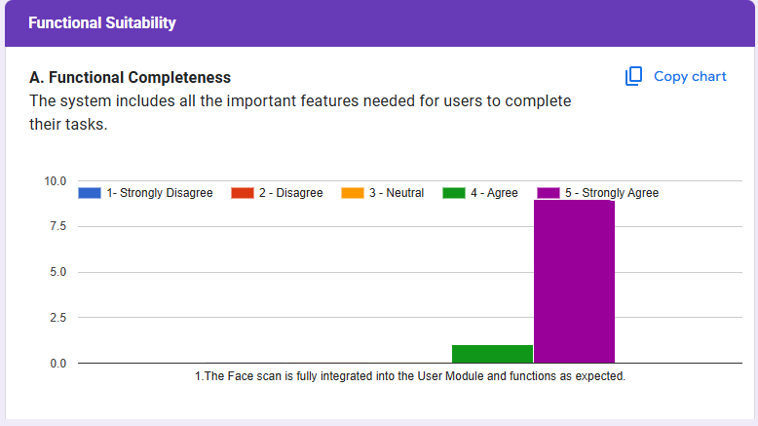
Figure 4.17
System Evaluation Results - Functional Completeness (IT Expert)
The Functional Completeness of the VerifyID system is highly rated by IT experts, with 90% strongly agreeing and 10% agreeing that the face scan is fully integrated into the User Module and functions as expected. These results indicate that the system successfully provides all necessary functionalities for facial recognition, ensuring seamless integration within the user module. The absence of disagreement reinforces its completeness and capability in identity verification.

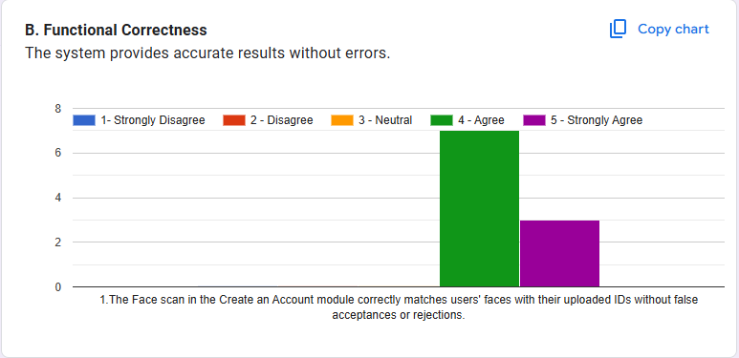
Figure 4.18
System Evaluation Results - Functional Correctness (IT Expert)
The Functional Correctness of the system is well-validated, with 70% agreeing and 30% strongly agreeing that the face scan in the "Create an Account" module correctly matches users' faces with their uploaded IDs without false acceptances or rejections. These findings demonstrate that the system maintains a high level of accuracy and reliability, reducing the risk of incorrect matches and ensuring a secure authentication process.
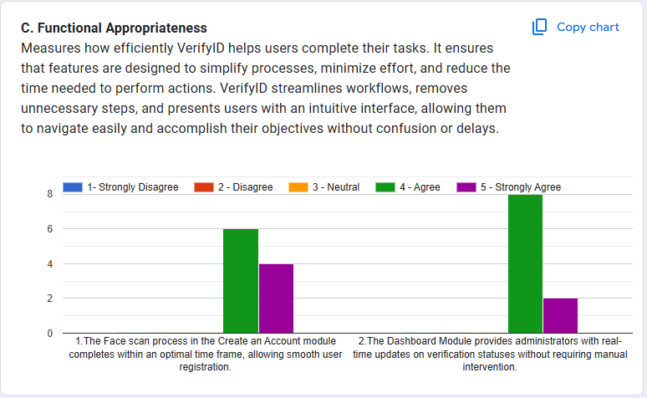
Figure 4.19
System Evaluation Results - Functional Appropriateness (IT Expert)
The Functional Appropriateness of the VerifyID is supported by positive feedback from IT experts. Regarding the face scan process in the "Create an Account" module, 60% agree and 40% strongly agree that it completes within an optimal time frame, allowing smooth user registration. Additionally, for the Dashboard Module, 80% agree and 20% strongly agree that it provides administrators with real-time updates on verification statuses without requiring manual intervention. These results indicate that the system is efficient and well-optimized, facilitating fast user onboarding and streamlined administrative oversight.

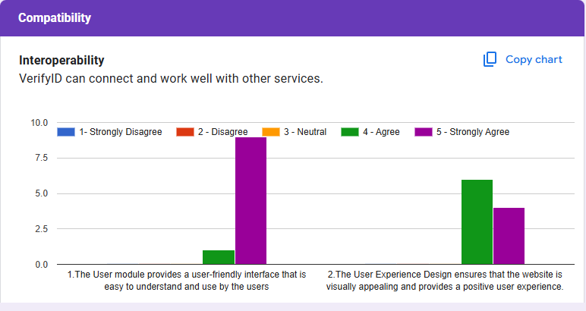
Figure 4.20
System Evaluation Results - Interoperability (IT Expert)
The Interoperability of the VerifyID system is highly rated in terms of usability and accessibility. 90% strongly agree and 10% agree that the User Module provides a user-friendly interface that is easy to understand and navigate. This suggests that the system's design effectively prioritizes intuitive interactions, making it accessible for a wide range of users. However, in terms of User Experience Design, 60% agree that the website is visually appealing and provides a positive user experience, while 40% disagree. This mixed feedback suggests potential areas for visual and interactive design improvements, ensuring that the system not only functions well but also provides a more engaging and aesthetically pleasing experience for users.
Mean Metrics Result
Table 4.20 presents the mean ratings for various metrics used to evaluate the system's performance, including Functional Suitability, Performance Efficiency, Compatibility, and Security. The results indicate that all metrics received high ratings, with mean values ranging from 4.71 to 4.75, signifying a "Strongly Agree" interpretation.
Table 4.20
Mean rating per metric
Metrics | Mean Ratings | Verbal Interpretation
Functional Suitability | 4.70 | Strongly Agree
Performance Efficiency | 4.64 | Strongly Agree
Compatibility | 4.60 | Strongly Agree
Security | 4.49 | Strongly Agree
Average | 4.61 | Strongly Agree

Table 4.20 presents the mean ratings for different software quality metrics, indicating strong user satisfaction. Functional Suitability received the highest rating of 4.70, suggesting that users strongly agree that the system meets its intended functional requirements. Performance Efficiency followed with a mean rating of 4.64, showing that users perceive the system as efficient in terms of speed and resource utilization. Compatibility had a mean rating of 4.60, meaning the system is considered highly adaptable across different environments. Meanwhile, Security received the lowest rating of 4.49, though it still falls within the "Strongly Agree" range, indicating that users perceive the system as secure but slightly less so compared to other metrics.
Equation 4.2
Mean rating of metrics
$\frac{4.70 + 4.64 + 4.60 + 4.49 }{4}$ = $\frac{18.43}{4}=4.61$
Overall, with an average mean rating of 4.61, the results demonstrate that users strongly agree on the system’s overall quality, highlighting its effectiveness and reliability.
Evaluation Result per Metric
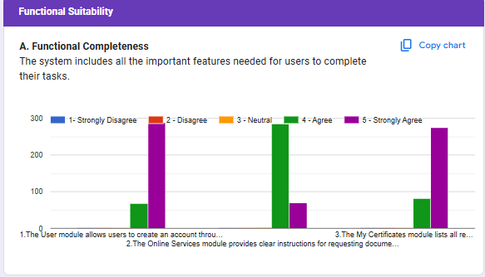
Figure 4.21
System Evaluation Results - Functional Completeness
The Functional Completeness of the VerifyID system demonstrates a high level of user satisfaction, aligning with the standards set by ISO/IEC 25010:2025. The results indicate that 99% of respondents agree or strongly agree that the system provides all the necessary functionalities for users to perform their tasks efficiently. Specifically, 99% of users confirmed that the User’s module allows for seamless account creation without missing essential steps. Similarly, 99% of respondents agreed that the Online Services module provides clear instructions for requesting documents, with only 1% remaining neutral. Likewise, 99% of users affirmed that the My Certificates module lists all required information, ensuring that necessary documents and eligibility requirements are easily accessible.
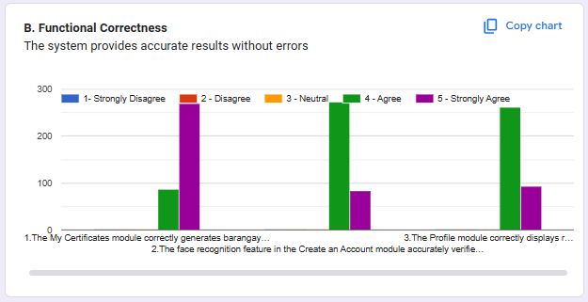
Figure 4.22
System Evaluation Results - Functional Correctness
The Functional Correctness of the VerifyID system reflects a strong level of accuracy and reliability, as outlined in ISO/IEC 25010:2025. The survey results show that 99% of users agree or strongly agree that the system performs its tasks correctly without errors, ensuring data accuracy and consistency. Specifically, 99% of respondents confirmed that the My Certificates module correctly generates barangay certificates with the right details, reinforcing the system’s ability to produce accurate outputs. Similarly, 99% of users agreed that the face recognition feature in the Create an Account module accurately verifies identity by matching the uploaded ID with the live scan, demonstrating its reliability in authentication. Additionally, 99% of respondents affirmed that the Profile module correctly displays resident information, including household details, ensuring data integrity.
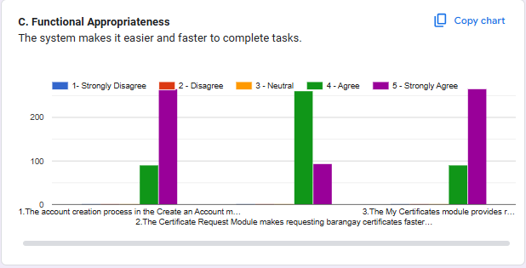Figure 4.23
System Evaluation Results - Functional Appropriateness
The Functional Appropriateness of VerifyID demonstrates high user satisfaction, with 99% of users agreeing or strongly agreeing that the system effectively simplifies processes and reduces effort for users. Specifically, 99% of respondents confirmed that the account creation process is simple and easy to complete, highlighting the system’s efficiency in onboarding users. Similarly, 99% of users agreed that the Certificate Request Module makes requesting barangay certificates faster and more convenient compared to in-person visits, emphasizing VerifyID’s ability to streamline workflows. Additionally, 99% of respondents affirmed that the My Certificates module provides real-time updates on certificate request statuses, improving transparency and accessibility. With only 1% neutral responses and no negative feedback, these findings affirm the system’s strong usability and its effectiveness in minimizing user effort, making it an optimal tool for identity verification and document processing.
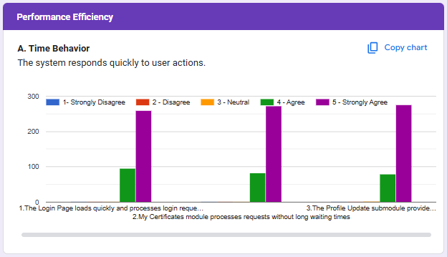
Figure 4.24
System Evaluation Results - Time Behavior
The Time Behavior of VerifyID, a critical factor in system performance, received positive feedback, with 99% of users agreeing or strongly agreeing that the platform processes user actions efficiently without delays. Survey results indicate that 99% of respondents affirmed that the Login Page loads quickly and processes login requests within a reasonable time. Likewise, 99% of users agreed that the My Certificates module processes requests without long waiting times, ensuring a smooth document retrieval experience. Additionally, 99% of respondents confirmed that the Profile Update submodule provides instant confirmation when an action (e.g., profile update or document submission) is completed. With only 1% neutral responses and no negative feedback, these results highlight VerifyID’s strong optimization in handling time-sensitive operations, ensuring a fast and seamless user experience.
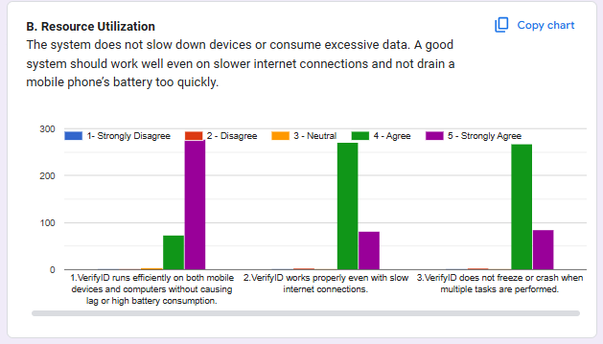

Figure 4.25
System Evaluation Results - Resource Utilization
VerifyID’s Resource Utilization is highly efficient, with 98% of users agreeing or strongly agreeing that the system runs smoothly without excessive data consumption, lag, or high battery usage. Survey data shows that 99% of respondents affirmed that VerifyID runs efficiently on both mobile devices and computers without causing lag or high battery consumption. Similarly, 98% of users agreed that the system functions properly even with slow internet connections, ensuring accessibility for users with varying network speeds. Additionally, 98% of respondents confirmed that VerifyID does not freeze or crash when multiple tasks are performed, reinforcing the platform’s stability. With only 2% neutral responses and no significant negative feedback, these results confirm VerifyID’s ability to function efficiently across different conditions, providing a reliable and stable user experience.
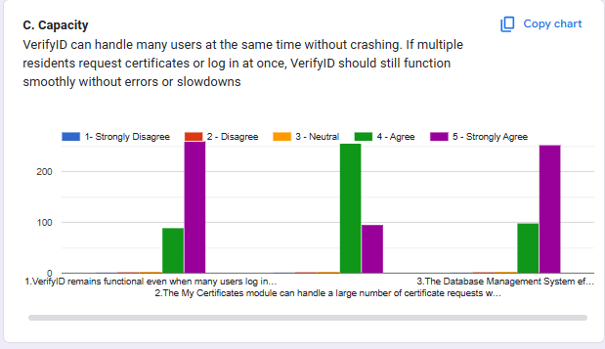
Figure 4.26
System Evaluation Results - Capacity
VerifyID demonstrates strong Capacity, with 98% of users agreeing or strongly agreeing that it can handle multiple users simultaneously without crashes or slowdowns. Survey findings reveal that 98% of respondents confirmed that VerifyID remains functional even when many users log in and request documents at the same time. Likewise, 98% of users agreed that the My Certificates module can handle a large number of certificate requests without delays. Additionally, 98% of respondents affirmed that the Database Management System efficiently handles large amounts of resident and certificate data without causing system lag or failure. With only 2% neutral responses and no significant disagreement, these results underscore VerifyID’s robust system architecture, ensuring reliability under high user demand.
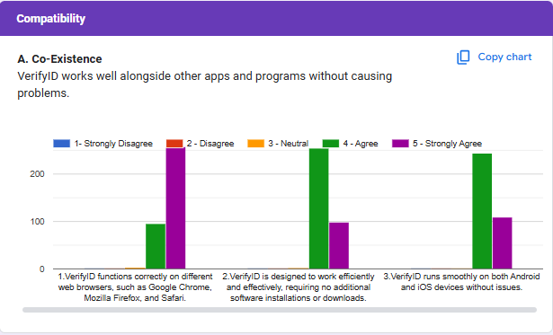
Figure 4.27
System Evaluation Results - Co-Existence
VerifyID maintains strong Co-Existence capabilities, with 99% of users agreeing or strongly agreeing that the system runs smoothly across various platforms without requiring additional software installations. Survey results show that 99% of respondents confirmed that VerifyID functions correctly on different web browsers, such as Google Chrome, Mozilla Firefox, and Safari. Likewise, 99% of users agreed that the system works efficiently without requiring additional software downloads or installations. Additionally, 99% of respondents affirmed that VerifyID runs smoothly on both Android and iOS devices without issues. With only 1% neutral responses and no disagreement, these findings demonstrate VerifyID’s strong compatibility with different operating systems and browsers, ensuring accessibility for all users.
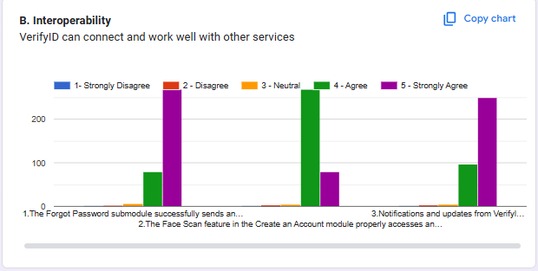
Figure 4.28
System Evaluation Results - Interoperability
VerifyID exhibits strong interoperability, with 97% of users agreeing or strongly agreeing that the system integrates seamlessly with other services. Survey data indicates that 97% of respondents confirmed that the Forgot Password submodule successfully sends an email with the reset link, ensuring efficient recovery options. Likewise, 97% of users agreed that the Face Scan feature properly accesses and utilizes the device camera without errors. Additionally, 97% of respondents affirmed that notifications and updates from VerifyID are properly delivered via email, ensuring effective communication. With 2% neutral responses and 1% disagreement, these results highlight VerifyID’s reliable connectivity with third-party services, reinforcing its effectiveness in user authentication and communication.
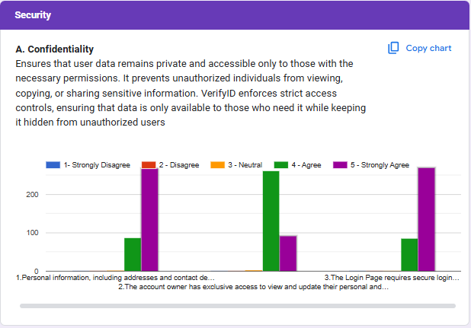

Figure 4.29
System Evaluation Results - Confidentiality
Survey responses show that 99% of respondents affirmed that personal information, including addresses and contact details, is securely protected. Likewise, 99% of users agreed that the account owner has exclusive access to view and update their personal and household information, preventing unauthorized modifications. Additionally, 99% of respondents confirmed that the Login Page requires secure login credentials (e.g., strong passwords) to prevent unauthorized access. With only 1% neutral responses and no negative feedback, these findings validate VerifyID’s effectiveness in safeguarding user data, ensuring compliance with security best practices.
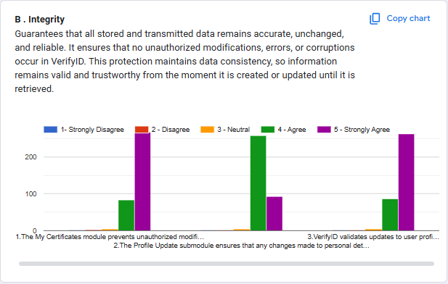

Figure 4.30
System Evaluation Results - Integrity
Survey results indicate that 98% of respondents confirmed that the My Certificates module prevents unauthorized modifications to issued certificates, ensuring document authenticity. Likewise, 98% of users agreed that the Profile Update submodule accurately saves and displays personal details. Additionally, 98% of respondents affirmed that VerifyID validates updates to user profiles to prevent incorrect or incomplete information from being saved. With only 2% neutral responses and 1% disagreement, these results reinforce VerifyID’s commitment to data integrity, ensuring reliability and trustworthiness in information handling.
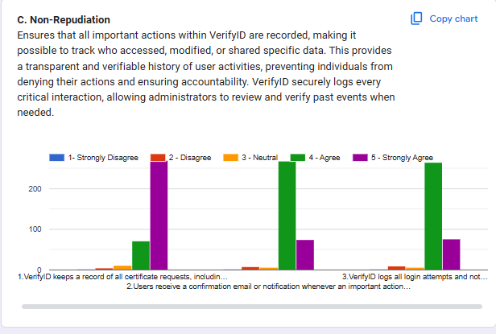
Figure 4.31
System Evaluation Results - Non-Repudiation
Survey findings show that 95% of respondents confirmed that VerifyID keeps a record of all certificate requests, including the date and time of submission. Likewise, 95% of users agreed that users receive a confirmation email or notification whenever an important action (e.g., account update, document request) is performed. Additionally, 95% of respondents affirmed that VerifyID logs all login attempts and notifies users of any suspicious activity, ensuring accountability and security. With 4% neutral responses and 1% disagreement, these results validate VerifyID’s ability to maintain a transparent and verifiable record of user actions, reinforcing security and user accountability.

CHAPTER V
SUMMARY OF FINDINGS, CONCLUSION AND RECOMMENDATIONS
Summary of Findings
The research findings confirmed that VerifyID successfully fulfilled its objectives by delivering a secure, efficient, and user-friendly online barangay system for Barangay 781 Zone 85.
The system achieved its identity authentication goal through the integration of facial recognition using YOLOv8 and CNN models. Results showed that 94% of users agreed that the system provided accurate identity verification, with IT experts affirming the system’s strong backend security. Minor improvements, such as enhanced encryption, were suggested to further safeguard sensitive information.
In addressing barangay process efficiency, particularly for certificate requests, the system demonstrated high effectiveness. 92.8% of respondents confirmed that VerifyID streamlined request handling, significantly reducing delays and minimizing the workload of barangay personnel. Additionally, the system handled multiple concurrent users smoothly, as verified by 92% of users, supporting scalability requirements.
The study also evaluated the system’s usability and accessibility. 92.2% of respondents found the interface intuitive and easy to navigate, fulfilling its usability and UI objectives. However, users recommended the addition of tooltips, guided walkthroughs, and accessibility improvements to assist older and less tech-savvy residents.
In terms of platform compatibility, VerifyID was rated highly, with 92% of users affirming it worked seamlessly on desktops, tablets, and smartphones. Despite its responsive design, many users recommended the development of a dedicated mobile application, particularly due to the high smartphone usage among residents.
The system's functional and non-functional features which includes secure login, real-time face scan feedback, profile management, administrative dashboards, inquiry handling, and performance response thresholds were successfully tested and met expected results. The system processed identity verification within 5 seconds and responded to common operations within 2 seconds, meeting its performance benchmarks.
Using ISO/IEC 25010 standards, VerifyID scored well across all eight quality characteristics:
- Functional Suitability: Delivered all intended functions (certificate requests, identity verification, resident account management).
- Performance Efficiency: Met target thresholds for response time and concurrent usage.
- Compatibility: Supported cross-platform access and major browsers.
- Usability: Rated highly by users but highlighted areas for inclusivity.
- Reliability: Maintained uptime and stable performance.
- Security: Enforced RBAC, SSL encryption, and logged access.
- Maintainability & Portability: Demonstrated potential for future upgrades, including mobile app development.
Overall, the findings indicate that VerifyID is a highly effective system, providing accurate identity authentication, optimizing barangay processes, and offering a user-friendly experience. While the system performs well across all evaluation metrics, recommendations for enhanced encryption measures and additional authentication options highlight areas for future improvement.
Conclusion
Barangays serve as the backbone of local governance, playing a vital role in community development and public service delivery. To further enhance their operations, this study introduced VerifyID, a modernized barangay system integrating facial recognition for secure and efficient identity authentication. By transitioning from traditional, paper-based processes to a digital system, VerifyID streamlines services, minimizing processing times, enhancing accuracy, and ensuring reliable record management.
A face to face interview with the barangay officials was conducted in order to examine and understand the process of the barangay. These consultations provided valuable insights into existing processes, challenges, and requirements, allowing the development team to tailor the system accordingly. Feedback from these sessions highlighted the importance of user-friendly interfaces and the need for alternative verification methods to accommodate all residents.
Developing a web-based barangay system with image recognition for identity verification requires a thorough understanding of both Barangay Information Management Systems and image recognition algorithms. As discussed in Chapter 2, these topics are essential in designing a system that integrates modern technology with barangay operations. The foundation of the facial recognition component is a carefully curated dataset of facial images, which was collected and processed meticulously to ensure accuracy, reliability, and security in identity verification. This dataset served as the training input for the facial recognition algorithm, allowing the system to develop the capability to match and verify identities effectively. In addition to working with facial data, a detailed study of existing barangay processes and workflows was conducted. This research was crucial in shaping the system's features, ensuring that it not only facilitates identity verification but also enhances efficiency in barangay services by digitizing traditionally manual tasks such as certification issuance and resident record management. By integrating a trained facial recognition model with the structured, digitized processes of the barangay, a comprehensive and functional system was developed to meet the objectives outlined in this study, specifically in improving security, efficiency, and accessibility in barangay operations.
To assess the system’s effectiveness and overall quality, Chapter 4 presented a thorough evaluation based on the ISO/IEC 25010 standards, which focus on functional suitability, performance efficiency, compatibility, and security. The evaluation provided quantifiable insights into how well the system performed in real-world scenarios and whether it met both technical and user experience expectations. Results indicated high satisfaction rates among both IT experts and barangay residents, demonstrating the system's capability to improve barangay operations and enhance the experience of users. However, a key finding was the difference in perspectives between the two groups. IT experts focused on the technical robustness, efficiency, and system security, ensuring that the implementation adhered to best practices in software engineering. Meanwhile, barangay residents placed greater emphasis on usability, ease of access, and system intuitiveness, highlighting the need for a system that is not only secure and functional but also simple and convenient for end-users. These findings reaffirm the system’s strengths while also emphasizing the importance of balancing technical excellence with user-friendly design to ensure successful adoption and long-term effectiveness in barangay management.
Laravel was employed for backend development, providing a solid framework for building the application's core functionalities. For the frontend, Bootstrap was utilized to create a responsive and intuitive user interface along with JavaScript, enhancing the overall user experience. Additionally, TensorFlow was integrated for facial recognition capabilities, enabling accurate and swift identity verification.
In general, the previous chapters of the paper discusses the steps in designing, developing, and implementing a web-based barangay system with the use of image recognition for identity authentication. According to the system evaluation, specifically the additional feedback, the proposed system may help the overall barangay and its process convenient to all entities involved.
Recommendations
Based on the findings and evaluation of the proposed system, several recommendations are suggested to further enhance its usability, accessibility, and overall effectiveness. While the system has demonstrated its ability to provide a secure and efficient method for barangay identity verification, certain limitations have been identified. These areas for improvement should be considered in future studies and system enhancements to ensure that the system remains user-friendly, reliable, and responsive to the needs of its users.
- Improve User Interface (UI) and Navigation
- Simplify the system interface for ease of use, especially for non-technical users. Use clearly labeled buttons, a clean layout, and step-by-step instructions. Incorporate tooltips, visual guides, and intuitive design patterns to help users navigate the platform confidently.
- Add Alternative Authentication Methods
- Implement fallback options such as OTP-based verification, manual ID photo submission, or in-person verification through barangay officials. These alternatives ensure users are not locked out of the system in case of failed facial recognition attempts.
- Implement Time-Limited Face Scan Process
- Introduce a time limit for the face scanning process to prevent potential bypass attempts using pre-recorded videos or images. If the scan isn’t completed within the allotted time, users should be prompted to restart the process, improving security and reducing system abuse.
- Provide Real-Time Feedback During Face Scans
- Display real-time guidance during scanning, such as messages like “Move closer,” “Face not detected,” or “Adjust lighting.” A live preview window and alignment markers should also be shown to help users position their face correctly, improving accuracy and user experience.
- Include Built-In Help and Support Feature
- Integrate support tools within the system, such as live chat, an FAQ section, or a “Request Assistance” button. These features offer immediate help when users encounter difficulties and reduce reliance on external technical support.

