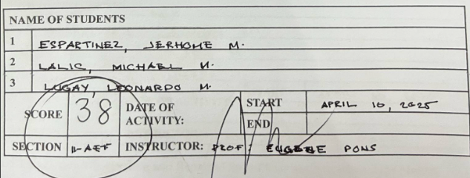
BET 22 Lesson 5 Rewinding and Repair of Split-Phase and Capacitor Type Motors
SINGLE-PHASE ELECTRIC MOTOR REWINDING
MOTOR TYPE: | WASH MOTOR SPECIAL DUTY REVERSIBLE CAPACITOR RUN MOTOR
MODEL/ SERIAL NUMBER:
NAMEPLATE DATA
VOLTS: | 220 v | AMPS: | 1.1 | RPM: | 255rpm | CAP (µF): | 10 µF
PHASE | 1 | S.F.: |  | H.P. (W) : | 200 w | Hz: | 60 hz
WINDING DATA
SLOTS: | 24 | POLES: | 4
ENDROOM (cm) |  | INSULATION THICKNESS (mils)
Front | Slot Liner | Slot | Cover
2.0 cm | 2.3 cm | 0.109 | 0.125
RUNNING WINDING |  | STARTING WINDING
COIL SPAN/PITCH | TURNS | COIL SPAN/PITCH | TURNS
1-6 | 250 | 1-6 | 250
1-4 | 160 | 1-4 | 160
WIRE SIZE | 28 | WIRE SIZE | 28
WEIGHT | 500 g | WEIGHT | 500 g

COIL PLACEMENT DATA
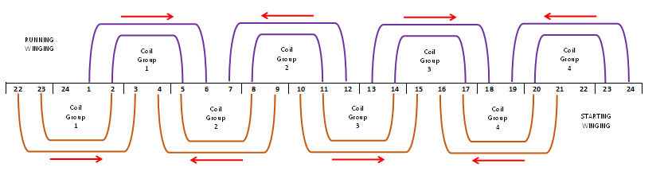
MOTOR CONNECTION DIAGRAM
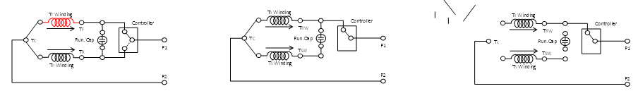

COIL CONNECTION SCHEMATIC DIAGRAM

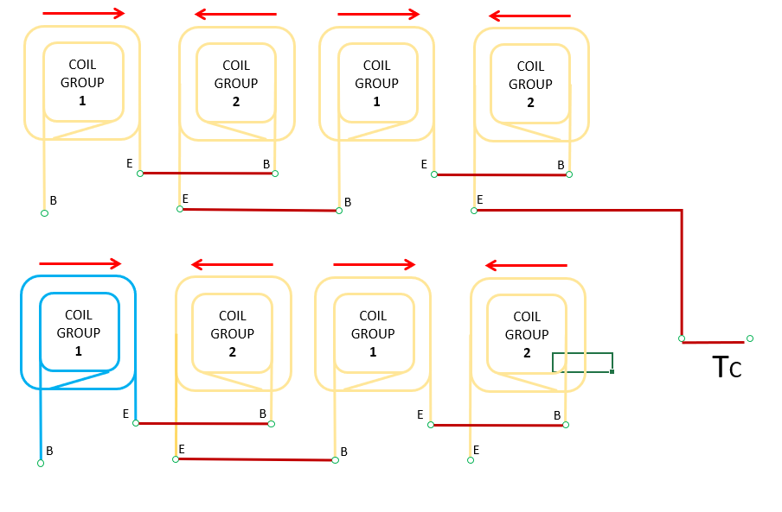

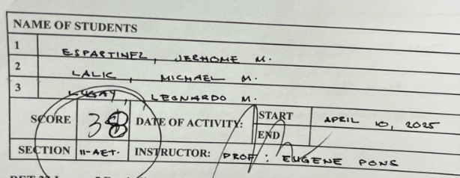
BET 22 Lesson 5 Rewinding and Repair of Split-Phase and Capacitor Type Motors
SINGLE-PHASE ELECTRIC MOTOR REWINDING

Single-Phase Electric Motor Rewinding Activity Rubric
Criteria | Total Points | Excellent | Very Good | Satisfactory | Needs Improvement
- Data Gathering and Initial Inspection | 4 | 5 | 4 | 3 | 2
 | 5 pts | Complete, accurate, well-analyzed data | Mostly accurate with minor omissions | Adequate data, some analysis flaws | Incomplete or unclear
- Stripping and Cleaning | 4 | 5 | 4 | 3 | 2
 | 5 pts | Clean removal, no damage | Slight residue, no damage | Mostly clean, minor flaws | Sloppy or incomplete
- Slot Liner Formation | 3 | 5 | 4 | 3 | 2
 | 5 pts | Precise and snug fit | Slight gaps or wrinkles | Mostly consistent | Loose or misaligned
- Coil Insertion and Insulation | 6 | 8 | 6 | 5 | 3
 | 8 pts | Properly placed, well insulated | Minor insulation flaws | Functional, some misalignment | Inconsistent or loose
- Termination and Connection | 6 | 7 | 6 | 5 | 3
 | 7 pts | Correct, tight, neat, labeled | Slight labeling or routing flaws | Acceptable with minor errors | Loose or unclear
- Coil Tying and Slot Securing | 4 | 5 | 4 | 3 | 2
 | 5 pts | Uniform, tight, secure | Slight unevenness | Generally secure | Inconsistent or loose
- Assembly and Final Testing | 8 | 10 | 8 | 6 | 4
 | 10 pts | Fully functional, neat, all tests passed | Minor test issues, clean build | Operates with flaws | Partially functional
- Safety Procedures | 3 | 5 | 4 | 3 | 2
 | 5 pts | All PPE, safe practices, tidy area | Minor lapses in PPE or safety | Basic PPE and awareness | Inconsistent safety use
TOTAL | 38
 | 50

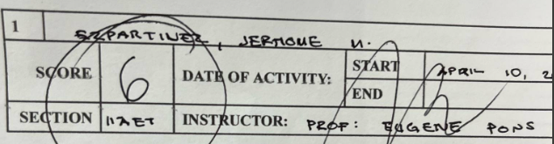
BET 22 Lesson 5 Rewinding and Repair of Split-Phase and Capacitor Type Motors
SINGLE-PHASE ELECTRIC MOTOR REWINDING

Individual Task Participation Rubric
Criteria | Score | Excellent  (2.5 pts) | Good  (2 pts) | Satisfactory (1.5 pts) | Needs Improvement (1 pt)
- Initiative and Task Ownership  Voluntarily starts assigned work - Prepares tools and materials - Organizes own workflow - Takes responsibility for tasks | 1.5 | Always initiates and completes tasks independently and on time | Often starts tasks with minimal prompting | Sometimes needs guidance and reminders | Rarely initiates or avoids responsibility
- Technical Involvement  Winding coils - Stripping and cleaning wires - Wiring and connections - Assembly and mechanical fitting - Testing with measuring tools | 1.5 | Performs all technical tasks with high skill, accuracy, and safety | Completes most technical tasks with minor errors | Contributes with assistance; moderate errors observed | Limited participation; lacks skill or interest
- Team Collaboration and Communication  Shares tasks and tools - Communicates clearly - Listens actively - Offers help when needed | 1.5 | Collaborates actively, supports teammates, and communicates well | Generally, works well with others, communicates adequately | Occasionally cooperative; needs encouragement | Disruptive or disengaged from team effort
- Safety and Work Cleanliness  Uses PPE properly - Handles tools safely - Maintains clean and organized area - Follows safety protocols | 1.5 | Strictly follows all safety and cleanliness standards | Usually safe and tidy, with few lapses | Sometimes forgets safety or leaves area messy | Unsafe work habits or messy station
Total Score | 6
 | 10

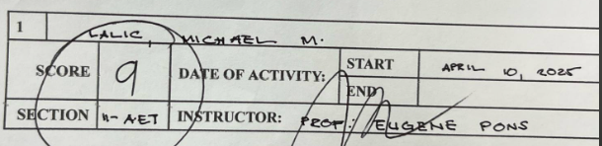
BET 22 Lesson 5 Rewinding and Repair of Split-Phase and Capacitor Type Motors
SINGLE-PHASE ELECTRIC MOTOR REWINDING

Individual Task Participation Rubric
Criteria | Score | Excellent  (2.5 pts) | Good  (2 pts) | Satisfactory (1.5 pts) | Needs Improvement (1 pt)
- Initiative and Task Ownership  Voluntarily starts assigned work - Prepares tools and materials - Organizes own workflow - Takes responsibility for tasks | 2.5 | Always initiates and completes tasks independently and on time | Often starts tasks with minimal prompting | Sometimes needs guidance and reminders | Rarely initiates or avoids responsibility
- Technical Involvement  Winding coils - Stripping and cleaning wires - Wiring and connections - Assembly and mechanical fitting - Testing with measuring tools | 2.5 | Performs all technical tasks with high skill, accuracy, and safety | Completes most technical tasks with minor errors | Contributes with assistance; moderate errors observed | Limited participation; lacks skill or interest
- Team Collaboration and Communication  Shares tasks and tools - Communicates clearly - Listens actively - Offers help when needed | 2.5 | Collaborates actively, supports teammates, and communicates well | Generally, works well with others, communicates adequately | Occasionally cooperative; needs encouragement | Disruptive or disengaged from team effort
- Safety and Work Cleanliness  Uses PPE properly - Handles tools safely - Maintains clean and organized area - Follows safety protocols | 1.5 | Strictly follows all safety and cleanliness standards | Usually safe and tidy, with few lapses | Sometimes forgets safety or leaves area messy | Unsafe work habits or messy station
Total Score | 9
 | 10

