**JOHANNAH MAICA YABA PLATA**

**MANOLITO S. DIAZ**

Punong Barangay

**CHAIRMAN**

**MANOLITO S. DIAZ**

**SANGGUNIAN MEMBERS**

**ALICIA M. NATIVIDAD**

**Chairman, Committee on Violence Against Women & Children**

**MARK J. BRIONES**

**Chairman, Committee on Bids and Awards**

**ROGELIO B. ARANETA**

**Chairman, Committee on Peace & Order**

**CHRISTOPHER L. ESTACIO**

**Chairman, Committee on Appropriation**

**and Committee on Health**

**ANTHONY G. PANTOJA**

**Chairman, Committee on Infrastructure and Committee on Clean & Green**

**RIGOBERTO C. LEONOR**

**Chairman, Committee on Sports**

**And Committee on Environment**

**JOAN PAULINE P. YPOL**

**SK CHAIRMAN**

**Chairman, Committee on Youth Development**

**RONA ANN C. ROXAS**

**Barangay Secretary**

**ELLEN S. ZOLETA**

**Barangay Treasurer**

**Republic of the Philippines**

**City of Manila**

**Barangay 781 Zone 85 District V**

**OFFICE OF THE BARANGAY CHAIRMAN**

**BARANGAY CERTIFICATE**

This is to certify that ***JOHANNAH MAICA YABA PLATA*,*****16***  years old, born on ***NOVEMBER 17, 2008***, is a bonafide resident of this barangay with postal address *at* ***2040 3C PILAR ESTATE A. FRANCISCO ST. STA. ANA, MANILA.***

This certification is being issued upon the request of the bearer whose picture and signature appears below, as a requirement to secure the ***PHILIPPINE*** ***NATIONAL ID*** and for whatever legal purpose it may serve.

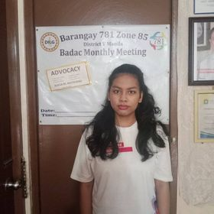

***SIGNED*** and ***ISSUED*** this ***21st*** day of ***APRIL*** 2023at

Barangay 781, Zone 85, Sta. Ana, Manila, Philippines.

**MANOLITO S. DIAZ**

Punong Barangay

***(not valid wit out barangay dry seal)***