C

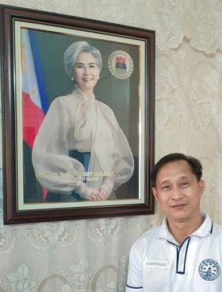0

**Republic of the Philippines**

**City of Manila**

**Barangay 781 Zone 85 District V**

**OFFICE OF THE PUNONG BARANGAY**

**BARANGAY INDIGENCY**

This is to certify that ***BOBBY O. ARCA* , *59*** years old, is a registered voter and bonafide resident with postal address at ***2350 F PASIGLINE ST. STA. ANA, MANILA*.** He/she is one of the indigents of this Barangay.

This certification is being issued upon the request of the

bearer for the reason stated below and for whatever legal purpose it may serve.

Financial Assistance Medical Assistance

School Requirement Hospital Requirement

Burial Assistance Scholarship Application

Educational Assistance Social Pension Application

For Indigent Senior Citizen

Others: ***FOR PANTAWID PAMILYANG PILIPINO PROGRAM***

***SIGNED*** and ***ISSUED*** this 12***h*** day of ***AUGUST*** 2023at Barangay781, Zone 85, Sta. Ana, Manila, Philippines.

**MANOLITO S. DIAZ**

Punong Barangay

***(not valid without barangay dry seal)***

*(not valid without Barangay Seal)*

**CHAIRMAN**

**MANOLITO S. DIAZ**

**SANGGUNIAN MEMBERS**

**ALICIA M. NATIVIDAD**

**Chairman, Committee on Violence Against Women & Children**

**MARK J. BRIONES**

**Chairman, Committee on Bids and Awards**

**ROGELIO B. ARANETA**

**Chairman, Committee on Peace & Order**

**CHRISTOPHER L. ESTACIO**

**Chairman, Committee on Appropriation**

**and Committee on Health**

**ANTHONY G. PANTOJA**

**Chairman, Committee on Infrastructure and Committee on Clean & Green**

**RIGOBERTO C. LEONOR**

**Chairman, Committee on Sports**

**And Committee on Environment**

**JOAN PAULINE P. YPOL**

**SK CHAIRMAN**

**Chairman, Committee on Youth Development**

**RONA ANN C. ROXAS**

**Barangay Secretary**

**ELLEN S. ZOLETA**

**Barangay Treasurer**