Time-series Analysis and Prediction

Introduction
As the name suggests, a time series (TS) is a collection of data points collected at constant time intervals. These are analyzed to determine the long-term trend, to forecast the future or to perform some other form of analysis. But what is different about a TS than a regular regression problem? There are 2 things:
- It is time dependent.
- Along with an increasing or decreasing trend, most TS have some form of seasonality, i.e., variations that are specific to a certain time frame.
The TS was carried out on one of the countries from the list of countries in the original dataset. This made it easier to visualize the change over a time. The data used was Temperature data for Cambodia for an 8-year period starting from 2010 to2018.
Python Environment
Anaconda Environment was used to carry out the analysis. Anaconda Distribution is a Python/R data science distribution that contains a package and environment manager, as well as a collection of over 7,500 open-source tools. Anaconda is platform-independent, so you may use it on Windows, Mac OS X, or Linux. Anaconda is a free and easy-to-use distribution with free community assistance (Anaconda Inc, 2022). To make use of the Anaconda environment, Anaconda has to be installed on the system, the installation package can be found on https://www.anaconda.com/products/distribution after which if you prefer a desktop graphical user interface (GUI) then Anaconda Navigator can be used but if you prefer to use Anaconda prompt (or terminal on Linux or macOS), then use that and conda. You can also switch between them.
You can install, remove, or update any Anaconda package with a few clicks in Navigator, or with a single conda command in Anaconda Prompt (terminal on Linux or macOS) (Anaconda Inc, 2022). There are over 250 packages installed automatically with Anaconda but there are over 7500 open-source packages that can be installed using *conda install* or *pip install* in command prompt.
To carryout the analysis, Jupyter Notebook was used. Jupyter Notebook is the original web application for creating and sharing computational documents. It offers a simple, streamlined, document-centric experience, The classic Notebook interface is a document-oriented interface that allows you to create, view, and execute code Jupyter Notebook. (Jupyter Team, 2022). To check if Jupyter Notebook environment was installed with Anaconda, we use *conda env list*. Also, the environment can be installed using pip install notebook or conda install -c conda-forge notebook.
After all the environments had been correctly installed, the next step was to import the libraries that would be used for the analysis and the file on which the analysis will be carried out on. pandas is a Python package that provides fast, flexible, and expressive data structures designed to make working with "relational" or "labeled" data both easy and intuitive (NumFocus, 2022b). NumPy offers comprehensive mathematical functions, random number generators, linear algebra routines, Fourier transforms, and more (NumFocus, 2022a). Matplotlib is a comprehensive library for creating static, animated, and interactive visualizations in Python (Matplotlib Developers, 2022). All these libraries can be installed using pip install library_name.
import os

cwd = os.getcwd() # Get the current working directory (cwd) files = os.listdir(cwd) # Get all the files in that directory print("Files in %r: %s" % (cwd, files))
# import
import pandas as pd import numpy as np
import matplotlib.pylab as plt

# plotting inside a notebook
%matplotlib inline
# define a new standard size for plots from matplotlib.pylab import rcParams rcParams['figure.figsize'] = 15, 6

Data import
# Import from csv file into a DataFrame
data = pd.read_csv(r'C:\Users\Jean-Marie Chukwuma\Downloads\data for␣ '→analysis\Timeseries_analysis\Data\cambodia.csv', index_col='Dates',␣ '→parse_dates=True)
print(data.head())

Dates | Cambodia
2010-01-01 | 25.75
2010-02-01 | 27.70
2010-03-01 | 28.51
2010-04-01 | 30.02
2010-05-01 | 29.66
The data has a time object (Dates) as index and ‘Cambodia’ as column. We can check the data type of the index with the following command:
#check datatype of index
data.index
DatetimeIndex(['2010-01-01', '2010-02-01', '2010-03-01', '2010-04-01',
'2010-05-01', '2010-06-01', '2010-07-01', '2010-08-01',
'2010-09-01', '2010-10-01',
…
'2018-03-01', '2018-04-01', '2018-05-01', '2018-06-01',
'2018-07-01', '2018-08-01', '2018-09-01', '2018-10-01',
'2018-11-01', '2018-12-01'],
dtype='datetime64[ns]', name='Dates', length=108, freq=None)
#convert to time series object: ts = pd.Series(data['Cambodia']) ts.head(10)
Dates
2010-01-01 25.75
2010-02-01 27.70
2010-03-01 28.51
2010-04-01 30.02
2010-05-01 29.66
2010-06-01 28.56
2010-07-01 27.51
2010-08-01 26.97
2010-09-01 27.25
2010-10-01 26.26
Name: Cambodia, dtype: float64

# If NaN values are included in the time series?
print('If NaN values are included in the time series?: ', ts.isnull().any())
If NaN values are included in the time series?: False

Check for stationarity
Stationarity is considered as an invariance under the time shift. There are two kinds of stationarity, weak and strong. A stochastic process {X(t)} is said to be strongly stationary or stationary in the strict sense if the joint distribution is invariant under the time shift. A second-order stochastic process {X(t)} is said to be weakly stationary or stationary in the wide sense if its average is constant, if its covariance function K(s, t) depends only on the difference s − t, and if K is continuous as a two-variable function (Kakihara, 2002). Most statistical models for time series work under the assumption that the time series is stationary. Intuitively, we can say that if a time series has a certain behavior over time, there is a very high probability that this can also be assumed in the future.
We can assume that a TS is stationary if it has constant statistical properties over time, i.e., the following:
- Constant Mean
- Constant Variance
- An autocovariance that does not depend on time.
The check for stationarity starts with the simple drawing of the TS and an initial visual analysis.

Drawing/Plotting the time series

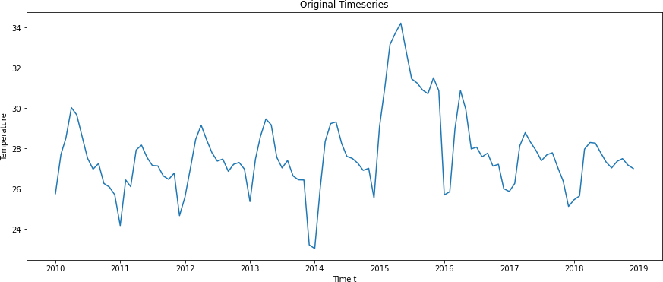

According to (Hyndman & Athanasopoulos, 2022), a stationary time series is one whose properties do not depend on the time at which the series is observed. This means that time series with trends, or with seasonality, are not stationary the trend and seasonality will affect the value of the time series at different times the data in certain seasons and lower at other seasons.
To check the stationarity of the time series the following steps were used:
- Plotting the moving average which is a technique to get an overall idea of the trends in a data set.
- the moving standard deviation (visual technique) which is a statistical measurement of volatility of the data.
Dickey-Fuller (DF) Test: This is a statistical test for stationarity. The null hypothesis of DF test is that there is a unit root in an AR model, which implies that the data series is not stationary. The alternative hypothesis is generally stationarity or trend stationarity but can be different depending on the version of the test being used (Jalil & Rao, 2019). Here the null hypothesis is that the time series is not stationary. The test results include a test statistic and some critical values for confidence levels. If the “test statistic” is smaller than the “critical value”, we can reject the null hypothesis and say that the series is stationary.
The function takes a time series and a corresponding label as input and plots the moving average and standard deviation and performs a Dickey-Fuller test.

Function for testing the stationarity of a time series
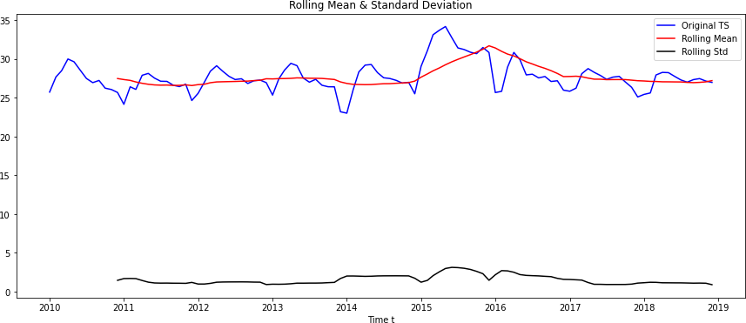

Results of Dickey-Fuller Test:
Test Statistic | -4.539774
p-value | 0.000167
Lags Used | 1.000000
Number of Observations Used | 106.000000
Critical Value (1%) | -3.493602
Critical Value (5%) | -2.889217
Critical Value (10%) | -2.581533

Evaluation:

Visual: We see that there is a linear trend in the mean and the standard deviation with time, but a peak can be seen in the mean between the year 2015 and 2016. Also based on the Original TS, the data is seen to have a seasonality and a trend. This means that the TS is not stationary.

Dickey-Fuller-Test: From the results of the the DT test, we see that the test statistic is significantly smaller than the critical values of the confidence levels, i.e., the null hypothesis (time series is non-stationary) can be rejected.

Implementation of Stationarity

From the visual technique, we see that there is non-stationarity in the TS. Therefore, the basic point is to analyze or estimate a time series’ trend and seasonality, then remove the observed trend and seasonality from the time series to produce a stationary time series. Then, in this stationary time series, statistical forecasting techniques can be used. The estimated values are then converted to the original scale by reintroducing trend and seasonality.

  - Estimation and elimination of the trend component

A log transformation may be used to erase a tendency in data variability (the higher the value, the bigger the variance). Log transformation is a data transformation method in which it replaces each variable x with a log(x). log transformation is to reduce the variability of data, especially in data sets that include outlying observations (Feng et al., 2014).
Dates

# log Transfo ts_log = np print(ts_lo # plot plt.plot(ts plt.title('lo plt.show() | rmation  .log(ts) g)  _log)  g-Transformation Timeseries')
2010-01-01 | 3.248435
2010-02-01 | 3.321432
2010-03-01 | 3.350255
2010-04-01 | 3.401864
2010-05-01 | 3.389799  …
2018-08-01 | 3.296947
2018-09-01 | 3.309082
2018-10-01 | 3.313822
2018-11-01 | 3.302113
2018-12-01 | 3.295837
The results of the log transformation show a more linear function compared to the results of the original data. With this transformation, TS analysis can be carried out further to remove trends and seasonality.
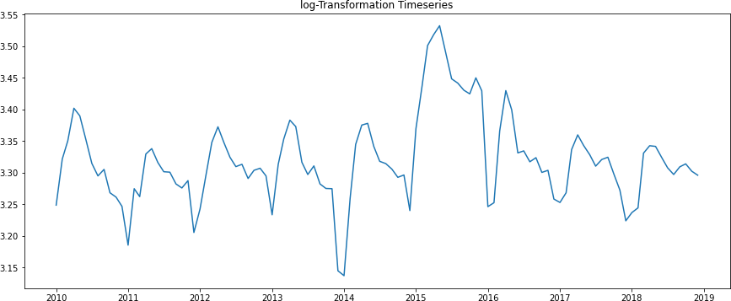

Some of the most commonly used methods for estimating and removing trends are: Aggregation - average for a period such as monthly / weekly averages Smoothing - rolling averages
Polynomial fitting - fit a regression model

Smoothing:

Moving average

Smoothing data removes random variation and shows trends and cyclic components. Inherent in the collection of data taken over time is some form of random variation. There exist methods for reducing of canceling the effect due to random variation. An often-used technique in industry is "smoothing". This technique, when properly applied, reveals more clearly the underlying trend, seasonal and cyclic components (Guthrie, 2020). Smoothing is useful as a data preparation technique as it can reduce the random variation in the observations and better expose the structure of the underlying causal processes. The rolling() function on the Series Pandas object will automatically group observations into a window. You can specify the window size, and by default a trailing window is created. Once the window is created, we can take the mean value, and this is our transformed dataset.
moving_avg = pd.Series.rolling(ts_log,12).mean() plt.plot(ts_log, label='log-transformed TS') plt.plot(moving_avg, color='red', label='moving average') plt.legend(loc='best')

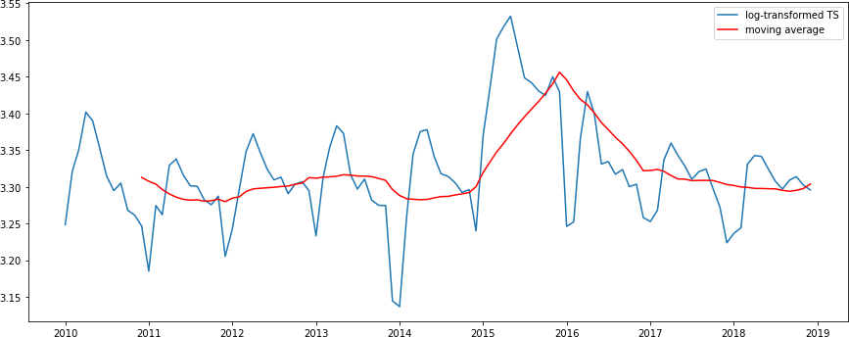

The red line shows the rolling average. The rolling average was then subtracted from the original series (ts_log).
# Difference formation log-transformed TS - estimated trend (moving average)
ts_log_moving_avg_diff = ts_log - moving_avg ts_log_moving_avg_diff.head()
Dates
2010-01-01 NaN
2010-02-01 NaN
2010-03-01 NaN
2010-04-01 NaN
2010-05-01 NaN

The rolling average is determined based on the last 12 values; hence it is not specified for the first 11 values. It is for this reason the first results return NaN values. 20 values are returned, we would see that from the 12th value, a value will be returned for the rolling average.
# Removing the NaN values ts_log_moving_avg_diff.dropna(inplace=True) ts_log_moving_avg_diff.head

2010-12-01 | -0.066328
2011-01-01 | -0.122430
2011-02-01 | -0.029131
2011-03-01 | -0.034336
2011-04-01 | 0.039116  …
2018-08-01 | 0.001748
2018-09-01 | 0.015153
2018-10-01 | 0.018579
2018-11-01 | 0.004380
2018-12-01 | -0.007911

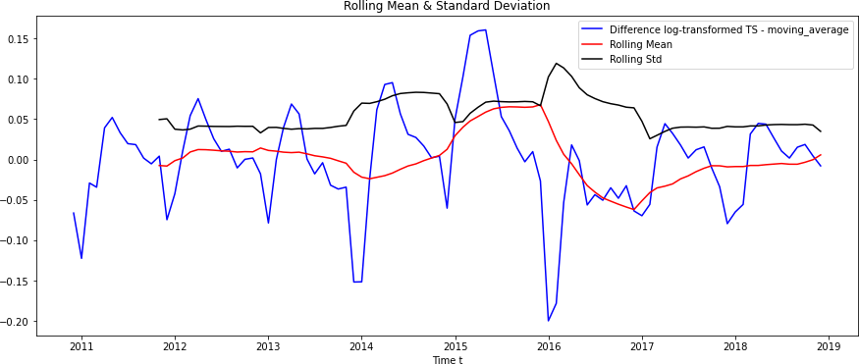
# Renewed test for stationarity
# Input: Residual = logarithmised time series - MovingAverage
test_stationarity(ts_log_moving_avg_diff, 'Difference log-transformed TS -␣
'→moving_average')

Results of Dickey-Fuller Test:
Test Statistic | -5.536097
p-value | 0.000002
Lags Used | 1.000000
Number of Observations Used | 95.000000
Critical Value (1%) | -3.501137
Critical Value (5%) | -2.892480
Critical Value (10%) | -2.583275

With the results of the DF test, we see the Test statistics change slightly, but there is no specific trend anymore. Also, the test statistic is seen to be lesser than the critical values, so we can say with 95% confidence that this is

a stationary series.
      - However, a disadvantage in this approach is that the time span must be strictly defined. In this case, we can assume annual averages.
      - Furthermore, we can use a “weighted moving average,” which gives more weight to recent numbers. Assigning weights can be done in a variety of ways. The exponentially weighted moving average is a common one, in which weights are allocated to all prior values with a ‘decay factor’.

Exponentially Weighted Moving Average
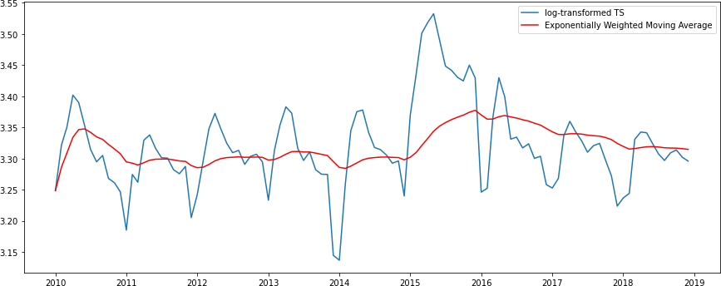
exp_weighted_avg = pd.Series.ewm(ts_log, halflife=12).mean() plt.plot(ts_log, label='log-transformed TS')
plt.plot(exp_weighted_avg, color='red', label='Exponentially Weighted Moving␣
'→Average')
plt.legend(loc='best')

The parameter ‘halflife’ is used to define the amount of exponential decay.
# Difference formation log-transformed TS - estimated trend (Exponentially␣
'→Weighted Moving Average)
ts_log_ewma_diff = ts_log - exp_weighted_avg test_stationarity(ts_log_ewma_diff, 'Difference log-transformed TS -␣ '→exp_weighted_avg ')

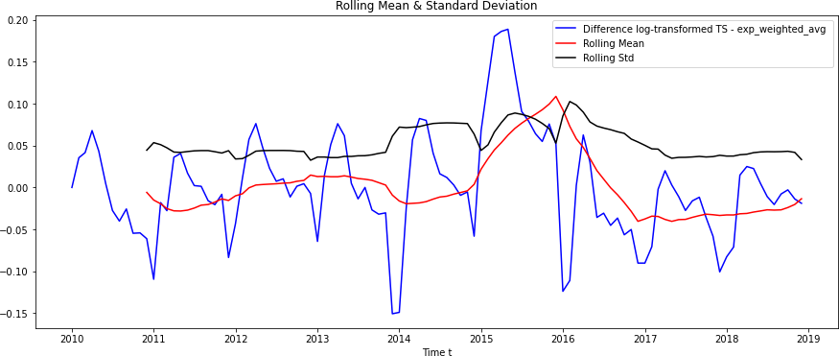

Results of Dickey-Fuller Test:
Test Statistic | -4.965470
p-value | 0.000026
Lags Used | 1.000000
Number of Observations Used | 106.000000
Critical Value (1%) | -3.493602
Critical Value (5%) | -2.889217
Critical Value (10%) | -2.581533
dtype: float64
This TS has larger variations in the mean and standard deviation. Also, the test statistic remains smaller than the critical value and the result is better than the previous case. Also there are no missing values in this case.
ts_log_ewma_diff.head()
Dates
2010-01-01 0.000000
2010-02-01 0.035445
2010-03-01 0.041596
2010-04-01 0.067848
2010-05-01 0.043302
2010-06-01 0.004454
2010-07-01 -0.027434
2010-08-01 -0.040090
2010-09-01 -0.025642
2010-10-01 -0.054634
2010-11-01 -0.054171
2010-12-01 -0.061121
Name: Cambodia, dtype: float64

Elimination of Trend and Seasonality
The above-mentioned easy trend reduction strategies may not always work, and issues can develop, especially when seasonality is high. As a result, let’s look at two more techniques to get rid of trend and seasonality:
Differencing - Differencing x(t+1) - x(t)
Decomposition - Trend and seasonality are modeled and then removed from the model.
Differentiating is one of the most common ways for dealing with trend and seasonality. The differ- ence between the observation at one moment and the observation at the previous moment is used in this technique.

Differencing:
The first order difference can be determined in pandas as follows:
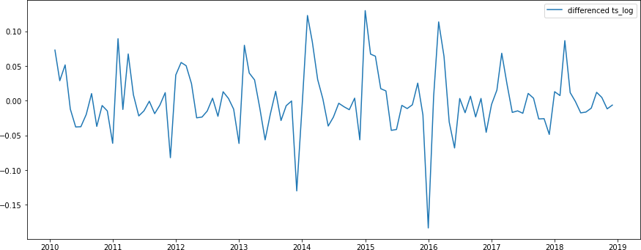
# Take first difference:
ts_log_diff = ts_log - ts_log.shift(periods=1)
# plot
plt.plot(ts_log_diff, label='differenced ts_log') plt.legend(loc='best')
plt.show()

# Stationarity test for the differentiated log-transformed time series
ts_log_diff.dropna(inplace=True)
test_stationarity(ts_log_diff, 'Difference log-transformed TS -␣
'→differencing_trend')



Results of Dickey-Fuller Test:
Test Statistic | -4.449253
p-value | 0.000243
Lags Used | 10.000000
Number of Observations Used | 96.000000
Critical Value (1%) | -3.500379
Critical Value (5%) | -2.892152
Critical Value (10%) | -2.583100
dtype: float64
The mean and standard deviation, as can be seen, have relatively minor fluctuations over time. The Dickey-Fuller test statistic is also less than the 10% critical threshold, indicating that the time series is stationary with 90% confidence.

Decomposition:
Separate models are used to model the trend and seasonality. The residuals and the modelled components (trend + seasonality) are the outputs.
# import the function 'seasonal_decompose'
from statsmodels.tsa.seasonal import seasonal_decompose
# Decomposition of the log-transformed time series
decomposition = seasonal_decompose(ts_log)
# Access to the components of the decomposition
trend = decomposition.trend seasonal = decomposition.seasonal residual = decomposition.resid
# Plotting the components
plt.subplot(411)
plt.plot(ts_log, label='Original')

plt.legend(loc='best') plt.subplot(412) plt.plot(trend, label='Trend') plt.legend(loc='best') plt.subplot(413)
plt.plot(seasonal,label='Seasonality') plt.legend(loc='best') plt.subplot(414)
plt.plot(residual, label='Residuals') plt.legend(loc='best') plt.tight_layout()
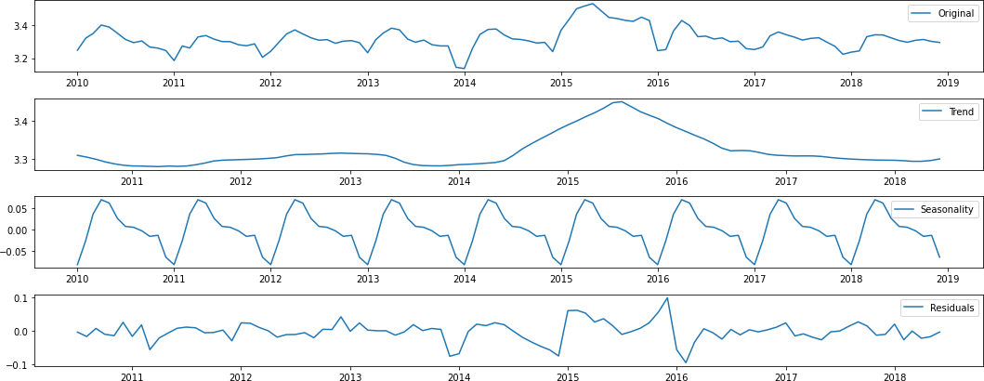


# Stationarity test for the residual ts_log_decompose = residual ts_log_decompose.dropna(inplace=True) test_stationarity(ts_log_decompose, 'Residual')

Results of Dickey-Fuller Test:
Test Statistic | -6.546561e+00
p-value | 9.068594e-09
Lags Used | 1.000000e+00
Number of Observations Used | 9.400000e+01
Critical Value (1%) | -3.501912e+00
Critical Value (5%) | -2.892815e+00
Critical Value (10%) | -2.583454e+00
dtype: float64

The Dickey-Fuller test statistic is significantly lower than the 1% critical value. So this time series is stationary with 99% confidence.

Model Adjustment
The time series was then adjusted according to Differencing. Also, adding noise and seasonality to anticipated residuals is relatively simple. After making the time series stationary. In this case we have to use statistical models like ARIMA to predict the data.
ARIMA stands for Auto-Regressive Integrated Moving Averages. ARIMA models offer a different perspective on time series forecasting. The two most generally used approaches to time series fore- casting are exponential smoothing and ARIMA models, which provide complimentary approaches to the problem. While exponential smoothing models try to explain the data’s trend and sea- sonality, ARIMA models strive to characterize the data’s autocorrelations. For a stationary time series, the ARIMA forecast is only a linear equation. The predictors are determined by the ARIMA model’s parameters (p, d, q):
Number of AR (Auto-Regressive) terms (p): An autoregression model, is a linear combination of the variable’s previous values. It is a regression of the variable against itself. AR terms are only lags of the dependent variable. For example, if p=5, the predictors for x(t) are: x(t-1), … ,x(t-5).
Number of MA (Moving Average) terms (q): In a regression-like model, a moving average model incorporates past predicted errors. MA terms are lagged forecast errors in the prediction equation. For example, if q=5, the predictors for x(t) are: e(t-1), …, e(t-5), where e(i) is the difference between the moving average at the same time and the actual value.
Number of differences (d): These are the number of differences, i.e. in this case we have taken the first order. So we can either set this variable d = 0 and pass ‘ts_log_diff’ or pass the original log-transformed TS and set d = 1. Both produce the same results.
What is important here is how to determine the value of ‘p’ and ‘q’. Two plots to determine these numbers.
Autocorrelation Function (ACF): It’s a statistic for how well a time series correlates with a delayed version of itself.
Partial Autocorrelation Function (PACF): This determines the correlation between the time series and a lagged version of itself after removing the changes previously accounted by the preceding comparisons.

ACF & PACF Plots
The ACF and PACF plots for the time series after differentiation can be plotted as follows:
#import functions to determine the ACF and PACF

from statsmodels.tsa.stattools import acf, pacf
# Calculation of acf and pacf
numlag = 20
lag_acf = acf(ts_log_diff, nlags=numlag)
lag_pacf = pacf(ts_log_diff, nlags=numlag, method='ols')
#Plot ACF:
plt.subplot(121) plt.plot(lag_acf)
plt.axhline(y=0,linestyle='--',color='gray')
plt.axhline(y=-1.96/np.sqrt(len(ts_log_diff)),linestyle='--',color='gray') plt.axhline(y=1.96/np.sqrt(len(ts_log_diff)),linestyle='--',color='gray') plt.title('Autocorrelation Function')
plt.xticks(np.arange(0, numlag+1, step=1.0))
#Plot PACF:
plt.subplot(122) plt.plot(lag_pacf)
plt.axhline(y=0,linestyle='--',color='gray')
plt.axhline(y=-1.96/np.sqrt(len(ts_log_diff)),linestyle='--',color='gray') plt.axhline(y=1.96/np.sqrt(len(ts_log_diff)),linestyle='--',color='gray') plt.title('Partial Autocorrelation Function')
plt.xticks(np.arange(0, numlag+1, step=1.0)) plt.tight_layout()
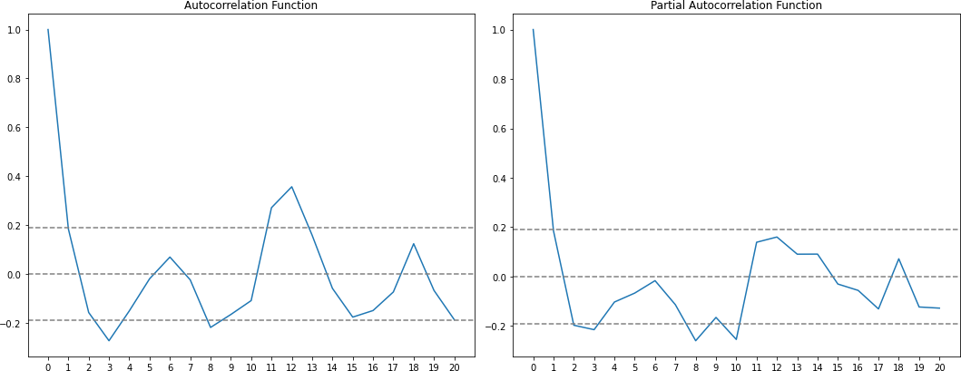

In this diagram, the two dashed lines on either side of 0 are the confidence intervals (97.5%). These
can be used to determine the values ‘p’ and ‘q’ as:
MA(q) - The lag value at which the ACF diagram falls below the upper confidence interval for the first time. In this case q = 2.
AR(p) - The lag value at which the PACF chart falls below the upper confidence interval for the first time. In this case p = 2.
Now we can generate 3 different ARIMA models and each model will be given: AIC (Akaike Information Criterion)
BIC (Bayesian Information Criterion) RSS (Residual Sum of Squares)
# Import
from statsmodels.tsa.arima_model import ARIMA
#from statsmodels.tsa.arima_model import ARIMAResults

AR(p)-Modell:
# AR(p)-Modell:
model = ARIMA(ts_log, order=(2, 1, 0)) results_AR = model.fit(disp=-1) plt.plot(ts_log_diff, label='ts_log_diff')
plt.plot(results_AR.fittedvalues, color='red', label='AR(2)-fitted model') plt.title('RSS: %.4f'% sum((results_AR.fittedvalues-ts_log_diff)**2)) plt.legend()
# Output criteria for model comparisons
print ('AIC (Akaike Information Criterion): ', results_AR.aic) print ('BIC (Bayesian Information Criterion): ', results_AR.bic)

AIC (Akaike Information Criterion): -358.3239773334688 BIC (Bayesian Information Criterion): -347.63266199562116
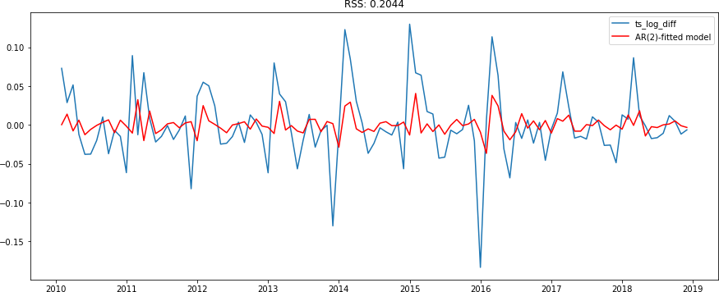

MA(q)-Modell
# MA(q)-Modell
model = ARIMA(ts_log, order=(0, 1, 2)) results_MA = model.fit(disp=-1) plt.plot(ts_log_diff, label='ts_log_diff')
plt.plot(results_MA.fittedvalues, color='red', label='MA(2)-fitted model') plt.title('RSS: %.4f'% sum((results_MA.fittedvalues-ts_log_diff)**2)) plt.legend()
# Output criteria for model comparisons
print ('AIC (Akaike Information Criterion): ', results_MA.aic) print ('BIC (Bayesian Information Criterion): ', results_MA.bic)

AIC (Akaike Information Criterion): -355.9729405120327 BIC (Bayesian Information Criterion): -345.2816251741851
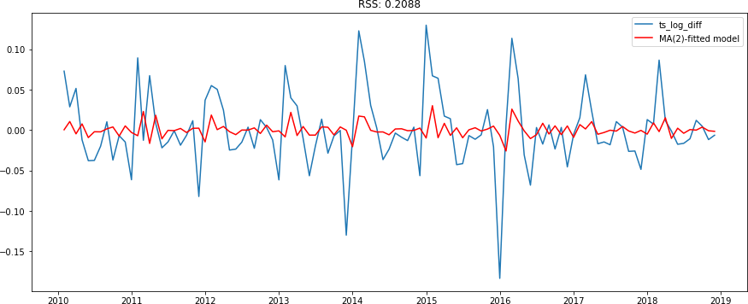

Combined model: ARIMA(p,d,q) model:
# combined model ARIMA(p,d,q) model::
model = ARIMA(ts_log, order=(2, 1, 2)) # define model
results_ARIMA = model.fit(disp=-1) # # plotting

size = len(results_ARIMA.fittedvalues) plt.plot(ts_log_diff, label='ts_log_diff')
plt.plot(results_ARIMA.fittedvalues, color='red', label='ARIMA(2,1,2)') plt.title('RSS: %.4f'% sum((results_ARIMA.fittedvalues-ts_log_diff[0:size])**2)) # Output criteria for model comparisons
print ('AIC (Akaike Information Criterion): ', results_ARIMA.aic) print ('BIC (Bayesian Information Criterion): ', results_ARIMA.bic)

AIC (Akaike Information Criterion): -367.3463355782216 BIC (Bayesian Information Criterion): -351.30936257145015
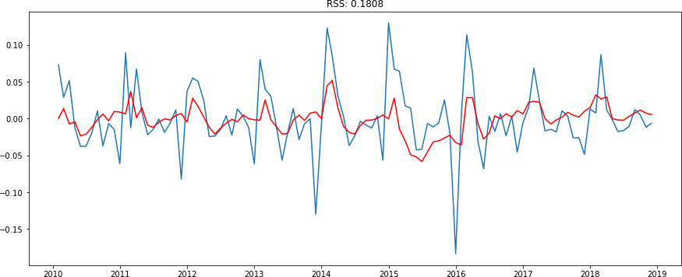

4.0.1 Evaluation
We see that the AR and MA models have almost the same RSS, but the combined model is clearly better. Now all that remains is the last step, i.e., to bring the values back to the original scale.
1 Forecast / Prediction
1.1 Predict() Function
# RSS
a = predict_ARIMA[0:size]-ts[1:size] a.dropna(inplace=True)
rss = sum(a**2)
# plot data + fitted model
plt.plot(predict_ARIMA, color='green', linewidth=2, label='fitted␣
'→ARIMA-Modell', linestyle='--') plt.plot(ts, label='Original Timeseries')
plt.title('Original Timeseries vs. Modell / RSS: %.4f' %rss) plt.legend(loc='best')
19
# get fitted model in original space with the predict function
predict_ARIMA_log = results_ARIMA.predict(typ='levels')
# reverse log transform
predict_ARIMA = np.exp(predict_ARIMA_log)
# get fitted model in original space with the predict function
forecast_ARIMA_log = results_ARIMA.predict(start='2010-12-01', end='2018-12-01'␣
'→,typ='levels')
# reverse log transform
forecast_ARIMA = np.exp(forecast_ARIMA_log)
# Plotting
# plot fitted model
plt.plot(predict_ARIMA, color='gray', linewidth=1, label='fitted ARIMA-Modell␣
'→(past)', linestyle='--')
# plot prediction/forecast
plt.plot(forecast_ARIMA, color='green', linewidth=2, label='fitted ARIMA-Modell␣
'→(future)', linestyle='--')
# plot data
plt.plot(ts, label='Original Timeseries')

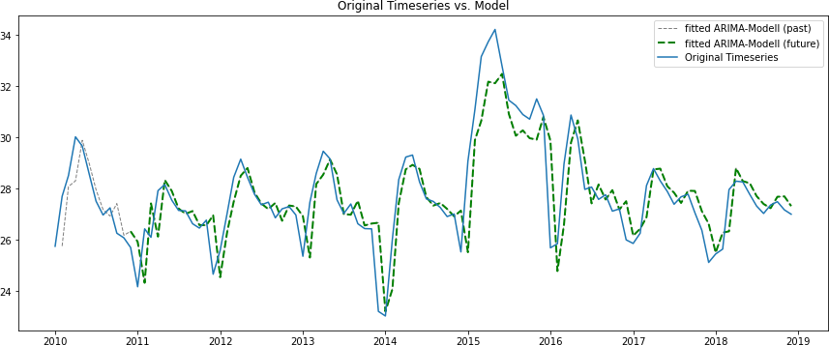

1.2 Forecast() Function
Provides a confidence interval in addition to the forecast (default: 95% confidence interval).
# one-step out-of sample forecast
n_steps = 60
forecast = results_ARIMA.forecast(steps=n_steps)
#95% CI (default) or set␣

# reverse log transform m_forecast = np.exp(forecast[0]) s_forecast = np.exp(forecast[1])
forecast_ci95 = np.exp(forecast[2])
# create a index for all predicted time steps
idx = pd.date_range(start='2019-01-01', periods=n_steps, freq='MS')
# create a dataframe with forecast values + confidence interval
fc_95 = pd.DataFrame(np.column_stack([m_forecast, s_forecast, forecast_ci95]), index=idx, columns=['forecast', 'std_error',␣
'→'lower_ci_95', 'upper_ci_95']) print (fc_95.head())

#convert columns to time series objects ts_forecast = pd.Series(fc_95['forecast']) lower = pd.Series(fc_95['lower_ci_95']) upper = pd.Series(fc_95['upper_ci_95'])
#plot
plt.plot(ts, label='Original Timeseries')
plt.plot(predict_ARIMA, color='gray', linewidth=1, label='fitted ARIMA-Model␣
'→(past)', linestyle='--')
plt.plot(ts_forecast, color='red', linestyle='--', label='forecast ARIMA') plt.title('Prediction (5 years) + 95% confidence interval')
# plot Confidence interval
plt.fill_between(ts_forecast.index, lower, upper, color='b', alpha=0.2,␣
'→label='Confidence interval') plt.legend(loc='best')
forecast std_error lower_ci_95 upper_ci_95 2019-01-01 27.255481 1.041305 25.176844 29.505733
2019-02-01 27.580818 1.060478 24.582418 30.944944
2019-03-01 27.834091 1.068465 24.446020 31.691728
2019-04-01 27.996282 1.071146 24.467986 32.033361
2019-05-01 28.088607 1.071871 24.516122 32.181673

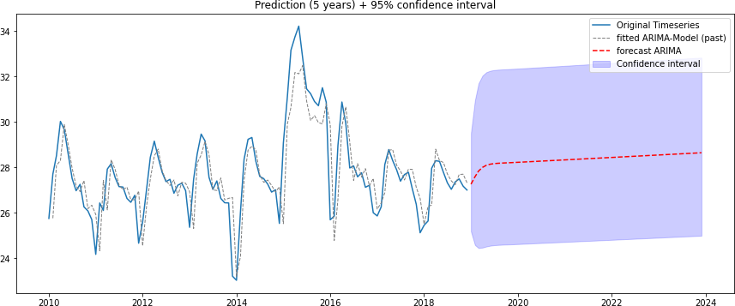

Further Model Approaches
  - Using SARIMA - Seasonal Auto Regressive Integrated Moving Averages
SARIMA (Seasonal ARIMA) is a modification of ARIMA that explicitly allows univariate time series data with a seasonal component. A difference filter is included in SARIMA models to eliminate the seasonal figure. As a result, time series with a seasonal figure of periodicity s, in addition to a possible trend, are considered.

ACF & PACF Plots
The ACF and PACF plots for the time series after differentiation (1st order difference) still shows a clear seasonality.
# Periodizität s
s = 12 # s = 12 für monatliche Daten
numlag = 36
# first difference
diff1 = ts_log - ts_log.shift(periods=1) diff1.dropna(inplace=True)
# seasonal component removed
diff_n = diff1 - diff1.shift(periods=s) diff_n.dropna(inplace=True)
# calculate acf and pacf
lag_acf1 = acf(diff1, nlags=numlag)
lag_pacf1 = pacf(diff1, nlags=numlag, method='ols')
lag_acf2 = acf(diff_n, nlags=numlag)
lag_pacf2 = pacf(diff_n, nlags=numlag, method='ols')
# output
print('ACF and PACF for the time series after differentiation (1st order␣
'→difference)')
#Plot ACF:
plt.subplot(121) plt.plot(lag_acf1)
plt.axhline(y=0,linestyle='--',color='gray')
plt.axhline(y=-1.96/np.sqrt(len(diff1)),linestyle='--',color='gray') plt.axhline(y=1.96/np.sqrt(len(diff1)),linestyle='--',color='gray') plt.title('Autocorrelation Function')
plt.xticks(np.arange(0, numlag+1, step=1.0))
#Plot PACF:

plt.subplot(122) plt.plot(lag_pacf1)
plt.axhline(y=0,linestyle='--',color='gray')
plt.axhline(y=-1.96/np.sqrt(len(diff1)),linestyle='--',color='gray') plt.axhline(y=1.96/np.sqrt(len(diff1)),linestyle='--',color='gray') plt.title('Partial Autocorrelation Function') plt.xticks(np.arange(0, numlag+1, step=1.0))
plt.tight_layout() plt.show()
# output
print('ACF and PACF for the time series after removing seasonality (s=12)')
#Plot ACFts_log_decompose.dropna(inplace=True)
plt.subplot(121) plt.plot(lag_acf2)
plt.axhline(y=0,linestyle='--',color='gray')
plt.axhline(y=-1.96/np.sqrt(len(diff_n)),linestyle='--',color='gray') plt.axhline(y=1.96/np.sqrt(len(diff_n)),linestyle='--',color='gray') plt.title('Autocorrelation Function')
plt.xticks(np.arange(0, numlag+1, step=1.0))
#Plot PACF:
plt.subplot(122) plt.plot(lag_pacf2)
plt.axhline(y=0,linestyle='--',color='gray')
plt.axhline(y=-1.96/np.sqrt(len(diff_n)),linestyle='--',color='gray') plt.axhline(y=1.96/np.sqrt(len(diff_n)),linestyle='--',color='gray') plt.title('Partial Autocorrelation Function') plt.xticks(np.arange(0, numlag+1, step=1.0))
plt.tight_layout()
plt.show()
ACF and PACF for the time series after differentiation (1st order difference)

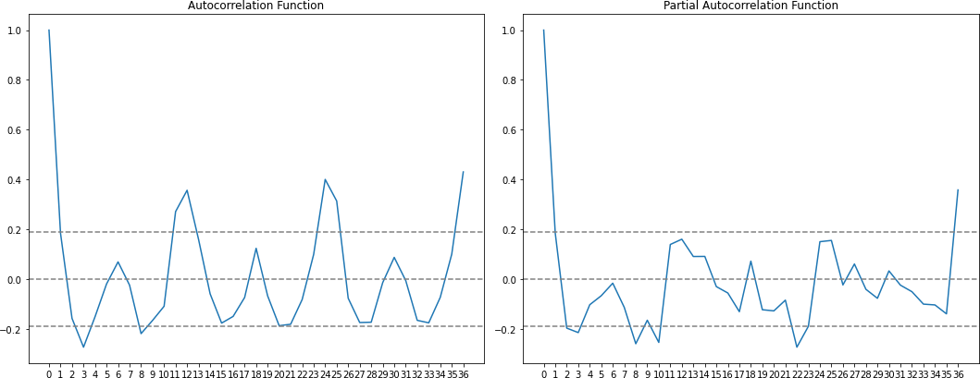

ACF and PACF for the time series after removing seasonality (s=12)
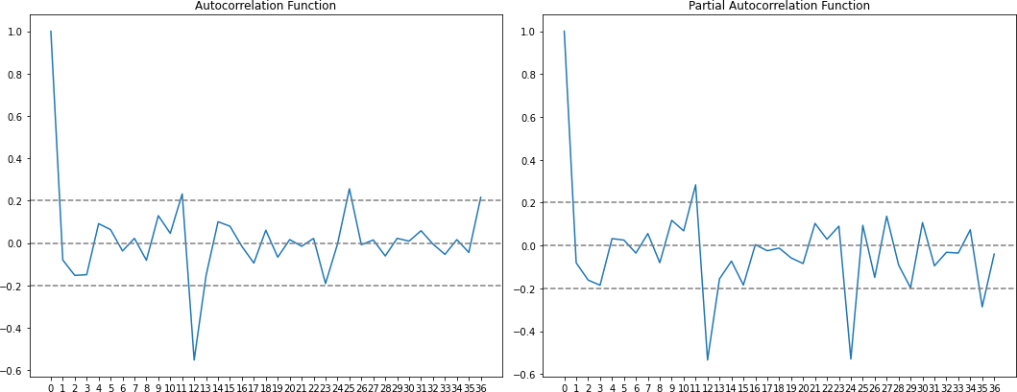

import statsmodels.api as sm

# cobined model SARIMA(p,d,q) model:
model = sm.tsa.statespace.SARIMAX(ts_log,
order=(2,1,2), seasonal_order=(1,0,1,12), enforce_stationarity=True, enforce_invertibility=False)

results_SARIMA = model.fit()
size = len(results_SARIMA.fittedvalues) plt.plot(ts_log)
plt.plot(results_SARIMA.fittedvalues[1:],
plt.title('RSS: %.4f'% sum((results_SARIMA.fittedvalues[1:size]-ts_log[1:
'→size])**2))
# Output criteria for model comparisons
print ('AIC (Akaike Information Criterion): ', results_SARIMA.aic) print ('BIC (Bayesian Information Criterion): ', results_SARIMA.bic)
color='red')
AIC (Akaike Information Criterion): -390.94538678681596 BIC (Bayesian Information Criterion): -372.2355849455826
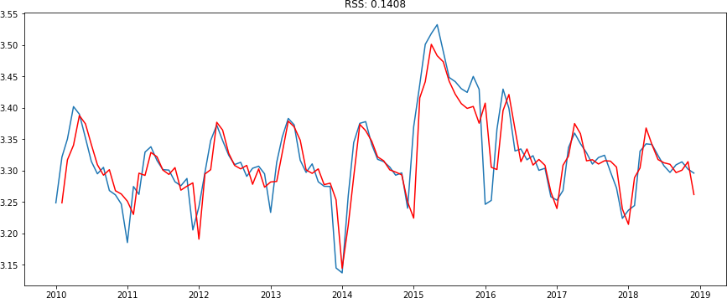

Evaluation
We see that the S-ARIMA model is better adapted to our time series. The last step was to bring the values to the original scale.

# get fitted model in original space with the predict function
predict_SARIMA = np.exp(results_SARIMA.predict(typ='levels'))
# plot data + fitted model
plt.plot(predict_SARIMA, color='green', linewidth=2, label='fitted␣
'→SARIMA-Modell', linestyle='--') plt.plot(ts, label='Original Timeseries')
plt.title('Original Timeseries vs. model / RSS: %.4f'% sum((predict_SARIMA[0:
'→size]-ts[0:size])**2))
plt.legend(loc='best') plt.show()
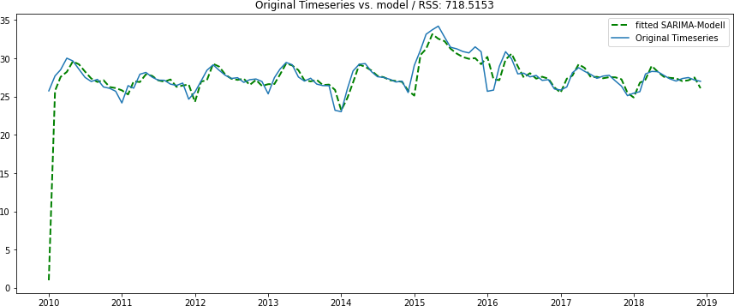

Forecast / Prediction

predict()
# get fitted model in original space with the predict function forecast_SARIMA = np.exp(results_SARIMA.predict(start='2019-01-01',␣ '→end='2029-12-01' ,typ='levels'))
#forecast_SARIMA = results_SARIMA.predict(start='2019-01-01', end='2029-12-01'␣
'→,typ='levels')

# plot data + fitted model
plt.plot(predict_SARIMA, color='gray', linewidth=1, label='fitted SARIMA-Modell␣
'→(past)', linestyle='--')
plt.plot(forecast_SARIMA, color='green', linewidth=2, label='fitted␣
'→SARIMA-Modell (future)', linestyle='--') plt.plot(ts, label='Original Timeseries') plt.title('Original Timeseries vs. Model') plt.legend(loc='best')

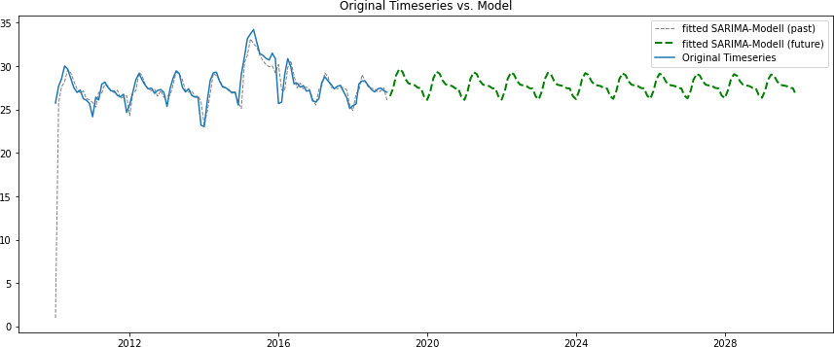

    - get_prediction()
pred_dynamic_log = results_SARIMA.get_prediction(start=pd.
'→to_datetime('2019-01-01'),

'→to_datetime('2029-12-01'), '→full_results=True)
pred_dynamic_ci = pred_dynamic_log.conf_int()
# back transform (log) predicted results
end=pd. dynamic=True,␣

pred_dynamic = np.exp(pred_dynamic_log.predicted_mean)
# create plot
plt.plot(ts, label='Original Timeseries') plt.title('Original Timeseries vs. Modell')
plt.plot(predict_SARIMA, color='gray', linewidth=1, label='fitted SARIMA-Modell␣
'→(past)', linestyle='--')
plt.plot(pred_dynamic, color='green', linewidth=2, label='fitted SARIMA-Modell␣
'→(future)', linestyle='--')
# plot confidence intervall plt.fill_between(pred_dynamic_ci.index, np.exp(pred_dynamic_ci.iloc[:, 0]),
np.exp(pred_dynamic_ci.iloc[:, 1]), color='k', alpha=.25, label='95% Confidence␣
'→interval')
plt.xlabel('Date') plt.ylabel('Values') plt.legend(loc='best') plt.show()

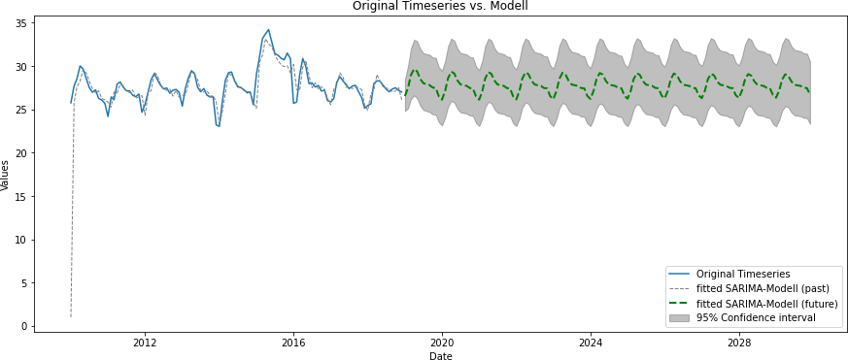

The results of the prediction show a linear trend in 10 years. This means that in the next 10 years, there would be no abrupt increase in temperature in Cambodia. This gives a chance to

References
Anaconda Inc. (2022, April 7). Anaconda Documentation — Anaconda documentation. https://docs.anaconda.com/
Feng, C., Wang, H., Lu, N., Chen, T., He, H., Lu, Y., & Tu, X. M. (2014). Log-transformation and its implications for data analysis. Shanghai Archives of Psychiatry, 26(2), 105–109. https://doi.org/10.3969/j.issn.1002-0829.2014.02.009
Guthrie, W. F. (2020). Nist/sematech e-Handbook of Statistical Methods (NIST Handbook 151). https://doi.org/10.18434/M32189
Hyndman, R. J., & Athanasopoulos, G. (2022, February 23). 8.1 Stationarity and differencing | Forecasting: Principles&nbsp;and&nbsp;Practice (2nd ed). https://otexts.com/fpp2/stationarity.html
Jalil, A., & Rao, N. H. (2019). Time Series Analysis (Stationarity, Cointegration, and Causality). In B. Özcan & I. Ozturk (Eds.), Environmental Kuznets curve: A manual / edited by Burcu Özcan, Ilhan Öztürk (pp. 85–99). Academic Press. https://doi.org/10.1016/B978-0-12-816797-7.00008-4
Jupyter Team. (2022, January 28). Try Jupyter — Jupyter Documentation 4.1.1 alpha documentation. https://docs.jupyter.org/en/latest/start/index.html
Kakihara, Y. (2002). Stochastic Processes. In R. A. Meyers (Ed.), Encyclopedia of physical science and technology (3rd ed., pp. 105–116). Academic. https://doi.org/10.1016/B0-12-227410-5/00739-0
Matplotlib Developers. (2022, March 2). Matplotlib — Visualization with Python. https://matplotlib.org/
NumFocus. (2022a, April 18). NumPy. https://numpy.org/
NumFocus. (2022b, April 18). pandas - Python Data Analysis Library. https://pandas.pydata.org/

