Global Motor Manufacturers Australia
Server Refresh Project - Fail Log Analysis & Planning Meeting Report
Prepared for: Server Refresh Planning Meeting
Data period analysed: July – December 2019 (client fail logs)
Prepared by: Service Delivery Team (Data Analysis)

Executive Summary
This report analyses the Global Motor Manufacturers Australia server fail logs for July–December 2019 to support the upcoming server refresh planning meeting. It addresses the four tasks set by the project manager: (1) visualising the current state of server downtime, (2) building a predictive model using a train/test split, (3) validating that model, and (4) recommending actions to reduce downtime. Findings are considered alongside the client's Key Operational and Strategic Changes document.

Task 1: Current State of Server Fail Logs
The chart below summarises the fail log data across four views: total downtime by month, number of incidents by month, total downtime by failure cause, and total downtime by office.
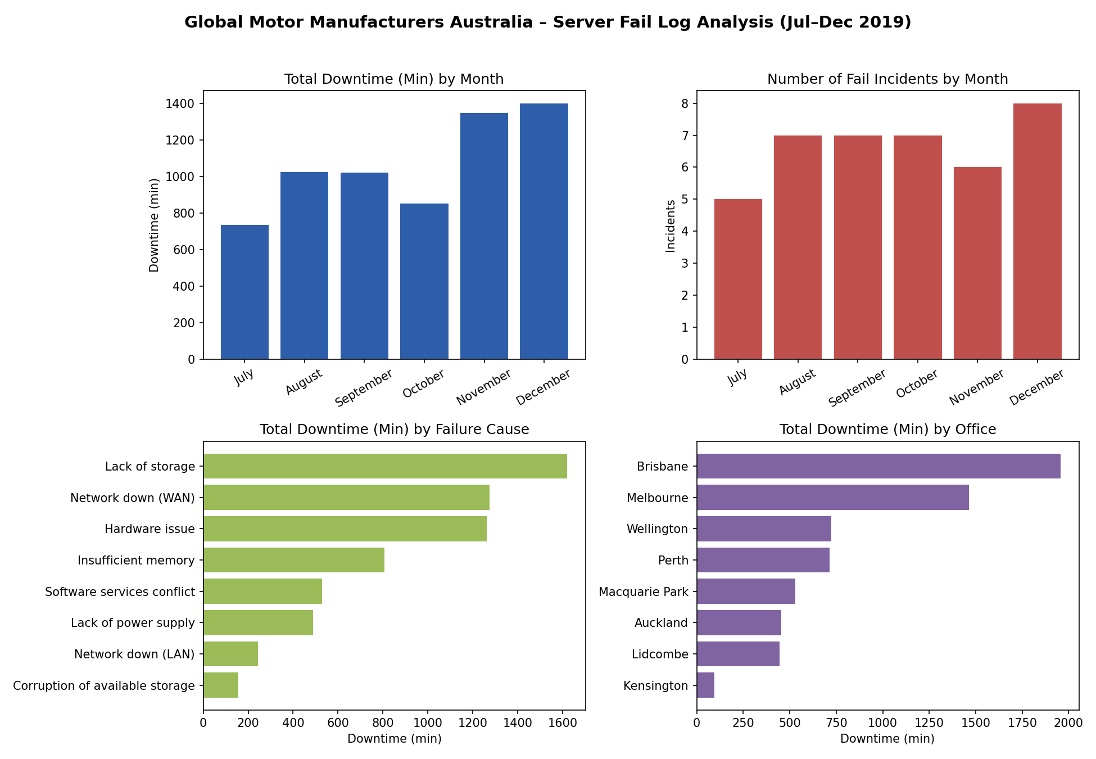

Key observations
- Downtime rose steadily across the period: from 734 minutes in July to 1,402 minutes in December, with the incident count climbing from 5 to 8 over the same months.
- Lack of storage, Network down (WAN) and Hardware issue are the three leading causes of downtime, together accounting for the majority of total minutes lost.
- Brisbane and Melbourne recorded the highest cumulative downtime of any office (around 1,950 and 1,470 minutes respectively), despite Brisbane having only 4 distinct assets logged.
- 50% of the client's servers are already out of support and, per the Key Operational and Strategic Changes document, will not be replaced in the coming year -this is a likely contributor to the rising trend.

Task 2: Predictive Model (Train/Test Split)
Modelling approach: the fail log was split by month, with July–November (32 records) used as the training set and December (8 records) held out as the test set, as requested. Downtime (minutes) was modelled as a function of Office and Event Notes (failure cause), one-hot encoded. Several model types were trained and compared on the December test set:
- Linear Regression (Office + Event Notes) -MAE 147.7 min
- Random Forest Regressor (Office + Event Notes, 300 trees) -MAE 139.7 min (best-performing model)
- Per-asset historical average (Asset ID lookup, train-set mean) -MAE 88.8 min
- Naive baseline (training-set mean downtime applied to every test record) -MAE 93.1 min
The Random Forest model was carried forward as the primary model since it captures non-linear interactions between office and failure cause. Its December test-set predictions versus actual downtime are shown below.
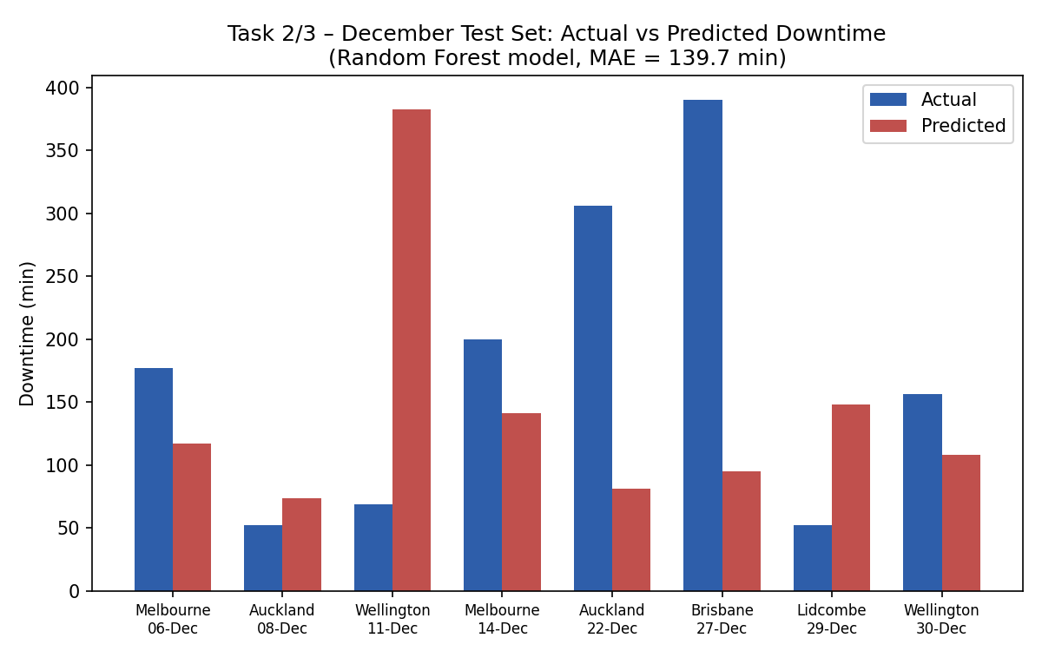
Office | Fail Date | Event Notes | Actual Downtime (min) | Predicted Downtime (min) | Abs Error (min)
Melbourne | 2019-12-06 | Hardware issue | 177.0 | 117.2 | 59.8
Auckland | 2019-12-08 | Network down (LAN) | 52.0 | 73.5 | 21.5
Wellington | 2019-12-11 | Lack of storage | 69.0 | 382.8 | 313.8
Melbourne | 2019-12-14 | Insufficient memory | 200.0 | 141.4 | 58.6
Auckland | 2019-12-22 | Network down (WAN) | 306.0 | 81.0 | 225.0
Brisbane | 2019-12-27 | Network down (WAN) | 390.0 | 94.6 | 295.4
Lidcombe | 2019-12-29 | Network down (LAN) | 52.0 | 148.0 | 96.0
Wellington | 2019-12-30 | Corruption of available storage | 156.0 | 108.3 | 47.7

Task 3: Model Validation
Target: Mean Absolute Error (MAE) below 30 minutes on the December test set.
Result: the model did not meet this target. The Random Forest model achieved an MAE of 139.7 minutes; the simpler per-asset historical-average lookup performed better at 88.8 minutes, but still well above the 30-minute threshold.

Why the target was not met
- The dataset is small (40 incidents over 6 months) and downtime per incident is highly variable (28 to 567 minutes) even within the same office or failure cause, leaving limited signal for any model to learn from.
- The available fields (Office, Asset ID, Event Notes) describe where and what type of failure occurred, but not its severity -e.g. two 'Hardware issue' events can differ by hundreds of minutes depending on the specific fault, which isn't captured in the data.
- No strong month-on-month trend exists at the individual-incident level (only an aggregate upward trend at the monthly-total level), so date-based features added little predictive value.

Recommendation for the planning meeting
Rather than treating this as a modelling shortfall, it should be flagged as a data-quality/data-availability gap: to reliably predict downtime to within 30 minutes, richer telemetry would be needed -for example asset age/support status, error codes, time-to-resolution logs, or server utilisation metrics (CPU, memory, disk) leading up to each failure. This can be raised as an action item for the refreshed environment's monitoring tooling.

Task 4: Recommendations to Reduce Server Downtime
The following three suggestions combine the fail log findings with the client's Key Operational and Strategic Changes document.

1. Prioritise the out-of-support server fleet, starting with Brisbane and Melbourne
Hardware issue, Lack of storage and Insufficient memory together drive a large share of total downtime, and the client has confirmed 50% of servers are already out of support with no planned replacement this year. Brisbane and Melbourne carry the highest cumulative downtime. Recommend a risk-based compensating control: prioritised spares/maintenance contracts, proactive capacity (storage/memory) monitoring, and scheduled health checks for the oldest, out-of-support assets in these two offices first, rather than waiting for a full refresh.

2. Bring forward and re-sequence the network capacity upgrade
Network down (WAN) is one of the top two causes of downtime, and the client has already planned a network capacity upgrade -split across September and December. Recommend re-sequencing this rollout so the offices with the worst WAN-related downtime (Brisbane and Auckland, based on the December test data, plus Wellington historically) are upgraded in the first tranche, rather than by a generic geographic or cost split.

3. Standardise storage and memory capacity monitoring across all offices
Lack of storage is the single largest cause of downtime by total minutes, and Insufficient memory also ranks highly, together with the largest incident (450 minutes, Melbourne, September). Recommend implementing standardised automated storage/memory threshold alerting across all offices as part of the refresh, so capacity issues are resolved before they cause an outage. This is a low-cost addition that can be rolled out alongside the office consolidation (4 offices closing) and the in-housing of application development, both already underway.

