EXPERIMENT 1

MINIMIZATION AND IMPLEMENTATION OF BOOLEAN FUNCTION

Aim
To minimize and implement a Boolean function using logic gates and verify the functionality using Synopsys VCS and DVE.

Software Required
- Synopsys VCS
- Synopsys DVE
- Linux Terminal
- Verilog HDL

Boolean Function
Consider the Boolean function:
F(A,B)=Σm(0,1,3)
The minimized Boolean expression is: F=A'+B
The function is implemented using Verilog HDL.

Files Used
File | Description
exp1_boolean_min.v | Verilog design file
exp1_boolean_min_tb.v | Verilog testbench
exp1_boolean_min.vcd | VCD waveform dump generated during simulation

1. Verilog Design File

//gedit fun.v
module fun (
input wire A,
input wire B,
output wire F
);
assign F = (~A) | B ; // F = A' + B
endmodule

2. Testbench

// gedit tb.v

module tb;

reg A, B;

wire F;

// Instantiate the design under test (DUT)

fun uut (

.A(A),

.B(B),

.F(F)

);

initial begin

// ---- VCD dump setup ----

$dumpfile("fun.vcd"); // name of the VCD file to be generated

$dumpvars(0, tb); // dump all signals in this testbench hierarchy

// ---- Apply all 4 input combinations ----

$monitor("Time=%0t A=%b B=%b | F=%b", $time, A, B, F);

A = 0; B = 0; #10;

A = 0; B = 1; #10;

A = 1; B = 0; #10;

A = 1; B = 1; #10;

#10 $finish;

end

endmodule

3. Truth Table
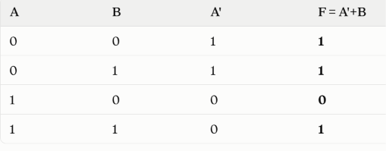

4. Simulation Procedure

STEP 1 – Open Terminal
Open a terminal in the experiment folder.
bash

STEP 2 – Load Synopsys Environment
source /synopsys/start.sh

STEP 3 – Compile Using VCS
vcs func_AB.v tb.v -full64
If compilation is successful, VCS generates the simulation executable:
simv

STEP 4 – Run Simulation
./simv
The terminal displays the input combinations and corresponding output F.
A VCD waveform file is also generated:
func_AB.vcd

STEP 5 – Open DVE
dve -full64

Other option
dve -full64 &
A DVE environment will open.

5. DVE Waveform Verification
In DVE:
- Open the testbench hierarchy.
- Locate the signals:
  - A
  - B
  - F
- Add the signals to the waveform window.
- Run/inspect the waveform.
- Verify that F = 1 whenever A = 0 (regardless of B), since A' = 1 dominates the OR expression.
- Verify that F = 1 whenever B = 1 (regardless of A), since B alone can force the OR output high.
- Verify that F = 0 only when A = 1 AND B = 0 — this is the single combination where both A' and B are 0.
The waveform should agree with the truth table.

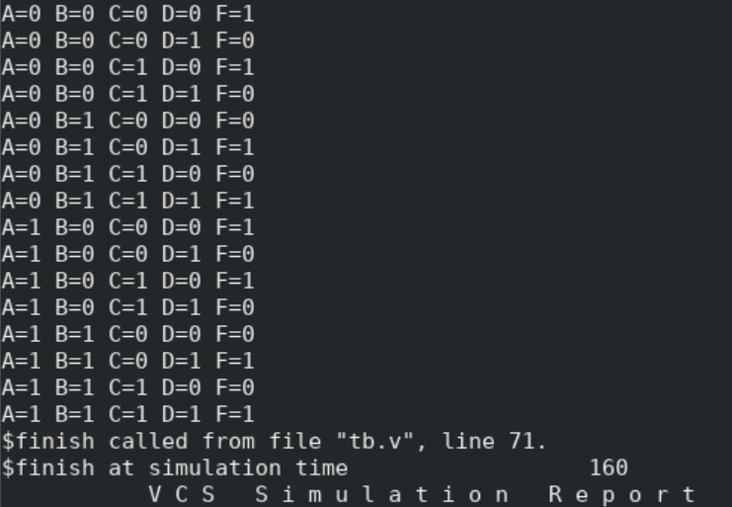

6. Expected Result
The Boolean function
F(A,B,C,D)=Σm(0,2,5,7,8,10,13,15), which simplifies to F=B'D'+BD.
was minimized to F=B'D'+BD.
and successfully implemented using Verilog HDL.
The design was compiled and simulated using Synopsys VCS, and the functionality was verified using DVE waveform analysis.
Output
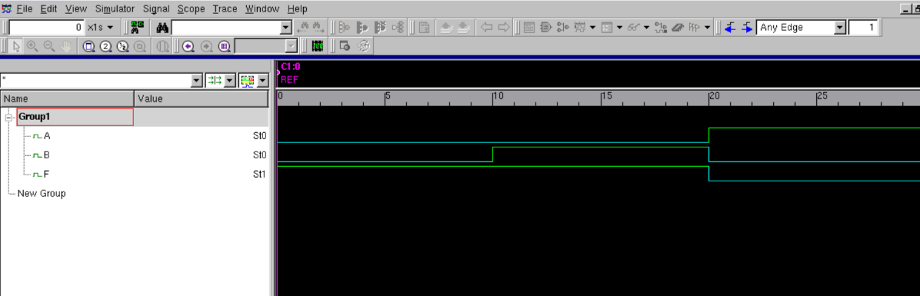

7. Viva-Voce Questions
- What is Boolean function minimization?
- What is a minterm?
- What is a Karnaugh map?
- Why is Boolean minimization required?
- What are universal gates?
- What is the difference between SOP and POS?
- What is the purpose of a Verilog testbench?
- Why is a VCD file generated?
- What is the purpose of ./simv?
- What is the purpose of DVE?
- What is the difference between simulation and synthesis?
- Why are A and C absent from the minimized expression?
- What is the purpose of $dumpfile?
- What is the purpose of $dumpvars?

Result
Thus, the Boolean function was minimized, implemented using Verilog HDL, successfully simulated using Synopsys VCS, and verified using Synopsys DVE.

