Rahul Mishra

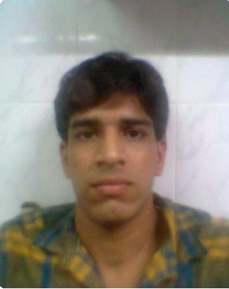

BehramBaug Jogeshwari(W) Mumbai-400102

E-mail: [mishrarahul824@gmail.com](mailto:mishrarahul824@gmail.com)

Phone:9768852964

Seeking a position to utilize my skills and abilities in the Information Technology Industry that offers professional growth while being resourceful, innovative and flexible.

OBJECTIVE

Having 20 months of Experience in PHP Development (CMS,API’s,Crons).

SUMMARY

Strong collabration & Interpersonal skills with proficiency in grasping new technical concepts quickly & utilizing them in an effective manner.

Executed various projects using technologies such as Laravel , Cakephp etc.

Abilities in handling multiple priorities with a bias for actionand a genuine interest in personal and professional development.(below there are my some works)

|  |  |  |
| --- | --- | --- |
| EXPERIENCE | Company: | GRAYMATRIX Pvt Ltd. |
|  | Duration : | 27th June 2014 – 16th February 2016 |

My Role : Creating API’s , CRONs , CMS Creation

|  |  |  |
| --- | --- | --- |
| PROJECT | Project : | HDFC Memories |
|  | Duration : | 1.5 months |
|  | Front End Used:  Back End Used: | Laravel 5.1  MYSQL |

My Role : Creating API’s , CRONs , Web

Description:

The HDFC Vimes is an online Platform where user can create and send an Image/Video Message for their Loved Ones.

|  |  |  |
| --- | --- | --- |
| PROJECT | Project : | Castrol |
|  | Duration :  Front End Used: | 2 months  Cakephp |

My Role : Creating CMS

Description:

The main objective of the project Castrol is to welcome customer with a personalized SMS (FREE).

Recommend customer with the best Lube for their bike. auto Service Reminder SMS (FREE) to your customer after 90 days. Maintain regular check of store inventory (Bike parts, Oils&other parts).

Easily manage your business reports on daily, weekly or monthly basis. Keep a track of each of your staff and know who is doing what.

|  |  |  |
| --- | --- | --- |
| PROJECT | Project : | HDFC CancerCare |
|  | Duration :  Front End Used: | 3 months  Laravel 5.1 |

My Role : Creating CMS,APIs ,Crons

Description:

HDFC Life brings Cancer Care plan that provides financial protection for both early and major stage of cancer. So you receive payouts not only on diagnosis of early or major stage of cancer but also receive lump sum payouts on treatment of early or major stage of cancers.

|  |  |  |
| --- | --- | --- |
| PROJECT | Project : | DrFixit |
|  | Duration :  Front End Used: | 2 months  Laravel 4.2 |

My Role : Creating CMS

Description:

Dr. Fixit Waterproofing App is an easy way to recommend the best of its class innovative solutions to customers. It’s have tailor-made the information to give you a quick reference of waterproofing just a click away. Versatile app catering to various scale of contruction ranging from Bunglows, Multi-storey and commercial buildings – simple waterproofing practices to elaborate complex structures waterproofing recommendations. A complete waterproofing guide for Architects, Builders, Consultants, Contractors, Engineers, and Applicators. Let the Waterproofing Expert take you through the latest Waterproofing techniques for Basement, Podiums, Wet Areas, Roofs, Exterior and Interior Walls.

B.Tech in Computer Science From L N Group of Institutes Mumbai in 2013.

QUALIFICATIONS

Diploma In Electronics & TeleCommunication Engineering From Ryan College Mumbai in 2009 with Distinction

10th from Sunflower Secondary School Mumbai in 2006 With 70.66%

Languages: C,C++,JAVA,PHP

TECHNICAL SKILLS

Database: SQL 2008,MS-Access,MySQL Operating System: Windows,Linux

Frameworks: Laravel,Cakephp,Angular JS

Reading Books,Newspaper , Playing Chess,Cricket.

INTERESTS

Date of Birth: 16th April 1991 Languages Known: English,Hindi Location Preference: Mumbai

PERSONAL DETAILS

REFERENCES