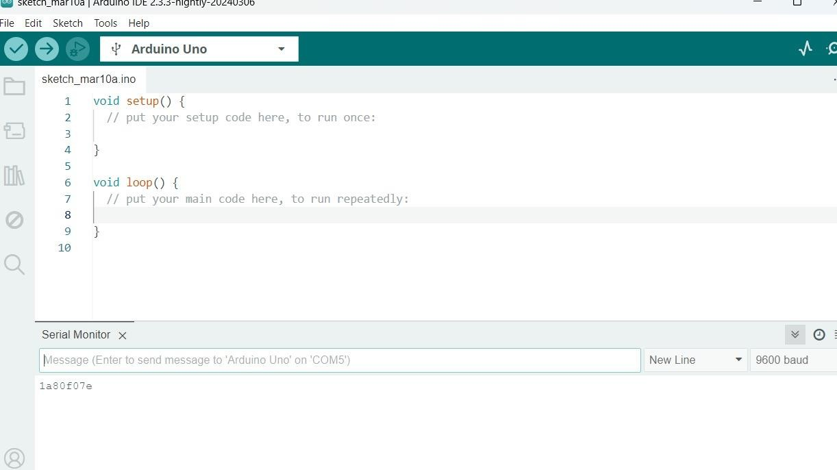

**Steps: Displaying the RFID on the serial monitor.**

The Arduino IDE's serial monitor plays a key role by displaying RFID code IDs when scanned, offering immediate feedback. This feature is part of the IDE's user interface, which is designed to be intuitive for students. With tools for code editing, compiling, and easy access to libraries and boards, the IDE interface streamlines project development. The serial monitor enhances this by enabling real-time communication monitoring, enhancing students' understanding and efficiency in Arduino projects. Together, these features make learning and application accessible and efficient for students.

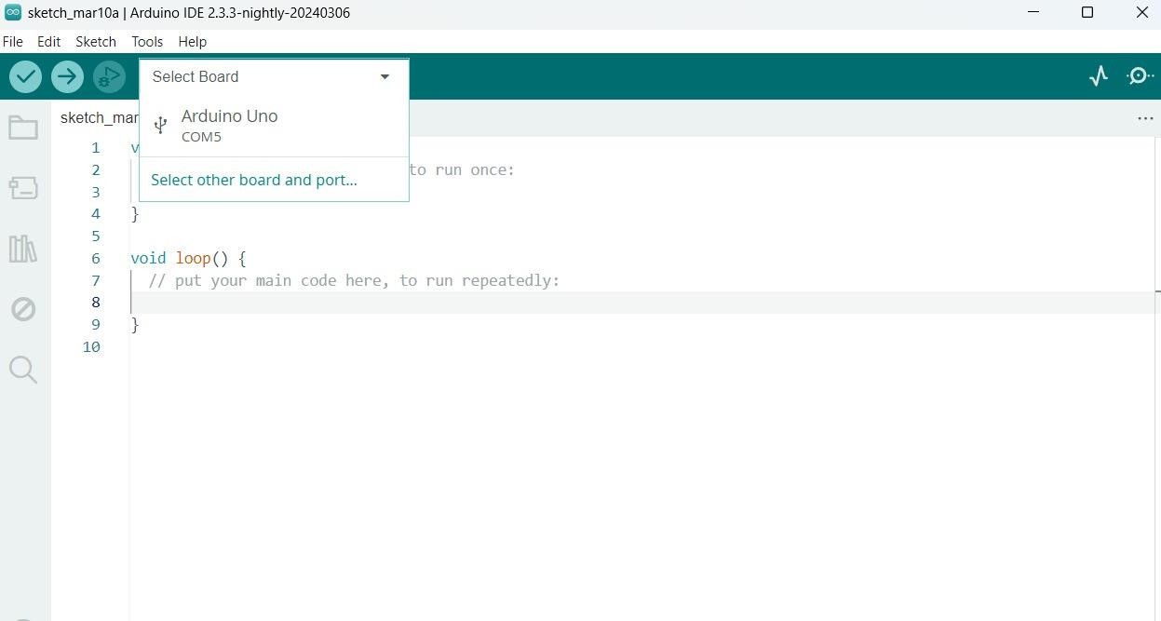

**Steps: Selecting the Correct Board.**

Choosing the right Arduino board is important for making sure everything works well. In the Arduino software, students just need to click on the "Tools" menu and pick the board they're using from a list. Then, they can write and edit their code right in the software. This makes it easy to connect the hardware and software parts of their project and helps them work on their projects smoothly.

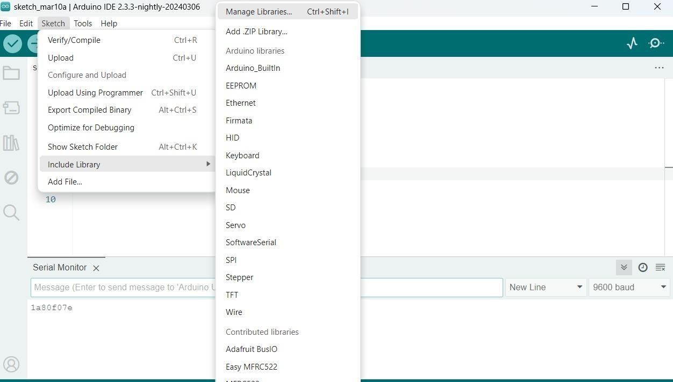

**Steps: installing correct libraries .**

**Library Used :**

**SPI.h: This library is used to communicate with devices using the Serial Peripheral Interface (SPI) protocol. In this code, it is likely used to communicate with the MFRC522 RFID module.**

**Wire.h: This library is used for I2C communication, which is a communication protocol commonly used to connect microcontrollers and peripheral devices. In this code, it is used for communication with sensors .**

**MFRC522.h: This library provides functions to interact with the MFRC522 RFID module. It includes methods for initializing the module, detecting RFID cards, and reading card data.**

"Installing correct libraries" simply means putting the right additional sets of code into your Arduino software. These libraries give your Arduino more functions and abilities, like connecting to specific sensors or devices. So, by installing the right libraries, you're making sure your Arduino can do exactly what you want it to do.