EXPERIMENT 7

AIM: BER VS SNR PLOT IN CASE OF SIMULATION OF RAYLEIGH AND AWGN CHANNEL USING BPSK

SOFTWARE: MATLAB

THOERY:

The experiment simulates Bit Error Rate (BER) performance of Binary Phase Shift Keying (BPSK) modulation under two different channel conditions: Additive White Gaussian Noise (AWGN) and Rayleigh fading.

1. **BPSK Modulation:** In BPSK, binary data (0s and 1s) are mapped to symbols -1 and +1, respectively.
2. **AWGN Channel:** The received signal is affected only by Gaussian noise, maintaining a consistent signal-to-noise ratio (SNR).
3. **Rayleigh Fading Channel:** The signal undergoes random amplitude variations due to multipath propagation, leading to deep fades and fluctuating SNR.
4. **Bit Error Rate (BER) Analysis:** The BER is computed by comparing the transmitted and received bits after applying a hard decision rule.

CODES:

AWGN:

clc;

clear all;

close all;

clear

N = 10^6 % number of bits or symbols

% Transmitter

ip = rand(1,N)>0.5; % generating 0,1 with equal probability

s = 2*ip-1; % BPSK modulation 0 -> -1; 1 -> 0

Eb_N0_dB = [-3:35]; % multiple Eb/N0 values

for ii = 1:length(Eb_N0_dB)

n = 1/sqrt(2)*[randn(1,N) + j*randn(1,N)]; % white gaussian noise, 0dB variance

%h = 1/sqrt(2)*[randn(1,N) + j*randn(1,N)];

x_1 = [randn(1,N) ];

x_2 = [randn(1,N) ];

% Channel and noise Noise addition

y = s + 10^(-Eb_N0_dB(ii)/10)*n;

% equalization

yHat = y;

% receiver - hard decision decoding

ipHat = real(yHat)>0;

%ipHat = real(y)>0;

% counting the errors

nErr(ii) = size(find([ip- ipHat]),2);

end

simBer = nErr/N; % simulated ber

%theoryBerAWGN = 0.5*erfc(sqrt(10.^(Eb_N0_dB/10))); % theoretical ber

%EbN0Lin = 10.^(Eb_N0_dB/10);

%theoryBer = 0.5.*(1-sqrt(EbN0Lin./(EbN0Lin+1)));

% plot

close all

figure

%semilogy(Eb_N0_dB,theoryBerAWGN,'cd-','LineWidth',2);

%hold on

%semilogy(Eb_N0_dB,theoryBer,'bp-','LineWidth',2);

semilogy(Eb_N0_dB,simBer,'mx-','LineWidth',2);

%axis([-3 35 10^-5 0.5])

grid on

%legend('AWGN-Theory','Rayleigh-Theory', 'Rayleigh-Simulation');

xlabel('Eb/No, dB');

ylabel('Bit Error Rate');

title('BER for BPSK modulation in AWGN channel');

RAYLEIGH:

clc;

clear all;

close all;

clear

N = 10^6 % number of bits or symbols

% Transmitter

ip = rand(1,N)>0.5; % generating 0,1 with equal probability

s = 2*ip-1; % BPSK modulation 0 -> -1; 1 -> 0

Eb_N0_dB = [-3:35]; % multiple Eb/N0 values

for ii = 1:length(Eb_N0_dB)

n = 1/sqrt(2)*[randn(1,N) + j*randn(1,N)]; % white gaussian noise, 0dB variance

%h = 1/sqrt(2)*[randn(1,N) + j*randn(1,N)];

x_1 = [randn(1,N) ];

x_2 = [randn(1,N) ];

h = sqrt(x_1.^2+x_2.^2);% Rayleigh channel

% Channel and noise Noise addition

y = h.*s + 10^(-Eb_N0_dB(ii)/10)*n;

% equalization

yHat = y./h;

% receiver - hard decision decoding

ipHat = real(yHat)>0;

%ipHat = real(y)>0;

% counting the errors

nErr(ii) = size(find([ip- ipHat]),2);

end

simBer = nErr/N; % simulated ber

%theoryBerAWGN = 0.5*erfc(sqrt(10.^(Eb_N0_dB/10))); % theoretical ber

%EbN0Lin = 10.^(Eb_N0_dB/10);

%theoryBer = 0.5.*(1-sqrt(EbN0Lin./(EbN0Lin+1)));

% plot

close all

figure

%semilogy(Eb_N0_dB,theoryBerAWGN,'cd-','LineWidth',2);

%hold on

%semilogy(Eb_N0_dB,theoryBer,'bp-','LineWidth',2);

semilogy(Eb_N0_dB,simBer,'mx-','LineWidth',2);

%axis([-3 35 10^-5 0.5])

grid on

%legend('AWGN-Theory','Rayleigh-Theory', 'Rayleigh-Simulation');

xlabel('Eb/No, dB');

ylabel('Bit Error Rate');

title('BER for BPSK modulation in Rayleigh channel');

OUTPUT:

For AWGN:

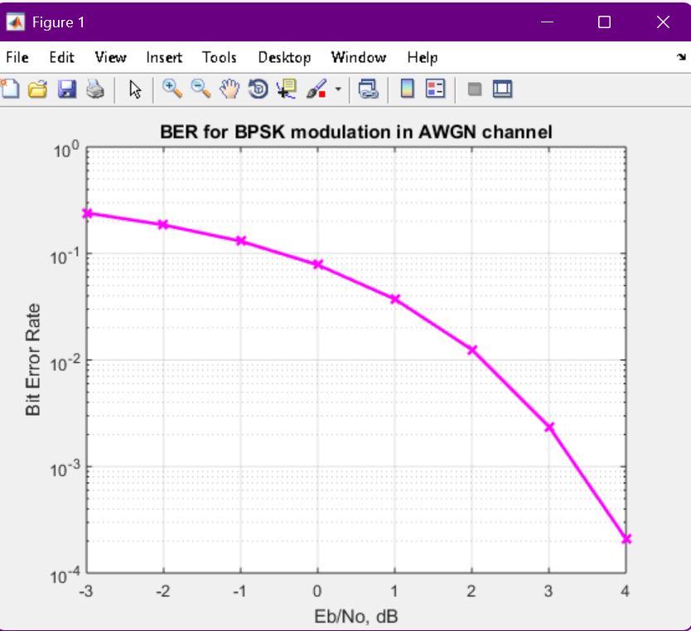

For RAYLEIGH:

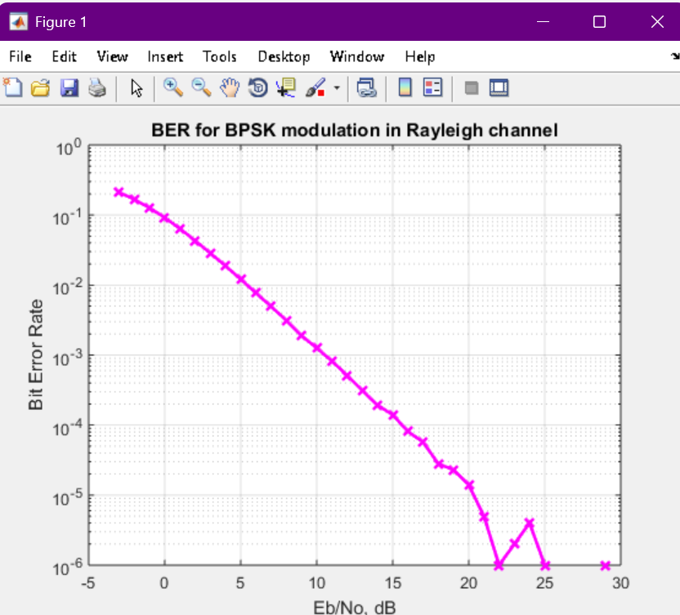

CONCLUSION:

In the **AWGN channel**, BER decreases exponentially as the signal-to-noise ratio (Eb/N0) increases, showing a gradual performance improvement.

In the **Rayleigh fading channel**, the BER performance degrades significantly due to channel-induced amplitude fluctuations. Equalization (division by the channel gain) improves the performance but does not match AWGN performance.

Rayleigh fading introduces additional randomness in the signal, making it more error-prone than AWGN at the same Eb/N0 values.