EXPERIMENT 8

AIM: BER for BPSK in AWGN and Rayleigh Channels (Analytical)

SOFTWARE: MATLAB

THOERY:

This simulation analytically compares the Bit Error Rate (BER) performance of BPSK modulation over two different channel models: **AWGN** (Additive White Gaussian Noise) and **Rayleigh fading**.

* **BPSK Modulation**: Binary Phase Shift Keying maps binary bits (0,1) to symbols (-1,+1).
* **AWGN Channel**: Noise is modeled as Gaussian and additive, affecting signal amplitude but not the phase.
* **Rayleigh Fading Channel**: Models wireless channels with multipath propagation, causing amplitude variations due to constructive and destructive interference.

BER for:

* **AWGN** is calculated using the Q-function: Q(√(2Eb/N0)).
* **Rayleigh** is derived from the formula: 0.5*(1 - √(Eb/N0 / (Eb/N0 + 1))).

CODES:

clc;

clear all; close all;

N = 10^6; % Number of bits or symbols

% Transmitter

ip = rand(1, N) > 0.5; % Generating 0,1 with equal probability

s = 2 * ip - 1; % BPSK modulation: 0 -> -1, 1 -> +1

Eb_N0_dB = -3:35; % Eb/N0 range in dB

EbN0Lin = 10.^(Eb_N0_dB / 10); % Linear scale

% Analytical BER for AWGN (using Q-function)

BER_AWGN = qfunc(sqrt(2 * EbN0Lin));

% Analytical BER for Rayleigh (using theoretical formula)

BER_Rayleigh = 0.5 * (1 - sqrt(EbN0Lin ./ (EbN0Lin + 1)));

% Plotting the results

figure;

semilogy(Eb_N0_dB, BER_AWGN, 'bo-', 'LineWidth', 2); % AWGN BER

hold on;

semilogy(Eb_N0_dB, BER_Rayleigh, 'r^-', 'LineWidth', 2); % Rayleigh BER

% Plot settings grid on;

axis([-3 35 10^-6 0.5]);

legend('AWGN (Analytical)', 'Rayleigh (Analytical)', 'Location', 'Best');

xlabel('Eb/No (dB)');

ylabel('Bit Error Rate (BER)');

title('BER vs. Eb/No for Rayleigh and AWGN Channels (Analytical)');

OUTPUT:

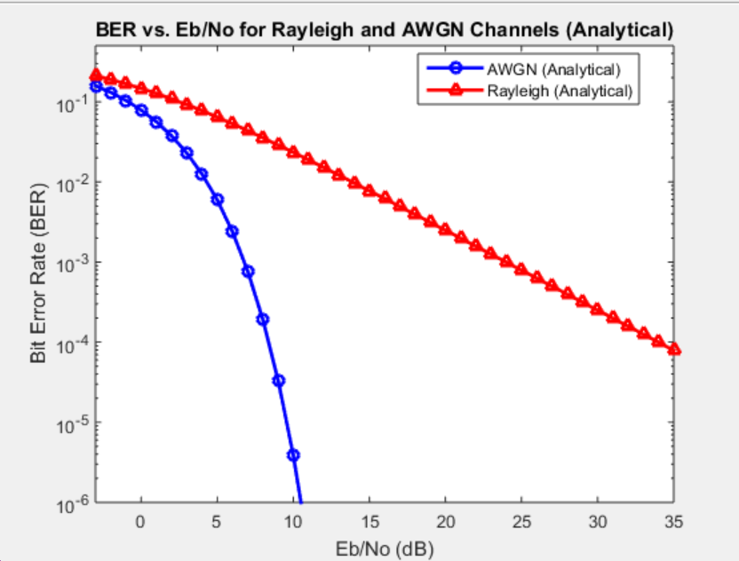

CONCLUSION:

The simulation shows that BPSK performs significantly better over an **AWGN channel** than over a **Rayleigh fading channel**, especially at low SNR (Eb/N0) values. This highlights the impact of multipath fading on wireless communication, where Rayleigh fading introduces more severe signal degradation than simple Gaussian noise.