EXPERIMENT 9

AIM: POWER DELAY PROFILE SIMULATION

SOFTWARE: MATLAB

THOERY:

In wireless communication systems, **multipath propagation** occurs when transmitted signals reflect off various objects and reach the receiver at different time instants. This causes multiple copies of the signal to arrive with various delays and power levels, forming a **Power Delay Profile (PDP)**.

The PDP is a statistical representation of the power received across different delays and is essential in understanding channel behavior. It helps in determining key **channel delay spread metrics**, which affect data rate, symbol duration, and overall system performance.

**Key Concepts:**

1. **Power Delay Profile (PDP)**:
   * Shows how much power is received at different delays (in microseconds).
   * Typically plotted as power (in dB or linear scale) versus delay.
2. **Conversion from dB to Linear Scale**:
   * Since dB is a logarithmic measure, it is converted to linear scale using:

Plinear = 10^ PdB/10

* + This is necessary for accurate mathematical computation of delay metrics.

1. **Mean Delay**:
   * Represents the average delay of the multipath components weighted by their power.

τˉ=∑τi*Pi/∑Pi

1. **RMS Delay Spread**:
   * Measures the **spread** or **dispersion** of delays around the mean delay.

στ=root(∑Pi⋅(τi−τˉ)^2/∑Pi)

1. **Delay Spread**:
   * Simple metric that indicates the total delay range:

Δτ=τmax​−τmin​

These metrics help determine the **coherence bandwidth** of the channel and decide whether equalization or other mitigation techniques are required.

CODES:

% Given data

delay_us = [0, 1, 3, 5]; % microseconds

power_dB = [-20, -10, 0, -10]; % dB

% Convert power from dB to linear scale

power_linear = 10.^(power_dB / 10);

% ---- T1: Plot Power Delay Profile ----

figure;

stem(delay_us, power_dB, 'filled');

xlabel('Delay (\mus)');

ylabel('Power (dB)');

title('Power Delay Profile');

grid on;

% ---- T2: Calculate Channel Metrics ----

% Mean delay

mean_delay = sum(delay_us .* power_linear) / sum(power_linear);

% RMS Delay Spread = sqrt(mean square delay - (mean delay)^2)

rms_delay_spread = sqrt(sum(power_linear.*(delay_us - mean_delay).^2)/sum(power_linear));

% Delay Spread = max delay - min delay

delay_spread = max(delay_us) - min(delay_us);

% Output results

fprintf('Mean Delay (us): %.4f\n', mean_delay);

fprintf('RMS Delay Spread (us): %.4f\n', rms_delay_spread);

fprintf('Delay Spread (us): %.4f\n', delay_spread);

OUTPUT:

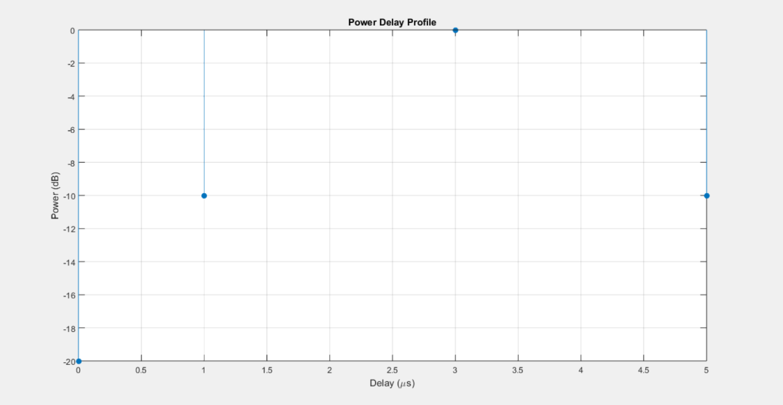

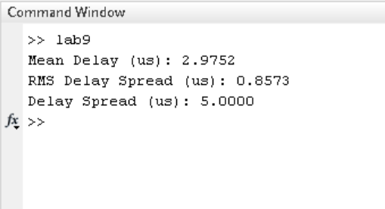

CONCLUSION:

The PDP plot visualizes how power is distributed across various delays. From the RMS delay spread, we can infer how significantly delayed components deviate from the average. A higher RMS delay spread indicates a more **frequency-selective channel**, which can lead to **inter-symbol interference (ISI)** in broadband systems.

This analysis is fundamental for designing robust modulation schemes, equalization methods, and estimating channel coherence parameters for wireless systems such as LTE, 5G, and Wi-Fi.