EXPERIMENT 6

AIM: SIMULATION OF DOPPLER EFFECT USING MATLAB

SOFTWARE: MATLAB

THOERY:

The **Doppler Effect** describes the change in frequency of a wave in relation to an observer moving relative to the wave source. In the case of electromagnetic waves, such as radio signals, the Doppler shift (fd) is given by:

fd=v*cos(θ)/ λ

where:

* V is the velocity of the receiver,
* Λ(lambda) is the wavelength of the transmitted signal,
* Θ(theta) is the angle between the velocity vector and the direction of wave propagation.

This experiment simulates the Doppler shift for a receiver moving at **30 m/s** with a transmitted signal frequency of **2.4 GHz**. The Doppler shift is analyzed for three different cases:

1. **Increasing Theta**: theta increases from 0 to π, reducing the Doppler shift over time.
2. **Decreasing Theta**: theta decreases from π to 0, causing an increase in the Doppler shift.
3. **Constant Theta**: theta is fixed at 90∘, resulting in a constant zero Doppler shift.

CODES:

clc;

clear all;

close all;

% Parameters

frequency = 2.4e9; % Frequency of the transmitted signal (Hz)

speed_of_light = 3e8; % Speed of light (m/s)

velocity_receiver = 30; % Velocity of the receiver (m/s)

wavelength = speed_of_light / frequency; % Wavelength of the signal (m)

% Define time vector

t = linspace(0, 10, 100); % Time varying from 0 to 10 seconds

% Initialize arrays to store Doppler shift for different values of theta

doppler_shift_increasing = zeros(size(t));

doppler_shift_decreasing = zeros(size(t));

doppler_shift_constant = zeros(size(t));

% Calculate Doppler shift for each time step

for i = 1:length(t)

% Calculate theta for each time step

theta_increasing = pi * t(i) / 10; % Increasing theta

theta_decreasing = pi - pi * t(i) / 10; % Decreasing theta

theta_constant = pi / 2; % Constant theta

% Calculate Doppler shift for each theta

doppler_shift_increasing(i) = (velocity_receiver / wavelength) * cos(theta_increasing);

doppler_shift_decreasing(i) = (velocity_receiver / wavelength) * cos(theta_decreasing);

doppler_shift_constant(i) = (velocity_receiver / wavelength) * cos(theta_constant);

end

% Plot Doppler shift for different values of theta

figure;

plot(t, doppler_shift_increasing, 'b', 'LineWidth', 2);

hold on;

plot(t, doppler_shift_decreasing, 'r', 'LineWidth', 2);

plot(t, doppler_shift_constant, 'g', 'LineWidth', 2);

xlabel('Time (s)');

ylabel('Doppler shift (Hz)');

title('Doppler Shift for Different Values of Theta');

legend('Increasing Theta', 'Decreasing Theta', 'Constant Theta');

grid on;

OUTPUT:

For 900MHz

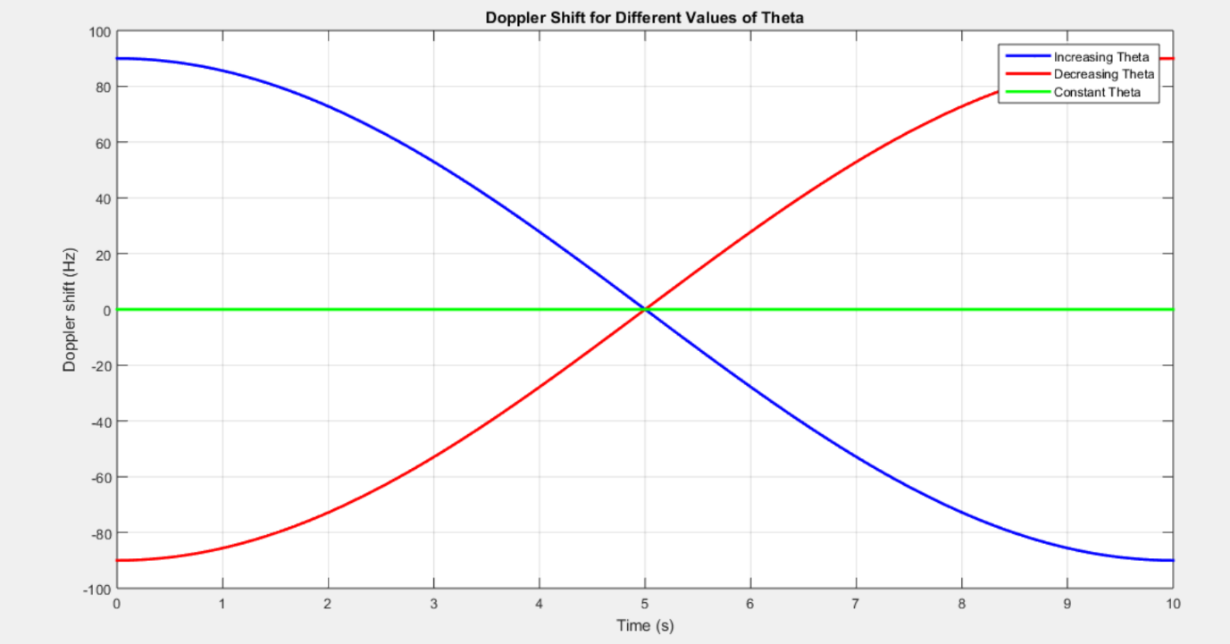

For 2.4GHz

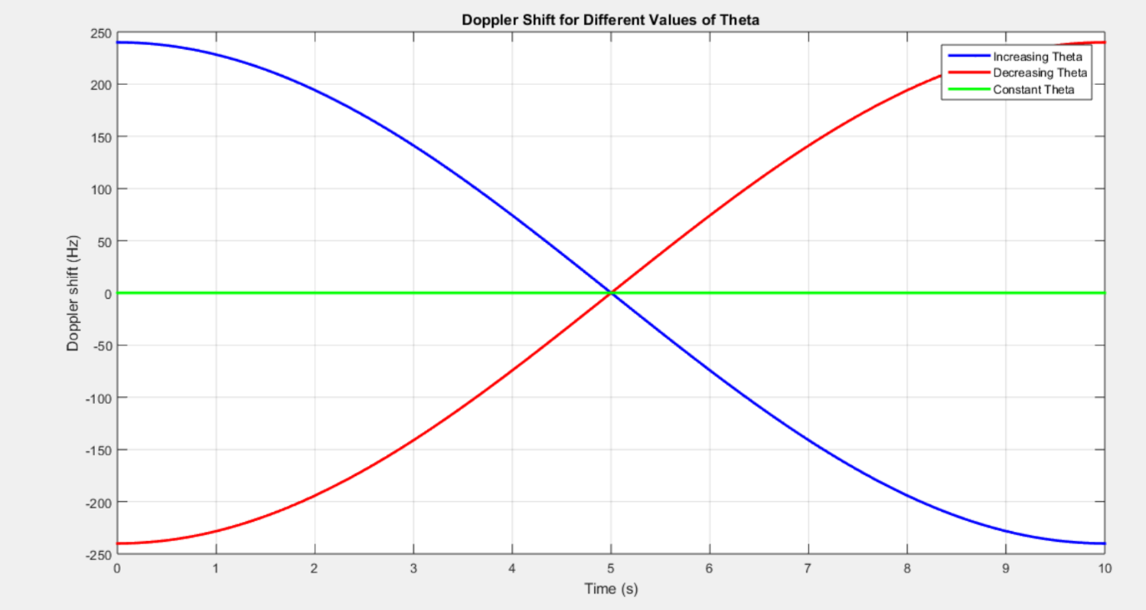

For 5GHz

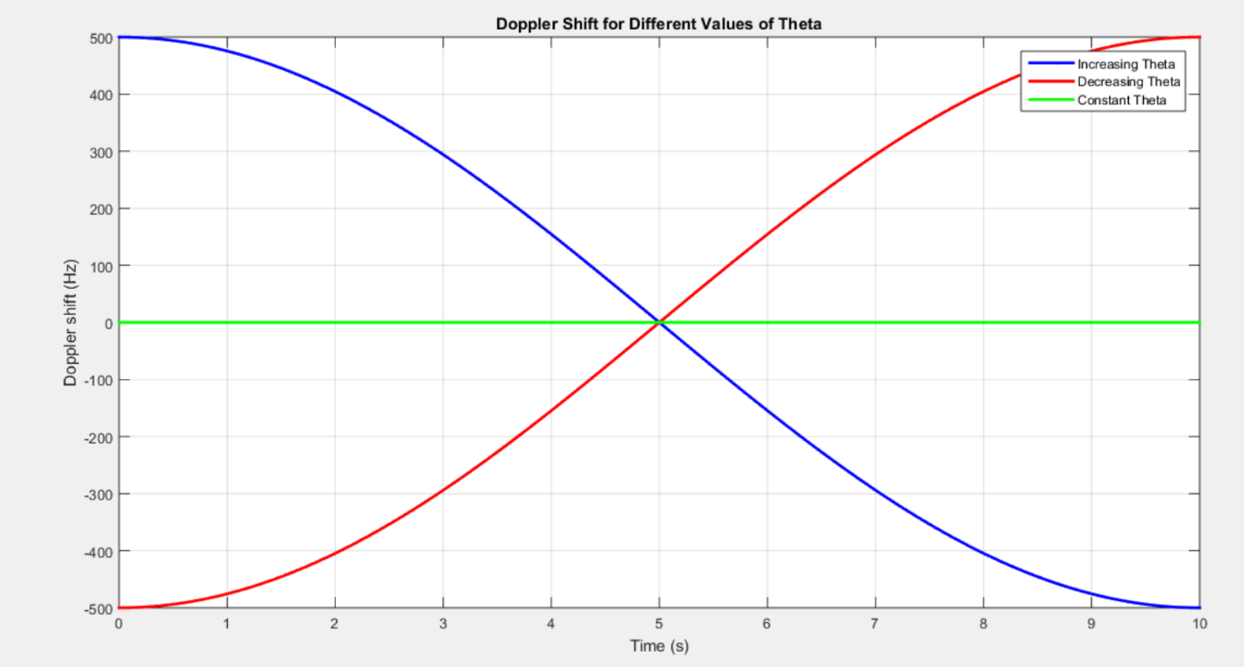

CONCLUSION:

The simulation results demonstrate that the Doppler shift depends on the receiver’s motion relative to the signal source. The shift is **maximum** when the receiver moves **directly toward or away** from the source (θ=0∘ or θ=180∘), while it becomes **zero** when moving **perpendicular** to the signal (θ=90∘). These observations are crucial in wireless communication, radar, and satellite navigation systems, where Doppler effects influence signal reception and processing.