DATA CENTER OPERATIONS
Master Requirements & Reference Model
Inventory-led operational blueprint for multi-region, multi-site data center operations

Document control | Value
Version | v0.1 — Working blueprint
Purpose | Consolidate the Data Center Operations operating model, functional requirements, information model, workflows and UI evidence.
Primary source | Current ideation plus Inventory module screens supplied in this conversation.
Screenshot policy | Screenshots are embedded and referenced by IDs INV-01 through INV-09 where they provide design/requirement evidence.
Status | Baseline for detailed product/engineering decomposition; not a final implementation specification.

Important distinction: Requirements marked as derived from the screens describe capabilities visibly represented in the supplied UI. Requirements marked as proposed extend the operating model so the module can support end-to-end Data Center Operations rather than becoming only an inventory application.

1. Executive Summary
The target is an operations platform for a large enterprise running multiple data centers, PoPs and sites across regions/circles. The platform should connect physical infrastructure, network/optical topology, facility capacity, services, customers, incidents, changes, financial exposure and operational intelligence into one operating model.
The Inventory screens establish a strong foundation: an estate hierarchy, location inventory, site-level reconciliation, network-element inventory, physical cabling, protocol links, service/customer views, alert diagnostics and AI-assisted recommendations. The next step is to make these capabilities part of a broader Data Center Operations control plane.

Target outcome
- One authoritative operational model of the estate: region/circle → location → data center/site → building/floor/room/rack → equipment → component/interface/port → physical/logical link → service/customer.
- A live command center that answers: what is happening, where, who/what is affected, why, what capacity is available, what will happen next, and what action is recommended.
- Closed-loop reconciliation between planned/recorded inventory and discovered/observed reality.
- Dependency-aware incident and change management that connects infrastructure events to services and customer/SLA impact.
- Capacity forecasting across power, cooling, rack space, ports, bandwidth, compute/storage and facility constraints.
- AI/Sentinel assistance for correlation, RCA, impact analysis, recommendations and controlled automation.

2. Operating Personas
Persona | Primary questions | Core views/actions
Global Operations Manager | What is the estate health and where is operational risk? | Command center, regional roll-up, incidents, capacity, SLA, executive risk.
Data Center Manager | Is the site safe, available and within capacity? | Site health, power/cooling, racks, equipment, maintenance, facility alerts.
Network Operations | What is down/degraded and what depends on it? | Topology, interfaces, links, protocols, services, alarms, RCA.
Compute / Storage Operations | Are workloads and infrastructure healthy and within capacity? | Host/cluster/storage health, utilization, dependencies, lifecycle.
Facility Operations | Are power, cooling, environment and physical systems healthy? | Power chain, UPS/DG/battery, cooling, temperature, humidity, alarms.
Capacity & Planning | Where will demand exceed available capacity? | Forecasts, headroom, build plan, CapEx/OpEx, what-if analysis.
Service / Customer Operations | Which services/customers are exposed? | Service map, SLA, customer impact, capacity and revenue exposure.
Incident / Problem Manager | What is the business impact and what should happen next? | Incident workspace, dependency graph, RCA, action plan, problem trends.
Asset / Inventory Manager | Does the record match reality? | Discovery, drift, reconciliation, lifecycle, custody and audit.
Executive / Leadership | Where is material operational and financial risk? | Estate health, major incidents, availability, capacity, CapEx/OpEx and trends.

3. Data Center Operations Reference Model

3.1 Hierarchy
- Estate
- Region / Circle
- Location
- Data Center / PoP / Site
- Campus / Building
- Floor
- Room
- Rack / Cabinet
- Equipment / Asset
- Component / Module / Interface / Port
- Physical connectivity / fiber / copper / patching
- Logical connectivity / OSPF / BGP / IS-IS / LLDP / LSP / L2/L3VPN
- Service / Circuit / Customer
- Incident / Change / Maintenance / Event
- Capacity / Cost / Contract / Vendor relationship

3.2 Core object model
Object | Key attributes | Relationships
Location | ID, name, type, region/circle, city, state, address, coordinates, status | Contains sites; belongs to region/circle.
Site / Datacenter | Site ID, type, status, zone, discovery state, coverage, capacity, financials | Contains buildings/equipment/services; has dependencies.
Rack / Room | Rack ID, room/floor, role, height, used/free U, power draw | Contains equipment; constrained by space/power/cooling.
Equipment | Asset ID, vendor, model, serial, OS/firmware, IP/MAC, rack/U, lifecycle | Has interfaces/ports; participates in links/services.
Interface / Port | Port ID, speed, state, utilization, optics, errors | Terminates physical/logical links.
Link | Link ID, type, endpoints, capacity, protocol, state, forecast | Connects interfaces; supports services.
Service | Service ID, type, customer, bandwidth, utilization, SLA, uptime | Runs over links/equipment; maps to customer impact.
Customer | Customer ID, segment, location, service portfolio, SLA | Consumes services; receives impact notifications.
Event / Alert | Source, code, severity, start/end, state, evidence | May correlate into incident/problem.
Incident | Incident ID, severity, impact, owner, timeline, RCA, actions | Aggregates alerts and dependencies.
Change / Maintenance | Change ID, scope, risk, window, approval, implementation, rollback | Targets assets/services and generates events.
Capacity item | Capacity type, current, committed, available, forecast, threshold | Attached to site/rack/device/link/service.
Financial item | CapEx committed/approved, OpEx run rate, vendor/contract | Attached to site/asset/service/project.

4. Product Module Map

4.1 Command Center
Estate-wide operational cockpit: health, incidents, capacity, SLA, financial exposure, top risks and recommended actions.

4.2 Global Locations & Datacenters
Inventory hierarchy, regional roll-ups, rollout status, geographic view, filtering and drill-down.

4.3 DC Explorer / Digital Twin
Site/building/floor/room/rack/equipment visualization with dependency and physical context.

4.4 Infrastructure Operations
Network, compute, storage, optical, security and platform equipment lifecycle/health.

4.5 Facility Operations
Power, UPS, DG, battery, cooling, temperature, humidity, environmental and physical-security systems.

4.6 Monitoring & Observability
Telemetry, events, alerts, availability, performance and health across infrastructure and facilities.

4.7 Incident / Problem / Change / Maintenance
Operational workflow from detection through impact, RCA, approval, remediation and closure.

4.8 Capacity & Forecasting
Power, cooling, rack, ports, bandwidth, compute/storage and facility headroom with forecast/what-if.

4.9 Service & Customer Operations
Service topology, customer exposure, SLA, revenue/service risk and service-level capacity.

4.10 Asset Lifecycle & Reconciliation
Discovery, drift, inventory reconciliation, lifecycle, warranty, serials, ownership and audit.

4.11 Vendor & Contract Operations
Vendor performance, spares, RMA, contracts, delivery/commissioning and supplier risk.

4.12 DR & Resilience
Redundancy, backup power, failover readiness, site dependencies, recovery posture and tests.

4.13 Financial Operations
CapEx, committed vs approved, OpEx run rate, cost drivers and operational business cases.

4.14 Automation / SOAR
Approved runbooks for diagnostics, remediation, isolation, service changes and reconciliation.

4.15 Sentinel Copilot
Unified operations intelligence: observe, investigate, act and optimise with evidence and guardrails.

5. Inventory Module — Consolidated Requirements
The supplied Inventory UI should be treated as the reference design baseline for inventory-centric operations. The following requirements formalize what is already visible and extend it where needed for an operational control plane.
DC-INV-001 — Estate inventory [Must]: Provide a single inventory of locations, datacenters, PoPs and sites with status, region/circle, city/state, site type and lifecycle state.
DC-INV-002 — Regional roll-up [Must]: Aggregate locations by region/circle with on-air, in-progress, planned and failed counts and discovery/coverage indicators.
DC-INV-003 — Inventory search/filter [Must]: Support search by name/location ID and filters for status, region, site type, discovery state, vendor, equipment class and operational risk.
DC-INV-004 — Discovery coverage [Must]: Show discovered vs recorded inventory and percentage coverage at estate, region, site and asset levels.
DC-INV-005 — Drift management [Must]: Identify configuration/attribute drift, duplicate serials and mismatched records; create reconciliation work items.
DC-INV-006 — Not-discovered management [Must]: Identify planned or recorded assets not seen by collectors and distinguish 'not discovered', 'collector unavailable' and 'not applicable'.
DC-INV-007 — Site operational profile [Must]: Provide a site page combining identity, topology, power, rack space, ports, buildings, financials and operational alerts.
DC-INV-008 — Physical inventory [Must]: Model buildings, floors, rooms, racks, equipment, ports, patch panels, ODFs and passive infrastructure.
DC-INV-009 — Cable/connection view [Must]: Provide endpoint-to-endpoint physical mapping with connection state, strand/core, equipment and port mapping.
DC-INV-010 — Protocol topology [Must]: Represent LLDP, OSPF, BGP, IS-IS, LSP and related logical relationships with state and neighbor health.
DC-INV-011 — Capacity forecast [Must]: Forecast link/port/service capacity based on utilization history, growth rate and thresholds.
DC-INV-012 — Service mapping [Must]: Map infrastructure and links to service instances, customers, SLA and utilization.
DC-INV-013 — Device health [Must]: Expose device health, uptime, CPU/memory/temperature, links, interface state and authentication/time-sync health.
DC-INV-014 — Alert correlation [Must]: Correlate multiple alerts/events into operational incidents using topology and dependency context.
DC-INV-015 — AI diagnostics [Must]: Provide evidence-backed probable cause, impact assessment, similar-event context and action plan.
DC-INV-016 — Auditability [Must]: Maintain source, discovery time, collector, previous value, new value, actor and reconciliation decision for inventory changes.

6. Data Center Site Operations
DC-SITE-001 — Site readiness [Must]: Track site commissioning, on-air readiness, planned/in-progress/failed status and blockers.
DC-SITE-002 — Power chain [Must]: Model utility feed, AC distribution, rectifier/DC plant, UPS, DG, battery bank and downstream load.
DC-SITE-003 — Power capacity [Must]: Calculate capacity, current load, peak load, reserve/headroom and forecasted exhaustion date.
DC-SITE-004 — Cooling [Must]: Model cooling equipment, capacity, current load, redundancy and environmental impact.
DC-SITE-005 — Rack capacity [Must]: Track rack U capacity, used/free U, power draw and thermal constraints by rack/floor/room.
DC-SITE-006 — Port capacity [Must]: Track copper, SFP/SFP+, optical/ODF and other port classes; show total/used/free/fill.
DC-SITE-007 — Building context [Must]: Track buildings, floors, rooms, racks, backup systems and physical constraints.
DC-SITE-008 — Site risk board [Must]: Surface unresolved inventory, facility, network, security, supplier and commissioning risks.
DC-SITE-009 — Financial exposure [Must]: Track approved vs committed CapEx and recurring/annualized OpEx at site and project level.
DC-SITE-010 — Operational timeline [Must]: Provide a chronological view of commissioning, changes, incidents, maintenance and capacity events.

7. Network, Optical & Service Operations
DC-NET-001 — Multi-vendor network inventory [Must]: Support routers, switches, optical/DWDM, access and other network elements across vendors.
DC-NET-002 — Interface inventory [Must]: Capture interface name, type, speed, state, utilization, errors, optics and peer relationships.
DC-NET-003 — Protocol health [Must]: Track protocol-specific link/neighbor state and abnormal transitions.
DC-NET-004 — Physical-to-logical mapping [Must]: Correlate cable/port → interface → protocol adjacency → service.
DC-NET-005 — Capacity forecasting [Must]: Forecast link/interface utilization and show warning/critical exhaustion thresholds.
DC-NET-006 — Service health [Must]: Track service status, bandwidth, utilization, SLA target, uptime and degradation.
DC-NET-007 — Customer impact [Must]: Translate infrastructure events into affected services and customers.
DC-NET-008 — Revenue/service exposure [Must]: Allow configurable business-impact attributes for premium or critical services.
DC-NET-009 — Network diagnostics [Must]: Provide ICMP, NTP, RADIUS/AAA and device health indicators where applicable.
DC-NET-010 — Topology exploration [Must]: Provide hop-by-hop and dependency-aware visualization from site to service/customer.

8. Facility Operations
DC-FAC-001 — Power monitoring [Must]: Collect and normalize electrical telemetry across utility, UPS, rectifier, PDU and downstream loads.
DC-FAC-002 — Backup readiness [Must]: Track DG capacity, battery runtime, UPS state, fuel/runtime where available and test status.
DC-FAC-003 — Cooling health [Must]: Track cooling capacity, active units, redundancy, temperature and thermal alarms.
DC-FAC-004 — Environment [Must]: Monitor temperature, humidity, smoke/fire and other environmental signals with thresholds.
DC-FAC-005 — Physical dependency map [Must]: Relate facility assets to racks, rooms, equipment and services.
DC-FAC-006 — Facility incidents [Must]: Correlate facility events with IT/network impact and avoid treating them as isolated alerts.
DC-FAC-007 — Maintenance [Must]: Schedule inspections/tests for generators, batteries, UPS, cooling and safety systems.

9. Incident, Problem, Change & Maintenance
DC-OPS-001 — Event-to-incident correlation [Must]: Group related alerts using topology, time, source and dependency evidence.
DC-OPS-002 — Impact assessment [Must]: Calculate affected site, rack, equipment, link, service and customer scope.
DC-OPS-003 — RCA workspace [Must]: Present evidence, probable cause, confidence, related events and diagnostic actions.
DC-OPS-004 — Action plan [Must]: Generate prioritized remediation steps with owner, expected impact, rollback and verification.
DC-OPS-005 — Change awareness [Must]: Correlate incidents with recent/active changes and maintenance windows.
DC-OPS-006 — Problem management [Must]: Cluster recurring incidents and identify systemic causes, vendor patterns and lifecycle issues.
DC-OPS-007 — Maintenance management [Must]: Track planned maintenance, affected dependencies, approvals, notifications and completion.
DC-OPS-008 — Closure verification [Must]: Require post-action health checks and evidence before incident/change closure.

10. Capacity, Planning & Financial Operations
DC-CAP-001 — Multi-dimensional capacity [Must]: Track power, cooling, rack U, ports, bandwidth, compute, storage and facility capacity.
DC-CAP-002 — Headroom [Must]: Calculate current utilization, committed capacity, available headroom and safe operating reserve.
DC-CAP-003 — Forecast [Must]: Provide time-based forecasts using historical growth and planned demand.
DC-CAP-004 — Thresholds [Must]: Support configurable warning/critical thresholds by asset class and operational policy.
DC-CAP-005 — What-if planning [Must]: Model proposed equipment/service growth and determine capacity impact.
DC-CAP-006 — Build planning [Must]: Identify sites approaching constraints and create recommended expansion candidates.
DC-FIN-001 — CapEx visibility [Must]: Show approved, committed and remaining CapEx by site/project.
DC-FIN-002 — OpEx visibility [Must]: Show monthly and annualized run rate with major cost drivers.
DC-FIN-003 — Cost-to-capacity [Must]: Relate financial spend to delivered capacity such as kW, racks, ports and bandwidth.

11. Resilience, Security & Compliance
DC-RES-001 — Redundancy model [Must]: Represent N, N+1, 2N and other configured redundancy patterns for critical facility/network assets.
DC-RES-002 — Dependency risk [Must]: Identify single points of failure across physical, power, network and service layers.
DC-RES-003 — Backup/failover readiness [Must]: Track DR tests, failover readiness, last test, result and open remediation items.
DC-SEC-001 — Access control [Must]: Role-based access by persona, region/circle, site and action.
DC-SEC-002 — Operational audit [Must]: Audit configuration, inventory, incident, change and automation actions.
DC-SEC-003 — Secrets protection [Must]: Keep credentials/tokens out of UI records and use secure integration mechanisms.
DC-SEC-004 — Compliance evidence [Must]: Provide evidence packages for asset ownership, maintenance, access and operational controls.

12. Sentinel / AI Operations Layer
Sentinel should sit above the operational data model rather than being a separate chat experience. Every recommendation should be grounded in current inventory, telemetry, topology, service dependency and historical evidence.
DC-AI-001 — Operational copilot [Must]: Allow natural-language questions such as 'what is at risk in Pune?', 'what services depend on this link?' and 'what changed before this incident?'.
DC-AI-002 — Evidence grounding [Must]: Show the data points, events, topology relationships and timestamps supporting each conclusion.
DC-AI-003 — RCA assistance [Must]: Correlate alerts, topology and recent changes to produce ranked hypotheses without hiding uncertainty.
DC-AI-004 — Impact analysis [Must]: Translate infrastructure failures into service/customer/facility impact.
DC-AI-005 — Forecasting [Must]: Explain why a capacity item is forecast to cross a threshold and by when.
DC-AI-006 — Recommendation engine [Must]: Recommend next actions with expected benefit, risk and prerequisites.
DC-AI-007 — Automation guardrails [Must]: Separate observe/recommend from execute; require approvals for disruptive actions.
DC-AI-008 — Learning loop [Must]: Capture operator confirmation/rejection of recommendations to improve future recommendations.

13. Priority End-to-End Workflows

WF-01 — Site onboarding / commissioning
- Create site → load planned inventory → assign collector → discover assets → reconcile → validate power/racks/ports → map connectivity → commission services → move site to on-air.

WF-02 — Inventory drift
- Detect mismatch → classify missing/duplicate/drifted → validate source → create reconciliation task → update record → audit evidence → close gap.

WF-03 — Network incident
- Alert → correlate → identify affected device/link → trace physical/logical dependencies → assess services/customers → RCA → action plan → verification → close.

WF-04 — Capacity risk
- Collect history → calculate utilization/headroom → forecast → cross threshold → identify affected site/service → propose expansion → estimate CapEx/OpEx → approve plan.

WF-05 — Facility incident
- Power/cooling alarm → determine redundancy → identify dependent racks/equipment → assess service impact → initiate runbook → monitor recovery → record incident/postmortem.

WF-06 — Change impact
- Create change → map affected dependencies → calculate risk → approval → implementation → correlate resulting events → verify → close/rollback.

WF-07 — Service/customer risk
- Service utilization/SLA degradation → map infrastructure path → identify customer exposure → predict capacity/degradation → recommend action → track resolution.

14. Data & Integration Requirements
Integration domain | Expected inputs | Expected outputs
Network management | SNMP, gNMI, streaming telemetry, CLI/API, LLDP, routing protocols | Normalized device/interface/link health and configuration evidence.
Observability | Prometheus, Telegraf, Alertmanager, OpenSearch/Kibana | Metrics/events/logs correlated to inventory and incidents.
SIEM/Security | Wazuh and security events | Security posture and security-driven operational incidents.
DCIM / facility | BMS, power meters, UPS, DG, cooling, environmental sensors | Facility telemetry and dependencies.
ITSM | Incidents, changes, requests, maintenance | Two-way operational workflow synchronization.
CMDB / inventory | Assets, CI relationships, ownership | Authoritative/reconciled operational inventory.
Financial / procurement | CapEx, contracts, purchase orders, vendor data | Financial exposure and build/maintenance planning.
Identity | SSO, RBAC, directory | Persona-based access and audit identity.
Automation | Runbooks/APIs/orchestrators | Controlled remediation and verification results.

15. Non-Functional Requirements
NFR | Requirement
Availability | Operations command center should be designed for high availability; loss of one collector/integration must not erase historical state.
Scalability | Support multi-region estates with tens of thousands of locations/assets and rapid telemetry/event growth.
Freshness | Display data freshness/last-seen timestamps and distinguish real-time, near-real-time and batch data.
Resilience | Integrations should tolerate intermittent collector/source failures with buffering and replay.
Security | SSO/RBAC, least privilege, encrypted transport, secret isolation and complete audit trails.
Performance | Estate-level dashboards should load quickly while allowing drill-down into high-cardinality device/link data.
Traceability | Every derived metric, alert correlation and AI recommendation should be traceable to source data.
Extensibility | New vendors, device models, protocols and facility systems should be onboarded without redesigning the core model.
Usability | Operators should reach from summary → site → asset → dependency → action with minimal context switching.
Data quality | Support confidence/source quality and reconciliation states instead of assuming all inventory records are equally authoritative.

16. UI / UX Principles Derived from the Screens
- Progressive disclosure: estate summary → region/circle → site → equipment → interface/port → service/customer.
- Persistent operational status: use consistent status semantics such as On-air, In progress, Planned, Failed, Healthy, Degraded and Critical.
- Metrics must be actionable: every KPI should provide a path to the underlying assets or work items.
- Show 'why' beside AI recommendations: evidence, confidence, impact and suggested action.
- Use side-by-side operational context: e.g., alert + RCA + impact + action plan.
- Keep physical and logical views connected: cable/port mapping should drill into protocol/service dependencies.
- Always expose data freshness and source where operational decisions depend on telemetry.
- Avoid dashboard-only dead ends; every risk card should open a filtered operational worklist.

17. Screenshot Reference Catalog
The following screenshots are embedded as design evidence. They should be retained with the requirements package so that UI discussions remain anchored to the supplied baseline.
ID | Screen | Primary requirement evidence
INV-01 | Datacenter inventory filtered list | Estate/location inventory, regional roll-up, discovery coverage and site-level filtering.
INV-02 | Datacenter site details — overview | Site identity, inventory reconciliation, CapEx/OpEx, power, rack space, ports and building context.
INV-03 | Network element — protocol links / capacity forecast | Device-level protocol health and LLDP link-capacity forecasting.
INV-04 | Datacenter site — attention / reconciliation | Not-discovered and configuration-drift reconciliation with recommended next steps.
INV-05 | Site equipment — cable view | Passive/physical connectivity, equipment, ports and in-to-out mapping.
INV-06 | Global inventory estate view | Estate-wide hierarchy, circles, location counts, aggregated inventory and geographic rollout.
INV-07 | Network services | Service instances, SLA, customer exposure, capacity outlook and AI recommendations.
INV-08 | Network element — alerts and AI diagnostics | Real-time alerts, incident context, root-cause assessment, impact and action plan.
INV-09 | Network element — operational overview | Device health, links, interfaces, alarms, uptime, ICMP/NTP/RADIUS and availability history.

INV-01 — Datacenter inventory filtered list
Estate/location inventory, regional roll-up, discovery coverage and site-level filtering.
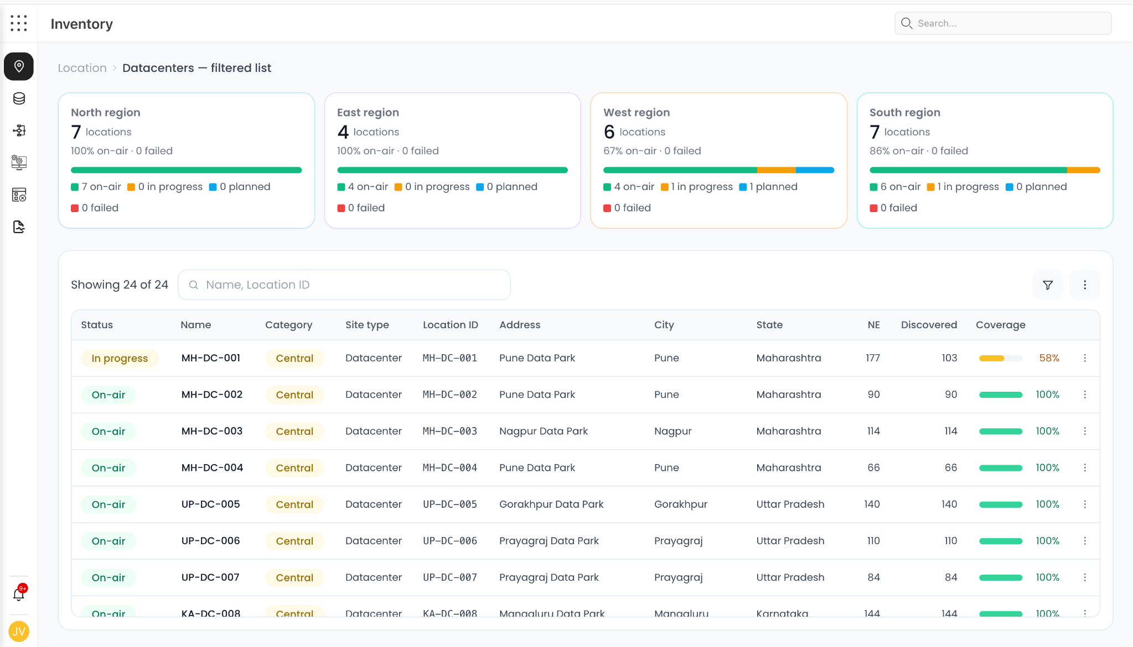
Figure INV-01: Datacenter inventory filtered list

INV-02 — Datacenter site details — overview
Site identity, inventory reconciliation, CapEx/OpEx, power, rack space, ports and building context.
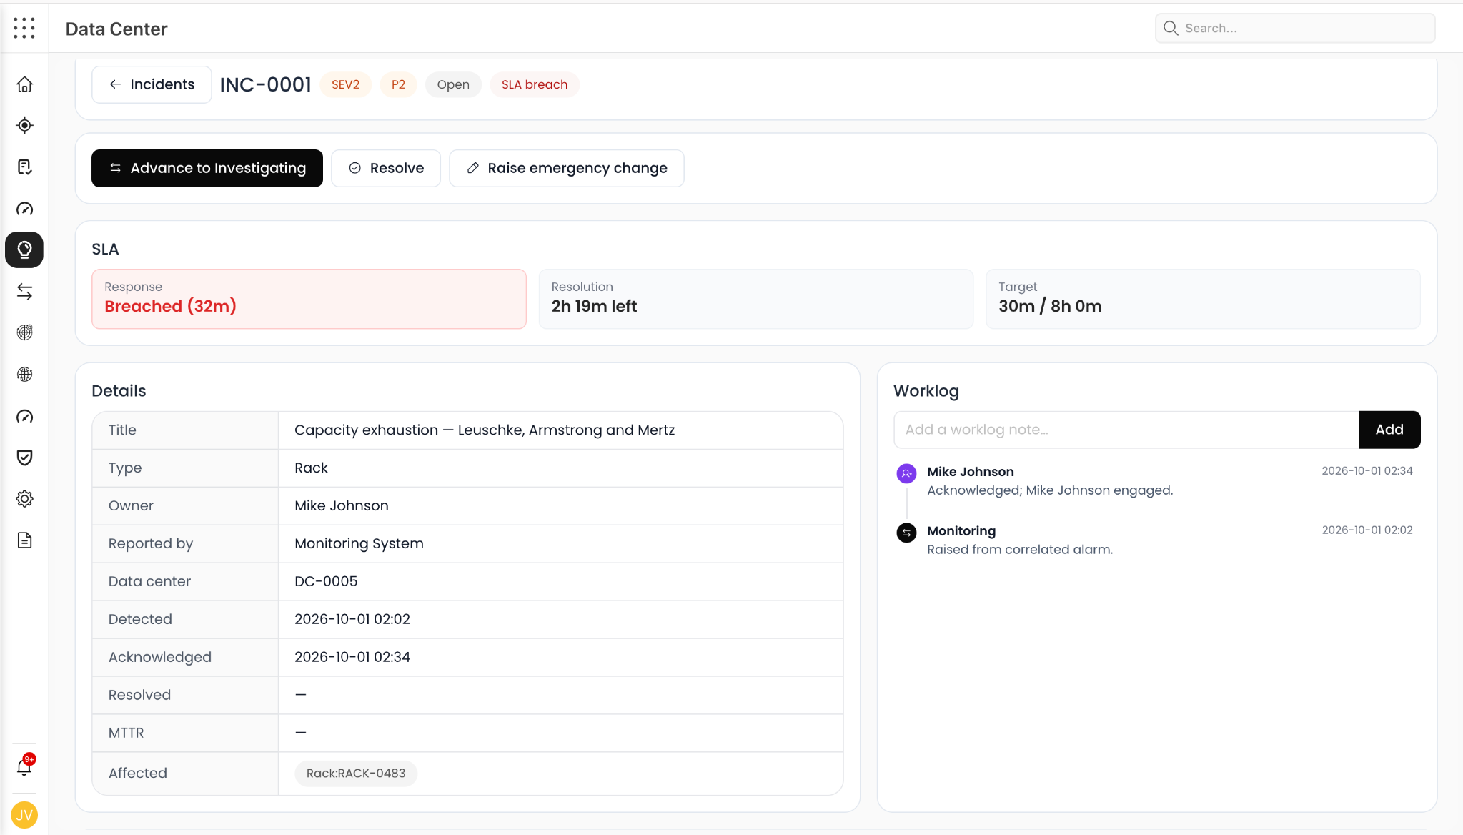
Figure INV-02: Datacenter site details — overview

INV-03 — Network element — protocol links / capacity forecast
Device-level protocol health and LLDP link-capacity forecasting.
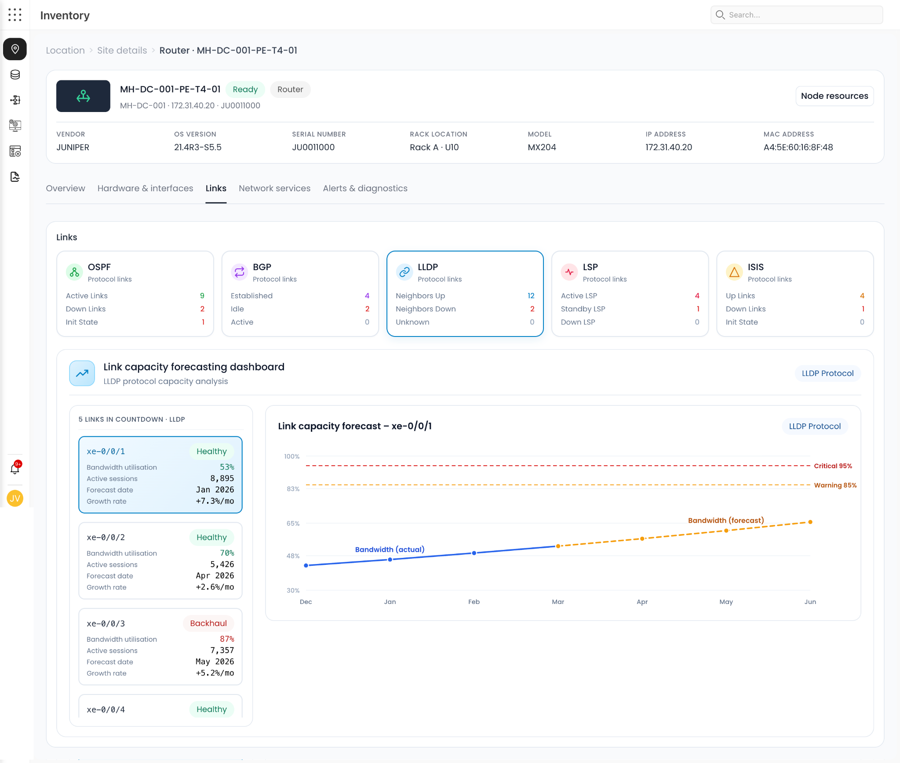
Figure INV-03: Network element — protocol links / capacity forecast

INV-04 — Datacenter site — attention / reconciliation
Not-discovered and configuration-drift reconciliation with recommended next steps.
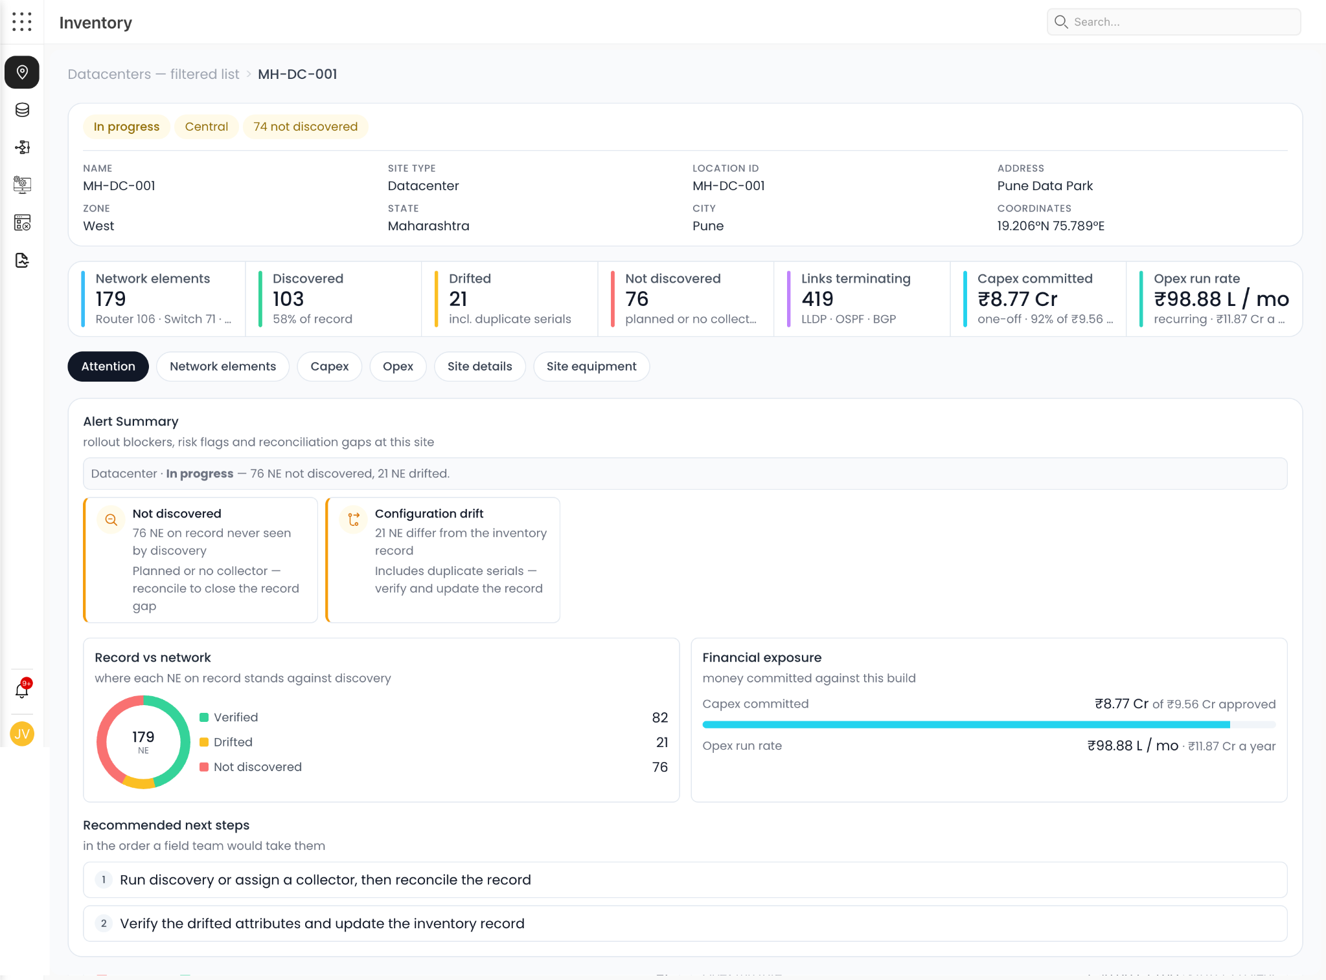
Figure INV-04: Datacenter site — attention / reconciliation

INV-05 — Site equipment — cable view
Passive/physical connectivity, equipment, ports and in-to-out mapping.
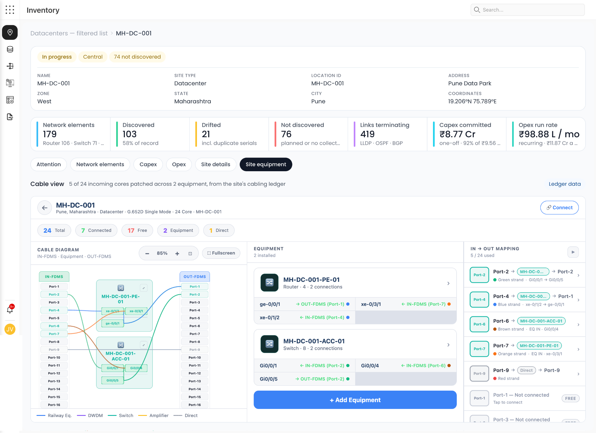
Figure INV-05: Site equipment — cable view

INV-06 — Global inventory estate view
Estate-wide hierarchy, circles, location counts, aggregated inventory and geographic rollout.
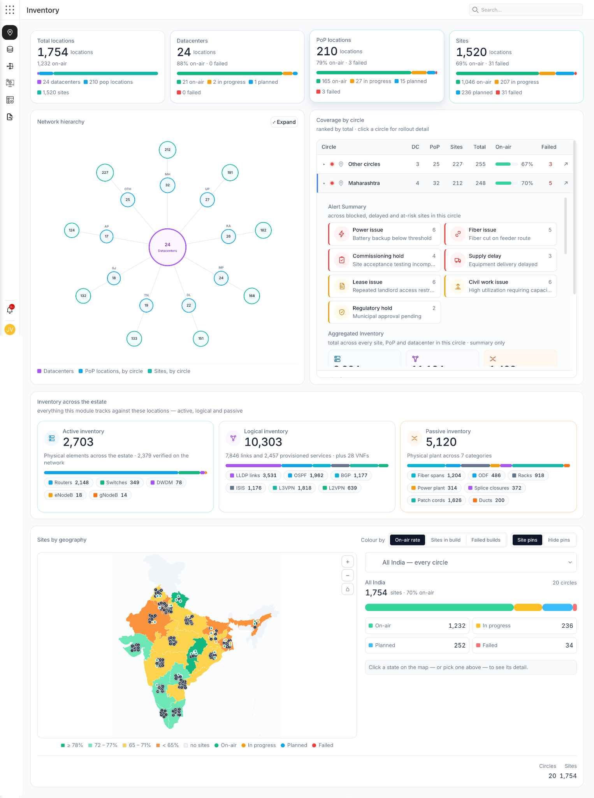
Figure INV-06: Global inventory estate view

INV-07 — Network services
Service instances, SLA, customer exposure, capacity outlook and AI recommendations.
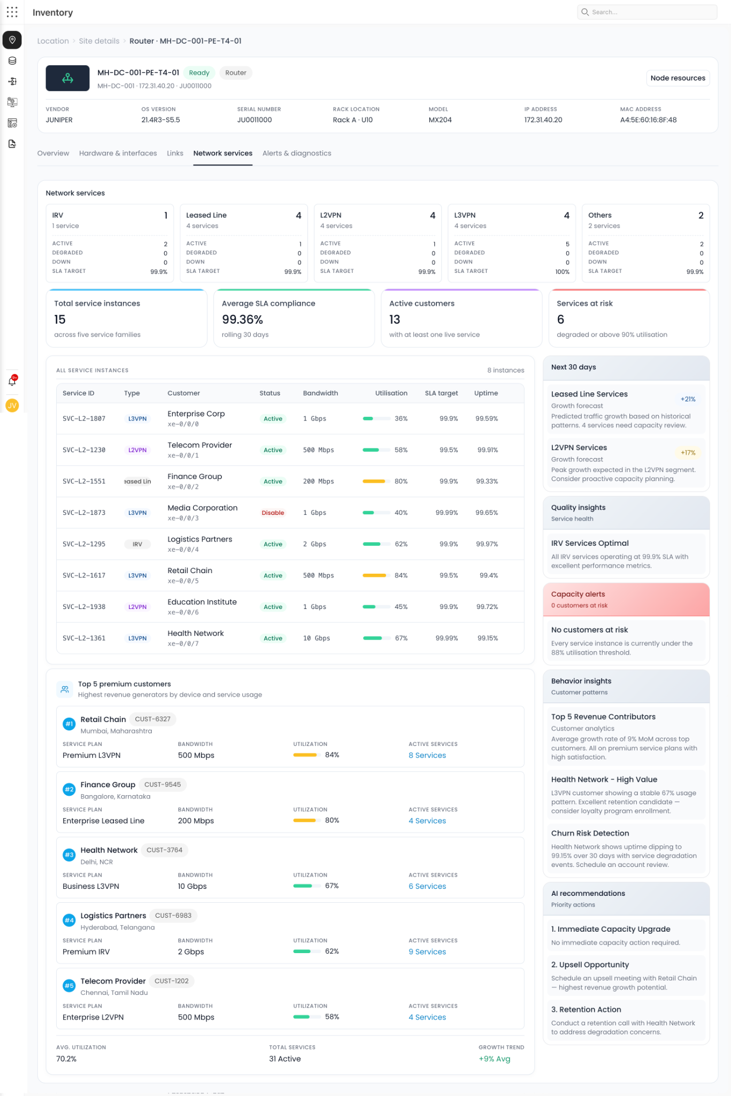
Figure INV-07: Network services

INV-08 — Network element — alerts and AI diagnostics
Real-time alerts, incident context, root-cause assessment, impact and action plan.
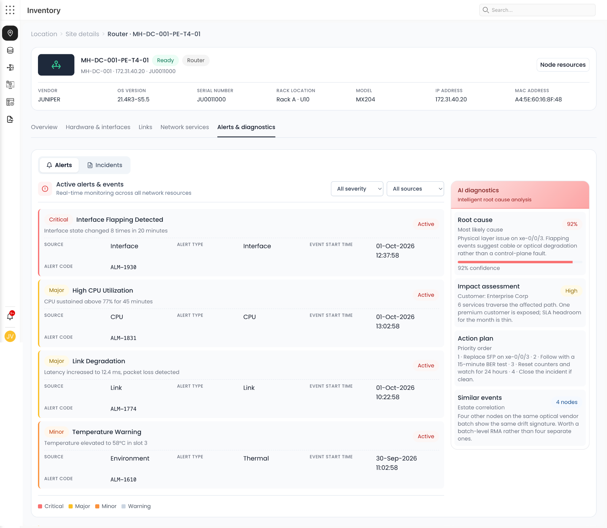
Figure INV-08: Network element — alerts and AI diagnostics

INV-09 — Network element — operational overview
Device health, links, interfaces, alarms, uptime, ICMP/NTP/RADIUS and availability history.
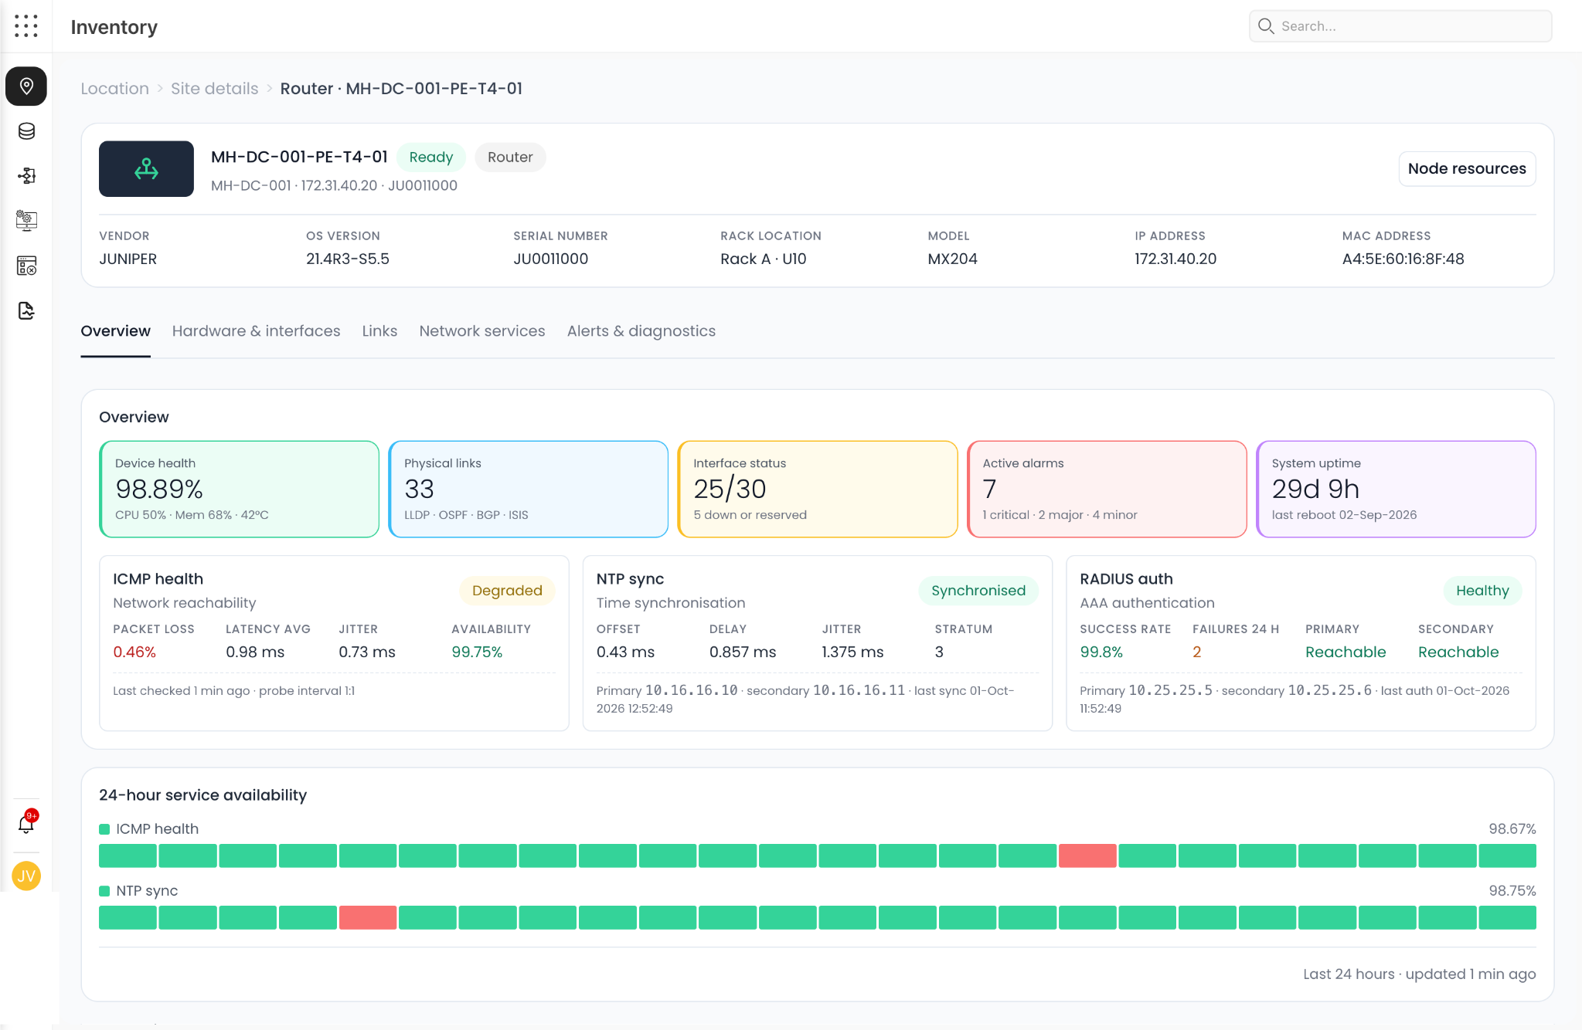
Figure INV-09: Network element — operational overview

18. Requirement-to-Screenshot Traceability
Requirements | Evidence | Interpretation
DC-INV-001 to 004 | INV-01, INV-06 | Estate/location inventory, regional roll-up, coverage and geography.
DC-INV-005 to 006 | INV-04 | Drift, not-discovered inventory and reconciliation workflow.
DC-INV-007 to 010 | INV-02, INV-05 | Site profile, physical plant, racks, ports and cable mapping.
DC-INV-011 | INV-03 | Link capacity forecasting and growth-based risk.
DC-INV-012 | INV-07 | Service/customer/SLA and utilization mapping.
DC-INV-013 to 015 | INV-08, INV-09 | Device health, alarms, diagnostics, impact and action plan.
DC-SITE-002 to 009 | INV-02 | Power, rack space, ports, building and financial exposure.
DC-NET-001 to 010 | INV-03, INV-05, INV-07, INV-09 | Network protocol, physical connectivity, services and device health.
DC-OPS-001 to 008 | INV-08 | Alert-to-incident, RCA, impact and remediation workflow.
DC-CAP-001 to 006 | INV-02, INV-03, INV-07 | Site, link and service capacity views.
DC-AI-001 to 008 | INV-04, INV-07, INV-08 | AI recommendations, RCA, impact and action planning.

19. Suggested Delivery Decomposition
Phase | Scope | Exit capability
Phase 1 — Operational foundation | Estate/location/site inventory, discovery, reconciliation, site details, equipment, ports, topology and RBAC. | Authoritative operational inventory with drill-down and data quality.
Phase 2 — Live operations | Telemetry, alerts, device health, facility health, incidents and dependency mapping. | Operators can detect, investigate and understand impact.
Phase 3 — Capacity & service | Power/cooling/rack/port/link/service capacity, forecasts, SLA and customer impact. | Operators can anticipate constraints and prioritize expansion.
Phase 4 — Change/resilience | Change, maintenance, DR, redundancy and dependency risk. | Controlled operational lifecycle and resilience management.
Phase 5 — Sentinel & automation | Copilot, RCA, recommendations, runbooks, approval and closed-loop actions. | Evidence-grounded AI-assisted operations with controlled automation.

20. Open Design Decisions
- Define authoritative source precedence when CMDB, DCIM, network discovery and manual records disagree.
- Define canonical identifiers for site, asset, interface, circuit/service and customer across systems.
- Define the exact region/circle model and whether geographic hierarchy is independent of operational ownership.
- Define standard severity, status and lifecycle taxonomies across network, facility and service domains.
- Define data freshness SLAs by source type and the behavior when a collector is stale.
- Define which AI actions are advisory only versus approval-gated automation.
- Define the service/customer criticality model and how business impact is calculated.
- Define retention requirements for telemetry, alerts, incidents, changes and audit evidence.
- Define integration boundaries with the existing Ops Singularity modules so capabilities are reused rather than duplicated.

21. Baseline Acceptance Criteria
- An operator can start at the estate level, select a region/circle, open a datacenter/site, drill to equipment, then interface/port and finally trace to service/customer.
- Inventory can distinguish recorded, discovered, drifted and not-discovered objects and provide an actionable reconciliation workflow.
- A physical connectivity record can be traced into logical topology and service dependency.
- A device alert can be correlated with topology, recent changes and affected services and produce an auditable impact/RCA workspace.
- Site capacity can be viewed across power, rack space, ports and network/service bandwidth with forecast and threshold information.
- Financial exposure can be viewed alongside operational capacity and site risk.
- AI recommendations provide evidence, confidence, impact and an explicit action path.
- All operational changes and automated actions are auditable.

22. Conclusion
The Inventory module should remain the operational system of record for the physical/logical estate, but the final Data Center Operations product should go beyond inventory. The differentiator is the connection between inventory, live telemetry, physical facility, topology, service/customer dependency, capacity, financial exposure, incidents and controlled action. The supplied screens already demonstrate many of these building blocks; this blueprint turns them into a coherent operating model that can be decomposed into epics, user stories, APIs, data contracts and UI specifications.

