Data Center Operations Platform Overview
Oct 7, 2026 · @JAYESH VERMA
The Data Center Operations platform gives an operations team one live view of every datacenter they run, from the power plant to the individual GPU, and tells them which problem to fix first and what it is costing.

What the platform is
It is an operations console for datacenter owners: one place that watches power, cooling, network, servers and GPUs across every site, and turns thousands of alarms into a short, ranked list of problems with a cause, an owner and a fix.
Today most operators run a datacenter from separate tools: a building management system for power and cooling, a network monitor, a server monitor, a ticketing tool and spreadsheets for customers and contracts. When something breaks, engineers jump between them to work out what failed, who is affected and what to do first. The platform joins those views on one data model, so a fault on a UPS, a cable or a GPU is shown together with the racks, services and customers it touches and the money at risk.
The current build is a working prototype on realistic demo data: 24 datacenters in India or the USA, about 4,000 to 6,000 devices per business model, and live-looking incidents, alarms and changes. It is live at datacenter-ideation.vercel.app.

How it works
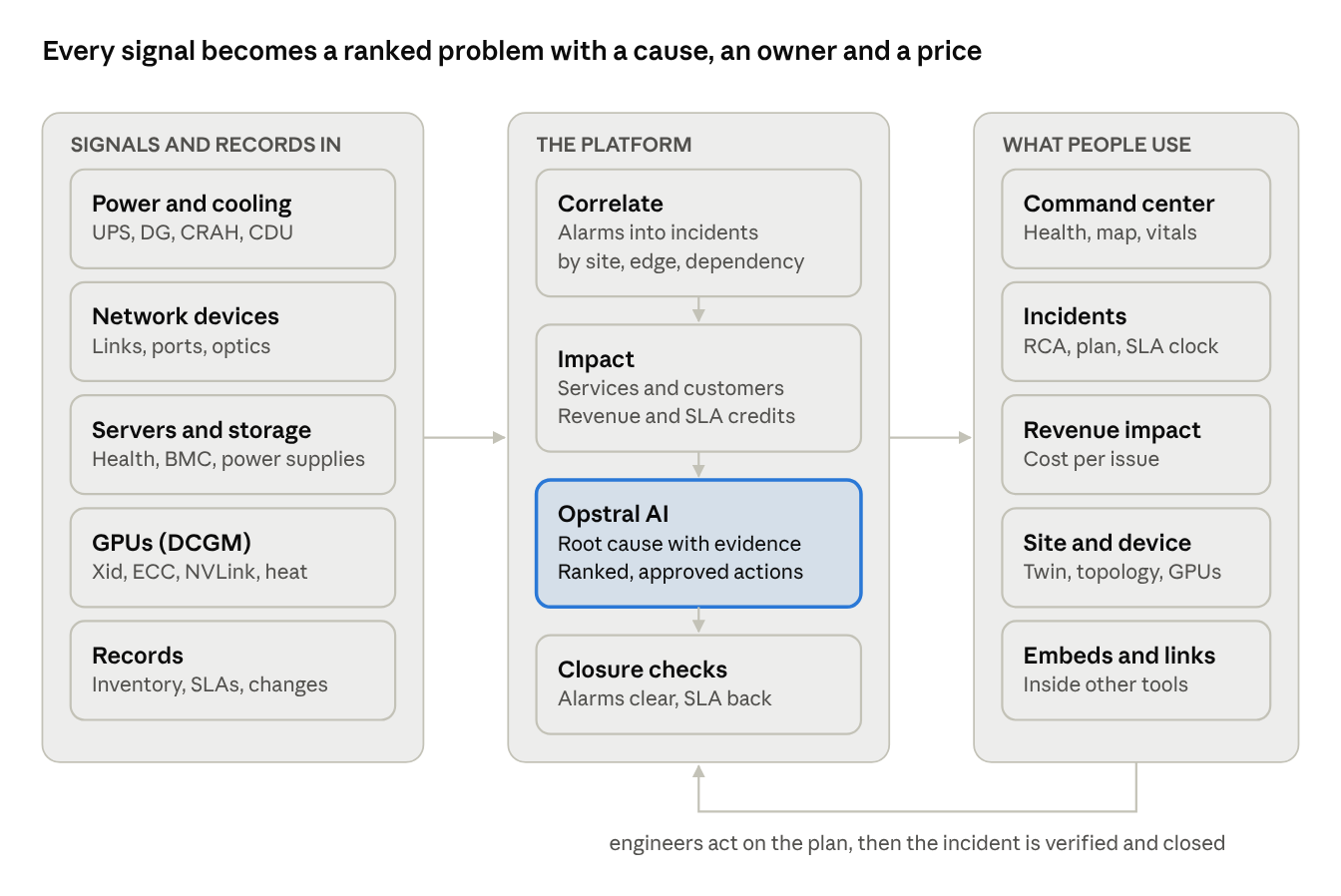
how it works · signals in, three platform stages, five ways people use it
Telemetry and records flow into one data model. The platform groups alarms into incidents, works out which services, customers and revenue they touch, and Opstral AI proposes the cause and the fix. People work from the screens on the right; an incident closes only when its checks pass.

Who it serves
The same estate can be shown as five business models, switched from the top bar, so each prospect sees their own equipment, words and money.
Business model | Who buys it | What sits in the racks | What customers buy | Money words
Telco DC | Telecom operators, ISPs | Routers, switches, optical (DWDM) | Circuits: L3VPN, L2VPN, leased lines, internet | Revenue impact, SLA credits
Colocation | Colo and wholesale providers | Tenant-owned gear, meet-me room | Cabinets, power circuits, cross-connects, remote hands | Revenue impact, SLA credits
Cloud | Cloud and hosting providers | Leaf–spine fabric, servers, storage, GPU nodes | VMs, Kubernetes, managed DB, storage, GPU clusters | Revenue impact, service credits
Enterprise | Banks, insurers, government | Fabric, virtualisation hosts, SAN, GPU nodes | Internal applications, charged back to business units | Business impact, cost of downtime, OLA rebates
NeoCloud | GPU clouds and AI infrastructure providers | GPU nodes on InfiniBand, Ethernet front-end, parallel storage | Reserved GPU clusters, on-demand GPUs | Revenue impact, service credits
Power, cooling, alarms and incidents are shared across all five; only the equipment, vocabulary, customers and services change.

Modules
Eight menu items, plus a page for each datacenter, cover the whole operational flow, from the estate overview down to a single port or GPU.
Module | The question it answers | What it shows
Command center | How is the estate right now, and what needs me first? | Health score with four areas, live map, six 24-hour vitals, critical incidents, who is affected, recommended actions, root-cause families
Revenue impact | Which issue costs the most, and what is at stake? | Revenue lost per hour, impact so far, credits owed, next credit step, issues ranked by money
Datacenters | Which sites need attention? | Every site with incidents, alarms, network and edge state, power and cooling load, customers and revenue; list or tile view
Datacenter page | What is happening inside this site? | 3D digital twin, attention list, topology, metrics, customers, revenue, AI & GPU, assets, equipment, power & space, ops log
Facilities | Is power and cooling safe? | Single-line power path, 24-hour load against capacity, "if utility power fails" ride-through, cooling heat balance, environment zones
AI & GPU | Are the GPUs healthy and the AI jobs productive? | GPU fleet, pods as heat maps, jobs, DCGM telemetry, cooling and power for GPU halls, InfiniBand fabric, GPU time lost
Alerts | What is the equipment reporting? | All alarms with severity, scope (site, edge, dependency) and source, filterable
Incidents | What problems are open, who owns them, are we within SLA? | Incidents with severity, SLA clocks, revenue impact, root-cause hypotheses, action plan, closure checks
Changes & maintenance | What work is planned or in progress, and did it cause anything? | Change and maintenance windows, risk, approvals, rollbacks, and links to incidents that followed
Every device has its own page with health, hardware and ports, links, impact on services and customers, alarms and, for GPU servers, per-GPU DCGM detail.

How it helps operations
The platform shortens the path from "an alarm fired" to "the right person is fixing the right thing", and gives each role the view it needs.
Role | Before | With the platform
NOC engineer | Hundreds of raw alarms across several tools; works them in arrival order | Alarms grouped into incidents with one owner, ranked by severity, SLA clock and customer impact
Facilities engineer | Power and cooling in a separate building system; impact on customers unknown | Power path and cooling on the same screen as the racks, services and customers they feed; battery and fuel clocks in minutes and hours
AI / GPU operations | GPU health in scripts and dashboards; a failed GPU found when a customer complains | Every GPU's DCGM counters, jobs and the GPU time each fault is wasting; early warnings from rising error counters
Customer success | Learns about outages from the customer | Sees which customers are at risk at each site and the fault behind each one, before the call
Change manager | Cannot easily see which change caused a problem | Incidents show the change that preceded them; risky and rolled-back changes are visible in one list
Leadership and finance | Outage cost estimated after the fact | Revenue lost per hour, credits owed and revenue at stake, live and by issue, site and customer
The common effect is faster diagnosis, fewer missed SLAs and a fix order driven by business impact rather than by whoever shouts loudest.

A real incident, step by step
At 13:20 on a Thursday, a telecom operator's NOC lead opens the platform; within a few clicks they know what is burning, why, who is hurt and what to do. The figures are the demo's Telco persona in India.
- Command center. Operations health is 86 of 100, band Watch. Two critical and four high incidents are open across six sites; 11 incidents are past SLA. The live map pulses at the affected sites.
- Revenue band. The estate is losing ₹5,993 an hour; ₹8.49 Cr of monthly revenue is at stake on services one failure away from going down.
- The UPS on battery. At DL-DC-009 New Delhi, utility feed A has tripped and UPS-2 carries the load at 71% with about 13 minutes of battery. 46 services for 24 customers, ₹3.88 Cr a month, ride on it.
- Root cause. The incident page shows the generator controller was left in MANUAL after the previous day's feeder switchover, a change the platform links to the incident (CHG-2005). The action plan says: start the generator by hand, transfer the load, set the controller back to AUTO. Disruptive steps wait for approval.
- The costliest issue. Revenue impact ranks issues by money. A flapping backhaul port at MH-DC-001 Pune costs ₹2,970 an hour across nine degraded services, six of them premium, with the next service-credit step due in 19 minutes. Its cause: a degraded optic installed during a fibre re-patch 15 hours earlier (CHG-2001).
- Customers. The Pune site's customer tab lists the six premium customers at risk and names the same port behind each one, so the account team calls with the reason.
- Fix and close. Engineers move premium traffic to a healthy port, swap the optic, and the incident can only be resolved once closure checks pass: alarms cleared, health green for 15 minutes, services back within SLA.
The same story runs in every business model, with that model's equipment, customers and money.

Opstral AI
Opstral AI is the built-in assistant: it proposes the likely root cause with evidence, ranks what to do next, and answers questions in plain language, while people keep the final say.
- Root cause. Each incident lists ranked hypotheses with a confidence score and the evidence behind it, such as "physical-layer issue on xe-0/0/3, 92%" backed by flap counts, CRC errors and optic light levels. Engineers confirm or reject each one, which trains future suggestions.
- Correlation. Related alarms are grouped into one incident by topology, time and source, and remote sites that suffer because of this datacenter are shown as downstream symptoms rather than separate issues.
- What to do next. The command center ranks actions across all incidents. Each step names an owner, the expected result, a rollback and how to verify it.
- Approval gates. Disruptive steps, such as rerouting traffic or replacing hardware, need approval before they run.
- Questions. "Which issue is costing the most revenue?", "What is INC-0002 costing us?" or "Which GPU job is losing the most?" get answers built from the live estate, with links to the evidence.
In the prototype these answers are deterministic logic over the demo data; no external AI service is called.

GPU and AI infrastructure
For GPU estates the platform watches every GPU through NVIDIA DCGM and turns hardware faults into the GPU time and revenue they waste. In the NeoCloud demo that is 16,728 GPUs on 2,091 servers, losing ₹46,301 an hour of productive GPU time.
- Fleet and pods. GPUs are shown as heat maps: one square per GPU, eight per server, up to 32 servers per pod. Colour shows busy, idle, throttled, degraded or failed.
- Jobs. Training, fine-tuning and inference jobs show their GPUs, owner, step time and state. One failed GPU can stop a whole job: the demo shows one GPU stopping a 144-GPU training run, with 52 minutes of work to redo since the last checkpoint.
- DCGM telemetry. Per-GPU utilisation, tensor activity, memory, temperature, power, clocks, throttle reasons, ECC memory errors, PCIe replays, NVLink errors and Xid error codes, plus 24-hour history and fleet histograms.
- Cooling and power. Liquid-cooling loops (CDUs), GPU rack power and caps. A drop in coolant flow shows as GPUs in thermal slowdown and a slowed job.
- Fabric. The InfiniBand compute network, the Ethernet front-end and the management network are shown separately, down to each cable.
- GPU time lost. A stalled job counts all its GPUs, a slowed job the share of time lost, and an idle allocation everything it holds, priced per GPU-hour.
Colocation operators see tenant AI cages by power, coolant and inlet temperature only, because the GPUs belong to the tenant.

Revenue and SLA impact
Every open issue carries a price: what it is losing now, what it has cost so far, what is at stake, and when the next service-credit step starts. This lets the team fix in order of business impact, and flags a costly issue that was logged at low severity.
Figure | How it is worked out | Example (Telco, India)
Losing now | Monthly charge of each down service ÷ 730 hours; degraded services count 30% | ₹5,993 per hour
Impact so far | Revenue lost since each fault began, plus service credits already triggered | ₹3.66 L
At stake | Monthly revenue of services still running but riding a critical fault, such as a UPS on battery | ₹8.49 Cr a month
Service credits | 10%, 25% or 50% of the monthly charge, by how far availability falls below the SLA | Next step ₹4.68 L in 9 minutes
Within SLA | Share of revenue whose services met their availability target over 30 days | 87.6%
Each service is charged to one issue only, the most severe on its path, so totals reconcile across issues, causes, datacenters and customers. Enterprise estates use the same model with internal words: cost of downtime and OLA rebates.

Fitting into a customer's world
The platform adapts to the prospect in front of you without separate builds.
- Business model. The persona switch in the top bar, or ?persona=network|colocation|cloud|enterprise|neocloud in the link, regenerates the whole estate for that model.
- Geography. ?geo=in shows India with rupees and Indian sites; ?geo=us shows the same 24 sites as US markets with dollars and US dates.
- Embedding. ?shell=false hides the menu and top bar so any screen can sit inside another product in an iframe. Every screen has a direct link with its filters in the URL.
- Deployment defaults. A deployment setting can force a persona or geography, for example showing colocation to anyone who opens a US telco link.
Three companion guides are served with the platform: the demo script, the embedding and route guide and the field guide to terms.

Status and next steps
The prototype shows the full operational experience on realistic mock data; connecting it to live systems is the next phase.
What it is today:
- A navigable product covering every screen in this document, for five business models and two geographies.
- Mock data generated from a fixed seed, so numbers reconcile everywhere and every demo tells the same story.
- Deterministic AI logic grounded in that data.
What a production build needs, as open questions:
- ☐ Which telemetry sources to connect first: building management (power, cooling), network (SNMP, streaming telemetry), servers (BMC), GPUs (DCGM exporter)?
- ☐ Where inventory and customer contracts come from: an existing CMDB, a billing system, or both?
- ☐ Which ticketing or ITSM tool incidents and changes must sync with?
- ☐ Single sign-on, roles and per-tenant views for colocation customers?
- ☐ Which business model and geography to pilot first?

