Step 1: Create the Object
- Go to Setup
- Search for Object Manager
- Click Create → Custom Object
- Fill details:
  - Label: Student
  - Plural Label: Students
  - Object Name: Student
- Click Save
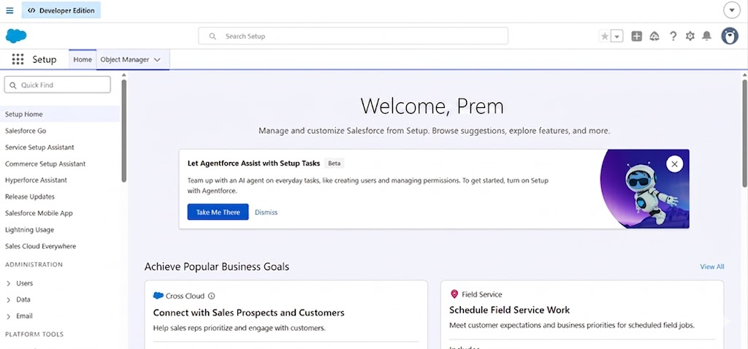
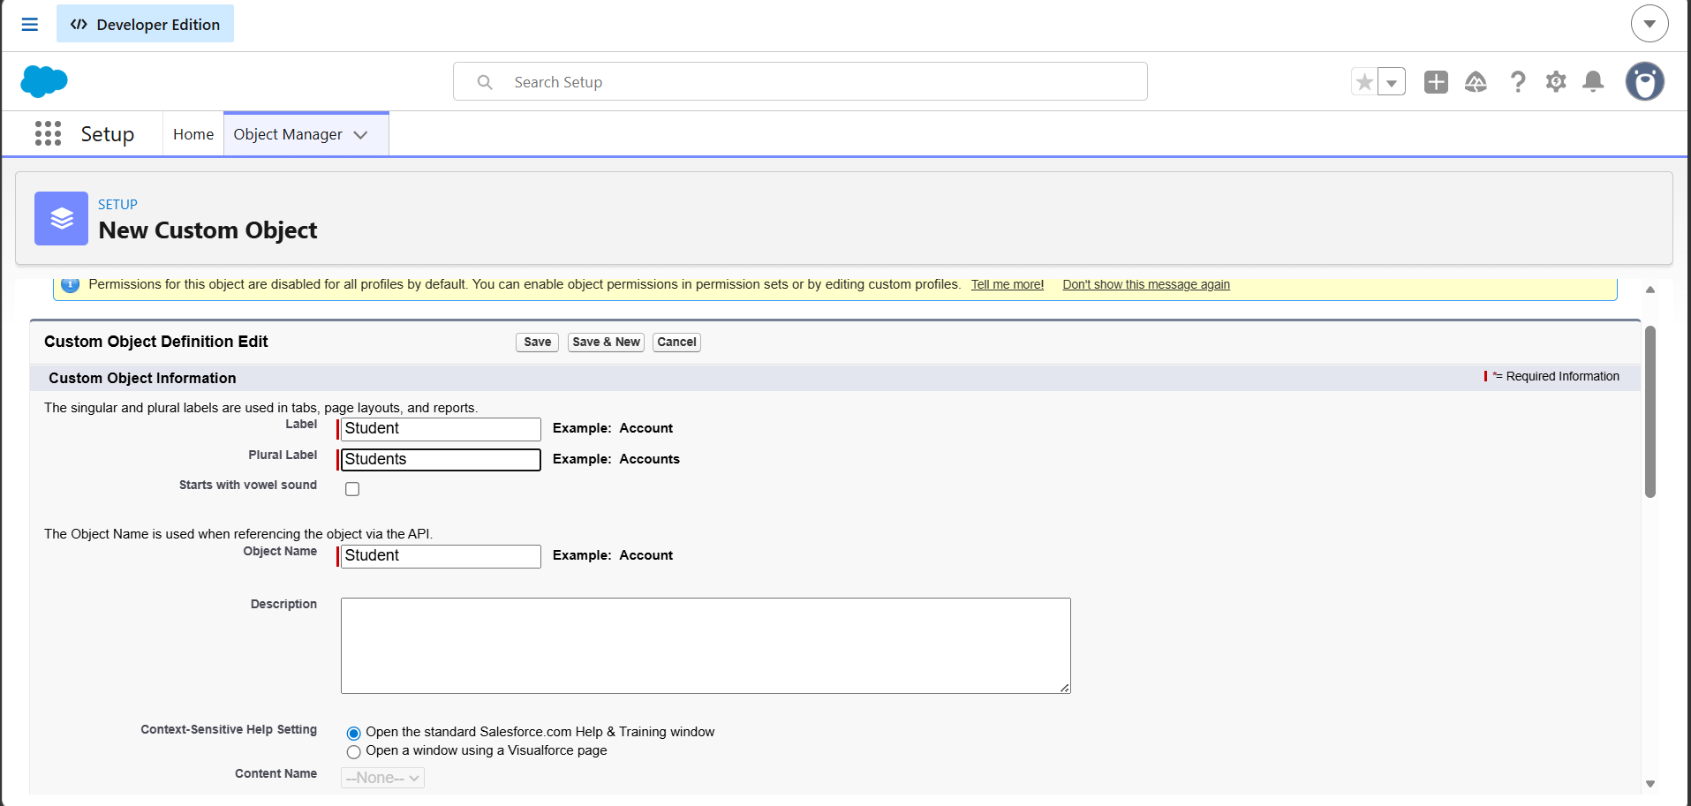

✔️ Step 2: Add Remaining Fields
After clicking Save, you’ll go to the Student Object page.

➤ Go to: Object Manager → Student → Fields & Relationships → New

🔹 Add Student ID Field
- Click New
- Select Auto Number (recommended) or Text
- Click Next
- Fill:
  - Field Label: Student ID
  - Display Format: STU-{0000}
- Click Next → Save

🔹 Add Marks Field
- Click New
- Select Number
- Click Next
- Fill:
  - Field Label: Marks
  - Length: 3
  - Decimal Places: 0
- Click Next → Save

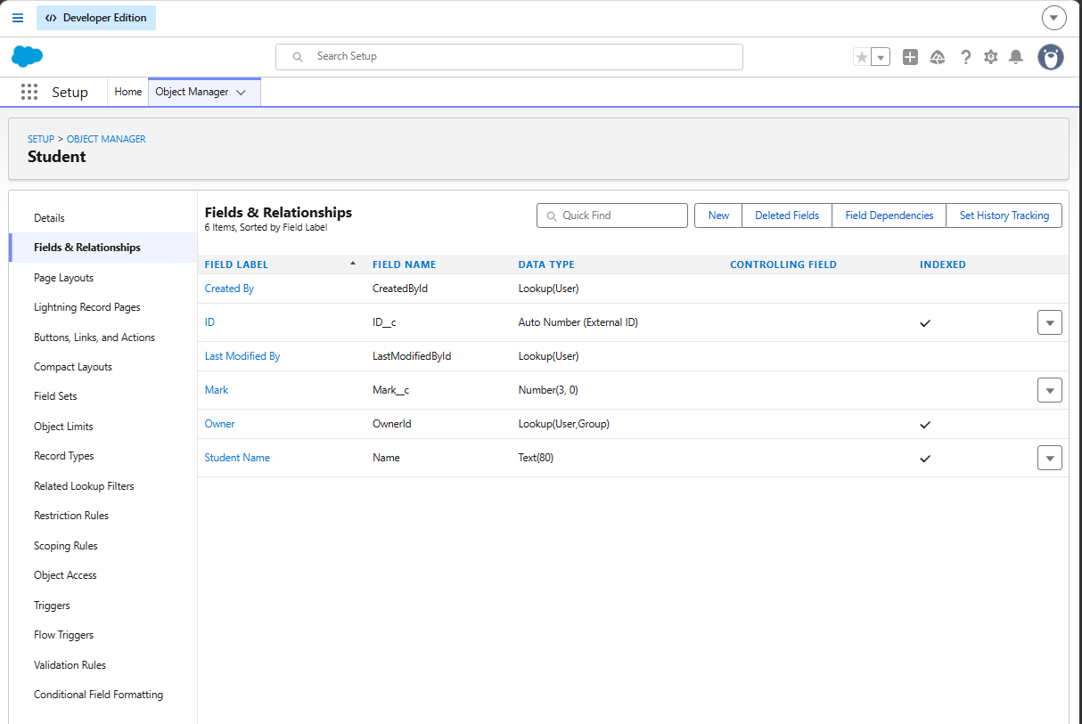

3️⃣ Create Tab for Student Object
- Go to:
  - Setup → Tabs → New Tab
- Select:
  - Object: Student
  - Choose any Tab Style
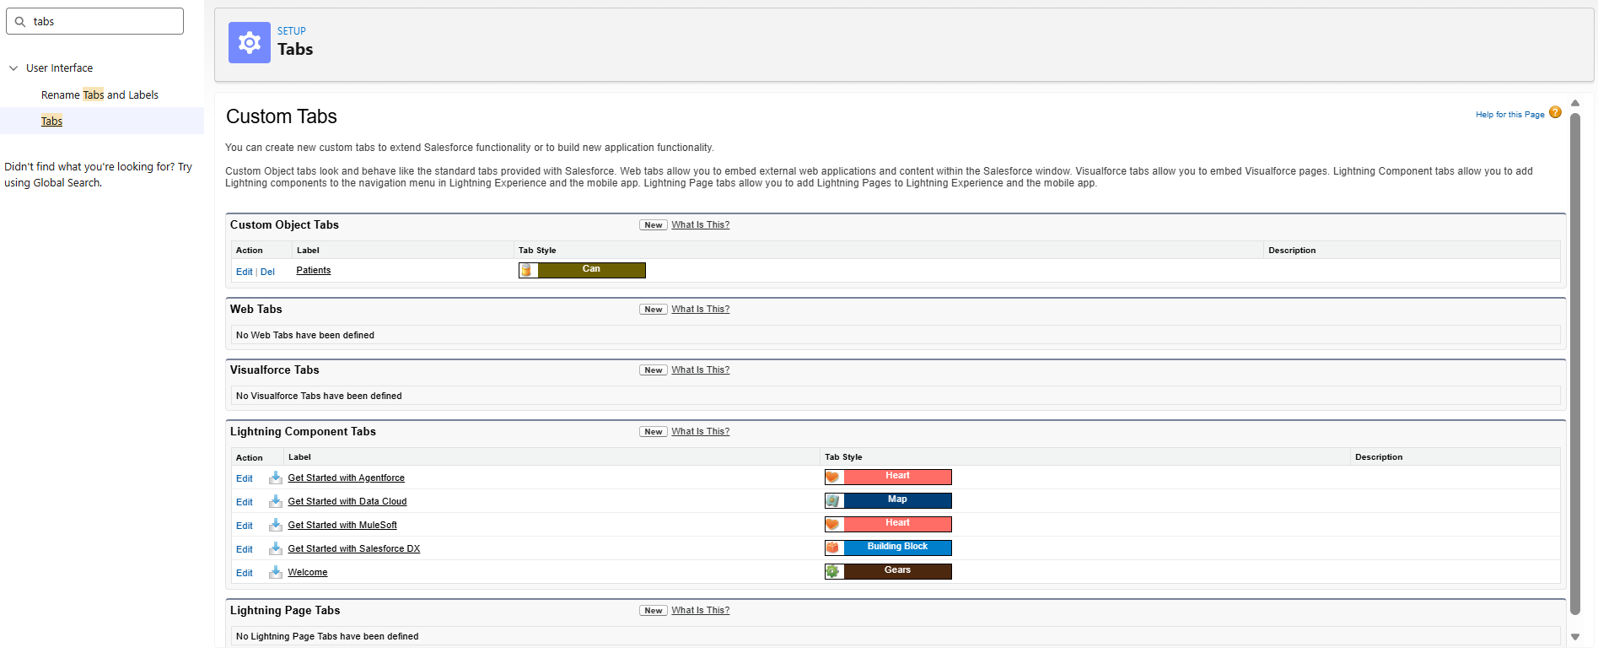

4️⃣ Add Object to App
- Go to:
  - App Manager → Edit App
- Add Student Tab to navigation

5️⃣ Create Sample Record
Example:
Student Name | Student ID | Marks
Prem | STU-0001 | 88
Raj | STU-0002 | 92

