Step 1) Here we are installing VMwareESXi cloud
    - Host/NodeESXi installation:-
    - ESXiHardwareRequirements:-
- ESXi6.7requiresahostmachinewithatleasttwoCPUcores.
- ESXi6.7supports64-bitx86processors
- ESXi6.7requirestheNX/XDbit to be enabled for the CPU in the BIOS.
- ESXi6.7requiresaminimumof4GBofphysicalRAM.Itisrecommended to provide atleast 8 GB of RAM to run virtual machines in typical productionenvironments.
- Tosupport64-bitvirtualmachines,support for hardware virtualization (IntelVT-xor AMDRVI) mustbeenabledonx64CPUs.
- One or more Gigabit or faster Ethernet controllers. For a list of supportednetwork adapter models.
- SCSI disk oralocal,non-network,RAIDLUN with unpartitioned space for the virtualmachines.


ForSerialATA(SATA), a disk connected through supported SAS controller or supported on board SATA controllers. SATA disks are considered remote not local. These disks are not used as a scratch partition by default be cause they are seen as remote.
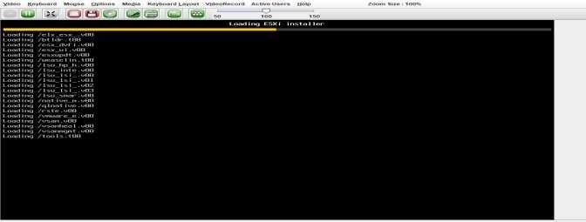

ESXiInstaller: Accept Agreement:

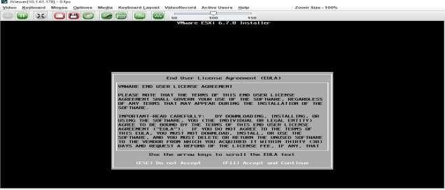
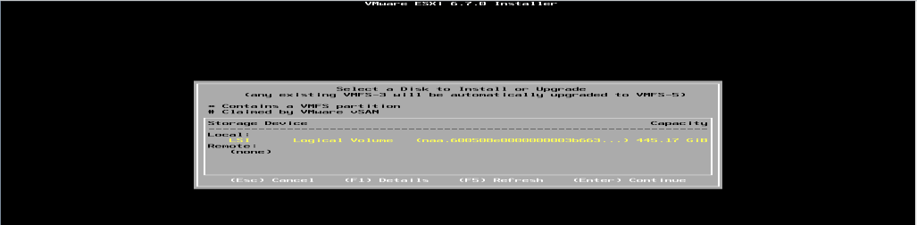

- Select storage :

- Select Keyboard Layout :


- Set NodeESXi Root Password :


- Installation complete (Reboot)CLII interface to configuration
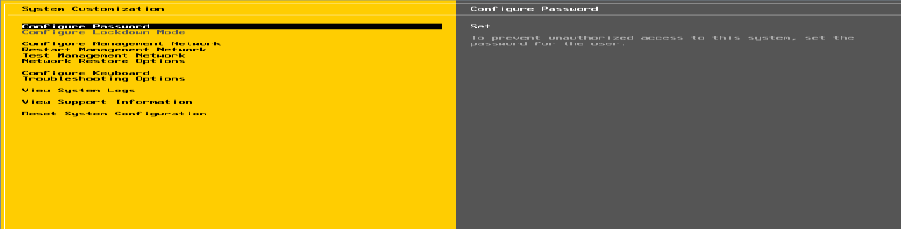

- CLI Interface to Configuration:
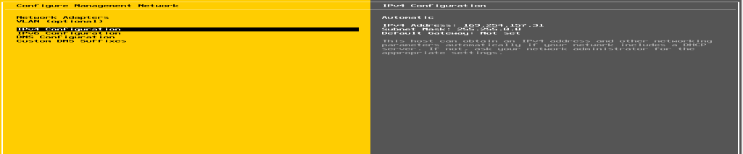

- Configure Management Network
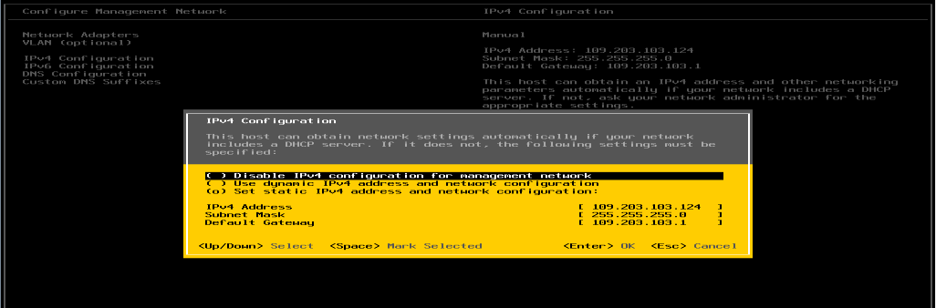

- Set IPV4
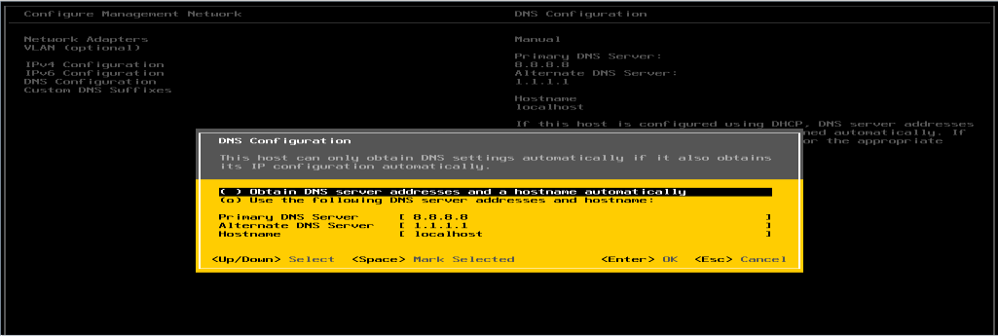
- Set DNSeriver :

- Restart Management Network
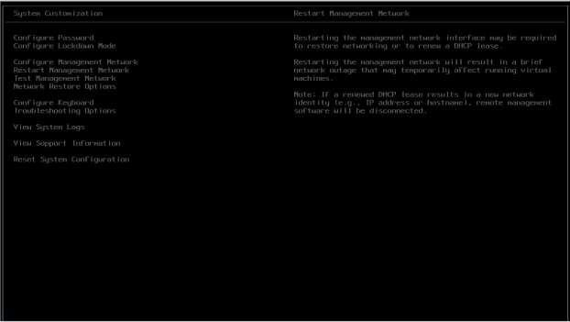

- GUIAccess :
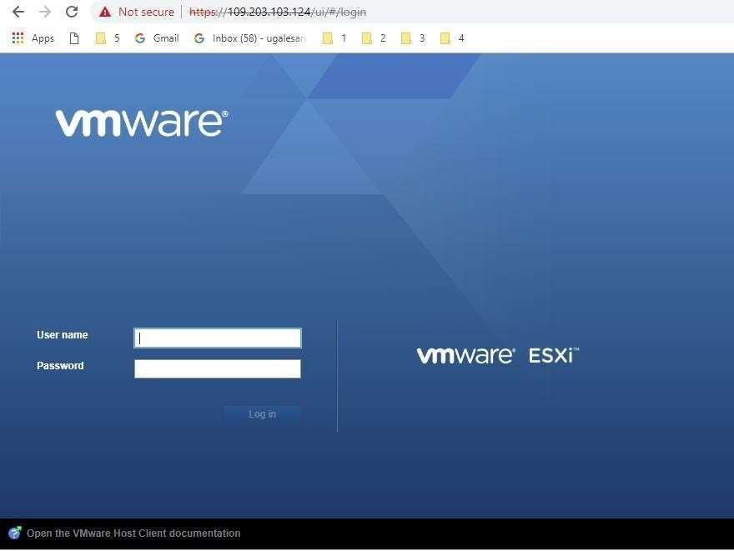

- ClusterSetup
- CreatingDatacenter
- CreatingCluster
- Adding Hosts incluster
- Resourcesafteraddingcluster.
- DRS
- Failover

VCenter Access:
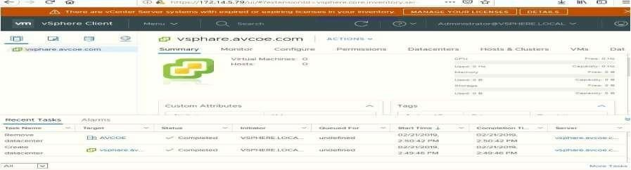

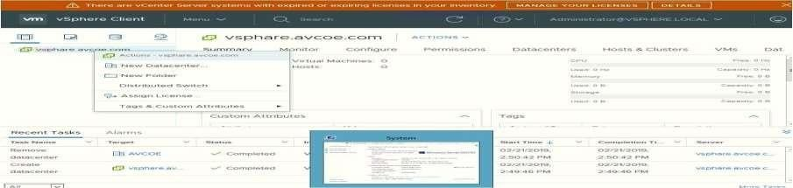
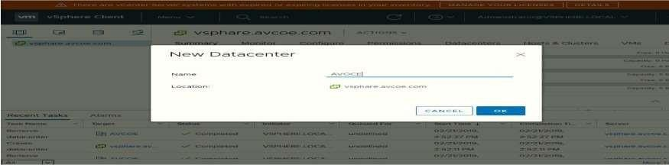
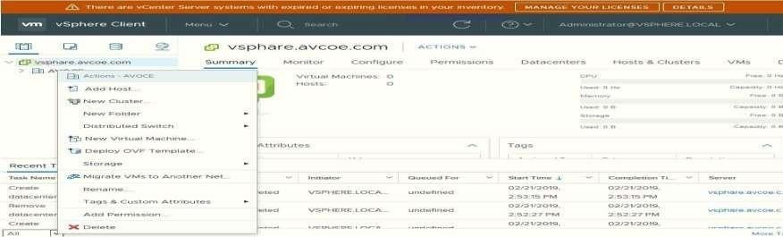
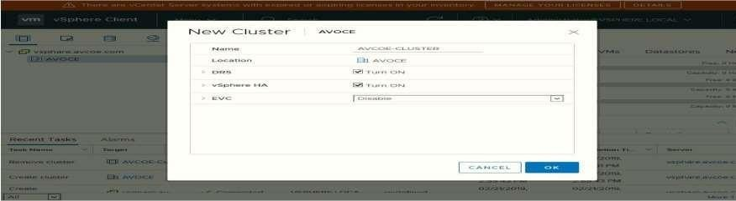

Create Datacenter:

Create cluster : Assign cluster name :

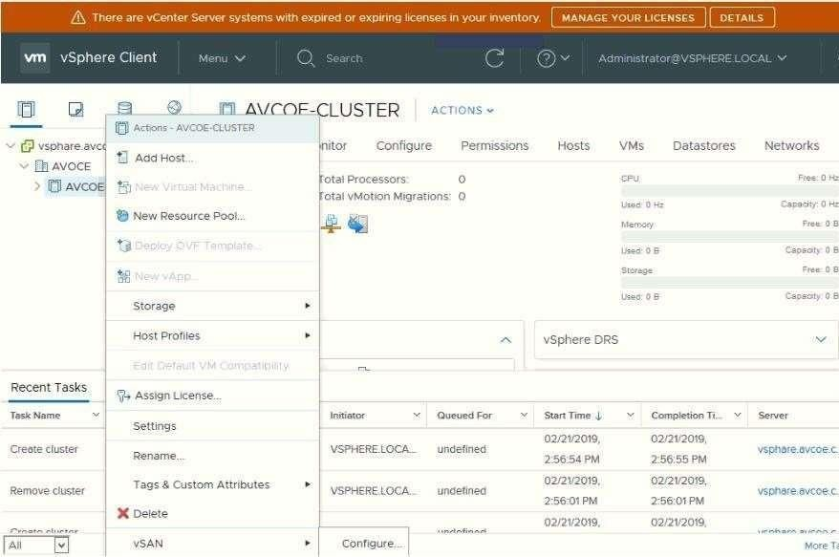
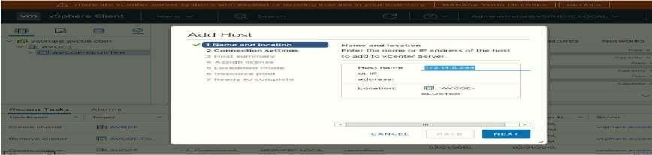
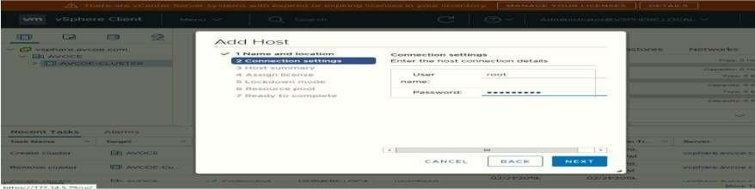

Add host .:

Add host IP :

Enter host credential :

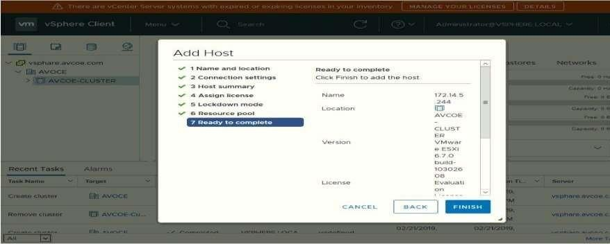

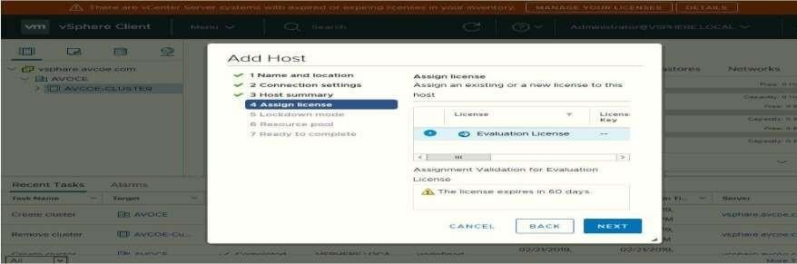
Hot summary : Lock Down mode:
Add Host In Pool:
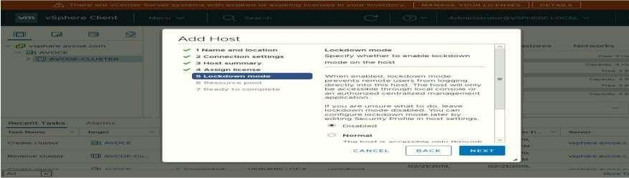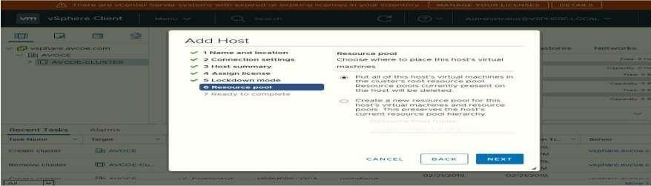

Finish:

Host View and View Config:

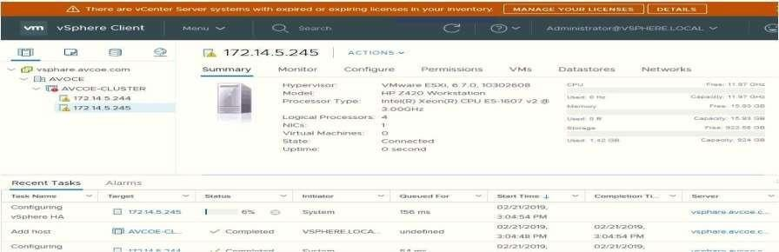
Cluster View and Configuration:

