**A Database Mini Project Report**

**on**

**“HOSPITAL MANAGEMENT SYSTEM”**

Submitted to the

Savitribai Phule Pune University

In partial fulfillment for the award of the Degree of

Bachelor of Engineering

in

Information Technology

by

**FirstName Last Name**

(Exam Seat No. / Roll No. & Division)

Under the guidance of

**Dr/Prof. Emmanuel**



Department Of Information Technology

Pune Institute of Computer Technology College of Engineering

Sr. No 27, Pune-Satara Road, Dhankawadi, Pune - 411 043.

**2019-2020**



**CERTIFICATE**

This is to certify that the mini project report entitled **“Hospital Management System”** being submitted by **Name of Student (Exam Seat No. / Roll No. & Division)** is a record of bonafide work carried out by him/her under the supervision and guidance of Dr.Emmanuel M in partial fulfillment of the requirement for **TE (Information Technology Engineering) – 2015 course** of Savitribai Phule Pune University, Pune in the academic year 2019-2020.

Date: 15/10/2019

Place: Pune

Guide Subject Coordinator Head of the Department

Principal

This Project Based Seminar report has been examined by us as per the Savitribai Phule Pune University, Pune requirements at Pune Institute of Computer Technology, Pune – 411043 on . . . . . . . . . . .

Internal Examiner External Examiner

**ACKNOWLEDGEMENT**

I have taken efforts in this project. However, it would not have been possible without the kind support and help of many individuals and organizations. I would like to extend my sincere thanks to all of them.

I am highly indebted to Dr.Emmanuel for his valuable guidance and constant supervision as well as for providing necessary information regarding the project & also for his support in completing the project.

I would like to express my gratitude towards my parents for their kind co-operation and encouragement which help me in completion of this project.

My thanks and appreciations also go to my classmates in developing the project and people who have willingly helped me out with their abilities.

Devdatta Pande 33114

Jayesh Asawa 33107

Sampada Gaikwad 33116

Mansi Deshpande 33113

(Students Name & Signature)

**CONTENTS**

|  |  |  |
| --- | --- | --- |
| **Sr.No** | **TITLE** | **Page no** |
| **1.** | **Content’s Abstract** | **3** |
| **2.** | **Introduction** | **3** |
| **3.** | **Overview** | **4** |
| **4.** | **Background and Motivation** | **4** |
| **5.** | **Methodology** | **4** |
| **6.** | **Scope** | **4** |
| **7.** | **Requirements** | **4** |
| **8.** | **E-R Diagram** | **6** |
| **9.** | **Relational Database design** | **6** |
| **10.** | **Database Normalization** | **7** |
| **11.** | **Graphical User Interface** | 8 |
| **12.** | **Conclusion** | **16** |
| **13.** | **References** | **17** |

**ABSTRACT**

Our project Hospital Management System includes storing the details of the hospital employees (doctors and nurses), registration of patients and storing their details into the system. Our software has the facility to give unique ID for every patient and stores the details of every patient and staff automatically in the databases. It includes a search facility to know the current status of each room. User (admin/receptionist in this case) can search availability of doctor and the details of the patient using patient ID.

The Hospital Management System can be entered by username and password. It is only accessible by admin/receptionist of the hospital. Operations such as add, view, modify and delete can be performed on the employee as well as patient database by the admin/receptionist. Data from the database can be retrieved easily. The interface is very user friendly. The data are well protected and makes the data processing very fast.

INTRODUCTION

Hospital Management System starts with the admin/receptionist entering his/her username and then logging into the system. The database contains two records namely, employee records and patient record. Employee record contains the database that contains the information and the related details of doctors and nurses, whereas patient record contains all the details of the patient. The System generates a unique patient ID for every new patient. The System books an appointment for the patient, it initially checks whether the person is already a patient of the hospital with patient ID, if yes the system displays the patient details and if no then the admin is redirected to the patient registration form to fill in the details of the new patient. The system also allocates room (if required) for the patient at the time of appointment booking. The system displays the status of appointment as “in progress” for the ongoing appointment and displays the status as “completed” on completion of the appointment. Lastly, the system generates the total bill for the patient that includes doctor charges and medicine charges.

**OVERVIEW**

The Hospital Management System is designed for any Hospital to replace their existing manual, paper based system. The new system is to control the following information: patient information, room availability, staff and operating room schedules, and patient invoices. These services are to be provided in an efficient, cost effective manner, with the goal of reducing the time and resources currently required for such tasks.

A significant part of the operation of any hospital involves the acquisition, management and timely retrieval of great volumes of information. This information typically involves; patient personal information and medical history, staff information, room and ward scheduling, staff scheduling, operating theatre scheduling and various facilities waiting lists. All of this information must be managed in an efficient and cost wise fashion so that an institution's resources may be effectively utilized. The system will automate the management of the hospital making it more efficient and error free. It aims at standardizing data, consolidating data ensuring data integrity and reducing inconsistencies.

**Background and Motivation**

1. Existing System

Hospitals currently use a manual system for the management and maintenance of critical information. The current system requires numerous paper forms, with data stores spread throughout the hospital management infrastructure. Often information (on forms) is incomplete, or does not follow management standards. Forms are often lost in transit between departments requiring a comprehensive auditing process to ensure that no vital information is lost. Multiple copies of the same information exist in the hospital and may lead to inconsistencies in data in various data stores.

2. Proposed System

The Hospital Management System is designed for Any Hospital to replace their existing manual, paper based system. The new system is to control the following information; patient information, room availability, staff and operating room schedules, and patient invoices. These services are to be provided in an efficient, cost effective manner, with the goal of reducing the time and resources currently required for such tasks. Use of database system will help reducing data redundancy and data loss.

**OBJECTIVE**

**Need of Hospital Management System**

* Easy Access to Patient Data.
* Cost Effective.
* Improved Efficiency.
* Reduces Scope of Error.
* Increased Data Security & Retrieve-ability.
* Improved Patient Care.
* Improve data security.
* Better revenue management.

**METHODOLOGY**

To implement the above goals, the following methodology needs to be followed:

1. JDBC
2. JSP
3. MYSQL workbench

**SCOPE OF PROJECT**

1. Patient’s information will be registered by the admin using registration form in computerized database system.
2. Appointment will be booked depending on the convenience of the patient and the availability of the doctor.
3. Rooms for the patient will be allocated depending on the vacancy.
4. Appointment status will reflect “in progress” for ongoing appointment and will reflect appointment “completed” after completion of the appointment.
5. Each room will be governed by a particular nurse.
6. Final payment invoice will include doctor and medicine charges.

**REQUIRMENTS**

Software Requirements: -

* Operating System **:**Windows XP
* Programming  language**:** .JAVA
* Front-End**:**JSP
* Back-End**:**MYSQL Workbench

**E-R DIAGRAM**

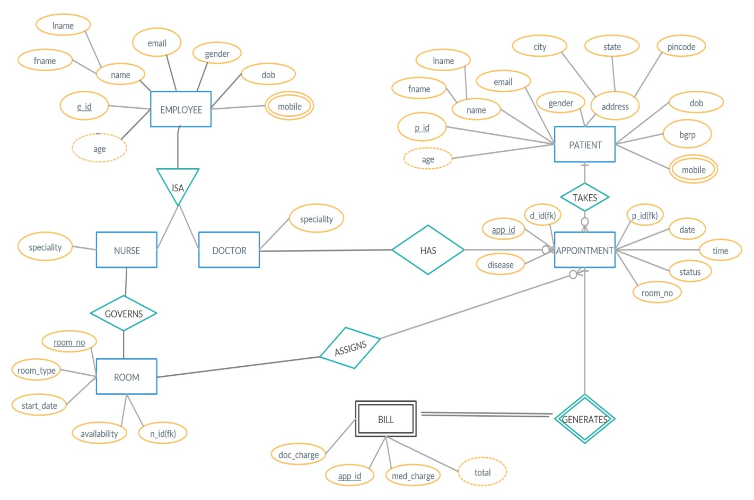

RELATIONAL DATABASE DESIGN:

1. EMPLOYEE:

|  |  |  |  |  |  |
| --- | --- | --- | --- | --- | --- |
| e_id | fname | lname | dob | gender | email |

2) EMPLOYEE_MOBILE_NO:

|  |  |
| --- | --- |
| e_id | mob_no |

1. DOCTOR:

|  |  |
| --- | --- |
| d_id(fk) | d_speciality |

4) NURSE:

|  |  |
| --- | --- |
| n_id(fk) | n_speciality |

5) PATIENT:

|  |  |  |  |  |  |  |  |  |
| --- | --- | --- | --- | --- | --- | --- | --- | --- |
| p_id | fname | lname | dob | gender | bgrp | city | state | pincode |

6) PATIENT_MOBILE_NO:

|  |  |
| --- | --- |
| p_id | mob_no |

7) APPOINTMENT:

|  |  |  |  |  |  |  |  |
| --- | --- | --- | --- | --- | --- | --- | --- |
| app_id | p_id(fk) | d_id(fk) | date | time | disease | room_no(fk) | status |

8) ROOM:

|  |  |  |  |  |
| --- | --- | --- | --- | --- |
| room_no | room_type | start_date | availability | n_id(fk) |

9) BILL:

|  |  |  |
| --- | --- | --- |
| app_id | doc_charge | med_charge |

NORMALIZATION

1st NORMAL FORM (1NF)

The relation is in 1NF if it has no repeating groups. All tables has no repeating groups so they are in 1NF.

1. EMPLOYEE:

|  |  |  |  |  |  |
| --- | --- | --- | --- | --- | --- |
| e_id | fname | lname | dob | gender | email |

2) EMPLOYEE_MOBILE_NO:

|  |  |
| --- | --- |
| e_id | mob_no |

3)DOCTOR:

|  |  |
| --- | --- |
| d_id(fk) | d_speciality |

4) NURSE:

|  |  |
| --- | --- |
| n_id(fk) | n_speciality |

5) PATIENT:

|  |  |  |  |  |  |  |  |  |
| --- | --- | --- | --- | --- | --- | --- | --- | --- |
| p_id | fname | lname | dob | gender | bgrp | city | state | pincode |

6) PATIENT_MOBILE_NO:

|  |  |
| --- | --- |
| p_id | mob_no |

7) APPOINTMENT:

|  |  |  |  |  |  |  |  |
| --- | --- | --- | --- | --- | --- | --- | --- |
| app_id | p_id(fk) | d_id(fk) | date | time | disease | room_no(fk) | status |

8) ROOM:

|  |  |  |  |  |
| --- | --- | --- | --- | --- |
| room_no | room_type | start_date | availability | n_id(fk) |

9) BILL:

|  |  |  |
| --- | --- | --- |
| app_id | doc_charge | med_charge |

2nd NORMAL FORM (2NF)

A relation is said to be in second normal form if it is already in first normal form and it has no partial dependency

1. EMPLOYEE:

|  |  |  |  |  |  |
| --- | --- | --- | --- | --- | --- |
| e_id | fname | lname | dob | gender | email |

2) EMPLOYEE_MOBILE_NO:

|  |  |
| --- | --- |
| e_id | mob_no |

3)DOCTOR:

|  |  |
| --- | --- |
| d_id(fk) | d_speciality |

4) NURSE:

|  |  |
| --- | --- |
| n_id(fk) | n_speciality |

5) PATIENT:

|  |  |  |  |  |  |  |  |  |
| --- | --- | --- | --- | --- | --- | --- | --- | --- |
| p_id | fname | lname | dob | gender | bgrp | city | state | pincode |

6) PATIENT_MOBILE_NO:

|  |  |
| --- | --- |
| p_id | mob_no |

7) APPOINTMENT:

|  |  |  |  |  |  |  |  |
| --- | --- | --- | --- | --- | --- | --- | --- |
| app_id | p_id(fk) | d_id(fk) | date | time | disease | room_no(fk) | status |

8) ROOM:

|  |  |  |  |  |
| --- | --- | --- | --- | --- |
| room_no | room_type | start_date | availability | n_id(fk) |

9) BILL:

|  |  |  |
| --- | --- | --- |
| app_id | doc_charge | med_charge |

3rd NORMAL FORM (3NF)

A relation is said to be in third normal form if it is already in 1st and 2nd NF and has no transitive dependency.

1. EMPLOYEE:

|  |  |  |  |  |  |
| --- | --- | --- | --- | --- | --- |
| e_id | fname | lname | dob | gender | email |

2) EMPLOYEE_MOBILE_NO:

|  |  |
| --- | --- |
| e_id | mob_no |

3)DOCTOR:

|  |  |
| --- | --- |
| d_id(fk) | d_speciality |

4) NURSE:

|  |  |
| --- | --- |
| n_id(fk) | n_speciality |

5) PATIENT:

|  |  |  |  |  |  |  |
| --- | --- | --- | --- | --- | --- | --- |
| p_id | fname | lname | dob | gender | bgrp | pincode |

6) PATIENT_ADDRESS

|  |  |  |
| --- | --- | --- |
| pincode | city | status |

7) PATIENT_MOBILE_NO:

|  |  |
| --- | --- |
| p_id | mob_no |

8) APPOINTMENT:

|  |  |  |  |  |  |  |  |
| --- | --- | --- | --- | --- | --- | --- | --- |
| app_id | p_id(fk) | d_id(fk) | date | time | disease | room_no(fk) | status |

9) ROOM:

|  |  |  |  |  |
| --- | --- | --- | --- | --- |
| room_no | room_type | start_date | availability | n_id(fk) |

10) BILL:

|  |  |  |
| --- | --- | --- |
| app_id | doc_charge | med_charge |

EXTENDED ER FEATURES-SPECIALIZATION

Specialization follows bottom up approach. Entity table EMPLOYEE is split into two different entities DOCTOR and NURSE as entities DOCTOR AND NURSE have similar attributes except for attribute employee_id and attribute specialization. Therefore specialization feature is used for splitting the main table into two different tables.

EMPLOYEE:

|  |  |  |  |  |  |
| --- | --- | --- | --- | --- | --- |
| e_id | fname | lname | dob | gender | email |

DOCTOR:

|  |  |
| --- | --- |
| d_id(fk) | d_speciality |

NURSE:

|  |  |
| --- | --- |
| n_id(fk) | n_speciality |

**GRAPHICAL USER INTERFACE**

The application is very user friendly and uses a GUI interface implemented in PHP and HTML to Communicate with the user. Various features are self – explanatory. Forms are easy to fill in and components can be added, removed and updated very easily through a Single dialog box. The application includes tool-tip hints to give a brief description of the particular input Field.

List boxes are used to display all the components at once so that user can see all the components of a Particular type at once. One can just select the component and modify and remove the component.(based on the access control of the person)

***Features***

1. Clean separation of various components to facilitate easy modification and revision.

2. All the data is maintained in a separate file to facilitate easy modification

3. All the data required for different operations is kept in a separate file.

4. Quick and easy saving and loading of database file.

**CONCLUSION**

Thus we have successfully implemented HOSPITAL MANAGEMENT SYSTEM which helps us in centralizing the data used for managing the tasks performed in Hospital Management System.

We have successfully implemented various functionalities of relational database system and created the fully functional database management system for Hospital Management System

**CONCEPTS USED**

1. MySQL - (Database Backend)

2. JSP - (Front End)

3. JDBC (Connectivity)

4. Triggers/Procedures/etc