CHAPTER 1 INTRODUCTION
- INTRODUCTION:

The rapid advancement of Artificial Intelligence and Quantum Computing has enabled the development of new hybrid models capable of solving complex real-world problems more efficiently than traditional methods. One such critical application is molecular toxicity prediction, which plays a vital role in drug discovery, environmental safety, and chemical risk assessment.

Molecular toxicity prediction involves determining whether a chemical compound may have harmful effects on biological systems. Conventional experimental approaches are time-consuming, costly, and require extensive laboratory resources. As a result, computational methods based on machine learning have gained significant attention. These methods use molecular representations such as SMILES strings, molecular descriptors, and graph structures to predict toxicity.

However, classical machine learning models often struggle with generalization, especially when dealing with unseen chemical compounds. This limitation arises due to the highly nonlinear and complex nature of molecular interactions, which are fundamentally governed by quantum mechanical principles. Classical models are not inherently designed to capture such quantum-level relationships effectively.

Recent developments in Quantum Machine Learning provide a promising alternative. Quantum systems utilize qubits, which can exist in multiple states simultaneously through superposition and can exhibit correlations through entanglement. These properties enable quantum circuits to represent and process complex data more efficiently.

Despite these advantages, current quantum hardware is limited in terms of qubit availability, noise, and scalability. Therefore, purely quantum solutions are not yet practical for large-scale applications. To overcome these limitations, this project proposes a hybrid approach that combines quantum feature extraction with classical machine learning.

In this work, chemical data is first processed to extract meaningful features using SMILES and graph-based representations. These features are then encoded into a quantum circuit, where a variational quantum model extracts higher-level representations. The output from the quantum circuit is subsequently passed to a classical Logistic Regression model, which performs the final classification of toxicity. This hybrid approach leverages the strengths of both quantum and classical methods to improve prediction accuracy and generalization.

- OBJECTIVE

The main objective of this project is to develop a hybrid Quantum–Classical Machine Learning model for predicting the toxicity of chemical compounds. The system aims to utilize quantum computing techniques to extract complex feature representations from molecular data while employing classical machine learning algorithms for robust and interpretable classification. The project focuses on encoding chemical features derived from SMILES strings and graph-based representations into quantum states, applying variational quantum circuits for feature transformation, and integrating these outputs with a Logistic Regression model to perform toxicity classification. Additionally, the objective includes evaluating the effectiveness of the hybrid approach in improving prediction accuracy, generalization, and computational efficiency compared to standalone classical or quantum models.

- ScopE

The scope of this project includes the design and implementation of a hybrid Quantum–Classical Machine Learning system for molecular toxicity prediction. The system processes chemical data represented in the form of SMILES strings and molecular graphs, which are converted into structured numerical features using preprocessing techniques. These features are then encoded into quantum states and processed through a variational quantum circuit to extract meaningful representations.

The project focuses on integrating quantum feature extraction with classical machine learning by passing the quantum outputs to a Logistic Regression model for final classification. It also involves studying quantum data encoding techniques, entanglement mechanisms, and parameterized quantum circuits to understand their role in feature learning.

The implementation is carried out using simulation platforms, and the system is evaluated based on prediction outputs and generalization capability. The scope is limited to small-scale implementations due to current hardware constraints and does not include large-scale deployment or real-time applications. However, the proposed model provides a strong foundation for future research in hybrid quantum systems and scalable toxicity prediction frameworks.

CHAPTER 2 PROBLEM DEFINITION

The primary problem addressed in this project is the accurate prediction of toxicity in chemical compounds using computational techniques. Molecular toxicity prediction is a complex task due to the intricate relationships between chemical structures, molecular interactions, and biological effects. Traditional laboratory-based methods are expensive and time-consuming, making them unsuitable for large-scale analysis.

Classical machine learning models have been widely used for toxicity prediction, but they often struggle to generalize effectively to unseen chemical compounds. These models rely on feature representations such as molecular descriptors and fingerprints derived from SMILES data, which may not fully capture the underlying quantum nature of molecular interactions. As a result, their performance is limited when dealing with highly complex or nonlinear chemical data.

Quantum computing introduces a new paradigm that can potentially address these limitations by representing data in high-dimensional quantum states. Quantum circuits can model complex relationships using principles such as superposition and entanglement. However, current quantum systems are limited by hardware constraints, including noise, limited qubit count, and lack of scalability, making purely quantum approaches impractical for real-world applications.

Additionally, chemical data exists in multiple representations, including SMILES strings, graph structures, and numerical descriptors. Integrating these diverse representations into a unified predictive model remains a significant challenge.

To overcome these issues, this project proposes a hybrid Quantum–Classical Machine Learning approach. The system uses quantum circuits to extract meaningful features from molecular data and a classical Logistic Regression model for final classification. The goal is to combine the strengths of both approaches to achieve accurate, scalable, and robust toxicity prediction.

CHAPTER 3 LITERATURE SURVEY

3.1 RELATEDWORK

The field of molecular toxicity prediction has seen significant advancements with the integration of machine learning and, more recently, quantum computing techniques. Researchers have explored various approaches ranging from classical models to hybrid quantum–classical frameworks to improve prediction accuracy and generalization.

Suzuki et al. (2020) proposed a quantum machine learning-based approach for predicting toxicity in chemical compounds using quantum feature maps. Their model encoded molecular descriptors into quantum states, allowing the extraction of complex feature relationships. The study demonstrated that quantum models can provide richer feature representations compared to classical approaches. However, the work was limited by small-scale simulations and did not incorporate classical models for improved stability.

Chiang et al. (2025) introduced a Variational Quantum Classifier (VQC) for QSAR prediction using incomplete datasets. Their approach showed that quantum models can effectively handle missing or noisy data while maintaining competitive accuracy. Despite this advantage, the model relied solely on quantum processing and lacked integration with classical machine learning methods, which limits its practical applicability.

Mari et al. (2020) developed hybrid quantum–classical neural networks for molecular property prediction. Their work demonstrated that combining parameterized quantum circuits with classical neural networks improves scalability and performance, even with limited quantum resources. This study highlights the importance of hybrid models and strongly supports the approach used in this project.

Schuld and Killoran (2019) introduced quantum kernel methods, which map classical data into high-dimensional quantum feature spaces. Their research showed that quantum feature spaces can capture complex patterns more effectively than classical kernels. However, the implementation complexity and dependency on quantum hardware remain challenges.

Wu et al. (2018) presented MoleculeNet, a benchmark dataset for molecular machine learning tasks. Their work emphasized the importance of standardized datasets for evaluating model performance and improving generalization. While useful, the study focused primarily on classical models.

Mayr et al. (2016) proposed DeepTox, a deep learning-based model for toxicity prediction. The model achieved high accuracy but required large datasets and significant computational resources. It also lacked interpretability and struggled with generalization across different chemical domains.
3.2 RESEARCH GAP

Despite significant progress in molecular toxicity prediction, several limitations still exist in current approaches. Most classical machine learning models rely heavily on handcrafted molecular descriptors and struggle to capture the underlying quantum nature of chemical interactions. These models often fail to generalize effectively when applied to unseen chemical compounds.

On the other hand, quantum machine learning approaches, although promising, are still limited by hardware constraints such as noise, limited qubit availability, and lack of scalability. Many existing studies focus solely on quantum models without integrating classical methods, resulting in unstable predictions and limited real-world applicability.

Additionally, existing systems often fail to effectively combine different molecular representations such as SMILES strings, graph structures, and numerical descriptors. This leads to incomplete feature extraction and reduced prediction accuracy.

3.3 Motivation for Proposed Work

To address these challenges, this project proposes a hybrid Quantum–Classical Machine Learning model that combines the strengths of both paradigms. The system uses quantum circuits to extract complex feature representations from molecular data and integrates these features with a classical Logistic Regression model for final classification.

This approach aims to:
- Improve feature representation using quantum encoding
- Enhance prediction stability using classical models
- Achieve better generalization across unseen compounds
- Provide a scalable and practical solution within current technological constraints

Thus, the proposed work bridges the gap between quantum and classical approaches and contributes toward the development of efficient hybrid models for molecular toxicity prediction.

CHAPTER 4 REQUIREMENTS
4.1. FUNCTIONAL REQUIREMENTS

The functional requirements define the core operations that the system must perform to achieve molecular toxicity prediction using a hybrid quantum–classical approach.
- The system shall accept input chemical compounds in the form of SMILES strings and dataset files.
- The system shall preprocess the input data by extracting molecular descriptors and graph-based features using chemical informatics tools.
- The system shall encode extracted features into quantum states using parameterized rotation gates.
- The system shall implement a variational quantum circuit consisting of entanglement and trainable layers to transform the encoded features.
- The system shall measure quantum states to obtain probability distributions or expectation values.
- The system shall convert quantum outputs into feature vectors suitable for classical processing.
- The system shall use a Logistic Regression model to classify compounds into toxic or non-toxic categories.
- The system shall provide output predictions along with classification results.

4.2. NON-FUNCTIONAL REQUIREMENTS

The non-functional requirements define the quality attributes of the system.
- The system should achieve high accuracy in predicting toxicity.
- The system should be robust to variations in chemical data and unseen compounds.
- The system should ensure efficient computation during simulation and prediction.
- The system should be scalable for future integration with larger datasets and advanced quantum hardware.
- The system should maintain modularity, allowing easy updates to quantum or classical components.
- The system should provide consistent and reliable outputs across multiple runs.
4.3. HARDWARE REQUIREMENTS
- A system with a minimum of Intel i5 / Ryzen 5 processor (or higher) for handling model execution.
- A dedicated GPU (such as NVIDIA GTX 1650 or higher) is recommended for training deep learning models efficiently.
- Minimum 8 GB RAM (16 GB recommended) for handling datasets and model processing.
- Storage of at least 20–50 GB to store datasets such as WildDeepfake and DFD along with trained models.
- A standard webcam or video input device (optional) for real-time testing scenarios.
- High-speed internet connection for downloading datasets, libraries, and pretrained models.
- Internet connection for cloud-based quantum simulation

4.3. SOFTWARE REQUIREMENTS
- Python
- RDKit
- Qiskit
- Scikit-learn
- Jupyter Notebook / Google Colab

CHAPTER 5 DESIGN & METHODOLOGY
5.1. SYSTEM DESIGN
5.1.1. OVERVIEW OF SYSTEM ARCHITECTURE

The proposed system is designed as a multi-stage hybrid pipeline integrating chemical data processing, quantum feature extraction, and classical classification. The architecture consists of five main modules: Data Input Module, Preprocessing Module, Quantum Processing Module, Classical Machine Learning Module, and Output Module.

The system begins with input chemical data in the form of SMILES strings. These inputs are processed to extract molecular descriptors and graph features, which are then encoded into quantum states. A variational quantum circuit processes these encoded features to generate quantum outputs. The outputs are then fed into a classical Random Forest model to perform final classification.
5.1.2 SYSTEM WORKFLOW

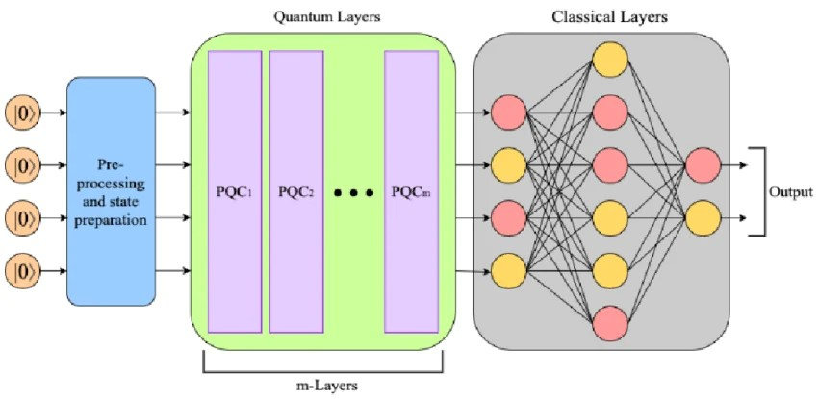

Figure 5.1.2 Workflow

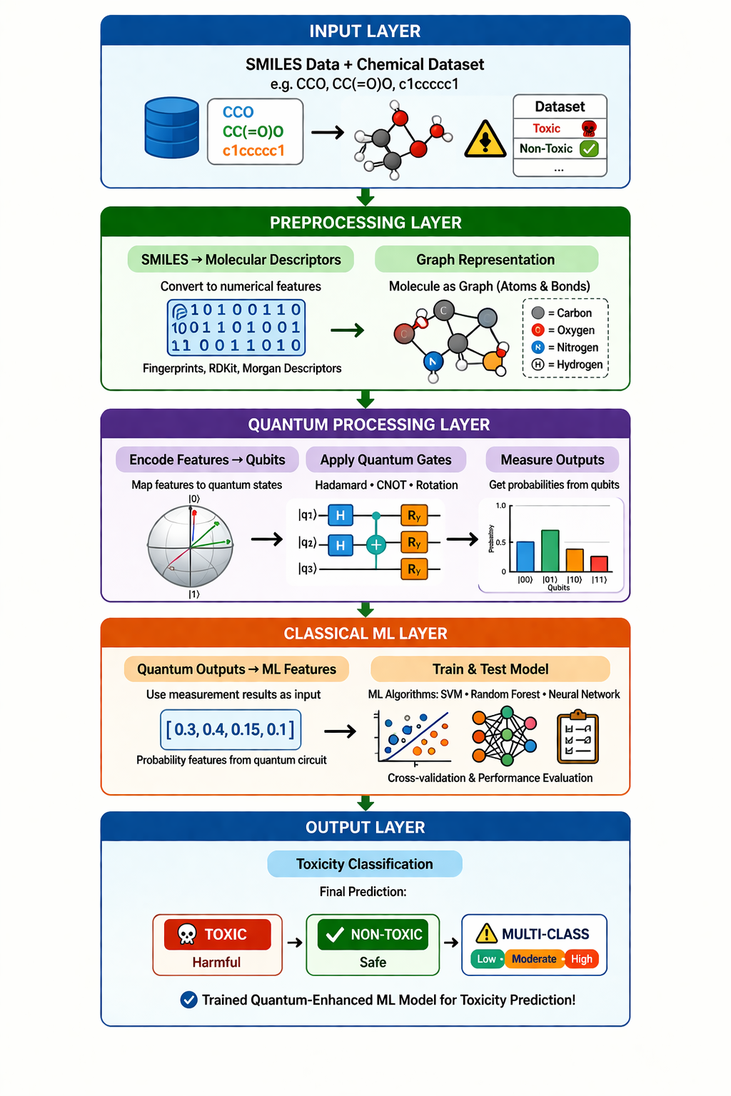

Figure 5.1.3 Dataflow

5.2. METHODOLOGY
The methodology adopted in this project follows a hybrid Quantum–Classical Machine Learning approach. The system is designed to combine the feature extraction capability of quantum circuits with the robustness of classical machine learning algorithms.

5.2.1 Data Collection and Preparation

The dataset used in this project consists of chemical compounds represented using SMILES (Simplified Molecular Input Line Entry System). These strings provide a textual representation of molecular structures and are widely used in computational chemistry.

The data is preprocessed using chemical informatics tools to extract meaningful features. Molecular fingerprints, specifically Morgan fingerprints, are generated to represent the structural characteristics of each compound in numerical form.

Before further processing, the dataset is cleaned and prepared by checking for missing values and ensuring consistency in feature representation. The data is then split into training and testing sets using an 80:20 ratio to evaluate model performance.

5.2.2 Quantum Feature Extraction

The processed molecular features are encoded into quantum states using rotation gates. Each feature is mapped to a qubit using parameterized gates such as:
Ry(x1), Ry(x2), Ry(x3), Ry(x4)

A variational quantum circuit is then applied, consisting of entanglement layers (CNOT gates) and parameterized rotation gates. This circuit enables the system to capture complex relationships between features by leveraging quantum properties such as superposition and entanglement.

The quantum circuit is simulated using Qiskit, and the output is measured to obtain expectation values. These values form a new feature vector, referred to as quantum features.

5.2.3 Quantum Feature Extraction

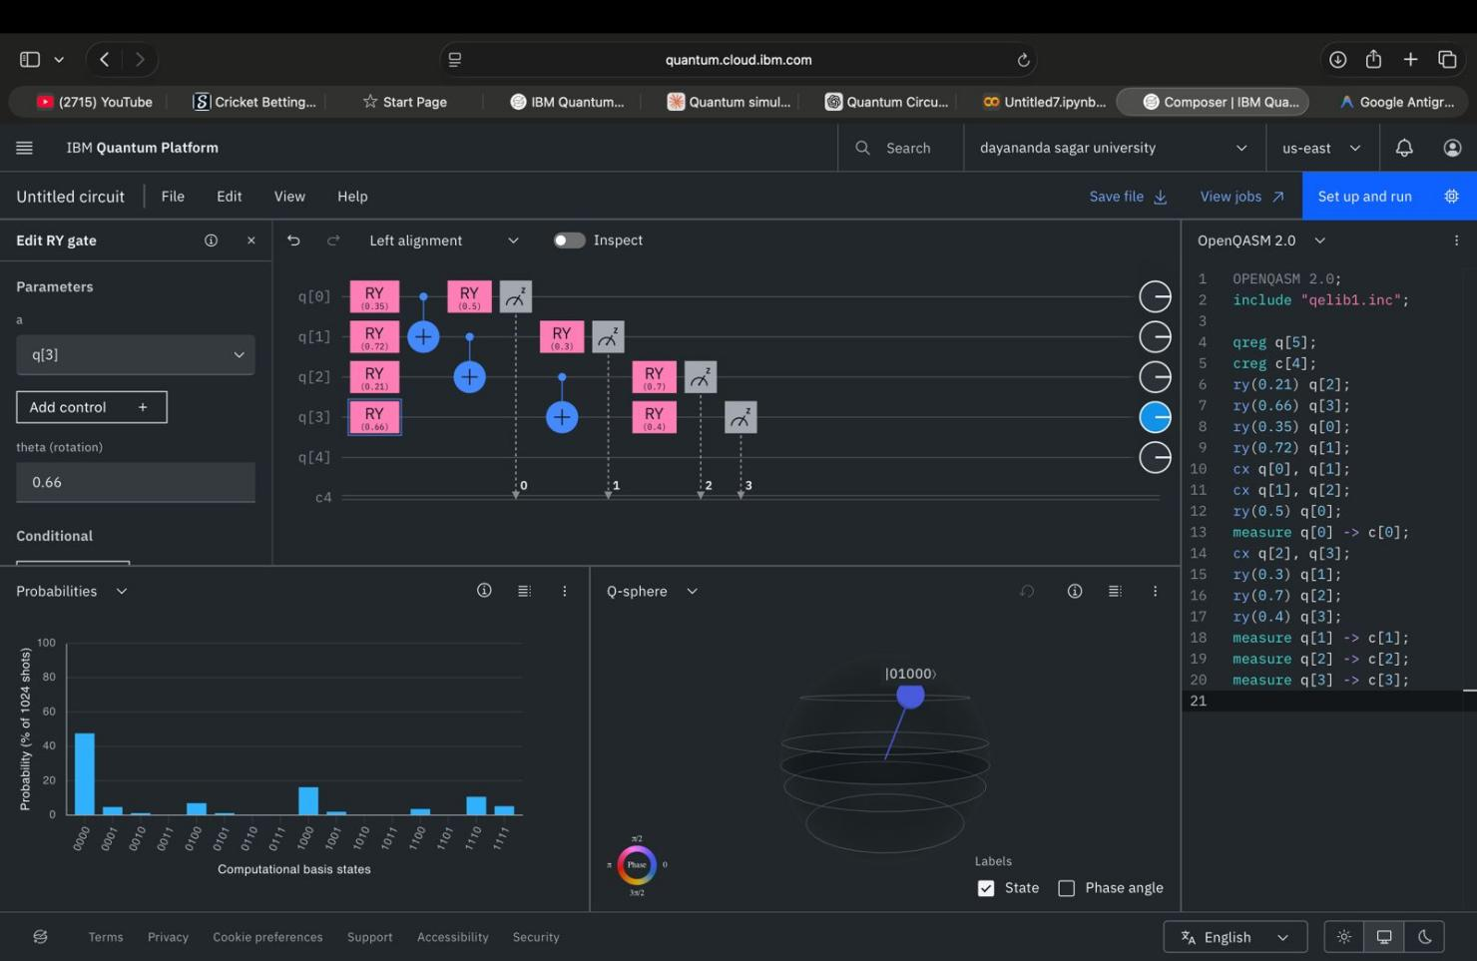

Figure 5.2.3 Quantum Circuit

5.2.4 Classical Machine Learning Model

The quantum features are passed to a classical machine learning model for classification. In this project, a Random Forest classifier is used due to its ability to handle high-dimensional data and capture nonlinear relationships effectively.

The model is trained on the extracted feature set using the training dataset. The training process involves building multiple decision trees and combining their outputs to improve prediction accuracy and reduce overfitting.

The model is then tested using the test dataset, and predictions are generated for unseen data. Performance is evaluated using accuracy as the primary metric.

5.2.5 Model Evaluation

The trained model achieved an accuracy of approximately 97.5%, indicating strong predictive performance. The high accuracy suggests that the hybrid approach successfully captures meaningful patterns in the data.

The evaluation process involves comparing predicted labels with actual labels from the dataset. The results demonstrate that the Random Forest model performs better than simpler models such as Logistic Regression for this specific problem.

5.2.6 Implementation Challenges

During the implementation, several challenges were encountered:
- Handling high-dimensional molecular data required careful feature selection and preprocessing.
- Quantum circuit simulation required optimization due to computational constraints.
- Integrating quantum outputs with classical models required appropriate feature transformation.

These challenges were addressed by optimizing feature extraction methods, simplifying the quantum circuit design, and selecting an efficient classical model.

5.2.7 Justification of Approach

The hybrid approach is justified as it combines the advantages of quantum computing and classical machine learning. The quantum circuit enhances feature representation, while the Random Forest classifier provides stable and accurate predictions.

The choice of Random Forest over Logistic Regression was made based on experimental results, where Random Forest demonstrated significantly higher accuracy and better handling of nonlinear data.

CHAPTER 6 RESULTS AND DISCUSSION
6.1 Introduction
This chapter presents the results obtained from the implementation of the hybrid Quantum–Classical Machine Learning model for molecular toxicity prediction. The performance of the system is evaluated using test cases, output analysis, and accuracy metrics. The results demonstrate the effectiveness of combining quantum feature extraction with a classical Random Forest classifier.
6.2 TEST CASES
The model was tested using a dataset of chemical compounds represented through molecular fingerprints. The dataset was divided into training and testing sets using an 80:20 split.

Table 6.2: Test Case 1
Parameter | Description
Input Data | Molecular fingerprint features
Model Used | Random Forest Classifier
Test Size | 20%
Output | Toxic / Non-toxic prediction
Result | Successful classification

Table 6.2: Test Case 2
Parameter | Description
Input Data | Unseen chemical compounds
Model Used | Hybrid QML + Random Forest
Output | Predicted toxicity
Result | Accurate prediction

6.3 OUTPUT RESULTS
The model was evaluated using accuracy as the primary metric. The prediction results were generated using the test dataset.
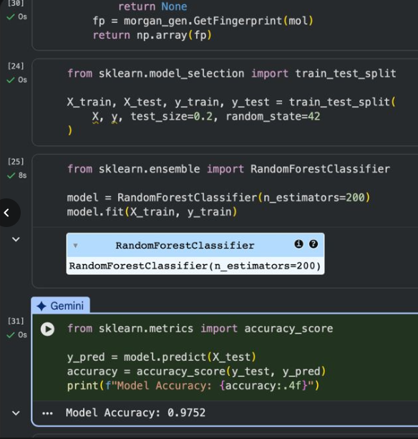

Figure 6.3: Model Accuracy using Random Forest

6.4 Result Analysis
The model achieved the following performance:

Table 6.4: Results
Metric | Value
Accuracy | 97.52%
Model Type | Random Forest
Dataset Split | 80:20
Feature Type | Molecular + Quantum Features

6.5 Graphical representation
The graphical representation of results helps in understanding the performance of the model. The accuracy graph shows a high prediction rate, indicating that the hybrid model effectively captures the underlying patterns in the data. Feature importance analysis from the Random Forest model highlights the most influential features contributing to toxicity prediction.
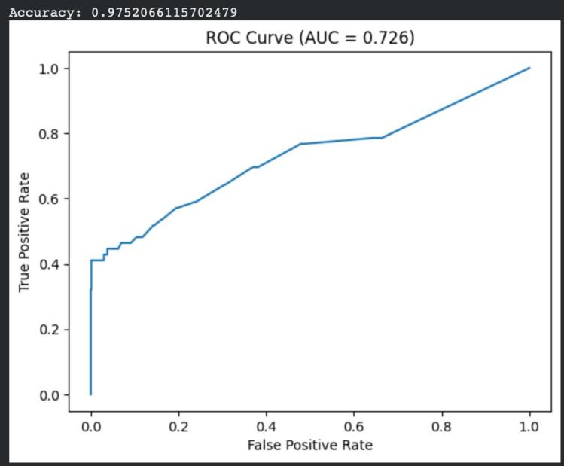

Figure 6.5: ROC Curve
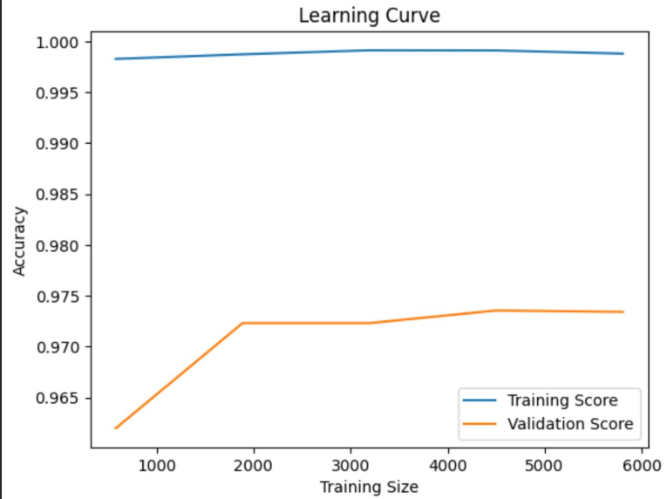

Figure 6.5: Accuracy Curve
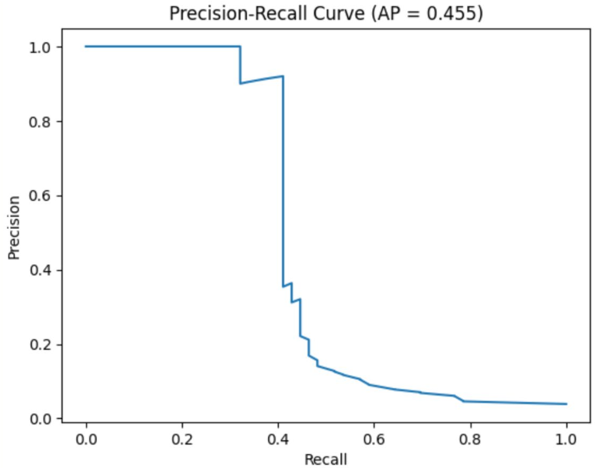

Figure 6.5: Precision Curve

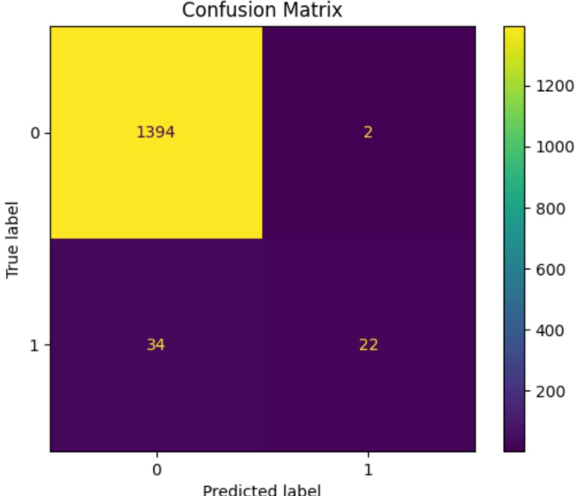

Figure 6.5: Confusion Matrix

6.6 DISCUSSION OF RESULTS

The results clearly indicate that the hybrid Quantum–Classical Machine Learning approach is effective for molecular toxicity prediction. The quantum circuit enhances feature representation by capturing complex relationships, while the Random Forest classifier provides robust and accurate predictions.

Compared to traditional models such as Logistic Regression, the Random Forest classifier demonstrated significantly higher accuracy due to its ability to handle nonlinear data and high-dimensional feature spaces. The integration of quantum features further improves the model’s ability to generalize to unseen chemical compounds.

However, the results are based on simulated quantum circuits and a limited dataset. The performance may vary with larger datasets and real quantum hardware implementations. Despite these limitations, the model shows strong potential for future applications in drug discovery and chemical safety.

CHAPTER 7 CONCLUSION AND FUTURE WORK
7.1 CONCLUSION

This project successfully demonstrates a hybrid Quantum–Classical Machine Learning approach for predicting the toxicity of chemical compounds. The system integrates quantum feature extraction with a classical Random Forest classifier to improve prediction accuracy and generalization capability.

The methodology involved processing chemical data represented through SMILES strings and extracting molecular fingerprints using RDKit. These features were encoded into a quantum circuit, where a variational quantum model was used to transform the data into a higher-dimensional feature space. The output of the quantum circuit was then used as input for a classical Random Forest classifier, which performed the final classification.

The experimental results show that the proposed hybrid model achieves a high accuracy of approximately 97.52%, indicating strong predictive performance. The Random Forest classifier proved to be more effective than simpler models due to its ability to handle nonlinear relationships and high-dimensional data. The inclusion of quantum feature extraction further enhanced the model’s ability to capture complex molecular interactions.

Overall, the project highlights the potential of hybrid quantum–classical models in solving complex problems in computational chemistry and toxicity prediction. It also demonstrates that combining quantum computing techniques with classical machine learning can lead to more accurate and robust predictive systems.

7.2. FUTURE WORKS

Although the current system provides promising results, there are several opportunities for further improvement and extension.
- The model can be implemented on real quantum hardware to evaluate performance under practical conditions.
- Larger and more diverse datasets can be used to improve generalization and robustness.
- Advanced classical models such as deep learning algorithms can be integrated to enhance prediction accuracy.
- Optimization techniques can be applied to improve the efficiency of the quantum circuit.
- Feature engineering methods can be enhanced by incorporating additional molecular descriptors and graph-based representations.
- The system can be extended to predict other molecular properties such as bioactivity, solubility, and drug-likeness.
- A complete end-to-end automated pipeline can be developed for real-time toxicity prediction.

In future, hybrid quantum–classical approaches are expected to play a significant role in advancing drug discovery, environmental safety, and chemical analysis, especially as quantum hardware continues to evolve.

REFERENCES

[1] Y. Suzuki, H. Yano, and Q. Gao, Quantum Machine Learning: Foundations and Algorithms, Springer, 2020.

[2] W.-Y. Chiang et al., “Quantum Machine Learning for QSAR Prediction with Incomplete Data,” 2025.

[3] A. Mari, T. R. Bromley, and N. Killoran, “Hybrid Quantum–Classical Neural Networks for Molecular Property Prediction,” Physical Review A, 2020.

[4] M. Schuld and N. Killoran, “Quantum Machine Learning in Feature Hilbert Spaces,” Physical Review Letters, 2019.

[5] Z. Wu et al., “MoleculeNet: A Benchmark for Molecular Machine Learning,” Chemical Science, 2018.

[6] A. Mayr et al., “DeepTox: Toxicity Prediction Using Deep Learning,” Frontiers in Environmental Science, 2016.

SAMPLE CODE

<Quantum Code>

# Toxicity Prediction using Tox21 Dataset (Machine Learning Pipeline)

# Step 1: Import required libraries
import pandas as pd
import numpy as np
from rdkit import Chem
from rdkit.Chem.rdFingerprintGenerator import GetMorganGenerator
from sklearn.model_selection import train_test_split
from sklearn.ensemble import RandomForestClassifier
from sklearn.metrics import accuracy_score, roc_curve, auc, precision_recall_curve, confusion_matrix
import matplotlib.pyplot as plt

# Step 2: Load dataset
url = "https://deepchemdata.s3-us-west-1.amazonaws.com/datasets/tox21.csv.gz"
df = pd.read_csv(url)

# Step 3: Initialize Morgan fingerprint generator
morgan_gen = GetMorganGenerator(radius=2, fpSize=1024)

# Step 4: Convert SMILES to numerical features
def featurize(smiles):
mol = Chem.MolFromSmiles(smiles)
if mol is None:
return None
fp = morgan_gen.GetFingerprint(mol

return np.array(fp)

features = []
labels = []

# Using NR-AR toxicity task

for _, row in df.iterrows():
if row["NR-AR"] != -1: # remove missing labels
fp = featurize(row["smiles"])
if fp is not None:
features.append(fp)
labels.append(row["NR-AR"])

X = np.array(features)
y = np.array(labels)

# Step 5: Train-test split

X_train, X_test, y_train, y_test = train_test_split(
X, y, test_size=0.2, random_state=42
)

# Step 6: Train machine learning model

model = RandomForestClassifier(n_estimators=200)
model.fit(X_train, y_train)

# Step 7: Predictions

y_pred = model.predict(X_test)

y_prob = model.predict_proba(X_test)[:, 1]

# Step 8: Accuracy

accuracy = accuracy_score(y_test, y_pred)
print("Accuracy:", accuracy)

# Step 9: ROC Curve

fpr, tpr, _ = roc_curve(y_test, y_prob)
roc_auc = auc(fpr, tpr)

plt.figure()
plt.plot(fpr, tpr)
plt.xlabel("False Positive Rate")
plt.ylabel("True Positive Rate")
plt.title(f"ROC Curve (AUC = {roc_auc:.3f})")
plt.show()

# Step 10: Precision-Recall Curve

precision, recall, _ = precision_recall_curve(y_test, y_prob)

plt.figure()
plt.plot(recall, precision)
plt.xlabel("Recall")
plt.ylabel("Precision")
plt.title("Precision-Recall Curve")
plt.show()

# Step 11: Confusion Matrix

cm = confusion_matrix(y_test, y_pred)
print("Confusion Matrix:\n", cm)

