Q1] A) Illustrade sorting via insertion sort on the array A[19,5,9,52,26,35,61,28]
- J=2
1 2 3 4 5 6 7 8
`19 | 5 | 9 | 52 | 26 | 35 | 61 | 28

- J=3
1 2 3 4 5 6 7 8
5 | 19 | 9 | 52 | 26 | 35 | 61 | 28

- J=4
1 2 3 4 5 6 7 8
5 | 9 | 19 | 52 | 26 | 35 | 61 | 28

- J=5
1 2 3 4 5 6 7 8
5 | 9 | 19 | 52 | 26 | 35 | 61 | 28

- J=6
1 2 3 4 5 6 7 8
5 | 9 | 19 | 26 | 52 | 35 | 61 | 28

- J=7
1 2 3 4 5 6 7 8
5 | 9 | 19 | 26 | 35 | 52 | 61 | 28

- J=8
1 2 3 4 5 6 7 8
5 | 9 | 19 | 26 | 35 | 52 | 61 | 28

- Final Sorted Array
1 2 3 4 5 6 7 8
5 | 9 | 19 | 26 | 28 | 35 | 52 | 61

Q1. B]
Illustrate sorting via merge sort on the array A[19,5,9,52,26,35,61,28]

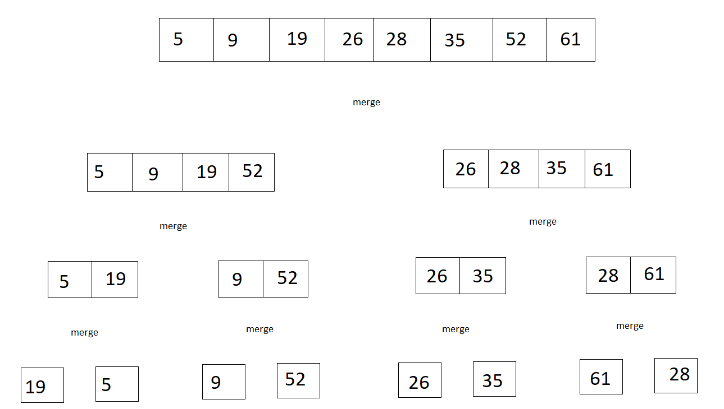

Q4] Tower of Hanoi Pseudo Code
MOVE(n, start,end):
If n == 1 :
print(“Move the top disk from rod”, start, “to rod”, end)
else:
middle = third rod …… // calculate from start and end rod
MOVE(n-1, start, middle)
Print(“Move the top disk from rod”, start, “to rod”, end)
MOVE(n-1, middle, end)

Following is a screenshot of the code implemented from the above pseudo code for reference:
