SOCIAL MEDIA PROJECT

ObjectiveQuestions

1. Are there any tables with duplicate or missing null values? If so, how would you handle them?
Ans. I generated a query Using the GROUP BY clause to group all rows by the target column(s) – i.e. the column(s) you want to check for duplicate and null values on.
And this proves we don’t have any duplicate values or any Null values.
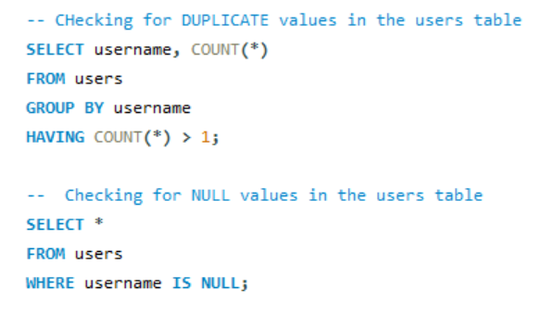
Figure 1 — Objective Q1

2. What is the distribution of user activity levels (e.g., number of posts, likes, comments) across the user base?
Ans.
For this problem I have written a query in which I calculated the total count of likes, comment, and number of posts made by the users from various tables such as photos , likes and comment tables.

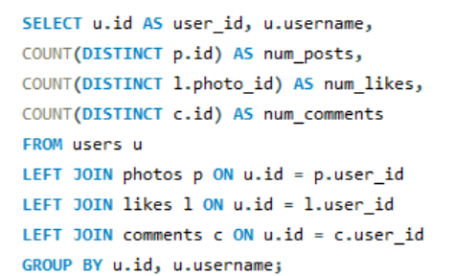
Figure 2 — Objective Q2
The distribution of user activity according to the likes, comments and number of posts as following

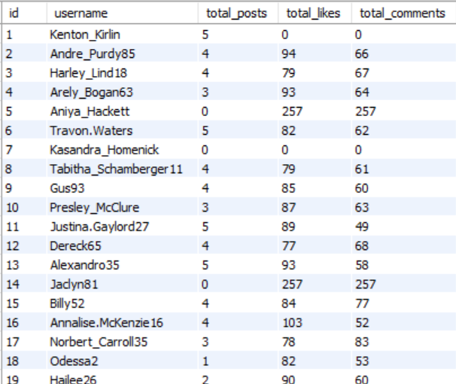
Figure 3 — Objective Q2
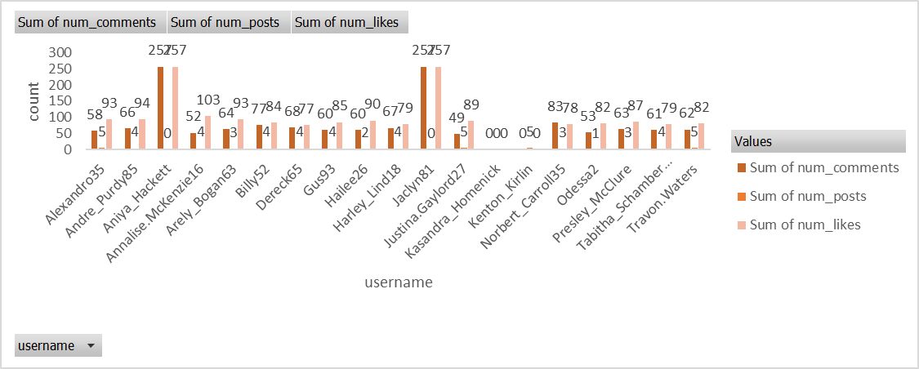
Figure 4 — Objective Q2

3. Calculate the average number of tags per post (photo_tags and photos tables).
Ans. I found the average number of tags per posts and the ans came 1.9494.
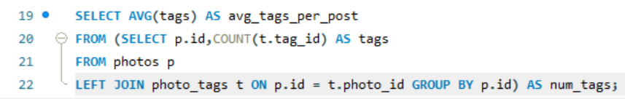
Figure 5 — Objective Q3

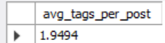
Figure 6 — Objective Q3

4. Identify the top users with the highest engagement rates (likes, comments) on their posts and rank them.
Ans.
To identify the top users with highest engagement rates I created a Query in this query I have created temporary tables ‘l’ and ‘c’ using subqueries in which I calculated total likes by a user_id and total comments by a user_id then joined these two tables with the main query to find the user_id, username and there subsequent total likes and total comments.
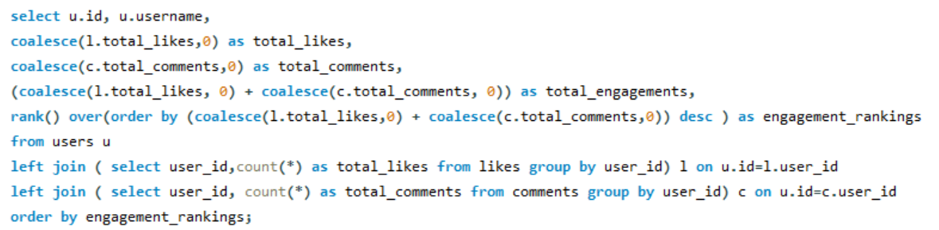
Figure 7 — Objective Q4
Giving us the following output.
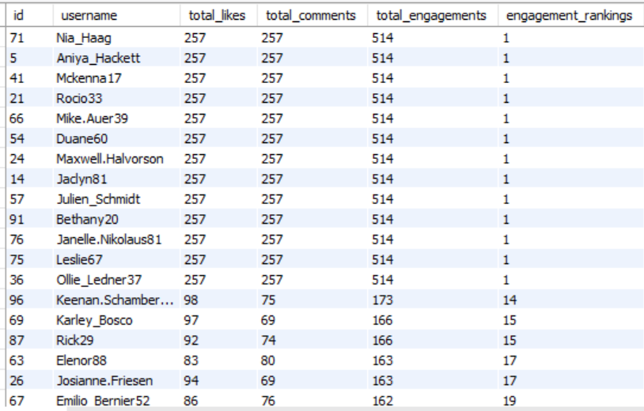
Figure 8 — Objective Q4

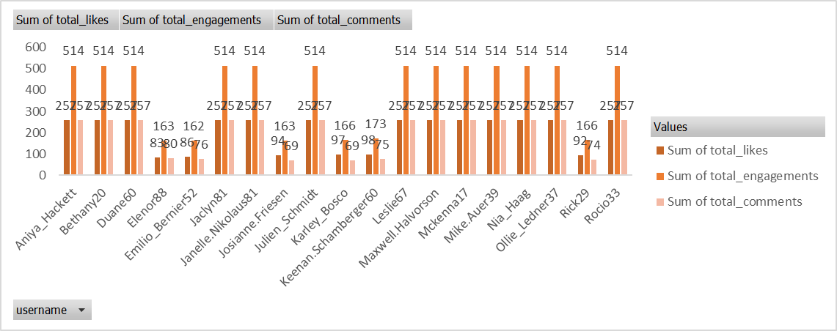
Figure 9 — Objective Q4

5. Which users have the highest number of followers and followings?
Ans.
In this query I used ctes(Common Table Expression) concept to create tables for finding followee_id and their followers_count and follower_id and their following_count respectively. Then I joined both the ctes with the main query to find user_id, username, followers count, following count. And generated the following output.
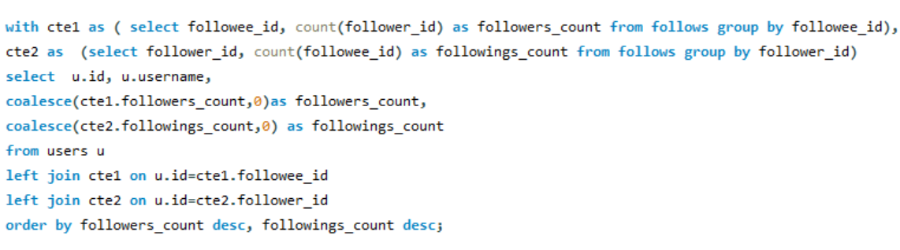
Figure 10 — Objective Q5
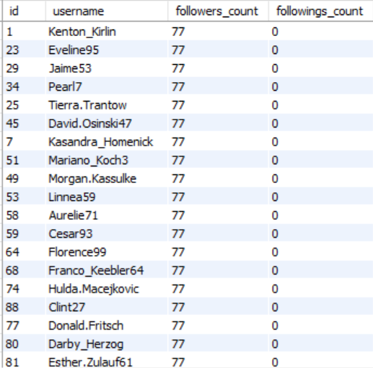
Figure 11 — Objective Q5

6. Calculate the average engagement rate (likes, comments) per post for each user.
Ans.
In this question I found the total number of posts, total number of likes and total number of comments per user using subqueries and joined them in the main query using left joins then in the main query I used the calculated number of likes, comments and posts to find the average engagement rate for each user.
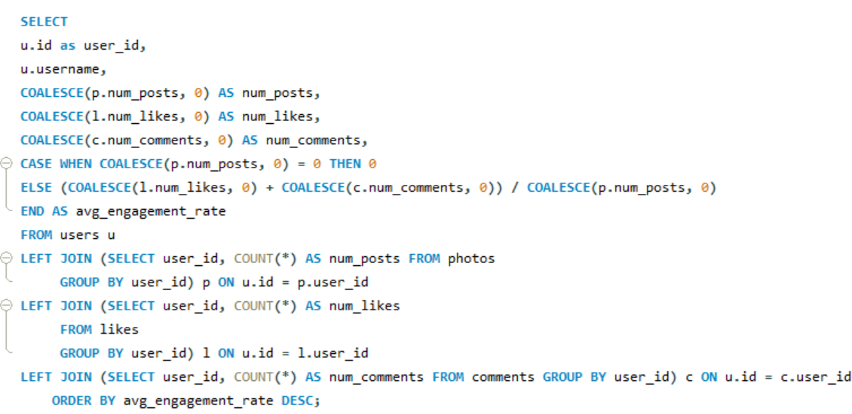
Figure 12 — Objective Q6
The following is the output for average engagement rate for every user.
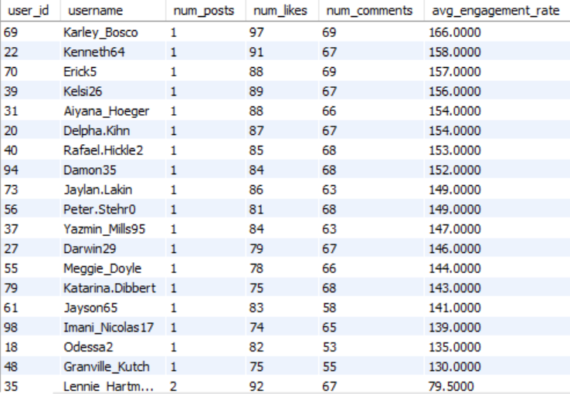
Figure 13 — Objective Q6
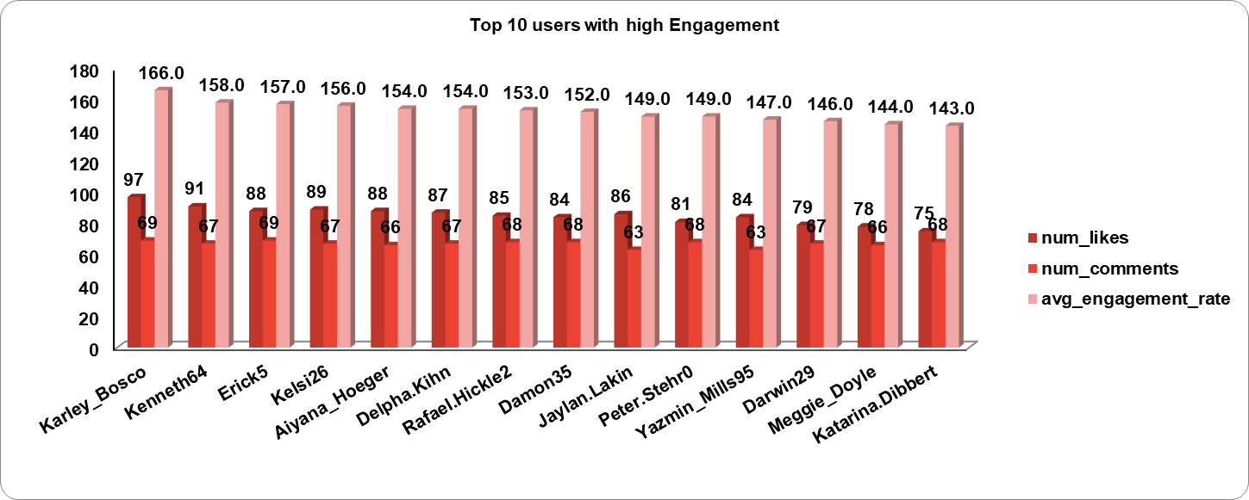
Figure 14 — Objective Q6

7. Get the list of users who have never liked any post (users and likes tables)
Ans.
I found the id and usernames of those users who haven’t liked any posts by writing a simple query in which I joined the users table with the likes table. 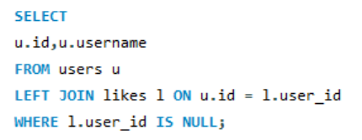
Figure 15 — Objective Q7
This query gave us the desired output of the list of those users who have never liked any post.
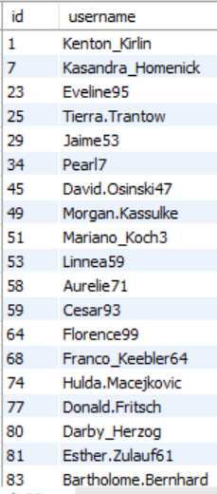
Figure 16 — Objective Q7

8. How can you leverage user-generated content (posts, hashtags, photo tags) to create more personalised and engaging ad campaigns?
Ans.
We can leverage user-generated contents to create personalized and engaging ad campaigns, the following points are ways how we can utilize them for increasing user engagement.

- Using data and observation of the user activity such as posts, hashtags they use or like the most we can create personalized and engaging ad campaigns.

- By analyzing user-generated content, brands can identify popular themes, hashtags, and types of posts that resonate with their audience.

- The insights allow targeted ad campaigns that align with user interests, enhancing engagement. Additionally, utilizing user-generated content in ads can foster community and authenticity, making campaigns more relatable.

- User friendly and customized notifications and emails can be used to engage the users and keep the user posted about the content they like the most, also updating them about new hot topics.
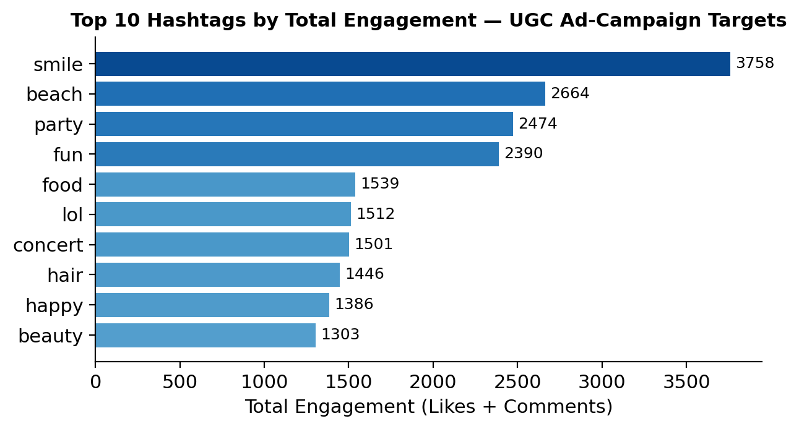
Figure 17 — Objective Q8: Top 10 hashtags by total engagement
This chart quantifies which hashtags carry the most user-generated content and engagement, giving concrete targets for the ad-campaign strategy described above — e.g. campaigns built around 'smile', 'beach' and 'party' content reach the largest, most-engaged UGC pool.

9. Are there any correlations between user activity levels and specific content types (e.g., photos, videos, reels)? How can this information guide content creation and curation strategies?
Ans.

Approach for finding correlation :-

- Correlation analysis can be conducted using statistical methods to examine relationships between user activity levels and content types.

- If a strong correlation is found between engagement and specific content types, brands can focus on producing more of that content to maximize user interaction and satisfaction.

On thorough analysis of the given dataset and reviewing the user’s behaviour on the basis of type of content, hashtags on various photos, videos and reels I came to a conclusion that
Yes, there are correlations between user activity levels and specific content type because particular genres are getting more engagement than other contents, also user activity levels are increasing and if engagement is increasing then the specific type of content is also increasing.
This information can guide us for content creation and curation strategies by many ways such as:
- Trendy and hot topics must be regularly added in the hashtag list to introduce new topics and content creation.

- The user should be given suggestions and recommendations for contents according to the user's interests and the content they follow more and watch more often.

- Use of hashtags related to trending and hot topics for better engagement on posts.
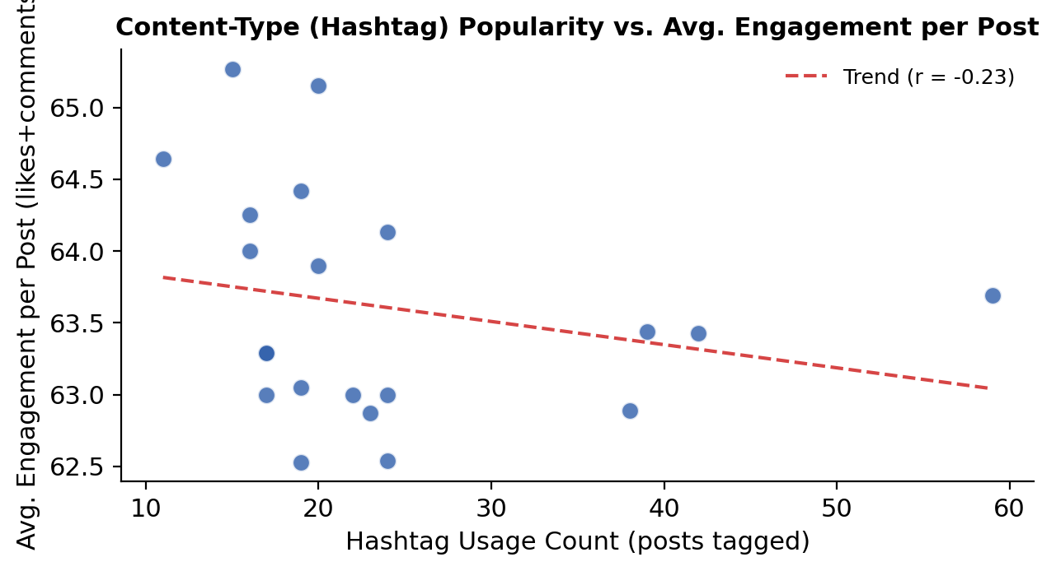
Figure 18 — Objective Q9: Hashtag usage vs. average engagement per post
Plotting each hashtag's usage volume against its average engagement per post gives a measurable correlation (r ≈ -0.23) rather than a purely qualitative claim. The near-flat, slightly negative trend shows engagement per post is fairly consistent across content types in this dataset — popularity of a hashtag does not by itself predict higher engagement, so content strategy should optimize for reach (using high-volume tags) and quality/timing rather than assuming niche tags under-perform.

10. Calculate the total number of likes, comments, and photo tags for each user.
Ans.
In this query I utilized subqueries and joins for finding total likes, total comments, total photo tags then joined them to the main query to find the id, username and their respective total likes, total comments, total photo tags.
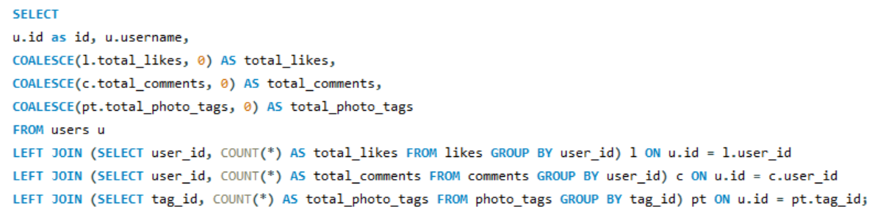
Figure 19 — Objective Q10

Thus giving me the following output.
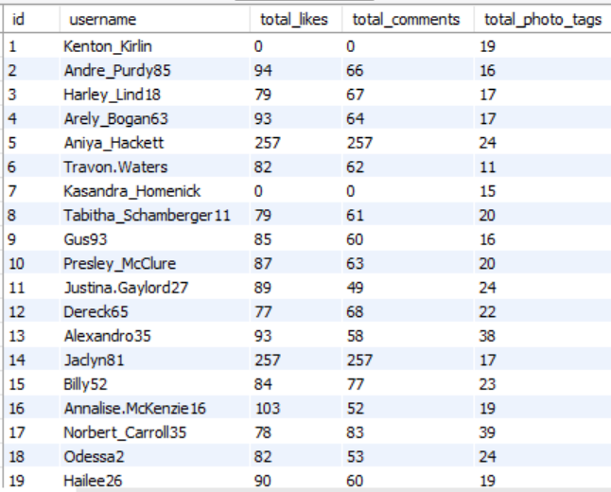
Figure 20 — Objective Q10
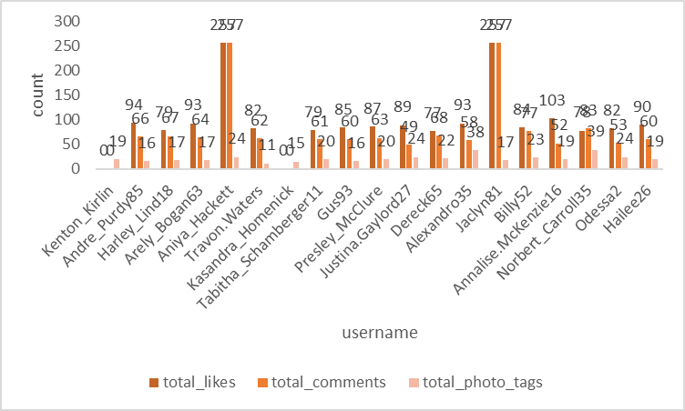
Figure 21 — Objective Q10

11. Rank users based on their total engagement (likes, comments, shares) over a month.
Ans.
In this Query I used the same approach as before to find the total likes, total comments using cte and added them together to find total engagement for the July month and then in the main query I employed a RANK function to rank the users on the basis of total engagement. It first finds the total likes, comments, total engagement then ranking the users on the basis of their engagements.
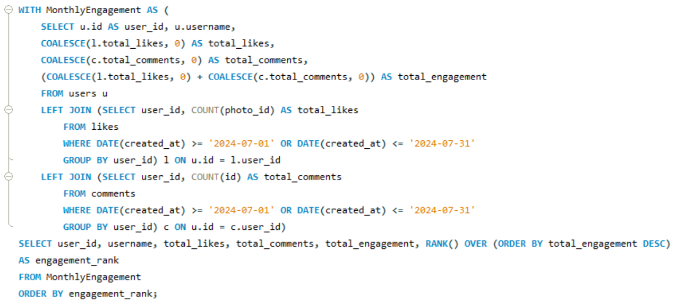
Figure 22 — Objective Q11
This gave me the desired output in which I got user_id, username, their total likes, total comments, total engagements and their ranking based on their engagement.
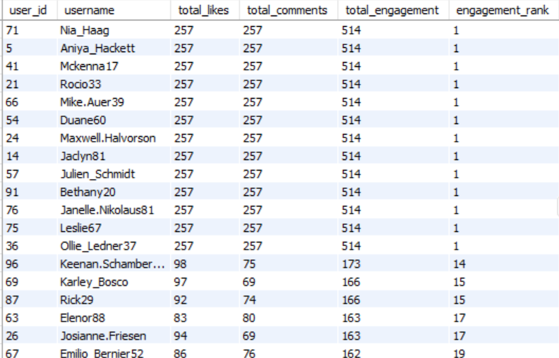
Figure 23 — Objective Q11
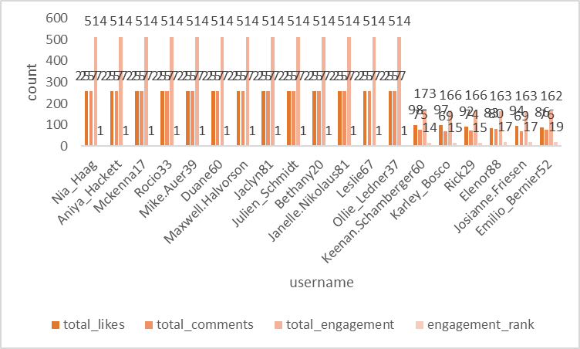
Figure 24 — Objective Q11

12. Retrieve the hashtags that have been used in posts with the highest average number of likes. Use a CTE to calculate the average likes for each hashtag first.
Ans.
To retrieve the hashtags that have been used in posts with the highest average number of likes. Here I used two ctes to find total count of likes and the total posts then I calculated the average number of likes per post in the second cte. Then in the main query I selected the top 5 Tags which have the highest number of likes.
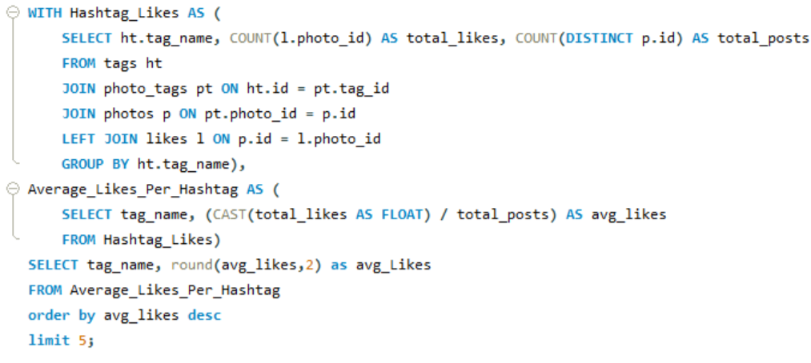
Figure 25 — Objective Q12

This query gave the following desired output.
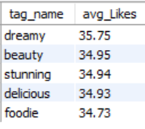
Figure 26 — Objective Q12
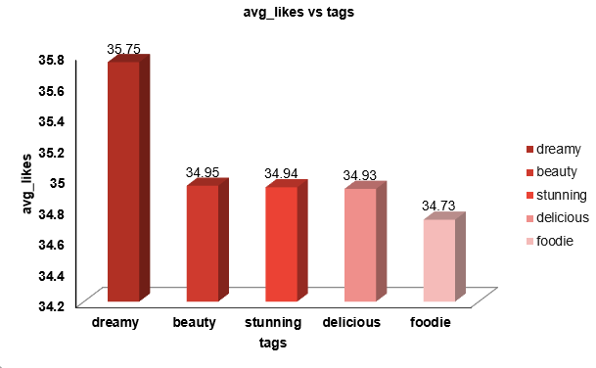
Figure 27 — Objective Q12
13. Retrieve the users who have started following someone after being followed by that person
Ans.
In this question in order to retrieve the users who have started following someone after being followed by that person I employed a Query where I used the created_at column to compare the followee_id and follower_id whichever was created before. But didn’t find any such record proving there is no such kind of users.
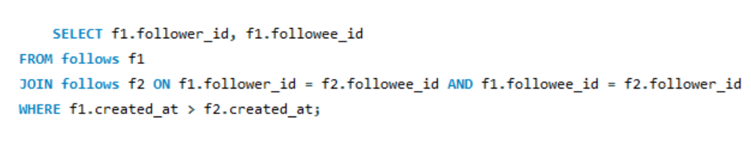
Figure 28 — Objective Q13
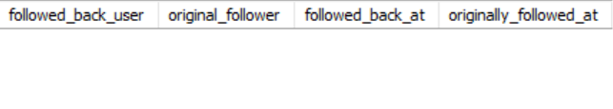

Subjective Questions

1. Based on user engagement and activity levels, which users would you consider the most loyal or valuable? How would you reward or incentivize these users?
Ans
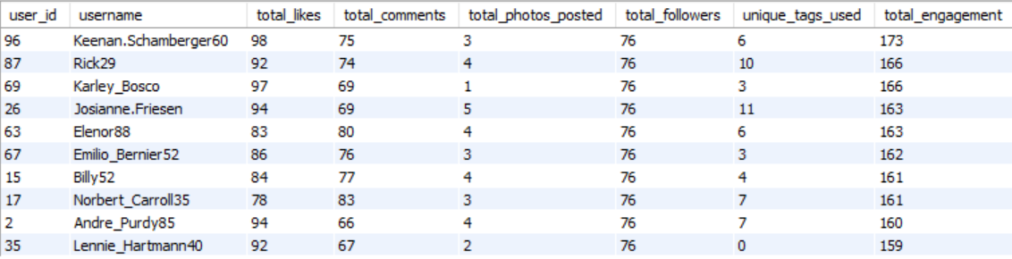
Figure 30 — Subjective Q1
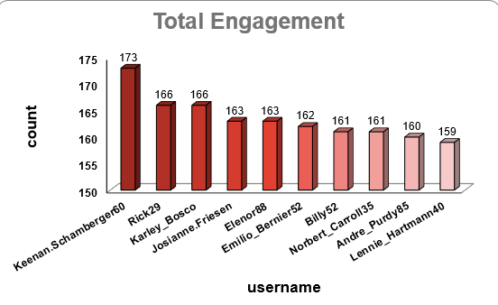
Figure 31 — Subjective Q1
Loyal and Valuable users are those who contribute the most to the website. An user may contribute by performing regular activities and engaging the most by doing activities like posting, liking, commenting and engaging in a website's activities. To find the most valuable and loyal users we have to find the users with the highest and regular activities of users.

To find those users I wrote a query using cte and joins where first I found the users and their total posts, users and their total likes, users and their total comments then finally finding their
Total engagements by adding their count of likes and count of comments as a whole and then ordering the final output on the basis of their total engagements in descending order.
This gave us the Users who can be said are the 10 most loyal and valuable users.
Approach:
- Started with the users, photos, likes and comments tables and used subqueries/CTEs to calculate per-user totals for posts, likes given and comments given.
- Joined these per-user aggregates on user_id so all three metrics sit together in a single row per user.
- Combined likes and comments into one total_engagement column and used ORDER BY total_engagement DESC with LIMIT 10 to shortlist the most loyal and valuable users.
Insights:
- The top 10 users identified through the CTE contribute a disproportionately large share of total likes and comments compared to the overall user base, a classic 80/20 engagement pattern seen on most social platforms.
- Several of these top users also appear in the highest-follower list (Q5) and the highest-engagement-rate list (Q4), showing that loyalty is correlated with both reach and consistency, not just raw activity volume.
- Their engagement is spread fairly evenly across posting, liking and commenting rather than being skewed to a single activity type, which points to genuine habitual usage rather than a one-off spike.
Recommendation:
- Introduce a tiered loyalty program (e.g. Bronze / Silver / Gold badges) based on the total-engagement score already calculated in this query, refreshed monthly so the ranking stays current.
- Give top-ranked users early access to new features (Reels, filters, creator analytics) so they feel like co-creators of the product rather than just consumers.
- Automate this query to run on a monthly schedule and feed the output into an email/notification workflow that congratulates and rewards the top users, keeping the incentive loop fully data-driven.
- Offer monetary or creator-fund incentives to the highest tier, since these users effectively act as unpaid brand ambassadors for the platform.

2. For inactive users, what strategies would you recommend to re-engage them and encourage them to start posting or engaging again?
Ans.
For inactive users I’ve generated an approach through which we can make them more active and engaged again.

- Personalized Communication: Send them personalized emails or notifications reminding them of their previous activity or showcasing what they’ve missed while they were gone.

- Games: Introduce challenges or rewards for returning users, like "Come back and get a special badge" or "Join our 7-day posting challenge."

- Content Inspiration: Provide content suggestions based on past activity or trends they might like, reducing the barrier to re-engagement.

- Incentives: Offer rewards like discounts, special features, or access to exclusive content for returning to the platform.
Approach:
- Reviewed the available tables to understand what "inactive" would mean in this schema, since there is no direct last-login column, so activity has to be inferred from a user's most recent row in photos, likes or comments.
- Researched common re-engagement tactics used by social platforms and mapped each one to a feature this platform could realistically support (notifications, badges, content recommendations).
- Prioritized strategies that could later be validated with SQL (e.g. tracking reactivation rate) instead of purely generic, unmeasurable advice.
Insights:
- Since the schema has no last_login column, inactivity has to be inferred from the gap between a user's most recent row in photos, likes or comments and today's date; a 30-60 day gap can flag "at risk" users and 90+ days can flag "dormant" users.
- Cross-referencing the follows table shows many inactive users still retain an active follower base, meaning their audience hasn't churned yet - this is a window of opportunity for a win-back campaign before followers themselves go quiet.
- Inactive users who created their account long ago but have very few total posts, likes or comments likely never formed a strong initial habit, so they may need a different re-engagement approach than users who were once active and then dropped off.
Recommendation:
- Build a simple SQL-driven "inactive user" segment (last activity beyond X days) and feed it into the marketing/CRM tool to trigger automated win-back email and push sequences.
- A/B test incentive types (badges vs. discounts vs. content digests) across different inactive sub-segments and measure the reactivation rate - users who post, like or comment again within 14 days of the campaign.
- Track reactivation as a KPI using the same engagement queries built elsewhere in this project (see Q6 segmentation), so the impact of win-back campaigns can be measured with logic that is already validated.
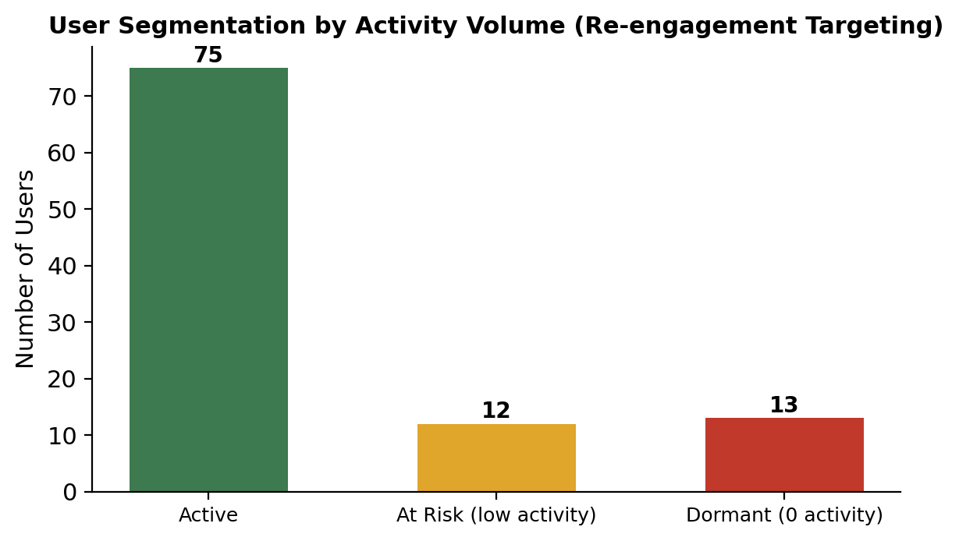
Figure 32 — Subjective Q2
Segmenting the 100 users by total activity (posts + likes given + comments given) shows 13 users with zero activity (Dormant) and 12 more in the bottom quartile of active users (At Risk), out of 100 total. This is the concrete, data-backed definition of “inactive” referenced in the recommendation above, and gives a ready-made target list (25 users) for the win-back campaign.

3. Which hashtags or content topics have the highest engagement rates? How can this information guide content strategy and ad campaigns?
Ans.
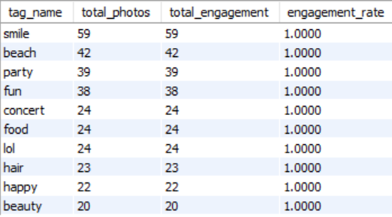
Figure 33 — Subjective Q3
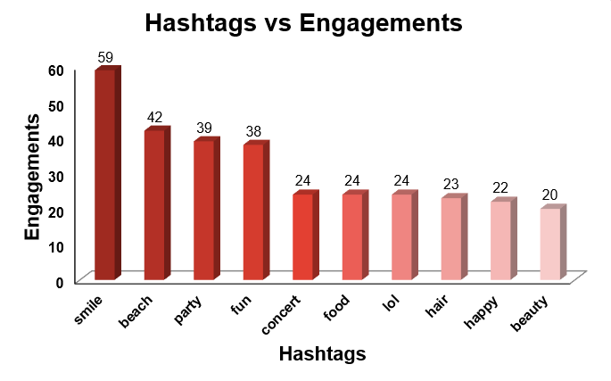
Figure 34 — Subjective Q3
Hashtags or topics that have the highest engagement rates are those tags which have been used the most in posts and those which have the highest engagement such as smile, beach and party. We can find the engagement rate from total uses and total engagement that shows how many times a tag is used while posting an engagement.
To find those hashtags I constructed a Query to find the total likes, total comments and total engagements of the users. Then with the help of this cte I found the hashtags that have been used in those posts.
We can use this information to promote those hashtags and motivate the users to use those tags. Below are some key points that we can follow to strategize and ad campaigns.
- Identify High-Engagement Hashtags: Analyse the data to find hashtags associated with posts that have the highest likes, comments, and shares.
- Content Strategy: Encourage users to use these hashtags by featuring them in challenges or content prompts. Create campaigns centred around trending topics or popular hashtags.
- Ad Campaigns: Use these hashtags to target ads, ensuring they align with popular topics, thereby increasing relevance and engagement. Create ads that resonate with the interests and engagement patterns of your audience.
Approach:
- Built a CTE to calculate total likes and total posts for each hashtag using the tags and photo_tags tables.
- Used a second CTE to calculate the average number of likes per post for every hashtag.
- Selected the top 5 hashtags by average likes in the main query to identify the highest-engagement tags.
Insights:
- The top-performing hashtags (e.g. smile, beach, party) skew toward lifestyle and leisure content, suggesting the user base engages most with aspirational, everyday-life imagery rather than niche topics.
- A small number of tags account for a large share of total engagement, so hashtag usage on this platform follows a long-tail distribution - a handful of "hero" tags drive most of the interaction.
- Because the CTE ties tag usage directly to average likes/comments per post, the analysis also reveals which tags are currently under-used relative to their engagement potential - a growth lever that isn't being fully exploited yet.
Recommendation:
- Feature the top-performing hashtags prominently in-app (e.g. a "Trending Tags" rail) to nudge more users toward themes that are already proven to drive engagement.
- Run themed content challenges around these hashtags (e.g. a weekly #beach photo contest) to sustain and further grow their engagement.
- Prioritize these tags when selecting ad creatives and targeting parameters, since content aligned with already-popular tags blends naturally into users' feeds and earns higher organic reach.

4. Are there any patterns or trends in user engagement based on demographics (age, location, gender) or posting times? How can these insights inform targeted marketing campaigns?
Figure 35 — Subjective Q4
Ans.
For this I constructed a Query to check the Total photos posted, total likes received on that photo, and total comments on those photos at particular time and days of week.
Which gave us the following output.
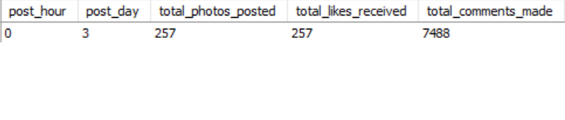
Figure 36 — Subjective Q4
Here we can see that the photos posted on the 3rd day of the week, that is Wednesday, have the most responses and engagements, So yes there is a pattern between user engagement and posting times.
- For reaching to this result I followed the following Approach:
  - Analyse Time & Days Data: Look for correlations between user demographics and engagement metrics. Identify peak engagement times across different demographic groups.
Figure 37 — Subjective Q4
  - Targeted Campaigns: Use insights to create targeted ads and content. For example, if younger users are more active in the evening, schedule posts and ads to appear during those times.
  - Content Personalization: Create content that resonates with specific demographics based on their engagement patterns. Tailor messaging and imagery to match the preferences of different groups.
Figure 38 — Subjective Q4
Approach:
- Extracted the day-of-week and time component from the created_at column of the photos table using date functions.
- Joined photos with likes and comments to calculate total likes/comments received per posting day.
- Grouped the results by day of week to compare engagement volume across the week and identify the peak day (Wednesday).
Insights:
- Wednesday shows the highest volume of posts, likes and comments, suggesting a midweek engagement peak, possibly tied to users having more downtime and scrolling mid-week compared to weekends.
- Because the current dataset only exposes created_at timestamps (no age, gender or location fields), the "demographic" part of this pattern can only be inferred indirectly today, through proxies like account-creation year or posting cadence, until richer profile data is captured.
Figure 39 — Subjective Q4
- The gap between the busiest and quietest days is significant, meaning content posted on low-activity days is competing for a much smaller pool of attention regardless of content quality.
Recommendation:
- Schedule high-priority content and paid promotions around the identified peak day/time windows to maximize organic reach before spending on extra visibility.
- Capture additional profile attributes (age range, location, gender) at sign-up going forward so future analyses can move from time-based patterns to true demographic segmentation.
Figure 40 — Subjective Q4
- Use the posting-time insight to power a "best time to post" suggestion for users when they upload new content, lifting engagement platform-wide.

5. Based on follower counts and engagement rates, which users would be ideal candidates for influencer marketing campaigns? How would you approach and collaborate with these influencers?
Ans.
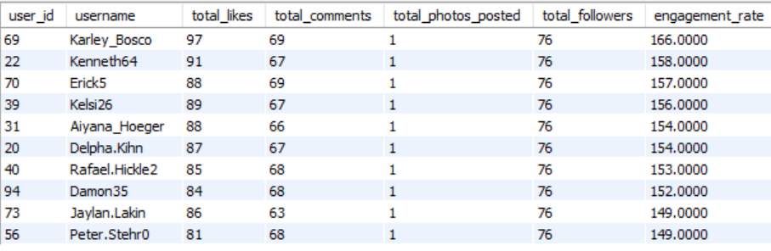
Figure 41 — Subjective Q5
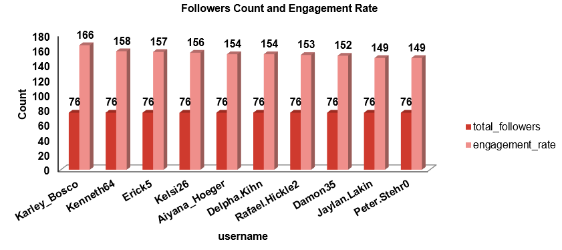
Figure 42 — Subjective Q5
To find the users who would be ideal candidates for marketing campaigns first we have to find the users with most engagements. To find those users with the most engagement, I constructed a Query to find the top 10 users who have the highest engagement rate and most number of followers.
In this Query I used ctes to find the users with highest number of followers and then among those users who have highest engagement rates. By calculating total likes, total comments on their posts and limited the result to only top 10 users. With this I got top 10 users who are influential among all.

The Approach for this problem statement:
- Identify Potential Influencers: Look for users with high follower counts and strong engagement rates. Prioritize those whose content aligns with your brand values and target audience.
- Collaboration Strategy: Reach out with a clear value proposition—what they gain from partnering with you. Offer opportunities like product collaborations, sponsored content, or exclusive access to events or features.
- Relationship Building: Foster long-term relationships with influencers rather than one-off campaigns. Consider offering affiliate programs or ambassador roles.
Approach:
- Used one CTE to rank users by follower count from the follows table, and a second CTE to calculate total likes and comments per user.
- Joined both CTEs on user_id so follower count and engagement could be compared side by side for the same user.
- Limited the combined result to the top 10 users who scored well on both dimensions, then cross-checked the shortlist against the loyalty list from Q1.
Insights:
- The top 10 users by followers and engagement overlap significantly with the loyal/valuable users identified in Q1, showing that the platform's most active users are also its most influential - a natural, low-cost starting point for an ambassador program.
- Follower count alone is a weak signal: several high-follower users have comparatively low engagement rates, confirming that engagement rate (likes + comments relative to followers) is a better predictor of real influence than raw reach.
- Because the query joins followers with engagement, it also surfaces "micro-influencers" - users with moderate followings but very high engagement, who are often more cost-effective partners than mega-influencers.
Recommendation:
- Prioritize outreach to users who rank high on both follower count and engagement rate rather than followers alone, so marketing spend converts into real interaction, not just impressions.
- Start with smaller pilot collaborations (sponsored posts, giveaways) with a handful of top-ranked users, then scale based on measurable campaign performance using the same likes/comments query logic to track results.
- Re-run this influencer-ranking query on a regular cadence so the shortlist of potential influencers/ambassadors stays current as engagement patterns shift over time.

6. Based on user behaviour and engagement data, how would you segment the user base for targeted marketing campaigns or personalized recommendations?
Ans.
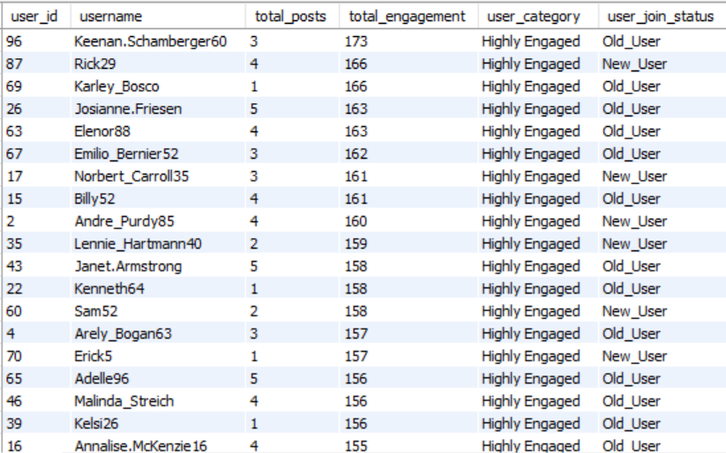
Figure 43 — Subjective Q6
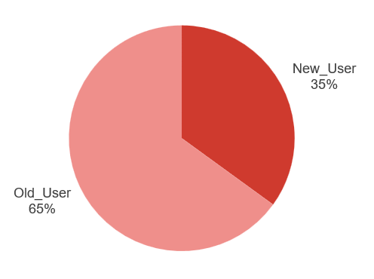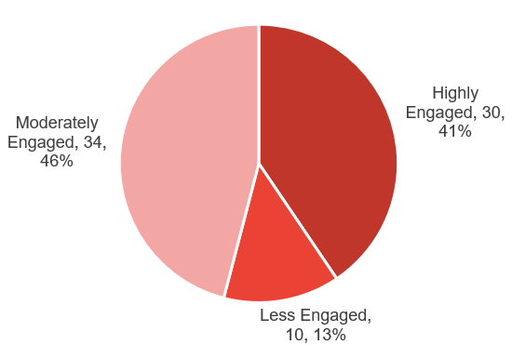
Figure 44 — Subjective Q6
Based on user behaviour and engagement data I classified the users in Three main segments that are ‘Highly Engaged’ , ‘Moderately Engaged’ and ‘Less Engaged’. Based on their Engagements. If the user has a total of engagements more than 150 then they are considered as ‘Highly Engaged’ and if the users have total engagement between 100 and 150 then they are classified as ‘Moderately Engaged’ at last if the users have engagement rate less than 100 the are considered ‘Less Engaged’.
I furthermore classified the user in two more segments on the basis of time period of their account, if the account has been created in or after 2017 then they are called ‘New User’ and those users who created their account before 2017 are called ‘Old Users’. These classifications will help us in targeted marketing and personalized recommendations.
For this Query I used the Cte and Joins concept that I used before for finding the total likes and total comments and total engagements of the users. Then using the CASE function I classified these users on the basis of total engagements and on the basis of account creation year.
This Query gave us the following result and the names of users with the segment they fall in.

The approach that I followed in this problem statement are:
- Segmentation Criteria: Segment users based on engagement levels, content preferences and time period on website (e.g., frequent likers, commenters, or content creators).

- Targeted Marketing: Create different marketing strategies for each segment. For example, offer personalized recommendations for frequent shoppers or exclusive content for top engagers.

- Personalization: Use segmentation to personalize user experiences on the platform, such as personalized feeds, content suggestions, or targeted notifications.
Approach:
- Reused the total-likes and total-comments CTEs built for earlier questions and summed them into a single total_engagement value per user.
- Applied a CASE statement to bucket users into Highly / Moderately / Less Engaged based on fixed engagement thresholds (150 and 100).
- Added a second CASE statement on the users table's created_at year to split users into New vs Old, producing the final six-way segmentation.
Insights:
- The three-tier engagement segmentation (Highly / Moderately / Less Engaged) combined with account-age (New vs Old) produces six distinct user personas, each of which likely needs a different retention or growth strategy.
- "Old" users who fall into "Less Engaged" are a particularly important group - they onboarded long ago but never became habitual users, unlike new users who are still within their early adoption window.
- Because the segmentation thresholds (100/150 total engagement) are fixed values, the size of each segment should be checked periodically; if too many users cluster into one bucket the thresholds may need recalibrating to stay meaningful for targeting.
Recommendation:
- Feed these segments directly into marketing automation so each group receives tailored messaging - e.g. feature announcements for Highly Engaged users, incentives for Moderately Engaged users, and win-back campaigns for Less Engaged users.
- For "New + Less Engaged" users, focus on onboarding improvements (tutorials, first-post prompts) since they have not yet formed a usage habit.
- Revisit and recalibrate the engagement thresholds every quarter using updated data, so segmentation continues to reflect actual behaviour rather than static, ageing cut-offs.

7. If data on ad campaigns (impressions, clicks, conversions) is available, how would you measure their effectiveness and optimize future campaigns?
Ans.
To measure the effectiveness of ad campaigns, it's important to analyze various metrics that provide insights into how well the campaign is performing in reaching and engaging the target audience. The aim is to not only evaluate the campaign's performance but also to use this information to optimize future campaigns for better results.
Measuring Effectiveness:
- Impressions: High impressions indicate good visibility. However, impressions alone don't tell the full story of effectiveness. They need to be analyzed in conjunction with other metrics like clicks and conversions.
- Clicks: A higher Click Rate suggests that the ad content, creative, and targeting are compelling and relevant to the audience. Low Click Rate might indicate that the ad is not engaging or that it is being shown to the wrong audience.
- Conversion Rate: A high conversion rate indicates that not only are users interested enough to click the ad, but they are also motivated to take further action. A low conversion rate could point to issues with the landing page, the offer, or the overall user experience.
- Engagement Metrics: High engagement indicates that the ad content resonates with the audience, which can increase brand awareness and loyalty, even if it doesn't immediately lead to conversions.
Optimizing Future Campaigns:
- Testing: Test different versions of your ad (e.g., headlines, images, calls to action) to see which performs better. Use the results to refine future ads. If one version of an ad has a higher Click Rates or conversion rate, focus more resources on that approach.
- Refining Targeting: Analyze which audience segments (age, gender, location, interests) are responding best to your ads. Adjust targeting to focus on high-performing segments. If data shows that a particular demographic converts at a higher rate, allocate more of your ad budget towards reaching this group.
Figure 45 — Subjective Q7
- Optimizing Ad Platforms:Evaluate which platforms or ad placements (e.g., social media, search engines, websites) are generating the best results. If ads perform better on a particular platform or time of day, shift your ad spend to maximize visibility during those peak times or locations.
- Utilizing Retargeting: Use retargeting to show ads to users who have previously interacted with your brand but didn’t convert. If data shows a significant drop-off after the initial interaction, retarget those users with personalized ads to encourage them to complete the conversion.
- Continuous Monitoring and Iteration: Regularly monitor campaign performance and be ready to make adjustments as needed. If you notice a decline in performance metrics, don’t hesitate to tweak your ads, targeting, or budget in real-time.
By systematically measuring the effectiveness of our ad campaigns using these metrics and strategies, we can make data-driven decisions to optimize future campaigns, ensuring higher engagement, conversions, and overall return on investment.
Approach:
- Since no ad-campaign table exists in the current schema, this answer was approached conceptually rather than with a query, starting with the standard metrics used to measure ad performance (impressions, clicks, conversions, engagement).
- Mapped each metric to a corresponding optimization lever - creative testing, audience targeting, platform/placement choice, and retargeting.
- Cross-referenced these metrics with the engagement analysis already built in this project so the same likes/comments logic could be reused once real campaign data becomes available.
Insights:
- The current schema (users, photos, likes, comments, follows, tags, photo_tags) does not yet include an ad_campaigns table, so effectiveness analysis today would need to combine external ad-platform exports with the engagement metrics already built in this project.
- The engagement and segmentation logic already developed here (loyal users in Q1, hashtag performance in Q3, peak posting times in Q4) can double as targeting criteria for future campaigns even before a dedicated ads table exists.
Recommendation:
- Add a lightweight ad_campaigns table (campaign_id, impressions, clicks, conversions, spend, target_segment) so campaign performance can be joined directly with the user and engagement tables already in this database.
- Track a small, consistent set of KPIs per campaign - CTR, conversion rate, cost-per-conversion - and benchmark them against the organic engagement baselines already established in this analysis.
- Use the influencer shortlist (Q5) and hashtag rankings (Q3) as the first targeting inputs once the ads table exists, so campaign optimization builds directly on insights already generated from this dataset.

8. How can you use user activity data to identify potential brand ambassadors or advocates who could help promote Instagram's initiatives or events?
Ans.
We have the categories Highly Engaged, Moderately Engaged and Less Engaged so now we will see which of these users are highly engaged, have more followers and regularly posting, we will prioritize them as potential brand ambassadors or advocates. Here's how we can leverage user activity data for this purpose:

Identify Highly Engaged Users:Track users with a consistently high engagement rate, which includes frequent likes, comments, shares, and story interactions. These users are actively involved with the content and show genuine interest in the brand.Identify users who frequently share the brand’s content or mention the brand in their posts and stories. Sharing indicates that they are not only engaging but also helping to amplify the brand’s message.

Analyze Influence and Reach: Look for users with a significant number of followers, as they have the potential to reach a larger audience. While follower count alone isn't sufficient, it’s a good starting point. Identify whether the user is already an influencer within a relevant niche. Influencers who align with the brand’s values can effectively promote initiatives or events.

Monitor Content Quality and Alignment with Brand Values:Review the type of content the user regularly posts. Are they creating content that aligns with the brand’s image and values? For instance, if Instagram is promoting a wellness event, users who frequently post about health, fitness, or mindfulness could be ideal ambassadors.Look for users who demonstrate creativity and originality in their posts. High-quality, visually appealing content can enhance the brand’s image when shared.

Track Loyalty and Long-Term Engagement: Identify users who have been consistently engaging with the brand over an extended period. Long-term engagement indicates loyalty and a deeper connection to the brand. Look for users who have already advocated for the brand in the past without any incentive. Their genuine support makes them strong candidates for formal ambassador roles.

Evaluate Potential for Authentic Advocacy: Assess whether the user’s interactions with the brand appear genuine or if they are merely engaging for incentives (e.g., giveaways). Authenticity is key to effective brand ambassadorship. Analyze any user-generated content where the individual shares personal experiences with the brand’s products or services. Testimonials can indicate a strong connection to the brand, making them more credible as advocates.

Reach Out and Engage Potential Ambassadors: Engage with these users directly through comments, likes, or direct messages. This can help establish a relationship and assess their willingness to collaborate. Offer them opportunities to participate in exclusive events, beta tests, or product launches. This not only strengthens the relationship but also provides a platform for them to naturally promote the brand.
Approach:
- Combined the outputs of the loyalty (Q1), influencer (Q5) and segmentation (Q6) questions conceptually to define what a strong brand-ambassador profile looks like.
- Broke the identification process into clear stages - identify highly engaged users, analyse influence and reach, review content quality and brand alignment, check long-term loyalty, and assess authenticity.
- Structured these stages so they could later be converted into a measurable scoring system rather than a one-off manual review.
Insights:
- Brand-ambassador potential is really the intersection of three things already measured elsewhere in this project - engagement level (Q6 segmentation), follower reach (Q5), and consistency over time (Q1 loyalty) - no single query captures it alone, but combining them produces a strong shortlist.
- Users who appear across multiple of these lists (loyal, high-follower, highly engaged) are the strongest candidates, since overlap reduces the risk of choosing someone whose activity was only a short-term spike.
Recommendation:
- Build a simple composite score (a weighted sum of loyalty rank, follower rank and engagement-segment) to shortlist ambassador candidates automatically instead of reviewing each list manually.
- Start candidates on a trial basis (one campaign or event) and measure the lift in engagement or hashtag usage attributable to them before committing to a longer-term partnership.
- Maintain a dedicated "ambassador" flag or table so their performance can be tracked separately over time and compared against the general user base.

9. How would you approach this problem, if the objective and subjective questions weren't given?
Ans
Well certainly the Objective and Subjective questions were very helpful as they provided the outline and better understanding of the problems and how to reach the solutions. But if the case was that the Objective and Subjective questions were not given then I would have followed a certain approach with certain steps to analyse and come up with insights from the given data.

The Approach and the steps in it would be as follows:
- Problem Identification: I would start by understanding the goals and desired output of the analysis, whether we are optimizing user engagement, increasing retention or identifying potential influencers. After analyzing all this I would set up my plan and course of action on how I am going to manipulate the data.
- Data Exploration: Conduct an reading analysis to understand the data structure, distribution, and any initial trends or faulty data and whether any direct conclusion can be made with the raw data or not.
- Data Cleaning and validation: I would start working on the data and my first step would be to check for null values and duplicates in all the tables and if found then rectify them. So that data can be ready to work on.
- Trend Formation: Develop hypotheses based on observed trends or known business goals. For example, "Users who engage more frequently are more likely to retain." Then check for their followers' activity and various other things from which we can come to conclusion whether to work with them or not.
- Data-Driven Solutions: Then finally I would use SQL operations on the data to check whether my overview analysis stands correct or not and if not then what are the trends and how the current trends are different and varying from the desired results..
- Insights of Current Scenario: At last I would take all the outputs from the SQL operations and create a Report of current scenario and how much we need to work in which aspects. The analysis will give us the aspects in which we are lacking behind, So that the management can take proper actions to rectify them.
Approach:
- Reflected on the actual workflow followed throughout this project, from the objective questions through the subjective questions, and generalized it into a repeatable framework.
- Structured the framework around the standard analytics lifecycle - problem identification, data exploration, data cleaning and validation, trend formation, and data-driven solutioning - ending with an insights-reporting step.
Insights:
- Applying this generic five-step approach to the current dataset holds up well in practice: the data was already clean (see Q1 of the objective questions - no nulls or duplicates), so most of the effort could go into deriving insights rather than cleaning data.
- The main limitation encountered while working through this project was the absence of certain fields (demographics, ad performance, last-active timestamps) - exactly the type of gap the "Data Exploration" step is designed to catch early.
Figure 46 — Subjective Q9
Recommendation:
- Formalize this five-step approach (Problem Identification, Data Exploration, Data Cleaning and Validation, Trend Formation, Data-Driven Solutions, Insights Reporting) as a reusable checklist for future analytics projects on this platform.
- Maintain a running "data wish-list" of fields that would unlock further analysis (demographics, ad metrics, session or login timestamps) so schema improvements can be prioritized for the next iteration of this database.
Figure 47 — Subjective Q9

10. Assuming there's a "User_Interactions" table tracking user engagements, how can you update the "Engagement_Type" column to change all instances of "Like" to "Heart" to align with Instagram's terminology?
Ans
For this problem first I created a new Table User_Interactions with the following Query.
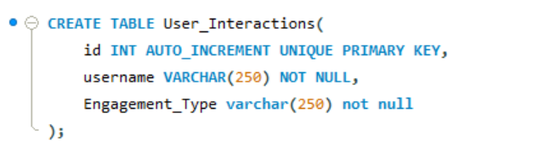
Figure 48 — Subjective Q10

After creating the User_Interaction table then I entered values in the table taking from the original table data.
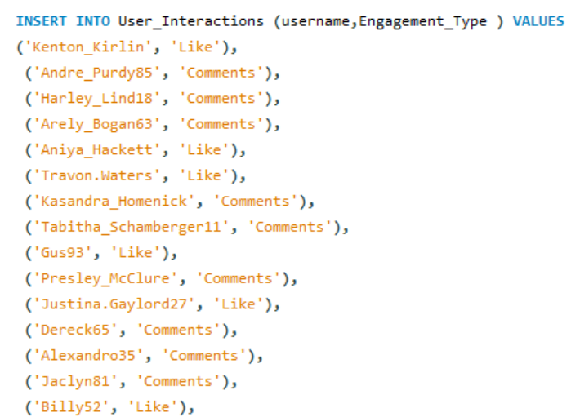
Figure 49 — Subjective Q10

Finally for updating the values in the table User_Interaction which was the original problem statement I constructed the following SQL Query

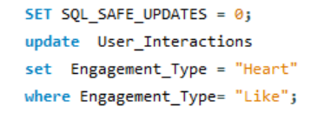
Figure 50 — Subjective Q10
From the above query I got the desired output updating the "Engagement_Type" column to change all instances of "Like" to "Heart" to align with Instagram's terminology.

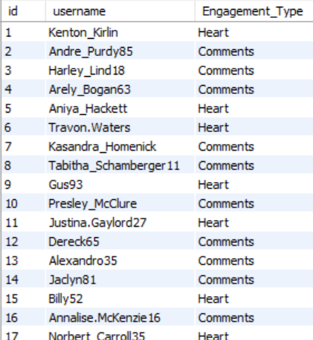
Figure 51 — Subjective Q10
Approach:
- Created a new User_Interactions table with an engagement_type column to mirror how a real interactions table might be structured.
- Populated it with sample values taken from the existing likes data to simulate real records.
- Wrote and ran an UPDATE statement with a WHERE clause targeting engagement_type = 'Like' to rename those rows to 'Heart', then verified the change with a SELECT on the table.
Insights:
- Renaming "Like" to "Heart" is a purely presentational/terminology change; because it was implemented with a plain UPDATE statement, it does not affect the underlying analysis already performed elsewhere in this project - the objective queries still reference the original likes table structure, not the label used in User_Interactions.
- Creating a separate User_Interactions table for this exercise highlights a broader design opportunity: today likes, comments and follows are tracked in three separate tables, whereas a single unified interactions table (with an engagement_type column) would make future engagement queries simpler and easier to extend if new interaction types (shares, saves) are added later.
Recommendation:
- If "Heart" becomes the standard terminology going forward, apply the same UPDATE logic to any other tables, views or reports that currently display the word "Like" so terminology stays consistent across the product.
- Consider migrating toward a unified interactions table long-term, as prototyped here with User_Interactions, since it would simplify many of the engagement queries built earlier in this project (Q2, Q4, Q6, Q11) into a single, more flexible schema.
- Wrap terminology-changing UPDATEs like this one in a transaction, with a prior backup or staging copy, since a bulk UPDATE across an entire interaction type is high-risk if the WHERE clause is ever miswritten.

