Jayesh Malviya
Business requirement document (BRD)
Refund Tracking & Notification System

Executive Summary
FoodExpress has observed an increasing number of customer support tickets related to refund inquiries. Customers currently have limited visibility into the status of their refund requests after initiating a refund. This lack of transparency results in repeated customer contacts, increased support workload, and reduced customer satisfaction.
To address this issue, FoodExpress proposes the implementation of a Refund Tracking & Notification System that will enable customers to track refund status, view refund progress, receive refund-related notifications, and access refund history through the application.

Business Objectives
Objective ID |  |  |  |  |  | Business Objective
BO-001 |  |  |  |  |  | Reduce refund-related support tickets by 40%
BO-002 |  |  |  |  |  | Improve customer satisfaction regarding refund experience
BO-003 |  |  |  |  |  | Increase refund process transparency
BO-004 |  |  |  |  |  | Reduce average handling time for refund-related support queries
BO-005 |  |  |  |  |  | Enable customers to self-service refund inquiries

Project Scope
In Scope
- Refund status tracking
- Refund timeline visibility
- Expected refund completion date display
- Refund-related notifications
- Refund history view
- Refund failure reason display
Out of Scope
- Refund approval workflow
- Refund policy changes
- Payment gateway modifications
- Finance backend processing changes
- Refund amount calculation logic

Stakeholders
Stakeholder | Role
Product Manager | Business Sponsor
Customer Support Manager | Process Owner
Finance Team | Refund Operations Owner
Customers | End Users
Business Analyst | Requirement Gathering & Documentation
Engineering Team | Development
QA Team | Testing

Business Requirements

BR ID | Business Requirement
BR-001 | Customers shall be able to track refund status.
BR-002 | Customers shall be able to view refund progress through a timeline.
BR-003 | Customers shall be able to view expected refund completion dates.
BR-004 | Customers shall receive notifications when refund status changes.
BR-005 | Customers shall be able to view refund history.
BR-006 | Customers shall be able to view refund failure reasons when applicable.

Functional Requirements
ID | Functional Requirement | MoSCoW Priority
FR-001 | System shall display current refund status. | M
FR-002 | System shall display refund timeline stages. | M
FR-003 | System shall display expected refund completion date. | M
FR-004 | System shall send refund status notifications. | M
FR-005 | System shall display refund history. | S
FR-006 | System shall display refund failure reason. | S

MoSCoW Rating:
- Must Have: Describes a requirement that must be satisfied in the final solution for the solution to be considered a success
- Should Have: Represents a high-priority item that should be included in the solution if it is possible. This is often a critical requirement but one which can be satisfied in other ways if strictly necessary.
- Could Have: Describes a requirement which is considered desirable but not necessary. This will be included if time and resources permit.
- Would Have: Represents a requirement that stakeholders have agreed will not be implemented in a given release, but may be considered

Non-functional Requirements

NFR ID | Requirements
NFR-001 | Refund status should load within 3 seconds.
NFR-002 | System availability should be 99.9%.
NFR-003 | Customer refund information must be securely stored.
NFR-004 | Notifications should be delivered within 1 minute of status change.
NFR-005 | Application should support concurrent users without performance degradation.

As-Is Process Flow

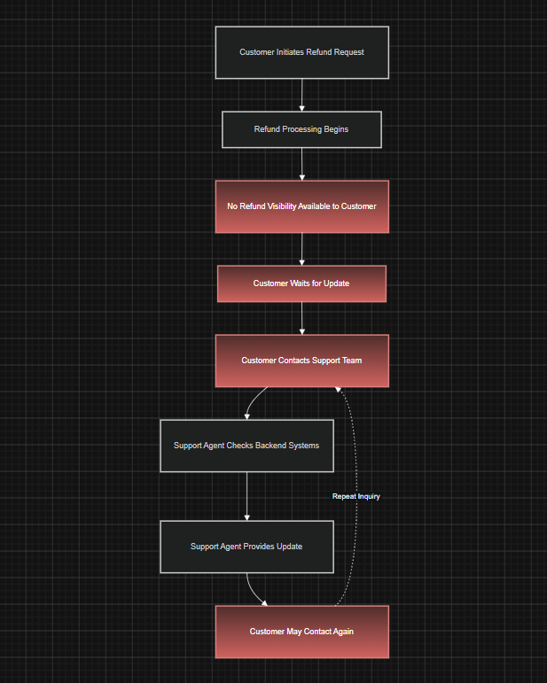
To-Be Process Flow

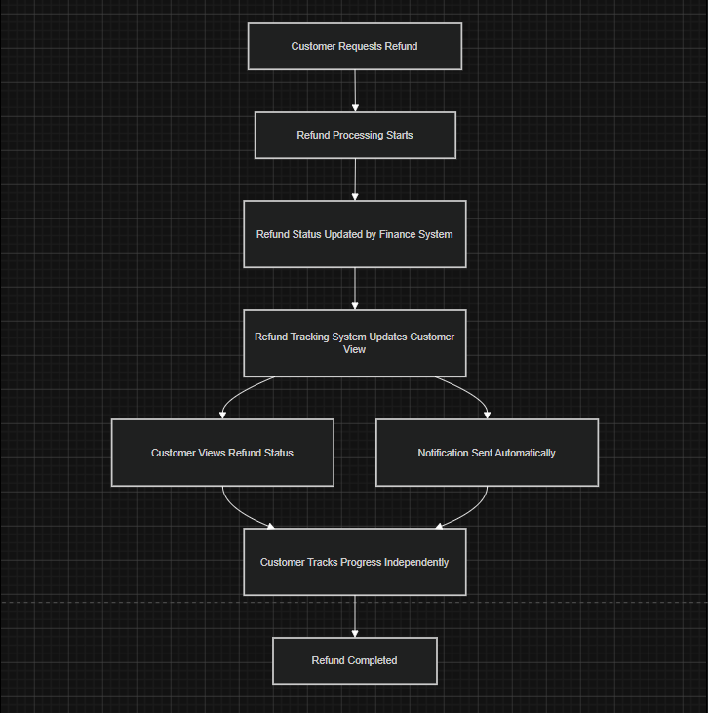

Assumptions
ID | Assumption
A-001 | Refund status data is available from existing backend systems
A-002 | Notification infrastructure already exists
A-003 | Refund ETA can be calculated from existing business rules
A-004 | Customers access refunds through the existing application

Dependencies
ID | Dependency
D-001 | Finance refund processing system
D-002 | Notification service
D-003 | Customer mobile application
D-004 | Refund database and APIs

Risks
ID | Risk | Impact
R-001 | Incorrect refund status synchronization | High
R-002 | Notification delivery failures | Medium
R-003 | Inaccurate ETA calculation | High
R-004 | Delays in backend API integration | Medium

