Jayesh Malviya
Functional Rquirement Document (frd)
Refund Tracking & Notification System

Purpose
The purpose of this document is to define the functional behaviour of the Refund Tracking & Notification System Enhancement.

System Overview
The solution will allow customers to:
- Track refund progress
- View refund timelines
- Receive notifications
- View refund history

through the FoodExpress mobile application.

Functional Requirements
ID | Functional Requirement | MoSCoW Priority
FR-001 | System shall display current refund status. | M
FR-002 | System shall display refund timeline stages. | M
FR-003 | System shall display expected refund completion date. | M
FR-004 | System shall send refund status notifications. | M
FR-005 | System shall display refund history. | S
FR-006 | System shall display refund failure reason. | S
FR-007 | System should display refund information in details. | M

FR-001 Refund Tracker
Description : System shall allow customers to track refund status.
Actors : Customer
Preconditions : Refund request exists
Functional Flow

Customer Login
↓
My Orders
↓
Select Order
↓
Refund Tracker
↓
View Refund Details

Data Displayed
- Refund ID
- Refund Amount
- Refund Status
- Refund Request Date
- Expected Refund Date

FR-002 Refund Timeline
Description : System shall display refund progress timeline.
Actors : Customer
Statuses

Refund Requested
↓
Approved
↓
Processing
↓
Sent To Bank
↓
Completed

Business Rule: Current stage shall be highlighted.

FR-003 Expected Refund Date
Description : System shall display estimated refund completion date.
Business Rules
UPI: 1-2 Days
Wallet: Instant
Debit Card: 3-5 Days
Credit Card: 5-7 Days

FR-004 Notification Service
Description : System shall notify customers whenever refund status changes.
Event | Notification
Refund Initiated | Yes
Refund Processing | Yes
Refund Completed | Yes
Refund Failed | Yes

Channels
- Push Notification
- SMS
- Email

FR-005 Refund History
Description : System shall allow customers to view previous refunds.
Information Displays
- Order ID
- Refund Amount
- Refund Date
- Refund Status

FR-006 Failed Refund Handling
Description : System shall display failure reason when refund processing fails.
Examples
- Bank Rejected Transaction
- Invalid Account Information
- Payment Gateway Failure

Business Rules
Rule ID | Rule
BRL-001 | Refund status must come from Finance System
BRL-002 | Refund date shall be calculated based on payment method
BRL-003 | Notifications shall be triggered on status change
BRL-004 | Refund history shall show last 12 months

FR-007 Refund Information in Details
Description: Customer should have an option to see its refund information in details.

Non-functional Requirements

NFR ID | Non-functional Requirements
NFR-001 | Refund status should load within 3 seconds.
NFR-002 | System availability should be 99.9%.
NFR-003 | Customer refund information must be securely stored.
NFR-004 | Notifications should be delivered within 1 minute of status change.
NFR-005 | Application should support concurrent users without performance degradation.

Use Cases
UC-001: Track Refund Status
NAME | Track Refund Status
USE CASE NO. | UC-001
DESCRIPTION | View current refund status of a refunded order
ACTORS | Customer
PRECONDITIONS | Customer is logged in.  Refund request exists.
POST CONDITIONS | Customer successfully views refund status.
TRIGGER | Customer clicks on track Refund status
DESCRIPTION | STEP | ACTION
 | 1 | Customer opens My Orders.
 | 2 | Customer selects the refunded order.
 | 3 | Customer clicks Track Refund.
 | 4 | System retrieves refund information.
 | 5 | System displays refund details.

Error Handling
Scenario | System Displays
Customer selects an order without a refund request. | No refund request found for this order.
Refund service is unavailable. | Refund information is temporarily unavailable. Please try again later.

UC-002: View Refund Timeline
NAME | View Refund Timeline
USE CASE NO. | UC-002
DESCRIPTION | Customer should be able to see their Refund Timeline
ACTORS | Customer
PRECONDITIONS | Refund request exists.
POST CONDITIONS | Customer understands current refund progress.
TRIGGER | Customer clicks on track Refund status
DESCRIPTION | STEP | ACTION
 | 1 | Customer opens Refund Tracker.
 | 2 | System retrieves refund timeline.
 | 3 | System displays refund stages.
 | 4 | Current stage is highlighted.

Timeline Stages:
Refund Requested
↓
Approved
↓
Processing
↓
Sent To Bank
↓
Completed.

UC-003: System Calculates Expected Refund Date
NAME | System Calculates Expected Refund Date
USE CASE NO. | UC-003
DESCRIPTION | Customer gets expected refund date
ACTORS | System
PRECONDITIONS | Refund request exists.
POST CONDITIONS | Customer receives expected refund date.
TRIGGER | Refund gets initiated.
DESCRIPTION | STEP | ACTION
 | 1 | Refund is initiated
 | 2 | System detects the medium that customer selected for refund.
 | 3 | System adds the dedicated business days to the Order date.
 | 4 | System calculated expected refund date.
 | 5 | System displays expected refund date.

Business Rules
- UPI: 1-2 Days
- Wallet: Instant
- Debit Card: 3-5 Days
- Credit Card: 5-7 Days

UC-004: Receive Refund Initiated Notification
NAME | Receive Refund Initiated Notification
USE CASE NO. | UC-004
DESCRIPTION | Customer gets notification when refunds initiated.
ACTORS | System
PRECONDITIONS | Refund request exists.
POST CONDITIONS | Customer receives refund initiation confirmation.
TRIGGER | Refund gets initiated.
DESCRIPTION | STEP | ACTION
 | 1 | Refund is initiated
 | 2 | System triggers notification event.
 | 3 | Notification is generated.
 | 4 | Notification is sent to customer.
 | 5 | Customer receives notification.

Notification Content
- Refund ID
- Refund Amount
- Refund Initiation Date

Error Handling
Scenario | System Response
Customer disabled push notifications. | System sends SMS or Email.

UC-005: Receive Refund Processing Notification
NAME | Receive Refund Processing Notification
USE CASE NO. | UC-005
DESCRIPTION | Customer gets notification when refund is in processing stage.
ACTORS | System
PRECONDITIONS | Refund status changes to Processing
POST CONDITIONS | Customer is informed about refund processing.
TRIGGER | Refund status changes to Processing
DESCRIPTION | STEP | ACTION
 | 1 | Refund enters Processing stage.
 | 2 | System detects status change.
 | 3 | Notification is generated.
 | 4 | Notification is sent to customer.
Notification Content
- Refund Status
- Estimated Refund Date

UC-006: Receive Refund Completed Notification
NAME | Receive Refund Completed Notification
USE CASE NO. | UC-006
DESCRIPTION | Customer gets notification when refund is completed.
ACTORS | System
PRECONDITIONS | Refund status changes to Completed
POST CONDITIONS | Customer knows refund has been successfully completed.
TRIGGER | Refund status changes to Completed.
DESCRIPTION | STEP | ACTION
 | 1 | Refund status changes to Completed.
 | 2 | System detects status change.
 | 3 | Notification is generated.
 | 4 | Notification is sent to customer.
 | 5 | Customer receives confirmation notification

Notification Content
- Refund Amount
- Completion Date
- Transaction Reference Number

UC-007: Receive Refund Failed Notification
NAME | Receive Refund Failed Notification
USE CASE NO. | UC-007
DESCRIPTION | Customer gets notification when refund is failed.
ACTORS | System
PRECONDITIONS | Refund status changes to Failed
POST CONDITIONS | Customer is informed about refund failure
TRIGGER
DESCRIPTION | STEP | ACTION
 | 1 | Refund processing fails.
 | 2 | System captures failure reason.
 | 3 | Notification is generated.
 | 4 | Customer receives failure notification.

Failure Reasons
- Bank Rejected Transaction
- Invalid Account Information
- Payment Gateway Failure

UC-008: View Refund History
NAME | View Refund History
USE CASE NO. | UC-008
DESCRIPTION | Customers view their refund history
ACTORS | Customer
PRECONDITIONS | Customer is logged in.
POST CONDITIONS | Customer successfully reviews refund history.
TRIGGER | When customer clicks on refund history.
DESCRIPTION | STEP | ACTION
 | 1 | Customer navigates to Refund History.
 | 2 | System retrieves refund records
 | 3 | System displays refund history list.
 | 4 | Customer selects a record for detailed view.

Information Displayed
- Order ID
- Refund Amount
- Refund Date
- Refund Status

UC-009: View Refund Details
NAME | View Refund Details
USE CASE NO. | UC-009
DESCRIPTION | Customers view their refund records in details.
ACTORS | Customer
PRECONDITIONS | Refund record exists
POST CONDITIONS | Customer successfully views detailed refund information.
TRIGGER | When customer selects Order Details.
DESCRIPTION | STEP | ACTION
 | 1 | Customer opens Refund History.
 | 2 | Customer selects a refund record.
 | 3 | System displays refund details.

Information Displayed
- Refund ID
- Order ID
- Refund Amount
- Refund Status
- Refund Request Date
- Expected Refund Date
- Payment Method
- Transaction Reference Number

3User Stories & Acceptance Criteria

User Story US-001: Track Refund Status
User Story
As a customer,
I want to view the current refund status,
So that I can know the progress of my refund request.

Acceptance Criteria
AC-001

Given Customer is logged in
When Customer opens Refund Tracker
Then System should display:

- Refund ID
- Refund Amount
- Refund Status
- Refund Request Date
- Expected Refund Date

AC-002
Given Customer opens Refund Tracker
When No refund request exists
Then System should display:

No refund request found for this order.

AC-003

Given Customer opens Refund Tracker
When Refund service is unavailable
Then System should display an appropriate error message.

User Story US-002: View Refund Timeline
User Story:
As a customer,
I want to view the refund timeline,
So that I can understand which stage my refund is currently in.

Acceptance Criteria

AC-004

Given Refund request exists
When Customer opens Refund Timeline
Then System should display all refund stages.

AC-005

Given Refund is currently in Processing status
When Customer views timeline
Then Processing stage should be highlighted.

AC-006

Given Refund has been completed
When Customer views timeline
Then Completed stage should be highlighted.

User Story US-003: View Expected Refund Date

User Story
As a customer,
I want to see the estimated refund completion date,
So that I know when I can expect my money.

Acceptance Criteria

AC-007

Given Refund exists
When Customer views refund details
Then Expected refund date should be displayed.

AC-008

Given Payment method is UPI
When Expected date is calculated
Then System should use 1–2 business days.

AC-009

Given Payment method is Wallet
When Expected date is calculated
Then System should instantly send the refund.

AC-010

Given Payment method is Credit Card
When Expected date is calculated
Then System should use 5–7 business days.

AC-011
Given Payment method is Debit Card
When Expected date is calculated
Then System should use 3-5 business days.

User Story US-004: Receive Refund Initiated Notification

User Story
As a customer,
I want to receive a notification when my refund is initiated,
So that I know the refund process has started.

Acceptance Criteria

AC-012

Given Refund request is successfully initiated
When Refund status changes to Initiated
Then Notification should be sent.

Notification should contain:
- Refund ID
- Refund Amount
- Initiation Date

User Story US-005: Receive Refund Processing Notification

User Story
As a customer,
I want to receive updates while my refund is being processed,
So that I know my refund is progressing.

Acceptance Criteria

AC-013

Given Refund status changes to Processing
When Status update occurs
Then Notification should be sent.

Notification should include:
- Current Status
- Expected Refund Date

User Story US-006: Receive Refund Completed Notification

User Story
As a customer,
I want to receive confirmation when my refund is completed,
So that I know my money has been refunded.

Acceptance Criteria

AC-014

Given Refund status changes to Completed
When Status update occurs
Then System should send completion notification.

Notification should include:
- Refund Amount
- Completion Date
- Reference Number

User Story US-007: Receive Refund Failed Notification

User Story
As a customer,
I want to be informed if my refund fails,
So that I can take corrective action.

Acceptance Criteria

AC-015

Given Refund processing fails
When Status changes to Failed
Then System should send failure notification.

Notification should display failure reason.

System should provide: Contact Support option.

User Story US-008: View Refund History

User Story
As a customer,
I want to view my previous refund requests,
So that I can review past refund transactions.

Acceptance Criteria

AC-016

Given Customer is logged in
When Customer opens Refund History
Then System should display refund records.

System should display:
- Order ID
- Refund Amount
- Refund Date
- Refund Status

AC-017

Given No refund records exist
When Customer opens Refund History
Then System should display:
No refund history available.

User Story US-009: View Refund Details

User Story
As a customer,
I want to view detailed refund information,
So that I can understand all refund-related information.

Acceptance Criteria

AC-018

Given Customer selects a refund record
When Refund details page opens
Then System should display:
- Refund ID
- Order ID
- Refund Amount
- Refund Status
- Payment Method
- Expected Refund Date
- Transaction Reference Number

AC-019

Given Refund details unavailable
When Customer attempts to view refund details
Then System should display an error message.

Wireframes
WF-001: Refund Tracker Screen

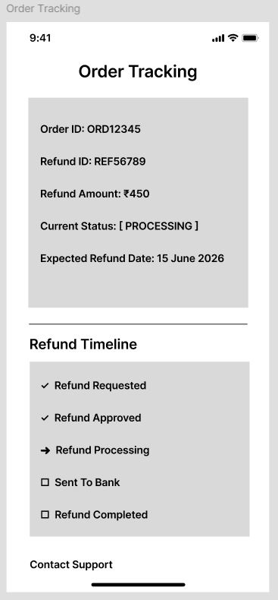
Note: It’s Refund* Tracking, not Order Tracking.

WF-002: Refund History Screen

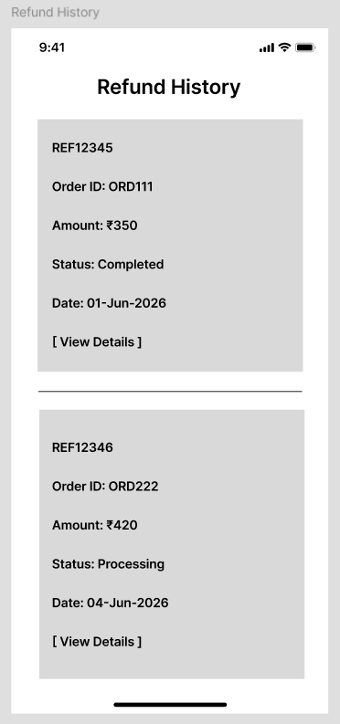

WF-003: Refund Details Screen

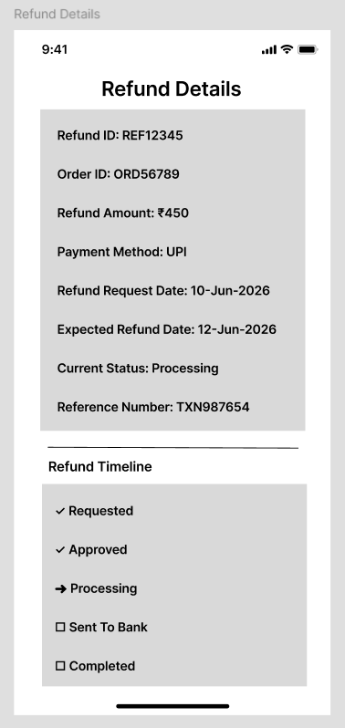

WF-004: Refund Failed Screen

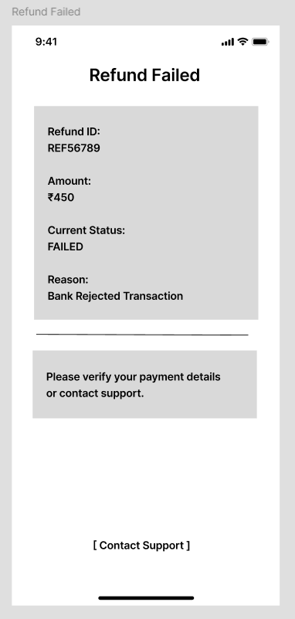

Requirement Tracability Matrix (RTM)

BR ID | Business Requirement | FR ID | Use Case | User Story
BR-01 | Track refund status | FR-001 | UC-001 | US-001
BR-02 | View refund timeline | FR-002 | UC-002 | US-002
BR-03 | View expected refund date | FR-003 | UC-003 | US-003
BR-04 | Receive refund notifications | FR-004 | UC-004, UC-005, UC-006, UC-007 | US-004, US-005, US-006, US-007
BR-05 | View refund history | FR-005 | UC-008 | US-008
BR-06 | View refund failure reason | FR-006 | UC-007 | US-007, AC-015
BR-07 | View refund details | FR-007 | UC-009 | US-009

